Module: Introduction In Health and Social Care

Module code: LCH4003

Student name: zahraa bi

Student ID: 2507270

Lecturer: Azida Zainol

Current Functioning of the Service

Key Challenges Facing Domiciliary Care

Target Population and Benefits

Explanation of the Service
Brief History of Domiciliary Care

Home care (domiciliary care) is a type of personal, social and simple healthcare that is provided at the home of an individual.
- Aspires to foster independence, dignity, safety and quality of life.
- Helps one to stay in familiar environments and not in institutions.
Target groups include:
- Older adults
- Physically and/or learning disabled people.
- Individuals with long-term or chronic illnesses.
- Patients who have just come out of sickness, injury or even hospitalization.
Key principles:
- Person-centred care
- Appreciation of individual preferences, culture and autonomy
- Independence and wellbeing promotion
Common services provided:
- Personal hygiene (washing, bathing, dressing) Mobility and transfer support.
- Prompting and administration of medication.
- Nutrition and preparation of meals.
- Light household tasks Social and emotional support.
Advantages of domiciliary care:
- Minimizes the hospitalizations and residential care placement
- Facilitates mental health and social engagement
- Increases autonomy and self-respect
- Delivers affordable community-based care (Department of Health and Social Care, 2022)
Domiciliary Care Services within the Community
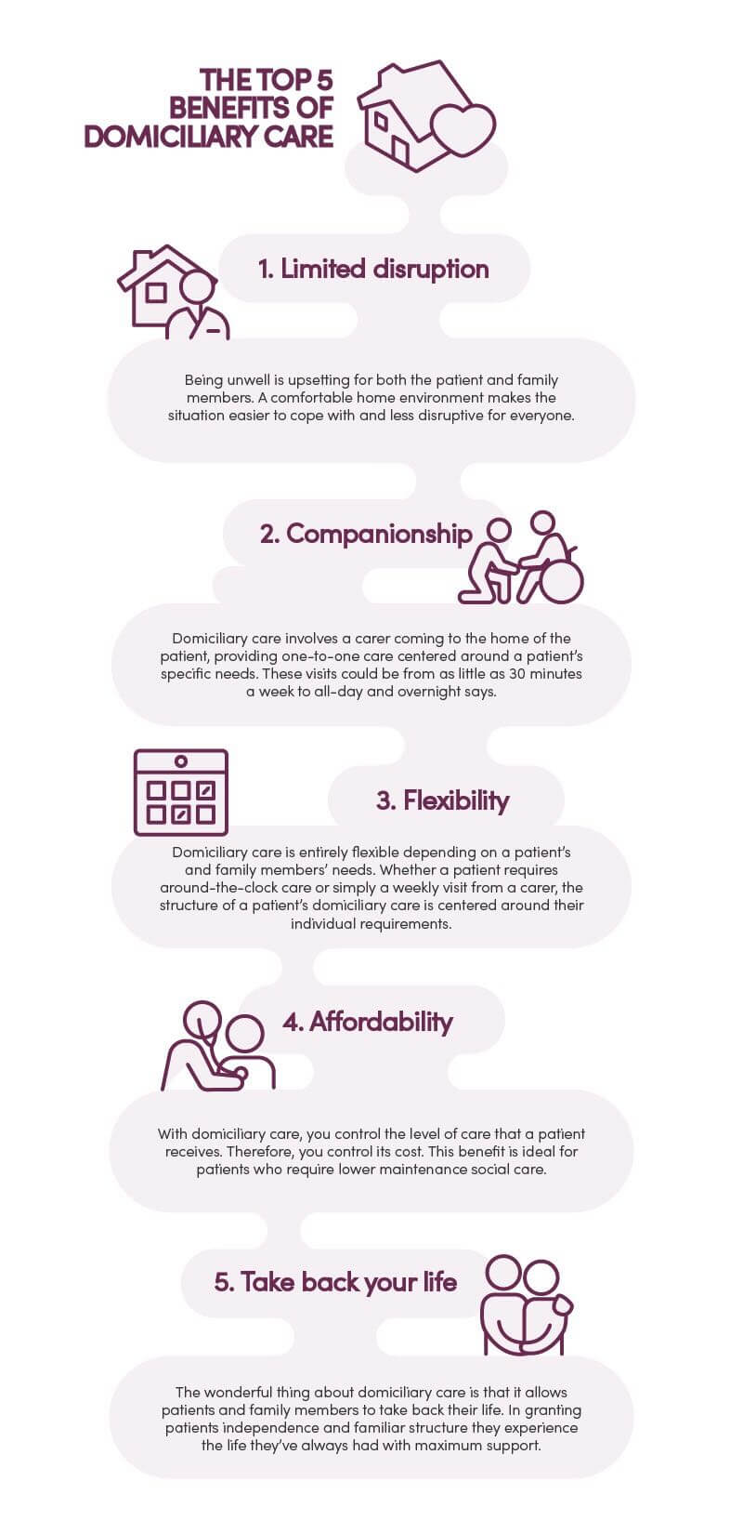
Challenge 1: Staffing Unavailability
The problem with hiring and retention of care workers.
Contributing factors:
Low wages
Limited career progression
Physically and emotionally hard jobs
High staff turnover leads to:
Unpredictable care delivery.
Less continuity to the service users.
This will put more strain on the remaining workforce.
Impact on service users:
Reduced trust
Lower satisfaction
The possible threats to the quality of care (Skills for Care, 2023).
Issue 2: Financial Strain
Growing demand due to:
Ageing population
Greater morbidity of chronic diseases
The lack of local authority funds leads to:
Shorter care visits
Unmet care needs Inequalities in service access in the region.
Limited funding affects:
Workforce development
Innovation and quality of service. Sustainability risk in long term of the domiciliary care services ( The Kings Fund, 2022).
Domiciliary Care Significance in the Community.
Enables individuals to:
Remain independent
Live safely at home
Maintain dignity and choice Reduces pressure on:
Hospitals
Nursing homes and residential
Assists informal carers, families
Critical to sustainable community-based health and social care.
Target Population
The elderly who are frail due to old age.
Physically challenged persons.
Persons with learning disabilities.
Patients with mental illnesses.
Individuals who experience long-term or chronic diseases.
Patients who have been discharged out of illness, injury or hospitalization.
Benefits for Service
Users Allows people to stay at their respective residences.
Keeps routines, well known surroundings.
Favors social relations with neighbors and family.
Encourages self-reliance, integrity and self-determination.
Enhances self-esteem and emotional wellbeing.
Minimizes social isolation and loneliness.
Favors efficient management of chronic illnesses.
Benefits for the Health and Social Care System
Minimizes hospital and emergency strain.
Slows down or blocks residential care homes.
Helps to release patients early in hospitals.
Aids in an environmentally friendlier and more affordable health and social care (The King's Fund, 2022).
Services provided as a joint venture between:
- Local authorities
- Voluntary and private care providers.
- Healthcare professionals
Local councils:
- Conduct needs assessments Establish funded care eligibility.
- Provider-based commission services.
Care delivery:
- According to personalized, systematic care plans.
- Administrated by domiciliary care workers who are trained.
Working multi-disciplinarily with:
- General practitioners District nurses
- Occupational therapists
- Physiotherapists
Control and quality:
- Managed and checked by Care Quality Commission.(cqc 2025)
Use of technology:
- Digital care records
- Telecare alarms
- Remote monitoring systems
Focus on:
- Safeguarding
- Risk management
- Sequentially and continuity of care (Skills for Care, 2023)
In the pre-20th century, the care was predominantly institutional (workhouses, hospitals, residential homes).
Lack of community support of older or disabled people.
Establishment of the National Health Service (1948):
- Healthcare accessibility.
- Slow transition to community-based care.
NHS and Community Care Act (1990):
- Launched the care in the community.
- Devolved the social care to the local government.
- Home based care and not institutionalization.
Care Act (2014):
- Focused social care on wellbeing.
- Stress on prevention, personalization and independence.
- Enhanced the position of domiciliary care in new services.
- Domiciliary care is now recorded as a fundamental social care service, which is situated in the community (Glasby, 2017).

Task 2: Critically Evaluating Ambulance Services
Ambulance care is an essential element of the contemporary medical care systems, offering the immediate response in case of emergency, urgent treatment, and the transportation of the patients in a safe way. Their job has grown over time to include more than simple transport services to elaborate, clinically based emergency care givers. This essay is a critical assessment of the origins of ambulance services, their current way of operation, and the influence on the quality of life of the service users.
Traditionally, the history of ambulances back dates to the late nineteenth century when primitive transport systems were created to deliver injured or sick people to the hospital. The early ambulances provided little medical care with the staff training being very minimal and there was not much coordination for the healthcare institutions. A major change was after the development of the National Health Service in 1948, where ambulance services were brought to be under government funding and control. This amalgamation-initiated standardization of training, better equipment and closer integration towards the care based in hospitals. In the following decades, ambulance services were transformed into a frontline healthcare provision and not a transport role alone due to the development of emergency medicine and policy changes (Wankhade and Mackway-Jones, 2015).
The ambulance services in modern healthcare are a highly specialised and clinically oriented system. In the UK they are provided by regional NHS ambulance trusts under co-operation with emergency departments, urgent care centres and primary care provision. The paramedics and emergency medical technicians have been trained to treat, diagnose or assess the patients at the scene, and sometimes make complex clinical decisions about whether the patients should be taken to the hospital or not. It is a change in the direction of a more patient-centred and efficient emergency care practice by treating and referring (or seeing and treating) (NHS England, 2023).
Nevertheless, even with these developments, ambulance services have significant operational problems. The rising demand due to the ageing population, prevalence of chronic diseases, and lack of community services has imposed a large burden on the response times and the staff capacity. Slow handovers at hospitals caused by congested emergency departments also lower the availability of ambulances. Critically, the improvement of clinical capability has been accompanied by constrained system-wide pressures that tend to impair the efficacy of service provision both in terms of the wellbeing of the staff and patient outcomes.
Ambulance services are crucial in improving the quality of life of those who consume the services since they ensure that they offer lifesaving services by availing themselves in a timely manner in medical emergencies. Quick availability of services in response to cardiac arrest, stroke, trauma, and respiratory distress leads to a significant improvement of survival and long-term health outcomes. To the service users, especially those with acute distress, the availability of competent paramedics gives them confidence and pain management, as well as emotional support in very vulnerable situations.
Moreover, contemporary ambulance services also improve the quality of life through the minimization of unjustified hospital admission. Ambulance teams can attain a level of independence and independence is encouraged as they provide care on-site or send patients to the relevant community services; this allows patients to stay in their usual environment, and this aspect alleviates stress associated with hospitals. The method is especially useful in case of older adults and people with long-term conditions where hospitalisation may result in functional deterioration (The King’s Fund, 2023).
However, continuous delays and pressures of response time may have adverse impacts on the experience and results of service users. Waiting time in the emergencies can contribute to anxiety and deteriorate the clinical conditions and decrease the confidence of the population in the service. So, although essential to the quality of life, ambulance services should be associated with sufficient funding, staffing, and coordination with the rest of the health and social care system.

References:

- Association of Ambulance chief Executives (2024) A vision for the NHS ambulance sector. Available at: https://aace.org.uk/wp-content/uploads/2024/03/Ambulance24-vision-final.pdf
- Care Quality Commission (2023) The state of health care and adult social care in England. London: CQC
- College of Paramedics (2023) Developing a new paramedics curriculum
- Department of Health and Social Care (2022) Care and support statutory guidance. London: DHSC
- Eaton G (2023) Addressing the challenges facing the paramedic profession in the United Kingdom. British Medical Bulletin, 148(1), pp. 70–78. Available at: https://academic.oup.com/bmb/article/148/1/70/7262998
- Glasby, J. (2017) Understanding health and social care. 3rd edition. Bristol: Policy Press.
- NHS England (2023) Ambulance response programs. London: NHS England. (accessed 15th feb 2026)
- Skills for Care (2023) The state of the adult social care workforce in England. Leeds: Skills for Care. (Accessed 15th feb 2026)
- The King’s Fund (2022) Social care funding and reform. London: The King’s Fund
- The King’s Fund (2023) Urgent and emergency care services in England. London: King’s Fund.
- Wankhade, P. and Mackway-Jones, K. (2015) Ambulance services: leadership and management perspectives. Cham: Springer. (Access date 19th feb 2026)

