

Assessment 1 – Reading Task Template
Upload your photo of your A3 in-class notes here:
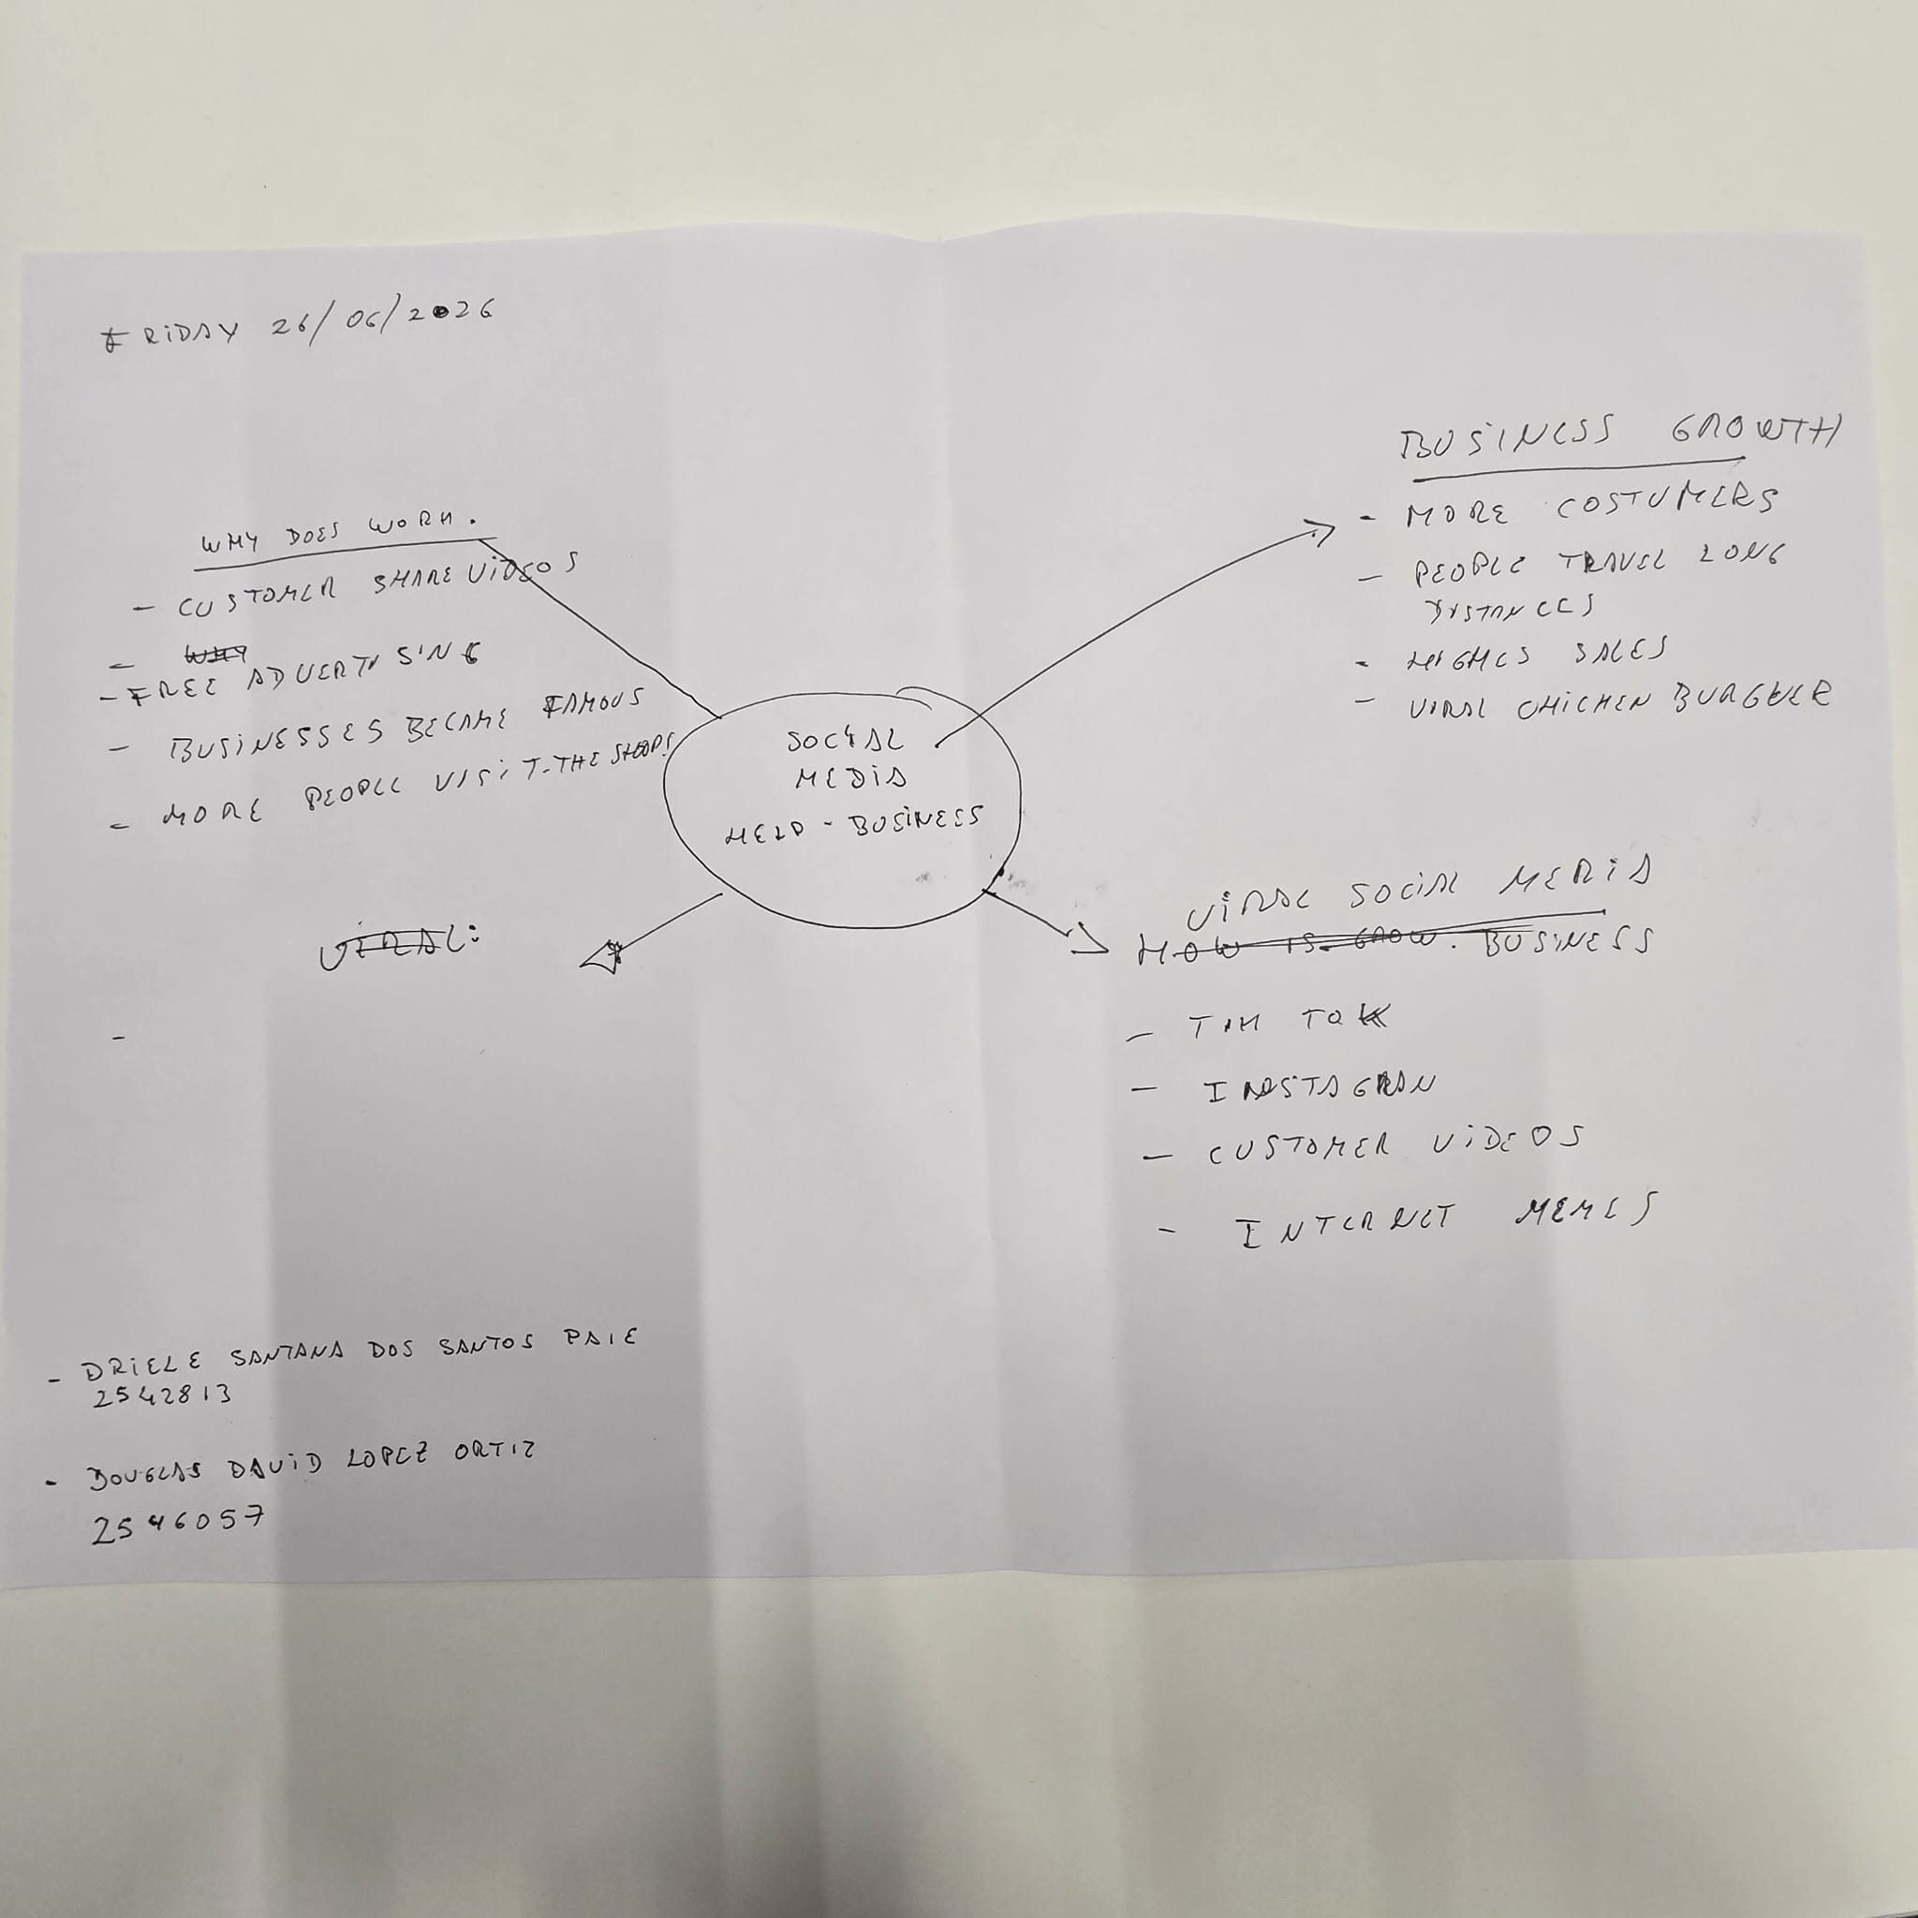

1. Answer these questions using the sentence starters below
a. What is the main idea of the text?
The main idea is that, the businesses turning likes intonlivelihoods.
b. What are two key points?
One key point is that social media platforms can help small business become popular and attract and more customers.
Another key point is the shop became successful because customers shared videos of the shop online
c. What part of the text did you find most important? Why?
The most important part is that customer videos on social media helped the shop grow because it shows how important social media can be for business.
d. Was anything unclear or difficult to understand?
I was not sure about how long the social media trend will last and if the business will keep getting more customers.
e. How did your group help you understand the text better?
My group helped me by discussing the main the ideas and explaining words or parts that were confusing.
2. One sentence reflection
Question: What did you find challenging about this task?
The hardest part was how to identify the main idea of text as well as having a clear understanding of the key point.

