
health assessment REPORT
INTRODUCTION TO PHYSIOLOGY (BMPH5003)

OMENEKE YUSUF (2009232)

LECTURER: RACHEAL RIVERS

TABLE OF CONTENTS
CASE STUDY 2
INTRODUCTION 2
BOB’S LIFESTYLE. 2
SUMMARY OF FINDINGS 3
obesity and diet 4
cardiovascular problems and activities. 5
PSYCHOLOGICAL IMPACT ON HEALTH 5
drinking and smoking 6
LIFESTYLE CHANGE AND HEALTH EDUCATION 6
REFERENCES 9

CASE STUDY

INTRODUCTION
The goals for composing a report on the case study is to provide an in-depth information on the state of Bob’s health and his lifestyle. The report will incorporate all aspects of Bob's normal lifestyle in question and the Impact on his health. To conduct a health and fitness exam on Bob once the necessary information about his state of health has been gathered, and the evaluation to show techniques and procedures in place.
The case report will identify physiological functions, abnormal physiology, and the detected health concerns such as over-weight or BMI issues. The findings together with a discussion of how their influence contributed to the healthy and unhealthy physiology of the case study. Lastly, recommendations that reflects the findings for Bob’s lifestyle change and healthy living according to guidelines will be highlighted. Due to the nature of their work, truck drivers have few opportunities to engage in healthy behaviours while on the job, (Greenfield et al., 2016). As a result, many truck drivers engage in risky behaviours such as not getting enough exercise, sitting for long periods of time, eating poorly, smoking frequently, drinking excessively, and not getting enough sleep, (Sieber et al., 2014)

BOB’S LIFESTYLE.
Bob is a 52-year-old male divorcee and a truck driver who live alone in Birmingham city all his life. Bob has a 27-year-old daughter named Dana who is married to Josh with two children, Alex and Taylor, but lived far away from Bob in Huddersfield. Bob spent most of time on the road driving Truck since divorce from wife 5 years ago. Bob usual smokes for the past 20 years to pass time and enjoys it. Usually Cooked in the past for the family while enjoying family quiz games but now eat on the road as he goes. Presently has trouble sleeping and drinks a bottle of whiskey occasionally when home to help with sleep, sometimes sleeps on the road in the truck Bob and has no time to exercise, mainly lives on the whatever food is available on the road to buy. Height is 175cm (5’9) and weighs 95kg (15 stones).

ASSESSMENT REPORT
Findings from Bob’s lifestyle
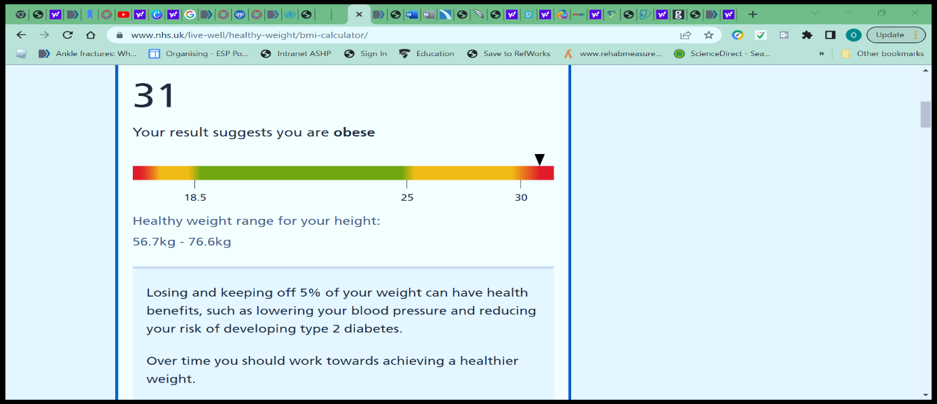
Fig 1; (NHS, 2018)
Figure 1 above shows a screen shot from the National Health Services Search (NHS), (2018). BMI calculations of Bob’s details.

SUMMARY OF FINDINGS
- BMI is 31, which by indication show that is obesity (NHS, 2018)
- Smoking 10-19 cigarettes a day
- High cholesterol and high blood pressure from the questionnaire
- Insomnia and sleeping rough
- Tired easily
- Bored
- frequent unhealthy food
- Seldom Exercise
- Drinks 3 to 6 units a day
- Never had heart attack or Stroke but has a family history of it.
IMPLICATION TO HEALTH
People's decisions might have long-term implications for their physical and mental well-being, below is some of effects of the lifestyle choices of Bob on his health. There is high risk of Obesity, high cholesterol and cardiovascular diseases among people with sedentary occupation. Health issues including high blood pressure, high cholesterol, being overweight, smoking, not getting enough exercise, and not getting enough sleep were mentioned in a study carried out by Sieber et al., (2014)

obesity and diet
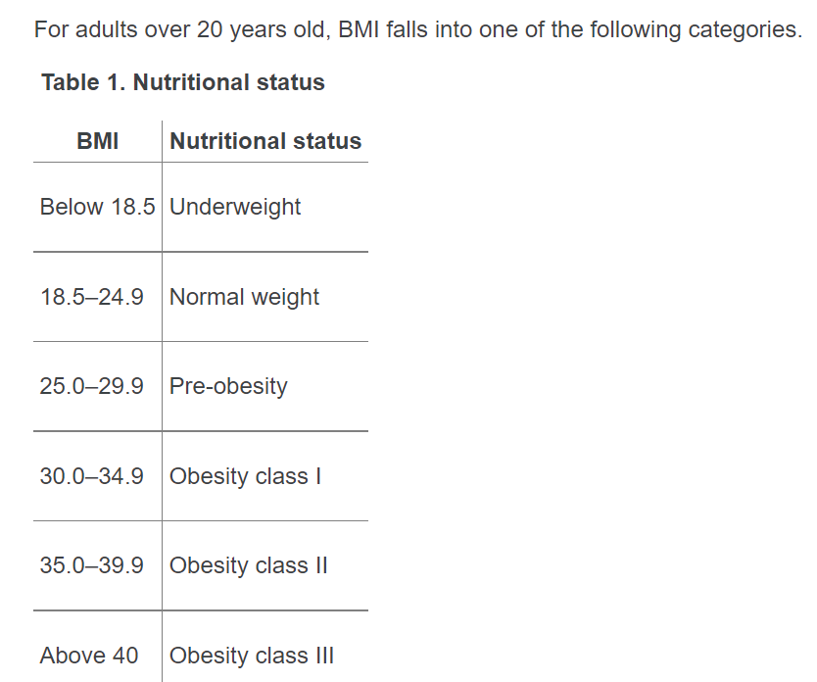Fig.2 by WHO (2010).
Bob has a BMI of 31, which by indication shows Obesity class 1, (NHS, 2018), (WHO,2010). Studies suggest that 84% of HGV drivers 'are' overweight or obese’. By 2050, it's possible that 60% of men and 50% of women would be clinically obese; In the absence of action, healthcare expenses due to obesity-related ailments would rise to £45.5 billion annually, (Nationalarchives.gov.uk, 2007). The body mass index (BMI) is calculated by using the individual's weight in kilogrammes divided by their height (squared) in centimetres. The normal range for body mass index (BMI) is 18.5-24.9, which was adopted from the worldwide WHO standard, (2010)
The choice of diet chosen by Bob has an enormous impact on his health and body function. Frequent consumption of fast food and junk food can predispose him to high cholesterol and heart problems, (NHS,2018). Obesity is becoming a general health concern. Most Brits are overweight or obese, 61.9% of adults and 28% of 2-15-year-olds making it more likely to acquire type 2 diabetes, CVD, and cancer, (GOV.UK, 2016). Weight problem result mostly from unhealthy eating which is popular with truck drivers and individuals with less time for cooking healthy meals. WHO suggests consuming fruits and vegetables, minimising fat, sugar, and salt, and exercising for a better living. Body mass index (BMI) can be used to determine if someone is overweight or obese. In Bob’s situation, BMI of 31 indicates mild obesity which can predispose to heart diseases and type 2 diabetes, (NHS,2018)..

cardiovascular problems and activities.
According to research by the National Health services NHS (2021b), Getting regular exercise can decrease the chances of dying by up to 30 percent, as well as the risk of developing serious health problems including heart disease, stroke, diabetes, and cancer.
Bob ‘sedentary job contributes negatively to the ability to lead an active lifestyle. Bob has reported seldom engagement in any other activities apart from truck driving. 61% of truck drivers had two or more risk factors: hypertension, obesity, smoking, high cholesterol, insufficient physical exercise, 6 or fewer hours of sleep per 24hours (Sieber et al., 2014). Being inactive for long time worsens health outcome leading to high blood pressure, high cholesterol and worsening obesity over time, Greenfield et al, (2016). Truck drivers spend lengthy hours driving and sitting still which is harmful, (Driver Require, 2021), Hypertension, heart disease, and obesity can result from a sedentary employment ,World Health Organisation (WHO, 2010). HGV driver shortages make it harder to stay healthy which is essential for a successful HGV driving career, (Driver Require, 2021). Despite the busy schedule, maintaining a healthy strategy should help in staying in shape and for best performance.
HGV organisations needs to work with the government and health agencies to put all the policies in place and there should be consequences for breaking the rule. Noncommunicable illnesses such as obesity, diabetes, cardiovascular disease, some forms of cancer, and skeletal disorders are some of the most preventable with a good diet, (WHO,2010).

PSYCHOLOGICAL IMPACT ON HEALTH
Bob lives alone after the divorce from wife and complains of boredom and trouble sleeping resulting in indulging in drinking a bottle of whiskey to sleep; equally enjoys smokes to pass time. The health advantages of regular physical exercise, such as walking, cycling, or dancing, are substantial. Exercise can greatly lessen the possibility of developing heart disease, diabetes, or osteoporosis; aid in maintaining a healthy weight; and improve one's state of mind (World Health Organization, 2010). Overweight people may find it difficult to get and keep a job, and it may affect their self-esteem and mental health, (NHS, 2018), this might account for why Bob tends to remain in the same position despite the negative impact on health. Bob needs more interaction with family and friends and join a sporting club to help him socialise with others. Having an exercise regime or gym membership will assist in meeting other people and improve his self-esteem and worth. Getting in shape improves one's chances of making friends, expanding one's professional network, and discovering one's own unique cultural identity. When people are more physically active, they are more likely to connect with one another and form bonds with their neighbours and families, (WHO,2010).

drinking and smoking
The World Health Organization (2010)) does not establish specific limits for alcohol intake since the research demonstrates that the best option for one's health is to abstain from drinking at all, which means that drinking less is preferable. Bob ‘s habit of drinking a bottle of whiskey to help him sleep will deteriorate his health over time and needs to stay within the limit or abstain, (NHS, 2021). A single glass of wine may have as many calories as a little piece of chocolate. The accumulation of extra pounds is a well-documented side effect of heavy and chronic alcohol consumption, (Nationalarchives.gov.uk, 2007)
Tobacco smoke is poisonous to both smokers and bystanders, Tobacco's health consequences impact Britain's poorest communities worst, (Public Health England, 2022).
(WHO, 2018). Since the year 2003, most types of cigarette advertising have been forbidden, however it has not help in reducing the number of people who still indulge in smoking thus Involving specialists to help with quitting smoking is important for Bob to make an inform choice. Compared to those who don't smoke, those who do are at much higher risk for several illnesses,(WHO,2018). From 2017 to 2019, smoking was estimated to have caused 191,900 fatalities in England, (Public Health England, 2021). Things like nicotine path to assist gradual quitting from smoking. It's well-known that smoking is bad for health, Chronic heart disease, stroke, and other circulatory problems are all made worse by smoking's negative effects on the cardiovascular system, (Public Health England, 2021).

LIFESTYLE CHANGE AND HEALTH EDUCATION
Healthy nutrition, regular exercise, staying hydrated, maintaining a clean atmosphere in the truck while driving, and getting enough sleep are the top 5 ways that truck drivers may improve their health and fitness (Driver Require, 2021). NHS recommends that individuals "be active every day and seek to obtain at least 150 minutes of physical exercise throughout the week" (2021). This will help improve the overall health of an individual if strictly adheres to. Exercise is the most effective method for long-term weight loss success. In the short term, prevention efforts for truck drivers can work on improving both their health outcomes and the way they act, (Mandy et al., 2014). In addition to improving, overall health, regular exercise can help shed the excess pounds that won't budge no matter how much cut back on food, (NHS Choices, 2018. A glass of water could be all that is needed when hungry, but chances are people normally go for something else, perhaps something higher in calories as it is easy to confuse thirst with hunger. (NHS, 2021). Keeping tempting foods out of the house is a good way to stay on track. Make a weekly menu that includes breakfast, lunch, dinner, and snacks, (NHS Choices, 2018). Make sure not to go over the daily calorie allotment. When dieting fails, it's a good idea to see a doctor to get a check-up (Nationalarchives.gov.uk, 2007) and find out if there are any underlying health disorders that might be contributing to weight gain and talk about a treatment plan and any drugs that might be needed, (NHS 2021b).
Stopping can lessen the danger of the smoking related illnesses no matter how long one has been a smoker, for instance, the likelihood of developing lung cancer drops to around half that of a smoker after just 10 years, (Public Health England, 2021). The NHS help to Quit services is a good step to take as help is at hand for stopping to smoke.
RECOMMENDATIONS AND CONCLUSIONS
Like combating global warming, preventing obesity is a pressing public health issue that requires collective action, (Nationalarchives.gov.uk, 2007). It calls for collaboration between authorities, academics, businesses, and all citizens. 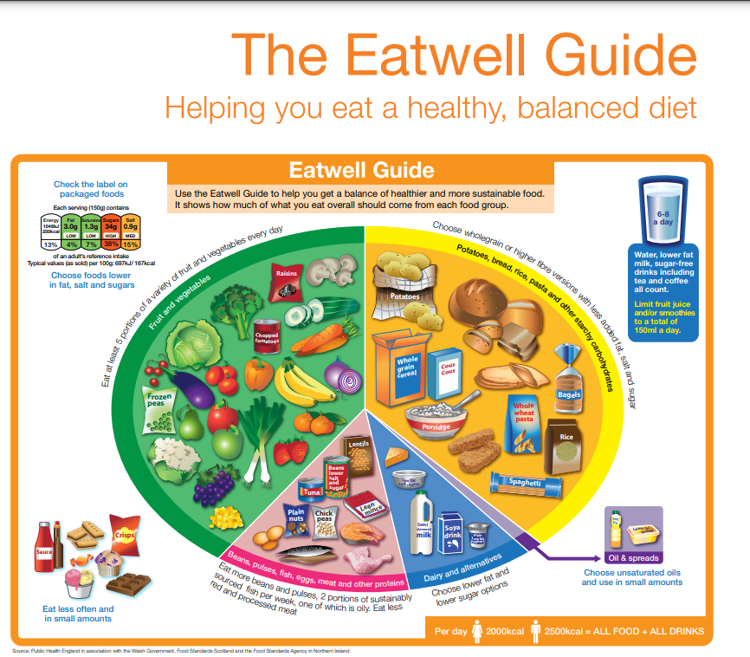Fig.3 (NHS Choices, 2018)
Adhering to Recommended guidelines based on relevant current advice and health-related measures to support Bob’s existing lifestyle in a way that will improve the quality of life is Important. Overweight and Obesity affects everyone, and individuals must adjust their behaviour to reduce weight.
- pushing local stores to show calorie counts on menus so clients may make educated food selections and guiding customers on regular exercise (GOV.UK, 2016).
- It is essential that Bob is motivated and assists to consume healthier foods and beverages through education on the health benefits of eating a nutritious diet.
- Engage in extra regular exercise; and provide guidance on how to maintain a healthy lifestyle in terms of activities and exercise.
- Improving food and beverage packaging to assist in healthy decision-making, a standard approach of labelling food and drink products to ensure customers can readily understand the components mentioned, (GOV.UK, 2016).
- Waist size measurement is a good way to check for extra abdominal fat, which can contribute to heart disease, type 2 diabetes, and stroke. (94cm for males and 80cm for women) and above is unhealthy.
Government and industry must assist individuals lose weight by ensuring that the food industries follow a healthy guideline and employers make shifts suitable for breaks and healthy eating. While the overall smoking rate is decreasing, at least a quarter of all patients treated in primary care settings and a third of those admitted to hospitals have a smoking-related illness, (Public Health England, 2021a). Preventing illnesses will help decrease strain on government resources, and supporting the economy are all outcomes that benefit from strategically selected and widely executed treatments.

REFERENCES
Driver Require. (2021). 5 Health & Wellness Tips That HGV Drivers Should Know. [online] Available at: https://driverrequire.co.uk/news/item/health-wellness-tips-for-hgv-drivers [Accessed 10 Nov. 2022].
GOV.UK (2016). 2010 to 2015 government policy: obesity and healthy eating. [online] GOV.UK. Available at: https://www.gov.uk/government/publications/2010-to-2015-government-policy-obesity-and-healthy-eating/2010-to-2015-government-policy-obesity-and-healthy-eating [Accessed 6 Nov. 2022].
Greenfield et al, (2016). Truck drivers’ perceptions on wearable devices and health promotion: a qualitative study. BMC Public Health, 16(1). doi:10.1186/s12889-016-3323-3.
Mandy et al, (2014). Effectiveness of health promotion programmes for truck drivers: A systematic review. Health Education Journal, 74(3), pp.270–286. doi:10.1177/0017896914533953.
Nationalarchives.gov.uk. (2007). Foresight - Tackling Obesities - Future Choices Project. [online] Available at: https://webarchive.nationalarchives.gov.uk/ukgwa/+/www.dh.gov.uk/en/Publichealth/Healthimprovement/Obesity/DH_079713 [Accessed 14 Nov. 2022].
NHS (2018). BMI Healthy Weight Calculator. [online] NHS. Available at: https://www.nhs.uk/live-well/healthy-weight/bmi-calculator/ [Accessed 7 Nov. 2022].
NHS (2021a). 12 tips to help you lose weight. [online] nhs.uk. Available at: https://www.nhs.uk/live-well/healthy-weight/managing-your-weight/12-tips-to-help-you-lose-weight/ [Accessed 14 Nov. 2022].
NHS (2021b). Benefits of Exercise. [online] NHS. Available at: https://www.nhs.uk/live-well/exercise/exercise-health-benefits/ [Accessed 14 Nov. 2022].
NHS Choices (2018). Live Well. [online] NHS. Available at: https://www.nhs.uk/live-well/ [Accessed 19 Nov. 2022].
Public Health England (2022). Smoking and tobacco: Applying All Our Health. [online] GOV.UK. Available at: https://www.gov.uk/government/publications/smoking-and-tobacco-applying-all-our-health/smoking-and-tobacco-applying-all-our-health [Accessed 14 Nov. 2022].
Public Health England. (2021). Local tobacco control profiles for England: short statistical commentary, July 2021. [online] Available at: https://www.gov.uk/government/statistics/local-tobacco-control-profiles-for-england-july-2021/local-tobacco-control-profiles-for-england-short-statistical-commentary-july-2021#summary-of-updated-indicators [Accessed 14 Nov. 2022].
Sieber et al,. (2014). Obesity and other risk factors: The National Survey of U.S. Long-Haul Truck Driver Health and Injury. American Journal of Industrial Medicine, 57(6), pp.615–626. doi:10.1002/ajim.22293.
World Health Organisation (2010). A healthy lifestyle - WHO recommendations. [online] www.who.int. Available at: https://www.who.int/europe/news-room/fact-sheets/item/a-healthy-lifestyle---who-recommendations [Accessed 5 Nov. 2022].

