TASK 1
For PTE I was in a Year 2 class with 30 children aged 6 to 7 years old. The book used was Parti Doli Glwt which was selected as it was the next step in their medium-term plan (Appendix 1). The children had heard the book once, several weeks prior to my lesson but had limited recall of the story, so I chose to re-read it and follow up with activities to support the learning. There were two reasons for this decision, firstly they had only heard the story once, so it was not overly familiar to them, and secondly, because the sentence structures were currently focused on during Helpwr Heddiw, so they had some familiarity with them. The book also offered the opportunity to extend the children’s skills through additional questioning that took the familiar patterns they knew and used them slightly differently. This would occur through my character information hunt where the children would use fact file worksheets (Appendix 2) to answer questions about the characters from the book.

When reading the story, my learning objective (LO) was for the children to recognise simple and familiar words and phrases that were within their experience (Department for Education and Skills, 2015). This LO was used again for my character fact file, with an additional LO of communicating by writing words and sometimes sentences to express factual and personal information, using familiar patterns (Department for Education and Skills, 2015).

TASK 2
https://youtu.be/VMME7qN5Dys

TASK 3
During my PTE experience I was able to deliver three Welsh lessons in a Year 2 class. The first two lessons lasted half hour each with the third lasting one hour. Teaching three sequential lessons allowed me to provide a range of activities that reinforced the children’s speaking, listening, reading and writing skills in Welsh and experience their inter-dependency while building on prior learning (ESTYN, 2013). For my first lesson I read the story Parti Doli Glwt to the children and questioned them throughout. I pre-prepared my questions for the story (Appendix 3) and checked them with a Welsh speaking teacher prior to the lesson, to ensure my language and phrasing were correct. I also practiced the story and questions at home beforehand to ensure I was confident and fluent in what I would be reading and asking the children. When reading the story, I used the sandwich approach to ask questions that the children found challenging to understand. In this approach, words or phrases are said in Welsh, repeated in English then repeated in Welsh. Using this approach, children who found it challenging to understand Welsh, heard its English translation and began to associate the phrases. It provided initial understanding for the children and once they knew the meaning of the questions, the English could be withdrawn and they would still understand the questions (Scheffler, 2012).

I did not sandwich every question as the children were familiar with some of them, instead I would use actions to prompt their answers. For example, when asking “Sut wyt ti?” I would model the answer verbally and provide an accompanying action. This method was a variation on the total physical response (TPR) approach where instead of giving the children a verbal prompt and they respond with a physical action (Asher, 1969), I gave the children physical prompts and they selected the appropriate word. With regards to the example question, this was introduced in nursery and the children had been asking and answering it for several years so should have been confident in responding. However, it was clear who did not understand the question, and those were the children I provided actions for. I could see the recognition of what they were being asked when I performed the actions and they were then confident to answer the question. As TPR creates a link between speech and action, this caused a reduction in stress for the children (The Teacher Toolkit, n.d.) which was obvious in those I used this approach with.

As I had only met the children the day before my first Welsh lesson, I was unfamiliar with their names so chose to use lollipop sticks to select random children to answer questions. This enabled me to identify the children, while also using an appropriate assessment for learning (AfL) strategy. The Welsh Government (DCELLS, 2010) promotes the use of random learners to ensure that all children are engaged and alert to the possibility of being called upon and I felt that it was successful as most of the children remained on task during the story. I was pleased to be able to incorporate AfL into my lesson as the use of formative assessment is of great benefit to all children and enhances their learning (Black and Wiliam, 1998). Although only a small element of AfL was used, it was successful in engaging the children and developing their learning.

Considering I had spent limited time with the children, and this was my first time teaching them, I felt the story reading went well. The children were generally responsive, and the majority remained engaged throughout. Most of them answered the questions, with different approaches used where appropriate, and the behaviour was fairly good overall. I did not feel very confident with my behaviour management due to my inexperience with the class, but this was an area that I worked to improve during my time on PTE. The children were unsettled near the end of the lesson because they had come straight from assembly and had been sitting for a long time, so it was challenging keeping their attention.

When planning my activities, I used the story as a stimulus. The first activity involved a speaking, listening and reading carousel of activities where the children sequenced the story (Appendix 4), discussed their likes and dislikes relating to food (Appendix 5), matched food and words (Appendix 6) and role played as Doli Glwt in a hot seating task (Appendix 7). The purpose of the carousel was for the children to use their knowledge of the story and sentence structures to develop their Welsh language skills. This occurred orally, through the various speaking activities, and listening to and reading the Welsh words and phrases on the language mats. They began to associate specific words with pictures as a precursor to writing sentences using these words. This was a form of task-based learning using language mats to prompt discussion using familiar sentence structures. The use of task-based learning developed the children’s fluency and accuracy while engaging them as active learners. The focus remained on the completion of a task that was interesting and used familiar language (Frankfurt International School, n.d). The children worked in pairs and groups for each task and they all answered questions simply, with some confidently using full sentence structures. The feedback given at the end of the activity was mostly positive and the children enjoyed taking part in different activities. A few children expressed a dislike of Welsh but still participated fully in the carousel. The use of the carousel also had the benefit of allowing the children to move around the classroom instead of sitting still after a long assembly, therefore they were more engaged in the learning.

My second activity was a character fact file where the children were provided with a sheet containing questions about a character (Appendix 2). I placed each character’s answers (Appendix 8) around the classroom and the children had to read the question before finding the correct answer, they would then copy this onto the sheet. Task-based learning was evident in the activity with the use of familiar questions and answers in a different context which lead to them answering questions about themselves at the end. They utilised the sentence structures learnt during previous lessons to do so. To make the activity more engaging for the children, I provided a differentiated challenge for them (Appendix 9) which was displayed on the white board throughout. This differentiation gave the children the choice of the level they were comfortable with and the chance to push themselves further if confident. This involved all children in the lesson and encouraged them to take responsibility of their own learning by challenging themselves (Grigg, 2015). Many children were eager to achieve the gold challenge and were very focused on the task. Some lower ability children achieved the gold challenge with support from peers and me and felt a great sense of achievement (Appendix 10).

The tasks had the specific purpose of engaging the children in their use of Welsh and focusing their attention on the ‘meaning and the purpose for communication’ (Welsh Government, 2018b, p. 3). Additionally, the task-based learning encouraged the children to use their linguistic knowledge of sentence structures and vocabulary alongside their analytical skills (Welsh Government, 2018a). In the character fact file, this involved the children analysing the answers provided around the room to find the appropriate one for their question. The questions asked were familiar and used every day in their Helpwr Heddiw session and the outcome of the activity was a fact file about the characters and themselves relating to their likes, dislikes and feelings. When the children were tasked to search out the correct answers around the classroom, they often did so in pairs or threes and provided support for each other which reduced their need to ask myself for support unless they were unable to solve any issues themselves. This interaction with others and discussion of the task demonstrated the social nature of learning which provided a motivation for successful learning and enabled the children to develop their Welsh in a supporting environment (Burns and Richards, 2012).

Throughout the Welsh lessons that I taught, I was very aware of my own Welsh language skills and practiced a lot at home to ensure I was able to use the incidental Welsh (Appendix 11) and sentence structures confidently. The Welsh used in Year 2 was at a level I was comfortable with and practice enabled me to feel confident teaching the children. The class teacher used a lot of incidental Welsh which encouraged me to do so as well and I found myself using it automatically by the end of my final lesson. However, although I felt confident, I still checked all my written work with a Welsh speaking teacher so that the children were working with accurate resources.

Overall, my experience of teaching Welsh in Year 2 was positive and by the end of the three lessons, the children expressed their enjoyment of the activities, even those who had previously told me they disliked Welsh. Unfortunately, there was some challenging behaviour from children who spent more time talking and playing about instead of working. I feel that I should have worked closer with these children to ensure they remained on task, especially during the character fact file, but found it difficult to do so at the time as my attention was drawn by children finishing a character sheet and wanting me to check it so they could receive their next one. I was without the teaching assistant during the lessons due to a family bereavement and the teacher, while in the classroom, was marking books and leaving me to take charge. This left me overwhelmed at times and is an area that I need to further work on regarding classroom and behaviour management. On reflection, with regards to teaching and using Welsh, I am pleased with my lessons and use of incidental Welsh and am looking forward to continuing to develop these areas further.

Task 1 – 239 words
Task 3 – 1676 words
Total word count - 1915

REFERENCE LIST
Asher, J.J. (1969) ‘The Total Physical Response Approach to Second Language
Learning’, The Modern Language Journal, 53(1), pp. 3-17. Available at: https://www-jstor-org.ezproxy.uwtsd.ac.uk/stable/322091?seq=1#metadata_info_tab_contents [Accessed: 16th March 2019].
Black, P. and Wiliam, D. (1998) Inside the black box: Raising standards through
classroom assessment. London: GL Assessment.
Burns, A. and Richards, J.C. (2012) The Cambridge Guide to Pedagogy and
Practice in Second Language Teaching. New York: Cambridge University Press.
DCELLS (2010) How to develop thinking and assessment for learning in the
classroom. Cardiff: Welsh Government.
Department for Education and Skills (2015) Foundation Phase Framework. Cardiff:
Welsh Government.
ESTYN (2013) Supplementary guidance: Welsh. Cardiff: ESTYN.
Frankfurt International School (n.d) Language teaching methodologies. Available at:
http://esl.fis.edu/teachers/support/method.htm [Accessed: 13th March 2019).
Grigg, R. (2015) Becoming an Outstanding Primary School Teacher. Abingdon:
Routledge.
Scheffler, P. (2012) ‘The Bilingual Reform: A Paradigm Shift in Foreign Language
Teaching’, ELT Journal, 66(1), pp. 117-119. Available at: https://academic-oup-com.ezproxy.uwtsd.ac.uk/eltj/article/66/1/117/394718 [Accessed: 16th March 2019].
The Teacher Toolkit (n.d.) Total Physical Response (TPR). Available at:
http://www.theteachertoolkit.com/index.php/tool/total-physical-response-tpr [Accessed: 16th March 2019].
Welsh Government (2018a) An overview of approaches to second language
acquisition and instrumental practices. Cardiff: Welsh Government.
Welsh Government (2018b) An overview of approaches to second language
acquisition and instructional practices (Summary). Cardiff: Welsh Government.

APPENDIX 1
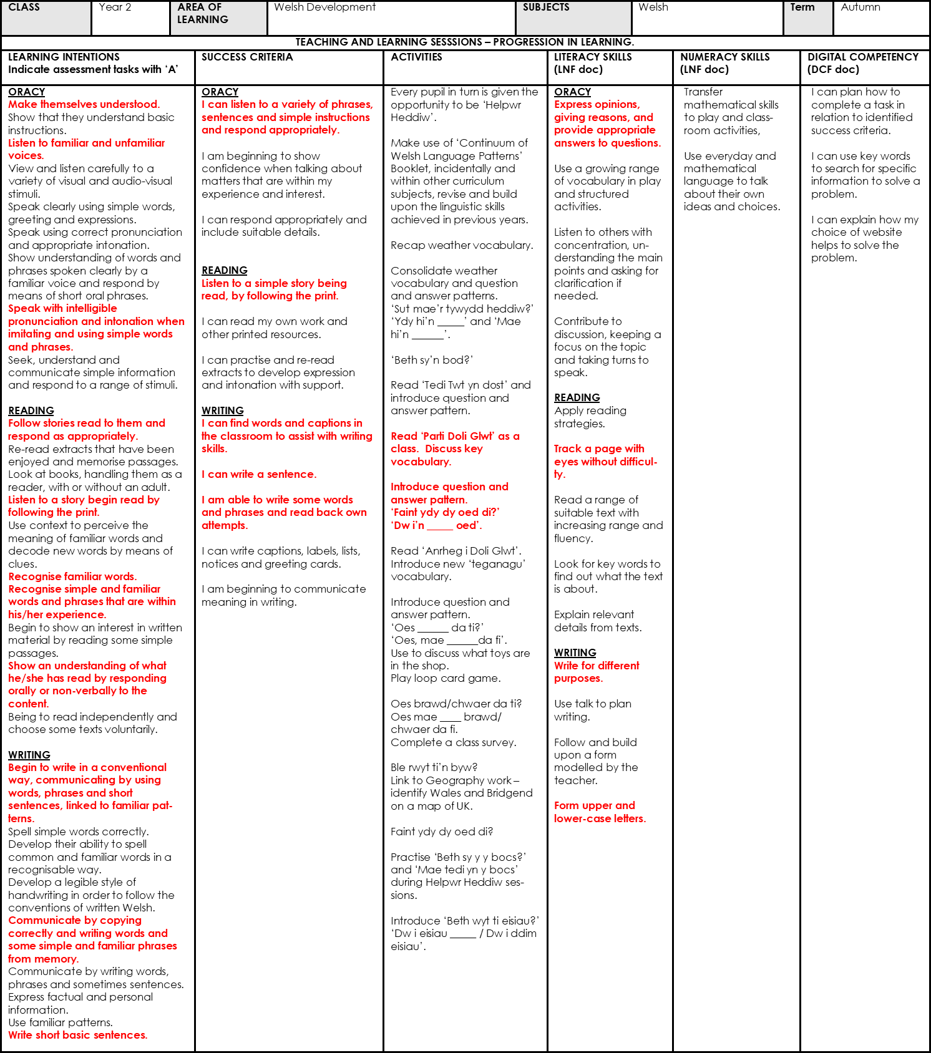
Writing in red was targeted in my three lessons.

APPENDIX 2
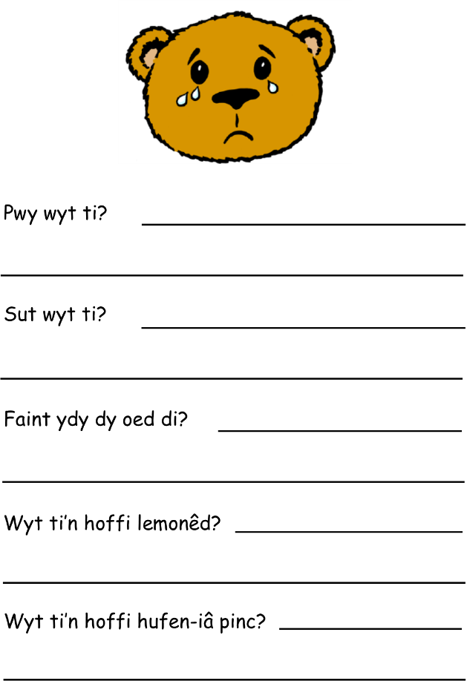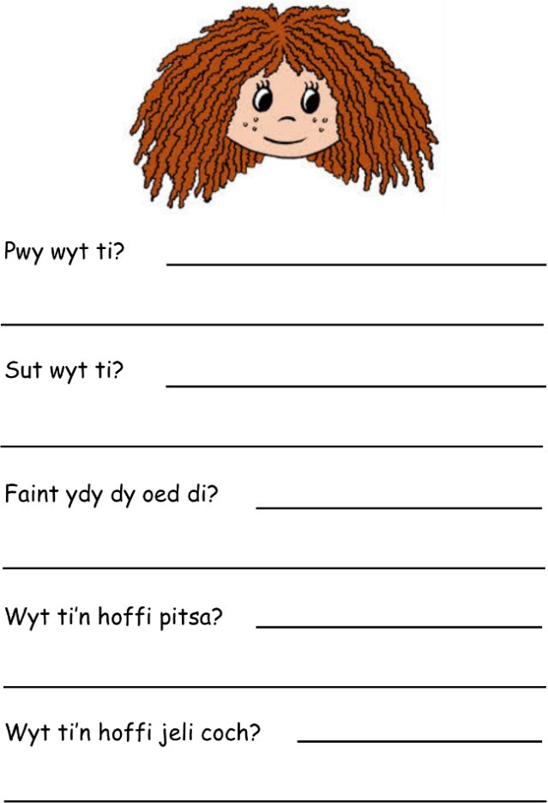

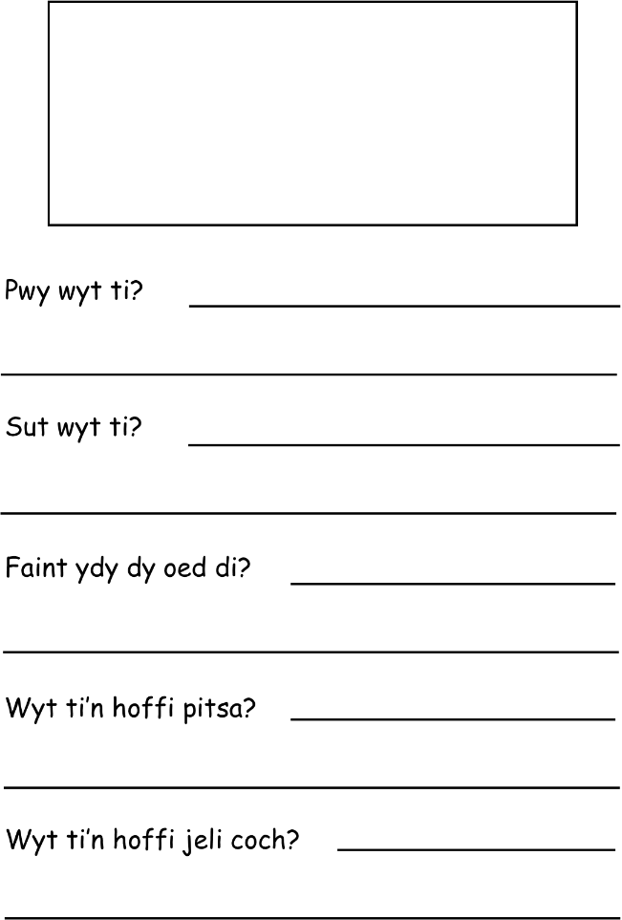

APPENDIX 3

Page 1 Beth yw penblywdd hapus? What is happy birthday?
Pa rhif? What number?
Rhifwch. Count.

Page 2 Pwy wyt ti? (pointing to Doli Glwt then asking the children and
prompting them to reply with their name) Who are you?
Pwy sy’n hapus? Who is happy?
Sut wyt ti? (To children) How are you?
Faint ydy oed Doli Glwt? How old is Doli Glwt?
Beth ydy dy oed di? (To children) How old are you?

Page 3 Canwch. Sing.

Page 4 Ble mae Ted Twt yn mynd? Where is Tedi Twt going?
Beth sy meddwl yn y parsel? What do you think is in the parcel?
Pa liw ydy parsel? What colour is the parcel?

Page 5 Pa liw ydy’r câs pensiliau? What colour is the pencil case?
Dw i’n hoffi gwyrdd. I like green.
Wyt ti’n hoffi gwyrdd? (To children) Do you like green?
Pa liw wyt ti’n hoffi? What colour do you like?
Beth sy yn y câs pensiliau? What is in the pencil case?

Page 6 Erdrycwch ar y bwyd. Look at the food.
Pa fwyd sy yn y parti? What food is in the party?

Page 7 Mmm, dw i’n hoffi jeli coch. Mmm, I like red jelly.
Beth wyt ti’n hoffi bwyta? What do you like eating?

Page 8 Pa rhif eto? What number again?
Pwy sy’n chwech oed? Who is 6?
Pa liw ydy’r teisen? What colour is the cake?
Wyt ti’n hoffi teisen? Do you like cake?

Page 9 Beth sy ar y pitsa? What is on the pizza?
Wyt ti’n hoffi caws / pinafal / madarch ar y pitsa? Do you like cheese /
pineapple / mushrooms on pizza?
Beth wyt ti’n hoffi ar y pitsa? (To children) What do you like on pizza?

Page 10 Dw i’n hoffi hufen iâ vanilla gyda saws siocled. I like vanilla ice cream
with chocolate sauce.
Pa flas ydy’r hufen iâ? What flavour is the ice cream?
Pa flas wyt ti’n hoffi? (To children) What flavour do you like?
Ble rwyt ti’n bwyta hufen iâ? Where do you eat ice cream?

Page 11 Wyt ti’n hoffi lemonêd? Do you like lemonade?
Beth wyt ti’n hoffi yfed? (To children) What do you like to drink?

Page 12 Beth sy’n digwydd? What’s happening?
Pa oed ydy Doli Glwt? How old is Doli Glwt?

APPENDIX 4

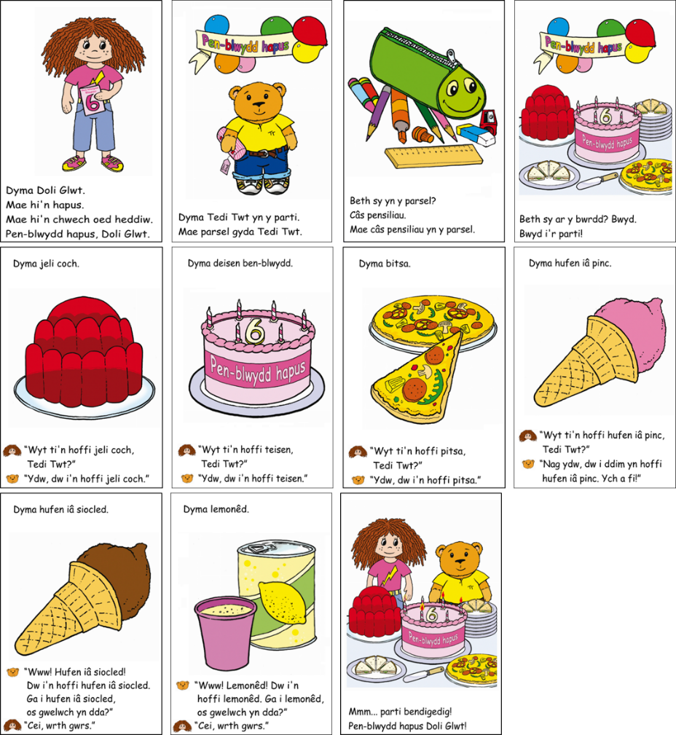

APPENDIX 5

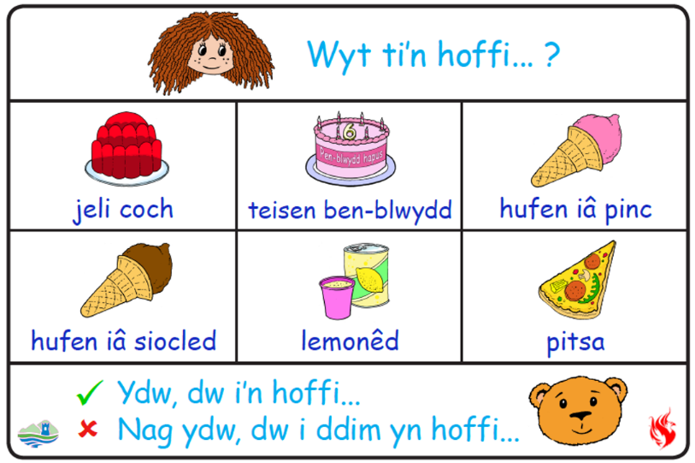

APPENDIX 6

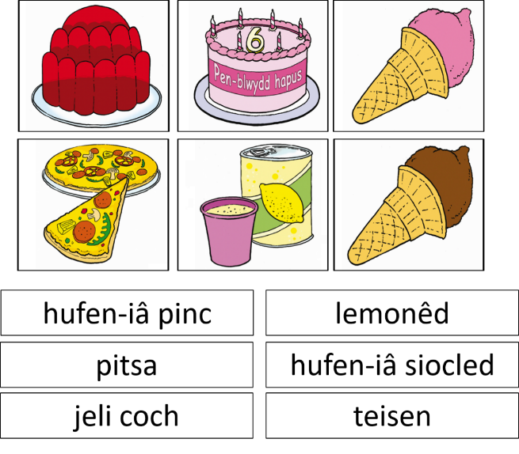
APPENDIX 7
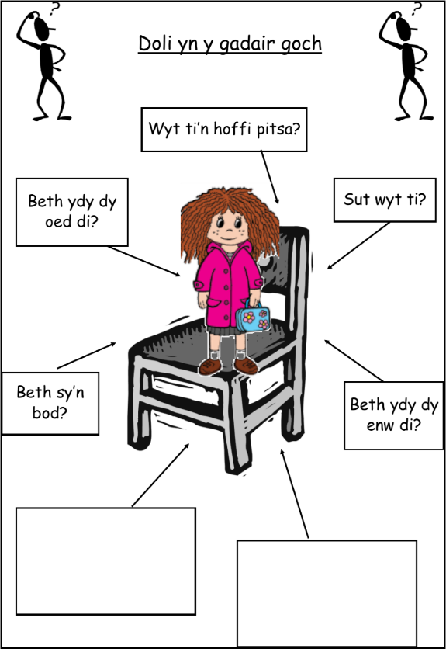

APPENDIX 8
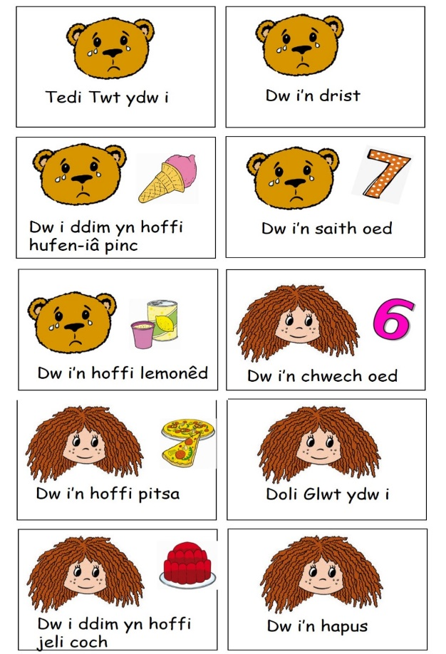
APPENDIX 9

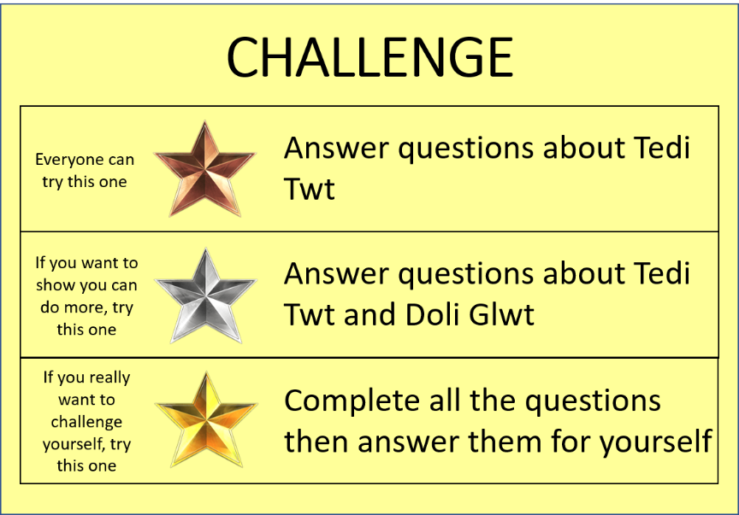

APPENDIX 10

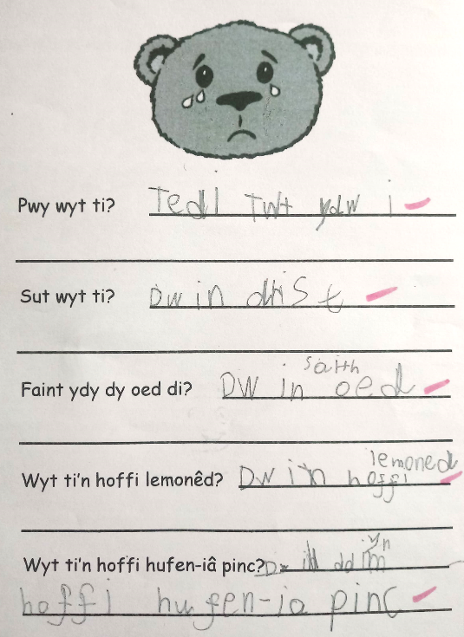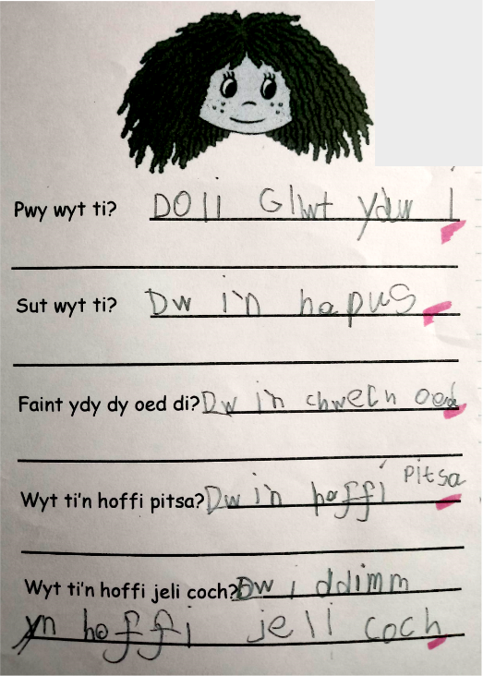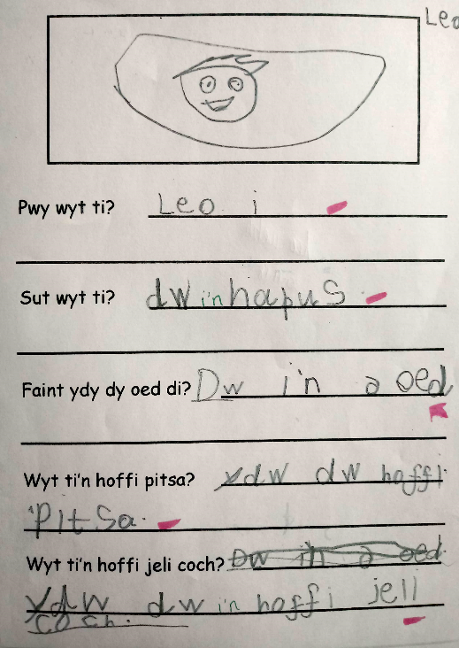

APPENDIX 11



