STRATEGIC MANAGEMENT SBMA - 7103D
MARKUS SCHLOTBOHM
STUDENT-NUMBER: 1603888
08.08.2018

ASSIGNMENT
STRATEGY EVALUATION
CITIGROUP COLOMBIA
WORD COUNT CHAPTER 01-06: 4.384



Table of Contents
EXECUTIVE SUMMARY 4
1.0 INTRODUCTION 5
2.0 EXTERNAL FRAMEWORK FOR CITIGROUP COLOMBIA 6
2.1 CITIGROUP OVERVIEW 6
2.2 CITIGROUP GOVERNANCE 6
2.3 CITIGROUP IN COLOMBIA 7
2.3.1 VALUE CHAIN CITIGROUP COLOMBIA 8
2.3.2 STAKEHOLDER ANALYSIS CITIGROUP COLOMBIA 9
2.3.3 CULTURE (CULTURAL WEB) 9
2.3.4 CORPORATE SOCIAL RESPONSIBILITY (CSR) - SITUATIONAL ANALYSIS 10
2.4 PESTEL COLOMBIA 11
2.4.1 POLITICAL 11
2.4.2 ECONOMICAL 12
2.4.3 SOCIOLOGICAL 13
2.4.4 TECHNOLOGICAL 13
2.4.5 ENVIRONMENT 14
2.4.6 LEGAL 14
2.5 SWOT ANALYSIS - CITIGROUP COLOMBIA 14
3.0 STRATEGIC LEVELS 15
3.1 CORPORATE LEVEL – STRATEGIC DRECTIONS UNDERTAKEN 15
3.2 ALTERNATIVE OPTION 17
4.0 IMPLICATIONS OF THE OPTIONS PRESENTED 18
4.1 INTERNAL 18
4.1.1 BUSINESS UNIT STRATEGY LEVEL IMPACT 18
4.1.2 FUNTIONAL LEVEL STRATEGY IMPACT 19
4.2 EXTERNAL 21
4.2.1 CLIENT PERCEPTION / BRAND IMPACT 21
4.2.2 COMPETITIVE ADVANTAGE VS OTHER BANKS 21
5.0 CONCLUSION 23
6.0 RECOMMENDATIONS 24
APPENDIX I CITIGROUP ICG BUSINESS 25
APPENDIX II CSR IMPACT CITI COLOMBIA (EXTRACT) 26
APPENDIX III CULTURE DIFFERENCES 27
APPENDIX IV KNOWLEDGE-BASED APPLICATION 28
REFERENCES: 29

TABLE OF FIGURES
Figure 1 CITIGROUP - DIVISIONS 6
Figure 2 CITIGROUP DECISION PASS TEST 6
Figure 3 CITIGROUP - BOARD - COMMITTEE 7
Figure 4 VALUE CHAIN – CITIGROUP COLOMBIA 8
Figure 5 MENDELOW STAKEHOLDER ANALYSIS 9
Figure 6 CULTURAL WEB - CITIGROUP COLOMBIA 10
Figure 7 CSR - GUIDELINES - SELECTED PROJECTS 10
Figure 8 COUNTRY PROFILE - BASIC FACTS (IMD 2017) 11
Figure 9 CORRUPTION INDEX COLOMBIA 11
Figure 10 ECONOMIC-COLOMBIA 12
Figure 11 COUNTRY PROFILE - LANDSCAPE 12
Figure 12 SOCIOLOGICAL FACTS COLOMBIA 13
Figure 13 TECHNOLOGICAL DIMENSION COLOMBIA 13
Figure 14 IT READINESS 13
Figure 15 SWOT CITIGROUP COLOMBIA 14
Figure 16 STRATEGY - AREAS OF EXECUTION 15
Figure 17 PORTER GENERIC STRATEGIES 15
Figure 18 ANSOFF MATRIX - CITIGROUP 16
Figure 19 CORPORATE STRATEGY - ALTERNATIVE 17
Figure 20 CHANGE KALEIDOSCOPE - CITIGROUP COLOMBIA 18
Figure 21 CHANGE MANAGEMENT vs CHANGE LEADERSHIP 19
Figure 22 INSTITUTIONAL BUSINESS - COMPETITIVE ADVANTAGE 21
Figure 23 BUSINESS LEVEL STRATEGY - ALTERNATIVE 22
Figure 24 ICG DIVISIONS 25
Figure 25 GCB DIVISIONS 25
Figure 26 HOFSTEDES POWER DIMENSIONS 27
Figure 27 UNCERTAINTY AVOIDANCE DIFFERENCES 27

EXECUTIVE SUMMARY

This comprehensive report is presenting Citigroups (Citi) Corporate strategy and evaluates the derived business unit level- and function unit level strategy in Citi’s local market Colombia. Methods of analysis used are a Foreign Market Research consisting of a Country Profile, PESTEL Analysis as well as Hofstede’s Culture Ratios applied and as well, specific for Citi Colombia, a Corporate Governance Application, a Value Chain Analysis, a Stakeholder Analysis, a Cultural Web analysis and a Corporate Social Responsibility presentation. Furthermore, the corporate strategy, including its alternative, were assessed with Porters framework of generic strategies and visualized with the Ansoff matrix. The applied business unit level strategy as well as the functional unit level strategy were further evaluated in terms of change management and change leadership, using diagnostic frameworks like the change Kaleidoscope.
Results of data analysed show that although the Corporate Strategy was well developed in terms of future prosperity for Citi global, local market conditions were ignored. Countries like Colombia, a still developing country, have very different market conditions than the Banks US Headquarter, not only in terms of macroeconomics but as well in cultural aspects. The analysis showed also that internal staff at Citi Colombia was not ready for the change required by the derived business- and functioning level strategy.
If not having a careful developed derived business unit level as well as functioning level strategy, addressing those differences, a corporate strategy can fail and in certain cases, as in Colombia, even lead to leaving partially the country. As shown, if the corporate strategy were applied differently, Citi could have been probably still having its consumer business in Colombia.
In order to execute the corporate strategy globally, it is recommended to first assess the specific market conditions, including also cultural values and empower- and involve various internal departments like Marketing - to realize the market demand impact and to determine a market strategy related to the new customer perception the bank wants to perceive with the new strategy as well as undertake internal marketing - and Human Resources - to develop first a status quo of the internal employee situation in terms of capability but also in terms of internal engagement and then develop a consequently strategy to mitigate any realized gap towards implementation of the derived business- and functioning level strategy. Furthermore, a change leadership- and proper change management team needs to be implemented, driving the execution of the strategy.
Limitations of the report include the missing financial forecast implication to assess the P&L impact on the strategy implementation for the next five years. Also, various internal reasons why the business unit strategy was not re-assessed during the implementation process was not available mainly due to the outlined silo thinking within Citi Colombia.

1.0 INTRODUCTION

In an ever-faster-globalized developing environment (WHO, 2016), banks need to address changing and evolving customer needs. (GLOBAL, 2018). One global bank affected is Citigroup Inc., that developed a mitigating corporate strategy, focusing strong on digitalization. In order to roll out the corporate strategy globally, the derived local business unit level as well as functional unit level strategies need to be developed and executed in every local market Citigroup operates in as for example in Colombia, where the bank is present since more than 100 years. Therefore, first it is necessary to give an overview on Citigroup Colombia’s internal and external environment, leading to a SWOT view. Furthermore, an assessment of the definition and execution of the business- and functional level strategy needs to be done, to determine the success of Citigroup Corporate Strategy in Colombia and if necessary, outline and assess alternative strategy options.

2.0 EXTERNAL FRAMEWORK FOR CITIGROUP COLOMBIA

2.1 CITIGROUP OVERVIEW
Citigroup Inc. is a US global investment bank and financial services company having its headquarter in New York City. Citigroup is the 4th largest bank in the United States. (COMPANY, 2018)
Citigroup is also member of the Fortune 500. Citigroup has over 200 million customer accounts and does business in more than 160 countries. It has 209,000 employees. Citigroup itself is a holding company and consist of the following divisions:
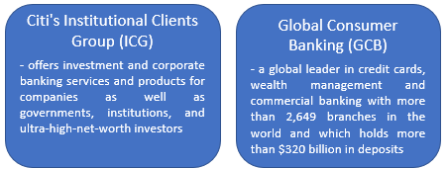
Figure 1 CITIGROUP - DIVISIONS
Further detailed information about ICG and GCB can be found at APPENDIX I.

2.2 CITIGROUP GOVERNANCE
If having a governance structure in place, formal, supervisory controls can be introduced in order to hold stakeholders accountable for their activities (Johnson et al, 2017)
Johnson et al. (2017, pp. 133-158) outlines the corporate governance framework and identifies stakeholders. It includes Core Values, Mission Statement, Vision Statement and Objectives. Applied to Citigroup, that framework looks as follow.
Citi's Corporate Value Proposition: A Mission of Enabling Growth and Progress. Citi's mission is to serve as a trusted partner to its clients by responsibly providing financial services that enable growth and economic progress (MISSION, 2018).
Citi works hard to gain and consequently maintain the public's trust by constantly executing to the highest ethical standards. In that context, Citi is requesting from all its employees that their decisions pass the following tests:
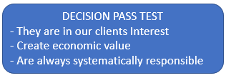
Figure 2 CITIGROUP DECISION PASS TEST
Citigroup, is a typical shareholder model applied organization (FRIEDMAN, 1962). It has a board structure that consists mainly of non-executive directors. The focus on directors from outside is with the purpose to provide stronger independence to the main role of the board (act on behalf of shareholders). It should be mentioned that this approach has its difficulties. Normally, the chief executive officer has strong influence in choosing non-executives, that arrives to the concern about their independence. Citi has chosen the board of directors from three main areas: Business Education, Former Bank Employees from

Citi and from other banks as well as -other finance related bodies. Furthermore, Citi has established a Board Committee, that consist of various areas:
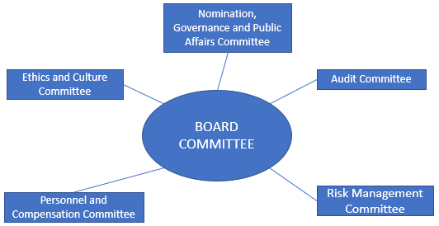
Figure 3 CITIGROUP - BOARD - COMMITTEE
Citi aspires to the highest standards of corporate governance and ethical conduct: doing what is said; reporting results with accuracy and transparency; and maintaining full compliance with the laws, rules and regulations that govern Citi’s businesses(COMPANY, 2018).
The advantage for shareholders are: "Relative to the stakeholder model the investor gets a higher rate of return", "There is a higher likelihood of the encouragement of economic growth and of entrepreneurship" (Johnson et al, 2017).
This model in theory contains also its flaws as e.g. "Corporate reputation and top management greed" and "managers prefer to pursue their own agenda rather than working towards shareholder value agenda” - which Citi is addressing by its board committee in terms of e.g. Compensation, Ethics and Audit. Citi had implemented after the financial crisis also stronger internal controls like implementation of Sarbanes Oxley processes to address events like happened at Enron (AUDIT 2018).

2.3 CITIGROUP IN COLOMBIA

Established in 1916, becoming the oldest international bank in the country, Citi Colombia is the preferred bank for multinational and most top domestic companies in Colombia. With its financial strength and unique transactional platforms, Citi is the bank of choice for foreign trade, FX trading, cash management and offshore investment products. Citi Colombia offers key services that include Personal Banker, differentiated processes and preferential service across all channels. (CITI-COL 2018)
In Colombia, the bank has 3,472 employees; It operates in 13 cities in the country and has close to 560,000 customers. (CITI-COL 2018)

2.3.1 VALUE CHAIN CITIGROUP COLOMBIA

Michael Porter’s Value chain concept (PORTER, 1985) is one of the most valued concept in today’s market because the Value chain explains how a company can differentiate its products by analyzing the chain of events which occur within the company. The Value chain of Citigroup Colombia looks as follow:
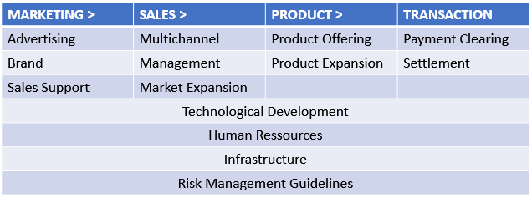
Figure 4 VALUE CHAIN – CITIGROUP COLOMBIA
Marketing plays an important factor for Citigroup(FORBES, 2014). Competition has grown intense in the developing country Colombia and there are arriving an increasing number of foreign banks in the market as Scotiabank and BBVA. Therefore, marketing is having a more important role for Citigroup to mitigate the competitive pressures. Segmentation is vital for banking because the consumer/institutional segments cannot be targeted the same way. Citi Colombia targets their different segments with according marketing-plans. Another matter is the Brand perception for Citi Colombia especially because the banks business is strongly influenced by the service quality. As outlined in chapter 2.3.2 Stakeholder analysis, it becomes visible that the Marketing function within Citigroup Colombia needs improvement in terms of having more influence on the decision making.
The importance of technology in the banking industry has risen significantly. Technology has become a source of competitive advantage for many banks because it supports to provide higher service quality than other banks and also enhanced bank’s productivity. However, Colombian Culture is shown still resistance in accepting new technology opportunities. (CULTURE, 2016)
Although the rising importance of technology, the HR function still is vital in the value chain of Citi Colombia also because the existing war for talents(BANKS, 2016). Due to the increased technology role, the underlying Infrastructure has an important part throughout the banking industry. Banking is also about risk taking. It is absolutely necessary for Citigroup to adequately manage its risks. Not poorly managed but also not unreasonably managed risks are in the interest of sustain prosperity of Citi (regulatory-/reputation reasons). For that reason, Risk management methods are intensively executed and constantly internally reviewed and if necessary adjusted.

2.3.2 STAKEHOLDER ANALYSIS CITIGROUP COLOMBIA

As stated by Johnson and Whittington (2017), “stakeholders refer to individuals or groups who depend on an organization to fulfill their own goals and on whom, in turn, the organization depends”.
Stakeholder analysis has many advantages for organizations. For instance, organizations are able to determine important- and less important stakeholders. Additionally, using stakeholder analysis, organizations are able to determine “negative” stakeholders with their possible harmful effect on an intended change strategy.
Applying Mendelow stakeholder mapping(KAPLAN, 2012) to Citigroup Colombia looks as follow
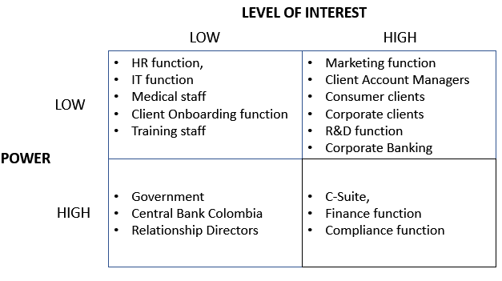
Figure 5 MENDELOW STAKEHOLDER ANALYSIS

2.3.3 CULTURE (CULTURAL WEB)

The Cultural Web contains of six interconnected dimensions that support what Johnson et al. (2017) is naming the pattern / model of the work environment. Evaluating each factor itself gives the opportunity to determine the overall view of the company’s internal culture and consequently answers the question what needs to be different towards achieving according strategies defined. All elements applied to Citigroup Colombia are outlines in the following view.

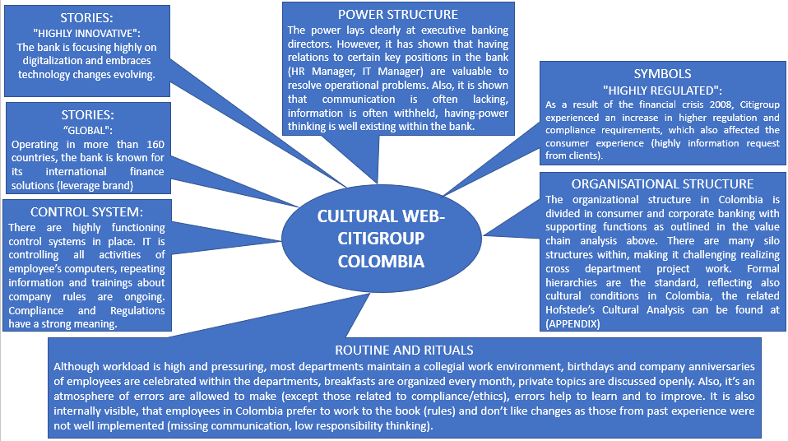
Figure 6 CULTURAL WEB - CITIGROUP COLOMBIA

2.3.4 CORPORATE SOCIAL RESPONSIBILITY (CSR) - SITUATIONAL ANALYSIS

Philip Kotler defined 2005 CSR as “a commitment to improve community well-being through discretionary business practices and contributions of corporate resources”(MARKETING 3.0, 2010).
Rachel Hutchisson went one step further than Kotler(Hutchisson, 2016). She stated a decade later regarding CSR that “Good is for Everyone.”, meaning it is for all type of small and large organizations, public and private, nonprofit and all other kind of social concern. In her view, it’s time to shift to HUMAN Social Responsibility. It means that all organizations, as conveners of people, will take their lead from their employees and their individual human social contracts.
At Citigroup Colombia, CSR is applied with the Hutchisson’s approach, although there are corporate guidelines as to what CSR means to the bank (CITIZENSHIP 2018), the selected related projects in Colombia are suggestions from its employees.
Guidelines and applied Projects were (extract):
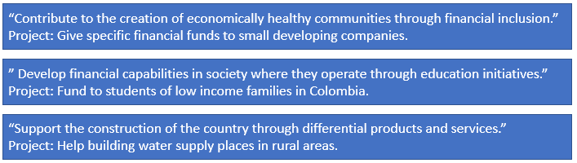
Figure 7 CSR - GUIDELINES - SELECTED PROJECTS
The beneficial effects for Citi Colombia can be found in Appendix II “CSR Impact Citi Colombia”.

2.4 PESTEL COLOMBIA

Colombia had a population of 49.29 million in the year 2017. In 2017, Colombia’s unemployment rate was 9.4%, inflation rate was below 5%, GDP amounted to 14.485 US$, ranking it globally on 54th place(IMD, 2017). Furthermore, Colombia is an OECD member since May 2018.
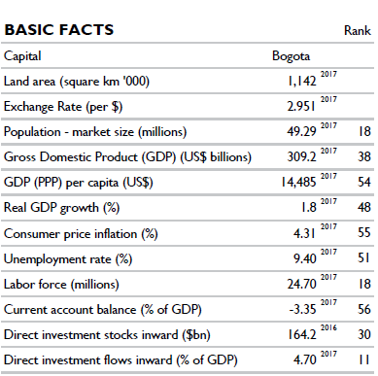
Figure 8 COUNTRY PROFILE - BASIC FACTS (IMD 2017)

2.4.1 POLITICAL

The Republic of Colombia is a unitary constitutional republic, consisting of 32 departments. Related to political stability and the absence of violence, Colombia had a low rank of 167 in 2016 (WORLDBANK 2017). The current coalition of Juan Manuel Santos contains six political parties. The most significant achievement of his time as president were the successful peace talks with the FARC guerillas, which ended the 52 years of civil war and which will support the country in a prosper development. As recent a new far right president was elected, who stated to re-evaluate the achieved peace agreement and therefore threatening the post-war process, a possible instability could be the consequence. Related to the latest Corruption Index(CORRUPTION, 2017), Colombia ranked 96th out of 180 Countries and has since many years a similar score, outlining its problems in corruption and shows a challenging framework when operating with public and private organizations.

Figure 9 CORRUPTION INDEX COLOMBIA

2.4.2 ECONOMICAL

Analysing the Economic aspect, it is showing Colombia is still a developing economy despite being the fourth biggest economy in Latin America. Colombia has been growing fast, mainly due to an increase in exports of commodities. Colombia is a major exporter of oil, coal and coffee. GDP is at present below 0.5%, but compared to the EU, still 0.1% higher (TRADING, 2018). Its main challenges lay in Business Efficiency and Infrastructure-Improvements(IMD, 2017).
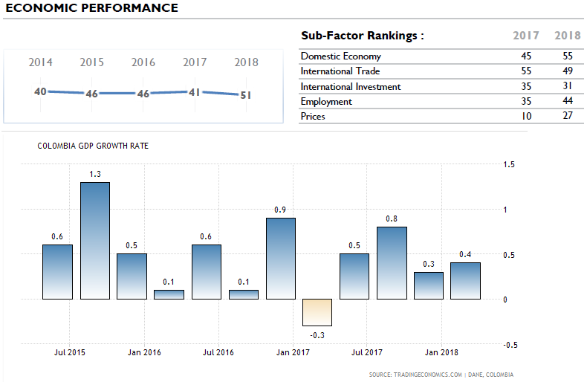
Figure 10 ECONOMIC-COLOMBIA
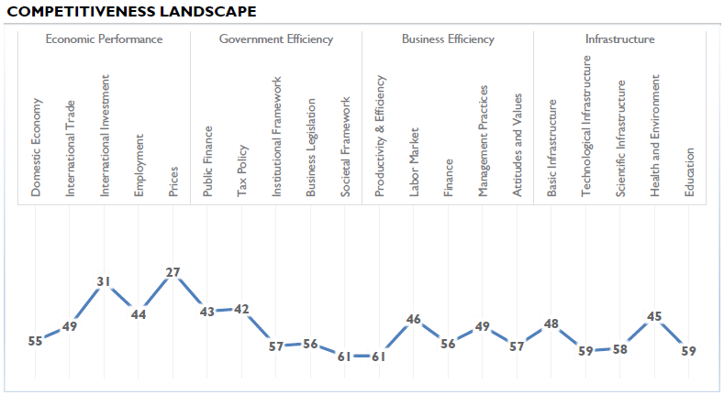
Figure 11 COUNTRY PROFILE - LANDSCAPE

2.4.3 SOCIOLOGICAL
According to the latest WHO report (WHO, 2018), Colombia is rated the highest among the Latin American nations – 22nd in the world. Further sociological facts can be found at the following view:
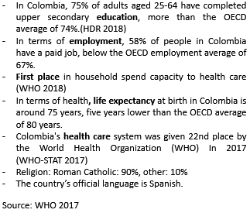
Figure 12 SOCIOLOGICAL FACTS COLOMBIA

2.4.4 TECHNOLOGICAL

Although, Colombia represents the third largest IT market in South America, according to the latest IMD statistics(IMD-TEC, 2018), Colombia is still in the developing country stage, missing modern standard IT infrastructure in consumer and organizational environment. In a ranking of 70 participating countries, Colombia ranked in the lower section of almost all technological rankings. Also, focusing on future readiness in terms of technology, it shows that Colombia still needs improvements to be implemented.

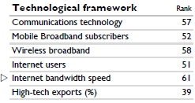
Figure 13 TECHNOLOGICAL DIMENSION COLOMBIA
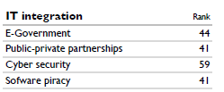
Figure 14 IT READINESS

2.4.5 ENVIRONMENT
The key environmental problems in Colombia are inadequate water supply, sanitation and hygiene. Air pollution and natural disasters are also key challenges the country is facing(COUNTRY, 2007).
The Weather in Colombia is tropical and isothermal because of its closeness to the Equator, resulting in five different natural regions and depending on altitude, temperature, humidity, winds and rainfall (WIKI 2018).

2.4.6 LEGAL
The legal system of Colombia is a civil law system influenced strongly by the Spanish and French civil codes(IM 2018). As confirmed by the OECD (OECD, 2018), Colombia has introduced major reforms to align its legislation, policies and practices to OECD standards, including on labour issues, the reform of its justice system, corporate governance of state-owned enterprises, anti-bribery, trade as well as new national policies on industrial chemicals policy and waste management. Those actions as well as post-FARC reconciliation, can be a way to support Colombia significant to become a developed country.

2.5 SWOT ANALYSIS - CITIGROUP COLOMBIA

Based on the analyzed overview of Citigroup Colombia internal and external factors, the following SWOT analysis has been developed:
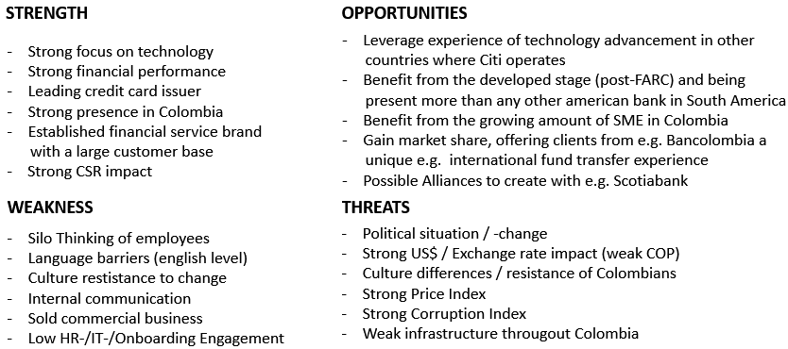
Figure 15 SWOT CITIGROUP COLOMBIA

3.0 STRATEGIC LEVELS

3.1 CORPORATE LEVEL – STRATEGIC DRECTIONS UNDERTAKEN
In terms of Citigroup’s strategic planning, the corporate board engage with management in the strategic management process. Annual Strategic Reviews are taken place. It is defined that the Board is supposed to review Citi’s long-term strategic plans once every year.
In the literature there is the concern mentioned, that this has "many practical problems concerning the time and knowledge level of (particularly) non-executive directors to perform their role this way" (CONCERN, 2017). That is why Citi has in its Board people with Financial Expertise implemented to address that concern.
Citigroup's corporate goal is to transform from a global bank to a leading global bank. The strategy to get there is based on execution in the following three areas:

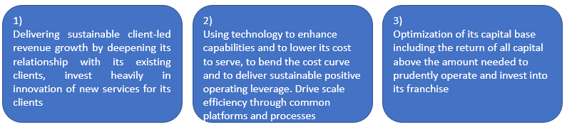
Figure 16 STRATEGY - AREAS OF EXECUTION
These steps can be seen as a combination of growth, expense discipline and credit discipline while leveraging technology, which is supposed to generate annual earnings of 20 Bn$ by 2020 (FINANCE 2018). Michael Porter developed a framework of generic strategies (PORTER, 1980), which is based on the following 4 aspects shown below:
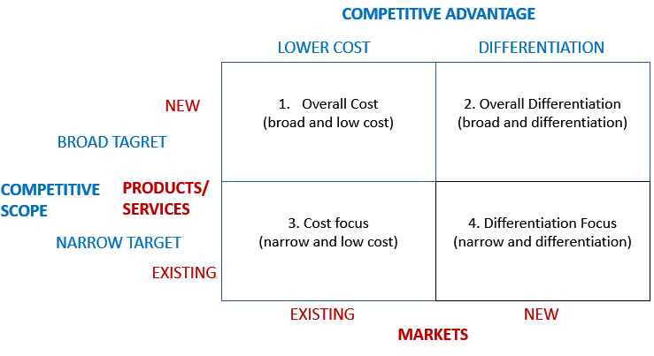
Figure 17 PORTER GENERIC STRATEGIES
Looking at Porters framework, it can be said that Citi after the financial crisis 2008/2009 applied heavily into point 1, focusing on its cost structure, working on its financial turnaround. Since roughly 2014, Citi works towards point 2 overall differentiation, seen in its heavily technology investment which supported the bank become on institutional side the largest mover of funds across 160 countries worldwide (CITI-REPORT 2017). Also, looking at the consumer banking division, Citigroup has become the world largest issuer on Credit Cards. It’s noticeable that Citi although able to rest on its success, already is future oriented by working on the post credit card area by developing the future way to pay by "digital payment".
However, the bank still has a strong focus on Cost, placing a spot in point 3 of Porters framework (cost focus). Not only part two of Citi’s corporate strategy outlined above is evidence but also the transition that the bank went through since 2008/2009, e.g. reducing Headcount from 260T to 220T (that number is actually higher but there were nearly 20T new hires in technology, risk management, compliance), reducing the number of institutional clients by 50%.
Related to Corporate Strategy, it can be said, Citigroup globally is fit for the future and is positioned well as it has embraced technology development rather than to stick to old habits as other banks have
(BANCA-DIGITAL 2017). Also, because its unique footprint is difficult to replicate in today economic- and regulatory environment, Citi followed its clients where they wanted to conduct business including to emerging markets like Colombia. In 2005, 9% of companies from emerging markets where in Fortune500, in 2016 this number rose to 40% from which 3/4 are with Citi(CITI-REPORT 2017).
As Porter stated that a company cannot choose both, Cost Leadership and Differentiation (PORTER 1980), it needs to be analysed if Citigroup is falling into that pattern, wanting both and therefore risking to fail as it happened with other companies, wanting to apply both(AIRBERLIN 2017). Citi is not in danger of falling in the middle. The focus on cost as consequence of the financial crisis 2008/09 was necessary to rebuild the bank and to optimize internal processes. The focus internally still is strong on cost optimization but their focus since a few years is dominantly in differentiation, most seeing in their heavily technology investments to embrace technology environmental changes. The following picture shows the strategical development that Citigroup aimed for.
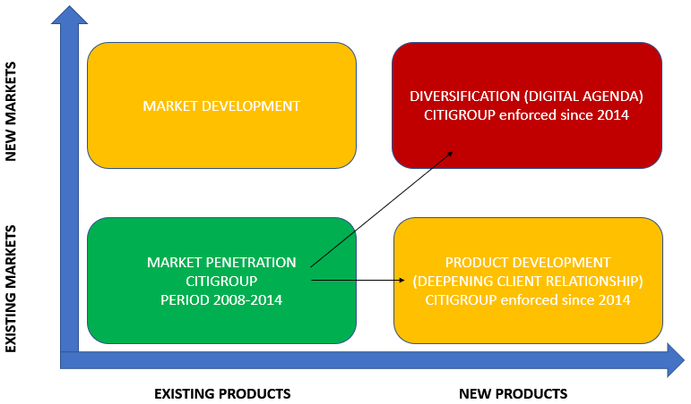
Figure 18 ANSOFF MATRIX - CITIGROUP
Critique to the existing corporate strategy of Citigroup can be seen in its underestimating efforts of the underlaying local business unit- and local functional unit level strategy formulation and execution, which will be further discussed at chapter 4.

3.2 ALTERNATIVE OPTION

Instead of focusing on diversification and product development, Citigroup could also have looked into Market Development. Not focusing on market development within the country, especially as the peace process (Post-FARC) has been forecasted to lead to increased better economic conditions(FARC, 2017) and therefore a higher demand of banking services consequently, could show an error in the chosen corporate strategy, also under the aspect that the required infrastructure for the diversification focus (digital agenda) in Colombia as developing country still is not advanced. Citigroup should not have forced all markets to execute the very same corporate strategy but adjust to local conditions(Chapter 2.3/2.4). The alternative offered Ansoff matrix for Colombia would look as follow:
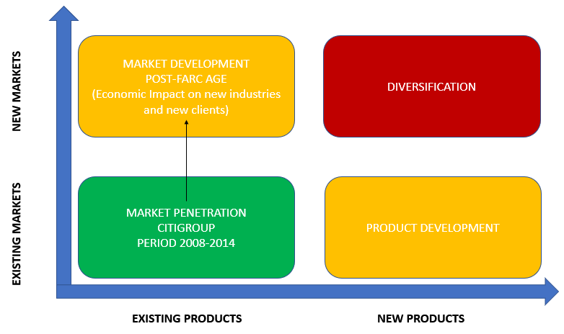
Figure 19 CORPORATE STRATEGY - ALTERNATIVE

4.0 IMPLICATIONS OF THE OPTIONS PRESENTED

4.1 INTERNAL

4.1.1 BUSINESS UNIT STRATEGY LEVEL IMPACT
The business unit level strategy answers the question how to compete in particular markets, in this evaluation it refers to the Colombian market for Citigroup.
As the outlined Corporate Strategy was the base for the local business unit level strategy for Colombia, the formulation and therefore required change impact can be analysed as follow.
The business unit strategy for the consumer business as well as for the institutional business in Colombia was focusing on transforming the customer experience, working towards the corporate strategy related heavily to the digital agenda.
That was also driven based on the internal argument that with client engagement rapidly shifting to digital channels, mobile continues to be at the core of a simpler, better customer experience in Colombia.
A diagnostic framework to assess this change at Citigroup Colombia, is the Change Kaleidoscope (Hailey & Balogun,2002). It can be particularly useful in a context sensitive change process. The following picture outlines the results of the change kaleidoscope application to Citi’s Digital Agenda in Colombia.

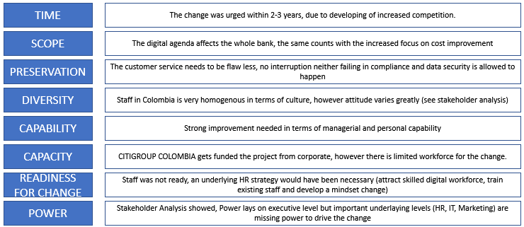
Figure 20 CHANGE KALEIDOSCOPE - CITIGROUP COLOMBIA
Based on those results, the reasons why the digital agenda in Colombia failed becoming visible and its consequently one of the reasons why Citi recently decided to sell the consumer business in Colombia. It would have been necessary to implement a proper change management as well as a functioning change leadership.

According to Kottler(KOTTER, 2015), Change management and Change leadership are two different aspects and can be seen at the following picture.
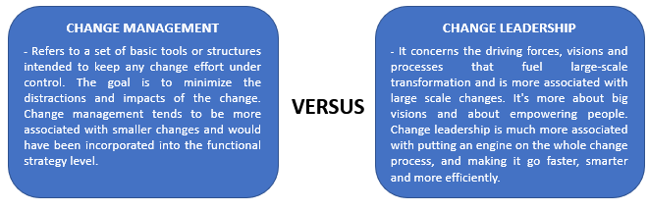
Figure 21 CHANGE MANAGEMENT vs CHANGE LEADERSHIP
Therefore, Citi Colombia, needed to have the right leadership in place, driving the business unit strategy towards the digital agenda. That would also have required a proper aligned Human Resource strategy, supporting the changes necessary to successfully implement the digital agenda strategy. (FORBES, 2018)
The main reason why Citigroup still is in Colombia, despite the digital agenda failing in this country, is because of the institutional business still being strong based on Citi’s international banking services.

4.1.2 FUNTIONAL LEVEL STRATEGY IMPACT
Functional level strategy are operational methods to implement the tactics (Johnson et al, 2017)
Related to Citi’s Corporate- and Business Strategy, the functional level strategies were formulated from top down approach. That means executive directors at Citi Colombia decided for both business units, consumer- and institutional business, that towards the corporate (and derived business) digital agenda strategy, cross departmental projects were defined (also an intent to overcome the silo thinking). However, support from HR- and IT function was not existing as internal competence conflicts were the norm. Also, Citi Colombia has one of the highest turnovers in Citi Latin America (Internal Source), resulting in not having the amount of staff necessary to realize the change. That goes along with the consequence of the other corporate strategy - to lower its cost.
Another impact was Culture and missing communication towards the functional level strategy.
As outlined in Appendix-III “Hofstede’s Power Ratios”, the Colombian Culture is laying against changes and prefers constant stability. Therefore, when the digital agenda was presented, resistance towards the internal change projects were evolving, making it difficult to execute the strategy. As HR was not supporting the change either as expressed before, how should have Citi Colombia reacted best?
Radically steps as laying off the resisting employee no matter what ranking and talent, as outlined by Kottler (KOTTLER, 2011), can be logical. However, this kind of behaviour in today’s talent-led knowledge economy (EWMD, 2017) suggest that it’s not recommended. If Citigroup Colombia applied Kottler advice directly, the impact on short term would be to get going - implementing the change - to any cost (layoff) if finding adequate substitute staff. The negative effect long term would be rising fears of employees stating any (very often justified) concern towards the change, labour climate could also suffer.
It would be questionable, if a wanted (and rare) talent would like to work in a company with such operation (MCKINSEY, 2017).
Also, in the aspect of proactive employee engagement it’s important to listen to the employee (FORBES, 2017).
In addition, any employee has talent (HRMAGAZIN, 2018), including the resisting employee and no bank can allow its ignorance. Therefore, long term not having the best talents as a consequence, could lead to decrease in competitive advantage. There should be more the question, if there is such constant resistance, were there perhaps deeper internal issues underlying (as Stakeholder Analysis suggests) which need to be addressed.
If a company thinks that it is honest, and its employees trust it and feel loyal to it, employees are much more likely to get on board with the changes quickly rather than to resist (ARMSTRONG, 2009). Therefore, the functional level strategy for Citi was failing as high resistance and low leadership qualities were ignored.
Both, business unit level- and functional unit level strategy impacts for the alternative option, presented at chapter 3.2., would have not affecting Citi Colombia’s consumer business negative as it would not have required such strong change process but rather an evolving development. However, it should be mentioned, that the underlying outlined internal problems still would exist and therefore might hinder Citi from prosper long term.
A possible approach towards a successful business-/functional level strategy implementation, related to the Digital Agenda in Colombia, will be presented at chapter 4.2.2.

4.2 EXTERNAL

4.2.1 CLIENT PERCEPTION / BRAND IMPACT

After the financial crisis, banks and within Citigroup were experiencing a client’s perceptions containing distrust(ECONOMIST, 2017).
In response, Citi build a “one-brand business” across all its divisions. It is embracing utility and digital ease-of-use into its brand identity. Citi aspires to be the Amazon of financial services (ADWEEK, 2014). In that context it developed the corporate strategy known at Citi as digital agenda.
Although the digital agenda strategy failed on business- and functional strategy level in Colombia, perception of clients within Colombia are mixed. Whereas consumer clients have lately a perception of Citi as being not competitive as it leaves Colombia - which could have been prevented if selected the alternative strategy option presented - the institutional clients have still a positive perception as service quality did not change and also because of its strong CSR agenda(Appendix II). Another reason needs to be seen in the alternative banks. The closest rivals in Colombia: Bancolombia, BBVA, Banco Popular do not have the international capabilities as Citi can offer its institutional clients, which leads to the next chapter.

4.2.2 COMPETITIVE ADVANTAGE VS OTHER BANKS

As the consumer business was sold in Colombia due to one reason being failing in the digital agenda, the bank still has a strong competitive advantage in its institutional business in Colombia, seen in the following view:
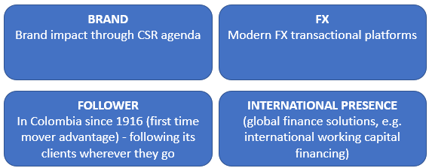
Figure 22 INSTITUTIONAL BUSINESS - COMPETITIVE ADVANTAGE

If executed successfully, the digital agenda strategy could have led to a strong competitive advantage for the consumer banking side in Colombia as most banks have not yet such strategy rolled out. Instead of selling its consumer business in Colombia, mainly due to the explained failing in the digital agenda, Citi should have stayed and worked towards a second try, which could look as follow and eliminate the flaws of the first approach as outlined before:
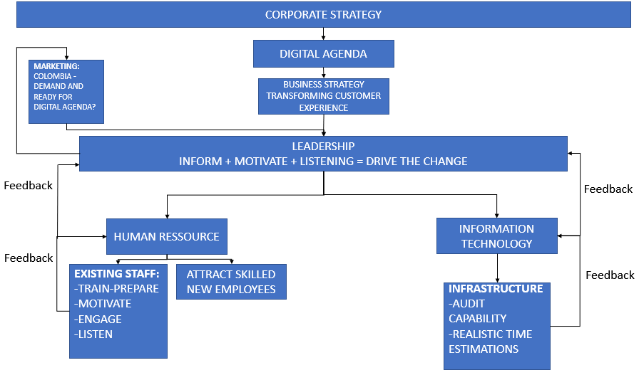
Figure 23 BUSINESS LEVEL STRATEGY - ALTERNATIVE
Also, choosing this alternative above, it would not have suffered too much as the infrastructure in Colombia is the same for all banks, making it difficult for all competitors to succeed in short- to medium term and therefore the first-time mover advantage could still have been developed.
The other strategy items relating to deepening relationships to its clients, works also towards enforcing Citi’s competitive advantage vs other banks in support of using its mass on collected information within the bank to leverage that knowledge to realize its strategy.

5.0 CONCLUSION
This document was created to analyse the Corporate Strategy of Citigroup (mainly its Digital Agenda as being main part of it) and its derived Business- and Functional Strategy in Colombia. For this task, it was first introduced the internal and external environment of Citigroup Colombia, which included Citigroups Governance Model, the Value-Chain of the Bank, its Stakeholders as well as its internal Culture and the applied Corporate Social Responsibility with its effect on Citigroup Colombia. Furthermore, a PESTEL examination was undertaken to present the external market conditions in Colombia. The result of the evaluation was source for the concluding SWOT analyses for the first part of the analysis. It showed that Citigroup Colombia, although strong in client’s perception and in its products, had internal strong difficulties (resisting Culture, Silo thinking, low engagement). The analysis showed too, that Colombia as developing country is on the way to prosperity due to the positive development through the peace process with FARC.
In further chapters the corporate strategy of Citigroup was outlined and due to its finding an alternative strategy for Colombia was presented. The derived business strategy as well as the functional strategy for Colombia was subsequently analysed in terms of its execution and impact on clients, brand and its competitive advantage versus other banks.
It showed, that Citigroup Colombia failed in execution of its business- and functional strategy. A consequently leaving of Citigroups Consumer Business in Colombia could have been prevented by applying either a different strategy as presented (towards Market-Development) or by preparing and executing the derived Business- and Functional level strategy in Colombia with a proper change management and -change leadership to overcome the presented difficulties. A first approach to it was introduced as Business-Level-Strategy-Alternative.
As this document was showing, Citigroup with its Digital Agenda in its corporate strategy is going the necessary step globally to address the changing developments in technology and meeting its derived increasing customer needs to protect its competitive advantage. However, the bank should address in its global strategy execution the different local market conditions as well as different cultures and consequently different needs, e.g. it is not recommended to introduce new digital products in a developing Country like Colombia if the local IT-Infrastructure is not ready for it neither if for culture reasons clients still prefer the personal touch in a local branch like in Colombia rather than communicate with a assistant via internet chat or an application.

6.0 RECOMMENDATIONS

Despite the failing in the Digital Agenda, it can be recommended Citigroup Colombia undertakes the following steps:
- Apply the Knowledge-based view (APPENDIX IV).
- Use Co-Creation (FORBES, 2016 + MARKETING-JOURNAL, 2015) with its clients. Globally, Citigroup is already focusing strategically at the consumer banking industry on the post-credit card age, developing e.g. the global "digital payment" standards using, among others, laboratories in Asia to co-create with clients to develop the new standard. In that process, Citi should involve also cultural experts to align to local differences within the 160 countries it operates and want to implement the digital strategy.
- Exercise transnational communication in South America to learn from other countries in the region how they execute the corporate strategy and create a best practice forum to prevent the next failing in Colombia.
- Introduce an experienced change leadership team that drives the business- and functional strategy level.
- Work together with Human Resources to:
  - mitigate the change resistance within Citi Colombia, apply concepts introduced by Sisodia book Firms of Endearment (ENDEARMENT, 2014).
  - attract the necessary talents, focus on millennials due to their positive attitude towards digitalization and their positive mind towards change (MILLENNIALS, 2017) – both necessary for the successful execution of the business- and functional strategy towards the digital agenda.
- Introduce feedback loops between top management and employees as a way to listening to employee’s internal feedback.
- Work together with Marketing to create external demands towards the digital agenda and to market the strategy internally to Citigroups Colombia’s employees.

APPENDIX I CITIGROUP ICG BUSINESS

Citi’s core activities are safeguarding assets, lending money, making payments and accessing the capital markets on behalf of its clients. The bank has 200 years of experience helping its clients meet the world's toughest challenges and embrace its greatest opportunities. Citi is the global bank – an institution connecting millions of people across hundreds of countries and cities. It protects people's savings and help them make the purchases that improve the quality of lives. (COMPANY 2018)
ICG consists of the following main divisions:
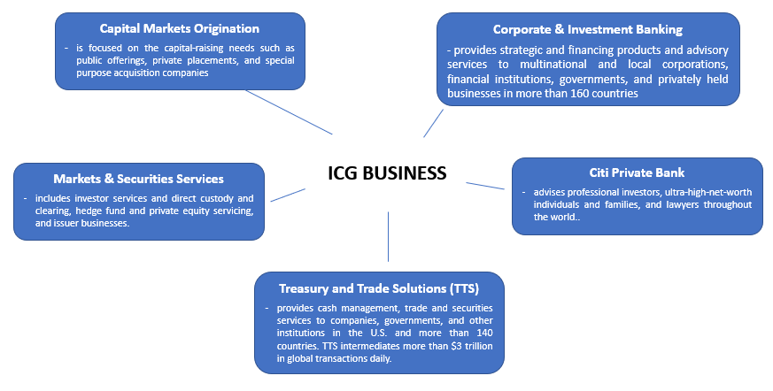
Figure 24 ICG DIVISIONS
GCB consisting of the following divisions:
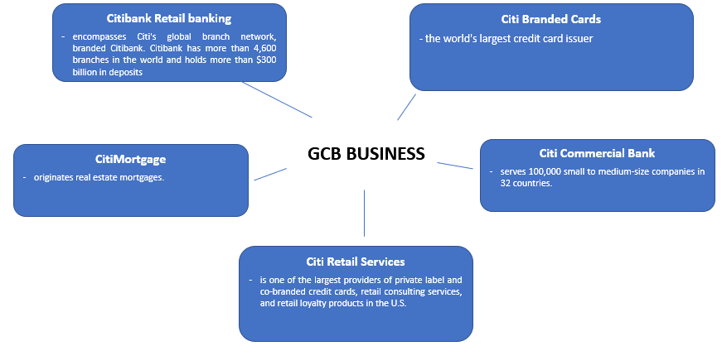
Figure 25 GCB DIVISIONS
According to Citigroups website: “The Bank advises people on how to invest for future needs, such as their children's education and their own retirement, and help them buy securities such as stocks and bonds. The organisation works with companies to optimize their daily operations, whether they need working capital, to make payroll or export their goods overseas. By lending to companies large and small, Citi helps them grow, creating jobs and real economic value at home and in communities around the world. It provides financing and support to governments at all levels, so they can build sustainable infrastructure, such as housing, transportation, schools and other vital public works.” (COMPANY 2018).

APPENDIX II CSR IMPACT CITI COLOMBIA (EXTRACT)

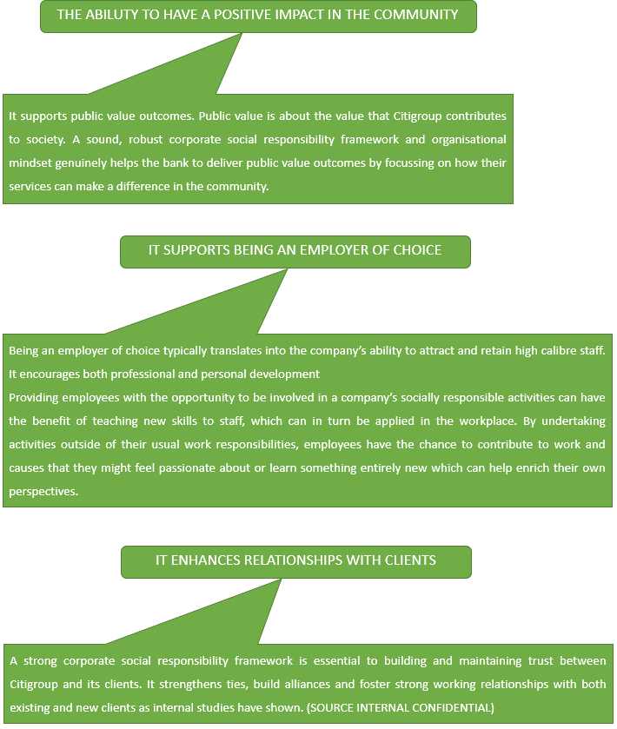

APPENDIX III CULTURE DIFFERENCES
Hofstede’s Ratio (Source: HRI 2018)
The following overview shows the cultural differences between the US (Corporate centre of Citigroup) and Colombia (Citigroup operates in) to show fundamental differences (especially in the “Uncertainty/Change Avoidance” metrics) that need to be taken into consideration when wanting to define and execute a local business- and functional level strategy that is derived from the corporate strategy in the US.
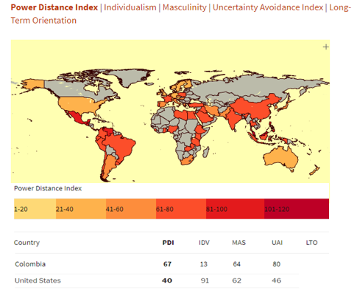
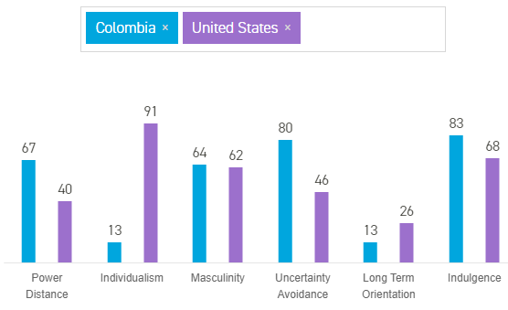
Figure 26 HOFSTEDES POWER DIMENSIONS

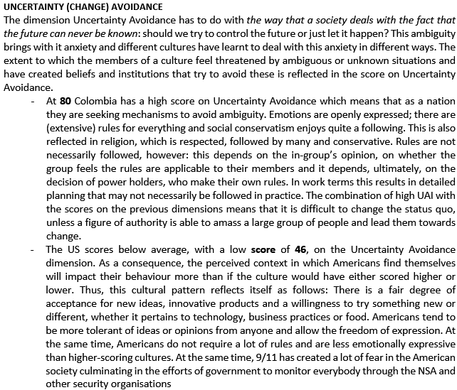
Figure 27 UNCERTAINTY AVOIDANCE DIFFERENCES

APPENDIX IV KNOWLEDGE-BASED APPLICATION

Towards recommendations, Citigroup Colombia should apply the Knowledge-based view (KBV) (Kraaijenbrink, 2009). KBV means that knowledge-based resources are usually difficult to imitate and socially complex. Furthermore, it means that heterogeneous knowledge bases and capabilities among firms are the major determinants of sustained competitive advantage and superior corporate performance. The resource based (RBV) theory argues that the optimum use of firm resources is applied to achieve superior performance. Citigroup in Colombia should not just focus on its resources it possesses but also use the knowledge it collects daily, e.g. through customer interaction. That can be used to determine trends in local customer needs in Colombia and assess when for example the Digital Agenda from client’s perspective can be introduced due to increased needs.

REFERENCES:

- ADWEEK 2014, Citi Pushes to Be the ‘Amazon of Banking’, available at: https://www.adweek.com/brand-marketing/citi-pushes-be-amazon-banking-152513/
[accessed at 06/06/2018]

- AIRBERLIN 2017, “What went wrong”, available at: https://www.news.com.au/travel/travel-advice/flights/everything-must-go-as-air-berlin-leaves-behind-mountain-of-debt/news-story/6b2a84ba1c5709369fdb589e053037b6 [accessed at 06/09/2018]

- ARMSTRONG 2009, Armstrong Michael (2009), "Armstrong’s Handbook of Management and Leadership", Second Edition, Kogan Press, ISBN: 9780749454173, pp 176-191

- AUDIT 2018, Sarbanes Oxley at Citigroup, available at: https://www.citigroup.com/citi/investor/data/auditriskcharter.pdf?ieNocache=155
[accessed at 06/15/2018]

- BANCA-DIGITAL 2017, Innovation and Technology Trends, available at: https://ibsintelligence.com/latin-america-digital-banking-age/ [accessed at 06/02/2018]

- BANKS 2016, The war for talent, available at: https://internationalbanker.com/technology/banks-vs-fintechs-the-war-for-talent/ [accessed at 06/02/2018]

- CITI-COL 2018, Citigroup in Colombia, available at: https://www.citibank.com/icg/sa/latam/colombia/ [accessed at 06/06/2018]

- CITI-REPORT 2017, Citi | 2017 Annual Report, available at: https://www.citigroup.com/citi/investor/quarterly/2018/annual-report/ [accessed at 06/02/2018]

- CITIZENSHIP 2018, Citizenship Citigroup, available at: https://www.citigroup.com/citi/about/citizenship/ [accessed at 06/01/2018]

- COMPANY 2018, available at: https://www.worldatlas.com/articles/the-largest-banks-in-the-us.htm [accessed 06/06/2018]

- CONCERN 20017, Risks faced by non-executive directors, available at: https://www.financierworldwide.com/risks-faced-by -non-executive-directors /#.W2X-OlAzbDc [accessed at 07/04/2018]

- CORRUPTION 2017, Corruption Index, available at https://www.ris.bka.gv.at/defaultEn.aspx [accessed at 06/05/2018]

- COUNTRY 2007, Colombia Country Environmental Analysis, available at: https://www.researchgate.net/publication/303196339_Colombia_Country_Environmental_Analysis_Overview [accessed at 06/11/2018]

- CULTURE 2016, Kate Cathey, Culture Colombia, Kuperard Press, page 52-58

- ECONOMIST 2017, A decade after the crisis, how are the world’s banks doing, available at: https://www.economist.com/special-report/2017/05/06/a-decade-after-the-crisis-how-are-the-worlds-banks-doing [accessed at 06/14/2018]

- ENDEARMENT 2014, Firms of Endearment - Sisodia/Sheth, Firms of Endearment: How World-Class Companies Profit from Passion and Purpose 2nd Edition, Pearson FT Press; (February 19, 2014)

- EWMD 2017, Global race for talent, available at: https://www.ewmd.org/system/files_force/Knowledge%20Economy-%20The%20global%20Race%20for%20Talent%20ad%20Ideas.pdf?download=1
[accessed at 07/09/2018]

- FARC 2017, FARC peace deal seen boosting Colombia’s economy, available at: https://www.cnbc.com/2017/11/14/farc-peace-deal-boosting-colombias-economy.html
[accessed at 06/22/2018]

- FINANCE 2018, Investor Data, available at: https://www.citigroup.com/citi/investor/data/q1605c.pdf?ieNocache=165
[accessed at 06/25/2018]

- FORBES 2014, Citi’s Marketing Approach, available at: https://www.forbes.com/sites/dansimon/2014/03/20/citis-customized-marketing-approach/#14310b7c518f [accessed at 06/14/2018]

- FORBES 2016, Customer Co-Creation Is The Secret Sauce To Success, available at: https://www.forbes.com/sites/christinecrandell/2016/06/10/customer_cocreation_secret_sauce/#2c3af0e85b6d [accessed at 06/02/2018]

- FORBES 2017, Motivating Employees Should Be One of a Leaders Top Priorities, available at: https://www.forbes.com/sites/williamcraig/2017/06/20/motivating-employees-should-be-one-of-a-leaders-top-priorities/#7d2806b01d7d [accessed at 07/23/2018]

- FORBES 2018, HR Competencies, available at: https://www.forbes.com/sites/forbeshumanresourcescouncil/2018/05/11/seven-human-resources-competencies-that-drive-company-success/#74848498425e
[accessed at 07/06/2018]

- FRIEDMAN 1962, Milton Friedman, Capitalism and Freedom, University of Chicago Press; 1962

- GLOBAL 2018, Global Banking 2020, available at: https://www.ey.com/gl/en/industries/financial-services/banking---capital-markets/global-banking-2020--foresight-and-insights
[accessed at 07/06/2018]

- Hailey & Balogun (2002), Change Kaleidoscope, Exploring Strategic Change. 2nd ed. London: Prentice Hall.

- HDR 2018, Statistics, available at: http://hdr.undp.org/en/indicators/137506
[accessed at 06/23/2018]

- HRI 2018, Hofstede’s Ratio Index, available at: www.clearlycultural.com/geert-hofstede-cultural-dimensions/power-distance-index/ [accessed at 06/10/2018]

- HRMAGAZIN 2018, Building a sustainable talent pipeline, available at: http://www.hrmagazine.co.uk/article-details/building-a-sustainable-talent-pipeline
[accessed at 06/21/2018]

- HUTCHISSON 2016, Rachel Hutchisson, The Era of Corporate Social Responsibility is Ending, available at: https://www.youtube.com/watch?v=N8dXNzCIVxg [accessed at 06/02/2018]

- IM 2018, Legal System Colombia, available at: https://www.indexmundi.com/colombia/legal_system.html
[accessed at 07/09/2018]

- IMD 2017, IMD 2017 WORLD COMPETITIVE CENTER, World Competitive Yearbook 2017, available at: www.imd.com [accessed at 06/10/2018]

- IMD-TEC 2018, World Competitive Technology Ranking 2018, available at: https://worldcompetitiveness.imd.org/eShop/Default.aspx [accessed at 06/21/2018]

- JOHNSON, G., Whittington, R., Scholes, K., Angwin, D. & Regner, P. (2017). “Exploring Strategy – Text and cases”, Eleventh Edition, Pearson, pp 133-148

- KAPLAN 2012, “Mendelow’s Matrix” [online]. Available at http://kfknowledgebank.kaplan.co.uk/KFKB/Wiki%20Pages/Mendelow%27s%20matrix.aspx [accessed at 06/10/2018]

- KOTTER, J. (2011). “John Kotter – Resistance to change”. Available at: https://www.youtube.com/watch?time_continue=216&v=Wdroj6F3VlQ [accessed at 06/10/2018]

- KOTTER 2015, “Change Management vs Change leadership: What’s the difference?”, available at https://www.youtube.com/watch?time_continue=110&v=yseq-v9DFqg [accessed at 07/10/2018]

- KRAAIJENBRINK 2009, Kraaijenbrink, Jeroen and Spender, JC and Groen, Aard (2009): The resource-based view: A review and assessment of its critiques. Published in: Journal of Management, Vol. 36, No. 1 (2010): pp. 349-372.

- MARKETING 3.0, Philip Kotler, From Products to Customers to the Human Spirit, John Wiley & Sons, Mar 30, 2010, page 127-142

- MARKETING CULTURE 2004, Marketing Across Cultures, Fons Trompenaars and Peter Woolliams, Capstone; 1 edition (September 24, 2004), page 234-247

- MARKETING-JOURNAL 2015, Collaboration and Co-Creation, available at: http://www.marketingjournal.org/collaboration-and-co-creation-the-road-to-creating-value/
[accessed at 06/27/2018]

- MCKINSEY 2017, Attracting and retaining the right talent, available at: https://www.mckinsey.com/business-functions/organization/our-insights/attracting-and-retaining-the-right-talent [accessed at 06/20/2018]

- MILLENNIALS 2017, Millennials Are To Rule The Workforce By 2020, available at: https://magazine.startus.cc/millennials-rule-workforce-2020-infographic/
[accessed at 07/07/2018]

- MISSION 2018, Citi Mission, available at: https://www.citigroup.com/citi/about/mission-and-value-proposition.html [accessed at 06/07/2018]

- OECD 2018, Statistics, available at: http://www.oecd.org/countries/colombia/
[accessed at 07/07/2018]

- PORTER 1980, Porter, Michael E. (1980). Competitive Strategy. Free Press. ISBN 0-684-84148-7.

- PORTER 1985, Porter, Michael E. (1985). Competitive Advantage. Free Press. ISBN: 0-684-84146-0

- REEVES 2012, The right strategic style for your environment, available at:
https://hbr.org/2012/09/your-strategy-needs-a-strategy [accessed at 06/22/2018]

- TRADING 2018, Statistics, available at: https://tradingeconomics.com/colombia/gdp-growth
[accessed at 07/12/2018]

- WHO 2016, Trends in Globalization, available at: https://www.wto.org/english/res_e/booksp_e/anrep_e/wtr16-2b_e.pdf [accessed at 07/07/2018]

- WHO 2018, available at: http://www.who.int/gho/countries/col.pdf?ua=1
[accessed at 06/10/2018]

- WIKI 2018, Climate Colombia, available at: https://en.wikipedia.org/wiki/Climate_of_Colombia
[accessed at 07/12/2018]

- WORLDBANK 2017, available at: https://www.theglobaleconomy.com/rankings/wb_political_stability/ [accessed at 07/10/2018]

