Student Name: Jack Lloyd
P Number: 1810856
Programme of Study: BA Music Technology (y1)
Module: ADAD4019
Tasks in the order I received them:
Task One: Semiotic Analysis (Ryan task) = 528 words
Task Two: Manifesto (Julia Task) = 495 words
Task Three. (Jon Task) = 543 words

Task 1 - Ryan Moule-Observational Writing: Identify an image and write a semiotic analysis

Semiotics is about looking for the obvious and the obscure meaning in anything and everything. D.Chandler (2002) States that “The shortest deﬁnition is that it is the study of signs.” For example, what colour is it, what is it set against, and what colour is the background. Is it the dominant feature on the page or is it small and uncentered? Is the circle supposed to represent a flag or is it just a plain old circle? Lots of meaning can be derived from anything presented to us.

As an example, there is a lot of meaning you can derive from the signs within this image. There are the obvious things, such as the text saying “open your mind” in bold and capitalised. And there is clearly a person with their head appearing as a solar system. However, there is meaning behind almost everything within the image. The denoted meaning of the image is that of a person's entire head being a few planets and stars. But the connotation is that this person's mind has, in fact, had a eureka moment due to knowledge they have just gained due to broadening their mind. Their suit implies the person is of the academy or a working environment, a suit implies success. This is done to associate you the observer with the concept of opening your mind and thus becoming successful. Hare W. (1985) states in ‘In Defence of Open-Mindedness’ “It is widely held that open-mindedness involves a willingness to form and revise one’s views as impartially and as objectively as possible.”

While opening your mind is not at all actually linked to the concept of success. This image associates them. And thus, associates them with you if you do in fact choose to follow the advice being given to you. This person is supposed to be you personified or else the possible future you once you have “O P E N ed Y O U R M I N D”. Most planets in this image are very dominant blue, blue is associated with water and water is associated with life. Making all the planets seem rather inhabitable and thus positive and perhaps friendly. Alive and meaningful at least. The yellow is in stark contrast with the blue as to contrast the current “You” as connoted by the yellow tie, with the Blues and life and openness and vastness the possible future you. The other planets also being of a yellow shade and resembling Jupiter in order to seem familiar rather than just some random planets.one of the planets in the image so closely resembles earth (Our home) that I would say it is a direct representation. This could also imply the concepts of learning and thinking outside the box as we ourselves are grounded on earth and yet this person (future you) is able to not only see all of the earth but other galaxies and stars and planets. Sessa, V., London, M. (2006) Expresses that “Learning is needed more than ever in today’s complex world.” As I reflected on this Poster from Walmart, I began to gain a clearer and deeper understanding for its genius and its meaning.

Bibliography
Chandler, D. (2002). The basics. 2nd ed. New York: Routledge.
Hare, W. (1985). In Defence of Open-Mindedness. Kingston and Montreal: McGill-Queen's University Press.
Sessa, V., London, M. (2006). Continuous Learning in Organizations. New York: Psychology Press, https://doi.org/10.4324/9781315820941

Task 2 - Julia Lockheart-Manifesto Writing: “What do I believe in?”

- If there is nothing you can do, don’t stress about it.
- The world is decaying like poorly cared for teeth.
- Don't compare yourself with other people; compare yourself with who you were yesterday – Jordan Peterson
- Fake news and misinformation are an ever-increasing issue in our day and age.
- Music can move any individual and has always been part of human evolution.
- Treat others as you would want them to treat you
- Hypocrisy is the bane of self-pride, confidence and integrity.
- Don’t sit on your thoughts, if you can do something about it DO IT.

If there is nothing you can do, don’t stress about it.


I’m a firm believer in productivity and efficiency. Over the years I have come to realise many things about psychology and, about futility. Picture this, Out of nowhere your lecturer has been told by the higher ups to change the date of your next submission, and as a result you totally miss your deadline and it’s a Friday so you wont be able to do anything till Monday. At this point there are two ways you can perceive the situation. You either stress endlessly about it all weekend and pull your hair out and lose sleep over it, even though it is out of your control. Evans, G. (1982) Defines stress as “Any situation in which the environmental demands on an individual exceed their abilities to respond.” The alternative is you chill out, at the end of the day you can’t reverse time and stressing about it isn’t productive. Do I have any power to change the unfortunate circumstances? If the answer is no then that’s that. Stressing about it, feeling bad about it like “Oh If only I had done the work a week sooner”, isn’t a healthy mindset and it doesn’t help you in anyway.

Don’t sit on your thoughts, if you can do something about it DO IT.

When faced with a situation you aren’t comfortable with and expect that if you don’t do something about it, you may face the same situation again what do you do. Either you do nothing and feel bad about it, maybe someone said something, and it really bothered you but at the time you pretended unbothered, unconcerned. Because of that, that person could make that remark again assuming you don’t mind and finding it humorous. At this point it would be your fault for not addressing the situation at an earlier point. And perhaps you are just misinterpreting what they mean when they say what they say. Either way the best course of action is to gain full understanding of the situation, clarify with the person what they mean and (If the situation calls for it) Ask them to stop. People value REAL people and genuine interaction and to act differently to how you feel may seem disingenuous.

Don't compare yourself with other people; compare yourself with who you were yesterday – Jordan Peterson

Peterson, J. (2018) States “Compare yourself to who you were yesterday, not to who someone else is today”. Everyone has a past, whether you’re proud of all the actions you have ever done, or if you regret hundreds of things from your past, doesn’t matter. We all have a past, and we are never going to change those events behind us, we can however channel that energy towards repairing damage dealt and building a better future for yourself, that means building a future you, a better you. Hannum, K. (2012). says on the topic of social Identity “Social Identity refers to our way of thinking about ourselves based on social groupings.” Other people aren’t you, YOU are you and you are the only person that decided whether you get to be the person who envy’s everyone, or the person everyone envies.

Bibliography
Evans, G. (1982). Environmental Stress. New York: the Press Syndicate of the University of Cambridge.
Peterson, J. (2018). 12 Rules for Life: An Antidote to Chaos. City of Westminster, London: Penguin UK.
Hannum, K. (2012). Social identity. New Jersey: Center for Creative Leadership (CCL).

Task 3 - Jon Pugh-Reflective Writing: Do you know what you think?
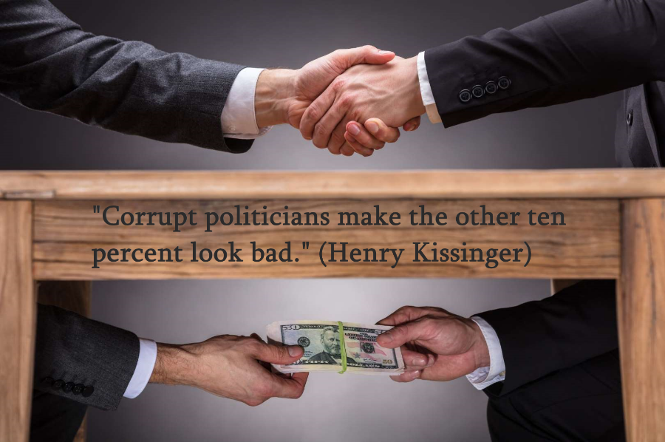
the song No More Sorrow by Linkin Park contains the phrases
Thieves and hypocrites (x4)
I was exposed to these lyrics very early in my life, these lyrics are spoke in a scream of passion and anger, in the middle of a song about bettering your life and cutting out Toxicity. And about influential or political powers being corrupt. This song among a few dozen Linkin park tracks heavily influenced my early life, and even to this day echo in my attitudes and my thought processes.
I have chosen this line because, while short and to the point it contains the word hypocrite. Grant, R. (2008) bemoans that “Hypocrisy is a regular feature of political life.” On the day I learned the definition of that word, I began to reflect on my actions within my recent and long past life events. I looked to how I treat people and how I make decisions, and I looked for any traces of hypocrisy. I looked for every time I had told someone not to do something only for my personal gain and decided that from that moment on, I would never again be part of an act of hypocrisy, intentional or otherwise. And from that day since I’ve built morals and mindsets, I’m very proud of, and can say with satisfaction that I stayed true to my word. I have never since intentionally been a hypocrite. And any occurrences of unintentional hypocrisy, I used to learn. Working on this led to other ideals being imbued into my life. Integrity and sincerity kindness and understanding. I truly believe that one line, that one decision completely changed the course of my life, completely changed my attitude and actions. I still work every day to maintain and improve myself, every day I check my words and I check my decisions and thoughts and actions. Hare, R. (1952) explains that “The language of morals is that of a prescriptive language.” I always work to gain all information about subjects I need to have an opinion on. Haley, J. (1987) states that “To motivate someone to do something means persuading the person that there is some gain in it for him”. This is a quote keep in mind when helping people because it’s one of the most challenging parts. I always work to eliminate any bias I may have in any given area. And I channel all these things into helping people, I provide help and support for people of all walks of life and creeds, of all ages and genders. Giving them advice or just a person to vent to, someone who will help when you can’t think straight or someone to help you when you’re puzzling over something, someone you can come to for a second, and objective opinion. And I do so with the confidence I’ve built up based on all the previous skills I’ve been steadily developing for years. This means I do as I say, and I say as I do. This means that If a situation arises that requires me to tell someone to do something that I also should be doing, then that’s that, and I’m now channelling helping others into bettering myself because now I’m doing whatever they needed to be doing.
Bibliography
Grant, R. (2008). Hypocrisy and Integrity. Chicago: University of Chicago Press.
Hare, R. (1952). The Language of Morals. New York: Oxford University Press, Incorporated.
Haley, J. (1987). The Jossey-Bass social and behavioral science series. Problem-solving therapy (2nd ed.). Jossey-Bass.

