

BMSK4002
Effective Team Working and Communication

Part 2 Communication

Craig Bennett

1911380

May 22nd 2020

Table of Contents
Part 2 Communication 1
Communication Cycle 3
Communication in the Workplace 7
Active Listening 8
2.0 10
Assessing own Communication Skills 10
Gap analysis………………………………………………………………………………………10
Personal Development Plan 10
References 12
Appendix A SMART Objectives 13
Appendix B Self assessment quiz results ………………………………………………………….12

BMSK4002 Part 2 Communication

1.0

During the current Covid lockdown both myself and my company have had to change the way we communicate with our work based learners. Normally, this would be a face to face verbal conversation and exchange of ideas and feedback. Using the communication cycle we would produce work that I as the assessor would mark and discuss with the learner. But this has become a thing of the past for the time being and remote digital communication has become the new normal.
However let’s take the good old fashioned face to face communication first. This model was first introduced by Claude Shannon and Warren Weaver in 1949 in their book, The Mathematical Theory of Communication and it shows the communication process as a transmission model - as seen in their original diagram below.
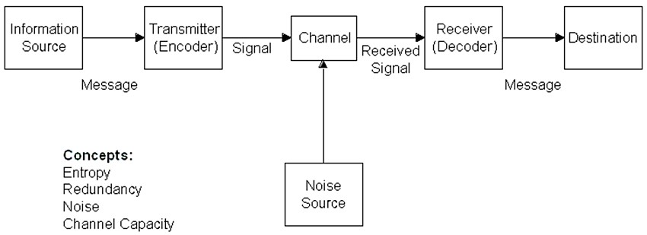

Communication Cycle

Shannon (1949)

As you can see the sender communicates a message (talks) through a channel and the receiver encodes this and deciphers the message and understands what is being asked. The receiver can then become the sender in responding to the original message.
Another example of this is the sender wants to send a communication message to his colleague, he must decide what to say (encoding), he choses a channel to send this message (verbal face to face), the receiver then decodes the message to understand what is being said and feeds this back to the sender repeating the cycle.
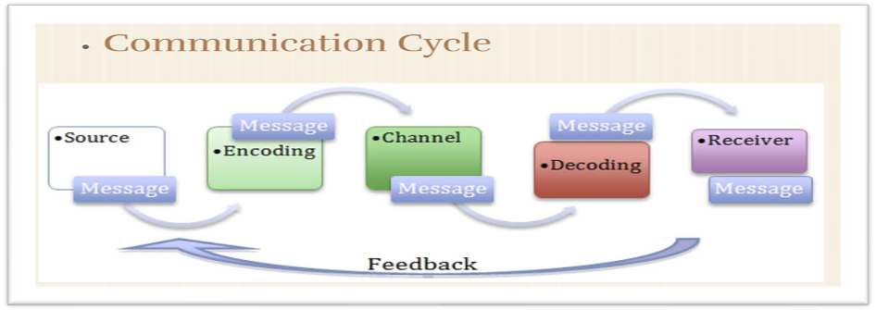

Patel (2013)

Normally you would have two people who interact with each other taking turns in being the sender of a message or conversation and the receiver who listens, thinks and formulates and answer to move the conversation along. The two people are not separate in a discussion but interdependent of each other, where both can ask a question to each other to get the desired results, so in essence both parties are senders and receiver

- If a message is misunderstood by the receiver what happens next?

Well in theory the receiver can ask the sender to repeat the question or elaborate on the question so they understand the question and can formulate an answer. However if the question is vague and in general the receiver does not understand the question then the sender should re-word the question in the receivers understanding so the receiver can then answer the question and move the conversation along.

- What is Noise?

There are 4 main types of noise
- Physiological
This is a noise distraction caused by a physiological response from the body like hunger, fatigue, headaches, medication and other physiological factors.

- Physical
This is when there are physical factors that interfere with the hearing or sight, things like really dim lighting, bright lighting, extreme temperatures for both cold and hot situations, crowded and noisy conditions, loud music, back ground music.

- Psychological
This is the most challenging one out of the four in my opinion, this refers to maybe something playing on your mind that takes up your mental concentration and you fail to recognise the questions asked as you have that something on your mind.

- Semantic
This is when the words the sender is saying make no sense at all. Imagine talking to a doctor or a nurse and you have no medical background, they are using medical jargon that you do not understand. Therefore you cannot join in the discussion and conversation because you genuinely do not know what is being said or asked of you.

- How can it be overcome?
To overcome all the above conditions and types of noise factors can be challenging, however always make sure you have something to drink (water not scotch), you have had something to eat. Take the surroundings into consideration if they are not conducive to a discussion ask to move to somewhere quiet or somewhere brighter so you can see the other person. Psychological is a tricky one and it’s easy to say “clear your mind” but in practise this is a really hard thing to do. Try to switch off your other problems and listen actively to what is being said. Semantic noise, personally there is nothing you can do to get through this, as stated if you are having a conversation with a doctor using medical jargon and you do not know anything medical how are you expected to join in on the conversation?

- Types of “Channels”
Between the sender and the receiver there are a whole host of channels available to communicate.
Verbal- this is talking, face to face communication using simplex (communication flows in one direction) and duplex (communication can send and receive at the same time). To give an example an ordinary phone call is duplex where the sender and receiver are interdependent and change sides during the discussion.
Non-verbal- Body language, nodding head, frowning, gesturing, laughing
Hearing- Actively listening to what is being said
Touching, tasting, smelling- Ask a chef if these are important and they will all say a definite yes, without these sensory facilities how can a conversation between chefs carry on of the first question could be “Is the soup ready?”, the receiver must taste, smell, check the texture, seasoning to be able to reply back to the head chef.

The original model has been expanded and built upon over the years beginning with the SMCR Model which was introduced by David Berlo in 1960 and this model explored the different skills and attitudes used in the deceptively simple act of sending and receiving a message.
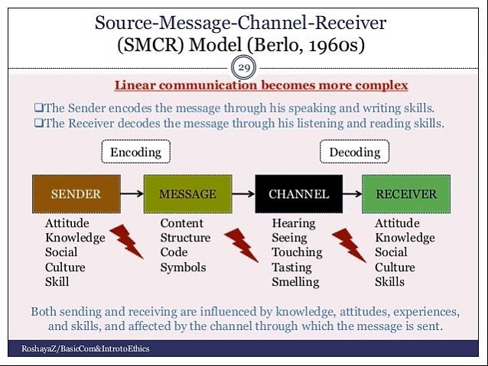

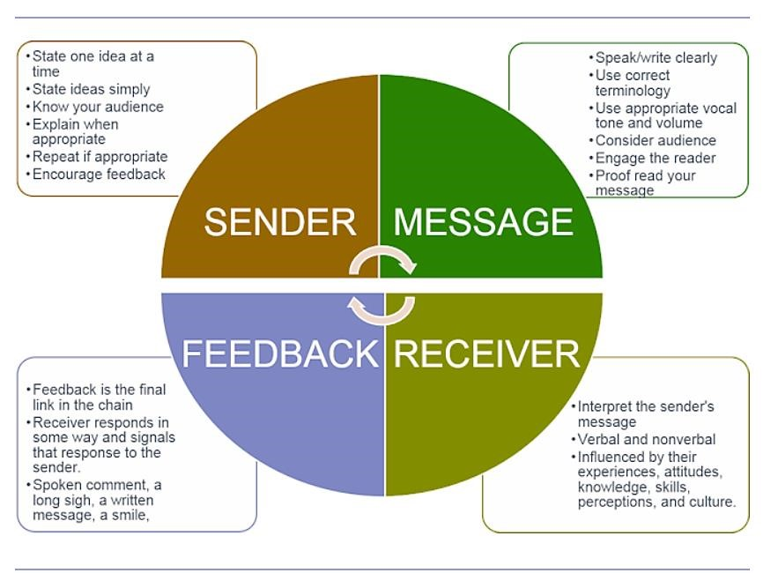

Blenkinsop (2013)

I can relate bad and really poor examples of poor communication within the workplace. When I was a duty manager in a Wetherspoon pub the manager had a phobia about people replacing her and taking over her. This got to extremes when she would take pictures of any small mistake anyone would do during a shift, an example of this was a shift leader who when the restaurant was really full and really busy left dirty dishes behind the bar glass wash area in a safe area to clear more dirty dishes from the restaurant floor. The process took no more than 10 minutes for them to clear 3 tables worth of dirty dishes, he then took the dirty dishes to the kitchen on a tray and placed in the dishwasher. However the manager took this as a hazard and took a picture then reprimanded the shift leader in front of the whole team.
This demoralised the shift leader and the whole team, everyone lost respect for the manager and refused to work with her. I had to write a report to the area manager who then in turn had to come down to the pub and sort the mess out.
In hindsight a quick and quiet word to the shift leader would have been sufficient and if she had done that she would have found out his reasoning and was justified in what he done.
A few months later I was transferred to another pub where the manager was more professional and people orientated, he said that the hands on approach to helping each other was paramount and no manager should forget that.
So when the restaurant and bar was really busy one day he simply got the management team together and we rolled our sleeves up and mucked in to get the work done, praising the team for their hard work. This motivated the team to do better and the team gelled together becoming stronger and through effective communication improved service.

Communication in the Workplace

Points to note when communicating in the workplace
- Be polite and professional – no shouting or swearing
- Do not judge others - be mindful on the strengths and weaknesses of others, never belittle anyone else
- Have emotional intelligence – try to empathise with other peoples point of view, try to understand where they are coming from and their viewpoint
- Clarity- speak clearly and articulate clearly to avoid any misunderstandings
- Actively listen to others and take part in team discussions and meetings

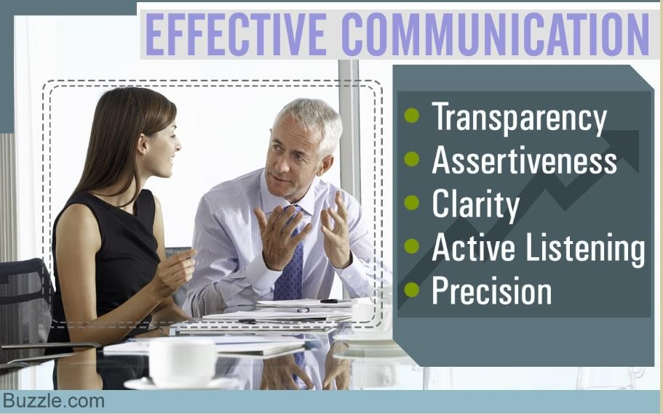

Myself, my colleagues and my company are really good at communicating effectively, by identifying verbal and non-verbal communication cues, assessing body language, we have developed a good emotional intelligence quota to be able to empathise with the learners and each other.

Active Listening
I learnt this when I was at school, I was not allowed to take physics as a GCE subject as it conflicted with my chosen subject cookery. I already had chosen a science subject chemistry so I was in my view relegated to a subject called rural studies. This was a subject I had no interest in and did not participate. I played truant, threw my proverbial dummy out the pram and was stubborn, non- participative and awkward. In hindsight I feel sorry for the teacher as I was always being sent to the headmaster or even worst the head of science. One day as usual did not complete my homework and was sent to Dr. Kerry Rosser (head of science), I explained I had no interest in rural studies and had not done my homework, I got the old fashioned cane for my troubles, but he asked me to join his physics class which was a year ahead of me. I sat down a little sore but what an eye opener, I participated, got involved and learnt how to actively listen as I had a love for physics. After that I attended Dr Rossers class instead of rural studies I achieved a “A” grade GCE a year ahead of my classmates.
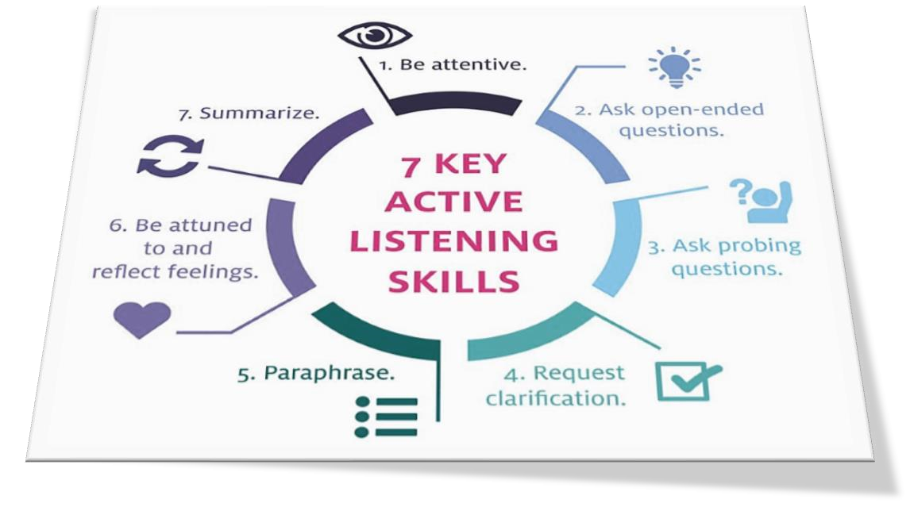

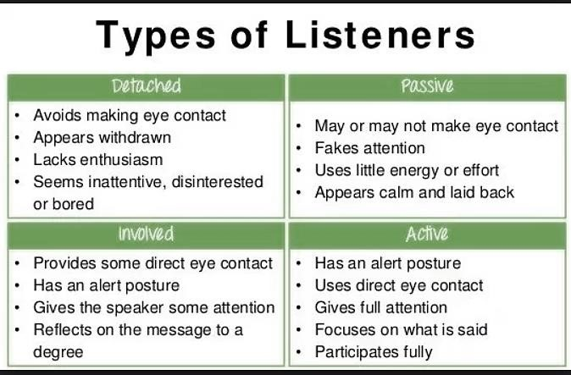

I would like to think I am an ACTIVE listener, I always maintain eye contact and give my full attention, focusing on what is said (most of the time), and I actively participate in team discussions. I tend to say nothing but take it all in then reflect and only then I would contribute to the discussion.
My manager is also an active listener, however unfortunately some of my colleagues and learners are all of the above criteria from detached to passive and include some involved colleagues. But on the whole everyone I work with and nearly all of my learners are classed as active listeners.

2.0 Assessing own Communication Skills

I would consider myself a good communicator as this is required as part of my job role, but I completes a self assessment test and the results are listed in the appendix. I found out that my emotional intelligence was 81%, verbal communication was 84%, group and team communication was 100%, however my listening skills were only 73%. Making an overall score of 86%.

Gap analysis
GAP Analysis
Objectives | Current Position | Deficiency | Action
Become more at ease with presenting a presentation | Basic presentation skills | Timing and rushing when delivering presentation | Attend NTFW workshop on effective presentations.  Watch Youtube videos to improve my skills
Learn how to do more and add content in presentations | Basic presentation skills | Lack of knowledge on adding resources to presentation | Attend Powerpoint tutorial and watch videos.
To do more presentations in work to get more proficient | I am currently only presenting as and when asked | AS an IQA I will hold more standardisation meetings with presentations | Develop lesson plans to include IQA

Personal Development Plan

Objectives | Tasks | Success Criteria | Time Frame | Resources
To become more proficient in Powerpoint presentation | To deliver more presentations in work | Ask colleagues for feedback | Review in 6 months 22-11-2020 | Powerpoint and Shareware
Be more effective in presenting my presentations | Learn how to stay calm during presentations | Ask colleagues for feedback | Review in 6 months 22-11-20 | Attend webinars and watch videos in effective presenting

Part 1 presentation findings

After my presentation in part 1 I received very positive feedback, however I agree with my tutor that I rushed through to get everything I wanted to say within the time allowed whereas it could have been more structured and delivered less rushed.

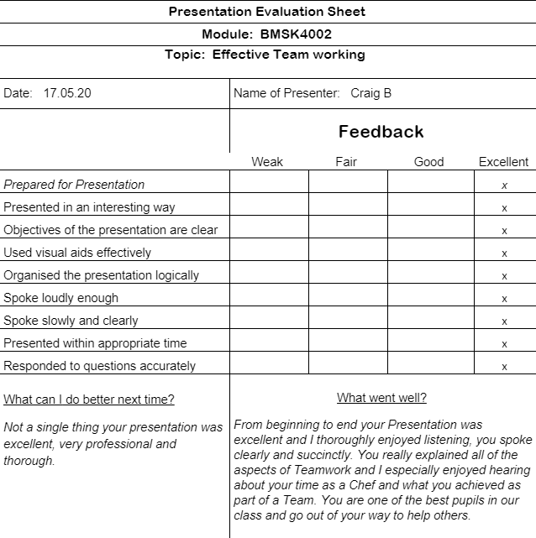

References

Berlo, D. (1960). The process of communication. New York,. New York: Rinehart, & Winston.

Blenkinsop, P. (2010) The Communication Cycle. [online] Available at: http://manyanaeducation.blogspot.com/2010/10/communication-cycle.html Accessed: 20.5.20

LyondellBasell (2019) Effective Communication [online] Available at:
https://www.lyondellbasell.com/en/sustainability/lifebeats/what-is-well-being/healthylife/effective-communication/ Accessed: 20.5.20

Patel, N. (2013) Communication Cycle [online] Available at:
https://nirmitpatel13es907.wordpress.com/2013/11/17/process-of-communication/ Accessed: 19.5.20

Skills You Need (2019) Interpersonal Skills Self-Assessment. [online] Available at:
https://www.skillsyouneed.com/ls/index.php/343479 Accessed: 20.5.20

Shannon, C., 2020. Shannon, C. E., & Weaver, W. (1949). The Mathematical Theory Of Communication. Urbana, IL The University Of Illinois Press, 1-117. - References - Scientific Research Publishing. [online] Scirp.org. Available at: https://www.scirp.org/(S(vtj3fa45qm1ean45vvffcz55))/reference/ReferencesPapers.aspx?ReferenceID=1311827 [Accessed 20 May 2020].

Wiley, J. 2016. Communicating in the 21st century John Wiley & Sons, Australia, Fourth Edition, 2015. [Online]. [20 May 2020]. Available from: Communicating in the 21st century. John Wiley & Sons, Australia, Fourth Edition, 2015

Appendix A

SMART Objectives
Specific:
To set a specific objective, you must first answer the six “W” questions:
Who? Who is involved?
^{What?} What do you want to accomplish?
Where? Identify a location
When? Create a timeframe
Which? Identify requirements and constraints
Why? Identify specific reasons, a purpose, or benefits of accomplishing the set goal.
Measurable:
Establish the criteria for measuring your progress while you work towards your objective. When you measure your progress, you stay on track in terms of dates, know when changes need to be made, and see what efforts work best for you and your team.
Ask yourself question like:
- How much time do I have to complete my Uni assignment
Attainable:
How is my assignment attainable? By working a little bit every week on the assignment until it is completed by the Timely factor.
Realistic:
In order to be realistic, your goal should represent an objective toward which you are both willing and able to work to, starting your assignment 5 minutes before the deadline is not realistic, however if you are starting working on it 6 weeks before the deadline then this is realistic.

Timely:
As mentioned in the realistic section, timely submission of the Uni assignment is critical, if you miss the deadline then you will be capped at 40% even if you have written the best dissertation report ever.

APPENDIX B
Communication self assessment results



