CRM
Natalie Reynolds - 2003716
Friday25th of February

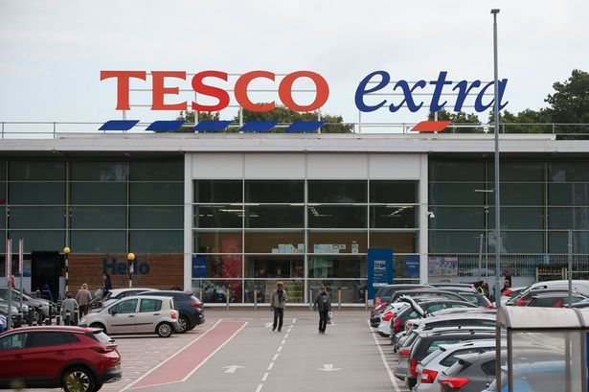

Executive Summary
The influence of Ethical Trading and the impact of sustainability policies and practices on the organisations Customer Relationship Management performance.
Tesco is one of the market leaders when it comes to customers relationship management. The organisation has been at the forefront at retaining customers, having a market share of 28% in the uk, achieving this by using impeccable customer relationship management practices.

CONTENTS PAGE
1.0 Introduction………….………….………….………….………….………….………………1
2.0 Findings……………………………….………….………….…….…….….………...……...2
2.1 Background of Tesco…………………………………………………………………………2
2.2 Customer Relationship Management Policy and Practices at Tesco…………………………3
2.3 Ethics and Sustainability……………………………………………………………………...3
2.4 Loyalty Ladder and Segmentation…………………………………………………….…. ….6
3.0 Tesco and Customer Segmentation and Utilisation of Loyalty Ladder………….…………...7
4.0 Recommendations………….………….………….……….……….………….……………...9
5.0 Conclusion………………………………………………………………….……….…….…10
6.0 Appendix………….………….………….………….………….………….……………. ….11
7.0 References…….………….………….………….………….…………………………….….13

1.0 Introduction
In this report, the Chief Marketing Officer of Marketing Week has requested a business report that highlights the influence of ethical trading coupled with the impact of sustainability policies and practices across the performance of the organisation’s customer relationship management. Marketing Week is an online publication produced by Tesco that helps its stakeholders monitor organisational processes and progress. These stakeholders include owners, investors, the public, media, suppliers, and government agencies. The report investigates the customer relationship management practices at Tesco based on ethical policies, sustainability policies, and influences of segmentation and the loyalty ladder. Information used in the report are from Tesco’s company reports, financial statistics, academic journals, and reputable newspapers. Various ethical and sustainability models and theories will be assessed in relation to practices that are used at Tesco. The report also assesses how Tesco engages with segmentation of its customers and how it uses loyalty ladder to enhance customer relationship management. the report will conclude on the impacts of these factors on CRM at Tesco. I have personally authored the report after it was requested in January 2022. It should be submitted by the 25th of February.

2.0 FINDINGS
2.1 Background Information – Tesco
Tesco is a British groceries and merchandise retailer that operates in various countries across the world. Tesco was founded in 1919 in Hackney, London (Boothby, 2019). Jack Cohen, the founder developed Tesco from a group of market stalls. The name Tesco was first used by Jack in 1924 (Boothby, 2019). By 1939, there were more than 100 stores across the UK. In the early 1940s, Tesco created its first self-service store. At the time, it was a revolutionary aspect in the retail industry, and this led to the rapid expansion of Tesco. Today, Tesco operates in eleven countries. However, it is important to note that it pulled out of the US market in 2013 (Jones, 2021). Tesco has also diversified into other industries or areas. Some of these areas include telecommunications, fuel, software, furniture, electronics, books, internet services, and financial services (Jones, 2021).
Its main success is attributable to being a low-cost retailer which is a major competitive edge of the multinational. By attracting large customer segments through low costs, Tesco can increase its sales revenues whilst gaining a slight profit margin. In the United Kingdom, Tesco has a market share of around 28%, which makes it a market leader (Jones, 2021). Tesco has more than seven thousand outlets and employs more than 400,000 employees making it one of the major employers in the world (Boothby, 2019). In 2020, Tesco had revenues of more than 64 billion GBP which was a decrease from the previous year owing to Covid-19 effects (Jones, 2021). Operating income in 2021 was 1.8 billion GBP and assets of 10 billion GBP (Jones, 2021). There are more than 4,500 locations or outlets that Tesco operates. It gains these revenues through supermarkets, convenience shops, and superstores. Additionally, Tesco is listed on the London Stock Exchange which has seen it become a major component of the FTSE 1000 Index. Some of the key people at Tesco include John Allan (Chairman) and Ken Murphy (CEO).

2.2 Customer Relationship Management Policy and Practices at Tesco
Tesco is one of the market leaders when it comes to customer relationship management. According to Kuusela (2013), customer relationship management allows a business to develop healthy and effective relationships with customers that in turn create loyalty among the customers. When this loyalty is achieved, customer retention increases which is favourable for any business. Tesco has been on the forefront at retaining its customers. Increased customer retention rates means that the business is guaranteed of certain sales levels regardless of the condition in the market or industry. As earlier stated, Tesco has a market share of 28% in the UK. Such a large market share has been achieved using impeccable customer relationship management practices at the retail giant. Tesco’s customer relationship management policy dictates continued efforts by the organisation to offer better services for its clientele at competitive prices.
An example of how Tesco achieves good CRM in its operations is through an effective feedback system across all its outlets and online shopping platforms. According to Nguyen & Waring (2018), customer feedback allows an organisation to collect information from customers that may help understand their tastes and preferences. Feedback systems at Tesco allow for collection of information relating to complaints and complements. Each of the two sets of data must be keenly studied by Tesco to identify any loopholes in their operations. Trust is achieved by Tesco by ensuring that only sustainable business practices are in place. Before suppliers are selected, Tesco conducts in-depth scans to determine adherence and compliance with various regulations such as international labour laws (Murphy, 2019). These examples are proof of how Tesco builds trust and improves customer satisfaction among its clientele.

2.3 Ethics and Sustainability
Various scholars have come up with different ethical and sustainability models in the past. These models capture complex concepts of thinking that are supposed to help shape the thinking of businesses and people regarding sustainability. The first model is a pictorial visualisation of sustainability. The World Conservation Union came up with three main dimensions that are represented as pillars of sustainability in the model (IUCN World Conservation Union, 2006). Appendix 2 is an illustration of the model in a Venn diagram. Tesco contributes to the balance by producing strict measures for all its suppliers (Potter, 2011). Any supplier who is found to be operating against the stated standards on environmental protection cannot be allowed to produce on behalf of Tesco. In the past, the sweatshop issue affected some of its suppliers specifically in the clothing industry (Murphy, 2019). Tesco came under sharp criticism from the public. The backlash meant that Tesco could no longer collaborate with suppliers who do not adhere to international labour standards.
The second major group of sustainability models are quantitative models. These are models developed for policymaking purposes. They guide politicians and economists who are key advisors to the government. However, they are also used by businesses when conducting environmental scans especially in new markets. According to Bréchet (2005), there are six major models including risk assessment models, equilibrium models, macro-econometric models, optimisation models, probabilistic models, and dynamics models. Tesco applies economic models and are seen as the most important since they assess crucial customer data that may help in customer relationship management. Risk management models are also as important in new product launches. Before the entry of any market or opening of a new store or outlet, Tesco conducts rigorous risk management (Finch, 2020). Doing this helps reduce sustainability risks that may affect the strategic goals of the business.
The third major group of sustainability models is physical models. According to Todorov (2006), physical models of sustainability are predominantly used in environmental protection and conservation. Human activities are the main causes of environmental degradation. Global warming and climate change are becoming more common due to release of greenhouse gases into the atmosphere. Businesses need to be more accountable, and these models can help in compelling organisations to be more responsible. Some of the areas where these models are being applied include energy, water conservation, urban design, and handling of pollution levels. Industry leaders are also employing these models to produce standards that should be adhered to by all participants (Todorov, 2006). They do this by creating laws that restrict pollution levels or produce maximum carbon footprints that businesses should have. Tesco has developed its net zero targets (Tesco, 2022). These illustrious goals will see Tesco reduce its carbon footprint and become a more sustainable business. The goals should be achieved by 2050.
Apart from sustainability models, Tesco also has a comprehensive customer relationship management policy. The policy at Tesco is also hedged on ethical policies and practices. According to Jones & Hillier (2011), one of the best ways that sustainable business practices can be achieved is by strict adherence to ethical policies. Tesco’s core values are rooted on strong compliance to safety and ethics. It is only then that it can deliver beneficial service to its customers and shareholders. Tesco only collaborates with suppliers who have a remarkable track record of ethical compliance with best practices in the industry (Winterman, 2013). All its products must be responsibly sourced to eradicate any incidences where unethical practices could have been used. For example, chocolate sold at its stores must be responsibly sourced in line with international labour standards (Winterman, 2013). Its suppliers must also eradicate sweatshops, which was at some point common in the fashion industry.
In the last decade, there has been significant pressure on businesses to adopt sustainability practices and policies. According to Bobe (2015), adoption of impeccable sustainability practices is a key element in developing effective customer relationships. Customers are keen on the responsiveness of organisations to climate change and reducing their carbon footprint. Tesco recently published the Living Planet Report (IUCN World Conservation Union, 2006). The report ascertains that carbon emissions, overfishing, and deforestation are on the rise. These elements have huge negative impacts on nature and could affect the future of humanity. Tesco developed three major goals to fight for the world. The first is helping customers eat more sustainably through food choices that do not harm the environment. The second is by restoring nature by only collaborating with suppliers who have a history of environmental conservation. The third is by eliminating waste. Reducing packaging helps Tesco eliminate waste.
Tesco employs the Carroll principle of sustainability. According to Walter (2018), Carool’s principle stipulates that an organisation’s operations should be economically viable while abiding by all laws and creating a positive social impact in society. It means that Tesco not only pursues sustainability to create a positive social impact, but also to make profits for its shareholders. Based on ethical conduct, Tesco adopts normative ethics. It prescribes to an already existing standard of doing operations instead of assessing each situation as and when it happens. Doing this helps reduce any chances that unethical practices are present in its operations. All employees are educated on these ethical guidelines and trained on the best way to guarantee customer satisfaction.

2.4 Loyalty Ladder and Segmentation
Segmentation has a huge influence on customer relationship management practices at Tesco. The main aspect that is used by Tesco in customer segregation is income. It mainly targets low-income and middle-income households. Majorityof its customers are cost-conscious meaning that it must always price its products with great sensitivity to the needs of its customers. Additionally, the loyalty ladder also comes into play in customer relationship management. According to Bernacchi (2016), the customer loyalty ladder allows a business to gradually assess how customers move up the loyalty ladder. Appendix 1 is an example of a customer loyalty ladder indicating the various levels of loyalty from prospective customers to advocates. Every company’s desire is to have as many advocates as possible. These customers can easily influence other prospective customers to purchase from the organisation.
Tesco has also developed good practices in the industry by following some of the strategies that are applied by some of its competitors. Use of good market practices is seen as a major way of improving customer experience while learning from various competitors. According to Jain (2015), improving customer relationship management requires an organisation to always be aware of what competitors in the market are doing. Many lessons on best practices can be found through environmental scanning. A current good example in the UK market today is Aldi. Aldi is known for providing a discount model where products are priced at the lowest prices possible. Tesco uses the Aldi Price Match aspect across all its stores. It is common to find Tesco products with a tag suggesting that the price is an Aldi price match. The practice allows Tesco customers to get bargains across hundreds of products in its stores.
The practice is extremely popular among loyal Tesco customers who see its potential to make savings. There are more than 20 million Tesco customers who have subscribed to the Tesco Clubcard (Tesco, 2021). The high subscription numbers indicate customer growth and increased loyalty which is critical for the business. Tesco has also developed partnerships with other brands such as F&F (Winterman, 2013). F&F has stands in Tesco outlets where customers can shop for various clothing. The move is supposed to enhance the competitive edge of Tesco compared to other rivals.
One of the main managerial frameworks that Tesco applies in utilising customer segmentation is the Porter’s Five Forces. One of main force that is evident in its operations is intense competition and rivalry from other retailers in the market. Tesco’s main competitors include Morrisons, ASDA, Aldi, Waitrose, and Sainsbury’s. The Tesco Clubcard is one of the main tools that Tesco uses to fend off any competition. More than 20 million people in the UK have a Tesco Clubcard (Tesco, 2022). Its popularity and many stores across the UK offer a competitive edge over other retailers in the market.

3.0 Tesco and Customer Segmentation and Utilisation of Loyalty Ladder
Customer segmentation is an essential element in the retail industry. According to Karjaluoto (2013), customer segmentation is the practice of dividing customers into separate groups based on certain similarities that are evident in each customer cluster. Tesco applies various elements of customer segmentation in its operations. Some of the common segmentation elements that can be used include age, gender, income, and occupation. Tesco serves all customers regardless of their age. One can find products that suit various age groups in its stores. Males and females can get a wide range of products on offer. The main element that is used in customer segmentation is income. Tesco mainly targets low-income and middle-income households (Bernacchi, 2016). These are customers who are conscious about their spending and are attracted when items are being sold at discounts. Tesco values customer loyalty across its operations.
According to Khairawati (2020), customer loyalty is one of the main factors that influences customer retention rates at an organisation. The higher the customer retention rate, the more successful it is in the market. Tesco values customer loyalty since it creates a competitive edge for the retailer despite intense rivalry and competition in the marketplace. Due to the significant importance of customer loyalty, Tesco has developed several illustrious ways to utilise the loyalty ladder concept. As earlier stated, the loyalty ladder produces various categories of how customers move up various relationship levels. These levels include prospect, customer, client, supporter, and advocate. Prospect is the lowest level whereas advocate is the highest relationship level. Tesco’s goal is to have as many customers as possible occupying the advocate level. Appendix 1 offers an illustration of these relationship levels and the increasing level of loyalty across the levels.
One of the ways that Tesco uses the customer loyalty ladder is through its Tesco Clubcard program. The program is a loyalty scheme where customers are awarded points for everything they purchase at its stores (Uncles, 2013). These points can be accumulated for a long time and earn them free shopping vouchers. Additionally, the program also allows customers to buy items at subsidised prices. For example, customers who are on the program may be allowed to purchase some products at a few pounds cheaper than customers who have not subscribed to the system. The Clubcard loyalty program is also used by Tesco to collect information about shopping habits of its customers. Such big data is later used to provide Tesco with information on how customer preferences and tastes can be met. Coupons to customers can also be customised based on the shopping habits of each customer on the program.

4.0 Recommendations
Several recommendations can be developed to improve Tesco’s operations. First, thorough screening must always be in place before commencing work with a new supplier. There have been instances where Tesco has come under sharp public criticism for collaborating with suppliers who operate sweatshops or have unsustainable business practices in their operations. The concern has been evident in groceries, especially imported vegetables. When customers realise that many of its products have not been sourced through sustainable means, public uproar and criticism may be observed. Such criticism can affect Tesco’s positive reputation in the market. Secondly, Tesco needs to learn from some of the competitors who are threatening its business model. Waitrose is an excellent example of a competitor which is expanding at the expense of Tesco. Diversification of its products could help provide a solution to this growing threat. Increasing consumer incomes in the UK also means that some of the people are no longer very conscious on how they spend when shopping for groceries and other household merchandise.

5.0 Conclusion
Each of the elements assessed in the report has huge impacts on the customer relationship management at Tesco. Ethical and sustainability practices have helped Tesco become more responsive and accountable to its customers and shareholders. Doing this has also helped shape an impeccable reputation among its clientele. Many customers are aware of its illustrious efforts to protect the environment and promote sustainability. Tesco has an illustrious feedback system which allows customers to contribute to service quality while pointing out any issues that could affect customer satisfaction. Segmentation has allowed Tesco to target low-income and middle-income households. These segments have customers who are conscious about their spending. Through segmentation, Tesco collects information that is used to inform shopping needs and preferences. Customer loyalty ladder application at Tesco has been expanded through the Tesco Clubcard programme. Millions of customers are on the programme, and this has led to collection of big data which is important in shaping services that suit customer habits. Tesco’s CRM is also enhanced through its pursuit for sustainability. As earlier stated, Tesco applies Carroll’s sustainability mode. The model calls for Tesco to create a positive social impact while operating a profit-making enterprise. Some of the sustainability measures such as in-depth assessments of supplier candidates can be expensive. As a result, the enterprise must first be making profits for this to be achieved.

6.0 Appendices
Appendix 1
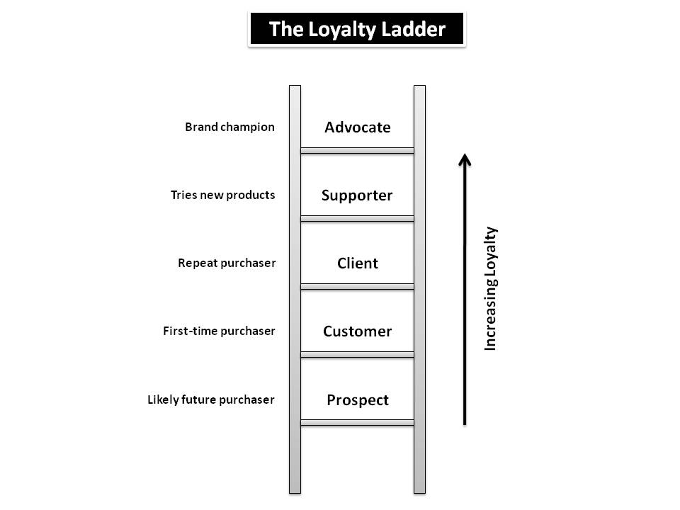

Mutyala (2021)

Appendix 2
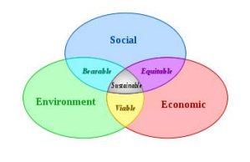
IUCN World Conservation Union (2006)

7.0 References
Bernacchi, M. 2016, "Lasting customer loyalty: a total customer experience approach", The Journal of Consumer Marketing, vol. 23, no. 7, pp. 397-405.
Bobe, C. 2015, "The sustainability policy of FIVE leading European retailers", Accounting and Management Information Systems, vol. 9, no. 2, pp. 268-283.
Boothby, K. 2019, "Tesco Stores Limited: The IDM Business Performance Awards 2006, Silver Award Winner and Innovation Winner Campaign: Tesco Clubcard -- Simpler and more rewarding", Journal of Direct, Data and Digital Marketing Practice, vol. 9, no. 2, pp. 191-197.
Bréchet, T. 2005, “Models for policy-making in sustainable development: The state of the art and perspectives for research”, Ecological Economics, 55, 337–350.
Finch, J. 2020, "Tesco opens its first zero carbon store". The Guardian. Available at: https://www.theguardian.com/business/2010/feb/02/tesco-carbon-neutral-green-building (Accessed on 16/02/2022)
Intergovernmental Panel on Climate Change (IPCC) (2007), “Climate Change 2007: The Physical Science Basis, Contribution of Working Group I to the Fourth Assessment Report of the Intergovernmental Panel on Climate Change”, Cambridge University Press, Cambridge.
IUCN World Conservation Union. 2006, The Future of Sustainability: Re-thinking Environment and Development in the Twenty-first Century, Available at: https://portals.iucn.org/library/sites/library/files/documents/Rep-2006-002.pdf (Accessed 15/02/2022).
Jain, V.K. 2015, "The role of service quality dimensions in shaping consumer behaviour", Prestige International Journal of Management & IT- Sanchayan, vol. 4, no. 2, pp. 65-79.
Jones, P. & Hillier, D. 2011, "Sustainability in the global shop window", International Journal of Retail & Distribution Management, vol. 39, no. 4, pp. 256-271.
Jones, 2017. 2021, "Tesco's American dream: Doing it differently", 2008, Strategic Direction, vol. 24, no. 2, pp. 11-15.
Karjaluoto, H. 2013, "Extending customer relationship management: from empowering firms to empowering customers", Journal of Systems and Information Technology, vol. 15, no. 2, pp. 140-158.
Khairawati, S. 2020, "Effect of customer loyalty program on customer satisfaction and its impact on customer loyalty", International Journal of Research in Business and Social Science, vol. 9, no. 1, pp. 15-23.
Kuusela, H. 2013, "Customer relationship management: the evolving role of customer data", Marketing Intelligence & Planning, vol. 31, no. 6, pp. 584-600.
Todorov, V. 2006, “System sustainability and development sustainability: Modelling problems (Is Econometrics of sustainable development possible?)”, Management and Sustainable \Development, 18(3-4), 136–140
Murphy, S. 2019, Tesco, Mothercare and M&S use factory paying workers 35p an hour, The Guardian. Available at: https://www.theguardian.com/business/2019/jan/21/tesco-mothercare-marks-and-spencer-use-bangladesh-factory-spice-girls-tshirts (Accessed 16/02/2022)
Mutyala, S. 2021, “The loyalty ladder: a sideways look”, Available at: https://www.eightleaves.com/2010/04/the-loyalty-ladder-a-sideways-look (Accessed 15/02/2022)
Nguyen, T.H. & Waring, T.S. 2018, "The adoption of customer relationship management (CRM) technology in SMEs", Journal of Small Business and Enterprise Development, vol. 20, no. 4, pp. 824-848.
Potter, M. 2011, "Tesco to outpace growth at global rivals – study". Reuters. Available at: https://www.reuters.com/article/tesco-igd-idUSLDE71F1LR20110217 (Accessed 16/02/2022)
Tesco. 2021,” Annual Report”, Available at:https://www.tescoplc.com/media/757589/tesco_annual_report_2021.pdf (Accessed 16/02/2022)
Uncles, M.D. 2013, "Customer loyalty and customer loyalty programs", The Journal of Consumer Marketing, vol. 20, no. 4, pp. 294-314.
Walter, L.F. 2018, "The corporate sustainability typology: analysing sustainability drivers and fostering sustainability at enterprises", Technological and Economic Development of Economy, vol. 24, no. 2, pp. 513–533.
Winterman, D. 2013, "Tesco: How one supermarket came to dominate". BBC News. Available at: https://www.bbc.co.uk/news/magazine-23988795 (Accessed 16/02/2022)

