These are the times and dates of your presentations. Please arrive 15 minutes before your slot and wait outside until you are called in. Once the presentations have started you will not be able to enter or leave until your group has finished these are exam conditions and therefore have strict rules. You need to upload your power point to Turnitin by the 30th June 9.00am. You will also need to email me your PowerPoint on the morning of your presentations before 9.00am. If you do NOT see your name on the list please let me know immediately.

Tuesday 1st July
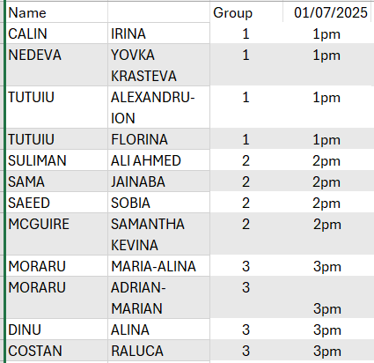

Tuesday 8th July


