

BA (Honors) Leadership and Management Skills for the Workplace

Student Name: Proserfina P. Cachero
Student Number: 2415938
Course Name: Project Management (LCLM 5003)
Lecturer Name: Dr. Xavier Matieni

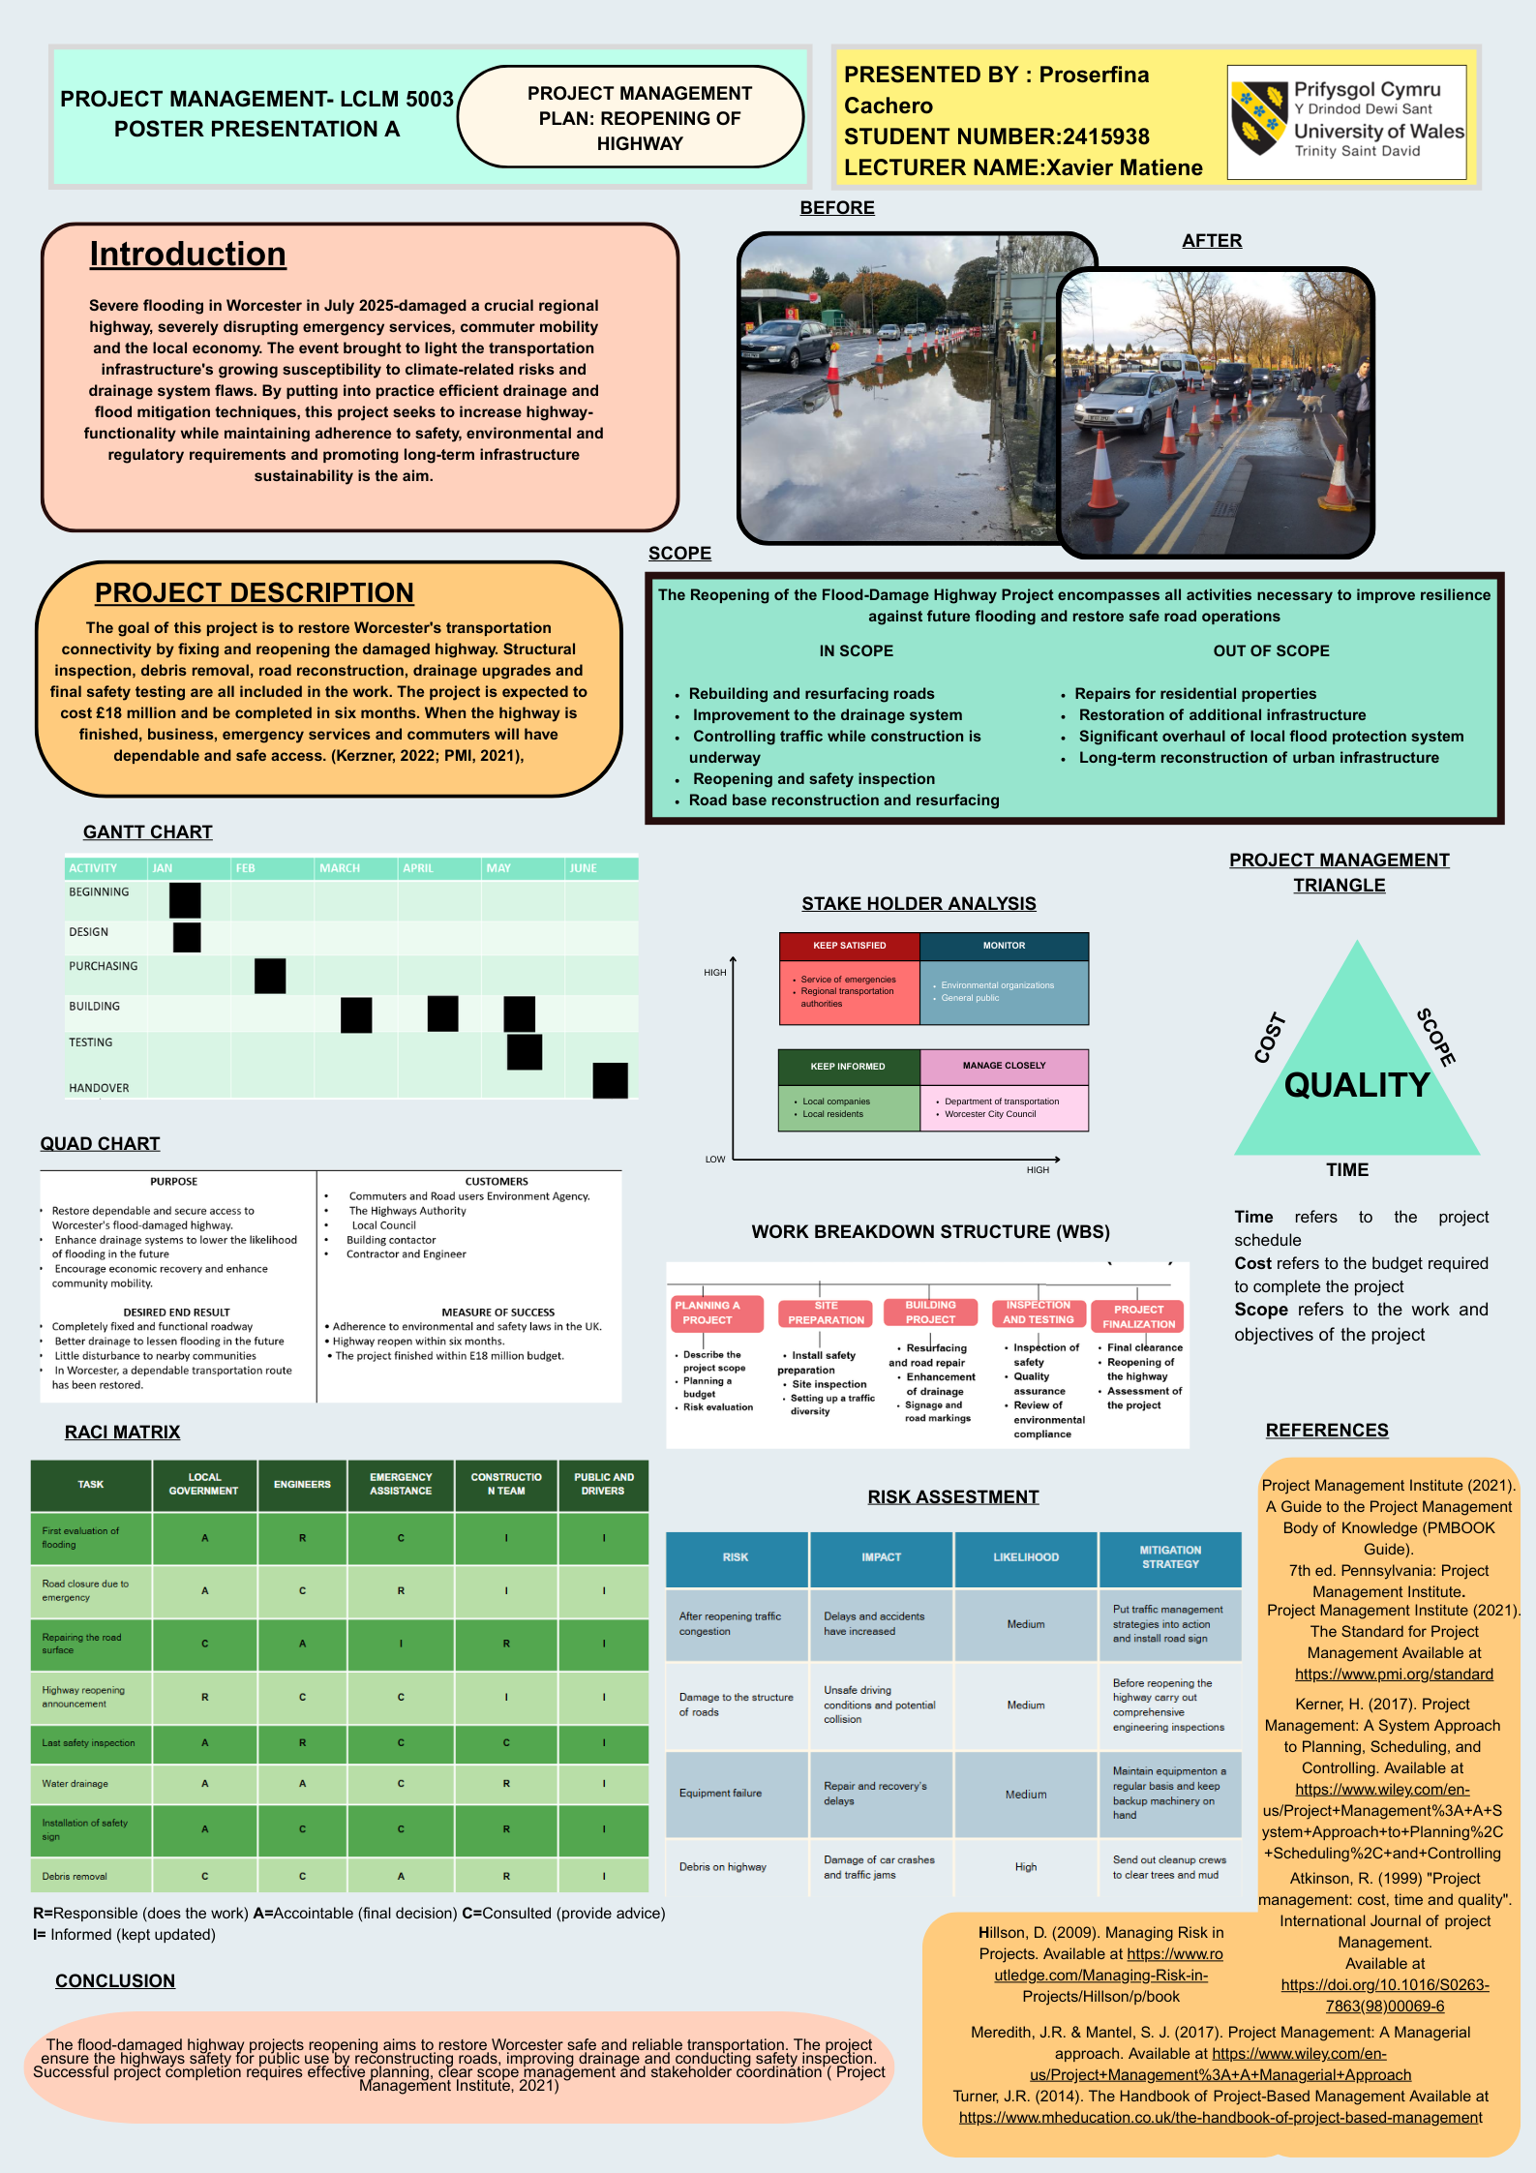

Table of Contents for Part B

1. Description…………………………………………………….…….……………4
2. Feelings………………………………………………………………….………..4
3. Evaluation…………………………………………………………………………4
4. Analysis………………………………………………………………...…………5
5. Action Plan………………………………………………………………………. 5
6. Conclusion……………………………………………………………………… 5
7. References……………………………………………………………………… 6

Part B REFLECTION (Gibbs Reflective Cycle)

Description
The lecture covered key project management concepts like project planning, time management, stakeholder identification and risk assessment. Additionally, it showed how these components could be successfully displayed in a research poster. I used these ideas in my project, which is about Rebuilding and Reopening a Highway that was Damaged by Flooding. I used tools such as Gantt Chart and balanced scope, time and cost using the Project Management Triangle. These tools are commonly used in project management practice.

Feelings
At the beginning of the lecture, I felt confused and overwhelm at the start of the lecturer because the concepts, particularly risk assessment and stake holder analysis, were so complex. I wasn’t sure how to use these in a practical situation like recovering from flood damage. This initial uncertainty is consistent with Gibbs (1998) who claims that learners frequently experience when exposed to new information. But as the talk went on the real-word examples were given, this lessened my confusion and made it simpler for me to connect theory to practice. Additionally, I felt more comfortable interacting with the material which improved my comprehension and inspired me to put the ideas into practice.

Evaluation
The lecture was useful because its provided practical knowledge that I could immediately apply to my project. For instance, I was able to visualize the timeline for fixing and reopening the highway by using a Gantt chart, while stakeholder analysis helps me identify key groups such as local governments, engineers and the local community. These tools are regarded as essential for successful project delivery (Kerzner, 2017). However, at first, it was difficult to fully comprehend some concepts due to lecturer rapid pace. My comprehension might have been further improved by more interactive conversations or actual case studies pertaining to infrastructure projects.

Analysis
The lecture material is consistent with accepted theories of project management. Planning, scheduling and risk management are emphasized by the PMBOK framework as essential procedures for attainting project success. Risk management is especially important in my project of uncertainties like weather and construction delays. Stakeholder theory also highlights the significance of managing relationships with all stakeholders, which is pertinent to my project since successful communication can affect project outcomes. However, effective learning necessities both theoretical knowledge and practical application, implying that more real-word case studies would improve comprehension.

Action Plan

I’ll go over the lecture materials again and do more research on project management tools,
especially risk assessments and stakeholder management to enhance my understanding. In
order to improve my comprehension, I will also practice using these ideas in upcoming
assignments. I can keep getting better by asking lecturers for feedback and thinking back on
how I performed. Gaining these abilities will keep me succeed academically and in my future
career.

Conclusion

All things considered, this experience has improved my capacity to apply theoretical
knowledge to real-world circumstances. Additionally, it has increased my confidence in me
ability to use project management tools efficiently. Through introspection, I have improved
my comprehension of my learning process and pinpointed important areas that need more
work in order to succeed academically and professionally in the future.

References
Project Management Institute (2021) A Guide to the Project Management Body of
Knowledge (PMBOK Guide). 7th edn. Available at: https://www.pmi.org (Accessed:10
April 2026).
Association for Project Management (2019) APM Body of Knowledge. 7th edn.
Available at: https://www.apm.org.uk/resources/find-aresource/apm-body-of-knowledge-7th-edition/ (Accessed: 10 April 2026).
Kerzner, H. (2017) Project Management: A Systems Approach to Planning, Scheduling, and Controlling. 12th edn. Hoboken: Wiley.

Table of Contents for Part C

1.Introduction………………………………………………………………………………7
2.Project Description………………………………………………………………………7
3.Scope……………………………………………………………………………………..8
4.Work Breakdown Structure……………………………………………………………..8
- Project Initiation…………………………………………..………………………...9
- Planning……………………………………………………………………..………9
- Site Preparation………………………………………………………….…………9
- Building and Maintenance………………………...……………………..………..9
- Quality Control and Inspection…………………………………………..…….....9
- Project Termination…………………………………....…………………………..9
5.Quad Chart……………………………………………………………………………….9
6.Gantt Chart………………………………………………...…………………………….10
7.Stakeholder’s Involvement………………………………………………..……………11
8.Allocation of Resources……………………………………..………………………….11
9.Risk Analysis………………………………………….………………………………….12
10.Conclusion……………………..………….……………………………………………13
11.Reference……………………………………………………………………………….14

1. Introduction

In July 2025, severe flooding in the West Midlands had a significant impact on Worcester and the surrounding areas infrastructure. The River Severn surpassed critical levels due to prolonged and heavy rainfall, causing extensive flooding damaged roads, interfered with transportation systems and had an impact on nearby communities. Resilient transport systems are more crucial because climate change has increased the risk of flooding and infrastructure damage (Environmental Agency, 2023).
Highways play an important role in regional connectivity because they facilitate the movement of goods, services and emergency response operations. Damage to such infrastructure delays recovery efforts and poses major safety risk. As a result, restoring Worcester’s flood-damage highways is critical for reestablishing connectivity and assisting with community recovery.
The goal of this project is to use structured project management techniques to repair and reopen the damaged highway. Road surface repairs, drainages system upgrades and increased flood resistant. The project will be finished effectively within scope, time and budget constrains if project management concepts like planning, scheduling and risk management are applied (Project Management Institute, 2021).

2. Project Description
The project’s main goal is to restore and reopen a highway that was severely damaged by flooding. Restoring the road infrastructure to a safe and a functional state is the main goal in order to facilitate the resumption of transportation and lessen the impact on the local economy and community. Debris removal, drainage system repair, road resurfacing, structural inspection and safety enhancements are all included in the project scope. These actions are necessary to guarantee that the highway satisfies safety requirements and can withstand upcoming environmental challenges. Construction teams, engineers and project managers are among the clearly assigned resources that will be used to complete the project within a predetermined timeframe. The coordination of numerous stakeholders, including local governments, contractors, engineers and the general public is critical to the success of this project. For expectations to be aligned and project execution to go smoothly, effective communication and stakeholder engagement are essential. Turner (2014) emphasizes that stakeholder cooperation and effective communication techniques are essential for project delivery success. In order to handle potential difficulties like weather delays, financial limitations and resource shortages, the project will also include risk management techniques. The project team can minimize disruptions and sustain progress by early risk identification and mitigation (Hillson, 2009).
The overall goal of this project is to provide a superior infrastructure solution that promotes long-term sustainability, increase safety and improves transportation efficiency.

3. Scope
The project’s scope outlines the parameters, deliverables and essential tasks needed to successfully reopen the highway that was damaged by flooding. In addition to preventing scope creep, which can have detrimental effect on time and cost performance, a clearly defined scope guarantees that stakeholders are aware of the project’s goals (Kerzner, 2017; Maylor, 2010). The evaluation of flood damage, debris removal, drainage system repairs, road resurfacing and safety inspection are all included in the project’s scope. In order to guarantee long-term durability and return the highway to operational standards, these actions are crucial. To minimize disruption to road users, the project also incorporates traffic management planning during construction. Major highway infrastructure redesign, road capacity expansion and long-term urban development initiatives unrelated to flood recovery are examples of out-of-scope components. To keep the project focused and prevent needless resources allocation, it’s critical to define exclusions (PMI, 2021). A fully restored and functional highway, enhanced drainage systems, safety compliance certification and final inspection reports are the project’s primary deliverables. Stakeholder satisfaction, regulatory compliance and quality standards will all be taken into consideration when evaluating these deliverables. The project is impacted by a number of constraints, such as financial limitation, time constraints, environmental laws and weather. The availability of trained labour, prompt material delivery and safety funding throughout the project’s duration are among the presumptions. Effective planning and execution are based on a clearly defined scope. It facilitates effective resource use and risk management while guaranteeing alignment between project objectives and stakeholder expectations (Turner, 2014).

4. Work Breakdown Structure (WBS)
The Work Breakdown Structure (WBS) is a hierarchical breakdown of the project into smaller, more manageable parts. It facilitates task organisation, responsibility assignment and effective progress monitoring. According to the Project Management Institute, the work breakdown structure (WBS) is an essential tool for project planning and control (PMI, 2021).
These projects work breakdown structure (WBS) is divided into key phases:
1. Project Initiation
This phase consists of defining project objectives, identifying stakeholders and securing approvals. It lays the groundwork for preparation and implementation.
2. Planning
This includes creating a project schedule, assigning resources, creating plans for risk management and establishing communication tactics. Effective project execution is ensured by careful planning.
3. Site Preparation
Site inspection, debris removal and the installation of safety precautions are among the tasks. This phase ensures that the site is prepared for construction work.
4. Building and Maintenance
Road resurfacing, structural upgrades and drainage system repairs are all parts of this project’s core phase. It requires collaboration among engineers, contractors and project managers.
5. Quality Control and Inspection
This phase ensures that all work meets the necessary safety and quality requirements. It entails testing, inspections and compliance verification.
6. Project Termination
The final phase includes documentation, stakeholder approval and transfer of the finished highway.
The WBS improves clarity by dividing complex activities into smaller tasks and make it simpler to assign duties and monitor advancement. It also helps with cost estimation, improve scheduling which are critical for project success (Kerzner, 2017).

5. Quad Chart
A visual tool for project management, the Quad Chart divides a project’s deliverables, risks and timeline into four main sections. It offers a succinct synopsis that is helpful for informing stakeholders about the project. The project’s goals are to minimize community disturbance, guarantee safety compliance and repair the flood-damaged highway. All project activities and decision-making procedures are guided by these goals. A fully operational highway, enhanced drainage system, safety inspection reports and completion paperwork are among the deliverables. These results show that the project was completed successfully and meet stakeholder expectation.
The project’s risks include adverse weather, material supply delays, budget overruns and construction safety hazards. To reduce this risks and guarantee project continuity, effective risk management techniques must be put into place (Hilson, 2009). The timeline describes the project’s schedule along with important checkpoints like site preparation, construction, inspection and completion. A clear schedule makes it easier to guarantee that the project will be completed on schedule and within the allocated budget.
Senior stakeholders who need a brief summary of the project will find the Quad Chart especially helpful. It facilitates decision-making, improves communication and guarantee that all important project components are presented in an understandable manner (Kerzner, 2017).

6. Gantt Chart
A Gantt Chart is a project scheduling tool that visually depicts the timeline of task and activities needed to complete a project. It displays each task’s start and end dates, duration and interdependencies. Planning, tracking and maintaining the project’s timeline all depends on this tool (Kerzner, 2017). The Gantt Chart for the highway reopening project is divided into following major stages: planning, construction, site preparation, inspection, project closure and project initiation. To guarantee effective workflow and team coordination, each phase is given a set amount of time.
It is anticipated that the project initiation phase, which involves defining objectives and obtaining approvals, will take one to two weeks. After that, there is a two-week planning phase that focuses on risk assessment, budgeting and scheduling. Depending on the degree of flood damage, the site preparation phase, which includes debris removal and safety setup, could take up to three weeks. The construction and repair phase takes the longest, ranging from six to eight weeks. This covers structural upgrades, road resurfacing and drainage repairs. To guarantee adherence to safety regulations, the inspection and quality assurance phase follows construction and takes roughly two weeks. Lastly one week is needed for documentation and handover during the project closure phase.
The Gantt Chart helps project managers identify critical paths, manage dependencies and adjust schedule as needed. It ensures that the project deadlines are effectively met by enhancing stakeholder communication and transparency (PMI, 2021).

7. Stakeholders Involvement
Stakeholders play an important role in the success of any project because they both influence and are affected by project outcomes. Aligning expectations, maintaining communication and minimizing potential conflicts all made possible by effective stakeholder management. Stakeholder engagement is essential to accomplishing project goals, according to the Project Management Institute (PMI, 2021). This project’s key stakeholders include local governments, project managers, engineers, contractors and the local community’. Funding, regulatory compliance and approvals fall under the purview of local authorities. Project managers are in charge of the project’s planning, implementation and oversight. While contractors are in charge of construction-related tasks, engineers offer technical expertise. Since they are directly impacted by road closures and construction projects, the local community is another significant stakeholder. Effective communication and engagement strategies are necessary to address their concerns about accessibility, safety and environmental impact.
A power-interest matrix can be used in stakeholder analysis to classify stakeholders according to their degree of interest and influence. Local governments and other high-power and high-interest stakeholders need close supervision and frequent updates. To preserve openness and confidence, low-power stakeholders should be informed (Freeman, 2010). Regular meetings, progress reports and public announcements are all effective ways to communicate. Throughout the course of the project, these tactics guarantee that stakeholders stay informed and involved. Stakeholders’ participation improves overall project success, facilitate more seamless project execution and lessens resistance to change (Turner, 2014).

8. Allocation of Resources
A crucial component of project management is resource allocation, which guarantees the effective use of material, financial and human resources. Appropriate distribution ensures that project goals are met within limitations, maximizes productivity and minimizes waste (Kerzner, 2017). Project managers, civil engineers, construction workers, safety officers and administrative personnel are among the human resources needed for the project. Depending on their areas of expertise, each team member is given distinct roles and responsibilities. Efficiency and accountability are enhanced by clearly defined roles. Budgeting for labour, supplies, machinery and emergency funds are all part of the financial resources. To avoid cost overruns and guarantee financial sustainability, effective budget management is crucial. Expenditures are managed through regular financial monitoring and cost estimation techniques (PMI, 2021). Asphalt, concrete, drainages pipes and safety equipment are among the construction materials available. To avoid project delays, materials must be procured and deliver on time. Additionally, construction and repair operations require equipment resource like vehicles, heavy machinery and tools. Proper equipment scheduling and maintenance ensure smooth operations.
Limited availability, budget constraints and environmental factors must all be considered when allocating resources. Effective resource planning lower delays, balances workload and enhances project performance. The project team can successfully accomplish project goals, maintain quality standards and guarantee timely completion by managing resources well (Turner, 2014).
9. Risk Analysis
An essential part of project management is risk analysis, which entails locating, evaluating and reducing possible risk that could affect project goals. Effective risk management for the highway reopening project guarantees that uncertainties are managed and project completion stays on schedule. Proactive risk management boosts decision-making and increases project success, claims the Project Management Institute (PMI, 2021). This project carries a number of risks. Unfavourable weather, especially heavy rainfall, is one of the main risks since it can cause delays in construction and have an impact on site conditions. Weather monitoring systems can be used to efficiently plan activities, and contingency time can be incorporated into the schedule to reduce the risk. Budget overruns, which can be brought on by unforeseen expenses like higher material costs or longer labour requirements are another serious risk. Allocating a contingency budget and carrying out routine financial monitoring to guarantee cost control are two ways to manage this risk (Kerzner, 2017). Another possible risk is the availability or resources, since a lack of qualified workers or building supplies could impede the project’s advancement. Strategies for supplier management and efficient procurement planning can help lessen this problem. Risk to health and safety are crucial when working on construction projects. Heavy machinery, shaky ground and traffic-related hazards are some of the risks that workers may encounter. Accident risk can be decreased by putting in place stringent safety procedures, training courses and routine inspections (Hillson, 2009). Project outcomes may also be impacted by stakeholders-related-risks, such as poor communication or disputes among stakeholders. It is possible to reduce misunderstandings and guarantee alignment by establishing clear channels of communication and engaging stakeholders on a regular basis. A risk matrix can be used to assess each risk’s impact and likelihood. Thia aids in risk prioritization and the distribution of suitable mitigation techniques. All thigs considered, a successful risk analysis helps the project team foresee difficulties, lower uncertainty and guarantee the highway reopening project’s successful completion.

10. Conclusion
In conclusion, the successful reopening of the highway damaged by the flood depends on the efficient use of project management concepts, instrument and methods. This project management plan shown how structed methods like resource allocation, stakeholder, analysis, Gantt charts, scope, definition and Work Breakdown Structure (WBS) contribute to effective project delivery. The project management triangle, which strikes a balance between scope, time and costs is essential to producing high-quality results. The project team can guarantee that the highway is restored on schedule and within budget while upholding strict safety and quality standards by carefully handling these limitations (Kerzner, 2017). One important component of project success has been found to be stakeholder involvement (Bourne, 2015). Building trust and ensuring smooth project execution can be achieved by involving stakeholders, keeping line communication open and attending to their concerns. In a similar vein, effective resource allocation guarantees the effective use of material, financial and human resources. By spotting possible problems and putting mitigation plans in place, risk analysis enhances the project even more. The project team can minimize disruptions and sustain progress by proactively managing risks like weather delays, financial limitations and safety hazards (PMI, 2021). All things considered, this project management plan offers a thorough framework for successfully completing the highway reopening project. It emphasizes how crucial planning, coordination and ongoing observation are to the project’s success. Using well-established project management techniques guarantees that the project not only achieves its goals but also enhances community well-being and long-term infrastructure resilience. This illustrates the usefulness of project management in solving problems in the real world and producing long-lasting solution.

References

Bourne, L. (2015). Stakeholders Relationship Management: A Maturity Model for
Organisational Implementation. 2nd ed. Routledge. Available at: https://www.routledge.com
Chapman, C. & Ward, S. (2003). Project Risk Management: Processes, Techniques and Insights. 2nd ed. Wiley. Available at: https://www.wiley.com
Freeman, R.E. (2010). Strategic Management: A Stakeholder Approach. Cambridge University Press. Available at: https://www.cambridge.org
Hillson, D. (2009). Managing Risk in Projects (2nd ed.). Gower Publishing.
Kerzner, H. (2017). Project Management: A System Approach to Planning, Scheduling, and Controlling (12th ed.). Wiley. Available at: https://www.wiley.com
Lock, D. (2020). Project Management.11th ed. Routledge. Available at: https://www.routledge.com
Maylor, H. (2010). Project Management. 4th ed Pearson Education. Available at: https://www.pearson.com
Meredeth, J.R., Mantel, S.J. & Shaper, S.M. (2017). Project Management: A Managerial Approach. Wiley. Available at: https://www.wiley.com
Project Management Institute (PMI) (2021). A Guide to the Project Management Body of Knowledge (PMBOK Guide) (7th ed.). Available at: https://www.pmi.org
Turner, J.R. (2014). Handbook of Project-Based Management (4th ed.). McGraw-Hill. Available at: https://www.mheducation.com

