

Hangsheng: Developing a New Landscape for Recruitment and Selection

Module code: BMMB7007
Module: Human Resource Management
Lecturer: Dr Rachel Cook
student name: Chen Yi
student number: 2106310

24 March 2022
Table of Content
Executive summary 2
1 Introduction 4
2 Overview of Hangsheng Electronics Co., Ltd. 4
3 Optimize recruitment and selection 5
3.1 Analysis of Shortages in the Recruitment and Selection of Hang Sheng 6
3.1.1 Incomplete recruitment and selection process 6
3.1.2 Lack of competency model for key positions 7
3.1.3 Lack of perfect people-organization fit assessment 8
3.3 The impact of inadequate recruitment and selection on the performance of the organization 8
3.4 Benefits to Stakeholders from Improved Recruitment and Selection 9
4 Conclusion 10
5 Recommendations 11
5.1 CCCE model 11
5.2 Person-Position-Organization Matching 12
5.3 AI in HRM 13
6 Reference list 14

Executive summary
With the continuous deepening of the process of global economic integration, the competition for talents is becoming more and more fierce. How to attract talents and select suitable talents has become one of the most important issues for enterprises. For a high-tech enterprise like Hangsheng, the effect of emphasizing the increase in research and development expenses is no longer obvious, and the focus needs to be shifted to the staff. Recruitment, as the starting point of human resources work, is an important means for enterprises to supplement talents. It not only plays a key role in improving the ability and performance of employees and achieving organizational goals, but also plays a positive role in strengthening the competitive advantage of enterprises in the market, shaping a good employer brand image for enterprises and realizing the long-term development of enterprises.
At present, in the funnel model, the recruitment management process of Hangsheng is not perfect, the recruitment process is understaffed, too much energy is put into basic work, there is not enough time to optimize the results based on data feedback, and the candidate's character and cultural identity cannot be understood. Next failed to examine the potential qualities in the iceberg model. There is no summary of job competency and no internal benchmark for evaluating candidates. At the same time, there was no good communication with the business department on the demand, which reduced the matching degree of the positions. Finally, it is impossible to evaluate the candidates' deep values, personalities, interests, etc. in the people-organization fit assessment. These deficiencies directly affect the level and efficiency of staff recruitment and selection, the matching degree and satisfaction degree of talents, and affect the efficiency and reputation of the enterprise. There is evidence that optimizing the recruitment and selection process can provide fair employment opportunities, improve the technological level, speed up the operation efficiency of the enterprise, and make Hangsheng more competitive in the automotive industry. At the same time, the stability and satisfaction of the employees are increased, and a better experience is brought to the consumers.
In view of the deficiency of Hangsheng in recruitment and selection, CCCE model, STAR principle, people-organization fit theory, Holland's volatile international interest classification are applied to optimize recruitment and selection.
Combined with the CCCE model, it evaluates the innate and acquired talents in four aspects of contribution, competence, loyalty and environmental adaptability, and helps to analyze the social role, self-concept, characteristics and adaptability of the candidates by means of situational assessment. The competency model is set up for the key position of project management manager to improve the talent level of this position and further promote the research and development progress of Hangsheng products.
Incorporate behavioral insights into recruitment and selection processes. Match the applicants with the corresponding occupational interest types to identify their suitable positions and fit with Hangsheng. Following a structured selection process, recruitment decisions should be firmly based on data rather than intuition.
The use of artificial intelligence technology, will take a lot of time work, such as screening resume, intelligent matching, preliminary evaluation, to the robot. AI uses neural language to interact with candidates through audio-visual and text methods, and calculates candidate scores based on fixed logic, so that recruiters have more energy to focus on setting goals, tracking progress and making data-driven decisions.

1 Introduction
In the era of industry 4.0, human capital has become the most effective strategic resource in the new economy (Joseph, 2016). Especially for high-tech enterprises, the core competitiveness of an enterprise depends first on talents and then on other factors such as technology and capital. Recruitment is the main channel for enterprises to obtain high-quality talents. It not only shoulders the important task of helping organizations to obtain talents and spread the brand image of employers, but also has the function of helping organizations to develop and build. It controls the level of organization members and affects the long-term efficiency of the organization (Dong and Li, 2018).
This report makes a detailed analysis and research on this key area from the aspects of recruitment and selection of Hangsheng's human resources management. It will be reported under the theoretical background of competency model, funnel model and people-organization matching theory, etc. It will provide constructive suggestions for the human resources department to optimize the recruitment system and enable it to efficiently obtain high-quality talents with limited manpower. First, the report will include the basic overview of Hangsheng Company, especially the human resources situation. Secondly, the report will analyze the deficiencies in the recruitment and selection process of Hangsheng, point out their impact on organizational performance, and identify the impact of optimizing the recruitment process on stakeholders. Finally, targeted recommendations will be provided, as well as potential problems and advantages of the change, and risk reduction options. This is of great practical significance in promoting the realization of han sheng's overall strategic objectives.

2 Overview of Hangsheng Electronics Co., Ltd.
For The Purpose of The Report Abbreviated Hangsheng was established in 1993. It is a high-tech enterprise that develops and produces products such as on-board intelligent internet information system and intelligent driving system for automobile enterprises. At present, the customer orders nearly 6 million sets per year, with a revenue of 5 billion yuan per year, and has established long-term and stable cooperative relationship with many Chinese automobile manufacturers. At present, China's market coverage rate is as high as 90% (Hangsheng,2021).
Since its inception, Hangsheng has attached great importance to technological research and development. However, in recent years, the management has found that the competition for talents has become the key to enterprises' sustainable competitive advantage. The level of staff directly affects the research and development level and management efficiency of Hangsheng. At present, the Company has 1,825 employees, among whom approximately 32.7% have bachelor's degree or above, which is lower than that of their peers. In addition, although the Human Resources Department exists as a relatively independent functional department in Hangsheng, there are only 12 regular employees. Among them, only 3 employees are responsible for recruitment (Hangsheng,2022). In particular, affected by the epidemic, staff mobility and instability increased, which further increased the difficulty and pressure of recruitment for the human resources department.
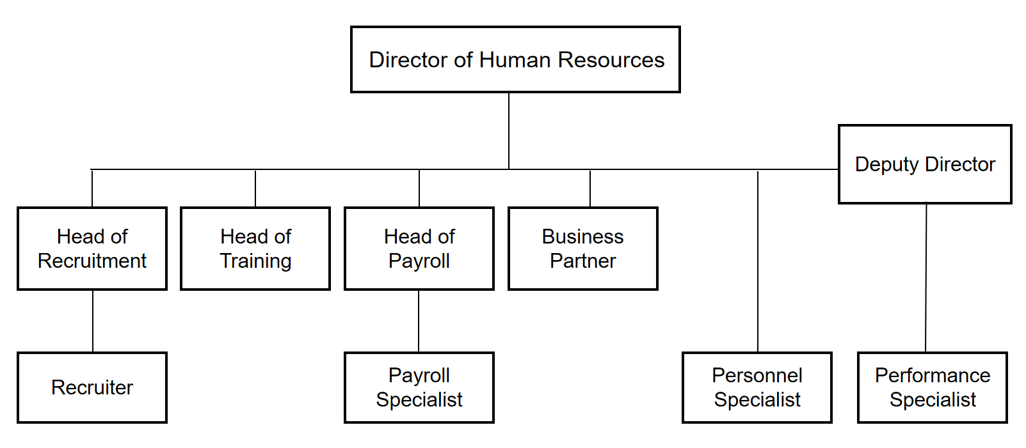
Figure 1 Organization Chart of Human Resources Department

3 Optimize recruitment and selection
As a high-tech enterprise, Hangsheng wants to obtain high-quality research and development personnel. Recruitment plays a key role, which can effectively reduce training costs and improve the overall quality of the organization. Anwar and Surarchith(2015) proposed that recruitment is a process of identifying or selecting and hiring the best qualified candidates from both internal and external sources. These potential candidates have the ability to help the organization achieve its goals (Othman et al, 2019). Enter the selection stage and select the right person for the position through targeted assessment and interview (Abdullah and Abdul Rahman, 2015). On the contrary, when employees introduce recruitment problems such as low quality or too long recruitment cycle, it will directly affect the department performance, thus causing the possibility of brain drain, reducing the stability of the team, in turn increasing the difficulty of human resources management and forming a negative cycle. Therefore, recruitment, as the first step in talent selection, should be a priority area for Hangsheng to improve.

3.1 Analysis of Shortages in the Recruitment and Selection of Hang Sheng

3.1.1 Incomplete recruitment and selection process
Funnel model is a methodology that can be applied universally. Its essence is to decompose and quantify, and achieve the goal through the form of quantification. The personnel selection funnel model includes the following five levels of "filters" (Zhong, 2018).
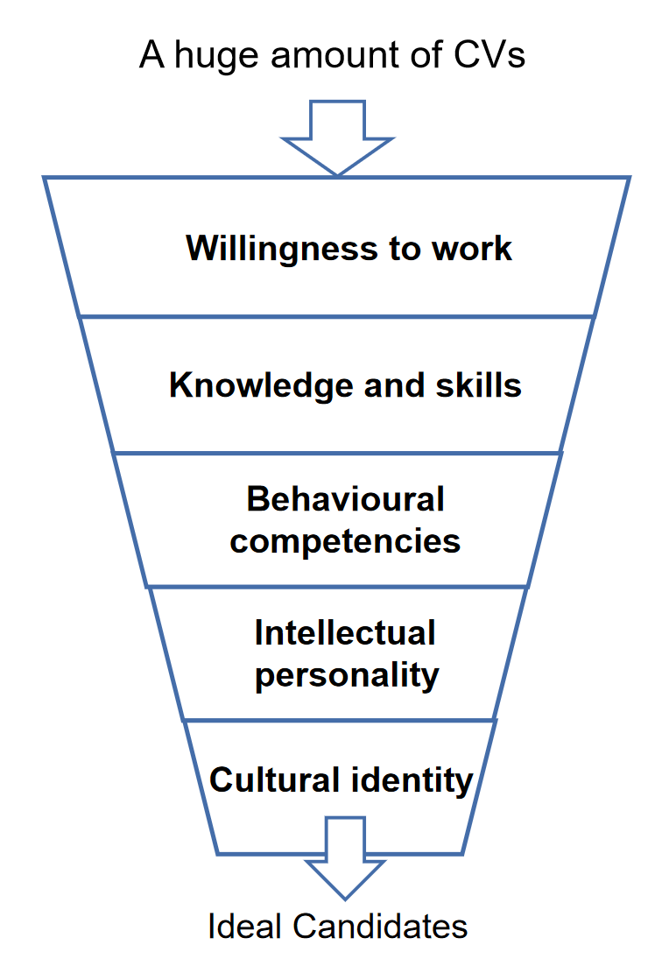
Figure 2 Funnel Model
In the model, the work willingness level investigates whether they are willing to work in Hangsheng, and then filters them through resumes and interviews in terms of knowledge and skills. However, due to the lack of understanding of the business-level needs of the staff recruited by Hangsheng, it is difficult to evaluate the candidates' abilities from a business perspective. In addition, I learned from the interview that in order to achieve their own performance goals, the recruiters had a high pass rate in the initial examination. In the investigation of behavior ability, Hangsheng did not have enough recruitment specialists to understand the job applicants' past work behavior and daily behavior performance level. In addition, the interviewers in the business department have insufficient skills, have not formed structured interviews, are unfamiliar and unprofessional, lack certain evaluation indicators, and are mainly evaluated by individuals. Too strong subjectivity leads to a decrease in scientificity and fairness. This not only reduces the applicant's favorable impression and identification with the company, but also reduces the effectiveness of the overall recruitment. Finally, there is basically no effect on the filtering layer of intelligence, character and cultural identity, or, to be precise, no energy filtering.

3.1.2 Lack of competency model for key positions
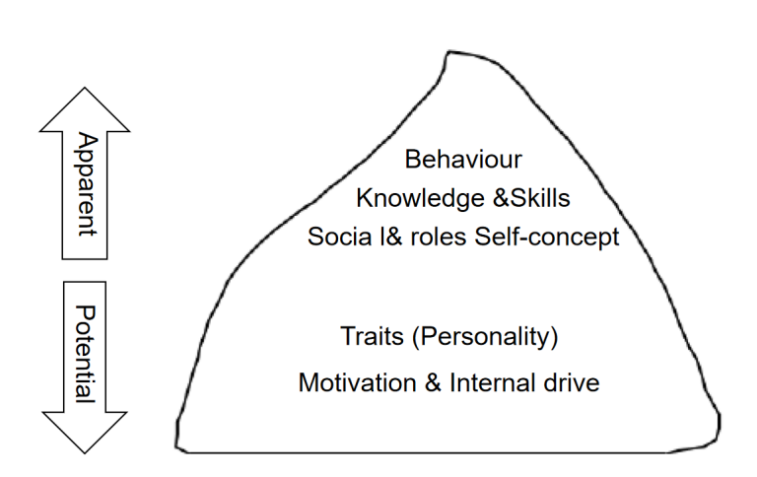
Figure 3 Competency iceberg model
The iceberg model proposed by American psychologist McLelland in 1973, in which knowledge and skills are an explicit feature (Luo,2018), and the recruiter of Hangsheng can measure this apparent quality by examining the form of qualification certificate, examination, resume, etc. However, social roles and self-concept traits and motivations are intrinsic and difficult to measure through one examination or communication. Moreover, these traits are relatively stable and are not susceptible to changes from the outside world. However, they play a crucial role in human behavior and performance (Uzair et al,2017). Especially, at present, there is no competency model for key positions in the recruitment of Hangsheng, which directly affects the progress of some projects. The interview process lacks a summary of the job competency, and there is no internal evaluation benchmark, so only through the unstructured interview, the potential quality can only be inferred from the part revealed by the candidates. In addition, the assessment criteria may be changed every time, resulting in the uneven level of recruitment of staff by Hangsheng (Dong,2018).

3.1.3 Lack of perfect people-organization fit assessment
With the general trend of flexible human resources management, many organizations and researchers tend to pay attention to the theory of people-organization fit (Kristof, 1996). On the one hand, the theory of people-organization fit emphasizes the match between the staff's ability and the specific job requirements, on the other hand, it also emphasizes the match between the internal characteristics of the staff and the potential characteristics of the organization (Zhang, 2010). The theory includes five aspects: values, ability, needs, goals and personality. It is a means to test whether a candidate matches his position and organization. However, the current assessment of Hangsheng lacks an assessment of the candidates' deep values, personalities, interests, etc., which results in some employed employees having professional skills and abilities that match, but are difficult to integrate into the team. They are isolated due to lack of communication with team members (Qin et al, 2018) and finally leave the company. This will affect the cohesion of the team and the normal development of the work, and increase the loss rate of personnel (Appelbaum,2020).

3.3 The impact of inadequate recruitment and selection on the performance of the organization
The defects mentioned above have directly affected the level of staff of Hangsheng and the efficiency of talent selection, resulting in the impact on the efficiency and reputation of the enterprise. First, the matching degree and satisfaction degree of the talents recruited by Hangsheng are low. It is possible to miss out on the real talent the enterprise needs, wasting resources and time (Guo,2018). Secondly, Hangsheng did not pay enough attention to recruitment and even human resources management, which could not motivate the work enthusiasm of the department and directly affected the quality and efficiency of talent recruitment. The level of personnel does not meet the requirements expected by the business department, which will greatly affect the output of research and development results. While the release cycle of new products is prolonged, the product performance advantages are difficult to be separated from peers, and it is not competitive enough, thus affecting the improvement of organizational performance (Münstermann et al, 2010). In addition, the recruitment and selection process does not form a whole, lacks clear evaluation indicators and is too subjective, which leads to a decrease in scientificity and fairness. This not only increases the possibility of recruitment errors, but also reduces the effectiveness of the overall recruitment. It also seriously affected the professionalism and recruitment experience of Hangsheng's recruitment work, and ultimately affected the brand building. A loss of brand reputation may not be a loss of performance.

3.4 Benefits to Stakeholders from Improved Recruitment and Selection
On the one hand, improving the recruitment system of Hangsheng and achieving a good operation of the recruitment process can provide a smooth path for the company's talent input. Under the condition of controlling the recruitment cost, help the enterprise to attract and recruit high-quality talents quickly and improve the operation efficiency of the enterprise. Secondly, when the level of staff introduced by Hang Seng is higher than that of its peers, the technical level will be correspondingly improved, which will make Hangsheng more competitive in the industry (Berge and Berger, 2018). On the other hand, it helps to diversify the workforce and improve the matching degree of the employees and the satisfaction degree to Hangsheng. In the process of loyalty promotion, the turnover rate of staff is reduced and the cohesion of the enterprise is enhanced. For consumers, better talents can provide them with products and services with better performance and a better consumption experience, thus enhancing the image of the enterprise and attracting more potential consumers. At the same time, if the products are more popular, the profitability will be improved (Hamza et al, 2021) and shareholders will be more supportive and trusting of the operators of Hangsheng. Finally, for the public, improving the recruitment and selection process will enable them to obtain more fair employment opportunities in Hangsheng.

4 Conclusion
In the report, Hangsheng was briefly introduced. It was clear that having high-performance talents under the background of the times was the most important driving force for any organization to achieve high performance targets and the driving force for maintaining lasting competitiveness. Based on the experience during the internship, the research of relevant information and the interview results of the staff, it is determined that recruitment and selection are the priority areas that need to be improved by Hangsheng. Combining with funnel model, iceberg model and the theory of people-organization fit, it is studied to analyze the deficiencies in the recruitment and selection of Hangsheng. First, the recruitment management process of Hangsheng is not perfect, and the candidate's character and cultural identity cannot be understood. The lack of clear criteria in the implementation of "filtering" results in different requirements in the implementation process. Secondly, there is no competency model for key positions, and the existing assessment methods are lack of judgment for hidden characteristics, motivation and internal drive. Then, the person-organization fit was not fully considered, and the candidate's situation was checked unilaterally, but it was not matched in the environment, which brought some hidden dangers to the personnel stability within the organization. One of the key factors running through these deficiencies is the shortage of recruitment staff, which makes human resources analysis and channel development have no energy to carry out, and communication with business departments is not sufficient, so that the demand for talents is not accurately grasped.

5 Recommendations

5.1 CCCE model
In order to comprehensively define the "quality" of the expected talents for Hangsheng, the adaptability to the new environment is integrated on the basis of the CCC Extended Competency Model (Ulrich and Small Wood,2012). This paper investigates the product effect of CCCE, which consists of four factors: contribution, competence, loyalty and adaptability to the new environment, and considers that each factor in talent evaluation has irreplaceable independent value (Hou, 2017). However, in order to comprehensively evaluate these four factors, the Human Resources Department of Hangsheng is bound to devote more time and energy to examining the candidates' achievements, assessing the sum of congenital and acquired talents, and judging the employees' willingness to work hard and adaptability in combination with the STAR principle. It will significantly increase the cost of manpower and time, but it is feasible to increase the number of recruiters and prevent the performance of individuals from falling sharply due to too many tasks (Lin and Shih, 2008).
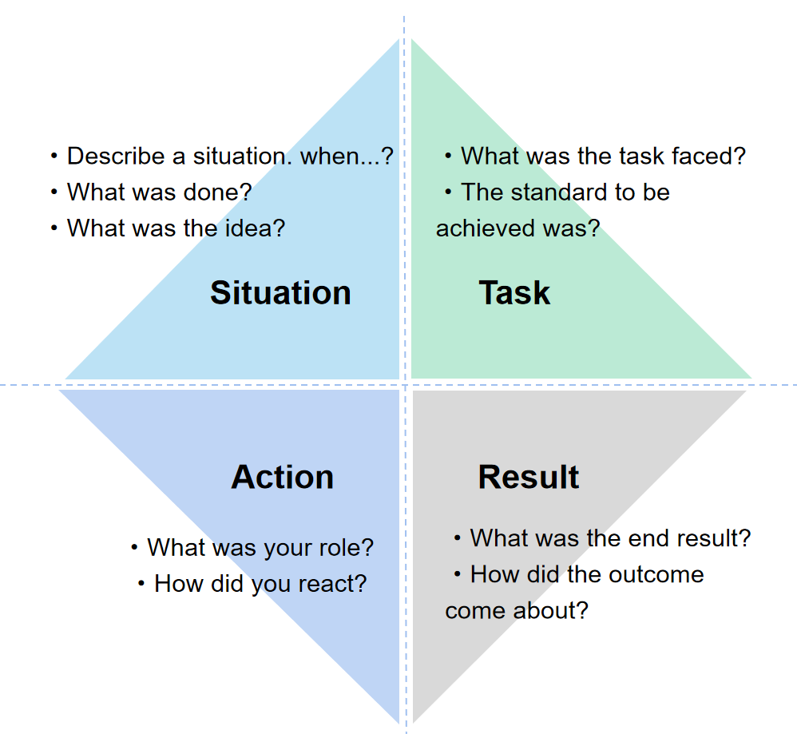
Figure 4 STAR Interview Principles
In addition, building competency model for key positions is the basis of accurate recruitment (Michibayashi, 2016). Select the position where Hangsheng is most relevant to the product development progress, i.e. the project management manager, to construct the competency model. First, the HR department should be familiar with the product development process based on the in-depth understanding of the corporate culture of Hangsheng, and then analyze the project manager position to identify the key tasks of the position. At the same time, according to the model, a structured interview question database is designed. Established evaluation criteria can reduce the possibility of making subjective judgments. However, in the process of building the model, multi-department coordination is required. If only the human resources department is doing this, is the model finally built applicable to all institutions?

5.2 Person-Position-Organization Matching
Based on the theory of people-organization fit, this paper evaluates the degree of correspondence between the candidate's own values and Hangsheng's perception of values, and the match between ability and quality and work requirements (CIPD, 2015), so as to give full play to talents' potential and achieve the goal of organizational development. Incorporate behavioral insights into recruitment and selection processes. First, recruiters should match the applicant type (Tokar and Swanson, 1995) with Holland's volatile interest classification to identify their suitable positions and the matching degree with Hangsheng. At the same time, based on the principle of "advantage positioning and dynamic adjustment", the candidates who are most suitable for this position are matched, not only those with high academic qualifications. Second, following a structured selection process, recruitment decisions should be firmly based on data rather than intuition. However, insight into the types and motivations of a large number of candidates will take up a lot of time and waste it. Only when artificial intelligence is considered to complete this step can recruiters have more energy to make decisions based on the results of data feedback (Soban, 2017).
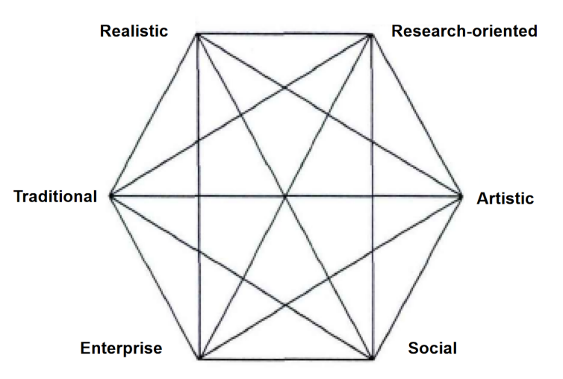
Figure 5 Holland’s volcational interest classification

5.3 AI in HRM
Digital innovations have revolutionized the way employers approach potential job seekers (CIPD, 2015), helping to increase satisfaction in employee well-being and among participants. Time-consuming tasks such as screening and preliminary assessment using AI. For candidates with high matching degree, they can intelligently retrieve their past experience, and use neural language to interact with the candidates through audio-visual and text methods (Akash and Anusha, 2018), feed back the analysis results and score. Recruiters only need to focus on setting goals, tracking progress and making data-driven decisions (CIPD, 2021) to achieve efficient and rapid evaluation. In addition, chat robots enable rapid response to emails or messages, improve the candidate experience and are more likely to attract and retain top talent (Burgess, 2018).
Of course, large-scale application of AI may face cost problems and moral hazard in recruitment. The wide application of AI is limited by capital. Whether the talent income obtained from investment in AI is directly proportional to the investment needs to be considered in the department strategic planning. In addition, although data-driven tools can improve processes and correct human bias, they do not inherit ethics or morality (CIPD,2021), and there are legal risks in intelligently retrieving candidates' experiences. These issues need to be weighed in the departmental strategic planning. After all, the staffing challenge of using AI technology is disruptive and always takes time to mature.

6 Reference list
Abdullah, N. N.and Abdul Rahman, M. (2015) ‘The Degree of Openness in Turkey's Public Expenditure’, International Journal of Administration and Governance, 12(1), pp. 8-12.
Akash, B. & Anusha, D. K. (2018) ‘Recruitment Chatbot’, International Research Journal of Engineering and Technology, 5(8), pp.1248-1250.
Amankwah-Amoah, J., Ifere, S.E. and Nyuur, R.B. (2016) ‘Human capital and strategic persistence: An examination of underperforming workers in two emerging economies’, Journal of Business Research, [online] 69(10), pp. 4348–4357. Available at: https://www.sciencedirect.com/science/article/pii/S0148296316302259.
Albert, E. T. (2019) ‘Ai in talent acquisition: a review of ai-applications used in recruitment and selection’, Strategic HR Review, 18(5), pp. 215-221.
Anwar, G. and Abdullah, N. N. (2021) ‘Inspiring future entrepreneurs: The effect of experiential learning on the entrepreneurial intention at higher education’, International Journal of English Literature and Social Sciences, p. 6.
Anwar, G. and Surarchith, N. K. (2015) ‘Factors Affecting Shoppers’ Behavior in Erbil, Kurdistan–Iraq’, International Journal of Social Sciences & Educational Studies, 1(4), p. 10.
Appelbaum, N. P., Lockeman, K. S., Orr, S., Huff, T. A., Hogan, C. J., Queen, B. A., & Dow, A. W. (2020) ‘Perceived influence of power distance, psychological safety, and team cohesion on team effectiveness’, Journal of interprofessional care, 34(1), pp. 20-26.
Berger, L.A. and Berger, D.R. (2018) The talent management handbook. New York: Mcgraw-Hill Education.
Burgess, A. (2018) ‘AI in Action’, In The Executive Guide to Artificial Intelligence, pp. 73-89, Palgrave Macmillan, Cham.
CIPD. (2015) A head for hiring: the behavioural science of recruitment. Available at: https://www.cipd.co.uk/knowledge/culture/behaviour/recruitment-report (Accessed: 21st August 2015).
CIPD. (a)(2021) Technology and the future of work. Available at: https://www.cipd.co.uk/knowledge/work/technology/emerging-future-work-factsheet (Accessed: 6th January 2021).
CIPD. (b)(2021) Using technology to improve hiring and onboarding. Available at: https://www.cipd.co.uk/knowledge/work/technology/digital-transformation-insights/improve-hiring-onboarding (Accessed:13th August 2021).
Dong, K. Y., Li, C. P. (2018) Introduction to Human Resource Management. Renmin University of China Press.
Guo, H. (2018) ‘The Formation of Highly-Cooperative Organizational Climate Considering Impacts of Organizational Commitment and Team Cohesion’, Advances in Economics, Business and Management Research, 58, pp. 431-434.
Hamza, P.A., Othman, B.J., Gardi, B., Sorguli, S., Aziz, H.M., Ahmed, S.A., Sabir, B.Y., Ismael, N.B., Ali, B.J. and Anwar, G. (2021) ‘Recruitment and Selection: The Relationship between Recruitment and Selection with Organizational Performance’, International Journal of Engineering, Business and Management, 5(3), pp. 1–13.
Hangsheng (2021) Key Technology, Development Trend and Market Judgment of Intelligent Cabin [video]. Available at: https://www.bilibili.com/video/BV19f4y1E7W1/ (Accessed: 29 September 2021).
Hangsheng. (2022) Overview of domestic market capbilities. Available at: http://www.hangsheng.com.cn/col.jsp?id=131 (Accessed: 19th March 2022).
Hou, J. Y. (2017) Research on Service Supply Chain and Talent Evaluation Model. Unpublished PhD thesis. Hefei University of Technology.
Hmoud, B.and Laszlo, V. (2019) ‘Will artificial intelligence take over human resources recruitment and selection’, Network Intelligence Studies, 7(13), pp. 21-30.
Kristof A．L. (1996) ‘Person—organization fit：An Integrative Review of its Conceptualization, Measurement, aIld Implications’, Personel Psychology, 49(1),pp. 1~49．
Lin, H.-C. and Shih, C.-T. (2008) ‘How Executive SHRM System Links to Firm Performance: The Perspectives of Upper Echelon and Competitive Dynamics’, Journal of Management, 34(5), pp.853–881.
Luo, J. (2018) ‘Construction on Vocational Competency Model for Tourism Talents in Intelligent Tourism Era’, International Conference on Education, Sports, Arts and Management Engineering, pp. 234-239(Accessed: 3rd July 2018).
Martin, G., Gollan, P.J. and Grigg, K. (2011) ‘Is there a bigger and better future for employer branding? Facing up to innovation, corporate reputations and wicked problems in SHRM’, The International Journal of Human Resource Management, 22(17), pp.3618–3637.
Michibayashi, C., Omote, S., Nakamura, M., Okamoto, R. and Nakada, A.I. (2019) ‘Competency model for public health nurses working on tobacco control in local governments in Japan: A qualitative study’, Japan Journal of Nursing Science, 17(1).
Münstermann, B., Eckhardt, A., & Weitzel, T. (2010) ‘The performance impact of business process standardization: An empirical evaluation of the recruitment process’, Business Process Management Journal.
Othman, B. J., Al-Kake, F., Diah, M. L. M., Othman, B., and Hasan, N. M. (2019) ‘This study examines the antecedents and the effects of knowledge management and information technology in the manufacturing industry’, International Journal of Psychosocial Rehabilitation, 23(02).
Qin, C., Zhu, H., Xu, T., Zhu, C., Jiang, L., Chen, E., & Xiong, H. (2018) ‘Enhancing person-job fit for talent recruitment: An ability-aware neural network approach’, In The 41st international ACM SIGIR conference on research & development in information retrieval, June, pp. 25-34.
Soban, M. (2017) ‘21st Century Staffing: The wave of artificial intelligence in recruitmentip’, Talent Acquisition Excellence Essentials. Available at: https://www.proquest.com/docview/2043508044?accountid=130472&forcedol=true# (Accessed: 17th Noverber 2017).
Tokar, D. M., & Swanson, J. L. (1995) ‘Evaluation of the correspondence between Holland′ s vocational personality typology and the five-factor model of personality’, Journal of vocational behavior, 46(1), pp. 89-108.
Ulrich, D. and Smallwood, N. (2011) ‘What is talent?’, Leader to Leader, 2012(63), pp. 55–61.‌
Uzair, S., Kanwal, S., & Haleem, R. (2017) ‘The use of social media in the recruitment process: A study on Karachi’, International Journal of Multidisciplinary and Current Research, 5, pp.360-364.
Zhang, H. Q. (2010) ‘Discussion on the control and optimization of recruitment process from the dilemma of recruiting talents’, China's human resources development，2010（4）, p.238.
Zhong, X.B. (2018) Design and Implementation of Cloud Recruitment System for Software Outsourcing Enterprises Based on Funnel Model. Unpublished PhD thesis. Wuhan University of Light Industry. DOI:10.27776/d.cnki.gwhgy.2018.000033.

