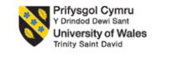
STRATEGIC MANAGEMENT AND SUSTAINABILITY
COMPONENT 2: COURSEWORK: WRITTEN REPORT
Student Name: Silviu Pirvu
Student ID:2315010
Executive Summary
This report has focused on strategic management and its importance in business organisations around the world. This report, therefore, has focused on Toyota and the way it is implementing different strategic formulations in its business operation. It has analysed the mission, vision, and objectives of Toyota. Following the same it has analysed the current business performance of this organisation around the world. Based on this analysis it has tried to evaluate whether the organisation is aligning with its external environment and internal environment and if the organisation is taking proper measures for the same. In such a way it has evaluated the strategic formulations Toyota is taking and its result in its performance. Based on the overall analysis this report has identified some recommendations which can enhance its business performance and sustain more clients irrespective of changing consumer preferences.

1.0 Introduction
Strategic management can be determined as the continuous process which includes planning, monitoring, and analysing the organisational goals, resources and environment in order to achieve long-term success. It helps the business organisations to implement a proactive and structured approach for a better defined direction, optimising resource allocation to ensure sustainable growth and fostering competitive advantage (Rêgo et al., 2022). WIth the involvement of strategic management business organisations can have better understanding of external environments and internal capabilities through which they become able to define the mission, vision and objectives that influence the flexibility of changing market conditions and threats.
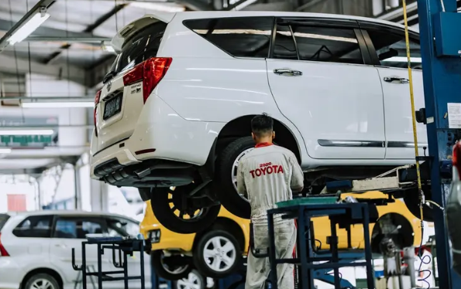
Figure 1: Toyota
(Source: Global, 2024)
The key benefits of using strategic management can be found in improving market share, profitability and overall organisational goal. It is also important to identify potential risks and its solutions to ensure its success. Implementation of strategic management is also important for aligning resources with organisational goals to maximise its efficiency.
This report, therefore, is going to focus on analysing the vision and mission of Toyota following which it will also analyse its current performance along with its external and internal environment. Based on the overall analysis, this report will find out some recommendations which will help Toyota to identify and resolve its current issues.

2.0 Background of the organisation
Toyota Motor Corporation was founded in 1937 in Japan. Headquartered in Toyota City, Japan, Toyota is a leading global automobile manufacturer that operates under a product-based and decentralised matrix structure. Employing around 383,853 consolidated employees, it emphasises “Kaizen” and the “Toyota Production System” to manage production along with five main brands that includes Toyota, Daihatsu, Lexus, Century, and Hino.

Figure 2: Headquarter of Toyota
(Source: Global, 2026)
It also uses a technology known as Pirus or pioneering hybrid technology. It produces more than 200 million vehicles while focusing on luxury, diverse vehicles and future mobility solutions. Known for its high “quality, durability and reliability” or QDR, Toyota has ranked consistently among the top global automakers. Currently, Toyota has its manufacturing plants and retail shops in more than 170 countries. TKM or “Toyota Kirloskar Motor” is a joint venture between Toyota and India that focuses on popular SUV and MPV segments (Toyotabharat, 2026).

3.0 Strategic Intent

3.1 Vision
Toyota’s organisational vision is to “lead the way to the future of mobility, enriching lives around the world with the safest and most responsible ways of moving people” (Global, 2026). Its vision is centered on “Happiness and Mobility for All” through which the organisation can focus on ceaseless innovation, sustainability and creating a better planet.

3.2 Mission
The core mission of Toyota is “Producing Happiness for All” with an aim of going beyond manufacturing vehicles in order to create “mobility for all” (Global, 2026). In this way Toyota focuses on sustainable, safe, and innovative transportation solutions through which it can enrich lives and improve society along with prioritising its quality and creating a better planet.

3.3 Objectives
The core organisational objectives of Toyota has identified below,
- It is aimed to achieve carbon neutrality in its manufacturing plants by 2030. Following the same it is also aimed to reduce vehicle life cycle emissions by 50% within 2035 and become an environmental leader through this way (Global, 2026).
- It is also aimed at shifting to a mobility company from a purely car manufacturer by offering services like AI and connected cities.
- With an aim of reaching zero accidents the company is planning to enhance safety technologies for both pedestrians and vehicles.

4.0 Current Performance of the organisation
Currently, Toyota is experiencing a record-breaking business performance with a selling record of 11.3 million vehicles around the world in 2025. It has retained its position as the top-selling automaker of the world for the sixth consecutive year. Despite managing high profits Toyota has faced some certification issues in 2025. However, upon managing those the organisation remained financially robust due to strong sales in Japan and the USA (Toyota-Europe, 2026). Focusing on early financial year 2025 it can be seen that Toyota has remained the top-selling automaker position in the global position as mentioned before. Following the same it has ensured significant growth of around 40% in India in 2024 (Global, 2024). However, in the same financial year, the operating margin of Toyota was 10% which is slightly lower than 2024 that is 11.9% which is still healthy.
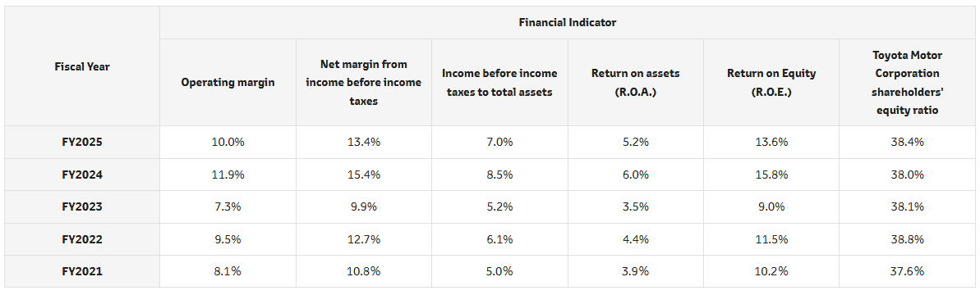
Figure 3: Financial Performance
(Source: Global, 2025)
Looking at its popularity it seems the company has high demand for its hybrid vehicles mainly in North America. However, currently the organisation is facing scrutiny for a slower adoption of full electric vehicles compared to its rivals. It is focusing on a “multi-pathway” strategy rather than electric vehicles which also includes fuel cells and hybrids. In the financial year 2024 and 2025 Toyota has achieved its best performance with 3, 37,148 units sold with a 28% growth. Irrespective of several challenges like slow growth in EV development and certification misconduct Toyota has successfully reduced its operating cost which is improving its global market position (Global, 2026).

5.0 Strategic Analysis of the organisation

5.1 Porter’s 5 Force Analysis
Factors | Analysis | Impact
Rivalry among competitors | Being a saturated market the European automobile market includes various European and international automobile brands which creates a strong competitive market atmosphere for Toyota. This market has various well-established players such as BMW, Volkswagen, Stellantis, and Mercedes-Benz which is increasing the competition of Toyota in terms of technology, pricing and market share (Globaldata, 2026). | High
Bargaining power of suppliers | Key suppliers of Toyota are the providers of batteries and semiconductors. However, this is concentrated among few suppliers based on their qualities which is giving them the leverage to increase their bargaining power. Long-term partnerships, and massive scale of Toyota helps Toyota to mitigate the issues. | Moderate
Bargaining power of buyers | Customers indeed have a significant number of options when it comes to purchasing cars along with a wide range of varieties. They can easily develop a comparison before purchasing one. As the price range is sensitively high and the countries in times of economic downturns consumers usually go for the cheaper one. This can increase the bargaining power of buyers. | High
Threats of new entrants | Toyota is indeed one of the most prominent automotive companies in the global spectrum and so as in Europe. Indeed with this immense popularity, massive capital investment, complex distribution networks, established supply chains and product variation creates high barriers to entry of new entrants in this market (Trendlyne, 2026). | Low
Threats of substitutes | The main substitute of this automotive company is the used car market. Increased focus on public transport, urban mobility, and car-sharing services in Europe is acting as a moderate threat of Toyota (Global, 2025). | Medium
Table 1: Porter’s Five Forces Analysis
(Source: Self-created)
From the overall analysis it can be understood that through its operational strategy Toyota has established a strong brand equity for reliable hybrids which acts as a significant differentiator against its high-end competitors. Its high-price volatility mainly for its battery materials requires Toyota to implement strong sourcing strategies. Hence, it is important for the brand to rethink its strategies in some areas to improve its operation and performance.

5.2 SWOT Analysis
Strengths  - It has a strong brand reputation with its strong recognition in reliability, quality and safety that supports a high-valued brand image.  - Being one of the largest global automobile manufacturers, it has a massive production and wide sales network.  - Toyota invests significantly in research and development with a total investment around 10.2 billion in 2023 in their hydrogen fuel cells, electric vehicles and software-defined vehicles (Global, 2026).  - Its TPS or Toyota Production System has reduced waste and improved efficiency. | Weaknesses  - Frequent product recalls are damaging brand reputation and incurred costs.  - Heavy reliance on suppliers are slowing the production process and also creating supply chain bottlenecks.  - Toyota has limited scope for market penetration in specific emerging markets and segments (Du, 2023).  - Large-scale manufacturing of Toyota requires fixed costs which is also reducing profitability during its sales drop.
Opportunities  - Toyota is increasing its investments and also expanding the product line to capture more in growing EV segments.  - Toyota is expanding in developing nations where demand for cars is increasing.  - Toyota is leveraging technological partnerships to develop autonomous driver systems (Hong, 2024).  - Partnerships with different firms are boosting technological development of Toyota and reaching new market segments. | Threats  - Toyota is facing intense competition in the global automotive market from General Motors, Volkswagen and others.  - The global economic environment is significantly diminishing customer purchasing power.  - Due to increased material costs are affecting profit margins negatively.  - Due to global economic volatility Toyota is facing significant issues.  - It is also facing disrupted manufacturing processes and supply chain issues due to national disasters in many countries.
Table 2: SWOT Analysis
(Source: Self-created)

6.0 Strategic Formulation to understand its strategic choices
Looking at the strategic formulation of Toyota it can be seen that the organisation mainly focuses on maintaining a global relationship with the help of hybrid approach of cost leadership and differentiation strategy. In such a way it focuses on long-term and stable growth along with sustainable mobility.
Toyota is leading towards the future mobility society through which the company is trying to enhance the lives through responsible, safe and sustainable transport. Toyota is also focusing on rigorous assessment of global emission regulations which is shifting consumer preference towards electric vehicles and intense competition (Thomasnet, 2024). The company is now leveraging high-quality manufacturing along with its TPS efficiencies which is building a strong brand reputation for Toyota in the international market.
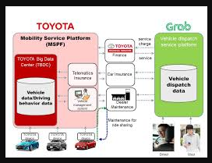
Figure 4: Strategic Plan of Toyota
(Source: Thomasnet)
Looking into strategic choices of Toyota it seems the organisation mainly operates through a multi-level strategic approach. It focuses on sustainable practices and expanding the business in new mobility services along with t reducing waste through Muda strategy. Focusing on business level it seems Toyota utilises TPS to reduce its production costs which is making their vehicles affordable. This will help the brand to enhance customer loyalty and attract new customers at the same time. Following the same it is also focusing on hybrid technology such as Prius and hydrogen fuel cells or Mirai which are helping the brand to enhance quality and reliability to justify the premiumness of the brand. Focusing on its functional level strategies it seems Toyota utilises “Just-in-Time” or JIT production system to manage inventory which is combined with Kaizen for continuous improvements. Toyota implements a comprehensive strategy which integrates digital channels and traditional channels to highlight eco-friendly initiatives of the organisation (Vanichchinchai, 2022). Toyota is investing a huge amount in connected vehicles, autonomous driving and battery technology to future-proof the product lineup. Finally, Toyota is localising the production system in its operating countries. It helps Toyota to reduce logistical costs and respond to local needs.

7.0 Conclusion and Recommendation

7.1 Recommendation
Based on the overall analysis this report has identified some recommendations which can improve the condition of Toyota for better organisational performance. The recommendations have been identified below.
- Toyota should target accelerating electrification in its cars to attract more customers and retain their loyalty. In this regard it should implement an aggressive development plan for next-generation solid-state batteries to become more competitive in the market (Vanichchinchai, 2022).
- Moving beyond traditional manufacturing Toyota needs to focus on digital marketing and software transformation. Along with that it should also pivot towards “software-defined vehicles” by utilising AI, improving software capability and increasing business partnerships.
- Toyota also needs to form alliances to ensure stable essential component supply mainly for battery materials which will help the organisation for risk mitigation and securing production.

7.2 Conclusion
Concluding the report it can be said that being one of the most popular global automotive business organisations Toyota goes through several turmoil in the global business market. This report has tried to evaluate the vision and goals of the organisations following which it has analysed whether the company is focusing on proper strategic formation. In this regard it has analysed both internal and external environments and its strategic formation through which Toyota is trying to expand in more countries.

Reference List
Du, Y., (2023). Business Analysis of Toyota Based on Enterprise Value Multiple and PEST Analysis. BCP Business & Management, 37, pp.401-406.
Global, (2024). FINANCIAL SUMMARY. Available at: https://global.toyota/pages/global_toyota/ir/financial-results/2024_4q_summary_en.pdf. [Accessed on: 13.4.2026]
Global, (2025). Financial Highlights & Financial Performance. Available at: https://global.toyota/en/ir/finance/#:~:text=Sustainability%20Bond-,Toyota%20Report,and%20ROE%20(Return%20on%20Equity) [Accessed on: 13.4.2026]
Global, (2026). Overview. Available at: https://global.toyota/en/company/profile/overview/. [Accessed on: 13.4.2026]
Global, (2026). Toyota Announces $1 Billion Investment in Kentucky and Indiana Plants. Available at: https://global.toyota/en/newsroom/corporate/44129928.html. [Accessed on: 13.4.2026]
Global, (2026). Toyota Global Vision. Available at: https://global.toyota/en/company/vision-and-philosophy/global-vision/#:~:text=and%20customer%20satisfaction.-,Ceaseless%20innovation,eco%2Dfriendly%20systems%20and%20solutions. [Accessed on: 13.4.2026]
Global, (2026). Toyota Global Vision. Available at: https://global.toyota/en/company/vision-and-philosophy/global-vision/. [Accessed on: 13.4.2026]
Globaldata, (2026). Toyota Motor Corp: Competitors. Available at: https://www.globaldata.com/company-profile/toyota-motor-corp/competitors/. [Accessed on: 13.4.2026]
Hong, J., (2024). Competitive Strategies and Market Positions of Global Automotive Giants: Toyota, Tesla, and BMW. In International Conference on Educational Information Technology (Vol. 6, No. 2).
Rêgo, B.S., Jayantilal, S., Ferreira, J.J. and Carayannis, E.G., (2022). Digital transformation and strategic management: A systematic review of the literature. Journal of the Knowledge Economy, 13(4), pp.3195-3222.
Thomasnet, (2024). Behind the Toyota Supply Chain. Available at: https://www.thomasnet.com/insights/behind-the-toyota-supply-chain/. [Accessed on: 13.4.2026]
Toyotabharat, (2026). Toyota Advantage. Available at: https://www.toyotabharat.com/toyota-in-india/about/#:~:text=Toyota%20has%20a%20reputation%20for%20quality%2C%20durability%2C,first**%20*%20**Developing%20a%20more%20sustainable%20future**. [Accessed on: 13.4.2026]
Toyota-europe, (2026). Toyota vision and philosophy. Available at: https://www.toyota-europe.com/about-us/toyota-vision-and-philosophy#:~:text=Our%20Mission:%20Happiness%20for%20All,next%20100%20years%20and%20beyond. [Accessed on: 13.4.2026]
Trendlyne, (2026). Toyota Motor Corporation – ADR. Available at: https://us.trendlyne.com/us/fundamentals/peer-group/1404968/TM/toyota-motor-corporation-adr/#peer-group. [Accessed on: 13.4.2026]
Vanichchinchai, A., (2022). The effects of the Toyota Way on agile manufacturing: an empirical analysis. Journal of Manufacturing Technology Management, 33(8), pp.1450-1472.

