
Programme Name: Master of Business Administration
Module Name: Dissertation
Module Code: LCMB7035
Title of the Dissertation: Investigating the Role of Microfinance in Promoting Women’s Economic Empowerment and Decision-Making in Rural India
Student Name: Abhishek Manishkumar Parekh
Student ID: 2427476
Name of the Lecturer: Isaiah Oino
Word Count: 14907
Date of Submission: 2nd February 2026



Master’s Degrees by Examination and Dissertation
Declaration Form.

I, Name, declare that this dissertation has been composed by myself, that the work contained herein is entirely my own except where explicitly stated otherwise in the text, and that this work has not been submitted for any other degree or qualification, in whole or in part, except as specified.

Signature: …Abhishek Manishkumar Parekh……………

Date: 02.02.2026

Abstract
This research examines the effects of microfinance on women's economic empowerment and decision-making in rural India, an area where financial services are not easily accessible. Women's empowerment is essential for sustainable development, and microfinance has been identified as a possible enabler. The research explores the determinants of empowerment outcomes, such as loan amount, interest rate, and training provided. The literature review shows a complex relationship between microfinance and women's empowerment, emphasising the need for social capital, group cohesion, and training in business.
A primary research method is used, integrating quantitative and qualitative information gathered from 75 women participants in microfinance programs. Regression analysis using SPSS explores the correlation between microfinance variables and empowerment outcomes. The results show that the purpose of borrowing microfinance loans and the effect of microfinance on empowerment are important positive predictors of women's empowerment. The analysis chapter sheds light on the analysis of survey-leveraged data from women around the rural segments of India. The results indicate that microfinance interventions make a significant contribution to women's empowerment, designed to meet their needs and requirements. The research concludes that microfinance is an effective instrument for women's empowerment in rural India, improving their decision-making authority and socio-economic conditions.

Acknowledgement
I would like to express my deepest gratitude to the participants, microfinance institutions, and organisations that contributed to this research concerning the role of microfinance in advancing women's economic empowerment and decision-making in rural India. Their willingness to participate in this research has been instrumental in bringing light to this critical issue. I also wish to express gratitude to the data collection team and the research team that worked hard to gather data for a comprehensive understanding of this issue in women's lives. I would also want to deliver a special thanks to my classmates and professors who guided me and cheered me up throughout this research.

Table of Contents
Chapter 1: Introduction 8
Research background 8
Research significance 9
Research problem 10
Research aims and objectives. 10
Research Questions 11
Research rationale 11
Research structure 12
Chapter 2: Literature Review 13
2.1 Introduction 13
2.2 Identification of the internal relationship of women's empowerment and decision-making with the development of microfinance in rural India 13
2.3 Strategies undertaken to develop microfinancing in rural India to promote women's empowerment and decision-making 16
2.4 Determination of different factors that affect microfinance in rural India in enabling women's empowerment and the decision-making process 18
2.5 Identification of the challenges of developing microfinancing in rural India 21
2.6 Determination of the impact of different challenges of microfinancing in rural India on women's empowerment 23
2.7 Recommendations for improving microfinance to boost women's welfare in rural India 25
2.8 Conceptual Framework 28
2.9 Literature Gap 50 Rup 29
2.10 Conclusion 29
Chapter 3: Research Methodology 31
3.1 Introduction 31
3.2 Research Onion 31
3.3 Research Philosophy 32
3.4 Research Strategy 33
3.5 Research Design 34
3.7 Methodological Choice 35
3.8 Data Collection Method 35
3.9 Data Analysis 36
3.10 Population and Sampling 37
3.11 Ethical Considerations 37
3.12 Conclusion 38
Chapter 4: Analysis and Discussion 39
4.1 Introduction 39
4.2 Data Analysis 39
4.2.1 Hypothesis Specification 39
4.2.2 Variables Specification 40
4.2.3 Descriptive Statistics 41
4.2.4 Graphical Representation 42
4.2.5 Correlation Analysis 50
4.2.6 Regression Analysis 51
4.2.7 Collinearity Diagnostics 53
4.3 Discussion 54
4.3.1 Discussion on Graphs 54
4.3.2 Discussion on Correlation Analysis 56
4.3.3 Discussion on Regression Analysis 57
4.3.4 Comparative Analysis 59
4.4 Conclusion 60
Chapter 5: Conclusion and Recommendation 61
5.1 Introduction 61
5.2 Discussion 61
5.3 Limitations 63
5.4 Recommendations 64
5.5 Future direction of the study 65
5.6 Conclusion 65
References 66
Appendices 83
Appendix 1: Survey Questionnaire 83
Appendix 2: Graphs 86

Chapter 1: Introduction

Research background
Microfinancing is a crucial factor in developing economic empowerment by delivering financial facilities like loans, savings, insurances. In India, microfinancing develops the economy by engaging more women entrepreneurs, providing them small ticket loans, and directly fostering economic inclusion. It has been depicted that nearly 65% people live in rural areas in India, and so, to develop the overall country’s economy, it is necessary to include the rural areas of India under the microfinancing facilities (pib.gov.in, 2023). In rural areas, to generate income for the women, microfinancing helps to provide a financing service to them. Through helping loans in different sectors in rural areas like textile, home decor, poetry, agriculture, livestock, and others, microfinancing encourages the women entrepreneurs to generate a steady income for themselves.
Microfinancing not only helps in generating a steady income for women in rural India, but it also helps in developing the decision-making process among the women (Hasan et al. 2024). After generating a steady income for the home, their decisions also get valued in the male-dominating family in rural India. Contributing financial resources for households, they also get the authority to make decisions about their children's education, financial investment, and healthcare. Therefore, microfinancing empowers women by building their assets, confidence, and decision-making power. Getting help through micro financial rural women is diversifying their incomes into different sectors and also starting their own employment.
In rural India, microfinancing is delivered to the women through the help of “Self Help Groups” (SHG) and microfinancing institutes. SHG are groups made up of women groups which manage funds for the rural women to develop collective economic power and provide peer support to encourage them. Self-help groups, formerly innovated by NGOs in India, work on developing the economy by sharing knowledge and capital in rural areas. Predominantly, for women, this group gathers financial resources and empowers them for upliftment. Currently, as per the data of 2025, nearly 9 million active SHGs serve rural India and deliver financial services to improve financial inclusion in rural India by mobilising approximately 10 crore rural households in India (data.gov.in, 2025). It has been depicted that over the years, microfinancing has increased in India. “Indiatimes” reported that, in the loan portfolio, the microfinancing sector has increased to Rs 4.43 lakh crore, and 99% of women are active borrowers among these accounts (bfsi.economictimes.indiatimes.com, 2025). Although microfinancing is leveraged in rural India, it often faces significant challenges due to the large number of borrowers. Understanding the significance of developing women's empowerment and decision-making power, a well-structured research is necessary about microfinancing and its impact in India's rural sector among women.

Research significance
This research is significant as this research will provide in-depth knowledge about microfinance and its impact on rural areas and developing women's empowerment in India. Microfinancing is an important tool in developing women's empowerment and the decision-making process (Andriani et al. 2022). With the help of the self-help groups, the process will help rural women understand financial literacy. This research will provide an awareness of developing financial literacy among women's empowerment in rural India and how it contributes to the developing economy in India. Analysing this research, the factors affecting the restriction of microfinancing in rural India will be understood and identified.
The literature section of this research will develop knowledge about the internal relationship between microfinancing and women's empowerment in rural areas in India. Furthermore, as this research will integrate several theoretical frameworks, it will improve the theoretical knowledge among the readers and understanding of its implications. The need for microfinancing and its connection to influencing decision making process among rural Indian women will be understood. Self-help groups (SHGs) that are associated with microfinancing in rural areas will also understand the right approach to convince and engage more women in microfinancing. This will help the rural women to start their financial independence by developing their knowledge about the importance of microfinancing. It will help to build their confidence and further their decision-making process. The challenges section will introduce the challenges the policy makers and self-help groups are facing in developing microfinancing, and strategies will also provide solutions to mitigate those challenges. In the social context, this research will help to develop gender equality in the rural areas where patriarchy is highlighted. It will also encourage the new rural women entrepreneurs to start their new business and increase their financial resources and capabilities.

Research problem
It has been depicted that despite the rapid expansion of microfinancing in India, some rural areas are still in a backward position. Lower financial literacy is one of the major problems in rural India, which hinders the growth of microfinancing in India (Sharma et al. 2023). Self-help groups present in India also find it difficult to engage rural women in microfinancing, as most of the women are restricted to access of credits and banking services. In some areas, women also do not have their former identity, and they are usually known by their family identity.
Due to the patriarchal system in rural areas, most of the women do not have the thought of becoming financially independent. They are not encouraged to become financially independent by their families as well. Besides, the lack of financial literacy and digital literacy among rural women is less, which affects the implementation process at a faster rate. Women's engagement in the decision-making process in households is uneven and mainly dominated by the male members. Women's empowerment in rural areas generally promotes political benefits. Actual implementation of microfinancing and its process is still lagging in the rural areas in India, which actually affects the overall outcome.

Research aims and objectives.
Aims
The study will aim to explore the significant role of microfinance and its relationship with women's empowerment within rural India. Furthermore, the research will determine the varied factors associated with microfinancing and how its impact enables promoting economic empowerment and decision-making among women in rural India.
Objectives
- To explore the role of microfinance and its relationship with women's empowerment.
- To analyse the varied factors related to microfinance in enabling women’s economic empowerment and decision-making in rural India.
- To evaluate the impact of microfinancing in shaping women’s economic empowerment and decision-making in rural India.

Research Questions
- What is the role of microfinance and its relationship with women's empowerment?
- What are the varied factors related to microfinance in enabling women’s economic empowerment and decision-making in rural India?
- What is the impact of microfinancing in shaping women’s economic empowerment and decision-making in rural India?

Research rationale
The issue is that awareness about microfinancing is less among women in India, where empowerment among women is necessary. Although the literacy rate among rural women is increasing in India, in some portions in India literacy rate among women is still lower. In rural India, gender inequality is high, which also affects women's empowerment and the development of microfinancing in these segments. Besides this, digital knowledge among women in rural India is low.
The issue is that low-income households in India are not aware of microfinancing and its significance. Lack of financial literacy, lack of banking facilities, and formal identification affected them in this process (Desai et al. 2024). Moreover, in higher patriarchal norms, generally, rural Indian areas are highly male-dominated, which restricts women's empowerment and does not influence the decision-making process. It restricts women's access to credit, banking service and making important decisions for households.
The issues persist because at the initial stage, most of the rural women join self-help groups without taking the consent of their family members or husbands. After joining, when they did not get permission, most of the women in rural India left the group, which broke the confidence of others.

Research structure
The introduction section has elaborated a structured backdrop of the research topic, which helps the researcher to understand the importance of the research and its necessity. The aim, objectives, and questions are formulated in this research to provide a certain direction to the researcher.
The literature review section will provide the internal relationship between women's empowerment and microfinancing in rural India. Integrating various research frameworks and theories, this chapter will develop knowledge among the readers and participants. This section will also provide a literature gap, which will help the researcher to identify the less explored areas.
The methodology section will include the primary research methodology process to complete the research. 75 women participants will be investigated and questioned by conducting a survey. This approach will help the researcher gather accurate data, which will allow them to understand their knowledge about microfinancing and their interest and engagement in this process.
The analysis and discussion portion of this research will collect data and provide statistical references to understand the growth of microfinancing in rural areas of India.
The recommendation section will provide effective solutions to mitigate the challenges regarding implementing microfinancing, and the conclusion chapter will provide a summary of the overall research paper.

Chapter 2: Literature Review

2.1 Introduction
This chapter will proceed to develop a critical insight into the role of microfinance in promoting women’s economic independence and decision-making. With the proper literature support, this section will delve into the internal relationship of women's empowerment with microfinance in rural India. This chapter will further shed light on the strategies undertaken by the Indian government regarding microfinance, helping women to become economically independent. Different factors of microfinance in rural India will be discussed with an emphasis on women's empowerment. Finally, certain challenges in microfinance in rural India, along with suggested solutions, will also be covered in this chapter.

2.2 Identification of the internal relationship of women's empowerment and decision-making with the development of microfinance in rural India
Women's empowerment and decision-making are significantly interconnected with microfinance. Microfinancing creates various benefits for women's decision-making and empowerment. The rural areas of India also focus on women's empowerment and decision-making with the help of microfinancing.
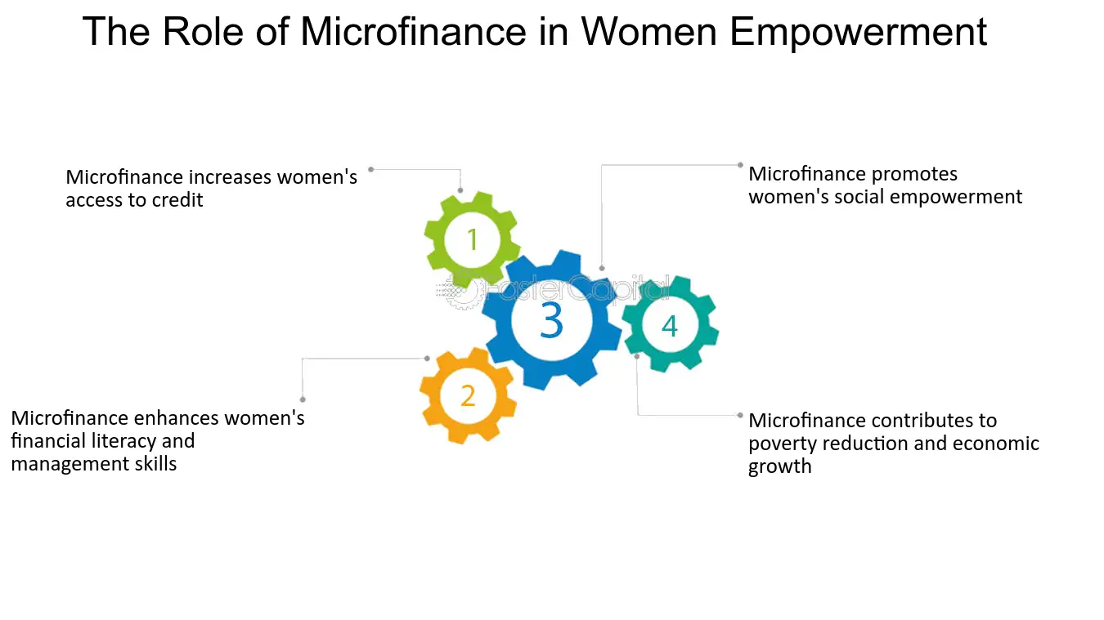
Figure 1: Role of Microfinance in developing women's empowerment
(Source: fastercapital, 2025)
As stated by Khursheed, (2022), microfinance institutions enable women entrepreneurs to gain collateral-free loans. As a result, women are able to prevent the issues associated with limitations of necessary assets in getting loans from commercial banks. Considering this, women associated with Self-Help Groups are empowered to have significant access to credit through microfinance, which further develops decision-making. This further allows women to start or expand there on businesses for generating income, which further helps them to become financially independent. Apart from that, Abebe and Kegne, (2023), state that through microfinance, women are able to increase their financial literacy as well as development skills. Microfinance institutions provide different programs associated with financial education and training for empowerment in the rural areas of India. This consequently enhances women's empowerment and their financial decision-making. As a result, women entrepreneurs are able to manage their small businesses in terms of financial aspects as well as the overall organisational management, which further empowers them in the rural areas of India.
In the opinion of Amoakohene et al. (2023), microfinance promotes social empowerment of women by improving their social status. With the help of microfinance programs provided by microfinance institutions, women are able to increase their participation in community activities, which further contributes to the development of their decision-making power. Apart from that, financial independence with the help of microfinance enables women to challenge traditional general rules and raise their voices for the advocacy of their rights. Thus, microfinance significantly develops social empowerment of women as well as decision-making in the rural areas in India. On the other hand, Mengstie, (2022), argued that microfinance reduces poverty and encourages economic growth in rural areas in India. Through microfinance, employment in rural areas increases due to job creation initiative which further develop entrepreneurship and income generation of women. Apart from that, loan amounts through microfinance help women to start their own small businesses, which contribute to the overall economic growth and employment opportunities in those areas.
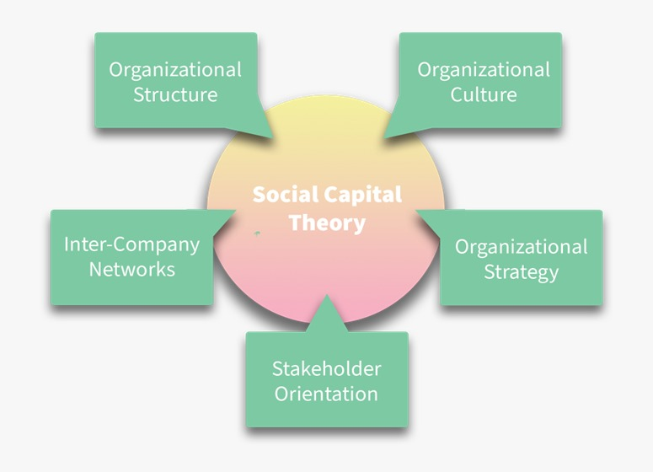
Figure 2: Social Capital Theory
(Source: worldfinancialreview, 2025)
Social capital, according to Sharma et al. (2025), refers to the collection of potential resources with a connection to long-lasting networks of relationships. In the rural areas of India, microfinance improves the access to credit of women as well as improves their financial literacy, along with management skills, which further contributes to women's empowerment in those areas. This consequently contributes to the overall development of organisational structure, culture, and strategy led by women entrepreneurs, resonating with the social capital theory. Apart from that, Anand and Karn, (2023), claimed that microfinancing allows women to become financially independent, which further reinforces the courage to challenge traditional roles and demand the advocacy of their rights. As a result, women are able to be empowered in terms of entrepreneurial mindset and utilise their potential in their organisations to develop stakeholder relationships as well as inter-company networks, connecting with the social capital theory. Thus, women's empowerment through microfinancing enables women to improve their decision-making to utilise their potential in their respective organisations for the overall business and entrepreneurial growth. As a result, women are able to understand the importance of social capital theory and its utilisation in organisations for the development of their entrepreneurship.

2.3 Strategies undertaken to develop microfinancing in rural India to promote women's empowerment and decision-making
The advent of microfinancing in rural India is considered a pivotal factor in promoting women's empowerment and decision-making, bridging the gap between social upliftment and financial inclusion. In the view of Agrawal et al. (2023), the diverse Indian rural tapestry is dominated by the emergence of microfinance, which acts as a powerful thread weaving economic opportunity, women's inclusion, and social evolution into economic decision-making. Pandhare et al. (2024), added that the method of developing Self-Help Groups (SHGs) has been crucially instrumental for women, as they get the opportunity to come and put forward their valuable opinions. These groups promoted women from the socio-economic diaspora in financial decisions, pooled their savings, and offered loans to them, fostering a culture of financial discipline and mutual support.
The emergence of Microfinance Institutions (MFIs) has complemented SHGs by providing a variety of financial services designed to cater to the needs of poor women, along with training in business management, financial literacy, and vocational training, which has empowered them to effectively deal with the economic scenario. According to Gupta and Saranya, (2025), financial literacy campaigns, like the Financial Literacy and Women Empowerment (FLWE) scheme, have been instrumental in spreading awareness among women regarding financial planning, savings, and entrepreneurship, thus breaking the glass ceiling of financial exclusion. Based on Aithal, (2024), government-sponsored schemes, such as the National Rural Livelihood Mission (NRLM) and the Deendayal Antyodaya Yojana (DAY-NRLM), have further strengthened these efforts by promoting SHGs and microfinance schemes, realising the potential of microfinance as a harbinger of rural development and women empowerment.
The effect of these approaches is evident. With more than 8 million SHGs in India, women are at the forefront of economic change in rural India, and this has contributed to the valuation of the microfinance sector at ₹3.5 trillion, with rural women leading the way (chaitanyaindia.in, 2025). The emerging data shows that 70% of microfinance loan borrowers in India are women, and this is a clear indication of the key role that women play in the growth of the microfinance sector and the impact of microfinance in changing the lives of women (chaitanyaindia.in, 2025). Women in SHGs have shown improvements in financial knowledge, income, and decision-making power.
The real-life examples highlight the impact of microfinance on the lives of individuals. Andriani et al. (2022), provided an example stating Suman Devi, a SHG leader in Uttar Pradesh, initiated a small vegetable business and is now employing others, symbolising the spirit of entrepreneurship and upliftment. Rekha, from a rural village, used a microfinance loan to initiate a poultry business, supporting her family and defying conventional norms. These examples are a testament to the transformative power of microfinance to bring about economic empowerment and change.
However, Yoganandham et al. (2025), asserted that the path to microfinance is not without its pitfalls. Overborrowing and high interest rates can be a threat, while a lack of financial literacy and social acceptance can hinder women's access to financial services. To overcome these hurdles, a comprehensive strategy is required, focusing on financial literacy, interest rate regulation, and awareness generation about microfinance services. Sabir and Majid, (2023), opined that as microfinance grows in rural India, its significance in women's empowerment and decision-making is expected to increase, providing a ray of hope for a brighter and more inclusive future.
The relationship between microfinance, women's empowerment, and rural development in India provides important lessons on the role of financial inclusion in bringing about social change. As the industry expands, Arora and Sharma, (2024), assert that it is important that it harnesses technology, promotes financial literacy, and creates an enabling environment to fully tap the potential of microfinance in rural women's empowerment and social change. As microfinance continues to develop in rural India, its contribution to women's empowerment and decision-making is expected to increase, providing a ray of hope for a brighter and more inclusive future. Minz, (2023), pointed out that with the government's initiative towards financial inclusion and digitalisation, microfinance institutions are expected to reach more women, promoting economic empowerment and change. By harnessing technology, promoting financial literacy, and creating an enabling environment, microfinance is expected to reach its full potential, empowering rural women and bringing about change. As such, women's participation in decision-making is expected to continue increasing, ushering in a brighter and more prosperous India. Through the bridging of the gap between financial services and rural women, microfinance remains an important instrument of women's empowerment and decision-making in India.

2.4 Determination of different factors that affect microfinance in rural India in enabling women's empowerment and the decision-making process
In rural India, Self-Help Groups (SHGs) have emerged as a crucial organisation for providing effective microfinance delivery services to encourage women's empowerment and decision making process. According to Kaur and Kumar, (2025), in terms of decision-making, SHGs enable women to access financial resources, develop collective strength, and participate actively with the aid of different government initiatives. The influence of SHG-based microfinance depends on different factors, depending on the circumstances. One of the key factors responsible for affecting microfinance in rural India in enabling women's empowerment and the decision-making process is the context. Miyal et al. (2025), stated that rural India is classified by patriarchal norms, low literacy levels, and employee opportunities. Therefore, it is crucial to learn the context efficiently to ensure proper participation of women in financial decision-making. The organisation are well known for collaborating with locals and aligning with the principle of collective responsibility for effective working in rural India. In addition, it serves as a safe platform for women to openly discuss their financial constraints and how to overcome such scenarios by discussing them with authorities. This, in turn, helps in strengthening their role in household and community decision-making by generating awareness. On the other hand, Nyarko et al. (2025), a holistic approach initiated by SHG, also plays a vital role in understanding microfinance in meeting women's financial needs. SHGs assess the broader socio-economic conditions of members, including income sources, family responsibilities, education levels, and livelihood opportunities, over traditional banking services.
This initiative further ensures that women learn effective skills required to be financially independent and also be able to access loans for personal and professional aspects. Eventually developing confidence and further gain a say in the household decision-making process. Gupta and Singh, (2025), opined that another factor affecting microfinance need is the customised financial products via help groups. The nature of seasonal employment, informal working system and agricultural dependency results irregular income pattern for women in rural areas. In such a scenario, SHGs offer emergency credit, small loans and emergency funding against the loan products with rigid repayment schedules. This measure further allow the women belonging to formal credit history or limited assets to attain loans for managing household expenses, support children’s education, and cope with emergencies seamlessly. Eventually, improving the engagement of women in household decisions over male family members.
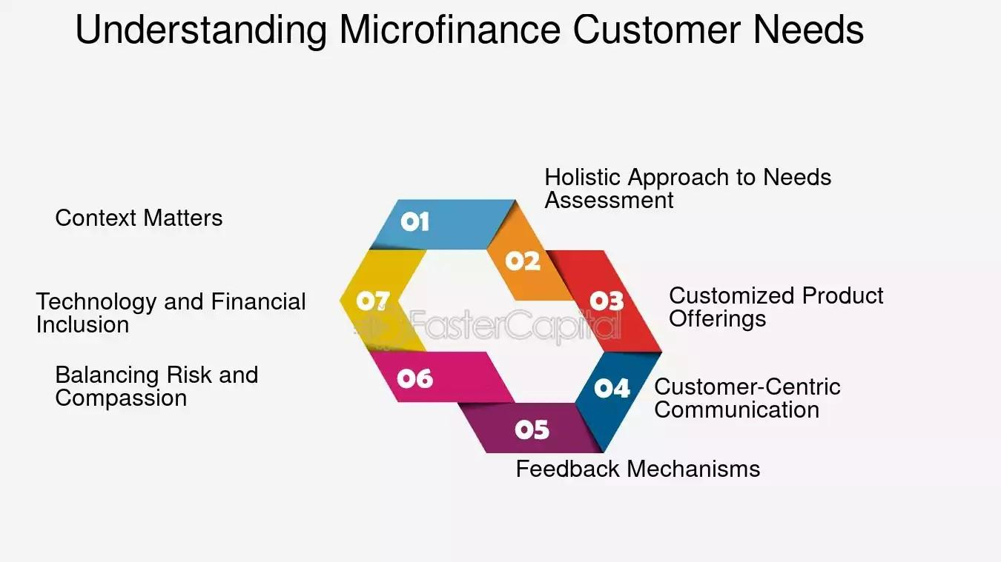
Figure 3: Factors of microfinance in meeting women's needs
(Source: fastercapital, 2025)
Okello Candiya Bongomin et al. (2025), termed that maintaining proper communication serves as a key factor for influencing the success of SHG-based microfinance in rural India for women specifically. The employees in the SHGs are well-trained for dealing with local communities by maintaining direct interaction and using local languages. In such a context, the women easily solve their queries by holding regular meetings with the authorities. Ultimately, playing a crucial role in explaining loan terms, repayment schedules, and savings procedures in simple terms. This results in fostering trust among the rural women and becoming more vocal about their rights a nd role in an Indian household decision-making capability. In the words of Rehman et al. (2025), feedback mechanisms are also a significant factor responsible for impacting the microfinance in meeting women's needs in rural India. After meetings held in SHGs, they leave their genuine feedback based on which the self-help groups develop the initiatives to meet the demands without any restriction.
As this platform encourages women to speak and initiate leading roles by raising concerns related to loans and engaging in democratic decision-making and leadership development. Therefore, developing negotiation skills, confidence, and problem-solving abilities of women in rural India. In terms of SHG lending, Singh et al. (2025), highlighted that a proper balance of risk and compassion is critical for affecting the microfinance of women. Considering the loan options, the rigid enforcement causes pressure among women in order to successfully ensure timely payment. In order to avoid such situations, SHGs provide peer support during crises and flexible payment options. This, in turn, results in reducing the risk of default and financial exclusion in the household decision-making process. Therefore, the balance is vital for building trust in the organisation and sustaining long-term participation. Thus, these factors collectively determine the success of SHG-based microfinance initiatives for women in rural India.

2.5 Identification of the challenges of developing microfinancing in rural India
Microfinancing is a good option for women entrepreneurs as they are able to set up their own businesses. In India, the government has undertaken several initiatives to microfinance the women so that they become economically empowered through making enhanced decisions. However, despite the initiatives launched by the government of India, there are challenges faced by women while developing microfinancing, especially in rural areas.
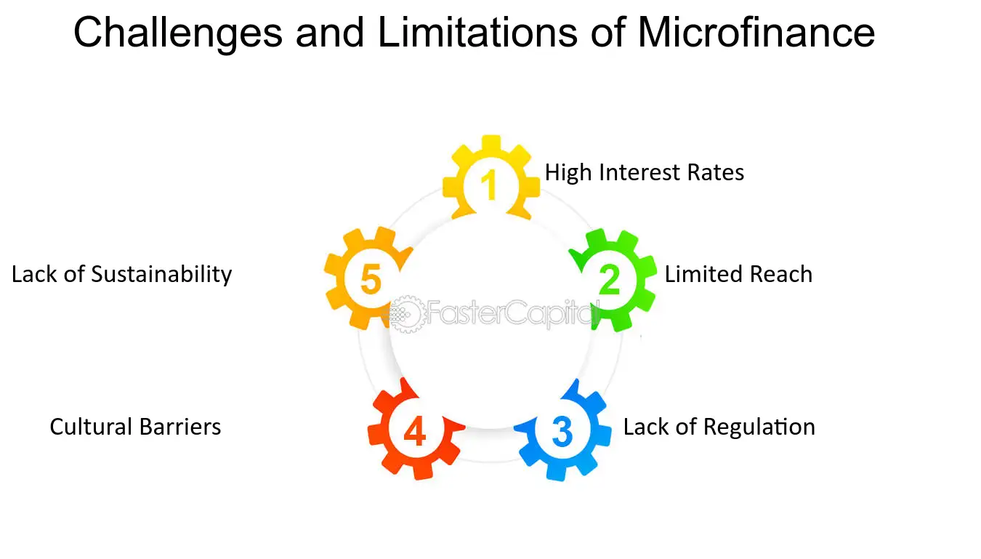
Figure 4: Challenges of developing microfinancing in rural India
(Source: fastercapital, 2026)
According to Saleh and Ahmad, (2023), the people who live in rural areas have low income and remain in poverty. The women in such areas are generally housewives or are involved in the self-help groups, where the profitability of the business is quite low. In rural areas, especially in India, high interest rates are one of the crucial challenges of microfinance. The microfinance organisations charge high interest rates from the borrowers, and it becomes difficult for the people of rural areas to pay the debts. As a result of this, it becomes difficult for the microfinances to sustain their business in the rural areas. Therefore, the rural areas of India are also not an exception, as the development of microfinances in such regions faces difficulty, which in turn impacts the promotion of women’s economic empowerment.
Andriani et al. (2022), claimed that the people who reside in rural areas have low access to capital or financial resources. The microfinances face difficulty in setting up their institutions in rural areas. Thus, limited reach is one of the challenges of developing microfinancing in rural areas. This is due to lacking resources availability or opportunities in the market. As a result of this, the women in the rural areas who remain involved with the self-help groups are not able to achieve empowerment economically, which in turn affects the decision-making. Therefore, the rural areas of India are also not an exception, as the development of microfinances in such regions faces difficulty, which in turn impacts the promotion of women’s economic empowerment.
In the opinion of Ranabahu and Tanima, (2022), the lack of regulation is one of the significant challenges for developing microfinances. It emerges as a challenge, as it hampers the reputation and image of the institutions in the market due to the unauthorised practices. Due to a lack of regulation, there are various microfinance institutions that charge unusual fees or rates from the borrowers. Also, they remain involved in unusual lending practices, and the people of the rural areas get trapped in this. As a result of this, they incur financial losses, and at the same time, the value of the microfinance institutions drops in the market. Therefore, the rural areas of India are also not an exception, as the development of microfinances in such regions faces difficulty, which in turn impacts the promotion of women’s economic empowerment.
Meanwhile, Duçi et al. (2025), claimed that cultural barriers is most important challenge that is faced in developing microfinances in the rural areas. It emerges as a challenge as there are certain groups in society that feels shameful to borrow money from the financial institutions. The people belonging to rural areas are usually illiterate and narrow-minded, which allows them to prioritise the culture first. Also, they have a belief that the microfinancing institutions might n ot understand their cultural values, which often results in conflict. The women of the rural areas are often engaged in the self-help groups, and they fear of investming money or borrowing funds through microfinance institutions. As a result of this, they fail to get economically empowered, which in turn affects the decision-making. Therefore, the rural areas of India are also not an exception, as the development of microfinances in such regions faces difficulty, which in turn impacts the promotion of women’s economic empowerment.
As per Roberts, (2025), the lack of sustainability is one of the significant challenges of developing microfinances in rural areas. This is due to the lower capacity of the people of the rural areas to repay the debts, which in turn increases the operational costs and impacts the productivity of the microfinances. Also, the microfinance institutions are highly dependent on external funds, which impacts the investment decisions, as it is very difficult to invest in rural areas. Therefore, the rural areas of India are also not an exception, as the development of microfinances in such regions faces difficulty, which in turn impacts the promotion of women’s economic empowerment.

2.6 Determination of the impact of different challenges of microfinancing in rural India on women's empowerment
Microfinancing significantly contributes to women's empowerment in rural India as well as to developing decision-making. However, different challenges occur while developing microfinance in rural India for women's empowerment. One of the major challenges of microfinancing is high interest rates in rural areas in India, causing economic troubles for people. As per Ranabahu and Tanima, (2022), certain microfinance institutions charge high interest on their loans, which creates a burden for people in rural areas regarding the repayment of their debts due to economic difficulties. For women, the burden of high interest rates is more difficult, as in rural areas, women are mostly housewives and part of self-help groups, where they do not acquire huge profits. Thus, high interest rates make the economic condition of women worse due to their lesser control over the money created through loans. As a result, women’s empowerment gets hampered in the rural areas of India. Also, high interest rates on loans encourage the increase of workload in organisations, which also creates a burden for women while balancing household responsibilities. This consequently prevents women’s empowerment as well as decision-making in the rural areas of India.
Also, Saleh and Ahmad, (2023), mentioned that although microfinance eases the lives of women in certain areas, in many rural areas of India, microfinance institutions are still not able to reach, which is another major challenge of microfinance in developing women's empowerment. As a result, women in those areas are excluded from the financial services, which hampers women's empowerment as well as decision-making. Also, lack of infrastructure and resources of extremely for areas also prevents micro finance institutions from reaching there and providing services. This consequently creates significant challenges in developing women's empowerment and decision-making in those areas. Whereas Kivalya and Caballero-Montes, (2024), said that the limited reach of microfinance institutions in the extremely poor areas also causes limitations in awareness of microfinance among the people of those areas. This results in a lack of financial literacy among people, including women, which prevents them from empowering themselves and making decisions for the betterment of their lives.
Moreover, Ahmad, (2022), stated lack of regulation is considered a crucial challenge of microfinancing, which hampers women's empowerment and decision-making in the rural areas of India. Unregulated microfinancing causes over-indebtedness as well as multiple borrowing. Women are able to borrow money from multiple microfinance institutions due to the limitations of centralised credit data, which results in crippling debt. This consequently hampers women's empowerment due to the trap of debt cycles instead of reinforcing independence. Apart from that, unethical methods of unregulated agents for the recovery of loans negatively impact the mental condition of women as well as cause social embarrassment for them, affecting women’s empowerment and decision-making in the rural areas in India.
Doering and Wry, (2022), claimed that cultural barriers are another significant challenge in microfinancing that negatively impact women's empowerment and decision-making in rural India. In the rural areas, the societal structure requires the consent of male personalities for loans, which represents patriarchal norms and male dominance in those areas that prevent the direct engagement of women with financial institutions. As a result, women are not able to be empowered and make decisions for the financial aspects of their lives. Apart from that, Parwez and Patel, (2022), argued that women are not able to travel to banks or other financial institutions alone due to the prohibition by cultural norms, which hampers their empowerment and decision-making in those rural areas. Also, the cultural norms in the rural areas highlight that, despite getting loans through microfinancing, women are not allowed to make decisions about the usage of the money, and they are often bound to allocate the money to the male family events with a non-productive purpose. As a result, the empowerment of women and decision-making gets hampered due to cultural barriers.
In the opinion of Sabir and Majid, (2023), a lack of sustainability is another challenge that impacts women's empowerment and decision-making in rural India. Poor financial literacy causes the misuse of funds, which results in frequent loans for urgent consumption needs instead of income-generating purposes. This consequently results in harassment and stress for women due to the intense pressure from lenders to repay the loans. Also, male relatives often force women to hand over the loan amounts to them, which reduces the control of women in their finances as well as hampers their empowerment and decision-making.

2.7 Recommendations for improving microfinance to boost women's welfare in rural India
Microfinancing plays a significant role in offering funds to small entrepreneurs so that they can set up their own businesses. In rural India, women are mostly engaged in self-help groups to earn a living and acquire funds from the microfinance institutions, which helps in boosting their welfare. However, the microfinances face certain challenges in establishing institutions in rural areas. Thus, to overcome the obstacles, the microfinances can follow the recommendations that can enable boosting the women’s welfare in rural India.
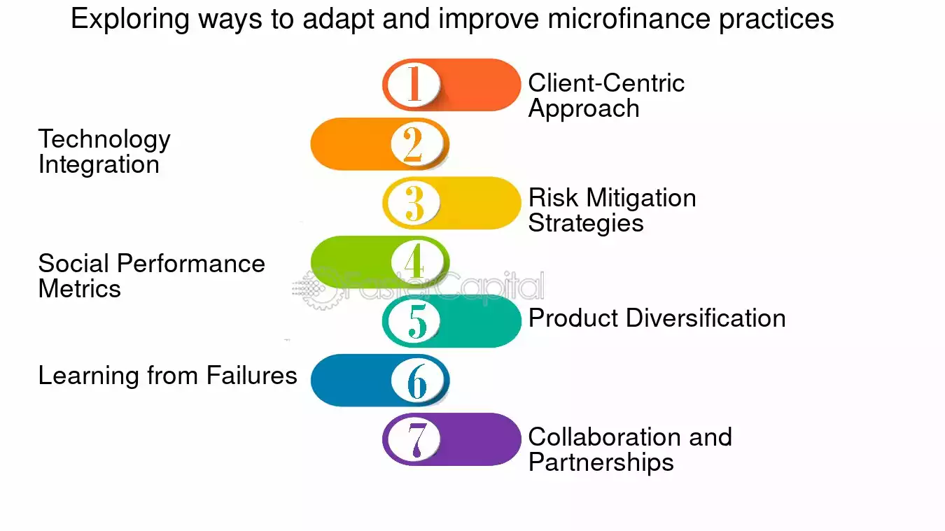
Figure 5: Ways to enhance microfinance for women's welfare
(Source: fastercapital, 2026)
Integrating the theory of planned behaviour, in the opinion of Law, (2024), microfinances can opt for a customer-centric approach, which can help in understanding their attitudes, intentions, and behaviour. The microfinances often develop the strategies without understanding the choices or the needs of the customers; however, using a customer-centric approach will enable them to prioritise their needs and offer them tailored financing options. This can enable the women in the rural areas to be financially independent and will contribute to the economic empowerment and decision making to the rural India.
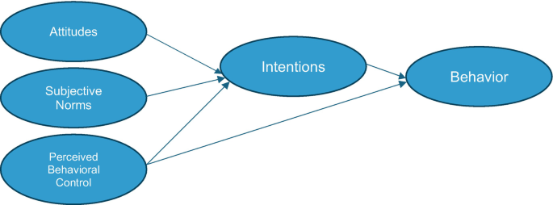
Figure 6: Theory of Planned Behaviour
(Source: Ramos, 2024)
Besides these, as per Subramaniam and Masron, (2025), the microfinancing institutions can perceive behavioural control by integrating technology. The use of technology in microfinances fosters automation, which also increases the accuracy of the work. Owing to the use of the technology by the microfinance institutions, it will increase the speed, enhancing the smooth processing of loans, reducing paperwork, and maintaining transparency. This, in turn, can enable the women entrepreneurs who are dependent on the self-help groups to access loans easily, which will facilitate economic empowerment and decision-making by boosting their welfare. Thus, the microfinancing institutions that aim to establish their business in rural India can adopt this recommendation to get better advantage.
In the opinion of Baltas and Liñares‐Zegarra, (2025), the microfinance institutions can implement risk mitigation strategies, as they can enable them to deal with vulnerabilities better. The microfinance institutions often face collateral issues, due to which they face the challenge of loan repayment by the borrowers. The implementation of the risk mitigation strategies can enable the microfinance institutions to have proper evidence, which in turn will enable them to offer loans to the customers. Thus, implementing this recommendation by the microfinance institutions in rural India can enable offering loans to the women, which will economically empower them and boost their welfare in society.
Meanwhile, Enjolras et al. (2025), claimed that the microfinance institutions can use social performance metrics as it helps in assessing the situation of the society. The use of such metrics helps in understanding the social conditions and offers loans to the public. The use of this strategy by the microfinance institutions in India can help to understand the condition of women, who heavily rely on the self-help groups to earn a living. Thus, it will allow the microfinancing institutions to offer funds to the women so that they become financially stable and feel empowered in the economy, boosting their welfare in the Indian society.
Chibueze, (2025), stated that microfinance institutions face several challenges while offering finances to the public. However, the microfinance institutions can opt for partnership and collaboration with private sector banks, government institutions, or NGOs. Collaboration or partnership enables the organisations to share ideas and risks, which in turn aids in acquiring opportunities by working with innovation. The collaboration of the microfinance institutions with the other entities can enable in acquiring opportunities and offer better financing options to the women, who mostly rely on the self-help groups. Thus, implementing this recommendation will allow the microfinancing institutions to offer funds to the women so that they become financially stable and feel empowered in the economy, boosting their welfare in the Indian society.

2.8 Conceptual Framework
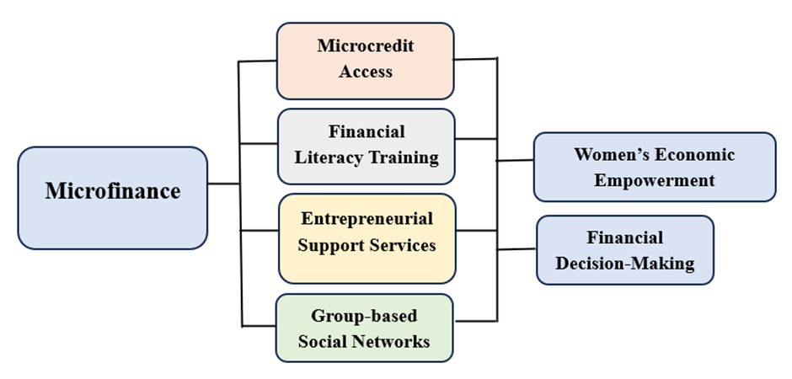
Figure 7: Conceptual Framework
(Source: Self-Developed)
In this conceptual framework, the role of microfinance in developing women's empowerment and decision-making in rural areas of India is discussed. Through microfinance, women are able to increase their micro credit access as well as develop their financial literacy with the help of training. As a result, women become highly aware of the use of finances in the right manner to create ways for income generation, which drives them towards meeting their financial needs. Apart from that, microfinance develops entrepreneurial support services for women as well as creates group-based social networks. As a result, women are able to improve their entrepreneurial abilities to become financially independent and make their own decisions. These aspects significantly contribute to the economic empowerment of women in the rural areas of India. This consequently develops their financial decision-making for their own lives and families.

2.9 Literature Gap 50 Rup
In this section, the role of microfinance in promoting women’s economic empowerment and decision-making in rural India has been briefly investigated, however it exhibits several gaps. The study is mainly focused on rural India further limiting the research of other demographics. Additionally, it lacks in providing empirical evidence and statistical support for the chosen topic for assessment.

2.10 Conclusion
In conclusion, this chapter has discussed microfinance as a driving force for women's empowerment and decision-making in rural India. Strategies such as Self-Help Groups, Microfinance Institutions, and financial literacy initiatives have empowered women economically and socially. Despite the challenges of over-indebtedness and low financial literacy, microfinance has made a remarkable impact. Real-life experiences demonstrate the potency of microfinance. To tap its full potential, it is essential to focus on financial literacy, control interest rates, and harness technology. In the end, microfinance can be a force for inclusive growth, empowering rural women and changing lives, marking the way for a brighter India.

Chapter 3: Research Methodology

3.1 Introduction
Research methodology in general is referred to as a systematic process that, as per Samanth, (2024), is used by researchers for analysing, collecting, and interpreting data to address the research objectives and frame the research in a valid and reliable manner. Based on this, to conduct this particular research, primary research methods like positivist philosophy, quantitative descriptive research design, and survey methods will be applied to effectively examine the influence of microfinance on the development of economic empowerment of women, especially within the rural Indian community, and in turn will contribute to ensuring reliable and context-specific findings.

3.2 Research Onion
The research methodology is known for framing the research, and to frame the methodology, using a proper framework as per Hamzani et al. (2023), allows for guiding researchers to select an appropriate research method. Based on this, the researcher will focus on using the Research Onion Framework, proposed by Saunders et al. (2019), which will contribute to providing a structured approach for selecting an appropriate method by framing the methodology in different layers, like philosophy, approach, design, strategy, and data collection. However, when it comes to this particular research, following a proper research methodology framework will contribute to maintaining methodological coherence while investigating the impact of microfinance on rural women, and in turn will contribute to aligning theoretical assumptions with practical data collection through surveys.
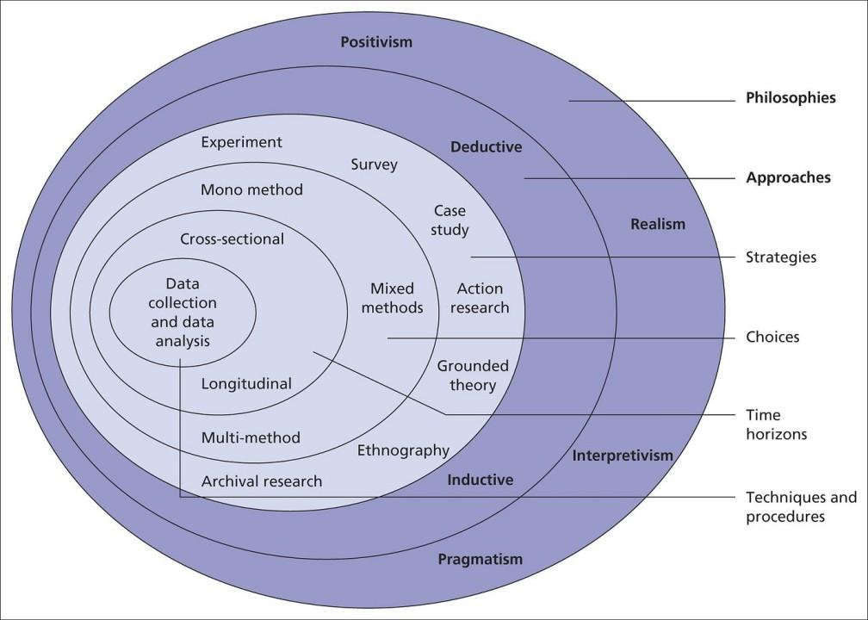
Figure 8: Research Onion Framework
(Source: Saunders et al. 2019)

3.3 Research Philosophy
Research philosophy, in general, is known to highlight the set of beliefs about the knowledge that the researcher develops for conducting the research and integrating valid evidence into it. It is considered an important aspect of the research because, as per Almusaed et al. (2025), it contributes to shaping interpretation and data collection methods, and in turn assists in strengthening overall research credibility. Considering this, to conduct this particular research, the researcher has focused on using positive philosophy out of different categories of philosophy— pragmatist, positivist, and interpretivist philosophies.
The use of positivist philosophy has been considered relevant because it is suitable for emphasising objective measurement through observable phenomena and quantifiable data. Therefore, in the context of this study, using this philosophy allows researcher for measuring income changes, decision-making participation, and financial independence for women is occurring due to microfinance accessibility. Moreover, Mwita, (225), opined that by using positivist philosophy, researcher has been able to use structures that allow for numerical data collection and emphasise statistical analysis. This approach is also considered suitable for identifying a clear relationship between microfinance services and levels of economic empowerment, and thereby providing reliable insights into rural development outcomes.

3.4 Research Strategy
Based on the research strategy, it can be stated that a proper research strategy acts as a specific method for researchers that allows for conducting the research by gathering relevant data. In the opinion of Ghazinoory et al. (2025), it serves as an important aspect because it helps in determining the reliability and practical of the research findings it is known that the research strategy are of three types specifically experiment action and service strategy out of which the research being reliant on primary research and has emphasized following survey method for the collection following the survey research strategy is the most suitable for this particular research.
The following survey research strategy is the most suitable because it contributes to the collection of standardised data from a large number of rural women participating in microfinance programs. Moreover, Arrar et al. (2024), opined that this particular strategy assists in properly structureing questionaires, which help in capturing information on saving behaviour, income changes, loan utilisation, and household decision-making involvement. Additionally, it can also be stated that the use of this particular strategy allows for making quantitative analysis, which helps in identifying patterns and relationships between microfinance accessibility and empowerment outcomes, and thereby helps in ensuring an objective assessment of its social and economic impact.

3.5 Research Design
A proper Research Design, in general, is referred to as an overall plan that a researcher develops for measuring and guiding data collection and making proper analysis for addressing the research questions effectively. In the opinion of Ferenhof et al. (2024), following a proper research design is important to the research because it contributes to ensuring that the research is valid and systematic, while aligning it with objectives. Therefore, it is known that the research design is categorised into 3 types— specifically, descriptive design, exploratory design, and explanatory design. However, for conducting this research, it has been considered that the descriptive research design is the most suitable. It is because this design has the potential to gain a deeper understanding regarding the influence of microfinance on women's empowerment in rural India, an area where economic and social dynamics vary widely.
Moreover, by applying this design, a thorough structured survey can be developed by exploring patterns in income generation, financial behaviour, and decision-making rules. Taking this into account, Samala et al. (2024), claimed that this aspect is suitable for identifying emerging trends, challenges, and opportunities that are associated with microfinance participation and, in turn, contribute valuable insight for policymakers and development organisations.
3.6 Research Approach
In terms of research approach, it can be stated that the use of a proper research approach contributes to outlining the ability by which theories are tested or developed during the formulation of the research process. As per Usman et al. (2024), a proper research approach is essential for structuring the research in a logical way. Therefore, in terms of research approach, it is known that the research approaches are of two types, specifically the inductive approach and the deductive approach. However, out of these two, the researcher has considered using a deductive approach because it helps in beginning the research with existing theories and hypotheses, which are then tested using empirical data.
In terms of applying established empowerment and financial inclusion theories, the researcher has further adopted a deductive approach to examine the impact of microfinance on the economic status of women and decision-making power in rural India. Therefore, hypotheses like improved income levels, in the opinion of Hakimi et al. (2024), contribute to enhancing and testing household decision participation through primary survey data. This, in turn, makes it evident that this structured approach contributes to ensuring systematic analysis while allowing clear conclusions regarding the effectiveness of microfinance initiatives.

3.7 Methodological Choice
Methodological choice is the overall approach of a researcher that is chosen for gathering and analysing the data to answer the set research questions. It involves choosing between qualitative, quantitative, or mixed methods based on the nature of the study, philosophical stance and objectives of research (Ganesha and Aithal, 2022).
In the present context, where emphasis is given on investigating the role of microfinance in stimulating economic empowerment and decision-making in rural India, the quantitative methodological choices are mostly suitable. It has been chosen as it enables researchers to objectively measure and conduct statistical analysis of empowerment outcomes. With the help of structured questionnaires and numerical indicators like savings, behaviour, income level, loan usage, and participation in household financial decisions, it allows researchers to explore patterns, connections and extent of influence across a wider group of women. Quantitative methods are also proven to be useful for researchers as it supports generalisation of findings, enable hypothesis testing and improve reliability through statistical tools. This approach effectively aligns with the positivist approach and is appropriate for evaluating measurable changes in the women’s economic status and decision-making power resulting from microfinance participation.

3.8 Data Collection Method
The data collection method in general refers to a systematic process that allows the researcher to gather information required for answering research questions and achieving the objectives of the research. In the opinion of Ojoboh and Igben, (2024), following a proper data collection method is important for research conduction because it contributes to enhancing accuracy, reliability, and validity of findings, which help in enabling meaningful analysis and allow for delivery and informed conclusions. However, when it comes to this particular research, out of publicly available secondary sources and first-hand collection of data through a survey method, the researcher has considered using survey questionnaires, which have been developed through Google Forms and distributed through social media platforms.
The survey question is further used for this research because it helps in capturing measurable information related to saving habits, income changes, loan uses, and financial independence in household decision-making. As per Shaheen et al. (2023), this method has the potential to ensure consistency across respondents, which helps to allow large-scale participation. Additionally, this helps in facilitating quantitative analysis suitable for identifying patterns and relationships between microfinance accessibility and levels of economic empowerment, thereby contributing to providing objective and generalisable evidence required for supporting development focused conclusion.

3.9 Data Analysis
The proposed research will examine the significance of microfinance in enhancing women's economic empowerment and decision-making in rural India. The process of analysing the data will be done using statistical evaluation, incorporating SPSS analysis and Excel calculations to extract valuable information. This research will adopt a quantitative research methodology, gathering data from structured questionnaires and surveys conducted among women beneficiaries of microfinance institutions in rural India.
The data will be analysed using descriptive statistics, inferential statistics, and regression analysis to determine the significance of microfinance in women's economic empowerment and decision-making. The SPSS software package will be utilised to conduct statistical tests, including correlation analysis, t-tests, and ANOVA, to investigate the relationship between microfinance participation, women's empowerment, and decision-making. Excel will be utilised for data cleaning, data manipulation, and graphical representation of the results. The analysis will concentrate on important indicators, such as women's income, savings, loan repayment, and decision-making authority in households. The proposed study will also examine the difficulties encountered by women in accessing microfinance services and the effect of microfinance on their social and economic welfare.

3.10 Population and Sampling
The method of sampling used in this research is purposive sampling, which focuses on women participants who are part of Self-Help Groups (SHGs) or microfinance schemes in rural India. A structured questionnaire with closed-ended and Likert scale questions was developed to collect data on income, savings, and decision-making. The questionnaire was conducted online using Google Forms, which targeted 75 women participants. The participants were chosen for the study based on their involvement in microfinance schemes, which made them relevant to the objectives of the study. The sample size of 75 women offers a specific perspective on the effect of microfinance on the economic empowerment and decision-making of women. The data was collected only from women who are part of SHGs or microfinance programs, which enabled a specific analysis of the role of microfinance in their economic lives. The online survey helped in the effective collection of data, which enabled the analysis of the results using SPSS and Excel.

3.11 Ethical Considerations
While conducting this research, priority has been given to adhering to established ethical principles to ensure that the protection, rights and dignity of all the participants involved in the process, which aimed to study microfinancing and women’s empowerment in the rural area in the context of India. Participants took part of their own will and informed consent was acquired before colection of data. All the participants were informed clearly about the nature of their involvement, the purpose of the study, and their rights to withdraw at any point without any negative consequences. Confidentiality and anonymity were maintained strictly by not collecting personally identifiable information and storing all the responses gathered in an aggregated form.
All the gathered information were store securlly in a password-protected and encrypted digital storage, which could only be accessed by the researcher and academic supervisor while adhering to General Data Protection Regulation (GDPR) and the UK Data Protection Act (2018). Due to the sensitive nature of financial and household decision-making information, all the participants had an option to skip any questions where they felt uncomfortable responding. Also, cultural sensitivity has been respected in the entire process of the research, mainly regarding the rural Indian context and potential power imbalances. The study had minimal risk and ensured no involvement of coercion, deception or harm. Ethical approval was also taken before data collection, and all the University provided guidelines related to Research Ethics and Integrity Code of Practice were followed to ensure transparency, integrity and accountability.

3.12 Conclusion
This methodology chapter applies positivism, a deductive and quantitative research approach employing a descriptive survey design. The primary method of data collection has been chosen for gathering data through structured questionnaires from rural women that allows for an objective measurement of microfinance outcomes. The overall approach ensures ethical integrity, relaibilty and valuable analysis of women’s economic empowerment in rural India.

Chapter 4: Analysis and Discussion

4.1 Introduction
The research is extensively reliant on investigating the effective role played by Microfinance in promoting economic empowerment among women and developing their decision-making ability, especially in rural areas of India. Based on this, here comes the fourth chapter of the research, which will focus on analysing the primary data collected through surveying women participants involved in microfinance schemes. Considering this, the researcher in this portion will aim to analyse the collected data using the SPSS method by means of correlation, regression, descriptive statistics, and graphical analysis, and will highlight the relevance, reliability, and validity of the research.

4.2 Data Analysis

4.2.1 Hypothesis Specification
Specification of hypothesis acts as a suitable approach to acts as a suitable approach to testing and guiding relationships (Al-Najjar et al. 2025). However, this particular research, it aims to test the relationship between microfinance factors and women's empowerment, and thereby contributes to the evaluation of measurable research assumptions.
Hypotheses | Statement | p-value | Result
H0- Null Hypothesis | Microfinance does not play any noticeable role in promoting economic empowerment and developing decision-making ability among women belonging to rural India | 0.000 | Rejected
H1- Alternative Hypothesis | Microfinance plays a significant role in promoting economic empowerment and developing decision-making ability among women belonging to rural India | 0.000 | Accepted
Table 1: Specification of Hypothesis
In terms of hypothesis specification, it is known that the selection of a hypothesis occurs based on the p-value calculated from the regression analysis. Regarding the p-value, it is known that 0.005 serves as the benchmark. Below the benchmark results in the selection of the alternative hypothesis, while above the benchmark results in the selection of the null hypothesis. However, for this research, it has been noted from the regression analysis that the p-value obtained is 0.0, which is lower than the benchmark and confirms the selection of the alternative hypothesis.

4.2.2 Variables Specification
In terms of variable specification, it is known that it acts as a suitable approach for clearly identifying inputs and, thus, for this research, it contributes to identifying inputs associated with microfinance and empowerment outcomes and thereby contributes to the delivery of accurate measurement, analysis, and interpretation of economic progress among rural women. Based on this, the independent and dependent variables include—
Dependent Variables | - Microfinance affects rural areas
Independent Variables | - Microfinance services in areas requiring rural development  - Reasons for taking a microfinance loan  - Impact of microfinance to start business  - Impact of microfinance on women's empowerment
Table 1: Specification of Variables

4.2.3 Descriptive Statistics
Descriptive statistics, in the opinion of Fulk, (2023), play a vital role in research by summarising patterns present in data while revealing central tendencies, variability and distribution and help in shaping research by enabling a clear understanding of the perception and responses provided by respondents. Based on this, microfinance-related abilities in enhancing women's empowerment and decision-making ability will be examined in this report with the help of descriptive statistics.
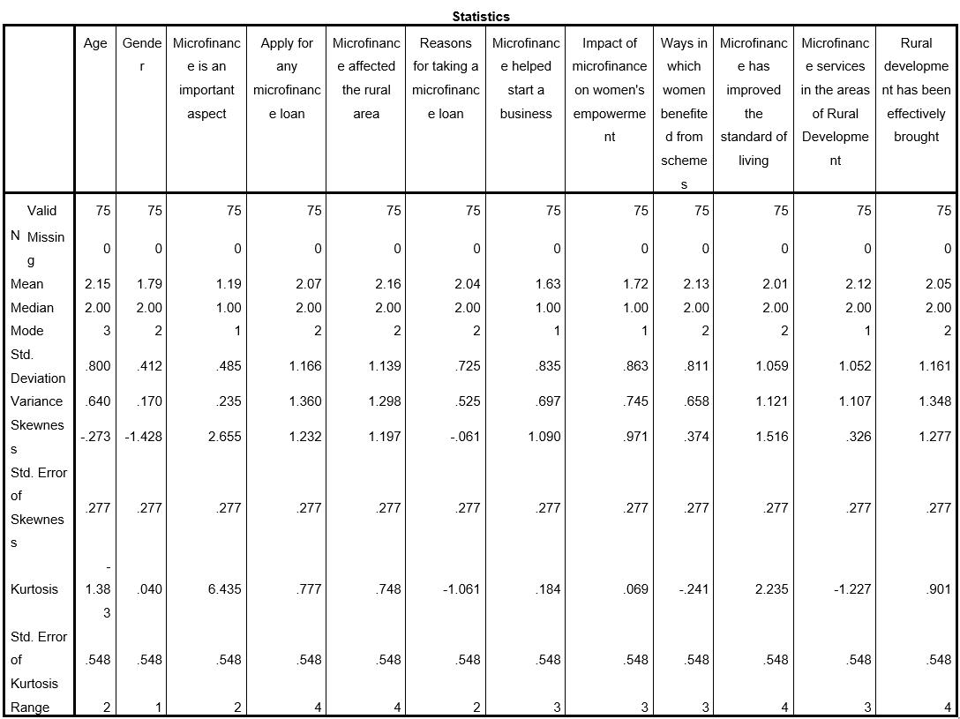
Table 2: Descriptive Statistics
(Source: Created through SPSS)
The table mentioned above have pointed out the effect of microfinance in rural area by showing a mean of 2.16 along with the median of 2.00 and thereby indicate the presence of moderate perceived impact for the dependent variable while showing a standard deviation of 1.139 and contributes to reflecting the presence of varied experiences among women the presence of positive skewness with 1.197 and moderate kurtosis 0.748 points out the need of more clustered responses at lower agreement with some higher extreme values. In terms of independent variables, it can be stated that reasons for taking microfinance loans have a mean of 2.04 along with low variability of 0.725, thereby indicating consistent motivation. In terms of the potential of microfinance in helping start businesses, shows a lower mean of 1.63, which implies a presence of strong agreement with slight positivity. Moreover, a mean of 1.72 has been observed for the impact on women's empowerment and thereby reflects the presence of a positive outcome. Additionally, a mean of 2.1 has been noted for rural development services, which shows moderate agreement with relatively normal distribution and thereby indicates the presence of balanced perception across respondents.

4.2.4 Graphical Representation
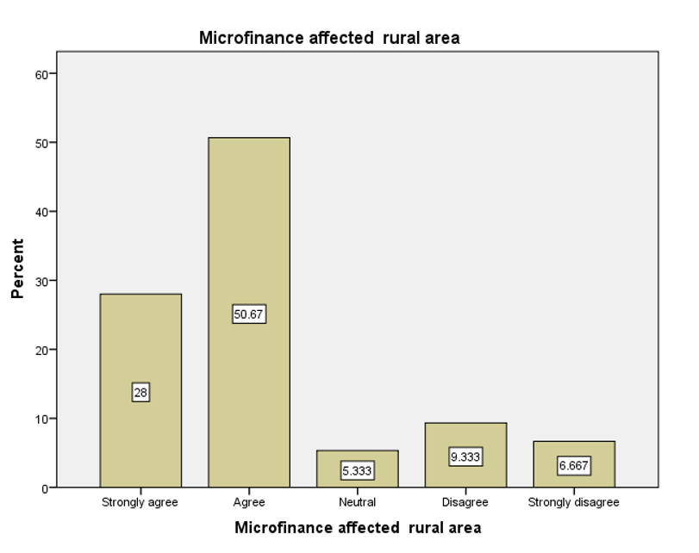
Graph 1: Microfinance affected the rural area
(Source: Generated through SPSS)
The above graph demonstrates that microfinance affected rural areas, and based on the graph, it is inferred that 28% of the respondents strongly agree that microfinance is affected in rural areas. Meanwhile, a major percentage of respondents with 50.67% agrees that microfinance is affected in rural areas. 5.33% of the respondents gave a neutral opinion of how microfinance affects rural areas. Despite getting a high response from microfinance-affected rural areas, there are respondents of 9.333% who disagree with the fact. Also, 6.667% respondents strongly disagree with the fact that microfinance affected rural areas. Thus, based on the responses of the respondents, it can be stated that microfinance affects the rural areas.
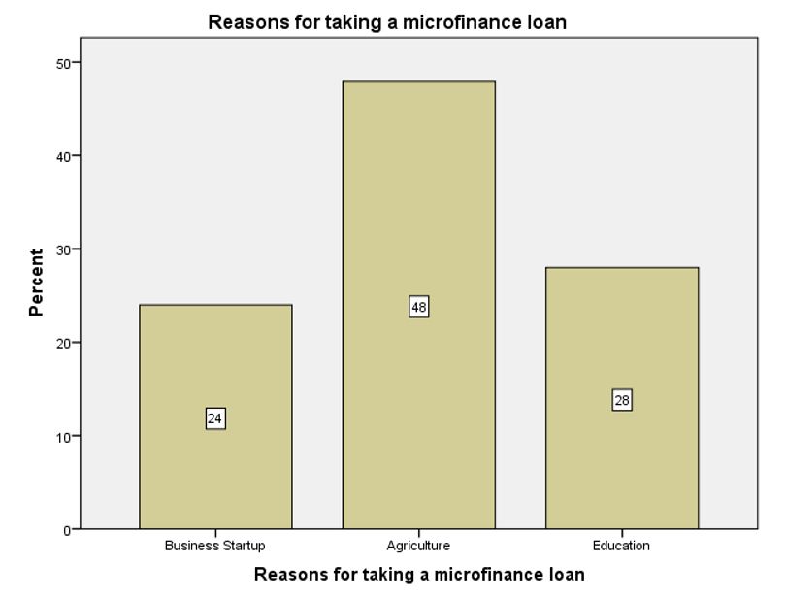
Graph 2: Reasons for taking a microfinance loan
(Source: Generated through SPSS)
The above graph demonstrates the reasons for taking microfinance loans by women. Based on the graph, it is inferred that 24% of the respondents take microfinance loans for starting up new businesses. The microfinance loans are usually taken by women, as it enables them to become financially stable and independent. Meanwhile, a maximum number of respondents with 48% takes microfinance loans for agriculture purposes, as in rural areas, it is one of the major sources for the people to earn a livelihood. Meanwhile, 28% of the respondents claimed that they take microfinance loans for educational purposes to increase their literacy level and become financially stable in the economy.
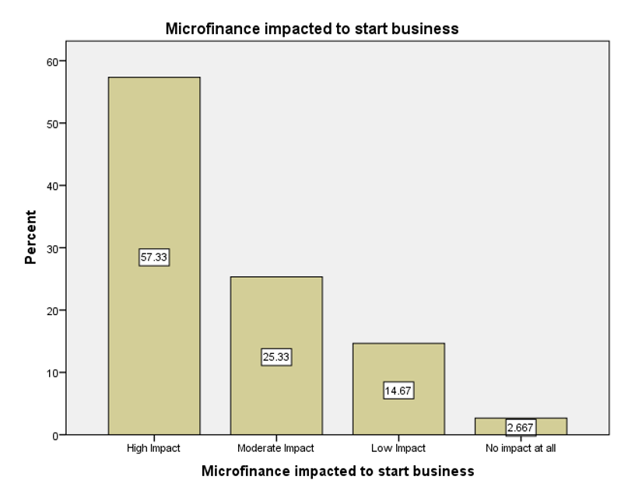
Graph 3: Microfinance impacted the start-up business
(Source: Generated from SPSS)
The above graph portrays how microfinance impacted the start business, and based on the graph, it is inferred that the start-up businesses are highly impacted due to microfinances as they are able to acquire funds and make effective developments. 57.33% of the respondents claimed that microfinance have high impact to start business, while 25.33% of them claimed that it has a moderate impact. Meanwhile, 14.67% of the respondents claimed that microfinance has a low impact to start business, and only 2.667% of respondents claimed that microfinances have no impact at all to start businesses.
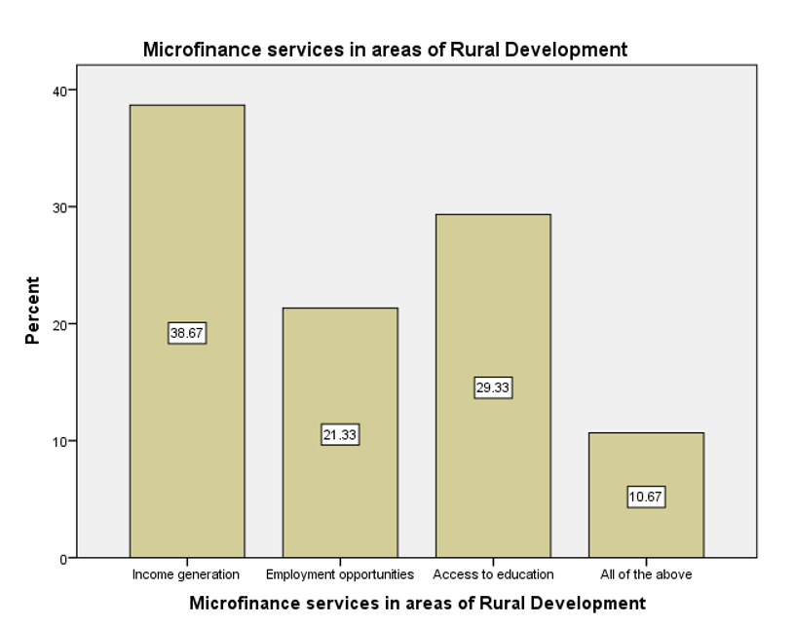
Graph 4: Microfinance services in areas of rural development
(Source: Generated through SPSS)
The above graph demonstrates microfinance services in the areas of rural development. Based on the graph, it is inferred that microfinance services have a significant contribution to the development of the rural areas, as 38.67% of the respondents claimed that it helps in income generation. Meanwhile, 21.33% of the respondents claimed that microfinance services provide employment opportunities to the local people, which in turn facilitates the development of rural areas. 29.33% of respondents claimed that they are able to better access to education due to set up of microfinance services in the rural areas. Moreover, 10.67% respondents claimed that all the mentioned factors are responsible for rural development due to the setup of microfinance services.
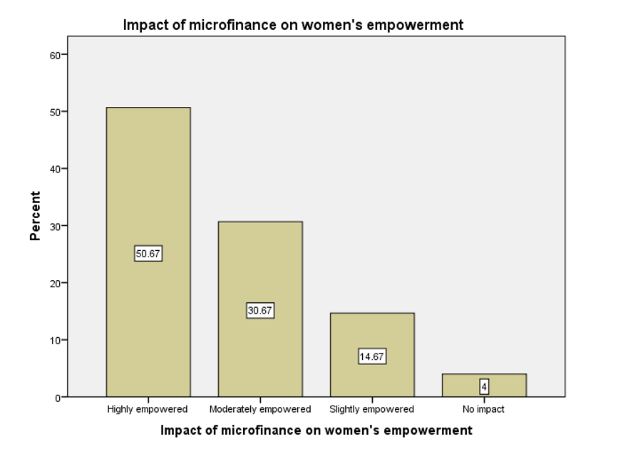
Figure 9: Impact of microfinance on women’s empowerment
(Source: Self-Developed)
The figure that has been shown above is about the perceived influence of microfinance on women’s empowerment in rural India, demonstrating its important role in promoting economic independence in a decision making ability. A significant portion of the respondents, 50.67%, reported being “highly empowered”, which implies that accessibility to microfinance has enhanced their income generation activities, financial confidence, and participation in economic and household decisions in a considerable manner. Nelary 30.67% of the respondents are of the view that they feel “moderately empowered”, indicating that structural or social limitations might still limit full empowerment despite their enhanced economic role. Apart from this, around 14.67% of them reported “slight empowerment”, highlighting that the marginal benefits might be due to reduced loan sizes, inadequate financial literacy and limited market access. Only a few respondents, which is 4%, reported “no impact”, demonstrating that microfinance initiatives are largely effective across rural areas with few expectations.
The figure effectively supports the belief of the study that microfinance is a key instrument for promoting economic empowerment of women and strengthening their role in decision making, thus contributing extensively in rula development in the context of India (Mengstie, 2022).
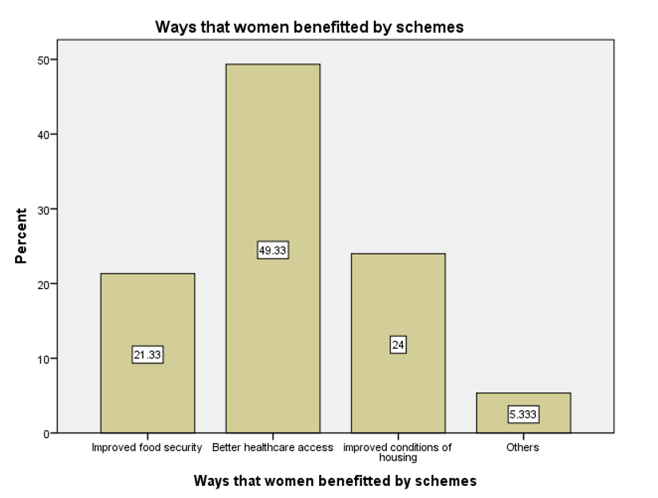
Figure 10: Ways that women benefit from schemes
(Source: Self-Developed)
The figure above illustrates fundamental ways through which women in rural India are benefited from microfinance-related schemes, indicating economic as well as social dimensions of women’s empowerment. It has been found that nearly half of the respondents, which is 49.33%, experienced “better access to healthcare”, highlighting that enhanced financial capability allows women to focus on health-related expenditure for themselves as well as their families. Moreover, the “improved conditions of housing” were experienced by 24% of the respondents, implying that microfinance supports long-term household stability and asset creation. Nearly 21.33% of the respondents have experienced “enhanced food security”, suggesting the role of improved income and savings in ensuring nutritious and regular meals. Only 5.33% of the respondents reported advantages under other categories, like social participation and education.
Thus, it can be said that microfinance significantly contributes beyond income generation by enhancing the standard of living and welfare outcomes. These improvements enhance the bargaining power of women within the communities and households, thus strengthening their role in economic decision-making and reinforcing the wider objective of women’s economic empowerment in rural India (Iqbal et al. 2025).
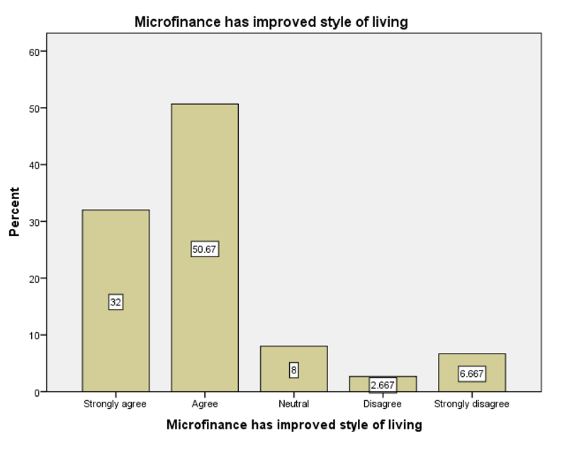
Figure 11: Microfinance has improved the standard of living
(Source: Self-Developed)
The figure depicted above highlights the perception of respondents related to whether microfinance has enhanced their living standards, offering insights about its role in women’s economic empowerment in rural India. A majority of respondents shows positive view, with 50.67% “agreeing” and 32% “strongly agreeing” that microfinance has improved their living standards. This highlights that accessibility to microfinance has allowed women to enhance household consumption, fulfil essential needs effectively, and invest in productive gains. Almost 8% of the respondents remained “neutral”, implying mixed or gradual results, while 2.66% and 6.67% of respondents remained “disagreed” and “strongly disagreed” respectively.
Thus, in the context of rural India, the figure supports the view that microfinance increases income level and also contributes to wider socio-economic empowerment and decision-making ability amongst women (Aithal, 2024).

4.2.5 Correlation Analysis
Correlation analysis, when it comes to social science research, Jeserich et al. (2023), opine that this contributes to quantifying the direction and strength of relationships between different variables and thereby helps researchers in understanding the way in which factors are capable of moving together while supporting evidence based conclusion. Considering this, the researchers in this particular research are focusing on investigating the role of microfinance.
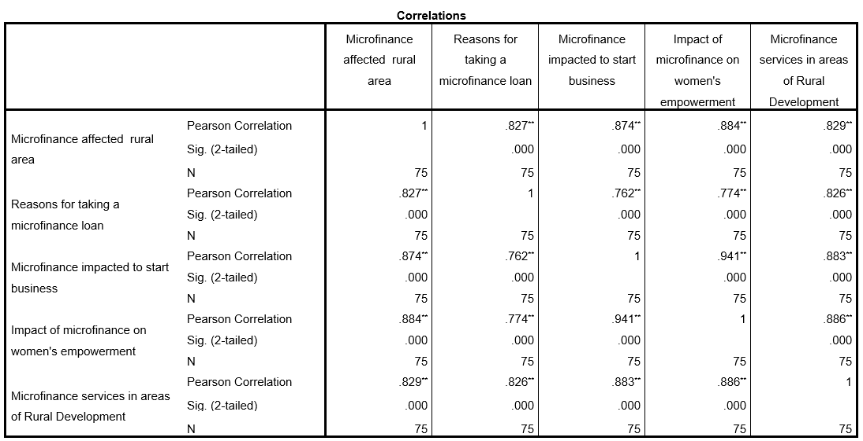
Table 3: Correlation Analysis
(Source: Created through SPSS)
The table mentioned above illustrates the correlation calculation regarding the relationship between the exposure of microfinance in rural areas, along with its empowerment-related outcomes. However, the results obtained indicate the presence of strong positive and statistically significant relationships. Specifically, it has been observed that the Pearson correlation value for taking loans is 0.827, which shows a high correlation with the effect of microfinance on rural areas. Similarly, it has been noted that business startup support correlates 0.874, while women empowerment is noted to have a Pearson correlation value of 0.884, and development services, on the other hand, have a Pearson correlation value of 0.829, which shows widespread development influence. However, the strongest relationship has been demonstrated between business creation and women's empowerment, which shows a strong Pearson correlation value of 0.941 and thereby suggesting that leveraging income-generating activities can help in strengthening the economic position of women while enhancing their decision-making power and thereby driving empowerment.

4.2.6 Regression Analysis
Regression analysis is considered a crucial approach in research, which, in the opinion of Roustaei, (2024), contributes to examining predictive relationships present between variables. Similarly, the ANOVA test helps in examining overall model significance and Coefficient analysis, as per Kulaylat et al. (2023), which contributes to recognising the impact of individual predictors. Based on this, the regression analysis will be framed regarding analysing the effect of Microfinance in enhancing decision-making capability and women empowerment in rural India.
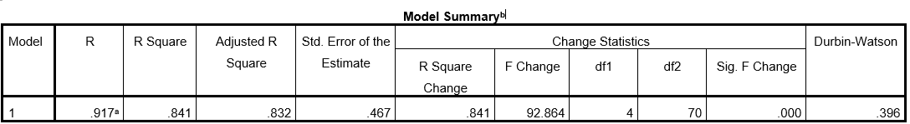
Table 4: Regression Analysis
(Source: Created through SPSS)
It can be stated that there is a very strong relationship between the factors associated with microfinance and its correlation with economic empowerment among women, which has further been evident from the R value, which is 0.917. In terms of R-squared value, it is noted to be 0.841, which indicates the presence of 84.1% variation in women's empowerment and decision-making ability. This has further been explained through the independent variables and thereby demonstrates high explanatory power. Moreover, the adjusted R-squared value of 0.832 confirms the presence of model stability, while a lower standard error highlights the need for accurate prediction.
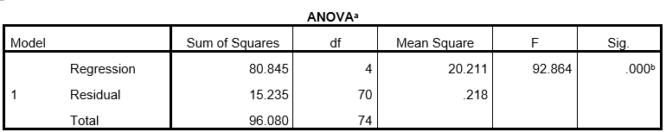
Table 5: ANOVA Test
(Source: Created through SPSS)
In the ANOVA test result, the F value being 92.864 and p-value being 0.000, has further made it evident that the regression model is statistically significant, and thereby confirms that the microfinance variables pose a collective yet meaningful impact on the outcomes of women empowerment in rural India.
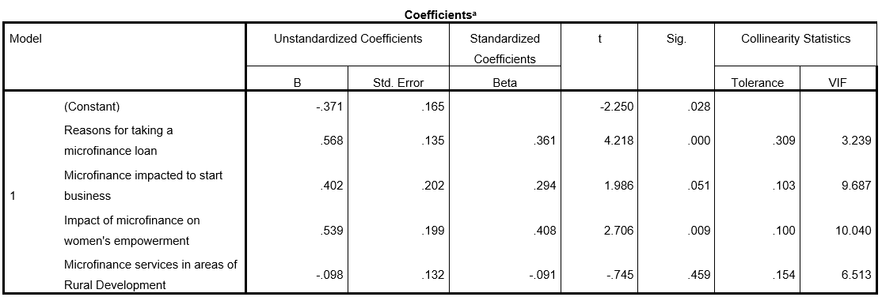
Table 6: Coefficient Analysis
(Source: Created through SPSS)
From the coefficient analysis table mentioned above, it is clear that the reasons for taking microfinance loans have a beta value of 0.361 and a p value of less than 0.0001, and the impact of microfinance on women's empowerment has a beta value of 0.408 and a p value of 0.009, pointing out the presence of significant positive predictors. However, business startups supported through microfinance show a marginal influence on the value of 0.051. Contrary to this, it has been noted that rural development services appear to have a statistically insignificant motivation, and empowerment outcomes are capable of driving the strongest effects.

4.2.7 Collinearity Diagnostics
Collinearity diagnostics are referred to as another important aspect of regression analysis, which, in the opinion of Kalnins and Praitis Hill, (2025), contributes to examining whether the independent variables are highly correlated or not and thereby have the potential to distort coefficient estimates and weaken the reliability of research conclusions. Based on this, the role of microfinance-related factors on women's empowerment in rural India will be evaluated.
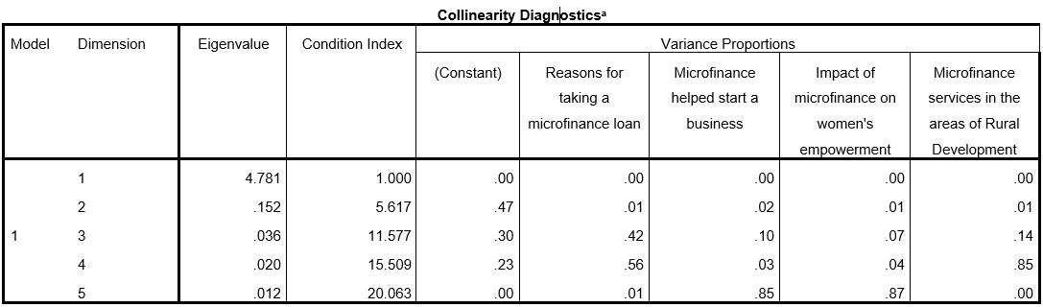
Table 7: Collinearity Diagnostics Analysis
(Source: Created through SPSS)
From the table mentioned above, it is clear that the condition index value is noted to range between 1.02 and 20.06, with the highest being slightly above the commonly accepted threshold of 15, thus indicating the presence of moderate multicollinearity. The table has also made it clear that the presence of higher variance proportions for microfinance-supported business start-ups and the impact on women's empowerment appear in the final dimension. This thereby suggests the presence of shared variance between empowerment-related predictors. However, other variables have also shown dispersed variance across dimensions and thereby contribute to explaining empowerment outcomes uniquely. Overall, it is noted that although certain microfinance factors are closely related, the model being statistically acceptable allows meaningful interpretation of the influence of microfinance on the economic empowerment in rural India.

4.3 Discussion

4.3.1 Discussion on Graphs
Graph 1 of this study demonstrates the perception of respondents on whether microfinance has an impact on rural areas. A significant portion of the responders have either agreed or strongly agreed to this statement, highlighting that microfinance institutions (MFIs) have obtained considerable attention and relevance in the rural environment. The smaller proportion of respondents who disagreed highlights that while microfinance is broadly recognised, its advantages might not be experienced similarly across all regions or households. This variation might arise from differences in location size, accessibility to services, or institutional support structure, thus indicating the need for region-specific microfinance strategies.
Graph 2 of this research illustrates the key reasons for women taking microfinance loans, whereby agriculture has emerged as a dominant purpose, followed by startup business and education. These findings indicate the agrarian nature of rural economies, where accessibility to credit is important for maintaining livelihood (Sahoo et al. 2022). In addition to this, a larger ratio of loans taken for educational purposes illustrates that women view microfinance as a tool for survival and also an investment in long-term human capital development, which is important for continuous empowerment.
Furthermore, Graph 3 of this research strengthens this argument by indicating that microfinance has a high to medium influence on the business institution for the majority of the respondents. The ability to access capital allows women to overcome financial issues, initiate income-generating activities, and lower reliance on informal moneylenders (Basu, 2025). The smaller proportion of respondents reporting no influence suggested that financial inclusion might be inadequate without complementary support, such as access to the market, development of skill and financial literacy.
Moreover, graph 4 extends the discussion by relating microfinance services to wider rural development results, comparing employment opportunities, income generation, and enhanced access to education. These findings highlight that microfinance produces a ripple effect above individual borrowers, which contributes to community-level development. The corresponding nature of such benefits supports the idea that microfinance functions.
Graph 5 of this research emphasises that microfinance schemes benefit women’s then just income generation, mainly by enhancing accessibility to housing conditions, health, and food security. These findings highlight that improved financial capability allows women to invest in long-term household stability and daily welfare (Voznyak et al. 2022).
Graph 6 further supports this by reducing the increased participation of women in financial decision-making and household, indicating increased confidence and autonomy. Collectively, these graphs highlight that microfinance functions as a catalyst for strong empowerment, linking economic support with enhanced standards of living and stronger decision-making roles for women in the context of rural India.
Graph 7 shows insights into enhanced standards of living due to microfinance. The majority of the respondents have either agreed or strongly agreed that their living standards and enhanced whic indicted positive socioeconomic outcomes. Few disengagements reveal that microfinance is largely effective, though its benefits vary across individuals and regions (Mia, 2022).

4.3.2 Discussion on Correlation Analysis
The research, being reliant on investigating the role of microfinance in promoting economic employment and decision-making ability among women in rural India, has contributed to providing strong empirical support for sustaining empowerment among women. From the correlation analysis, a consistently high and statistically significant positive correlation has been observed among all key variables, which indicates that increased accessibility to microfinance services is closely linked to Improved outcomes for rural development and broader opportunities to socio-economic conditions for women. Specifically, in relation to this research, it can also be stated that the research has demonstrated the presence of a strong relationship between microfinance and women's empowerment in rural areas. Taking this into account, Kim et al. (2024), opined that financial inclusion enables women to develop better control over economic resources while enhancing self-reliance and actively participating more in household and business-related decisions.
The presence of a strong correlation has also been noted for business startup activities and reasons for taking microfinance loans, which contribute to broadening entrepreneurial motivation among rural women. Taking this into account, Hasan et al. (2025), claim that microfinance is not merely used for consumption purposes but serves as a critical tool for generating income and creating livelihood. To this, Naab et al. (2023), added that this also contributes to enabling women to establish small enterprises and directly leads to the enhancement of financial stability by developing skills and promoting economic independence in the long term. And thereby aligns closely with the core objective of empowering women through sustainable economic participation.
Furthermore, it can also be stated that the correlation analysis highlighted the presence of an exceptionally strong correlation between women's empowerment and business creation and thereby conceptualises the idea which state that economic engagement serves as a key pathway to empowerment. Based on this, Okesina, (2025), asserted that when a woman generates income, their bargaining power within the household improves along with the improvement of children's education and health-related choices, and thereby contributes to a greater environment in financial decisions. However, this demonstrates that empowerment is not only associated with monetary benefit but also includes social and decision-making dimensions. Moreover, the strongest association has also been noted between microfinance services and rural development outcomes, and thereby indicates that microfinance institutions have the potential to drive community-level progress by improving accessibility to financial services, local economic growth, and employment opportunities. As per Sengupta et al. (2024), this interconnected development contributes to creating and enabling an environment where women can easily thrive economically.
Overall, the findings suggest that microfinance has the potential to serve as a catalyst for women's empowerment, alongside aiding in supporting entrepreneurship, strengthening the rural economy, and enhancing women’s autonomy. Overall, this correlation demonstrates the presence of a strong relationship but does not confirm causality. Considering this, it can be stated that future research on this can focus on the inclusion of integrating qualitative methods for exploring casual mechanism more deeply, even though the results show that microfinance serves as a vital instrument in advancing economic and decision-making ability among women.

4.3.3 Discussion on Regression Analysis
As the research extensively emphasises the role of microfinance in promoting economic employment and decision-making ability among women in rural India, the regression analysis focuses on offering strong quantitative evidence regarding the effectiveness of microfinance in empowering economic and decision-making capabilities of women in rural India. However, the high explanatory power of the model showcases that microfinance-related factors account for a substantial proportion of the variation and thereby states that microfinance helps in shaping the socioeconomic progress and financial inclusion initiatives among women. Considering this, Gugan et al. (2024), asserted that accessibility to microfinance not only contributes to isolating financial intervention but also results in integrating the development of a mechanism suitable for influencing autonomous entrepreneurial behaviour and household participation.
From the regression analysis, the statistical significance of the overall model has been evident, which confirms that microfinance variables potentially contribute to empowerment rather than occurring by chance. This, in the opinion of Radha, (2024), aids in reinforcing development theories that are crucial for crediting accessibility to the one who acts as a driver of poverty alleviation and gender equality in rural contexts. Therefore, by linking financial services with empowerment indicators, the findings have been able to validate microfinance as a strategic policy instrument, which helps in promoting inclusive growth among marginalised women populations.
Based on the coefficient results, it is further evident that their lies important dynamics within the empowerment process. In relation to this, it can be stated that the reasons for taking microfinance loans have a strong positive influence. This, thereby, suggests that women who are engaged with microfinance for productive and growth-oriented purposes are capable of experiencing greater empowerment outcomes. This, in the opinion of Chikwe et al. (2024), implies that motivation, goal-oriented borrowing, and financial literacy are capable of enhancing the effectiveness of microfinance programs. Similarly, Evwierhurhoma, (2024), added that the improved income control, confidence, and participation in economic decisions reflects significant positive impact of microfinance on women's empowerment, and thereby contribute to reinforcing the transformative role of financial accessibility.
However, from the regression analysis, it has been noted that there is a marginal effect of business start-up, which supports that entrepreneurship contributes to empowerment. However, in the opinion of Shenbei et al. (2023), its success may depend on complementary factors like market access, mentorship, and training. To this, Yani, A. and Zaakiyyah, (2024), added that without these supports, enterprises may not be able to fully translate into sustained empowerment. Contrarily, it has been noted that the insignificant role of rural development services suggests that broader community-level and thereby, asserts that financial services alone may not be capable of directly influencing individual empowerment, unless they are specifically tailored to address women's needs.
Overall, through the regression findings, it is evident that the strongest empowerment impact emerges through purposeful borrowing, which is possible through microfinance and therefore directly improves women's economic agency. These results, therefore, emphasise the importance of designing microfinance programs that are crucial to prioritising entrepreneurial motivation, financial education, and gender-focused outcomes.

4.3.4 Comparative Analysis
The findings and literature review chapter of this research are closely related to each other, whereby empirical evidence in the findings chapter supports the theoretical arguments and scholarly stances discussed in the literature review. The literature review has formed a strong conceptual and theoretical foundation by integrating existing literature and theoretical stances through primary data analysis and statistical testing on women’s economic empowerment and decision-making in the context of rural India.
The literature review conducted reveals that there is a significant contribution of microfinance to women’s empowerment as it has increased accessibility to credit, financial literacy, supports entrepreneurial activities and reinforces social capital through Self-Help Groups (SHGs). Khursheed, (2022), is of the view that financial independence, which is achieved through microfinance, increases the confidence, participation and bargaining power of women in the community and household. Chapter 4 also supports this argument, as descriptive statistics and graphical analysis highlight that a significant portion of respondents reported moderate to high levels of empowerment.
Moreover, Chapter 2 of this research comprehensively discusses the role of microfinance in the creation of business and income generation while recognising contextual limitations like cultural barriers, patriarchal norms and lack of literacy (Mengstie, 2022). All these elements are reflected in Chapter 4 in correlation and regression analysis. The powerful positive correlations amongst business startup support, microfinance exposure and women’s empowerment confirm the literature's focus on entrepreneurship as a fundamental pathway to empowerment. The findings gained from regression analysis further strengthen this relationship, indicating that variables related to microfinance explain more than 84% of the variations in the women’s empowerment and decision-making ability. These statistical outcomes directly align with the theoretical assertions stated earlier that income-generating activities are key to empowerment outcomes.
Apart from this, the comparative analysis also exhibits areas where findings from the primary survey add nuance to the literature. While the literature review widely argues that microfinance services support empowerment and development in rural India, on the other hand, Chapter 4 reveals that some variables, like rural development services, are statistically insignificant in the regression model. This implies that outcomes related to empowerment might not be strongly driven by direct access to finance and motivation for loans, rather than it might be an indirect development services. In addition to this, the literature chapter illustrates challenges like excess outstanding payments, higher interest rates, and cultural barriers (Sikka and Bhayana, 2024). Chapter 4 does not measure these challenges directly. The respondents' view of slight or no empowerment implies that these structural limitations restrict the overall effectiveness of microfinance. Altogether, the literature review chapter offers an in-depth theoretical perspective, whereas the findings chapter confirms the statements with strong empirical evidence. The findings imply strong consistency between the literature and the data gathered through the primary survey, while offering empirical clarity on the relative importance of different macroeconomic factors.

4.4 Conclusion
Overall, in concluding this specific chapter of the research, it can be stated that the findings obtained from the research have helped in confirming the potential of microfinance in significantly enhancing the economic, employment, and decision-making ability of women in rural India by promoting financial inclusion and the production and development-oriented outcomes across communities.

Chapter 5: Conclusion and Recommendation

5.1 Introduction
The conclusion chapter will provide a summary of the major findings of this research, which aimed to examine the effect of microfinance on the economic empowerment and decision-making of women in rural India. Through the analysis of data collected from women beneficiaries of microfinance schemes, this chapter will help to illuminate the manner in which microfinance can influence the economic empowerment of women and their decision-making roles in the household. This chapter will highlight an overview of the major findings, implications, and recommendations, which can help to inform strategies for improving the effectiveness of microfinance programs in rural India.

5.2 Discussion
The objectives of this research have been to investigate the role of microfinance in promoting women’s economic empowerment and decision-making in rural India. The objectives have been aligned with the research question, methodology, and conclusions, offering a critical understanding of microfinance’s role in empowering rural women in India. The primary objective of this research was to examine key factors influencing the effectiveness of microfinance in promoting women’s empowerment.
Objective 1: To explore the role of microfinance and its relationship with women's empowerment.
This analysis investigates the importance of microfinance and its correlation with women's empowerment, which is linked to the framework of the study using regression analysis and social capital theory. Using regression analysis, the quantitative relationship between microfinance participation and women's empowerment is established, based on variables such as decision-making and income levels. Regression analysis identified variables of importance that affect women's empowerment, including variables such as loan size, repayment, and training. Besides, the high-scoring R-values proved how impactful microfinance is on women's empowerment.
Social capital theory is important to this objective because it enables an understanding of the significance of social networks, trust, and collaboration among women in the achievement of empowerment outcomes (Pathak and Kumar, 2026). The use of group lending, which is a major form of microfinance, creates social capital among women, creating a feeling of solidarity between the female members, which enables them to support one another, leading to enhanced decision-making abilities (Faruk et al. 2026). The contribution of the article is that by utilising regression analysis and social capital theory, a detailed comprehension of the impact of microfinance on women’s empowerment is achieved. The matching of these two theories enables an in-depth investigation of both the quantitative and qualitative results of the empowerment notion.
Objective 2: To analyse the varied factors related to microfinance in enabling women’s economic empowerment and decision-making in rural India.
This evaluation provides insights while analysing the varied factors relating to microfinance in enabling women's economic empowerment and household decision-making in rural India calls for a robust approach through SPSS regression analysis. It examines the influence of factors like loan size, repayment terms, training received, and social support networks on various outcomes such as income levels, business growth, and decision-making power. The analysis also gauges whether microfinance participation positively influences women's autonomy in household decisions, and if interest rates, loan durations, and group lending models do play a significant role.
Based on the key predictors of empowerment, the microfinance institution can design products and services to better support rural women for improved economic and social well-being (Katmas et al. 2026). For example, this may include flexible repayment plans, business training, or group solidarity among borrowers. The insights that are gained could be of paramount importance in informing policymakers and MFIs about the most effective strategy to foster women's empowerment for more inclusive and sustainable development in rural India. Regression analysis facilitated the informed use of data by various stakeholders for strategic planning and optimisation of microfinance interventions targeted at improving women's conditions.
Objective 3: To evaluate the impact of microfinancing in shaping women’s economic empowerment and decision-making in rural India.
The analysis of the coefficients is consistent with the objective of the research on the topic of the impact of microfinancing on women's empowerment. The reasons behind the women taking the microfinance loans and the perceived effect of microfinance on empowerment have turned out to be strong positive predictors of empowerment, showing the effect of microfinance in the empowerment of women in rural India (Patra and Khosla, 2026). The results of the coefficient analysis suggest that motivation for availing loans for important purposes enhances the empowerment results for women.
The findings emphasise the need for developing microfinance products that meet the women's needs. Moreover, the substantial influence of microfinance on empowerment results shows that it has a genuine influence on the lives of women (Epari et al. 2026). However, the marginal impact of business startup services and the lack of any significant impact of rural development suggest areas of improvement. Overall, from the analysis, it can be concluded that microfinance services may prove to be a significant instrument for the empowerment of women for their own benefit in making important decisions towards enhancing their socio-economic status.

5.3 Limitations
There are a number of limitations to this research to establish its curative findings. The main quantitative research approach, which is based on survey data, may not be able to fully represent the complexity of women's experiences of microfinance. The data collected through surveys may be prone to biases, such as social desirability bias, where respondents tend to answer questions in a way that is expected of them. The sample size of 65 women, while adequate for exploratory purposes, may not be representative for generalisation. The sampling method of purposive sampling may be prone to selection bias, where the participants are selected based on their involvement in microfinance programs.
The approach of using SPSS ANOVA testing, while helpful for determining the statistical relationship, may not be able to fully represent the complexity of women's empowerment and decision-making. ANOVA testing assumes a linear relationship and may not be able to take into consideration the contextual factors that may affect the results. The approach of this research, which focuses on quantitative data, may not be able to take into consideration the qualitative aspects of women's experiences, which are important for understanding the impact of microfinance. Additionally, future research could take a more comprehensive approach by using qualitative research. The research will only focus on women participating in microfinance schemes, excluding women who may be excluded from accessing such services. The focus of the study indicates that further research is needed to investigate the situation of women who are not participating in microfinance schemes.

5.4 Recommendations
On the basis of the findings of the research, the following recommendations can be made to improve the effectiveness of microfinance in the economic empowerment and decision-making of rural women in India. Microfinance institutions (MFIs) need to develop financial products that address the needs of rural women, such as agricultural, small business, or education loans. In addition, MFIs can offer training and capacity-building programs to improve women's financial literacy, entrepreneurship, and digital literacy. This could involve training sessions on financial management, marketing, and business planning, empowering women to make better decisions about their businesses.
Social support systems and group lending programs can also be utilised to promote solidarity and support among women borrowers, helping to build confidence and decision-making capacity. In addition, MFIs need to be determined to focus on digital inclusion, using technology to improve access to financial services, particularly mobile banking and digital payments. This could involve collaborations with telecom operators or fintech companies to create friendly digital platforms. Organisations can also play an important role by collaborating with MFIs to develop and implement targeted financial products, investing in digital infrastructure, and providing market access opportunities for women entrepreneurs (Kodikal et al. 2026). By adopting these recommendations, MFIs and organisations can improve the effectiveness of microfinance in the movement of women's empowerment and decision-making in rural India. Finally, the research could point out further changes in the future terms of women's empowerment in economic means.

5.5 Future direction of the study
In future research, it would be useful to understand the longitudinal impact of microfinance on women's economic empowerment by tracking changes in decision-making power and income levels over time. Other areas of study could look into aspects related to technology, like mobile banking and digital platforms, which will prove to be helpful for rural women. Other studies across regions or countries could also provide insights into context-specific influencing factors of microfinance effectiveness. Research could also investigate how microfinance interacts with other variables such as education, health, and social norms to affect women's empowerment in complex ways (Ullah et al. 2026). In addition, studying men's views and engagement in women's economic empowerment could yield important lessons that underscore how men might effectively be involved in advancing gender equality. However, this research requires special attention in the cognitive delivery of women’s perspectives on the topic and how it can be improved based on their opinions, not according to the perception of Indian government authorities.

5.6 Conclusion
This chapter has pointed out the impact of microfinance on women's empowerment and decision-making trivia of rural Indian community. However, this segment has collectively ensured the delivery of significant insights on this topic with specific relevance to objectives. Additionally, this research highlights microfinance’s positive impact, suggesting tailored findings like financial literacy and digital inclusion. The recommendations offered in this chapter included MFIs designing context-specific products and companies enhancing women’s inclusion economically and socially.

References
Abebe, A. and Kegne, M., (2023). The role of microfinance institutions in women’s entrepreneurship development. Journal of Innovation and Entrepreneurship, 12(1), p.17. [Available at: https://link.springer.com/article/10.1186/s13731-023-00285-0].
Agrawal, A., Gandhi, P. and Khare, P., (2023). Women's empowerment through entrepreneurship: case study of a social entrepreneurial intervention in rural India. International Journal of Organisational Analysis, 31(4), pp.1122-1142. [Available at: https://www.emerald.com/ijoa/article-abstract/31/4/1122/139657/Women-empowerment-through-entrepreneurship-case?redirectedFrom=fulltext]
Ahmad, S., (2022). Managing Microfinance: Navigating Efficiency and Sustainability Challenges in Bangladesh's Financial Landscape. Journal of Business and Economic Options, 5(1), pp.1-7. [Available at: https://resdojournals.com/index.php/jbeo/article/view/207].
Aithal, P. S. (2024). Financial literacy for economic empowerment: Microfinance initiatives in Indian SHGs. Poornaprajna International Journal of Teaching & Research Case Studies (PIJTRCS), 1(1), 80-91. [Available at: https://poornaprajnapublication.com/index.php/pijtrcs/article/view/24]
Aithal, P.S., (2024). Financial literacy for economic empowerment: Microfinance initiatives in Indian SHGs. Poornaprajna International Journal of Teaching & Research Case Studies (PIJTRCS), 1(1), pp.80-91. [Available at: https://poornaprajnapublication.com/index.php/pijtrcs/article/view/24]
Almusaed, A., Almssad, A. and Yitmen, I., (2025). Philosophical Foundations of Research. In Practice of Research Methodology in Civil Engineering and Architecture: A Comprehensive Guide (pp. 169-204). Cham: Springer Nature Switzerland. [Available at: https://link.springer.com/chapter/10.1007/978-3-031-97393-2_6]
Al-Najjar, B., Salama, A. and Abed, A., (2025). From Compliance to Commitment: Examining the Influence of Corporate Governance and Social Performance on Firms’ Circular Economy Initiatives. Journal of Business Ethics, pp.1-24. [Available at: https://link.springer.com/content/pdf/10.1007/s10551-025-06111-9.pdf]
Amoakohene, G., Afriyie, S.O., Nkyi, J., Musah, M. and Lartey, P.Y., (2023). The Role of Microfinance in Promoting Women's Empowerment: A Socioeconomic Approach. In Empowering Women Through Microfinance in Developing Countries (pp. 175-191). IGI Global. [Available at: https://www.researchgate.net/publication/374984526_The_Role_of_Microfinance_in_Promoting_Women's_Empowerment_A_Socioeconomic_Approach].
Anand, A. and Karn, A., (2023). The Role of Microfinance in Women's Empowerment. In Empowering Women Through Microfinance in Developing Countries (pp. 192-212). IGI Global. [Available at: https://www.igi-global.com/viewtitle.aspx?TitleId=333117&isxn=9781668489796].
Andriani, L., Lal, S. and Kalam, A.A. (2022). Entrepreneurial activities and women empowerment in rural India between microfinance and social capital. Strategic Change, 31(2), pp.227-237. [Available at: https://eprints.bbk.ac.uk/id/eprint/47075/1/47075.pdf]
Andriani, L., Lal, S. and Kalam, A.A., (2022). Entrepreneurial activities and women empowerment in rural India between microfinance and social capital. Strategic Change, 31(2), pp.227-237. [Available at: https://onlinelibrary.wiley.com/doi/abs/10.1002/jsc.2492]
Andriani, L., Lal, S. and Kalam, A.A., (2022). Entrepreneurial activities and women empowerment in rural India between microfinance and social capital. Strategic Change, 31(2), pp.227-237. [Available at: https://onlinelibrary.wiley.com/doi/abs/10.1002/jsc.2492]
Arora, M. and Sharma, R.L., (2024). Analyzing microfinance as a resilience strategy for poverty alleviation and promoting sustainable tourism: A communicative perspective. In Dynamics of the tourism industry (pp. 125-143). Apple Academic Press. [Available at: https://www.taylorfrancis.com/chapters/edit/10.1201/9781003455431-9/analyzing-microfinance-resilience-strategy-poverty-alleviation-promoting-sustainable-tourism-communicative-perspective-manpreet-arora-roshan-lal-sharma]
Arrar, D., Kamel, N. and Lakhfif, A., (2024). A comprehensive survey of link prediction methods: D. Arrar et al. The Journal of Supercomputing, 80(3), pp.3902-3942. [Available at: https://link.springer.com/article/10.1007/s11227-023-05591-8]
Baltas, K.N. and Liñares‐Zegarra, J.M., (2025). Efficiency and financial risk management practices of microfinance institutions. International Journal of Finance & Economics, 30(2), pp.1011-1031. [Available at: https://onlinelibrary.wiley.com/doi/abs/10.1002/ijfe.2956]
Basu, S., (2025). Navigating exclusion: women's access to credit and indigenous practices inside handloom family enterprises–a case study of West Bengal, India. International Journal of Gender and Entrepreneurship, pp.1-27. [Available at: https://www.emerald.com/ijge/article-abstract/doi/10.1108/IJGE-10-2024-0360/1318273/Navigating-exclusion-women-s-access-to-credit-and?redirectedFrom=fulltext]
bfsi.economictimes.indiatimes.com, (2025), about borrowers. [Available at: https://bfsi.economictimes.indiatimes.com/news/nbfc/women-borrowers-drive-indias-microfinance-sector-to-rs-4-43-lakh-crore-report/1156688]. [Accessed On: 29.01.2026].
chaitanyaindia.in, (2025), microfinance impact on women. [Available at: https://www.chaitanyaindia.in/how-microfinance-is-helping-women-build-sustainable-businesses/] [Accessed on: 25.01.2026]
Chibueze, T., (2025). Leveraging strategic partnerships to expand msme financial inclusion and strengthen access to affordable, sustainable cooperative banking services. International Journal Of Engineering Technology Research & Management (IJETRM). 2025Aug31, 7(12), pp.580-99. [Available at: https://ijetrm.com/issues/files/Aug-2023-31-1756609217-DEC202350.pdf]
Chikwe, C.F., Kuteesa, C.F. and Ediae, A.A., (2024). Gender equality advocacy and socio-economic inclusion: A comparative study of community-based approaches in promoting women’s empowerment and economic resilience (2022). International Journal of Scientific Research Updates, 8(2), pp.110-121. [Available at: https://www.researchgate.net/profile/Chidinma-Chikwe/publication/386276547_Gender_equality_advocacy_and_socio-economic_inclusion_A_comparative_study_of_community-based_approaches_in_promoting_women's_empowerment_and_economic_resilience_2022/links/678fbcde1ec9f9589f55afb4/Gender-equality-advocacy-and-socio-economic-inclusion-A-comparative-study-of-community-based-approaches-in-promoting-womens-empowerment-and-economic-resilience-2022.pdf]
data.gov.in, (2025), about self-help groups. [Available at: https://www.data.gov.in/keywords/shg]. [Accessed On: 29.01.2026].
Desai, A.D., Sensarma, R. and Thomas, A., (2024). Roles of financial literacy and entrepreneurial orientation in economic empowerment of rural women entrepreneurs. Oxford Development Studies, 52(3), pp.243-260. [Available at: https://www.tandfonline.com/doi/abs/10.1080/13600818.2024.2403066 ]
Doering, L. and Wry, T., (2022). The challenges of supporting necessity entrepreneurs: Understanding loan officer exit in microfinance. Journal of Business Venturing, 37(2), p.106189. [Available at: https://www.sciencedirect.com/science/article/abs/pii/S0883902622000015].
Duçi, E., Tabaku, E., Lazaj, A. and Dervishi, E., (2025). The Impact of Microfinance on Small Business Growth and Income Stability: Challenges and Opportunities. Interdisciplinary Journal of Research and Development, 12(1), pp.25-25. [Available at: https://www.journal-uamd.org/index.php/IJRD/article/view/506]
Enjolras, G., Madiès, P. and Medina, P.M., (2025). The Sustainability of Microfinance Institutions: How Do Their Environmental, Social, and Financial Performance Interact?. Corporate Social Responsibility and Environmental Management. [Available at: https://onlinelibrary.wiley.com/doi/abs/10.1002/csr.70035]
Epari, V., Epari, V. and Dora, S., (2026). Motivators and Barriers in Functioning of the Women Self-help Groups in a Rural Block of Odisha, India: A Qualitative Study. Preventive Medicine: Research & Reviews, pp.10-4103. [Available at: https://journals.lww.com/pmrr/fulltext/9900/motivators_and_barriers_in_functioning_of_the.141.aspx]
Evwierhurhoma, F.E., (2024). Rural Development Challenges and Management Theories. Nigerian Agricultural Policy Research Journal (NAPReJ), 11(1), pp.8-14. [Available at: https://ageconsearch.umn.edu/record/343426/files/Evwierhurhoma%2C%20Rural%20Development%20Challenges%20and%20Management%20Theories.pdf]
Faruk, M.O., Rashid, M.M., Khan, S. and Tusher, I.H., (2026). Impact of Islamic Microfinance Institutions (MFIs) on Rural Development in Bangladesh: A Systematic Literature Review. Journal of International Business and Management, 9(1), pp.01-07. [Available at: https://www.researchgate.net/profile/Md-Mamonur-Rashid-4/publication/399913469_Impact_of_Islamic_Microfinance_Institutions_MFIs_on_Rural_Development_in_Bangladesh_A_Systematic_Literature_Review/links/696faa51abecff2489ed6362/Impact-of-Islamic-Microfinance-Institutions-MFIs-on-Rural-Development-in-Bangladesh-A-Systematic-Literature-Review.pdf]
fastercapital.com, (2025), about the factors influencing microfinance [Available at:https://fastercapital.com/content/Microfinance-Customer-Service--How-to-Provide-and-Improve-the-Service-and-Support-of-Microfinance-for-Customers.html] [Accessed on: 29.1.2026]
fastercapital.com, (2025), about the role of microfinance in developing women’s empowerment. [Available at: https://fastercapital.com/content/Women-Empowerment--Transforming-Lives-with-Microfinance.html]. [Accessed on: 25.01.2026].
fastercapital.com, (2026), about the challenges of developing microfinancing in rural India [Available at: https://fastercapital.com/topics/the-challenges-and-limitations-of-microfinance-and-group-banking.html/1] [Accessed on: 25.01.2026]
fastercapital.com, (2026), about the ways to enhance microfinance for women's welfare [Available at: https://fastercapital.com/content/Microfinance-failure-stories--How-to-Acknowledge-and-Learn-from-Your-Microfinance-Failure-Stories-and-Improve.html#Understanding-the-importance-of-acknowledging-and-learning-from-microfinance-failures] [Accessed on: 25.01.2026]
Ferenhof, H.A., Bonamigo, A., Rosa, L.G. and Vieira, T.C., (2024). Theoretical B2B knowledge management framework focused on value co-creation. VINE Journal of Information and Knowledge Management Systems, 54(2), pp.424-451. [Available at: https://www.emerald.com/vjikms/article-pdf/54/2/424/9506971/vjikms-10-2021-0239.pdf]
Fulk, G., (2023). Descriptive statistics, an important first step. Journal of Neurologic Physical Therapy, 47(2), p.63. [Available at: https://journals.lww.com/jnpt/fulltext/2023/04000/descriptive_statistics_an_important_first_step.1.aspx]
Ganesha, H.R. and Aithal, P.S., (2022). How to choose an appropriate research data collection method and method choice among various research data collection methods and method choices during Ph. D. program in India. International Journal of Management, Technology, and Social Sciences, 7(2), pp.455-489. [Available at: https://www.researchgate.net/publication/365096704_How_to_Choose_an_Appropriate_Research_Data_Collection_Method_and_Method_Choice_Among_Various_Research_Data_Collection_Methods_and_Method_Choices_During_PhD_Program_in_India]
Ghazinoory, S., Zadegan, M.G. and Phaal, R., (2025). Research Design Unlocked! Roadmapping for Integration of Paradigms, Strategies, and Tools. Journal of Open Innovation: Technology, Market, and Complexity, p.100688. [Available at: https://www.sciencedirect.com/science/article/pii/S2199853125002239]
Gugan, S.S., Stuward, J.J. and Subhashini, A., (2024). The role of women in economic development. Journal of Economics, 12(2), pp.94-103. [Available at: https://pdfs.semanticscholar.org/5027/c802d2d88713423ef174dddb981a53873e1c.pdf]
Gupta, M. and Singh, A.K., (2025). Factors Influencing the Sustainability of Women Micro-Entrepreneurship in Jammu and Kashmir. In Examining Barriers and Building Resiliency for Rural Women Entrepreneurs (pp. 129-162). IGI Global Scientific Publishing. [Available at: https://www.igi-global.com/chapter/factors-influencing-the-sustainability-of-women-micro-entrepreneurship-in-jammu-and-kashmir/365636]
Gupta, S.K. and Saranya, T.S., (2025). Empowering rural women through microfinance: Enhancing self-esteem and decision-making. Multidisciplinary Reviews, (Accepted Articles). [Available at: https://malque.pub/ojs/index.php/mr/article/view/8232]
Hakimi, M., Katebzadah, S. and Fazil, A.W., (2024). Comprehensive insights into e-learning in contemporary education: Analyzing trends, challenges, and best practices. Journal of Education and Teaching Learning (JETL), 6(1), pp.86-105. [Available at: https://www.pusdikra-publishing.com/index.php/jetl/article/download/1720/1540]
Hamzani, A.I., Widyastuti, T.V., Khasanah, N. and Rusli, M.H.M., (2023). Legal research method: Theoretical and implementative review. International Journal of Membrane Science and Technology, 10(2), pp.3610-3619. [Available at: https://www.researchgate.net/profile/Tiyas-Widyastuti-3/publication/375917477_Legal_Research_Method_Theoretical_and_Implementative_Review/links/66b044922361f42f23b4a486/Legal-Research-Method-Theoretical-and-Implementative-Review.pdf]
Hasan, N., Singh, A.K. and Dwivedi, R., (2024). Determinants of FinTech adoption by microfinance institutions in India to increase efficiency and productivity. International Journal of Business Innovation and Research, 35(3), pp.393-411.[Available at:https://www.inderscienceonline.com/doi/pdf/10.1504/IJBIR.2024.142306]
Hasan, N., Singh, A.K., Agarwal, M.K. and Kushwaha, B.P., (2025). Evaluating the role of microfinance institutions in enhancing the livelihood of urban poor. Journal of Economic and Administrative Sciences, 41(1), pp.114-131. [Available at: https://www.emerald.com/insight/content/doi/10.1108/jeas-09-2021-0175/full/html]
Iqbal, Z., Akram, S., and Akram, M. (2025). FROM LOANS TO BETTER LIVES: ASSESSING THE ROLE OF MICROFINANCE IN TRANSFORMING LIVING CONDITIONS. Contemporary Journal of Social Science Review, 3(4), 549-565. [Available at: https://ideas.repec.org/r/wbk/wbrwps/1083.html]
Jeserich, F., Klein, C., Brinkhaus, B. and Teut, M., (2023). Sense of coherence and religion/spirituality: A systematic review and meta-analysis based on a methodical classification of instruments measuring religion/spirituality. PLoS One, 18(8), p.e0289203. [Available at: https://journals.plos.org/plosone/article/file?id=10.1371/journal.pone.0289203&type=printable]
Kalnins, A. and Praitis Hill, K., (2025). The VIF score. What is it good for? Absolutely nothing. Organizational research methods, 28(1), pp.58-75. [Available at: https://journals.sagepub.com/doi/abs/10.1177/10944281231216381]
Katmas, E., Mulazid, A.S. and Muslimin, J.M., (2026). Microfinance and women empowerment: A pathway to achieving sustainable development goals. In Towards Resilient Societies: The Synergy of Religion, Education, Health, Science, and Technology (pp. 398-404). CRC Press. [Available at: https://www.taylorfrancis.com/chapters/oa-edit/10.1201/9781003654940-62/microfinance-women-empowerment-pathway-achieving-sustainable-development-goals-ekarina-katmas-ade-sofyan-mulazid-muslimin]
Kaur, R. and Kumar, P., (2025) June. Socio-economic empowerment: Revolutionising rural regions with microfinance-A review. In AIP Conference Proceedings (Vol. 3261, No. 1, p. 050003). AIP Publishing LLC. [Available at: https://pubs.aip.org/aip/acp/article-abstract/3261/1/050003/3348379]
Khursheed, A., (2022). Exploring the role of microfinance in women’s empowerment and entrepreneurial development: a qualitative study. Future Business Journal, 8(1), p.57. [Available at: https://link.springer.com/article/10.1186/s43093-022-00172-2].
Khursheed, A., (2022). Exploring the role of microfinance in women’s empowerment and entrepreneurial development: a qualitative study. Future Business Journal, 8(1), p.57. [Available at: https://link.springer.com/article/10.1186/s43093-022-00172-2].
Kim, J., Kim, D.H. and Kwak, S.G., (2024). Comprehensive guidelines for appropriate statistical analysis methods in research. Korean Journal of Anesthesiology, 77(5), pp.503-517. [Available at: https://synapse.koreamed.org/articles/1516088544]
Kivalya, N.Y.I. and Caballero-Montes, T., (2024). Understanding the dimensions of women entrepreneurs’ empowerment: a systematic review of the microfinance literature and avenues for research. International Journal of Gender and Entrepreneurship, 16(2), pp.197-226. [Available at: https://www.researchgate.net/publication/376189862_Understanding_the_dimensions_of_women_entrepreneurs'_empowerment_a_systematic_review_of_the_microfinance_literature_and_avenues_for_research].
Kodikal, R., Rahiman, H.U. and Aiyappa, S., (2026). Fostering Entrepreneurial Mindset in Women of Rural India—A Case Study. In Business Models of the Future: How AI and Advanced Digital Transformation are Reshaping Industries (pp. 429-442). Cham: Springer Nature Switzerland. [Available at: https://link.springer.com/chapter/10.1007/978-3-031-85398-2_38]
Kulaylat, A.N., Tran, L., Kulaylat, A.S. and Hollenbeak, C.S., (2023). Regression analysis. In Translational surgery (pp. 157-163). Academic Press. [Available at: https://www.sciencedirect.com/science/article/pii/B9780323903004000872]
Law, S.W., (2024). The Way Forward: A Client-Centric Regulatory Model. In Financial Inclusion, Technology and Virtual Banking: A Theoretical Perspective (pp. 121-127). Singapore: Springer Nature Singapore. [Available at: https://link.springer.com/chapter/10.1007/978-981-97-1127-7_7]
Mengstie, B., (2022). Impact of microfinance on women’s economic empowerment. Journal of Innovation and Entrepreneurship, 11(1), p.55. [Available at: https://link.springer.com/article/10.1186/s13731-022-00250-3].
Mengstie, B., (2022). Impact of microfinance on women’s economic empowerment. Journal of Innovation and Entrepreneurship, 11(1), p.55. [Available at: https://link.springer.com/article/10.1186/s13731-022-00250-3]
Mengstie, B., (2022). Impact of microfinance on women’s economic empowerment. Journal of Innovation and Entrepreneurship, 11(1), p.55. [Available at: https://link.springer.com/article/10.1186/s13731-022-00250-3].
Mia, M.A., (2022). Microfinance and microfinance institutions: History, concept and purpose. In Social Purpose, Commercialization, and Innovations in Microfinance: A Global Perspective (pp. 17-45). Singapore: Springer Singapore. [Available at: https://www.researchgate.net/publication/359058613_Microfinance_and_Microfinance_Institutions_History_Concept_and_Purpose]
Minz, N.K., (2023). Impact of Microfinancing and Self-Help Groups (SHGs) on Women’s Empowerment. Inclusive Innovation for Sustainable Development in the Contemporary Era, 1, pp.212-224. [Available at: https://www.researchgate.net/profile/Nitish-Minz/publication/374509962_Impact_of_Microfinancing_and_Self-Help_Groups_SHGs_on_Women's_Empowerment/links/65211999fc5c2a0c3bbe3886/Impact-of-Microfinancing-and-Self-Help-Groups-SHGs-on-Womens-Empowerment.pdf]
Muyal, A., Ghadei, K., Maji, S., Kamei, G., Pant, K. and Saklani, T., (2025). Development, testing, and evaluation of a participatory video module on virtual marketing for women's self-help groups in India. Cogent Social Sciences, 11(1), p.2495190. [Available at: https://www.tandfonline.com/doi/abs/10.1080/23311886.2025.2495190]
Mwita, K., (2025). Understanding research philosophies and designs: A guide for early-career researchers. Eminent Journal of Social Sciences, 1(1), pp.43-52. [Available at: https://ejss.eminentjournals.com/index.php/home/article/download/11/2]
Naab, G.Z., Arora, R., Anand, P., Naab, F.Z., Tiwasing, P. and Danquah, J.K., (2023). Designing financial products that support rural livelihoods: making microfinance work for the poor. In Entrepreneurial Financial Resilience and Financial Innovation in a Turbulent Era (pp. 155-189). Edward Elgar Publishing. [Available at: https://www.elgaronline.com/edcollchap/book/9781802203929/book-part-9781802203929-16.xml]
Nyarko, S.A., Beisland, L.A. and Mersland, R., (2025). Lending to women and credit risk in microfinance institutions: The moderating effects of patriarchy and female leadership. The Journal of Development Studies, 61(4), pp.614-637. [Available at: https://www.tandfonline.com/doi/abs/10.1080/00220388.2024.2434252]
Ojoboh, T.M. and Igben, H.G., (2024). Impact of Research Methodology on Data Quality and Research Findings. JPPUMA: Jurnal Ilmu Pemerintahan dan Sosial Politik UMA (Journal of Governance and Political UMA), 12(1), pp.34-42. [Available at: https://ojs.uma.ac.id/index.php/jppuma/article/download/11793/5700]
Okello Candiya Bongomin, G., Semukono, F., Yourougou, P. and Balinda, R., (2025). Replicating the suitability rule and economic theory in pursuit of microfinance inclusion of women micro-agribusinesses in rural financial markets. Journal of Agribusiness in Developing and Emerging Economies, 15(4), pp.643-674. [Available at: https://www.emerald.com/insight/content/doi/10.1108/JADEE-07-2023-0162/full/html]
Okesina, M., (2025). Microfinance Evolution and Development: A Critical Exploration. International Journal of New Political Economy, 6(1). [Available at: https://jep.sbu.ac.ir/article_105649_2555079baf6fdfa7b0d77f690cea432d.pdf]
Pandhare, A., Bellampalli, P.N. and Yadava, N., (2024). Transforming rural women’s lives in India: the impact of microfinance and entrepreneurship on empowerment in Self-Help Groups. Journal of Innovation and Entrepreneurship, 13(1), p.62. [Available at: https://link.springer.com/article/10.1186/s13731-024-00419-y]
Parwez, S. and Patel, R., (2022). Augmenting women's empowerment: a systematic literature review on microfinance-led developmental interventions. Journal of Global Responsibility, 13(3), pp.338-360. [Available at: https://www.researchgate.net/publication/360207247_Augmenting_women_empowerment_a_systematic_literature_review_on_microfinance-led_developmental_interventions].
Pathak, D.M. and Kumar, V., (2026). Rural Reconstruction Through Women Empowerment: Insights from SHGs in Rural Jharkhand. SEDME (Small Enterprises Development, Management & Extension Journal), p.09708464261415971. [Available at: https://journals.sagepub.com/doi/abs/10.1177/09708464261415971]
Patra, R. and Khosla, S., (2026). Women’s Empowerment and Sustainable Development Goal‐1: The Moderating Role of Financial Inclusion in Rural Eastern India. Sustainable Development. [Available at: https://onlinelibrary.wiley.com/doi/abs/10.1002/sd.70655]
pib.gov.in, (2023), about the rural areas in India. [Available at: https://www.pib.gov.in/PressReleasePage.aspx?PRID=189490]. [Accessed On: 29.01.2026].
Radha, P., (2024). An Overview of Economic Empowerment of Women for Sustainable Development. Economic Empowerment of Women for Sustainable Development, p.48. [Available at: https://books.google.com/books?hl=en&lr=&id=Nwz9EAAAQBAJ&oi=fnd&pg=PA48&dq=+interconnected+development+contributes+to+creating+and+enabling+an+environment+where+women+can+easily+thrive+economically&ots=nqX-n0oDqf&sig=kZSoLwwITYLCdsIMdsh_h1hAnV8]
Ramos, M.D., (2024). The Theory of Planned Behaviour (TPB), Self-Determination Theory (SDT), and Health-Seeking Behaviour. In Handbook of Concepts in Health, Health Behaviour and Environmental Health (pp. 1-26). Singapore: Springer Nature Singapore. [Available at: https://link.springer.com/rwe/10.1007/978-981-97-0821-5_27-1]
Ranabahu, N. and Tanima, F.A., (2022). Empowering vulnerable microfinance women through entrepreneurship: opportunities, challenges and the way forward. International Journal of Gender and Entrepreneurship, 14(2), pp.145-166. [Available at: https://www.researchgate.net/publication/354421464_Empowering_vulnerable_microfinance_women_through_entrepreneurship_opportunities_challenges_and_the_way_forward].
Ranabahu, N. and Tanima, F.A., (2022). Empowering vulnerable microfinance women through entrepreneurship: opportunities, challenges and the way forward. International Journal of Gender and Entrepreneurship, 14(2), pp.145-166. [Available at: https://www.emerald.com/insight/content/doi/10.1108/ijge-01-2021-0020/full/html]
Rehman, M.A., Ahmed, M. and Sethi, S., (2025). AI-based credit scoring models in microfinance: improving loan accessibility, risk assessment, and financial inclusion. The Critical Review of Social Sciences Studies, 3(1), pp.2997-3033. [Available at: https://thecrsss.com/index.php/Journal/article/view/370]
Roberts, O., (2025). Investigating the Economic Implications of Microfinance Programs in Developing Nations. [Available at: https://www.preprints.org/frontend/manuscript/0d07a1b577150f2aa8ef27722085b48a/download_pub]
Roustaei, N., (2024). Application and interpretation of linear-regression analysis. Medical Hypothesis, Discovery and Innovation in Ophthalmology, 13(3), p.151. [Available at: https://pmc.ncbi.nlm.nih.gov/articles/PMC11537238/]
Sabir, R.I. and Majid, M.B., (2023). Factors affecting women's empowerment: a micro-finance perspective. Journal of Entrepreneurship and Business Venturing, 3(1). [Available at: https://www.researchgate.net/publication/368900414_Factors_Affecting_Women_Empowerment_A_Micro_Financing_Perspective].
Sabir, R.I. and Majid, M.B., (2023). Factors affecting women's empowerment: a micro-finance perspective. Journal of Entrepreneurship and Business Venturing, 3(1). [Available at: https://jebv.pk/index.php/jebv/article/view/19]
Sahoo, G., Wani, A.M., Swamy, S.L., Roul, P.K., Dash, A.C. and Sharma, A., (2022). Livelihood strategy and sustainability aspects in industrialization as a source of employment in rural areas. In Social Morphology, Human Welfare, and Sustainability (pp. 643-670). Cham: Springer International Publishing. [Available at: https://www.researchgate.net/publication/361847893_Livelihood_Strategy_and_Sustainability_Aspects_in_Industrialization_as_a_Source_of_Employment_in_Rural_Areas]
Saleh, M.A. and Ahmad, Z., (2023). Microfinance in India: Issues, challenges and opportunities. Asian Journal of Economic Modelling, 6(2), pp.98-109. [Available at: https://www.researchgate.net/publication/369825669_Microfinance_in_India_Issues_Challenges_and_Opportunities].
Saleh, M.A. and Ahmad, Z., (2023). Microfinance in India: Issues, challenges and opportunities. Asian Journal of Economic Modelling, 6(2), pp.98-109. [Available at: https://www.researchgate.net/profile/Mohammad-Saleh-12/publication/369825669_Microfinance_in_India_Issues_Challenges_and_Opportunities/links/642e6a1a20f25554da11f114/Microfinance-in-India-Issues-Challenges-and-Opportunities.pdf]
Samala, A.D., Rawas, S., Criollo-C, S., Bojic, L., Prasetya, F., Ranuharja, F. and Marta, R., (2024). Emerging technologies for global education: A comprehensive exploration of trends, innovations, challenges, and future horizons. SN Computer Science, 5(8), p.1175. [Available at: https://rifdt.ifdt.bg.ac.rs/bitstream/handle/123456789/4205/s42979-024-03538-1.pdf?sequence=1]
Samanth, M., (2024). A brief introduction to research methodology. International Journal of Creative Research Thoughts (IJCRT), 12(5). [Available at: https://www.researchgate.net/profile/Mahima-Samanth-2/publication/382830515_A_brief_introduction_to_Research_methodology/links/66adfe1e2361f42f23af48cf/A-brief-introduction-to-Research-methodology.pdf]
Saunders, M., Lewis, P., Thornhill, A. and Bristow, A., (2019). Research Methods for Business Students" Chapter 4: Understanding research philosophy and approaches to theory development. Research methods for business students, pp.128-171. [Available at: https://www.researchgate.net/publication/330760964_Research_Methods_for_Business_Students_Chapter_4_Understanding_research_philosophy_and_approaches_to_theory_development]
Sengupta, R., Patil, A. and Lone, S., (2024). Revisiting Microfinance as an Instrument of Sustainable Development. In Creating Pathways for Prosperity (pp. 67-84). Emerald Publishing Limited. [Available at: https://www.emerald.com/insight/content/doi/10.1108/978-1-83549-121-820241006/full/html]
Shaheen, N., Shaheen, A., Ramadan, A., Hefnawy, M.T., Ramadan, A., Ibrahim, I.A., Hassanein, M.E., Ashour, M.E. and Flouty, O., (2023). Appraising systematic reviews: a comprehensive guide to ensuring validity and reliability. Frontiers in research metrics and analytics, 8, p.1268045. [Available at: https://www.frontiersin.org/journals/research-metrics-and-analytics/articles/10.3389/frma.2023.1268045/pdf]
Sharma, A., Sharma, M., Awasthi, M.G. and Poojari, M.L., (2023). Role of microfinance institutions in financial inclusion in India. Journal of Contemporary Issues in Business and Government Vol, 29(01).[Available at:https://www.researchgate.net/profile/Megha-Sharma-55/publication/371904403_ROLE_OF_MICROFINANCE_INSTITUTIONS_IN_FINANCIAL_INCLUSION_IN_INDIA/links/649b24d38de7ed28ba5cae0d/ROLE-OF-MICROFINANCE-INSTITUTIONS-IN-FINANCIAL-INCLUSION-IN-INDIA.pdf]
Sharma, S., Singh, G., Lim, W.M., Ali, A. and Singh, R., (2025). Metaverse through the integrated theoretical lenses of task technology fit theory, social capital theory, and social cognitive theory: the case of SMEs. Journal of Innovation and Entrepreneurship, 14(1), p.6. [Available at: https://link.springer.com/article/10.1186/s13731-024-00445-w].
Shenbei, Z., Ajaz, A., Sarfraz, M. and Ahmed, N., (2023). New insights into the rural development economies under the moderating role of gender equality and mediating role of rural women's development. Journal of Rural Studies, 104, p.103166. [Available at: https://www.sciencedirect.com/science/article/pii/S0743016723002322]
Sikka, V. and Bhayana, P., (2024). Barriers to comprehensive financial inclusion across the globe: From sociocultural norms to systemic challenges. In E-Financial strategies for advancing sustainable development: Fostering financial inclusion and alleviating poverty (pp. 89-126). Cham: Springer Nature Switzerland. [Available at: https://www.researchgate.net/publication/385373148_Barriers_to_Comprehensive_Financial_Inclusion_Across_the_Globe_From_Sociocultural_Norms_to_Systemic_Challenges]
Singh, S., Shridhar, R. and Sharma, M.S., (2025). MICROFINANCE AS A TOOL FOR WOMEN'S EMPOWERMENT: A CASE STUDY IN BILASPUR, CHHATTISGARH, INDIA. Cuestiones de Fisioterapia, 54(3), pp.1583-1603. [Available at: https://cuestionesdefisioterapia.com/index.php/es/article/view/1301]
Subramaniam, Y. and Masron, T.A., (2025). Digital technologies, poverty and microfinance in developing countries. Journal of Strategy and Management, 18(1), pp.110-122. [Available at: https://www.emerald.com/insight/content/doi/10.1108/JSMA-06-2023-0134/full/html]
Ullah, A., Shah, A.U.M. and Sapna, D., (2026). Empowering Rural Women through Microfinance and Skills Development: Evidence from the Sarhad Rural Support Program in District Karak. Social Science Review Archives, 4(1), pp.411-420. [Available at: https://policyjournalofms.com/index.php/6/article/view/1554]
Usman, F.O., Kess-Momoh, A.J., Ibeh, C.V., Elufioye, A.E., Ilojianya, V.I. and Oyeyemi, O.P., (2024). Entrepreneurial innovations and trends: A global review: Examining emerging trends, challenges, and opportunities in the field of entrepreneurship, with a focus on how technology and globalization are shaping new business ventures. International Journal of Science and Research Archive, 11(1), pp.552-569. [Available at: https://pdfs.semanticscholar.org/eae6/b5838438c818a60528daf6d775493c183643.pdf]
Voznyak, H., Mulska, O., Bil, M. and Radelytskyy, Y., (2022). The financial well-being of households is in instability. Investment Management & Financial Innovations, 19(1), p.135. [Available at: https://www.researchgate.net/publication/358506823_Financial_wellbeing_of_households_in_instability]
worldfinancialreview.com, (2025). Social Capital theory. [Available at: https://worldfinancialreview.com/in-good-company-how-organizational-resources-make-social-capital/]. [Accessed on: 25.01.2026].
Yani, A. and Zaakiyyah, H.K.A., (2024). The importance of mentorship in stimulating the growth and success of entrepreneurial business entities. Journal of Contemporary Administration and Management (ADMAN), 2(1), pp.337-342. [Available at: https://journal.literasisainsnusantara.com/index.php/adman/article/download/129/106]
Yoganandham, G., Varalakshmi, M.D. and Kalaivani, M.M., (2024). Unlocking Potential: Enhancing Women's Empowerment through Financial Inclusion in Northwestern India. Tuijin Jishu/Journal of Propulsion Technology, 45(1), p.2024. [Available at: https://www.researchgate.net/profile/Yoganandham-Govindharaj-2/publication/380169409_Unlocking_Potential_Enhancing_Women's_Empowerment_through_Financial_Inclusion_in_Northwestern_India/links/662f637506ea3d0b74168bc6/Unlocking-Potential-Enhancing-Womens-Empowerment-through-Financial-Inclusion-in-Northwestern-India.pdf]

Appendices

Appendix 1: Survey Questionnaire
- What is your age?
a. 20 to 25
b. 26 to 30
c. 31 and above
- What is your gender?
a. Male
b. Female
c. Others
- Do you consider Microfinance as an important aspect for your Development?
a. Yes
b. No
c. Maybe
- Have you ever applied for any microfinance loan?
a. Strongly agree
b. Agree
c. Neutral
d. Disagree
e. Strongly disagree
- Do you agree that has Microfinance affected your rural area and brought development?
a. Strongly agree
b. Agree
c. Neutral
d. Disagree
e. Strongly disagree
- What are the general reasons for taking a microfinance loan in your rural area?
a. Business Startup
b. Agriculture
c. Education
d. Others
- How has microfinance impacted your ability to start or expand a small business?
a. High Impact
b. Moderate Impact
c. Low Impact
d. No impact at all
- What has been the impact of microfinance on women's empowerment in your household?
a. Highly empowered
b. Moderately empowered
c. Slightly empowered
d. No impact
- What are the various ways women have been benefitted by the microfinance schemes?
a. Improved food security
b. Better healthcare access
c. improved conditions of housing
d. Others
- Do you agree that microfinance has improved your style of living?
a. Strongly agree
b. Agree
c. Neutral
d. Disagree
e. Strongly disagree
- Which area of Rural Development has been brought in by effective Microfinance services?
- Income generation
- Employment opportunities
- Access to education
- All of the above
12. Do you agree that rural development has been effectively brought in by proper microfinancing?
- Strongly agree
- Agree
- Neutral
- Disagree
- Strongly disagree

Appendix 2: Graphs


