
Module Name: Academic Skills in the Digital Era
Module Code: BMSW4013
Assessment 1: E-Portfolio
Student Name: Anas Khallaf
Student Number: 2510329
Lecturer: Scott James
Deadline: Friday 21st November 23:59PM

AI Acknowledgement
I confirm that I have not presented any AI generated materials as my own work.
I confirm that I have copies of my drafts, notes, and other resources I used, which I may be asked to provide in evidence.

Contents
Component 1 – Research and Planning Template (500 words) 4
Source Exploration (200 words) 4
Key Challenge for Students (100-150 words) 4
Key Opportunity for Students (100-150 words) 4
Planning Your Report (100 words) 4
Timeline for Component 2 4
Component 2 – Answering the Question (800 words) 5
Introduction (100-150 words) 5
Challenges Students Face (150-200 words) 5
Opportunities Digital Tools Provide (150-200 words) 5
How Students Can Adapt (200-250 words) 5
Conclusion (100-150 words) 5
Component 3 – Reflective Presentation 6
Slide 1 (Overview) 6
Slide 2 (Research) 6
Slide 3 (Planning & Writing) 6
Slide 4 (Challenges) 6
Slide 5 (Successes) 6
Reference List 7

Component 1 – Research and Planning

Source Exploration

The research paper "The Need of Integrating Digital Education in Higher Education: Challenges and Opportunities" from the journal Sustainability is the source I chose. It was authored by Mamdouh Alenezi, Saja Wardat, and Mohammed Akour, and it was published in 2023.
The study explores how information and communication technology (ICT) and digital education are changing higher education and describes the advantages and disadvantages of effective integration.
The authors claim that in order to stay competitive, increase access, and improve teaching and learning, higher education institutions (HEIs) are being forced to embrace digital tools due to the quickening pace of the digital revolution, which is being accelerated by the internet and technologies.
The use of digital technology in teaching and learning, such as Web 2.0, mobile devices, virtual and augmented reality, and blended and adaptive learning methodologies, is what they refer to as "digital education."
The authors list the following challenges: gaps in digital literacy between educators and students; less direct interaction between teachers and students; learners' need for strong self-discipline and motivation; problems with technology access and infrastructure; challenges with meeting deadlines and participating in an online environment; and the limited applicability of digital modes for practical or hands-on sessions.
This article's main argument is that digital tools are increasingly becoming an essential part of higher education. According to the authors, students can study in more flexible and active ways with the use of tools like mobile learning apps and virtual classrooms. Mobile learning, for instance, enables students to access classes at any time and from any location, which could improve their understanding of the material being studied. The essay does, however, also draw attention to certain difficulties, such as teachers' incomplete training in the use of digital tools and pupils' feelings of stress or anxiety when adjusting to new technology tools.
The authors highlight in their discussion and conclusion that HEIs must recognise that digital transformation is not only a technological issue but also a curricular, organisational, and strategic one and move past small adjustments (low-impact modifications) to higher-impact redesigns of their courses and methodologies.
They come to the conclusion that although digital education has a lot of potential, many institutions are still in the early stages of development. They encourage immediate and systemic measures to include digital education in higher education.
I chose this source because it is somewhat recent, well-written, and published in a peer-reviewed academic publication, all of that give it authority. It also specifically discusses the impact of digital technologies on learning, which makes it relevant to my essay.
This material will assist me in responding to the first query since it addresses the advantages and disadvantages of using digital tools in the classroom. It provides me with exact examples of how digital learning functions in the classroom, which I could use to support my report's argument.

Key Challenge for Students

One of the main challenges that students come across when working with digital tools is the difficulty of using or navigating Learning Management Systems, or LMS, combined with a lack of self-discipline and motivation. Many students find it difficult to use LMS platforms to upload work, check deadlines, or access materials confidently, especially if they lack the necessary digital skills. Without ongoing in-person assistance, they may put off attending class or turn in assignments late.
Limited teacher-student relationship and issues with technology access are further difficulties. Students may feel alone in online environments since they don't gain from enquiries or criticism. Additionally, not all students have dependable equipment or a steady internet connection, which makes it challenging for them to participate completely in their education.
This issue is important because students risk falling behind if they lack good self-control, digital competency, and interaction. These challenges may keep people from fully benefiting from digital learning, even if it offers flexibility.

Key Opportunity for Students

The convenience with which students can access a wide variety of educational resources is one of the main advantages of digital tools. The majority of the time, students relied on their teachers' notes or textbooks. Students can now study at any time and from any location thanks to tools like Learning Management Systems (LMS), recorded lectures, and online resources (Alenezi, Wardat & Akour, 2023).
According to the report, students can access additional internet resources or view recorded classes to better learn challenging subjects. I've found that using study apps and online tests makes it easier for me to practise and remember what I've learnt.
Since everyone learns differently, this chance is crucial. Reading, watching, and engaging in activities are the ways that some children learn best. Students can learn in a variety of ways that are most effective for them thanks to digital technologies, which make it easier for them to understand and keep the material.

Planning Your Report

I'll concentrate on both opportunities and challenges since, although digital tools may help students in learning in many ways, incorrect use of them can also lead to issues. To show how technology can improve learning in the digital age, I'll use examples like educational apps, online movies, and virtual classrooms.
I'll talk about issues including having unreliable devices or internet, having trouble focussing, and having trouble using learning management systems.
The report will be structured with a brief comment on how students could use digital technologies appropriately to maximise their learning, followed by an explanation of the potential and challenges.

Timeline for Component 2
Task | Date/ Deadline
Finish research | 26th October 2025
Draft first section | 7th November 2025
Complete first draft | 14th November 2025
Final editing | 21th November 2025

Component 2 – Answering the Question

Introduction
Around the world, digital learning is starting to play a significant role in education. Students can access lectures, materials, and assignments at any time and from any location thanks to laptops, tablets, educational apps, and online platforms. Since technology makes it simpler for students to study in flexible and interactive ways, this kind of learning has expanded quickly, particularly in higher education (Alenezi, Wardat & Akour, 2023).
But there are disadvantages to adopting digital technologies as well. Some students find it difficult to use learning management systems, maintain concentrate, or have dependable access to devices and the internet. meanwhile, digital tools offer a wide range of opportunities, including study apps that allow students to learn at their own pace, online resources, and access to lectures that have been recorded.
I will discuss the advantages and disadvantages of digital learning in this report. I'll provide examples of popular technologies, discuss how they affect pupils, and consider how digital tools might be used for learning.

Challenges Students Face
When attempting to use digital technologies, students face a number of major difficulties. For example, many lack digital literacy, making it difficult for them to use online platforms like Learning Management Systems (LMS) to locate resources, turn in assignments, or communicate. Students may find it difficult to participate effectively in their classes without these abilities.
Lack of motivation and self-control is another issue. According to the report, students frequently struggle to stay motivated or meet deadlines in online learning environments since there isn't someone monitoring over them all the time. This might cause them to become easily distracted, which can result in decreased engagement or even failing to do assignments on time.
Third, students' lack of engagement with teachers is a serious problem since they miss the face-to-face discussions and immediate feedback that typically happen in traditional classroom settings.
Lastly, some students find it challenging to fully engage in digital learning due to technical challenges like slow Internet, a lack of a device, or irregular access.
These issues are significant because they have the potential to lower learning quality, raise the likelihood of dropout, and reduce the equality and efficacy of the digital education promise for all students.

Opportunities Digital Tools Provide
Students have a great chance thanks to digital tools: simple and adaptable access to educational resources. Alenezi, Wardat, and Akour (2023) claim that digital education enables students to access internet resources, virtual classrooms, and recorded lessons at any time. This allows students to review challenging material, study at their own pace, and fit learning around their daily responsibilities.
Improved communication and cooperation are other advantages. Through shared platforms, group projects, and online debates, digital tools allow students to work together. Additionally, research indicates that interactive elements, like as discussion boards and quizzes, keep students engaged and motivated even if they have different methods of learning.
Because they allow students to study in ways that work best for them, these opportunities increase the effectiveness of learning. Effective use of digital technologies may improve understanding of classes, increase practice opportunities, and allow students to assist one another. Compared to typical classrooms, this helps pupils learn more, retain information better, and perform better.

How Students Can Adapt
Students can take several steps to succeed in a digital learning environment.
1. Boost digital skills: Students must dedicate time to learning how to use online research tools, educational apps, and learning management systems (LMS). Confusion and missed deadlines can be avoided, for instance, by becoming familiar with features like turning in assignments, seeing discussion forums, and checking grades. Stronger digital literacy has been linked to increased confidence and active participation in online courses, according to research. This is effective because students can concentrate on studying rather than struggling with technology when they are able to use digital platforms.
2. Develop an organised study plan: Effective time management is essential for online education. Students can designate particular periods for studying, participating in online courses, and finishing homework. For example, setting out time for studying using a digital planner or calendar can help you stay consistent. According to studies, students who schedule their study time are more likely to finish assignments on time and are less prone to put things off. This method is effective because it keeps pupils organised and guarantees that they give each subject appropriate attention.
3. Engage with peers and instructors online: In online Q&A sessions, group projects, and discussion boards, students should actively participate. Asking questions during online sessions or participating in a virtual study group, for instance, can help make complicated topics more understandable. Interaction increases motivation and understanding, according to research. Students gain from shared information, feedback, and assistance as a result of learning becoming collaborative.
Students can overcome barriers and maximise digital learning resources by combining these methods.

Conclusion
In conclusion, learners can benefit from a variety of digital resources, including recorded lectures, flexible access to lessons, and peer collaboration options. But there are other difficulties that students must overcome, such as limited access to devices or the internet, trouble focussing, and difficulty using learning management systems. Students can take concrete actions to succeed in this setting, such as improving their digital abilities, setting up a disciplined study routine, and actively participating in online interactions with teachers and peers.
Effective digital tool adaptation is essential because it enables students to make the most of the resources at their control, maintain organisation, and study efficiently in despite difficulties.
All things considered, digital learning has huge opportunities to improve education; however, students must be proactive and careful in their use of technology. By combining careful preparation, skill development, and active engagement, learners may overcome difficulties and make digital learning a successful and joyful experience.

Component 3 – Reflective Presentation

Slide 1 (Overview)
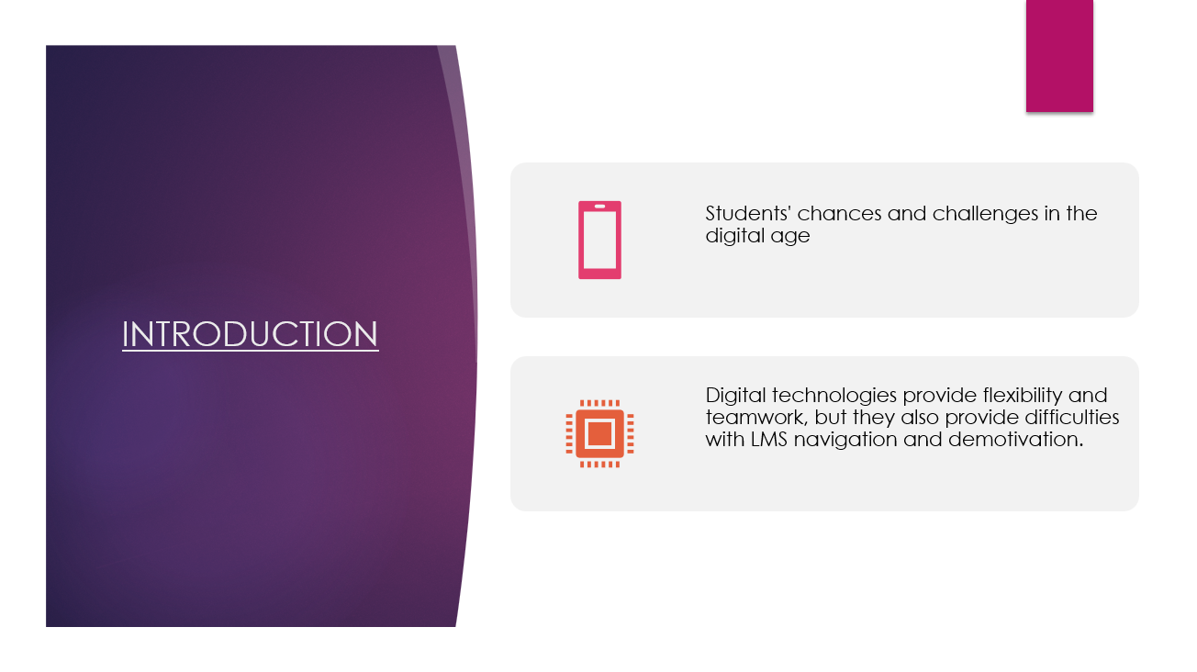

Slide 2 (Research)
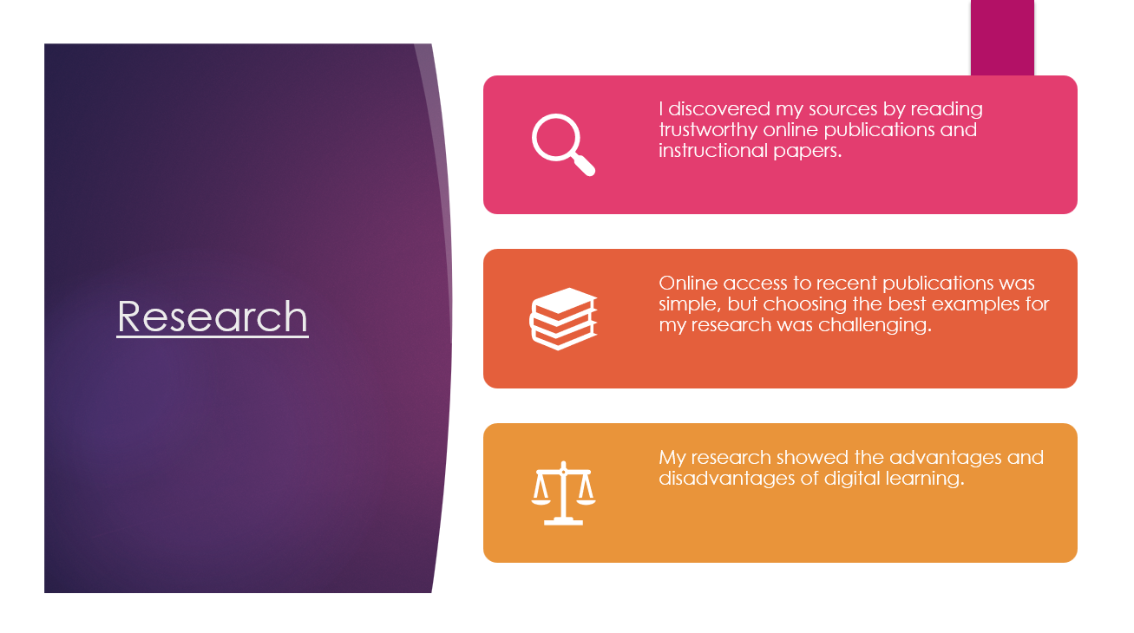

Slide 3 (Planning & Writing)
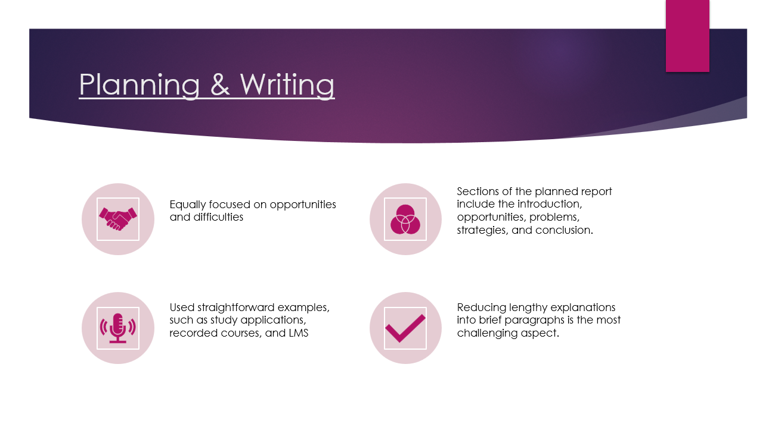

Slide 4 (Challenges)
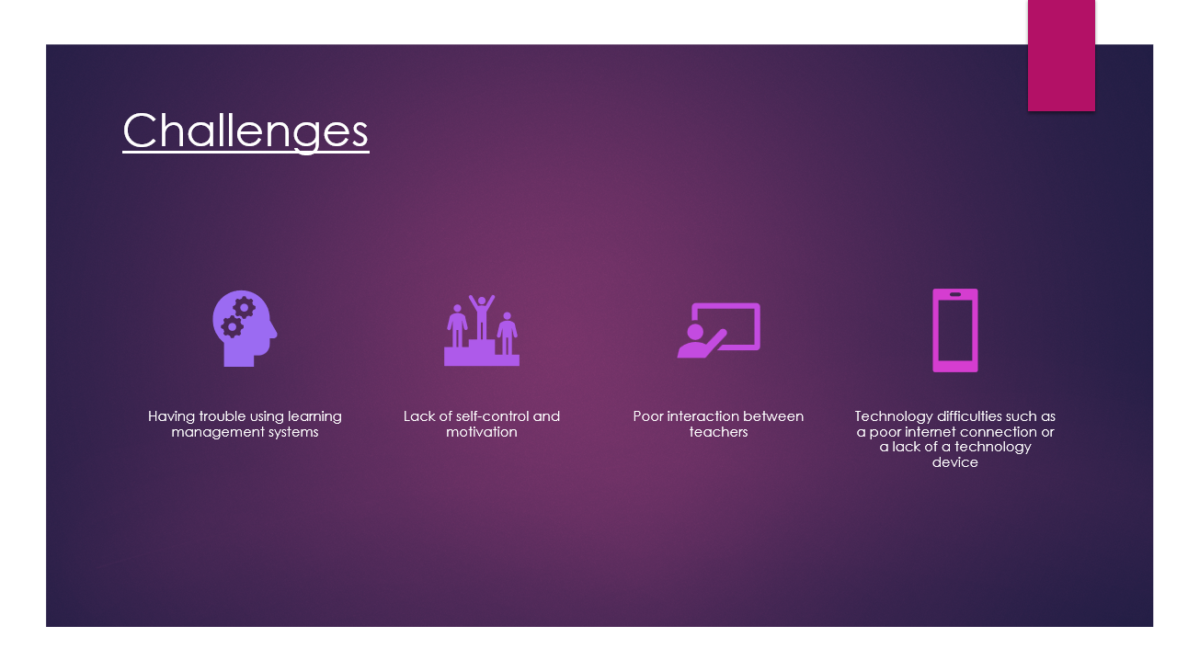

Slide 5 (Successes)
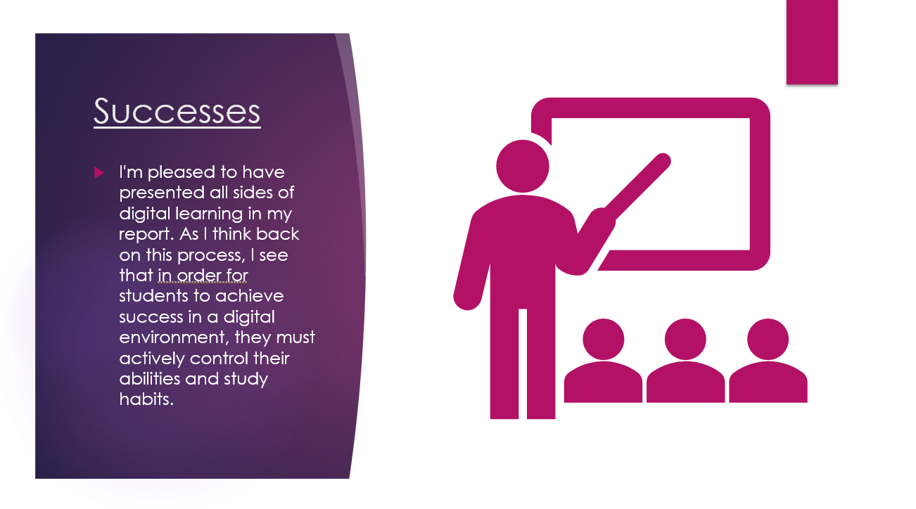

Reference List

21k School, 2023. Challenges of online education. [online] Available at: https://www.21kschool.com/in/blog/challenges-of-online-education/ [Accessed 20 November 2025].
Advantages School, 2023. Online education challenges. [online] Available at: https://advantagesschool.com/online-education-challenges/ [Accessed 20 November 2025].
Alenezi, M., Wardat, S. & Akour, M., 2023. The Need of Integrating Digital Education in Higher Education: Challenges and Opportunities. Sustainability, 15(6), p.4782.
Falmouth University, 2023. Advantages of technology in education. [online] Available at: https://www.falmouth.ac.uk/news/advantages-technology-education [Accessed 20 November 2025].
FS.com, 2023. Digital learning for students: 6 benefits you need to know. [online] Available at: https://www.fs.com/blog/digital-learning-for-students-6-benefits-you-need-to-know-3725.html [Accessed 20 November 2025].
ISTE, 2023. 3 ways to support an effective digital learning environment. [online] Available at: https://iste.org/blog/3-ways-to-support-an-effective-digital-learning-environment [Accessed 20 November 2025].
The Learning Professional Institute (LPI), 2023. Digital learning tips and tools for classroom success in a post-COVID world. [online] Available at: https://www.thelpi.org/digital-learning-tips-and-tools-for-classroom-success-in-a-post-covid-world/ [Accessed 20 November 2025].

