 | Strategies for resilience and prosperity Bmsp 6006  Glenn behenna  Natalie Emma Male 1702161  Report

Table of Contents

Executive summary …………………………………………………………………………………………………………………………2

1.0: Introduction 2
1.1 Company background…………………………………………………………………………………….2
1.2 Report objectives 2
1.3 Competitive strategy 2

2.0: Main Findings 3
2.1 Organisations strategy 3
2.2 Detailed strategy analysis 3
2.3 Advantages 3
2.4 Disadvantages 4
3.0: Conclusion 6

References 6

Executive summary

Overall summary of the report

1.0: Introduction

There are many theorists’ views to describe strategy. (Johnson, Scholes, & Whittington, 2007) state that “Strategy is the direction and scope of an organisation over the long term, which achieves advantage in a changing environment through its configuration of resources and competences with the aim of fulfilling stakeholder expectations”

Porter believes ..
Mintzberg believes .
Implementation is how the plan will be carried out. This is the point where many businesses will fail, it is important to note that strategy and implementation are two separate entities. Essentially it is how the activities are performed that is the essence of strategy. If not, strategy becomes little more than a marketing phrase. (Porter M. E., 1996)
Strategic management is an important tool in the success or failure of an organisation. “Strategy is also the test of the theory of the Business. Failure of the strategy to produce the expected results is usually the first serious indication that the Theory of the Business needs to be thought through again”. (Drucker, 2012)

(Lynch, 2018) purports that “Strategic management is exciting and challenging. It makes fundamental decisions about the future direction of an organisation, its purpose, its resources and how it interacts in the world in which it operates.

Achieving a stance of competitive advantage and intensifying performance comparable to its competitors. Are two important objectives an organisation should strive to attain, equalling that of their rivals. (Dirisu, Iyiola, & Ibidunni, 2013)
Mintzberg - an emergent process, being able to adapt

Business model eg public private- does this have an impact on strategy

Company background

Lever brothers was established by William Hesketh Lever. He developed his idea for sunlight soap in the 1890’s. This revolutionary product would popularise hygiene and cleanliness in the Victorian era. Fast forward to today and the company, now called Unilever, is a multi-national corporation. Concentrating mainly on food and beverages, laundry, and cleaning products.
Unilever has had a series of CSR issues in the past. According to Forbes in 2016 the company settled a lawsuit with 600 Indian workers regarding their exposure to mercury. ( Borelli, 2017) Following a number of controversies, a change in strategy was implemented, to increase CSR, sustainability and ethics. (Our strategy, 2020) suggests that“A belief that sustainable business drives superior performance lies at the heart of the Unilever Compass – our strategy to create long-term value for our stakeholders”.
Their vision appears to have remained the same as when the company was first established. (Alan Jope , 2020) CEO states that “I intend to build further on Unilever’s century-old commitment to responsible business. It is not about putting purpose ahead of profits, it is purpose that drives profits. A timeline of the company can be seen in Image 1
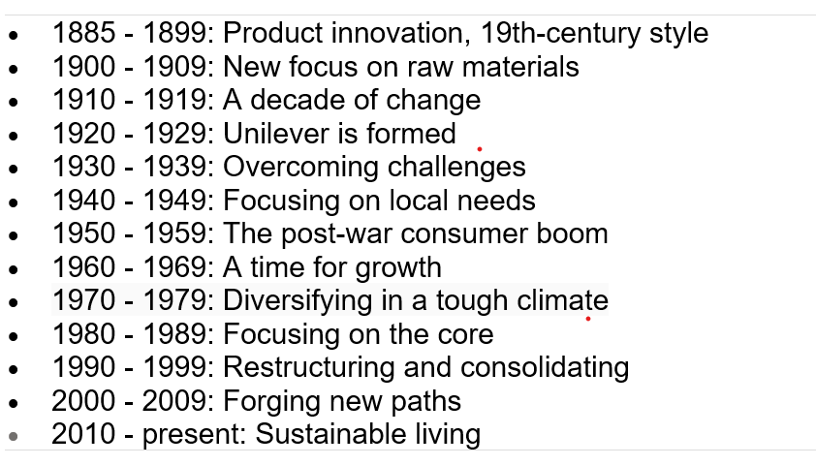
Image 1 (Our History, 2020)

Report objectives

The aim of this report is to ascertain the strategic management approach of Unilever. Utilising appropriate relevant literature, theoretical models, and frameworks.

Competitive strategy
What is Business level strategy -UNSURE
What is competitive strategy
Theorist or 2

Unilever is positioned in highly competitive and saturated market. Their main competitors are Proctor and Gamble and Colgate Palmolive
(Porter M. E., 1996) proposes that “Competitive strategy is about being different. It means deliberately choosing a different set of activities to deliver a unique mix

Wk 1 slides ?

2.0: Main Findings

2.1 Organisations strategy – what is their strategy

There are the levels of strategy that are implemented operationally within any organisation.
Corporate strategy is a higher level of strategy. A review will be undertaken, and recommendations will be made to the board
Business strategy has links to corporate strategy. Assessing the competitive advantage and value proposition for the customer.
Functional strategy looks at how the model will be implemented. With areas such as production, supply chain and customer service
APPLY TO UNILEVER (REFERENCES)
With a large organisation such as Unilever, it is highly likely that there will be a department dedicated to corporate strategy. In smaller businesses Corporate and business strategies are usually combined.
Sustainability and resilience in strategic management
Unilever has developed a strategic management approach that encompasses sustainability, corporate social responsibly and ethical considerations. This creates value for all stakeholders and society. The benefit is that the organisation is that they are better equipped to deal with environmental, Social, and economic changes. Sustainability an also increase profitability in the long term REFERENCE.

2.2 Detailed strategy analysis - to include a stakeholder analysis
Analysis should demonstrate an awareness of sustainability and resilience in the context of the challenging nature of business
Swot and pest analysis October 2020

STRENGHTS | WEAKNESSES
1. Human capital- Staff knowledge, experience, value, large volume of expertise  2. Size and proven history of the organisation  3. Operates in a large geographical market with a  high degree of sustainability and ethics | 1. High operational costs  2. Changing customer requirements  3. Prices are usually higher
OPPERTUNITIES | THREATS
1. Further research and development into products, particularly cleaning products due to Covid 19  2. Diversifying their food products into the health food market  3. Social media marketing | 1. Fluctuating economy  2. Strong competition  3. Large proportion of products are premium brands

The swot analysis shows that there are several areas of consideration. The company employs a large workforce. However, the fluctuating economy and strong market competition could be a cause for concern in the future. With regard to future profits and continued employment.

Political | Economic
1. Impact of Covid-19 and unpredictable changes in government policy  2. Volatile emerging markets and uncertain trade agreements  3. Subject to regulations and laws in different countries | 1. Economic recession due to lockdown restrictions  2. Reduced customer wealth due to furlough and loss of jobs  3. Currency exchange rates
Social | Technology
1. Age demographics  2. Lifestyle preferences  3. Population growth | 1. High level of automation  2. Advance technologies mean products can be copied by competitors  3. Development of E-commerce and marketing

Bowmans strategy clock was developed by economists, Bowman and Faulkner. This marketing models aim is to assist organisations to determine and analyse their market position, in comparison to their competitors. The clock has two dimensions price and perceived value of products and services. The clock is divided into eight potential strategies that can be adopted. This enables organisation to evaluate and analyse their current strategy therefore potentially improving market position. Unilever’s position on the clock is displayed in image 2.
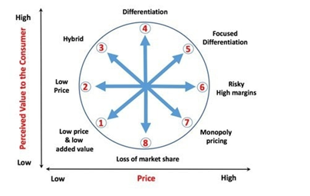
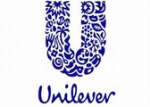

Image 2 (Bhasin, 2019)
Bowmans clock is a useful model in determining market position. Although, it is dependent on the input and interpretation of the individual conducting the analysis. Points 6,7 and 8 provide little opportunity in the competitive marketplace.
Unilever utilises broad differentiation as its collective strategy. This both ties into Porters generic strategy and Bowmans clock. Differentiation concentrates on features and characteristics, making products stand out from the competition. (Porter, 1985) argues that “A firm that can achieve and sustain differentiation will be an above-average performer in its industry if its price premium exceeds the extra costs incurred in being unique”.
For example, one of their beauty products is Dove soap, despite the high cost it stands out from other products due to the fact it concentrates on moisturising. Other products focus on cleaning and could be considered harsh or drying. This gives Unilever a unique selling point, addressing both price and perceived value for the customer.

Power and interest matrix

This matrix assists organisations to understand, prioritise and manage stakeholders, it determines the level of power and interest. Some stakeholders will hold more power, whilst some will hold more interest.

High Level of interest Low
High

Level of power

Low

Keep satisfied  . Stakeholders  . Government  . Suppliers  . Finance  . Legal department | Manage Closely  . Key shareholders  . Directors/executives  . Competitors
Monitor (Minimum effort)  . Media  . Customers | Keep Informed  . Research and development  . Employees  . Marketing

Mendelow’s stakeholder analysis assists to identify the most powerful stakeholders

3.0: Conclusion
the organisation has a proven longevity and adaptability

References

