Global Business Environment

By: Ioan-Alexandru Sas
Lecturer’s name: Rexon Nting
Module number: (LCBB4005)



Table of Contents
Introduction 3
Brief Introduction of a selected country 4
PESTLE analysis 4
Porter’s Five Forces 6
Hofstede Cultural Dimension 8
“Opportunities and challenges that are present and how to manage aspects of corporate governance, business strategy and cultural sensitivity in China” 9
"Different barriers experienced by foreign businesses in China" 10
Recommendation 11
Conclusion 12
Reference List 13

Introduction
International business is the business operations when an organisation undertakes the activities of the business away from the domestic market. Farmfood is a UK-based frozen food selling company focusing on expanding its Chinese market business. The company's focus will be extending its business operation in the Chinese Market to increase its sales and revenue. This study will focus on analysing the external factors and various cultural factors that impact the business in the international market. Based on the analysis and appropriate recommendations will be provided for the business to expand in the global market.

Brief Introduction of a selected country
China is one of the major developing countries and the most populous country in the world, with a population of over 1.4 billion. It is the third largest country in the world, with an area of over 9.6 square kilometres. It is one of the fastest-growing economies in the world and has a GDP of 14.895 trillion pounds, and the country's per capita income is 17309 pounds (Leong et al., 2018). Farmfood is looking to expand its business to the Chinese market as the company will gain several benefits, such as low labour costs and high literacy. Moreover, the frozen food market is growing in China, with a market of over 21.5 billion pounds. All these factors have been a significant reason for Farmfood to expand its Chinese market business.

PESTLE analysis
Political factors: Political condition of any country has an impact on the businesses which are located within the periphery. Even if China has a good relationship with most countries worldwide, political tension between the US and South China can impact the country's business condition (Liu & Woo, 2018). The Ukrainian war is another major factor affecting the country's political situation, which can impact the business of Farmfood when it is being expanded in the Chinese Market.
Economic factors: Economic factors also directly impact the businesses operating within a country. One of the significant positives related to the economic factor in the Chinese Market is that labour cost is low, and companies can create high-profit margins while operating in China. It is to be noted that the inflation rate in China is alarmingly high, which can have a negative impact on the businesses operating in the country. The average inflation rate in the country is 8%, which has reduced the buying power and can negatively impact businesses (Tian, 2019).
Social factors: Social factors must also be considered while operating businesses in the international market. China has a large population, and among them, 90% of them are literate. As a result, the company will gain type performing and efficient labour at a low cost in the Chinese Market, providing benefits to the company (Tian, 2019).
Technological factors: China has witnessed significant growth in E-Commerce in recent times as it has been introduced in the country recently. As a result, it can be beneficial for businesses to be operating in the online platform as well as the physical location as the labour cost is low and eCommerce is also growing (Song and Xiong, 2018).
Legal factors: There are some major regulations which are related to formulating an eCommerce business in the country. There are significant regulations for foreign companies operating in the country. Therefore the company must consider the significant rules to ensure that the business will run efficiently in the country.
Environmental factors: The environmental aspect is one of the major factors which needs to be considered by businesses while operating in China. Farmfood needs to ensure that the carbon footprint rate of the company needs to be kept low so that the negative impact on the environment can be reduced. It plays a vital role in ensuring that the business can operate in the country without facing any negative consequences in the case of environmental concerns (Lee, 2018).

Porter’s Five Forces
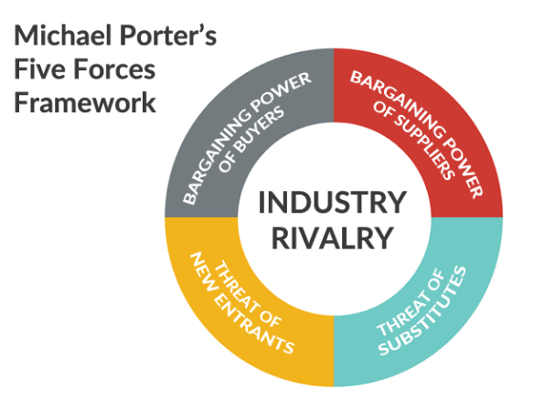
Figure No 1: Porter’s Five Forces
(Source: Bruijl and Gerard, 2018)
Factors | Impacts | Analysis
Threat of new entrants | High | The company will be facing a high threat of new entrants while operating in the Chinese Market. It is mainly due to the fact that there is no requirement for a high level of financial investment to be entering into the food processing industry (Frederick and Parappagoudar, 2021). Moreover labour charges in the Chinese Market are also low as a result of which the business faces a high threat of new entrants.
Bargaining power of the customers | Moderate | The bargaining power of the customers is moderate as there is less number of Frozen food companies operating in the Chinese market. There is a small number of options available for the customers to be bargaining at their full power. However, there are other options apart from Frozen food for the customers to choose. Therefore both these factors make the bargaining power moderate for the customers in the case of the frozen food industry (Shang et al., 2021).
Bargaining power of the suppliers | Low | The bargaining power of the suppliers is low which is due to the fact that raw materials related to the Frozen food industry are relatively easy to obtain. There are a large number of suppliers who can deliver the raw material required for the Frozen food industry in the Chinese Market. Apart from that the labour charges are also low making it comfortable for the businesses to supply the product to the customers.
Competitive rivalry | Moderate | The competition in the frozen food market in China is also moderate. There are a number of Frozen food selling companies in the Chinese Market. However there needs to be more customer loyalty in the section of the business or the industry (Juliana and Nyoman, 2019). Sanquan Food, Informa, Fujian Enjoy Foods Co Ltd, Meiji co ltd are some of the major companies in the sector of the business in the Chinese Market. With the appropriate level of marketing Farmfood will be able to gain the market share and also will be able to make sales in the market.
Threat of substitute products | High | Substitution of the frozen foods is relatively easy for various other businesses and also for small companies. Moreover, the financial investment required for the substitution of the product is also relatively easy. As a result of which the company faces a high level of threat which is related to the substitution of the product in the Chinese Market.
Table No 1: Porter's Five Forces Analysis
(Source: Created by the learner)

Hofstede Cultural Dimension
The UK and China have a vast level of cultural differences, and Farmfood needs to take proper consideration regarding the culture while the business is being expanded in the Chinese Market.
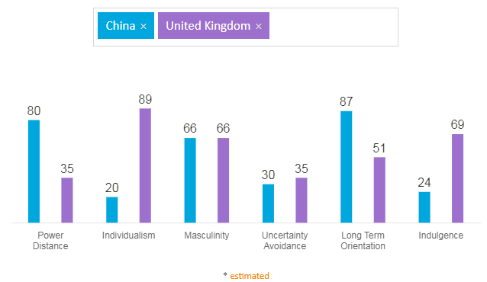
Figure No 2: Hofstede Cultural dimension of China and the UK
(Source: Huang and Crotts, 2019)
The first element of the Hofstede cultural dimension is the power distance, in which the score of the United Kingdom is 35 while the score of China is 80. It means that society has a belief that inequalities among people are acceptable. While in the case of the UK, societal inequalities are not permitted or accepted by society. The second factor related to the cultural dimension is individualism versus collectivism. In this case, China's score is 20, and the score of the UK is 89. It means that the people in China and society are collectivists. While the society of the UK is individualist, which means that the people in the UK do not have an interest in the group and have a higher focus on themselves, while it is the opposite in the case of Chinese culture (Huang and Crotts, 2019).
Another significant dimension in the case of the culture is masculinity versus feminism. The score of China, in this case, is 66, while the score of the UK is also the same. It means that both China and the UK are masculine societies. Masculine society mainly focuses on a culture which is success oriented and driven. People in this culture prefer to work more than leisure and family time (Jadil et al., 2022). The fourth dimension in the cultural dimension is uncertainty avoidance, and the score of China in this dimension is 30, while the score of the UK is 35. It means that people in the society or the culture are not necessarily threatened by the uncertain situation which can be faced in the future. Therefore they show less amount of uncertainty avoidance.
Another significant dimension is the long-term orientation, and China scores 87 in this dimension while the UK score is 51. It signifies that the people are very pragmatic and believe that the truth depends highly on the context, situation and time. While in the case of the UK, the score is 51, which does not provide a clear idea regarding its nature. The final factor related to it is indulgence; in this case, the score of China is 24, and the UK's is 69. It means the UK is an indulgent society while China is cynical and pessimistic (Beugelsdijk and Welzel, 2018).

“Opportunities and challenges that are present and how to manage aspects of corporate governance, business strategy and cultural sensitivity in China”
There are some significant opportunities as well as challenges which are faced by foreign businesses in the Chinese market. Therefore, Farmfood will also face some opportunities and challenges to operating effectively in the Chinese market. The company lists to ensure that all the cultural aspects related to the Chinese Market need to be properly considered while undertaking the marketing. The company also needs to ensure that it has an appropriate business strategy that allows the business to excel in the Chinese Market. To manage cultural sensitivity, the company's focus needs to be on hiring local employees who have a proper understanding of the culture of China (Lardy, 2019). It is also essential for the company to include diversity within the organisation so that business operations can take place in the proper manner.
Moreover, the focus should also be on ensuring that corporate governance is taken care of so that the challenges will be mitigated, which are related to high inflation and external factors that impact the business in the Chinese Market. For example, to minimise the challenges of cultural sensitivity and produce an effective outcome, the company should focus on marketing as per Chinese culture. The company should also have a proper approach to intellectual property rights which will ensure that the product of the company will not be copied in the Chinese Market.

“Different barriers experienced by foreign businesses in China”
Some of the significant challenges are foreign businesses barriers while doing business in China. One of the significant challenges faced by the following companies is the cultural challenge. China is one of the biggest emerging markets and provides an essential opportunity for foreign businesses to expand business in China. The ayurvedic culture of China is unique in its characteristics and distinctiveness. Foreign companies must adapt to China's culture and develop approaches that will allow the companies to function effectively in the country. Suppose foreign businesses need to have a proper understanding of the culture. In that case, there is a higher chance that cultural misunderstanding could lead to the failure of the business in the Chinese Market (Lardy, 2019). For example, AstraZeneca is a UK-based company which has its business operation in China. Still, due to cultural differences, it has faced some of the major issues in the marketing field.
Another major challenge an organisation faces is China’s Regulatory hurdles as it has procedures with prolonged administration for registration, permits and licensing, which is one of the significant challenges in the Chinese market. Most businesses need to have a licence of a standard company. Businesses need to ensure that they follow all the major requirements necessary to operate in the Chinese market. Higher regulations are required in the case of medical businesses in China. However, it is also important to make considerations regarding the regulations and also necessary for an organisation to ensure that all the regulations are met so that the businesses can operate effectively in the Chinese market.
Intellectual property rights are another major issue that foreign businesses face in China. China has been one of the major sources of counterfeits which are supplied across the world. A business faces a major issue in the country to protect intellectual property. It is also difficult for foreign businesses in the country to develop approaches to have effective global supply chains. Logistics systems in the country have been difficult for the country, which is difficult for foreign businesses. It is difficult for foreign businesses to have an adequate flow of materials in the country to ensure that the business functions effectively (Chen et al., 2022). Moreover, the competition in the Chinese market is also increasing daily, making it difficult for foreign businesses to operate efficiently in the Chinese market.

Recommendation
Based on the finding, the following recommendations can be provided to Farmfood while doing business in the Chinese market:
- The focus of the company should be on hiring local talent. It will ensure that the company will be familiar with Chinese culture, and the company will also have access to low-cost labour.
- The company should also use joint ventures as a market entry strategy. It will ensure that the company will have local expertise in the foreign market, allowing it to undertake business operations effectively (Bhattacharyya, 2020).
- It is also recommended that the focus of the company needs to be on making effective use of E-Commerce in the Chinese Market. It will ensure that the sales will be higher as eCommerce has been growing in the Chinese Market.

Conclusion
The study mainly focuses on analysing the Chinese market for a UK-based company to expand its business successfully. It has been found that various aspects of the business need to be considered while a company is growing a business in the international market. It has been found that culture and external factors play a significant role when a business is being expanded internationally.

Reference List
Beugelsdijk, S. and Welzel, C., 2018. Dimensions and dynamics of national culture: Synthesizing Hofstede with Inglehart. Journal of cross-cultural psychology, 49(10), pp.1469-1505.
Bhattacharyya, S.S., 2020. International business strategy: development of an integrated framework and typology. Review of International Business and Strategy.
Bruijl, D. and Gerard, H.T., 2018. The relevance of Porter's five forces in today's innovative and changing business environment. Available at SSRN 3192207.
Chen, J., Huang, W. and Sun, X., 2022. The Structure of Foreign Trade Game Business in China-Case Study from Tencent. Highlights in Business, Economics and Management, 2, pp.297-302.
Frederick, D.P. and Parappagoudar, S.K., 2021. A Descriptive Analysis on Sustainable Business Strategy of Online Food Service Industry.
Huang, S.S. and Crotts, J., 2019. Relationships between Hofstede's cultural dimensions and tourist satisfaction: A cross-country cross-sample examination. Tourism management, 72, pp.232-241.
Jadil, Y., Jeyaraj, A., Dwivedi, Y.K., Rana, N.P. and Sarker, P., 2022. A meta-analysis of the factors associated with s-commerce intention: Hofstede's cultural dimensions as moderators. Internet Research, (ahead-of-print).
Juliana, J.P.E. and Nyoman, Y.N., 2019. Factors influencing competitiveness of small and medium industry of Bali: Porter’s five forces analysis. Russian Journal of Agricultural and Socio-Economic Sciences, 89(5), pp.45-54.
Lardy, N.R., 2019. The state strikes back: The end of economic reform in China?. Peterson Institute for International Economics.
Lee, C.K., 2018. The specter of global China. In The Specter of Global China. University of Chicago Press.
Leong, Y.K., Tao, L.K. and Hobhouse, L.T., 2018. Village and town life in China. Routledge.
Liu, T. and Woo, W.T., 2018. Understanding the US-China trade war. China Economic Journal, 11(3), pp.319-340.
Shang, X.F., Choi, M.C., Pan, X.C., Zou, A.N. and Kim, H.E., 2021. A Research on the Development Strategy of Quanjude, a Time-Honored Brand in China. Turkish Journal of Computer and Mathematics Education (TURCOMAT), 12(13), pp.6195-6200.
Song, Z.M. and Xiong, W., 2018. Risks in China’s financial system.
Tian, G., 2019. Deceleration of China's Economic Growth: Causes and Countermeasures. Frontiers of Economics in China, 14(1).

