

Programme: BA (Hons) Leadership and Management Skills in the Workplace
Module: Project Management
Module code: LCLM5003

[West Midlands Flooding Disaster]

Student name: Vasile Vatamaniuc
Student ID: 2413828
Date of submission: 27/07/2026
Tutor name: Xavier Matieni
Table of Contents
Part A: Project proposal poster 3
Part B: Reflection on Feedback 4
Part C: Project Management Plan 6
1. Introduction 6
2. Project Description 6
3. Project Scope 7
4. Work Breakdown Structure (WBS) 8
5. Quad Chart 9
6. Gantt Chart 10
7. Stakeholder Involvement 11
8. Allocation of Resources 12
9. Risk Analysis 13
10. Conclusion 14
References 16

Part A: Project proposal poster
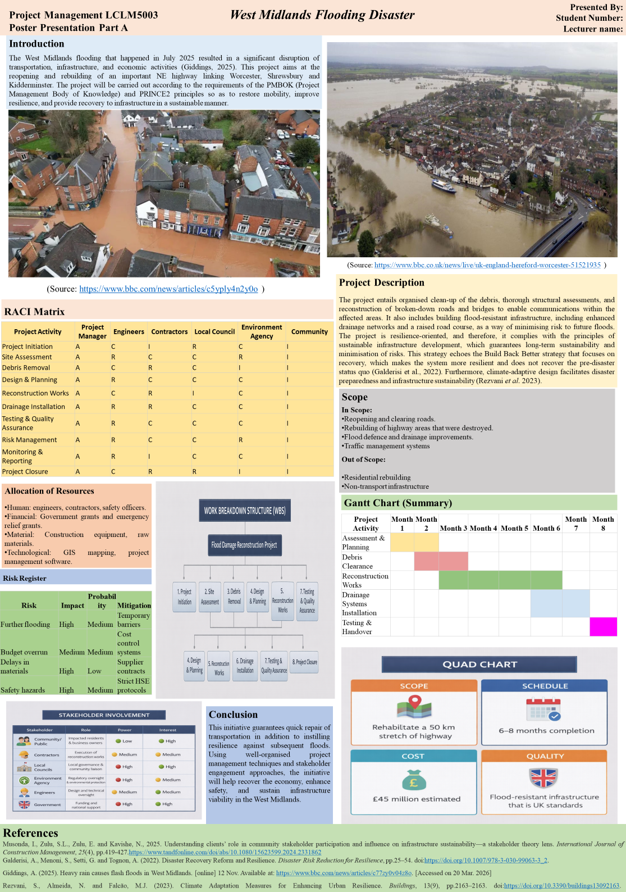

Part B: Reflection on Feedback
1. Introduction
This part is a reflection of the feedback concerning the project proposal poster prepared for the West Midlands highway reconstruction project. The reflection will be based on self-reflection and expected observation at the level of peers. This is to critically evaluate the strengths and weaknesses of the poster and determine where to improve. This reflective practice will help in the sustained enhancement of the practice of project management and also improve the quality of the completed project management plan.
2. What Went Well
The poster had a definite strong point regarding the structure, clarity, and principles of project management. The project goal was clear at the beginning of the project. It was concerned with reconstructing and re-opening a key highway that had been destroyed in flooding. This helped the project to be less abstract and closer to a practical and immediate need. On the other side, the alignment to the most popular frameworks like PMBOK and PRINCE2 empowered the academic base of the work. There was adequate inclusion of key knowledge areas like scope, risk and stakeholder management. The PRINCE2 structured approach to governance also aided role and responsibility clarity. Apart from that, the poster was well organised, addressing key areas, which included scope, Work Breakdown Structure (WBS), Gantt chart, and risk analysis. The consideration of the Build Back Better concept also reflected a realisation of sustainable and resilient infrastructure development. The identification and association of stakeholders with theoretical perspectives is evidence of an awareness of stakeholder participation in project success.
3. Areas for Improvement
Along with these strengths, there were a number of limitations identified. The WBS was not deep enough because it did not subdivide tasks into work packages. This reduces its applicability to the estimation of costs and allocation of tasks. Likewise, the Gantt chart was represented as an overview without depicting task dependencies, sequencing and critical path, which is vital in proper scheduling.
The risk analysis was quite simplistic, as it was done without quantitative methods and a comprehensive impact evaluation. This limits the capacity to prioritise and effectively handle risks. Moreover, there was weak academic integration in the poster with little theoretical references and little critical discussion. This undermines the academic rigour at this level.
The stakeholder engagement was also not developed. While key stakeholders were identified, there was no use of analytical tools such as a power-interest matrix to assess influence and engagement strategies. Also, distribution of resources was not justified using known methods like resource levelling which plays a key role in effective project implementation.
4. Improvements for Final Plan
In order to make the ultimate project management plan better, a number of improvements will be made. A clearer and more developed WBS will be designed with a breakdown of tasks and work packages in a hierarchical way. The Gantt chart will be extended with dependencies of tasks, milestones, and the critical path. The use of both qualitative and quantitative methods, including probability-impact matrices, will reinforce risk analysis. There will be structured models in stakeholder analysis to determine the level of influence and engagement. The management techniques and justifications will be used to support resource allocation.
Moreover, the final report will contain at least ten academic references and will show a greater integration of the project management theories and tools in the discussion.
5. Conclusion
Critical estimation is a significant aspect of enhancing projects. Evaluating the strengths and weaknesses results in improved planning and increased decision making ability. These enhancements will lead to a well-structured final project management plan that is professional. The report will also show scholarly honesty and provide an effective, practical solution.

Part C: Project Management Plan

1. Introduction
In July 2025, some towns in the West Midlands, including Worcester and Shrewsbury were hit with severe flooding. The River Severn overflowed due to heavy and extended rainfall. This resulted in a lot of damage to roads, infrastructure and local services. Due to the heavy rainfall, transport routes were closed and lots of places became inaccessible. The incident revealed the speed at which a natural disaster can endanger the economic activity and population security. Disaster recovery is largely subject to project management. It aids in prioritisation of tasks to be done, limited resources, and also the projects on time. PMI (2024) argues that complex situations are better coordinated and less baffled in a structured planning situation. On the same note, Kerzner (2017) describes how clear project frameworks facilitate effective decision-making and control.
The purpose of this report is to prepare a project management plan to rebuild a transport corridor that was destroyed. It uses established methodologies like PRINCE2 and PMBOK to help in proper planning and execution.

2. Project Description
The principal aim of this project is to restore and reopen a 50 km highway without access between Worcester, Shrewsbury and Kidderminster. The floods seriously damaged the road. The project will seek to recover safe and reliable transportation of people and goods. The main deliverables are the restoration of damaged roads and bridges, installation of better drainage systems, and other road safety provisions like signage and surveillance. This is all required so that the transport network is set back online as soon as possible. The project is core in the recovery of the region. Any impact on transport has an effect on the supply chains, emergency facilities and daily life. The UK Environment Agency (2023) argues that the structural impact of floods has the potential to severely slack economic recovery and cost. By constructing this highway anew, one will enhance accessibility, facilitate local businesses and ensure communities go back to normal. It will also minimize losses in the economy in the long term as the road will be more resistant to future floods.
The project is guided by the PRINCE2 Business Case principle that maintains the project provides value and justifies the project in its lifecycle (Pawar and Mahajan, 2017). The advantages in this case would be the efficiency in the transport, lower repair costs in the future, and increased safety. In addition, the project adopts the “Build Back Better” approach, which focuses on rebuilding infrastructure in a stronger and more sustainable way (Der Sarkissian et al., 2023).
A resilient design is superior to a conventional recovery plan since it equips infrastructure to withstand any risks in the future. Traditional approaches tend to revert to the past without correcting areas of weakness. The new design also incorporates elevated levels of the roads and improved drainage. These aspects will contribute to the minimization of the effects of any further flooding. This strategy is both sustainably long and more economically effective in utilizing the resources of the people.

3. Project Scope
Project scope outlines the inclusion and exclusion criteria other than the highway reconstruction project. The in-scope activities under this case will involve clearing debris, reconstructing damaged portions of the road, reconstructing bridges, and installing better drainage systems. It also comes with road traffic and safety controls in order to make the road functional. Nevertheless, residential reconstruction and other non-transport infrastructure are not part of the project. It is significant to specify these boundaries to prevent misunderstandings and make the project remain centred around its primary goal.
There are also a number of constraints to the project. The time is a major limitation because the road must be reopened in a short period to facilitate economic recovery. Another constraint is cost, as the project will rely on government funding, and should not exceed the budget. The weather also creates additional uncertainty, since additional rain might slow down construction. Among the key assumptions is that funding will be received in time and skilled workers and materials will not be lost to delays that are significant.
PMBOK presents scope management as a scope definition and scope control (Project Management Institute, 2021). A definite scope makes the project teams aware of what should be delivered, and scope control makes sure that the changes are managed. Among the risks is scope creep, where extra activities are introduced without due approval. This may add to the expense and time lag of the project. To prevent this, a scope baseline is prepared. The scope baseline serves as reference and assists in tracking alterations of the project. Kerzner (2017) identified a positive correlation between project meeting time and cost targets and adequately defined scope baseline.

4. Work Breakdown Structure (WBS)
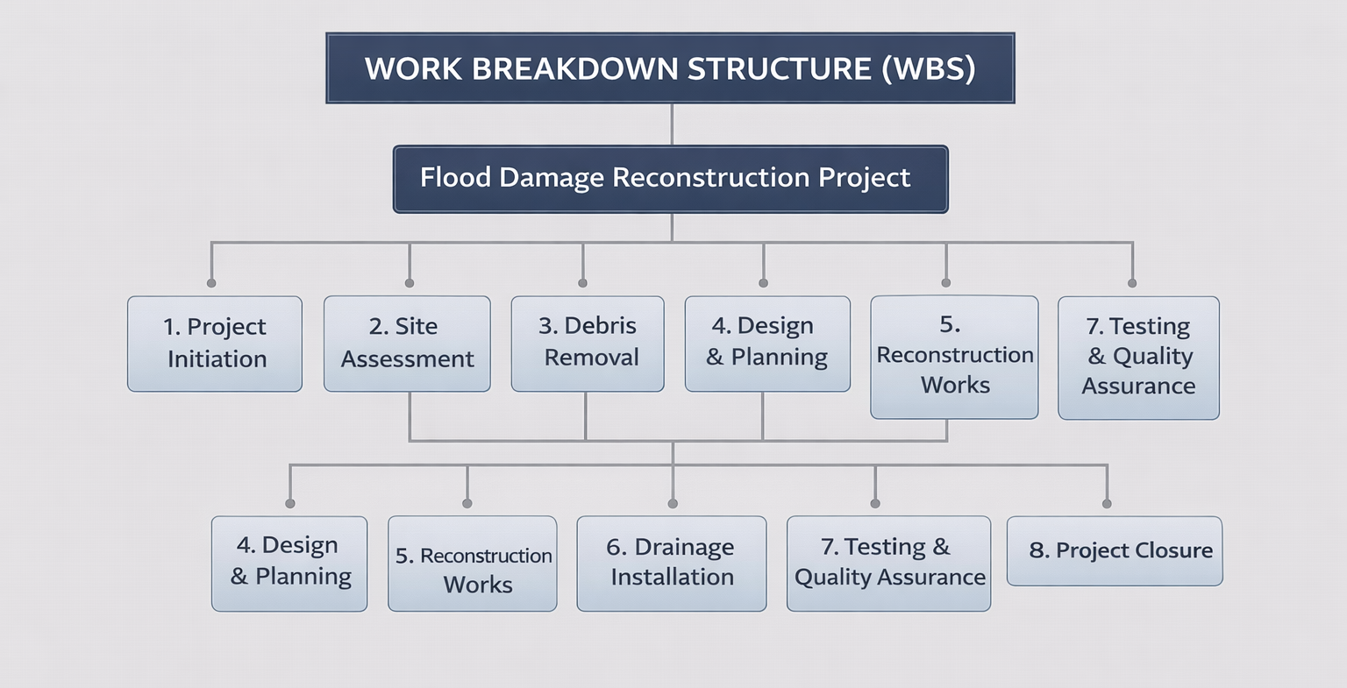
Figure 1: Work Breakdown Structure (WBS)
(Source: Self-developed)
The “Work Breakdown Structure” (WBS) is a structured manner of subdividing the project into manageable units. The project is organised in three major levels as illustrated by the developed WBS. At Level 1, the entire project is described as the Flood Damage Reconstruction Project. This is the entire work that is necessary to repair the highway following the flooding.
Under Level 2, the project is subdivided into major stages, which include project start, site analysis, clearing of the site, design and planning, construction, laying of drainage, testing and quality control and project termination. These steps are logically structured, and they are similar to the actual steps of infrastructure recovery. At Level 3, every phase can be further subdivided into certain tasks. As an example, the design and planning phase includes engineering design and approvals, whereas reconstruction involves road rebuilding and bridge repairs. This chronological format assists in defining and managing all the activities.
PMBOK defines a WBS as a project scope that is a breakdown by deliverable (PMI, 2021). It enhances the task clarity as it displays what work is required to be done. It is also used to help estimate costs accurately since you can assign resources and a budget to each of the tasks. Moreover, it aids in planning because duties can be planned as a definite schedule. It has been found that projects that have a clear WBS have a higher chance of completion on time and within a budget (Narvaez et al., 2020). Hence, WBS use in this project will enhance control, planning and coordination of all activities.

5. Quad Chart
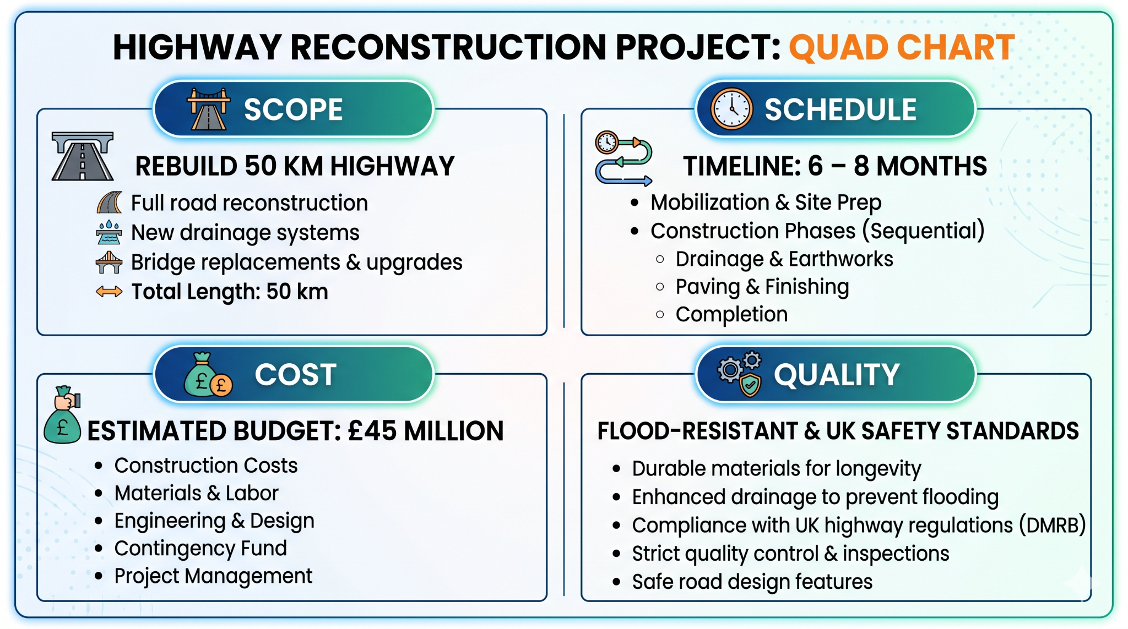
Figure 2: Quad chart
(Source: Self-developed)
The Quad Chart is a clear and easy overview of the project based on scope, schedule, cost and quality. This project includes a 50 km highway with roads, bridges, and drainage systems reconstruction. It has a rough estimate of six to eight months. This is an indication of the urgency with which transport should be re-established following the floods. It will cost around £45 million, depending on the costs of reconstruction and resources. Quality can be determined by the development of flood-resistant infrastructure that is safe according to UK standards.
This method is closely associated with project performance measurement. Similarly, success is measured by the level of management of these four elements. Time, cost, and scope are interdependent, according to the notion of the triple constraint in project management (Westland, 2025). A change in one factor will affect the others. To illustrate, a better material can be used to ensure quality, leading to a higher cost and a longer schedule. So, these trade-offs should be addressed by project managers to guarantee the success of the whole project.

6. Gantt Chart
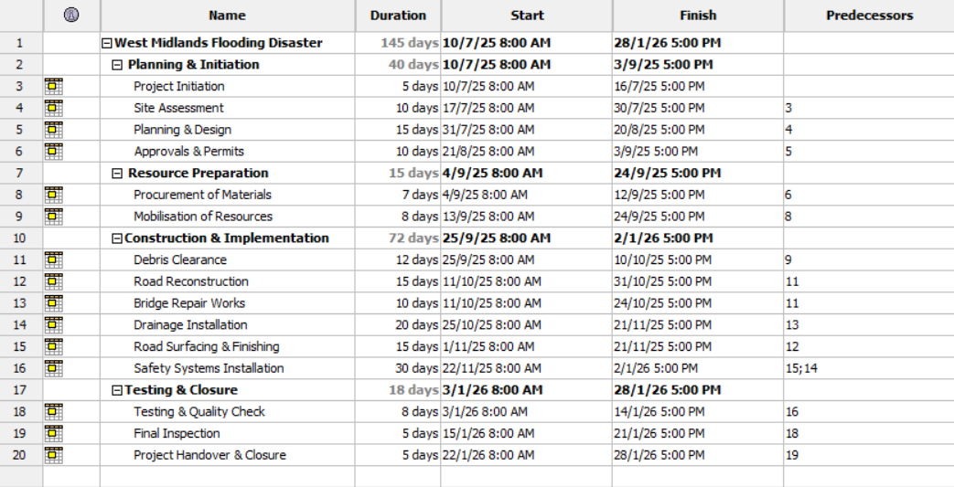
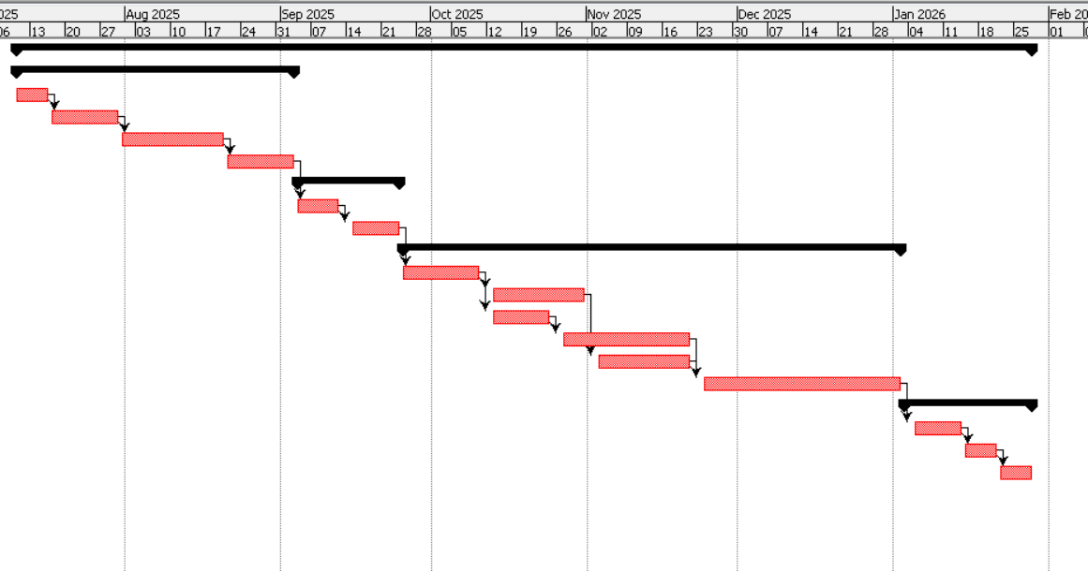
Figure 3: Gantt chart summary
(Source: Self-developed)
According to the developed gangster it has covered a total duration of 145 days. The project has been divided into four major parts. The major parts are planning & initiation, preparation of resources construction & implementation and testing & closure. Focusing on the main part of the project is also divided into major sub parts. Each of the tasks mentioned in the project is logically linked with predecessors. This pretty shirts make sure of proper sequencing to manage the entire task. As an example it can be straight that construction activities can only begin after completion procedure of resource allocation. The use of dependencies effectively supports the method of critical path. Critical path also assists to manage better time control. The structure schedule of the above developed gangster effectively improves project efficiency and ensures timely completion. This schedule entails task dependencies. As an illustration, debris clearance has to be done prior to reconstruction. On the same note, the drainage installation requires major reconstruction work to be done. Before testing and handover, all construction work is required to be completed. This sequence of activities executes work activities in a rational order. It also mitigates the risks of the need to revisit and repeat past stages.
The critical path is the longest sequence of interdependent tasks and it is used to calculate the total time required by the project. The same route, in this project, passes through operational assessment, clearance, reconstruction, installation of drainage and eventually testing. The timeline of any project will be impacted directly by any delay of these steps.
PMBOK emphasizes the importance of the time management as the core of project success (PMI, 2021). Wofuru-Nyenke (2024) also writes that the ‘Critical Path Method’ will assist in identifying crucial activities and help to create effective schedules. Timelines have even more relevance in disaster recovery projects. Delay may slow down emergency response, stall out economic recovery and endanger public safety. A clear and realistic schedule actually accelerates the recovery and makes sure that resources are utilized where they are the most required.

7. Stakeholder Involvement
The success of this highway project is tied to involvement of stakeholders. The major role has been played by the effective stakeholder. Potential stakeholders include government, contractors, the local community, and the UK Environment Agency (Gov.UK, 2026). Financing, licenses and policy advice are given by the government. The construction is carried out by contractors and provides technical expertise. The Environment Agency also deals with flood risk and makes certain that environmental standards are met. The local inhabitants are the straight influenced by the project and rely on the road in their everyday lives. These stakeholders have to be identified clearly so that they can have a better coordination and eliminate conflict.
The theory backed by Stakeholder Theory is this. It suggests that a project's success depends on meeting the needs of all key stakeholders (Mahajan et al., 2023). One such tool is the power-interest grid. It is an approach that clusters the stakeholders based on the degree of influence and interest (Bdaiwi, 2023). As an example, both the government and the Environmental Agency have high power and interest. The local people have great interest and less power, thus they must be informed and consulted on a regular basis.
The best engagement tactics are frequent meetings, periodic reports and consultations. This can be updated to government bodies on a weekly basis as local issues can be addressed on community meetings. An effective communication plan is also significant. Communication plan must expressly identify the information exchanged, frequency, and delivery through the medium, like emails, reports, or meetings. PMI (2021) observes that formatted communication enhances comprehension and minimizes the possibility of confusion. Effective stakeholder engagement leads to a smooth project delivery and a higher likelihood of communities facilitating the work being done.

8. Allocation of Resources
Resource allocation is one of the essential components of this project as it will make sure that activities are performed efficiently and in a timely manner. The project involves human resources, financial resources and technological resources. The human resources consist of engineers, construction workers, and safety officers who are performing technical and operational work. The primary source of financial resources includes government funding, which is applied to materials, labour, and equipment. Technological resources entail using tools like GIS mapping tools and project management software, which aid in the planning and monitoring processes.
Resource management is defined by PMBOK as planning, obtaining, and managing resources to achieve the project goals (PMI, 2021). Resource levelling is one of the techniques that corrects the project timeline to balance out resources and prevent overloading. As an illustration, when several tasks demand the same workers at the same time, the schedule can be altered so as to avoid delays and exhaustion.
Effective resource distribution aids in minimising delays and cost increases. Research shows that poor resource planning is one of the main reasons for project failure, especially in construction projects (Khalid, 2019). This is more critical in disaster recovery initiatives since delays may impact population security and the economy. So, the proper planning of resources will guarantee improved performance and the successful delivery of the project.

9. Risk Analysis
This project requires risk analysis since disaster recovery projects are characterised by great uncertainty and time constraints. The key risks are environmental, financial and operational risks. Construction work can be halted by environmental hazards, such as additional flooding. Financial risks could be associated with increasing material prices or financial constraints. Some of the operational risks are the labour shortages, equipment failure and safety aspects in the course of reconstruction.
PMBOK identifies a systematic procedure in risk management, which consists of identification and analysis of the risk and planning of the response (PMI, 2021). In this project, qualitative analysis is used through a probability-impact matrix to prioritise risks. The concept of quantitative thinking is also implemented through estimating the potential delays or cost escalation.
Table 1: Risk Register Matrix
(Source: Self-developed)
Risk ID | Risk Description | Type | Probability | Impact | Risk Level | Mitigation Strategy | Contingency Plan
R1 | Further flooding | Environmental | Medium | High | High | Temporary flood barriers, weather monitoring | Delay buffer and emergency response plan
R2 | Budget overrun | Financial | Medium | Medium | Medium | Cost control systems, regular audits | Use contingency reserve funds
R3 | Material delays | Operational | Low | High | Medium | Multiple suppliers, early procurement | Alternative suppliers
R4 | Labour shortage | Operational | Medium | Medium | Medium | Workforce planning, contractor agreements | Hire temporary workers
R5 | Safety incidents | Operational | Medium | High | High | Strict HSE policies, training | Emergency medical and safety response
The probability and impact are added to make the risk level. The flooding and safety incidents are the high-risk items that should be addressed immediately. It is also important to have contingency planning. This will involve additional time, alternative suppliers and emergency cash. A study by Albasyouni et al. (2025) reveals that risk planning is solid and will lessen delays and improve the outcome, particularly in construction projects. A special risk register will thus aid in making better decisions and will assist to deal with uncertainty during project.

10. Conclusion
This project effectively assists to recover transport and economic activity following the West Midlands flooding. The project of reconstruction of the highway will enhance connectivity, safety, and resilience. The project is well planned, incorporating the use of organisational tools like WBS, Gantt chart, and scope definition. Risk management has been effectively employed to eliminate significant uncertainties. Furthermore, the stakeholder participation would promote improved coordination and acceptability to society. The project is designed, practical and on track with the accepted project management principles, which enhances the chances of timely successful delivery.

References
Albasyouni, W., Kamara, J. and Heidrich, O. (2025). Key challenges and opportunities to improve risk assessments in the construction industry. Buildings, [online] 15(11), pp.1832–1832. https://doi.org/10.3390/buildings15111832.
Bdaiwi, Y. (2023). Stakeholder Analysis Using the Power Interest Grid. [online] Projectmanagement.com. Available at: https://www.projectmanagement.com/wikis/368897/Stakeholder-Analysis--using-the-Power-Interest-Grid. [Accessed on 29 Mar. 2026]
Der Sarkissian, R., Diab, Y. and Vuillet, M. (2023). The ‘Build-Back-Better’ concept for reconstruction of critical Infrastructure: A review. Safety Science, 157, p.105932. https://doi.org/10.1016/j.ssci.2022.105932.
Galderisi, A., Menoni, S., Setti, G. and Tognon, A. (2022). Disaster Recovery Reform and Resilience. Disaster Risk Reduction for Resilience, pp.25–54. https://doi.org/10.1007/978-3-030-99063-3_2.
Giddings, A. (2025). Heavy rain causes flash floods in West Midlands. [online] 12 Nov. Available at: https://www.bbc.com/news/articles/c77zy0v04z8o. [Accessed on 20 Mar. 2026]
Gov.UK (2026). Stakeholder engagement. [online] www.local.gov.uk. Available at: https://www.local.gov.uk/topics/severe-weather/flooding/local-flood-risk-management/stakeholder-engagement [Accessed 10 Apr. 2026].
Kerzner, H. (2017). Project Management. John Wiley & Sons.
Khalid, F.J. (2019). The Impact of Poor Planning and Management on the Duration of Construction Projects: a Review. [online] ResearchGate. Available at: https://www.researchgate.net/publication/333973330_The_Impact_of_Poor_Planning_and_Management_on_the_Duration_of_Construction_Projects_A_Review [Accessed 12 Apr. 2026].
Mahajan, R., Lim, W.M., Sareen, M., Kumar, S. and Panwar, R. (2023). Stakeholder Theory. Journal of Business Research, [online] 166(1). https://doi.org/10.1016/j.jbusres.2023.114104.
Musonda, I., Zulu, S.L., Zulu, E. and Kavishe, N., 2025. Understanding clients’ role in community stakeholder participation and influence on infrastructure sustainability—a stakeholder theory lens. International Journal of Construction Management, 25(4), pp.419-427.https://www.tandfonline.com/doi/abs/10.1080/15623599.2024.2331862
Narvaez, A.C., Fernández, A.P., Mateo, M.O. and Pérez, P.B. (2020). Integration of Cost and Work Breakdown Structures in the Management of Construction Projects. Applied Sciences, [online] 10(4), p.1386. Available at: https://www.mdpi.com/2076-3417/10/4/1386. [Accessed on 14 Apr. 2026]
Pawar, R.P. and Mahajan, K.N. (2017). Benefits and Issues in Managing Project by PRINCE2 Methodology. [online] ResearchGate. Available at: https://www.researchgate.net/publication/318555680_Benefits_and_Issues_in_Managing_Project_by_PRINCE2_Methodology. [Accessed on 9 Apr. 2026]
PMI (2024). Knowing When to Embrace Ambiguity | PMI. [online] Pmi.org. Available at: https://www.pmi.org/learning/library/ambiguity-managing-uncertainty-13462 [Accessed 8 Apr. 2026].
Project Management Institute (2021). PMBOK® guide. [online] Pmi.org. Available at: https://www.pmi.org/pmbok-guide-standards/foundational/pmbok [Accessed 10 Apr. 2026].
Rezvani, S., Almeida, N. and Falcão, M.J. (2023). Climate Adaptation Measures for Enhancing Urban Resilience. Buildings, 13(9), pp.2163–2163. https://doi.org/10.3390/buildings13092163.
UK Environment Agency (2023). Foresight Future Flooding. [online] Available at: https://assets.publishing.service.gov.uk/media/5a74c78de5274a3f93b48beb/04-947-flooding-summary.pdf [Accessed 16 Apr. 2026].
UK Government (2020). [Withdrawn] National FCERM Strategy for England 2011. [online] GOV.UK. Available at: https://www.gov.uk/government/publications/national-flood-and-coastal-erosion-risk-management-strategy-for-england [Accessed 7 Apr. 2026].
Westland, J. (2025). The Triple Constraint in Project Management: Time, Scope & Cost. [online] ProjectManager. Available at: https://www.projectmanager.com/blog/triple-constraint-project-management-time-scope-cost. [Accessed on 14 Apr. 2026]
Wofuru-Nyenke, O.K. (2024). Critical path method utilization for optimal scheduling of production activities. Future Sustainability, 2(3), pp.1–5. https://doi.org/10.55670/fpll.fusus.2.3.1.

