3/24/2025
University of Wales Trinity Saint David
London campus
E-Portfolio Link: https://2542913.wixsite.com/my-site-8
Module Name: Learning In the Digital Era
Module Code: ACCA 4025

Student Name: Servillano Pacleb Discargar
Student ID:2542913
Group: 1

Lecturer’s Name: Koushik Modak

LDE Assignment 1
E-Portfolio
Table of Contents
Introduction 2
Main Body 2
Task 1: Essential Academic and Employment Skills for the future career Path 2
Task 1 (a): Report on Essential Academic and Employment Skills 2
Task 1 (b): Evaluation of Task 1 (a) based on Similarity report 4
Task 2: Collaborative Mind Map and Individual Poster 5
Mind Map (Collaborative) 5
Poster (Individual) 6
Task 3: Virtual Collaboration and RefWorks 7
Report on Virtual Collaboration 7
Step-by-step process of using RefWorks with visuals 8
Task 4: E-Portfolio Creation and Evaluation 18
Task 4 (a): E-Portfolio Creation 18
Task 4 (b): Illustrative Review of E-Portfolio tool Selection 18
Conclusion 24
References 25
Task 1 References: 25
Task 3 References: 25

Introduction
In this assignment, I examined how critical thinking and problem-solving are essential skills in the technical field, and cybersecurity is described as a technology protector and criminal defender. These defensive capabilities, which were derived from my academic training, have assisted me in the development of a proactive cybersecurity mindset. I engaged in collaborative activities, utilised digital tools for referencing and virtual teamwork, and created a professional e-portfolio to showcase my learning journey. In task 1, I produced a report on the essential academic employment skill needed for my future. The topic I chose is cybersecurity because this is what I’m going to apply after my studies. I used Google Scholar; I researched and referenced key topics such as the importance of cybersecurity. Then evaluated my report based on the similarity report on task 1b. In task 2, we created a team in a collaborative mind map and created an individual poster to visually communicate key ideas related to the topic. In task 3, virtual collaboration by choosing a topic in unit 3 in Moodle, I chose the topic called Riding the storm, which focuses on conflict resolution in the storming stage. I also documented the step-by-step process of using RefWorks for academic referencing, and I also used IEEE. I took screenshots step by step of how I created the reference and inserted the references in my Microsoft Word. And lastly my task 4 I built a professional e-portfolio in Wix to present my work, and I provided an illustrative review of the tool’s strengths and limitations of Wix. Overall, this assignment helped me to develop digital and collaborative knowledge, and it prepared me for the future of the demands of the cybersecurity industry. It is also encouraging me to reflect on my personal growth and improvement.

Main Body

Task 1: Essential Academic and Employment Skills for the future career Path

Task 1 (a): Report on Essential Academic and Employment Skills
Cyber security is an essential skill in IT industry, it’s classified as a technology protector, a hacker defender which involves critical thinking, problem solving that can be achieve through academically [1]. Internet has been mode of communication and information which is available to most individuals, the benefit of the internet comes business, personal computer, companies, government etc. it is considered as one of the vital part of organisations, educational institutions and business, it is essential to protect families and children from potential online frauds.
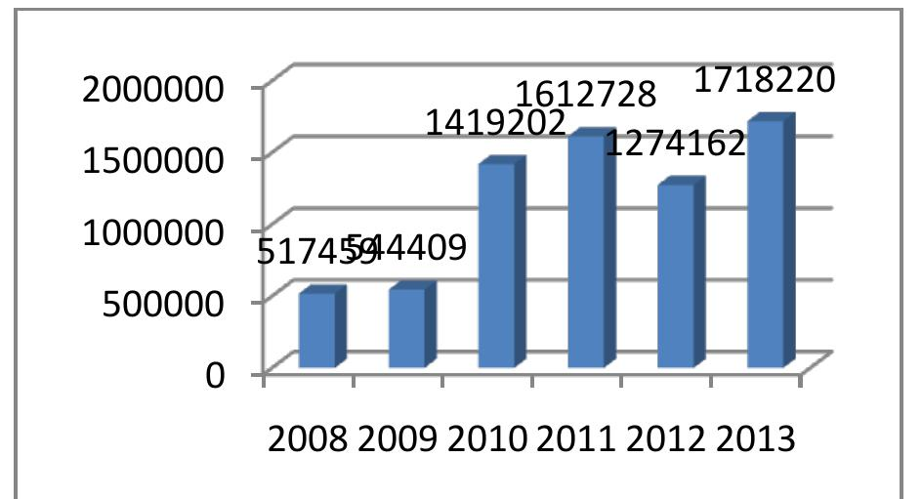
Figure 1: Graph of Websites hacking worldwide [1].
Mobile phones and computers use digital means and are transmitted through communication networks. The banks as well as other financial institutions use the internet as well as the network to make their financial transactions. This means that there is activity each day, with an estimated 10,000 new unique users registered each day. This report also highlights how many websites have been hacked over the last six years.
In supporting my career in the future, these defensive capabilities that stemmed from my academic training help me personally develop a proactive “Cyber Security mindset” grounded in how I evaluate threats and appraise risks [2]. Recognising that my future work will address human errors as the weakest link in digital infrastructure. I actively look beyond basic technical tools to focus entirely on my own. Continues upskilling and lifelong learning [3]. This academic environment directly bridges the gap between theory and real-world execution, giving me the practical, individualised confidence I require to handle high-pressure security incidents in the industry once I graduate [4].
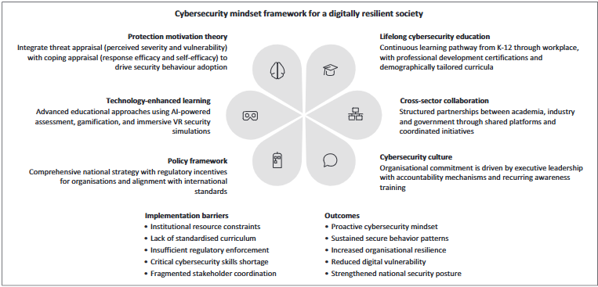
Figure 2: illustration of cybersecurity framework for a digitally resilient society [2]

Task 1 (b): Evaluation of Task 1 (a) based on Similarity report
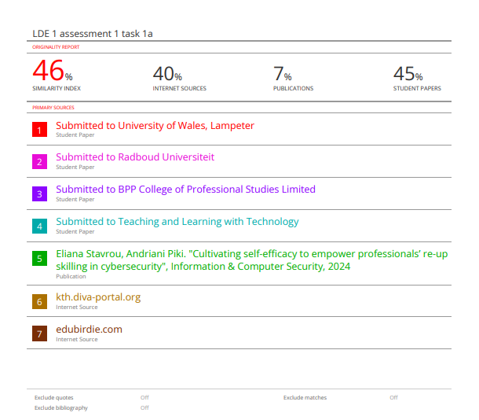

The similarity was 46%; most of it is due to the template used and using common words. Furthermore, what I could do to improve it is through reading more journal articles and expanding my vocabulary by omitting common words and expressing in a more compound vocabulary by using synonyms.

I would give myself a mark on my generic assessment criteria mark with Good 50-59% 2.2/Pass, because I believe that I have good and appropriate application of basic methods; however, I also believe that my language is quite simple. I could have put in more effort using more advanced vocabulary. Additionally, my word choice tends to be limited and quite ordinary.

Task 2: Collaborative Mind Map and Individual Poster

Mind Map (Collaborative)
Mind Map link: https://mm.tt/map/4046791868?t=jKaZnKKx6M
Mind Map Screenshot:
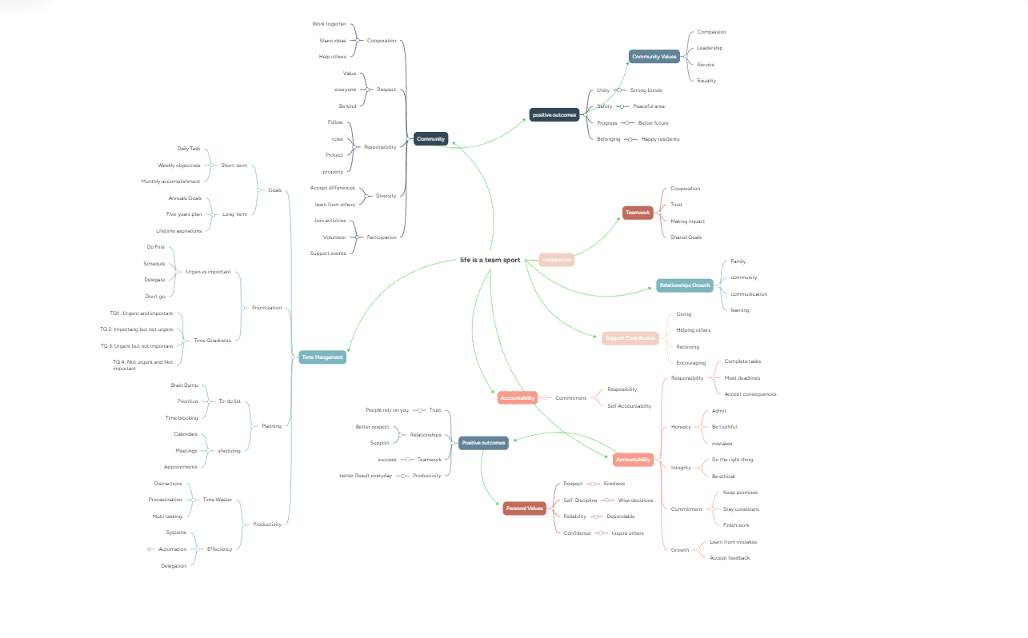

Poster (Individual)
Poster link: https://canva.link/dqro72dgfurc1ps

.
Poster Screenshots:
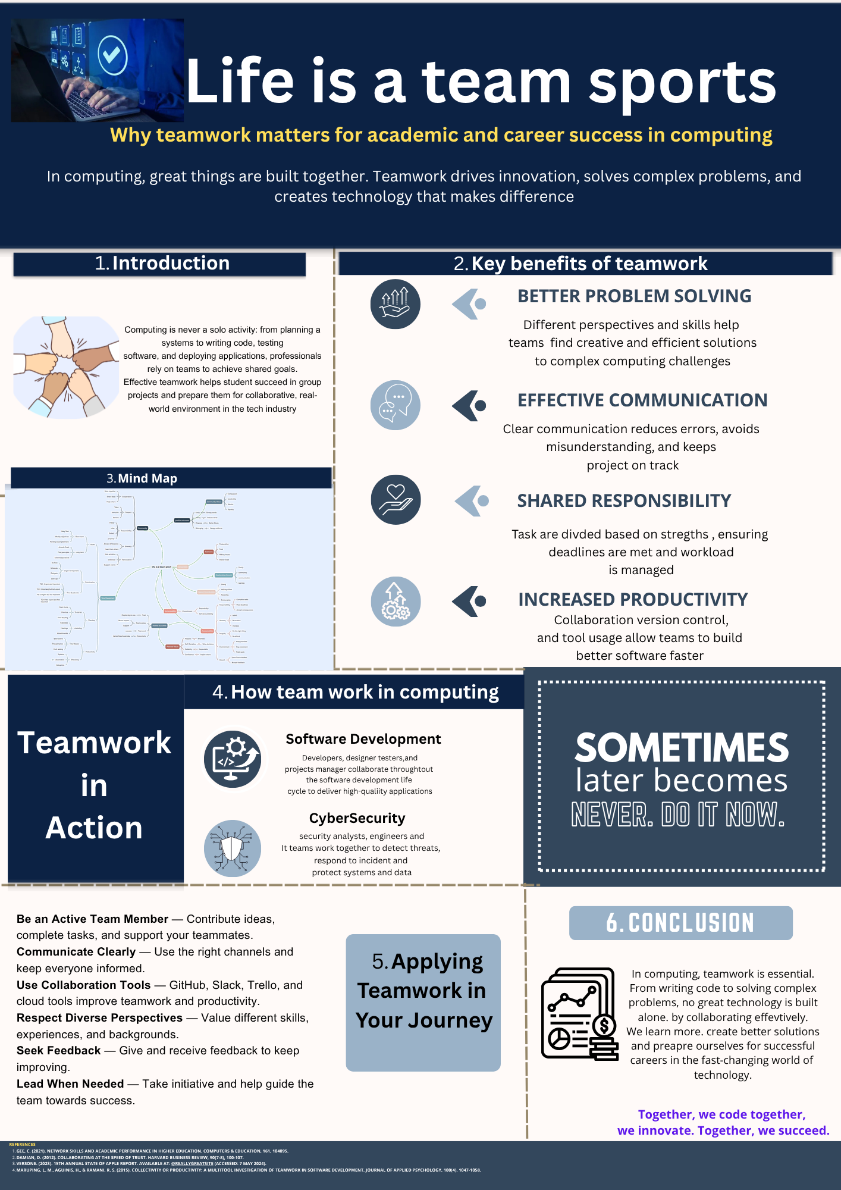

Task 3: Virtual Collaboration and RefWorks

Report on Virtual Collaboration
Topic 2: Riding the storm

Conflict resolution in virtual team development at the storming stage, according to Tuckman’s model, is an important stage in virtual team development where team members become more active in expressing their opinions and methods. This inevitably causes disagreements and conflicts. Although it is difficult to resolve such situations, it is quite natural for team development[1]. Competition, frustration, monologue, dominant personality, and cliquishness are some factors that may influence teamwork negatively. Learning materials stress that avoidance is not a good way to deal with conflict. In such a case, members will not be able to exchange their opinions and, thus monitor each other and make appropriate decisions [2]. It may be difficult for them to make commitments or reach a consensus. Now the attention is drawn to clarity and self-awareness. According to role, the expected behaviour is related to one’s status in the team. Unclear roles may create pressure or frustration. The learning materials point out that there are various roles in each team that team members play; some people lead while others generate ideas. Each of the roles has its own strengths and weaknesses, and realisation of these features facilitates cooperation [3]. Within this framework, individuals should be encouraged to understand their own personal traits and their contribution to the team. SWOT analysis will help to make the most of it [4]. Step-by-step process of using RefWorks with visuals
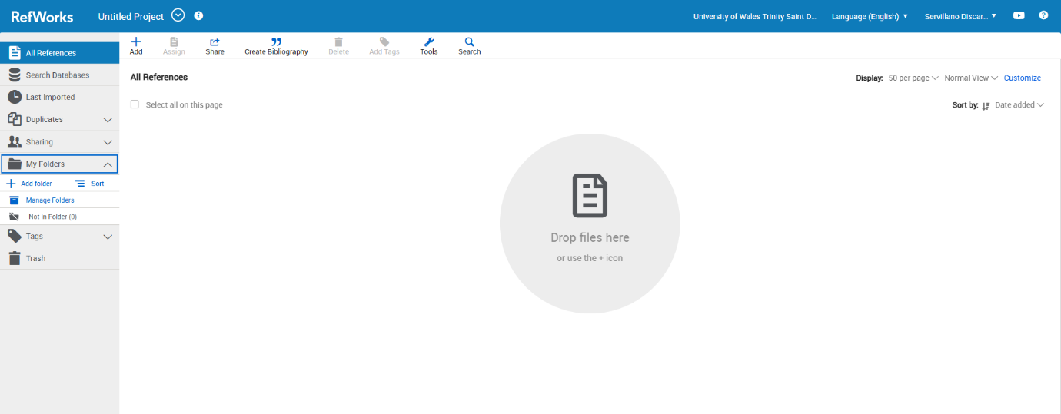
This screenshot shows the folder I created to store my references. I named it 'LDE ASSIGNMENT 1' to systematically organise my RefWorks tasks for the assignment.
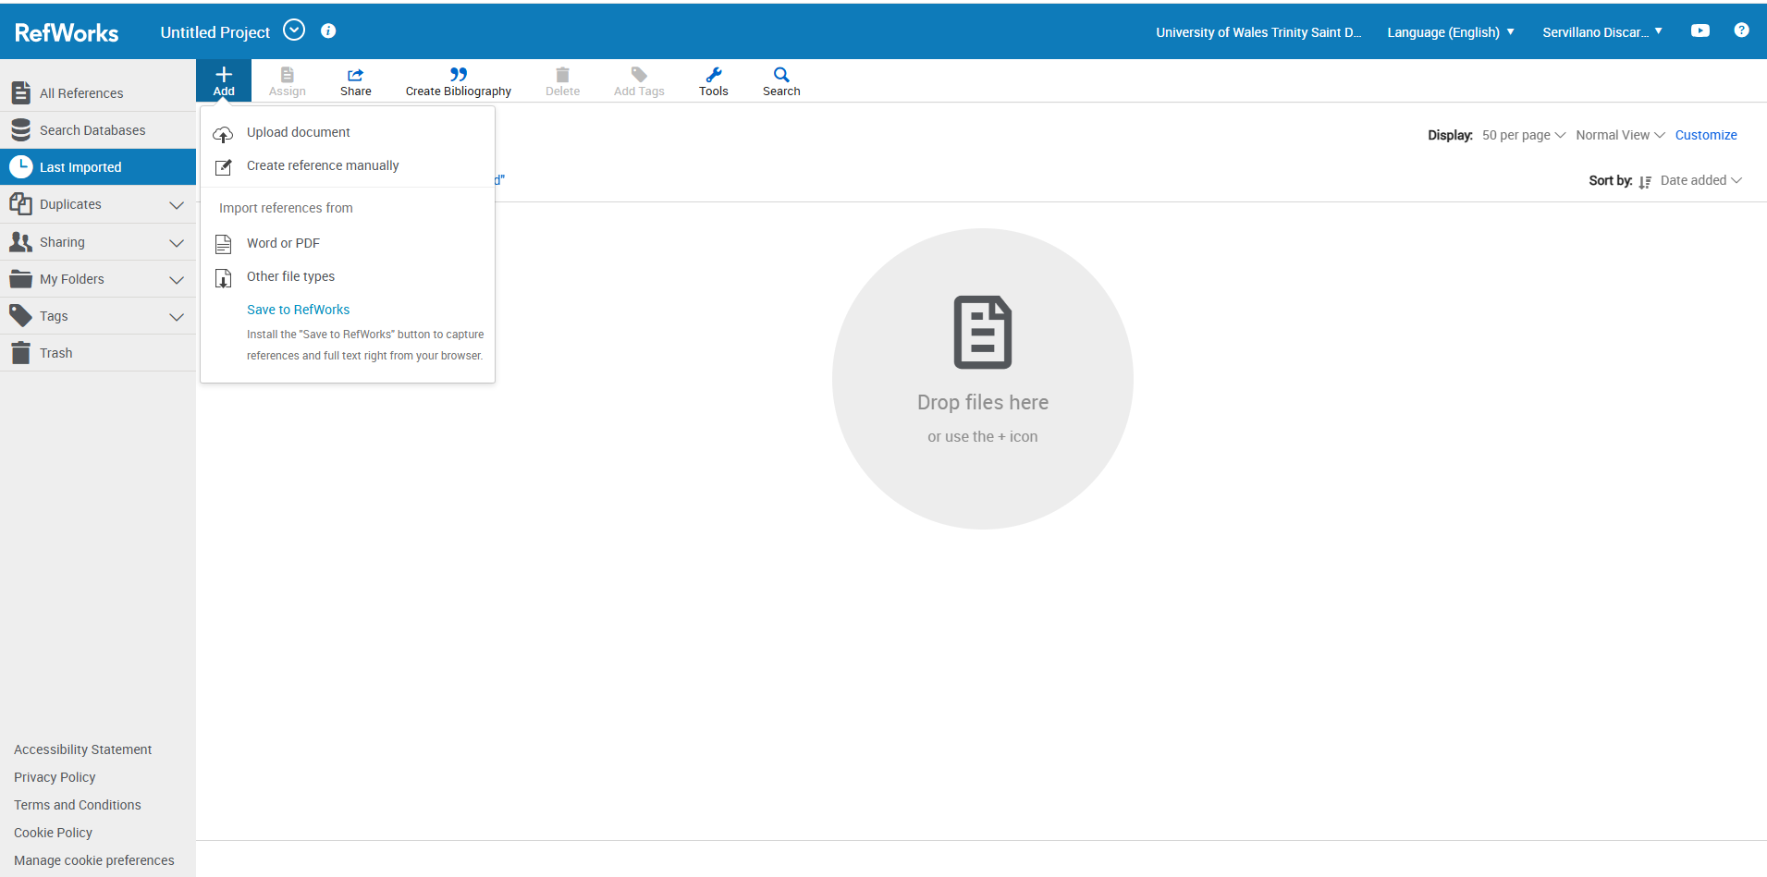
This screenshot here I created a reference manually for my task 3.
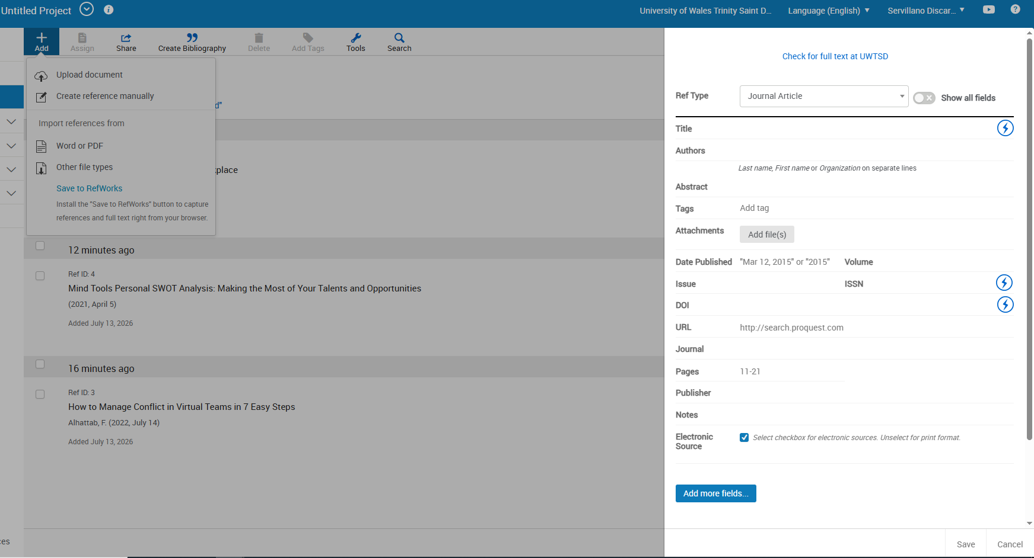
In this screenshot, I put my reference here in task 3, and I create 4 references. Once I'm done here, I get to my assignment in Word.
Here’s how I find RefWorks in Microsoft Word. Go to the top toolbar, click on Add-ins, and then click on RefWorks.

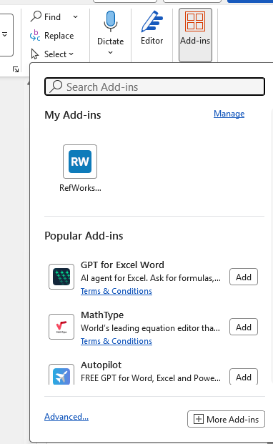
Once you see this you have to login first to see you created reference in RefWorks.

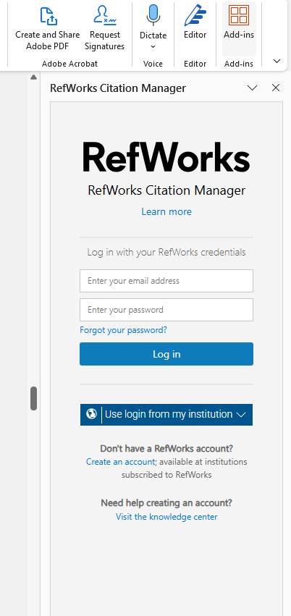
Then I click the RefWorks here it shows you need to put your email and password the account you did a in RefWorks. Then you will see this
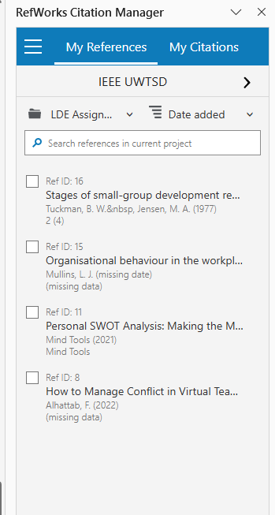

In this screenshot, I am viewing my RefWorks library. To create references, I click this button


Once u click that button you will see this

Also, when you click this button in RefWorks citation manager
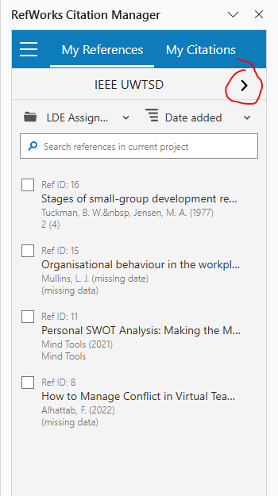
You will see the in-text citation and bibliography
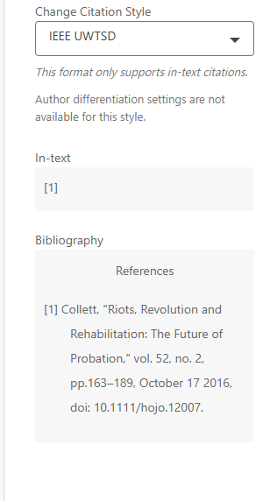
And when I checked my reference citation style, I did the following citation: IEEE UWTSD
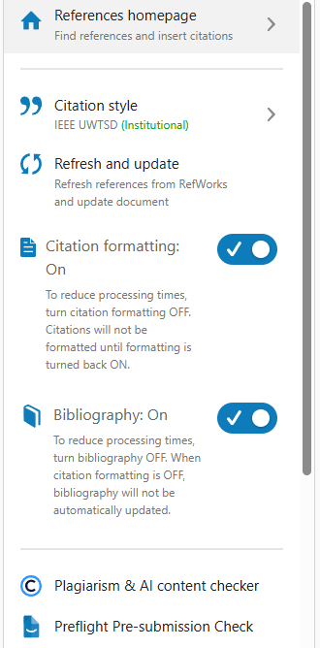

In RefWorks, I selected the IEEE UWTSD citation style. If the citations or bibliography did not appear, I simply turned them on.
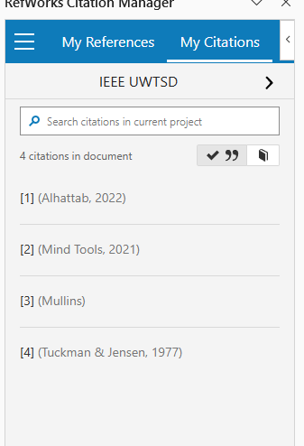
Now I am inserting my citations into my paragraph. I opened my citations in RefWorks, selected the relevant reference, and inserted it where I needed it.
This is what I did step by step to add my citation and references.

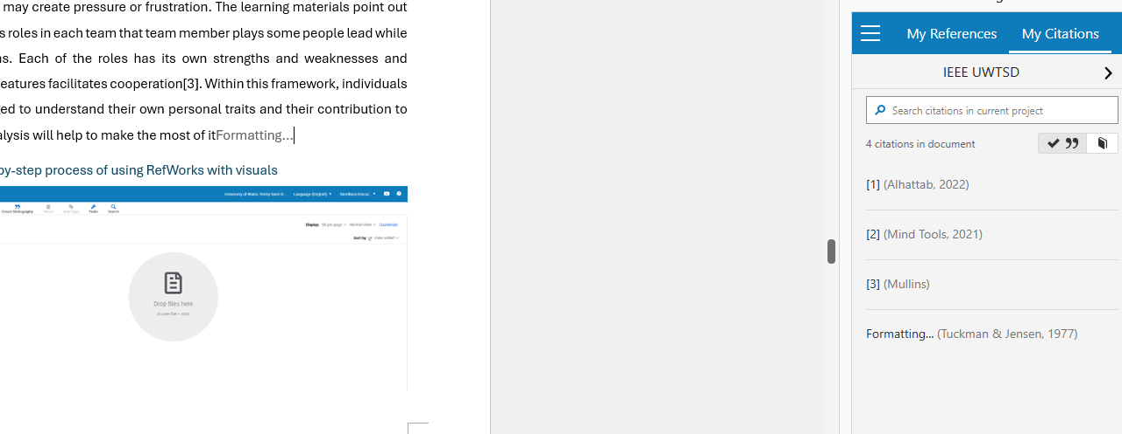
This is before inserting a citation

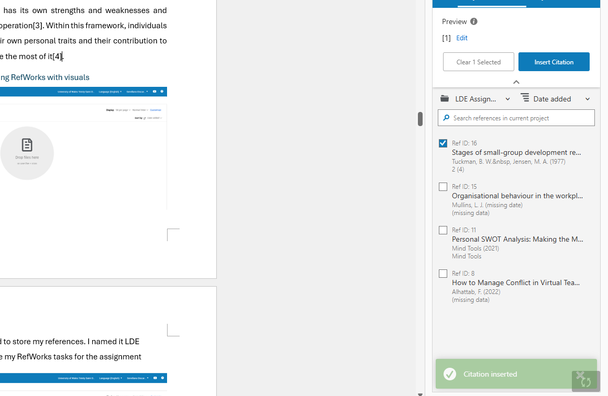
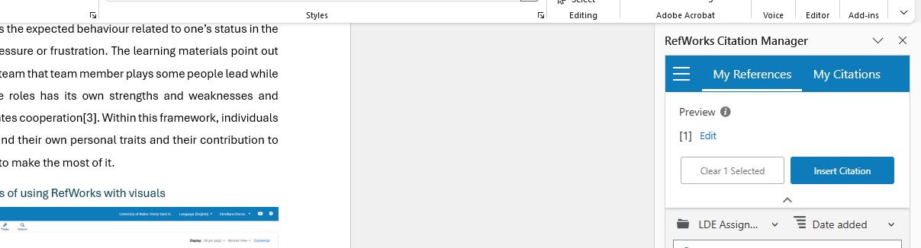
This is after inserting a citation. This shows that when I insert a citation, it will have a number.
The bibliography I make is when I hover my mouse over this.
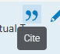
And click is automatic make to a reference
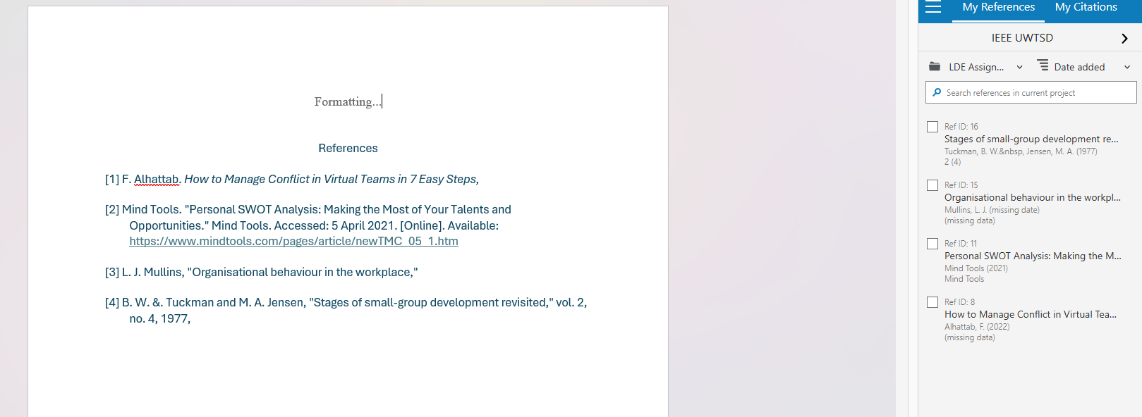
This is the result when I click the Cite button is automatically shows the references I made in RefWorks

Task 4: E-Portfolio Creation and Evaluation

Task 4 (a): E-Portfolio Creation
E-portfolio link: https://2542913.wixsite.com/my-site-8

Task 4 (b): Illustrative Review of E-Portfolio tool Selection

For my e-portfolio, I selected Wix because it is an easy-to-use website builder that does not require coding knowledge. Its drag-and-drop editor and customizable template allowed me to create a professional and well-organised portfolio while focusing on the content rather than technical web development. Using Wix, I selected separate for my about me, introduction and each of my task’s assessments. I made my portfolio easy to navigate and enabled visitors to access my work quickly. I also included images and screenshots of the figures, etc. I also added hyperlinks and screenshots of the mind map and my poster. One of Wix main strengths it is flexibility. I was able to customise the layout and the colours and create a clean design that reflects my personal style. Also, this platform allows my portfolio to be viewed on desktop and mobile devices. However, there were some limitations. The positioning and text required a little bit of careful adjustment to maintain the consistent layout across different screen sizes. In addition, this is only the free version of Wix. Overall, for me Wix was an excellent choice for my e-portfolio. It enabled to present my coursework in a clear, visually appealing, and professional manner. While the platform successfully supported my goal of showcasing my learning journey and academic progress.

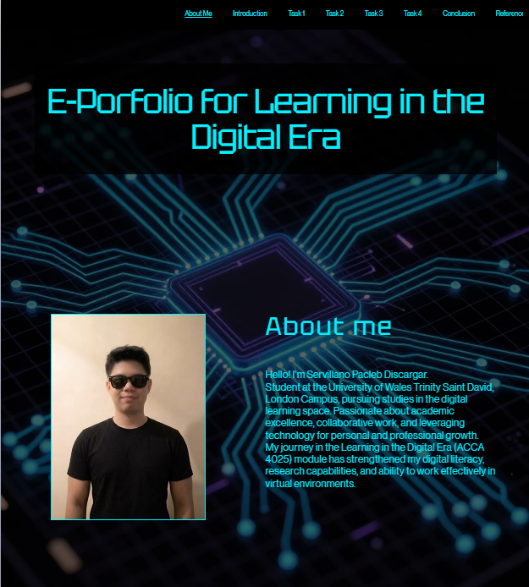
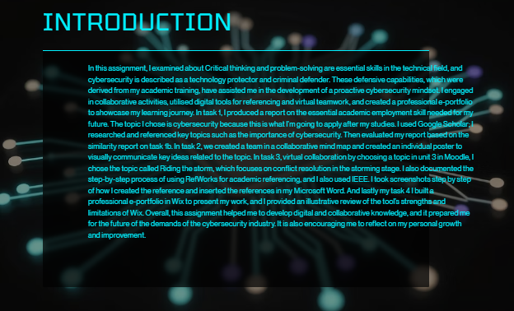
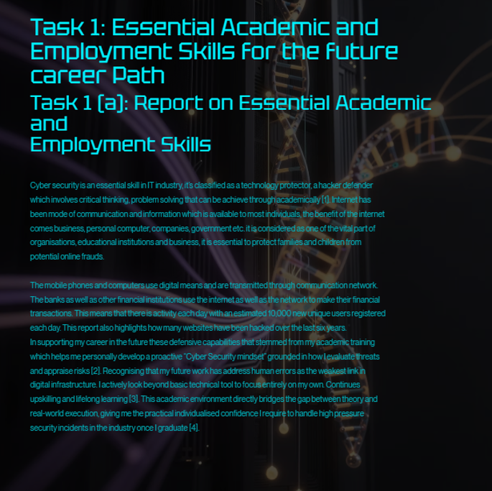
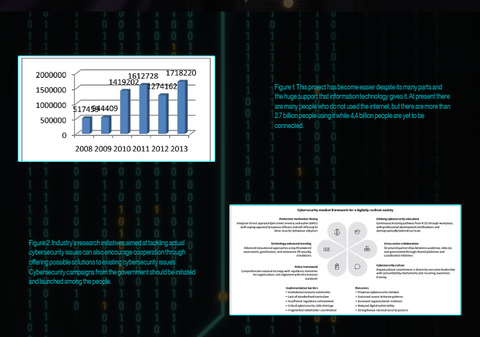
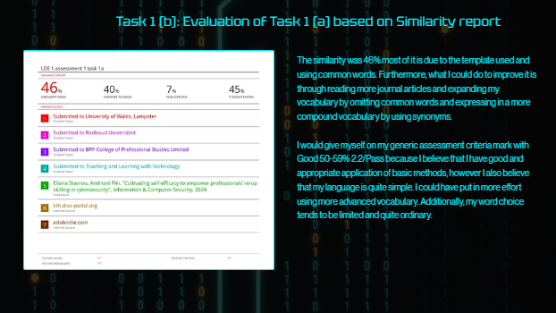
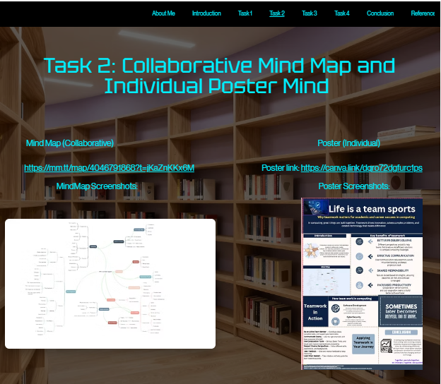
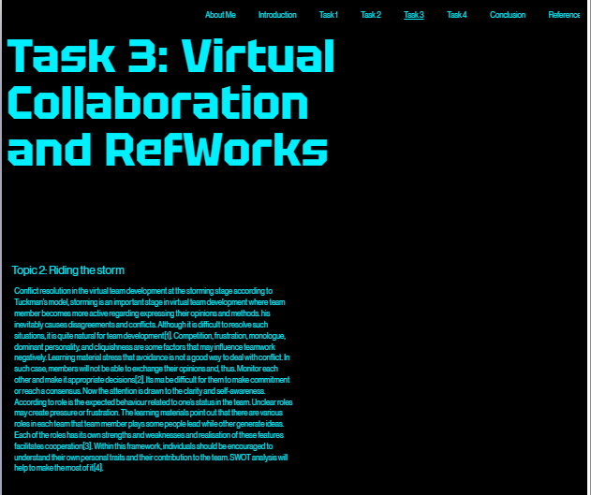
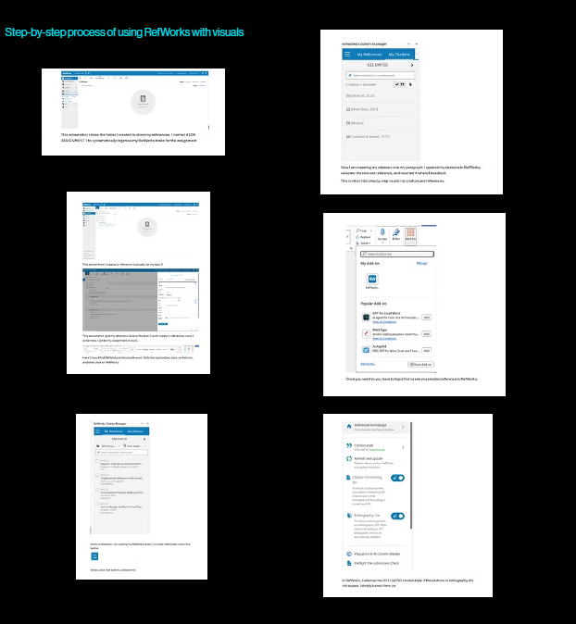
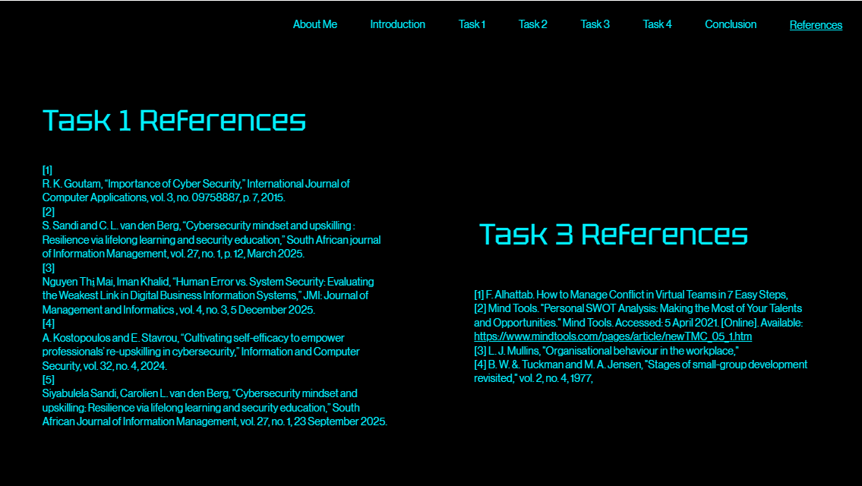

Conclusion
In conclusion, this assignment has significantly enhanced my understanding of academic and professional skill career about cybersecurity. Moreover, in completing tasks 1 to 4 in this assignment, I gained valuable insight into my own capabilities and the development needed. My task 1, researching on Google Scholar and writing about critical thinking and building a proactive cybersecurity mindset, helped me connect my academic learning in real world industries requirements. Also, evaluating my own work using the similarity report made me aware of the need to improve my vocabulary and use more advanced academic language. In my task 2, I did the collaborative mind map and individual poster, which improved my teamwork and visual communication skills. In Task 3, I chose the topic “Riding the storm,” which focuses on conflict resolution during the storming stage of virtual team development. I learned to use RefWorks, which also helped me with academic work in the future. In my Task 4, I created a professional e-portfolio on Wix, it helps me develop digital presentation skills and reflect on my overall learning journey. This assignment has strengthened my self-awareness and professional readiness. I am now more confident in my ability to apply critical thinking and collaborate effectively in virtual teams. Furthermore, to present my work professionally as I progress towards a career in cybersecurity.

References

Task 1 References:

References

[1] | R. K. Goutam, “Importance of Cyber Security,” International Journal of Computer Applications, vol. 3, no. 09758887, p. 7, 2015.
[2] | S. Sandi and C. L. van den Berg, “Cybersecurity mindset and upskilling : Resilience via lifelong learning and security education,” South African journal of Information Management, vol. 27, no. 1, p. 12, March 2025.
[3] | Nguyen Thị Mai, Iman Khalid, “Human Error vs. System Security: Evaluating the Weakest Link in Digital Business Information Systems,” JMI: Journal of Management and Informatics , vol. 4, no. 3, 5 December 2025.
[4] | A. Kostopoulos and E. Stavrou, “Cultivating self-efficacy to empower professionals’ re-upskilling in cybersecurity,” Information and Computer Security, vol. 32, no. 4, 2024.
[5] | Siyabulela Sandi, Carolien L. van den Berg, “Cybersecurity mindset and upskilling: Resilience via lifelong learning and security education,” South African Journal of Information Management, vol. 27, no. 1, 23 September 2025.

Task 3 References:

References
[1] F. Alhattab. How to Manage Conflict in Virtual Teams in 7 Easy Steps,
[2] Mind Tools. "Personal SWOT Analysis: Making the Most of Your Talents and Opportunities." Mind Tools. Accessed: 5 April 2021. [Online]. Available: https://www.mindtools.com/pages/article/newTMC_05_1.htm
[3] L. J. Mullins, "Organisational behaviour in the workplace,"
[4] B. W. &. Tuckman and M. A. Jensen, "Stages of small-group development revisited," vol. 2, no. 4, 1977,

