

Master of Business Administration

Module Title: International Business Concepts
Module Code: LCMB7034

Title: Netflix’s International Market Entry Strategy:
A Critical Analysis of Expansion into Vietnam

Lecturer: Gladius Kulothungan

Student Name: Jubel Ahmed
Student ID Number: 2432469

Table of Contents
Introduction 3
Section 1: Strategic Analysis of Netflix's Entry into the Vietnamese Market 4
1. Organisational Classification and Global Strategy 4
1.1 Strategic Categorisation of Netflix 4
1.2 Global Configuration and Competitive Advantage 5
2. Macro-Environmental Appraisal and Market Attractiveness 7
2.1 Host Country Analysis 7
2.1.1 Political Environment 7
2.1.2 Economic Environment 9
2.1.3 Legal Environment 11
2.1.4 Cultural Environment 12
2.2 Market Entry Analysis Using the OLI Framework 13
3. Strategy of Entry and Strategic Synthesis 16
3.1 Historical Pattern Recognition 16
3.2 Strategic Fit and Justification 17
3.3 Conclusion and Recommendations 18
Section 2: Reflective Account 20
1.1 Description 20
1.2 Feelings 20
1.3 Evaluation 21
1.4 Analysis 21
1.5 Conclusion 21
1.6 Action Plan 22
References 23

Introduction
Global business connections have grown incrementally with the progress of global economy and multinationals are looking for new markets to ensure future growth. The debate on which strategy- global, regional, or local to choose to expand across borders also hinges on the very nature of this expansion as Verbeke and Asmussen (2016) state. Netflix is the world's premier digital streaming service with over 280 million subscribers worldwide (Hsiao, 2024). In spite of Vietnam's fast-growing digital economy and youth population, however, Netflix has yet to develop a strong operational footprint in Vietnam. Vietnam offers a very interesting but complicated prospect, with high GDP growth, a high rate of Internet penetration and a large youth population (Khan, Ali, Petrillo and De Felice, 2023). Andrews et al. (2024) argue that formal institutional environment has an important impact on the development of a multinational strategy in emerging markets. This report adopts the approach of Bartlett and Ghoshal (1989) to classify Netflix's global strategy into the macro-environment of Vietnam, the OLI paradigm of Dunning and select appropriate entry mode.

Section 1: Strategic Analysis of Netflix's Entry into the Vietnamese Market

1. Organisational Classification and Global Strategy

1.1 Strategic Categorisation of Netflix
A very popular framework, put together by Bartlett and Ghoshal, (1989) categorises MNcs into four strategic classes according to the two pressures: pressure for local responsiveness and pressure for global integration. There are four strategies international, multi-domestic, international and global, and transnational. A digital streaming company like Netflix is under significant pressure on both measures and is thus most aligned to the transnational strategy model.
Netflix is a service between the global and the local, according to Lotz (2021). On the other hand, it is tightly integrated with the technology, a single subscription package, and offers a worldwide library of content, all of which have substantial economies of scale. This corresponds to high level of globalization. However, Netflix has been stepping up its local shows and films in a variety of countries over the last few years, including Korean, Spanish, Hindi, and even Japanese (Iordache, Raats and Afilipoaie, 2022). It shows a progressive responsiveness towards local customs and traditions. Daidj and Egert (2018) also note that Netflix adjusts its business model in various national environments, which may include partnerships with local telecom and/or content providers to access local markets.
Thus, Netflix can be said to have a transnational strategy to achieve the balance of working efficiently across the world while adapting to local markets. This is supported by Malik et al. (2019), who suggest businesses in a post financial crisis have to configure circumstances where they can be efficient and responsive. Netflix is an example of such an ambidexterity with its standardised platform and very localised content policies.

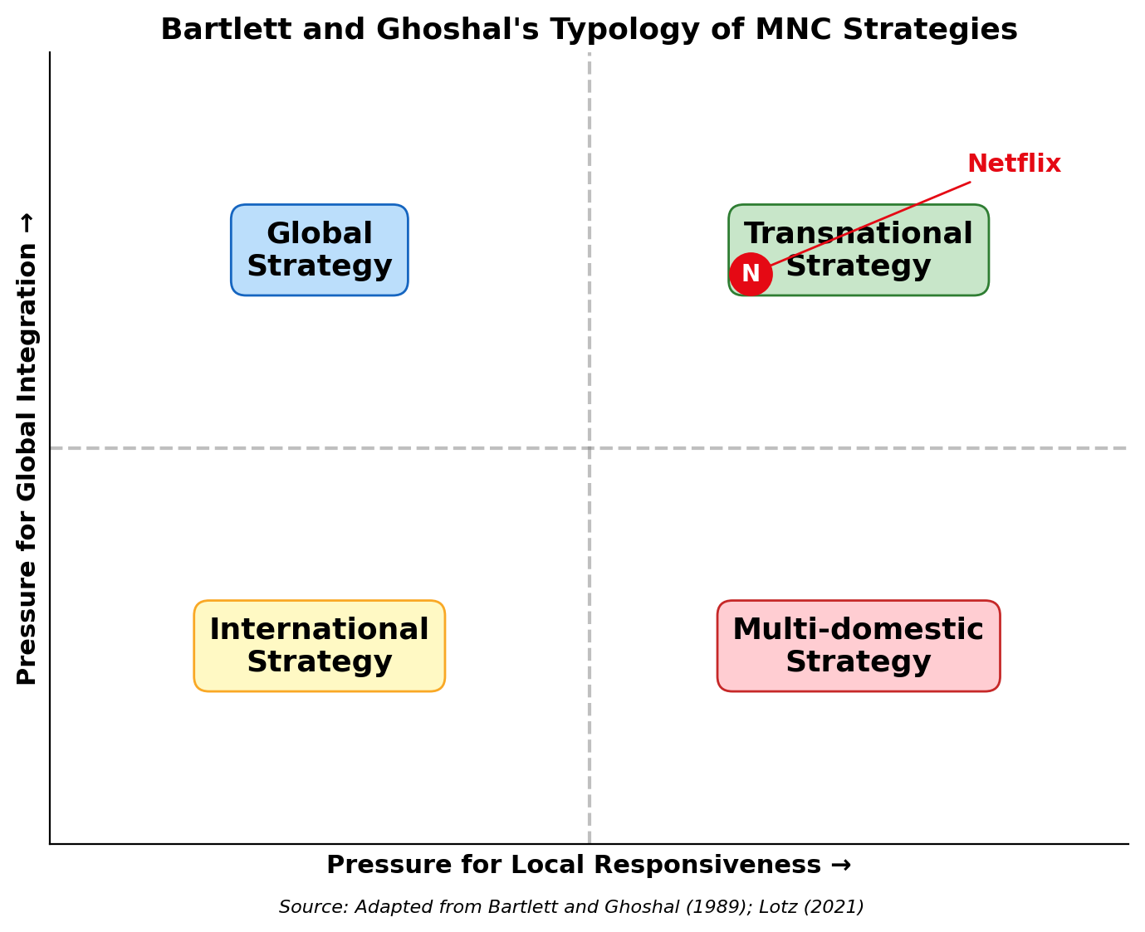
Figure 1: Bartlett and Ghoshal’s Typology – Netflix’s Strategic Position (Adapted from Lotz, 2021)
The Netflix company is in the middle of the Bartlett and Ghoshal grid as seen in the picture below. It's located in the transnational corner, having both strategies of keeping its platforms as international as possible with simultaneously a significant focus on local content and partnerships.

1.2 Global Configuration and Competitive Advantage
Netflix's global set-up is on a number of fundamental strengths. The company is available in more than 190 countries and has a content delivery network to ensure quick streaming no matter where the user is located (Aguiar and Waldfogel, 2018). It has a proprietary recommendation engine that looks at how users interact with the website to tailor the content suggestions to each viewer, which in turn helps in boosting engagement and decreasing churn. This data-focused strategy is a key element in Netflix's ability to engage users across diverse cultural markets, as also observed by Hsiao (2024).
Plus, Netflix has been investing heavily in original programming and this has become one of its key differentiators. From a different perspective, Iordache (2022) points out that Netflix's investment plans include producing a film in Europe, which it will expect to will to both the local market and others. This means that this can be done in two ways, to serve local demand needs and to add to the content library that exists for the entire world. For instance, when executed as part of a company's broader strategy, these subsidiary programs can improve the company's global competitiveness, which is what Asmussen, Foss and Nell (2019) suggest. Centralized technological control and decentralized content production are a great advantage to Netflix.
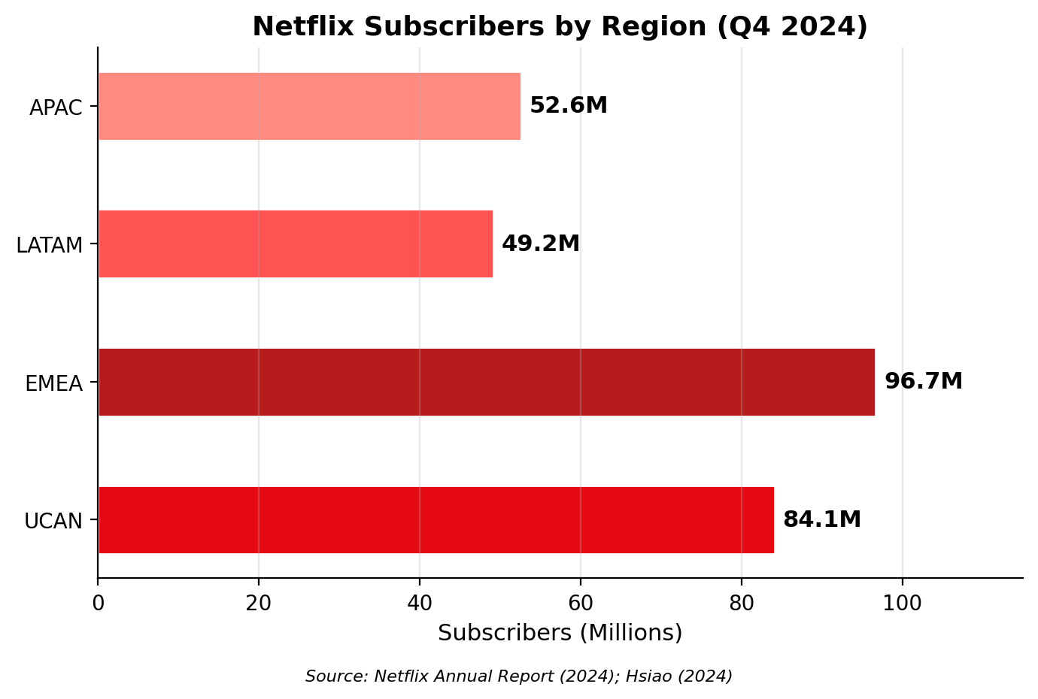
Figure 2: Netflix Subscribers by Region, Q4 2024 (Sources: Netflix Annual Report, 2024; Hsiao, 2024)
Asia Pacific has the largest subscriber base of around 52.6 million as depicted in Figure 2. This is on a good upward trend but it is one of the less penetrated regions with 96.7 million as compared with EMEA. In countries like Vietnam, where the adoption of digital is quickly gaining ground, there's ample opportunity for growth.

2. Macro-Environmental Appraisal and Market Attractiveness

2.1 Host Country Analysis
The external environment analysis is an important process for any firm to go through prior to entering in a foreign market and it cannot be done in a superficial manner. Whereas country-level analysis is required to be more than just descriptive, Hagenauer (2017) states that the analysis should also be critical and take into consideration the interaction between the macro-environmental factors and the specific industry environment and strategic goals of the firm. While a general description of all dimensions of the environment may yield some benefit at the tactical level, its value at the strategic level lies in helping to mark out for the more specific firm in question, those factors most likely to affect the success or failure of the firm.
In their work, Paramadita, Purnomo and Rumangkit (2024) illustrate the application of the PESTEL framework as a structured analysis of the macro-environment that can be applied in political, economic, social, technological, environmental and legal dimensions. But a one-dimensional application of each dimension may lead to a general analysis. Likewise, Ifeanyi (2017) suggested the process of macro-environmental analysis ought to focus on the elements that are specific to the strategic interests of a business or firm in the sector it operates, instead of offering a general overview of macro-environmental analysis.
Considering these principles the following section seeks to discuss the four dimensions most germane to Netflix's Vietnamese digital streaming business: political, economic, legal and cultural. Each dimension is analyzed in a critical manner particularly with respect to the direct impact it has on Netflix's potential entry into Vietnam and its sustainability in the country.

2.1.1 Political Environment
Vietnam is a socialist nation with one party (the Communist Party of Vietnam) ruling. In general, the political climate is favourable, and the government controls the media, communications and online information very tightly. For foreign investors political stability could be a positive factor since they are less likely to face a U-turn in policy. But Vietnam is highly controlling in terms of internet content regulation and it is directly impacting streaming platforms. In the case of foreign media, a strict content censorship requirement exists and content may be cut or blacklisted if it is considered politically sensitive or culturally inappropriate.
As all the above authors have remarked, in markets where the state plays a strong role, firms have to become familiar with the formal institutional structure at the national level, comprising national laws, enforcement of laws, government attitudes towards foreign investment. For Netflix, it translates to content that will have to be in line with government guidelines, which could mean that viewers in Vietnam may not be able to see everything Netflix has in its worldwide library. According to Nguyen (2020), foreign streaming services that wish to enter Vietnam must be authorized by the Ministry of Information and Communications and adhere to local broadcasting laws. This makes compliance even more expensive, but the political climate is not anti-foreign investment in general, it is a matter of identifying the path and engaging in dialogue with the regulators.
Furthermore, Vietnam has been opening barriers for foreign direct investments into the technology and service industries, as it has signed on to various free trade agreements, such as EU-Vietnam FTA and the Regional Comprehensive Economic Partnership. This means that although there will be strict regulation, there is a political climate that is pro-improvement of digital economy which is beneficial for Netflix's entry plans. The government further has initiated a National Digital Transformation Programme for the digital economy's growth, which will contribute 30% to the country's GDP by 2030, thereby demonstrating high political support for technology-driven businesses.

2.1.2 Economic Environment
The economy is undergoing rapid growth in Vietnam during the last ten years, becoming one of the fastest-growing in Southeast Asia. Khan, Ali, Petrillo and De Felice (2023) point out that macro-economic stability and an increase in disposable income in developing countries make it more conducive to foreign companies, especially those which provide exposure to citizens in the form of digital services. Vietnam's GDP has grown at an average of 6% per year except for the few years of 2020 and 2021 during the Covid-19 pandemic, after which it has recovered in strength to 7.1% in 2024.

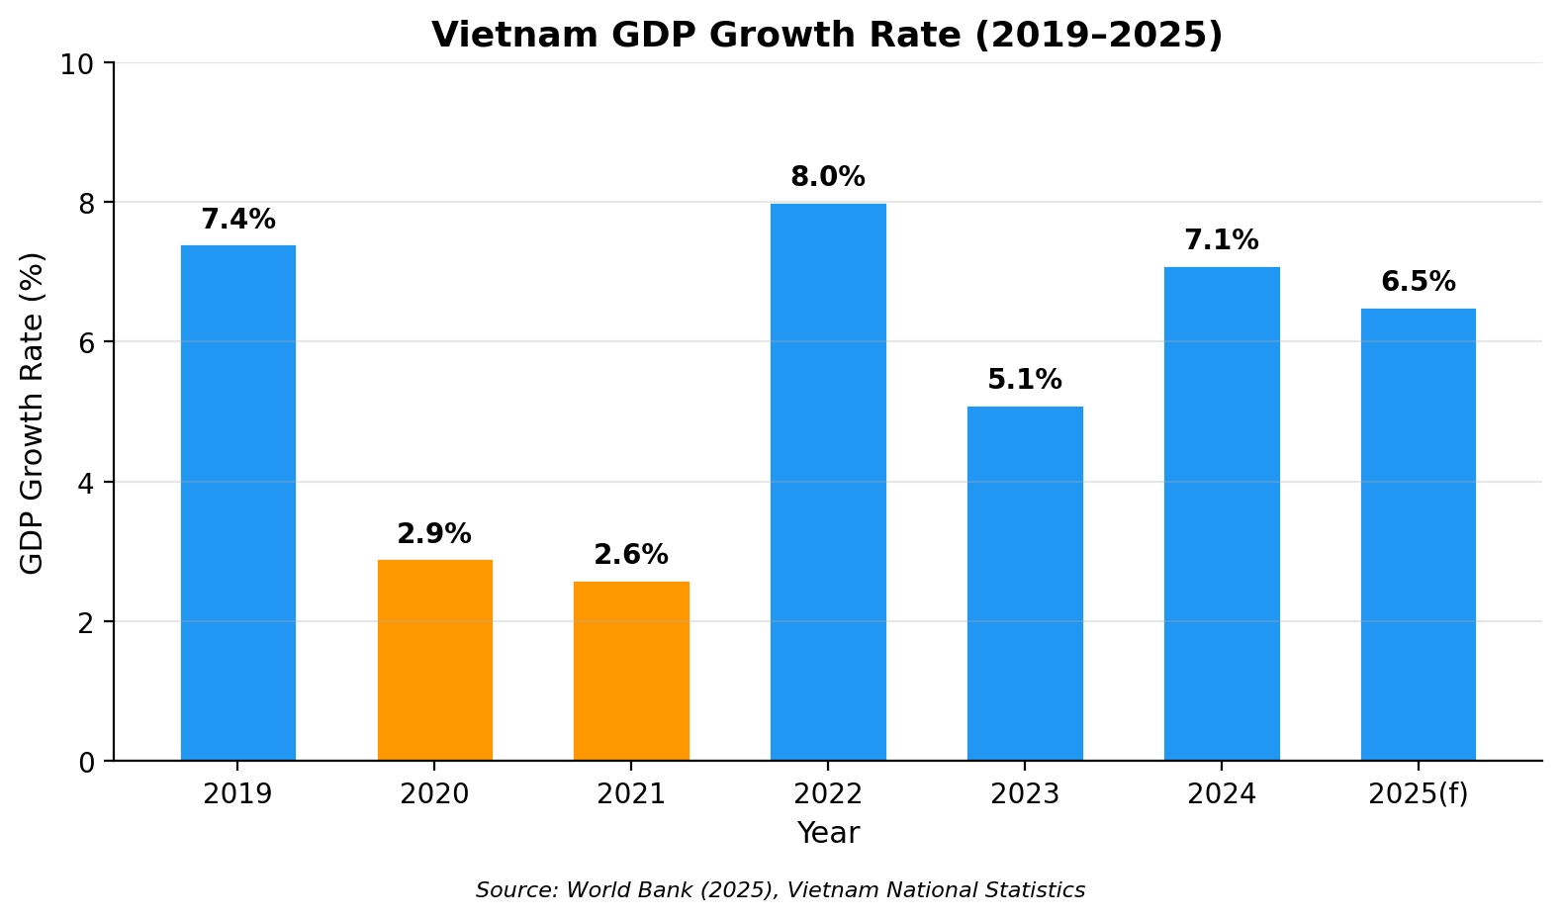
Figure 3: Vietnam GDP Growth Rate, 2019–2025 (Source: World Bank, 2025)
Vietnam's economy steadily recovered and performed well as illustrated in figure 3. Alongside this, there has been a growing middle class, urbanisation and fast internet and smart phone penetration. Based on the statistics from Nguyen and Preecharush (2019), Vietnam's Internet penetration was more than 70% in 2019 and is increasing. Internet penetration in Vietnam is more than 70% as of 2019, and is growing at a high rate (Nguyen and Preecharush, 2019). This is especially important for Netflix, who are a 100% digital streaming company. Expansion of 4G and 5G networks in key cities in Vietnam also contributes to the feasibility of high-quality video streaming.
Economic conditions, however, are also problematic. Vietnam is still a price-sensitively market, where average income per household is a lot lower than in developed countries. Because country attractiveness is judged not only by growth rates, the purchasing power of the target consumers must be taken into account, Peter Tindan (2023) states. Although the Netflix standard plan might seem cheap to people in western countries, it's perhaps a steep cost to Vietnamese consumers. In Urban Vietnam, the average income is about 350-400 USD/month, and a basic Netflix subscription could be a significant portion of entertainment budgets. This calls for region specific pricing approaches, which are also used in India (Nafees et al., 2021). Netflix launched a mobile-only offering in India for a much lower price, and it worked well when it came to gaining subscribers when you have to pay for everything. The same strategy can be implemented in Vietnam where most Internet access is through mobile devices. One of the most significant success factors for servitisation oriented firms in emerging markets is to adapt the service delivery models in line with the local economic conditions (Agnihotri et al., 2023).
Table 1: Key Economic Indicators of Vietnam
Indicator | Value (2024/2025) | Relevance to Netflix
Population | 100 million | Large potential audience
Median Age | 30 years | Young, tech-savvy demographic
Internet Penetration | 79% | Strong digital infrastructure
GDP Growth Rate | 7.1% (2024) | Rising disposable incomes
Smartphone Users | 65 million | Mobile streaming potential
Source: World Bank (2025); Nguyen and Preecharush (2019); Khan et al. (2023)
Table 1 shows key economic indicators in Vietnam that are most pertinent in Netflix's context. A massive young population and increasing Internet use and income is a favourable basis for digital streaming service. But, with its considerably lower per capita income as compared to Western markets, pricing will be a key determinant to its commercial success.

2.1.3 Legal Environment
Foreign digital service providers have both opportunities and constraints in the legal environment in Vietnam. The Cybersecurity Law has been enacted in Vietnam in 2018 that companies that operate in Vietnam must keep local data and follow the government's demands for removal of content. The complexity of regulation in emerging markets may render it more difficult to market and operate in the markets, as mentioned by Chopra et al. (2024). The obligation to meet with local data localisation sanctions implies Netflix will have to build or lease local server capacity, further adding to the capital investment requirement for getting in.
Furthermore, Vietnam's IP protection system is less effective than the developed market. Piracy is still problematic in the Vietnamese Entertainment Sector. However, when trying to attract Vietnamese consumers to legal video streaming platforms, it is necessary to not only make the services competitive but communicate with the consumer about their value and legal status of a paid platform as well, write Nguyen and Preecharush (2019). The Vietnamese government has been more proactive and dedicated in boosting IP protection, notably signing international new trade agreements like the Comprehensive and Progressive Agreement for Trans-Pacific Partnership (CPTPP), which has a clause on the protection of IP. Despite this, enforcement efforts are inconsistent, and illegal streaming services are still alive and causing the legal streaming services to lose revenue.
In addition, under Vietnam's Foreign Investment Law, WFOEs of many fields, such as digital services, are subject to particular licensing requirements. This is significant for Netflix as it allows the company to go into operation in the country without the need for a joint venture. But the licensing and compliance process can be lengthy, and Netflix would require the assistance of local law enforcement to effectively manage the various compliance issues. Foreign online content providers must also cover Vietnam's value-added tax (VAT) and corporate income tax on revenues earned on the local market, an important issue to consider when planning economic investments in Vietnam.

2.1.4 Cultural Environment
Confucian values, family cohesiveness and a collective orientation are the factors that contribute to Vietnam's cultural environment. When firms aim for global-local strategies, it is critical to comprehend the all-important local cultural values, otherwise the local consumers will reject foreign products/services, says Malik et al. (2019). The preferences of Vietnamese viewers are unique, and the local-language dramas, comedies and variety shows are well-received. Drama shows from Korea and Thailand show high level of popularity too, as are the case of other culture flows in the region.
It's a cultural context that carries significance for Netflix. Platform diversity is achieved by providing content from around the world but it will matter more if the content is available in the local language and popular local content to ensure success in Vietnam. It was found by Nafees et al. (2021) that Netflix expanded its operations into India where they had to invest in their own material produced locally, which is also a strategy that would need to be implemented in Vietnam. Lotz (2021) also notes that a strategy of Netflix's that is to popularize content that is more to the liking of their local audiences while still maintaining their global presence is what makes them so different from the other purely local companies. One of the biggest challenges facing the Vietnam market is developing a strong global brand while remaining culturally relevant, especially for a market which already has domestic competitors with strong market share like FPT Play and VieOn.
Moreover, the Vietnamese people are very active on social media and are using mobile devices, providing an opportunity for Netflix to use digital marketing and word-of-mouth marketing. To create brand awareness in Vietnam, a mixture of social media engagement, partnering with influencers and targeted advertising that aligns with the local culture is suggested by Nguyen (2020). Similar to Hilmersson et al. (2021), who found that companies regularly find market opportunities by purposefully pursuing a strategy and being organically involved in the local networks.

2.2 Market Entry Analysis Using the OLI Framework
Dunning's Eclectic Paradigm (OLI), is a more holistic theoretical framework to assess a company's decision to enter a foreign market and how. It is based on three concepts of benefits: ownership, location and internalisation. Prakash and Singhai (2024) have validated that OLI paradigm is still one of the most prevalent theories for analysing the foreign market entry decisions of multinational companies. Subrahmanyam, Santos and Marcão (2026) also explain that the OLI framework is well suited for technology-based companies because of its consideration of the role of proprietary knowledge assets as well as market and transaction-cost considerations. Each criterion of the OLI framework will be applied to Netflix's potential marketing of its streaming service into Vietnam. The next part of the analysis looks at each of the three OLI criteria and applies the framework to Netflix's potential marketing of its streaming service into Vietnam.
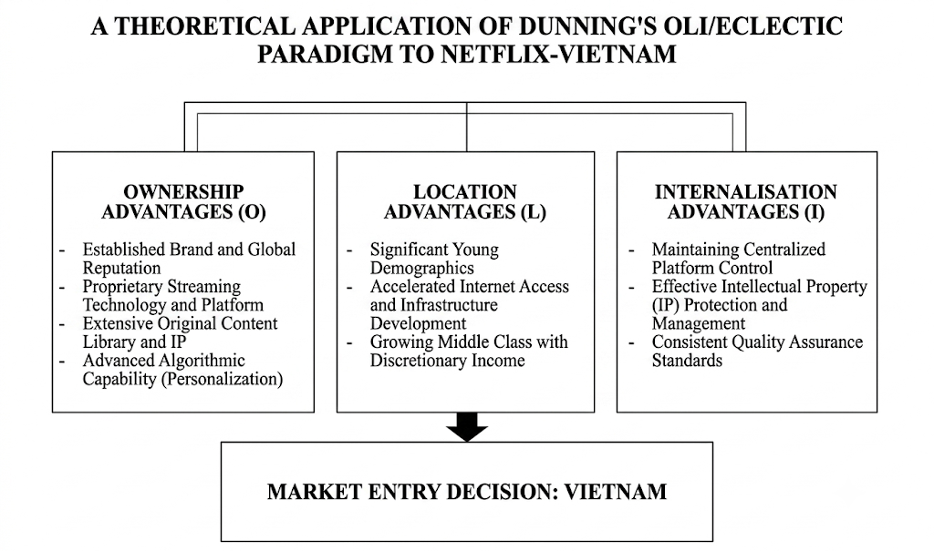
Figure 4: Dunning’s OLI Framework Applied to Netflix–Vietnam (Adapted from Dunning, 1980; Prakash and Singhai, 2024)

Ownership Advantages (O):
Netflix has a number of very favourable ownership assets that can help it be successful in Vietnam. The most outstanding among these is its “globally recognized brand” image that is almost synonymous with digital streaming in over 190 countries (Aguiar and Waldfogel, 2018). This familiarity will work in Netflix's favour when it launches a new service in a different country, as their service will enjoy instant momentum through being recognised. Perhaps more than brand equity, Netflix's homegrown algorithm for movie recommendations is a slew of valuable assets that belong to the company. This algorithm can examine billions of data points that encompass viewing habits, preferences, and engagement levels, providing highly personalized content recommendations that can boost viewer engagement and decrease subscriber attrition rates (Hsiao, 2024). This type of technology is hard and expensive to replicate locally, and that provides Netflix with a competitive leg up.
Moreover, Netflix has a huge library of their own films, varying by language, genre, and culture and offered as an ownership advantage. As Netflix works on original productions in various markets, Iordache, Raats and Afilipoaie note that the company has spent billions of dollars to not only produce content for local customers, but also to create something that will be part of its global content library. Furusawa and Ishida (2025) further emphasize on research and development efforts being undertaken at the subsidiary level, as this further solidifies ownership advantages, while giving the firm the strategic control due to the centralization. Rather, Netflix has been constantly investing in technology infrastructure, content development and data analytics, which make its system specific assets that can be difficult for competitors to replicate, and that may yield increasing returns to scale as the number of subscribers increases.
Location Advantages (L):
Vietnam has several compelling advantages that make it an attractive market for Netflix, that are specific to the country. The macro-environmental analysis touched on the population of nearly 100 million people, a very young population whose median age is around 30, making it a very digital population. Additionally, internet penetration rate is over 79%, and the use of smartphones has been increasing significantly, which are the requirements and building blocks for streaming services (Nguyen and Preecharush, 2019). Sometimes, companies find opportunities in the market that they have planned for, but also by a more accidental interaction with local market conditions, based on the argument of Hilmersson et al. (2021). Netflix's location advantages in Vietnam are largely due to its strategic location in Southeast Asia, the Vietnamese market's openness to Korean, Japanese and other East Asian films (that are already available on Netflix), and the improvement of the quality of the broadband and mobile network there. Additionally, Vietnam's middle class and high disposable income has given rise to a group of consumers who are willing and able to afford high quality digital entertainment. As machine-learning techniques are used to identify countries as high-potential markets, Ali (2025) notes that Vietnam is also in their sights thanks to its demographic, digital readiness, and entertainment consumption characteristics.
Internalisation Advantages (I):
The advantages of internalisation involve the benefit a firm can derive from performing in-house activities instead of outsourcing to external partners and/or licensing. According to Subrahmanyam, Santos and Marcão (2026), large-firms with substantial IP assets are more likely to rely on internalisation to safeguard their assets from possible misuse or imitation by the local firm. The storage, processing and dissemination of content, the algorithms that guide users to discover new products, user information and the licensing agreements for content represent very sensitive and strategically valuable assets that would be very hard to protect by an arm's-length contractual relationship, like a licence or a franchise. Alternatively, service-driven companies that gain competitive advantages from the quality and uniformity of their service experience have a strong preference for modes of entry that enable them to exert control in the service delivery, quality and customer interactions (Agnihotri et al., 2023). An internalised Vietnamese operation will guarantee that the user experience, creation of content, pricing policy and technical performance are aligned with the Netflix experiences, standards and policies throughout the world. Thus, Netflix has significant reasons for internalisation favouring a full participation subsidiary model, in line with its successful strategy in most of its international markets.

3. Strategy of Entry and Strategic Synthesis

3.1 Historical Pattern Recognition
Netflix's global strategy has traditionally been to have a wholly-owned subsidiary as its arm for expanding overseas. As per the classification of the market entry strategies by Watson IV et al. (2018), Netflix can be termed as digital market entry strategy with some relational element as seen in the partnerships for local content. In 2016, Netflix started its international rollout with its digital platform, allowing it to expand to around 130 countries at once, and keep 100% control over pricing, displays and technology (Aguiar and Waldfogel, 2018).
Netflix has deployed strategic partnerships in some markets to set up wholly-owned operations. As an example, Daidj and Egert (2018) explain the cases of the relations between Netflix and various local media companies and telecom providers in France, which are based on a coopetition model. Likewise, Nafees et al. (2021) cite Indian mobile operators like Jio, who have agreed to include the service to Netflix in their packages. They do not break from the fully-owned format, but complement it, with the goal of getting consumers to sign up in price-sensitive areas more quickly. In a medium institutional risk market, multi-criteria analysis of entry modes might often provide evidence that the most optimal entry mode would be a hybrid one, which is based on direct investment in conjunction with some local partner(s) (Górecka et al., 2025).

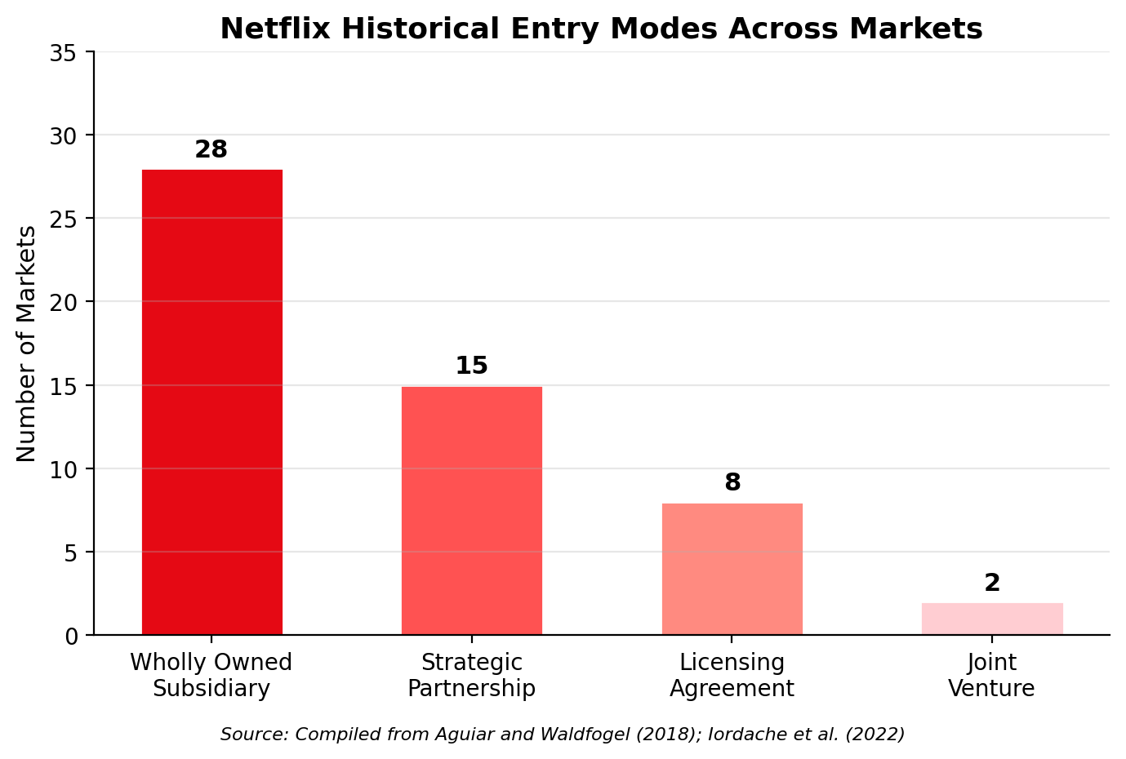
Figure 5: Netflix Historical Entry Modes Across Markets (Sources: Aguiar and Waldfogel, 2018; Iordache et al., 2022)
According to Figure 5, the wholly owned subsidiary has been Netflix's preferred mode of entry in its global operations. It is the same as how the firm would like to keep control over the user experience and interact with its proprietary technology.

3.2 Strategic Fit and Justification
The full ownership sub-model seems to be the best choice for Vietnam, but should be supplemented by local partner involvement in content and distribution. Tanrıverdi, Kundakcı and Ertuğrul (2026) recommend hybrid fuzzy models that take into account all three factors: risk, control, and resource commitment when analysing entry modes. Aytekin et al. (2025) also suggest a multi-criteria decision-making approach to systematically assess entry strategies.
There are several reasons why the wholly owned subsidiary model for Vietnam is recommended to be maintained. First off, Netflix' technology platform and content recommendation system will not work out in joint ventures or licensing deals, as they need centralised control. Second, the firm's global brand identity and user experience standards are best ensured by direct ownership not third-party operator ownership. Third, Vietnam is a challenging regulatory market, yet Vietnam does not forbid the operations of a WFOE in the digital services industry, unlike some other markets where foreign ownership requirement will necessitate joint venture structures. Wei and Nguyen (2017) present the argument that local firms receiving subsidies are best served by landing a partner that is familiar with institutional conditions, and vice versa, foreign firms entering emerging markets are best served by investing in a local firm that has learned about these institutional conditions. The fourth advantage from the risk viewpoint is that there is a chance to control the rate of investment and scale up operations slowly as per the market response, as opposed to large investments of joint ventures, giving Netflix a lesser risk exposure.
But the purely national-level solution has to be coupled with local strategic partnership to tackle local challenges in Vietnam. For Netflix in Vietnam, it might be about comebacks with local telecom giants like Viettel or VNPT, providing bundled packages in local language, or a co-production agreement with production studios in Vietnam, creating original Vietnamese-language content. In particular, Nguyen (2020) suggests that Netflix invest in marketing their brand to the Vietnamese consumer culture so they could outcompete the existing local industry players.

3.3 Conclusion and Recommendations
The report examined Netflix's potential market introduction in Vietnam extensively on the basis of Netflix's international strategy, macro-environmental context of Vietnam and the most appropriate way to enter the market. Netflix is a multinational firm with a mix of global integration and local responsiveness that favours its access to a variety of emerging markets. Vietnam's political, economic, legal and cultural environment analysis shows a market with significant growth potential but its challenges include price sensitivity and competition from local platforms and controversial issues of content.
By applying Dunning's OLI model, Netflix has very high advantages in ownership, location, and internalisation, which officially propel them to enter the Vietnamese market. The historical pattern analysis and the strategic fit assessment demonstrate that the entry mode should be a 100% subsidiary with strategic local partnerships. In particular, the following recommendations are made. One is that Netflix should be present in Vietnam under a completely local ownership model via its existing digital platform to retain full control of the user experience, technology and content. Second, the company should form an alliance or partnership with the telecom operators in Vietnam like Viettel and VNPT to launch a bundle subscription plan at an affordable price for the price sensitive market as seen in India in the case of Jio. Thirdly, Netflix needs to focus on producing Vietnamese Originals and hire local production, just as it does locally in other Asian markets like South Korea and India to gain more cultural relevance. Fourthly, a dedicated compliance team should be established to guide through Vietnam's regulatory framework, such as its censorship of content and data localization under the 2018 Cybersecurity Law. Last, but not least, a mobile-first pricing model should be thought of in the same way that what is successful in India today most Vietnamese users have mobile as their first device to access the internet. Combined, these recommendations offer Netflix a well-defined path to explore in a promising digital market in Southeast Asia, while controlling risk.

Section 2: Reflective Account
This section is an account of the process that was used to research, analyse and prepare Section 1 of this report and also a reflection on the process.
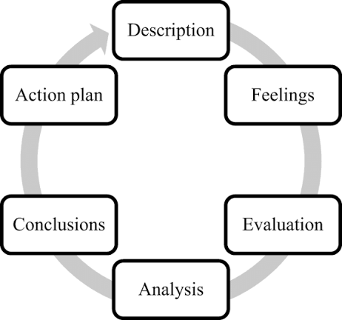
Figure 6: Gibbs' reflective cycle (Verbeke and Asmussen, 2016)

The reflection is based on the Gibbs (1988) reflective cycle that consists of the six stages of description, feelings, evaluation, analysis, conclusion and action plan.

1.1 Description
The requirements for this task were to pick an MNC and a target country to analyse the International Market Entry Strategy. The reason why I selected Netflix as the MNC and Vietnam as the target country is because I felt that this was an interesting and relevant topic to discuss. The task involved me to classify Netflix's global strategy with Bartlett and Ghoshal framework, to explore the macro-environmental analysis of Vietnam (political, economic, legal, and cultural), to conduct analysis of OLI framework to determine the feasibility on the market entry, and to make judgement of which entry mode is the most appropriate to Netflix in light of past history. This was done in depth by conducting reams of research from academic journal articles, industry reports and publicly available data from credible figures like the World Bank and Netflix's annual reports. I also studied case studies specifically focused on Vietnam consumer behaviours and the use of digital media. The work began by planning, then reading, structuring, writing and revising, and it has taken several weeks.

1.2 Feelings
I was motivated as well as a little overwhelmed at the start of the assignment. I loved to dive into the business scenario and bring together different theories with the actual scenario of the market. I also had a little trouble organizing it all into a coherent analysis that was critical. When I moved to the research stage, my confidence in my research increased, especially when I saw that I could see the practical application of Netflix' expansion strategy, as well as connecting the theoretical models discussed in the lectures. The most difficult part of the writing was keeping track of the information and which to include and which to leave out – it was always easy to go off on a tangent!

1.3 Evaluation
There were a number of things that went well in the process. I identified and was able to locate multiple credible academic sources that I used to create a solid evidence base for supporting arguments. The frameworks that I have used such as Bartlett and Ghoshal's typology and Dunning's OLI paradigm, gave clear analytical structures during my writing process, which helped to maintain my analysis focused and systematic. Developing charts and diagrams enabled me to pass on important data in a skilful way and made the report look better.
However, there are some things to be improved. In the beginning, I began to do too much research for background information, but without a clear idea of how to use it, so it wasn't very efficient. Also, it was difficult to keep a critical tone throughout the report. In some places my writing did not go so far as to analyse things, but I did have to rewrite it to move towards the analysis/evaluation/criticism of information.

1.4 Analysis
With the reflection of this assignment, I have realized that the module lectures gave me a good theoretical background, such as international business strategy and market entry frameworks, which I could use in practical cases. Class presentations and case studies continued to improve my analytical skills and the expectations I had for the level 7 work. It was a challenge, however, to sustain a critical depth as I had little experience working at a Master's level with writing. As I am practicing, reflecting and receiving constructive comments from both lecturers and other students, I learned to make good judgements, formulate critical arguments and assess evidence as I started to see improvement.

1.5 Conclusion
I have learned a few things during this process. I have learned that in order to be effective at academic research, one must have a clear strategy from the beginning; one must search the literature with specific research questions in mind, instead of reading broadly. I have also come to understand the need to ask important questions after my work to ensure that my analysis is going beyond description like, “so what?”, “why does this matter?”, and “well, what are the limitations of this evidence?”. In addition, I have learned more about the application of international business theories in real practice, and increased my connection between theory and business decision making ability.

1.6 Action Plan
I will use a plan of action to improve my future academic and/or career success. First, I will create a complete framework of research with clear objectives, milestones, and timelines to enhance research efficiency: from data collection, analysis, and report writing. I will also develop critical writing skills by critically assessing each draft to ensure an analytical focus rather than a descriptive discussion. Moreover, I will use the visual media, such as tables and figures, to communicate information effectively. Constructive feedback from lecturers and peers throughout the writing process will help for continuous improvement. Moreover, I will refine my quantitative research techniques to complement qualitative techniques and enhance research outcomes in future.

References
Agnihotri, A., Bhattacharya, S., Yannopoulou, N. and Thrassou, A. (2023) ‘Foreign market entry modes for servitization under diverse macroenvironmental conditions: taxonomy and propositions’, International Marketing Review, 40(4), pp. 561–584.
Aguiar, L. and Waldfogel, J. (2018) ‘Netflix: global hegemon or facilitator of frictionless digital trade?’, Journal of Cultural Economics, 42(3), pp. 419–445.
Ali, H. (2025) International Market Selection and Entry Strategies: Discovering the Potential of A Machine Learning Approach.
Andrews, D.S., Fainshmidt, S., Schotter, A.P. and Gaur, A. (2024) ‘Formal institutional context in global strategy research: A layer cake perspective’, Global Strategy Journal, 14(1), pp. 3–24.
Asmussen, C.G., Foss, N.J. and Nell, P.C. (2019) ‘The role of procedural justice for global strategy and subsidiary initiatives’, Global Strategy Journal, 9(4), pp. 527–554.
Aytekin, A., Küçük, H.Ö., Aytekin, M., Simic, V. and Pamucar, D. (2025) ‘Evaluation of international market entry strategies for mineral oil companies using a neutrosophic SWARA-CRADIS methodology’, Applied Soft Computing, 174, p. 112976.
Chopra, R., Bhardwaj, S., Baber, H. and Idris Sanusi, O. (2024) ‘Navigating global horizons: a review of export promotion and foreign market entry strategies for small and medium enterprises (SMEs)’, Journal of Business & Industrial Marketing, 39(12), pp. 2774–2790.
Daidj, N. and Egert, C. (2018) ‘Towards new coopetition-based business models? The case of Netflix on the French market’, Journal of Research in Marketing and Entrepreneurship, 20(1), pp. 99–120.
Furusawa, M. and Ishida, S. (2025) ‘R&D initiatives of foreign-owned subsidiaries and impact of global strategy penetration’, Innovation, pp. 1–21.
Górecka, D., Szałucka, M. and Mróz-Gorgoń, B. (2025) ‘Multi-criteria decision aiding for market and entry mode selection in the process of foreign expansion’, Scientific Papers of Silesian University of Technology. Organization & Management, (234).
Hagenauer, M. (2017) International Market Entry: Instruments and Methods for Country Analysis: A Critical Review. BSc thesis.
Hilmersson, M., Johanson, M., Lundberg, H. and Papaioannou, S. (2021) ‘Serendipitous opportunities, entry strategy and knowledge in firms’ foreign market entry’, International Marketing Review, 38(3), pp. 585–612.
Hsiao, Y.H. (2024) ‘The business strategy analysis of Netflix’, Transactions on Social Science, Education and Humanities Research, 11(10.62051).
Ifeanyi, E.M. (2017) Exploration and Evaluation of the Macro-environmental factors influencing Firm Competitiveness in the Nigerian Manufacturing Industry. Doctoral dissertation, University of Sunderland.
Iordache, C. (2022) ‘Netflix in Europe: Four markets, four platforms? A comparative analysis of audio-visual offerings and investment strategies in four EU states’, Television & New Media, 23(7), pp. 721–742.
Iordache, C., Raats, T. and Afilipoaie, A. (2022) ‘Transnationalisation revisited through the Netflix Original: An analysis of investment strategies in Europe’, Convergence, 28(1), pp. 236–254.
Khan, U.U., Ali, Y., Petrillo, A. and De Felice, F. (2023) ‘Macro-environmental factors and their impact on startups from the perspective of developing countries’, International Journal of Sustainable Engineering, 16(1), pp. 166–183.
Lotz, A.D. (2021) ‘In between the global and the local: Mapping the geographies of Netflix as a multinational service’, International Journal of Cultural Studies, 24(2), pp. 195–215.
Malik, A., Sinha, P., Pereira, V. and Rowley, C. (2019) ‘Implementing global-local strategies in a post-GFC era: Creating an ambidextrous context through strategic choice and HRM’, Journal of Business Research, 103, pp. 557–569.
Nafees, L., Mehdi, M., Gupta, R., Kalia, S., Banerjee, S. and Kapoor, S. (2021) ‘Netflix in India: expanding to success’, Emerald Emerging Markets Case Studies, pp. 1–31.
Nguyen, T. (2020) How Netflix Can Raise Its Brand Awareness and Affect Consumer Behaviour in New Market Case Vietnam.
Netflix (2025) 2024 Annual Report. Available at: https://ir.netflix.net/financials/sec-filings/default.aspx (Accessed: 12 July 2026).
Nguyen, T.H. and Preecharush, D. (2019) Engaging Consumers into Legal Video Streaming Services In Vietnam [online].
Paramadita, S., Purnomo, L. and Rumangkit, S. (2024) ‘Macro-Environmental Analysis Throughout Covid-19 Pandemic Using Pestel Framework: A Study in Indonesian Multi-Industry’, eCo-Buss, 7(1), pp. 271–282.
Peter Tindan, J. (2023) Country Attractiveness Evaluation and Visualization.
Prakash, K. and Singhai, M. (2024) ‘Analysis of Market Entry Strategies for Foreign Multinational Corporations in India: A Market Research Study’, International Journal for Multidisciplinary Research, 6(3), pp. 1–10.
Subrahmanyam, S., Santos, V. and Marcão, R. (2026) ‘Market Entry Modes and Strategies’, in Practices, Strategies, and Emerging Trends in Marketing for Global Expansion. IGI Global Scientific Publishing, pp. 45–78.
Tanrıverdi, Y., Kundakcı, N. and Ertuğrul, İ. (2026) ‘International market entry strategy analysis with hybrid fuzzy multi-criteria decision-making methods’, Review of International Business and Strategy, 36(1), pp. 97–128.
Verbeke, A. and Asmussen, C.G. (2016) ‘Global, local, or regional? The locus of MNE strategies’, Journal of Management Studies, 53(6), pp. 1051–1075.
Watson IV, G.F., Weaven, S., Perkins, H., Sardana, D. and Palmatier, R.W. (2018) ‘International market entry strategies: Relational, digital, and hybrid approaches’, Journal of International Marketing, 26(1), pp. 30–60.
Wei, Z. and Nguyen, Q.T. (2017) ‘Subsidiary strategy of emerging market multinationals: A home country institutional perspective’, International Business Review, 26(5), pp. 1009–1021.
World Bank (2025) GDP growth (annual %) – Vietnam. Available at: https://data.worldbank.org/indicator/NY.GDP.MKTP.KD.ZG?locations=VN

