Module: Awe and wonder—science, mathematics, and the outdoors.
Student Number: 2305254.
ECEY5005.
Portfolio.
Word Count: 3,812

Part 1: Portfolio Image
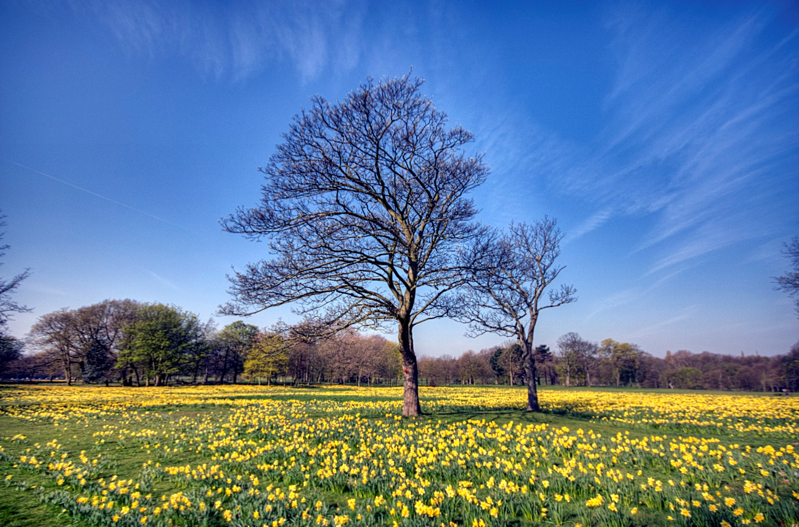
Source: Leafless tree on yellow petalled flower field during daytime HD wallpaper | Wallpaper Flare (2017). https://www.wallpaperflare.com/leafless-tree-on-yellow-petaled-flower-field-during-daytime-wallpaper-3073.
At 8:50am, the children arrived at the nursery school. They were all 4 years old. Today I have been delegated to observe 6 children. As I approach the children, I say out loud, "Boys and girls, look, it is sunny outside.” One boy responded, “Wow, it’s never sunny normally, miss." Can you see your shadows on the grass? I point with excitement; I wonder how that happens. The children started to look down at the grass in front of them and pointed out how tall they looked. “Are our shadows getting longer or shorter as we move?” I asked. One girl replied, “I look so tall when I move backwards, but when I go forward, I look small again." “Yes, that is correct. Shall we look at some books on this when we go back into class?"
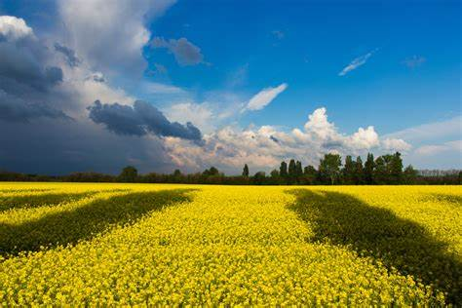
Source - Premium Photo | High angle view of shadow on field (2023). https://www.freepik.com/premium-photo/high-angle-view-shadow-field_98972041.htm.
“For now, children, we can go and explore what else is around us; let’s go get on our waterproofs and wellies just in case the weather changes." With some help from two other staff members, the children independently go and get their waterproofs on. While getting dressed, a boy asked, “Does the rain feed the flowers and trees?” “What a brilliant question,” I replied, “yes, I guided the children to the flowers and trees." As a group, we gathered around a huge, tall tree and looked to the bottom, where the tree root began.
I explained to the children that trees and flowers need oxygen, sun, and rain to enable them to grow and survive. One girl asked, "But miss, my mum told me trees help us too.” “That is correct," I answered. Trees help us with many things, like breathing and paper for us to write and spell our names with!" The children burst into excitement, telling me who could write their name better.
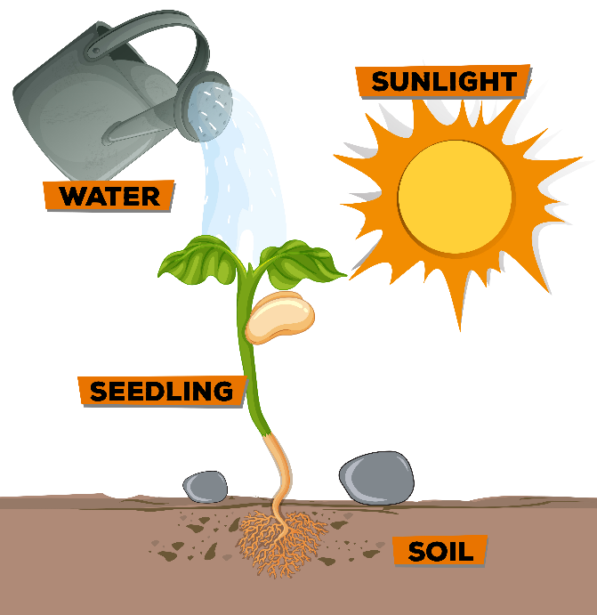

Source - Boyer, L., Jr (2024) 'Water in plant growth,' All About Worksheets, 10 January. https://learningmediablotted.z21.web.core.windows.net/water-in-plant-growth.html.
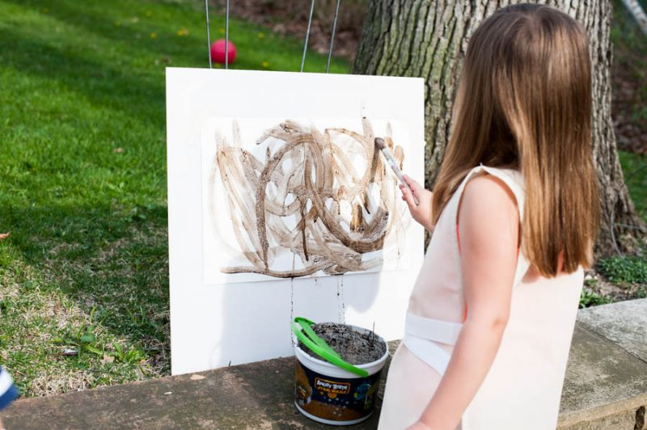
The children then scattered around the play areas. I decided to place some objects in certain areas of the field. In one area, there were kitchen utensils and bowls for mud. While playing, the children placed mud into the bowls until they filled them to the very top. They created patterns, then insisted on showing me how they drew their names with sticks they had found on the way down to the field. They created all different patterns, such as zigzag lines and notes and crosses.

I decided to ask the children to draw a triangle. Once they had completed this, I then asked them to count how many sides a triangle has. "1, 2, 3 sides a triangle has miss”. Great work, I replied, while they carried on filling the bowls up with mud from the ground. “Miss, I have filled my bowl up to the very top; look!" “Oh, amazing. Was the bowl empty or full before?” I asked. "Yes, miss, there was no mud in it before, so it was empty." I suggested using the bowl of mud to plant more flowers in the field with the seeds I had bought for the children. I asked all the children to go and find a spot in the field to plant their first flower and come back over once they had completed this activity.
Once the children had completed their flower planting, I asked everyone to quietly put their hand up and explain to me how they did it. The boy I chose said, “I dug a big hole, put the seed in the hole, covered all the mud on it, and used the water from the potion making to help make it grow.” “Oh wow, that is amazing. How clever are you?" I replied with excitement. All the children were talking and asking questions. “I wonder what else makes a flower grow,” I asked the children. “The sun is what my dad told me.” “Correct, well done. The sun, water, and mud all help grow the flowers here on this field." Creating this activity gave the children independence and an understanding of nature.
The children started doing one thing and moved on and extended their play throughout the field. I provided 4 sections, after planting flowers, I came over to observe the children building a den in one of the sections. At first the children were arguing over who could have certain equipment, whereas the other 3 children were working as a team. “Miss, these sticks won't stick together.” “Gosh, why might that be?” I asked. The children soon realised one stick was much lighter than the other. The children then asked for help, “We do not have enough sticks on one side." I then asked the children to count how many sticks they had so that the den would balance. “Where do you think this stick will make the den stronger?" I asked them, each of them worked together to create the den while one child ran over to me about an insect they saw on a flower. “Miss, we saw a bee; with our magnifying glasses, it was sitting on the flower.” I explained to the two girls that flowers contain pollen, and that they are used by bees as a food and energy source to get to and from their home. They were so interested and told me they were going to go find some more bees and tick whatever insects they find on the paper notepad provided already on the field for that activity. I took them both over to the insect area, where books were provided on what insects they may find in the outdoors and what equipment they needed to wear. Four sets of gloves were put with all the equipment
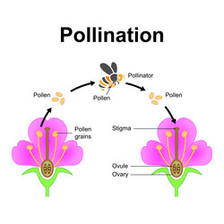
Source - blueringmedia (no date) Diagram showing pollination with flower and bee vector image. https://www.vectorstock.com/royalty-free-vector/diagram-showing-pollination-with-flower-and-bee-vector-27144302.

Two of the boys were kicking a ball into the goal hoop provided by the staff from the school. I encouraged the boys to work together. “Why don't you pass the ball to each other? That would be great teamwork.” “Oh yes, that is what football teams do on TV,” the boys replied. I made a game for them, and while they started working together, “boys, you cannot shoot the ball in the goal unless you have kicked the ball at each other three times." Once they had been doing this, they kept counting each time someone had the ball; this was creating coordination and teamwork at the same time. Once I headed back over to the den, I could see the children had collected leaves, flowers, and other natural items to help the den stay at a certain height for the children to hide underneath the blankets. I knew this activity would encourage their creativity and fine motor skills. “This is an amazing den, guys,” a girl replied, “yes, we did it all by ourselves and even tied everything together.” “I am so proud of all of you,” I said with excitement. The time came to 11:30am, which meant it was time to head back to school for dinner time. Before we packed up to leave, I asked the children how they found their time today at the flower field. “Boys and girls, did you enjoy your outdoor trip today?" They all screamed, "Yes, it was the best time ever.” “I am tired now." I asked the children some things they enjoyed learning through the morning; one boy replied, "I loved the football game we played, but I am so tired now.” “Aw amazing, you have been using your muscles and exercising all day.” We arrived back at the school, ready for dinner time. The children independently took their waterproofs and wellies off and went to wash their hands.
)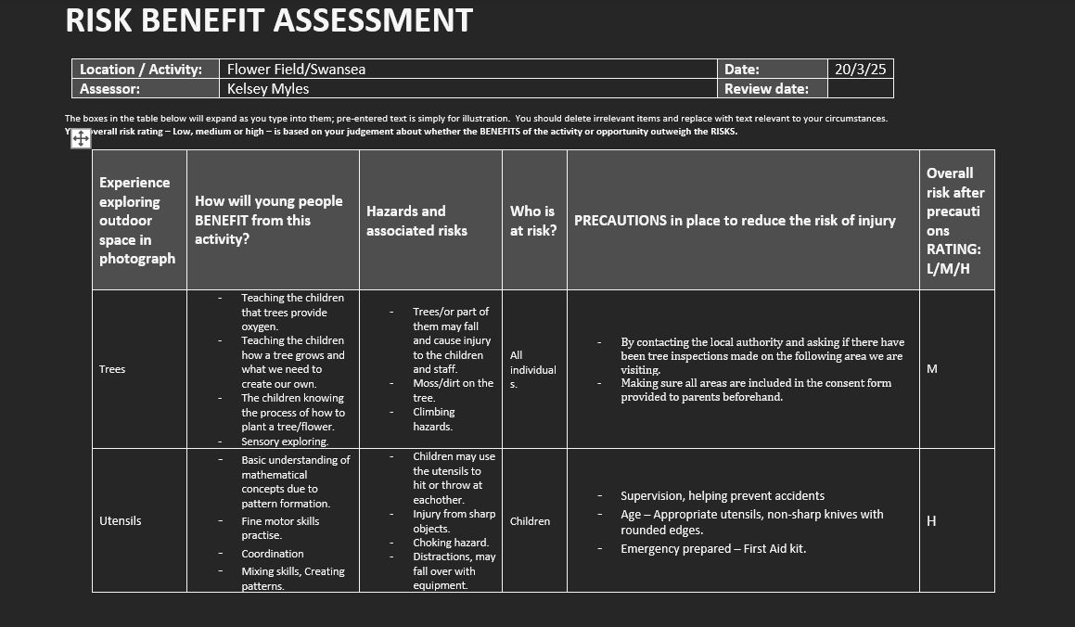
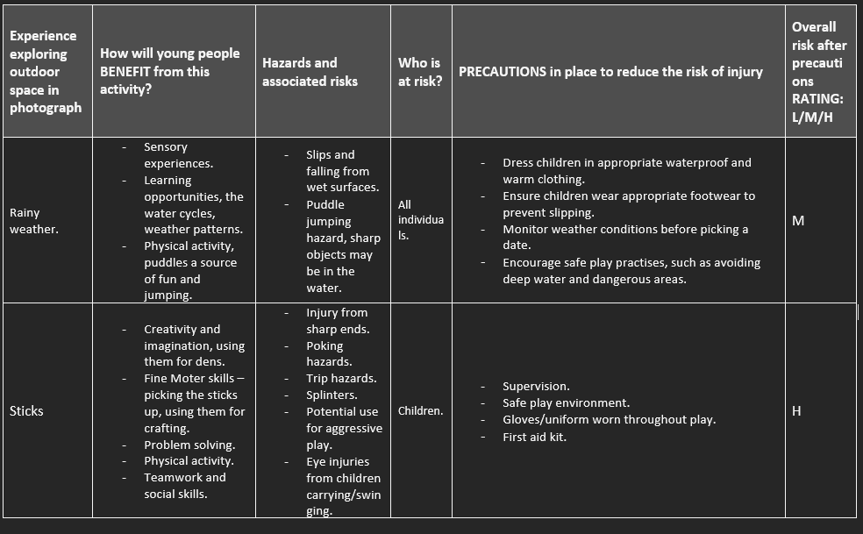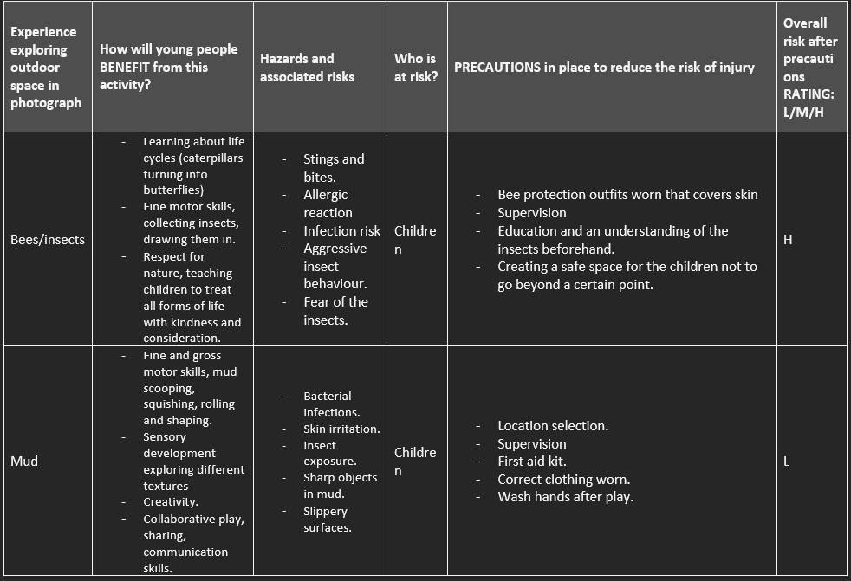

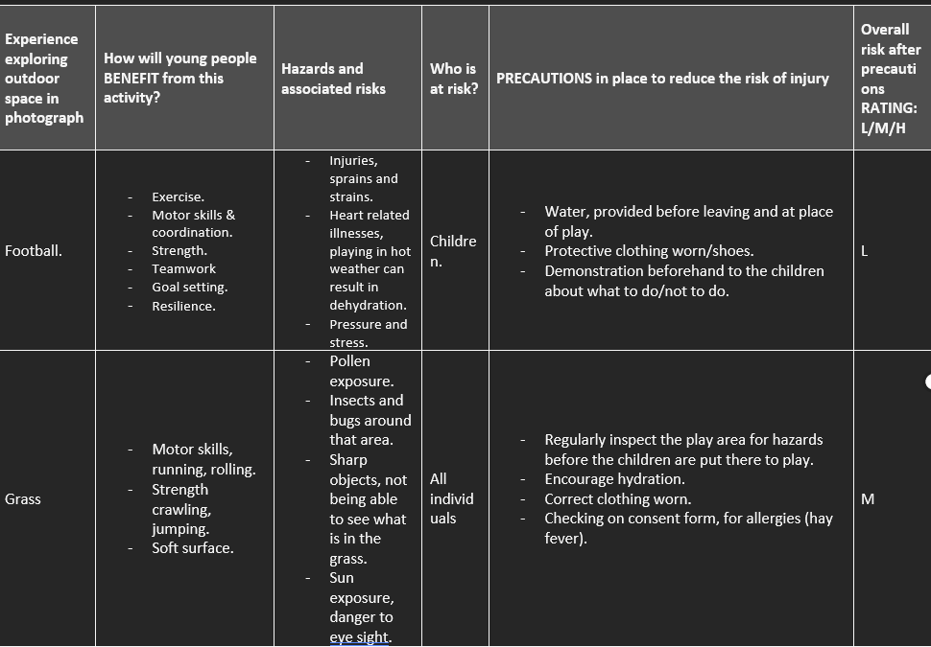
Outdoor play is defined as the experience and play of children outdoors in open areas like playgrounds, gardens, or nature like forests and beaches, Lorenzo Luchetti (2023). Outdoor play involves structured play and unstructured play where children can use their body, problem-solving, and creativity skills to use the environment, Early Years Alliance (2022). Outdoor play encourages movement, which helps develop motor skills, strength, and balance. Providing an opportunity for children to be physically more active, which is essential for maintaining a healthy lifestyle, Evergreen Canada (2016).
In addition, movement is important for children; it improves their gross and fine motor skills, exercise, physical development, mental health and their aid learning Maria Montessori (n.d.). Movement also shows embodied learning. “Did you see the size of that splash? Let’s do it again." Children use their whole bodies to learn. A quote from Sir Ken Robinson (2012) said, “It amazes me how quickly and how often we forget that we are embodied and that we see the world the way we do because we live in these bodies." Working and playing outdoors helps children come together and experience the outdoors. If children start going outdoors at a young age, it is seen that they will be more interested in the outdoors growing up. Dr. Lara N. (2016). There are several factors on how movement improves a child's lifestyle: movement lifestyle; movement and doing build the brain and the body; physical play promotes personal and social growth; and learning how to play with others and forming relationships through movement. Dr. Lara N. (2016). Ofsted research from 2022/23 showed that children are entering reception with lower levels of fundamental movement skills; it is also highlighted that “practitioners play an important role in encouraging less active children to move more and in teaching children movement.
Manipulation skills also involve handling and controlling objects with the hand, feet, or any part of the body that includes movement, Ofsted (2022). They are often called motor skills; they support the development of strength, coordination, proficiency, control, and positive awareness. Movement can help a child's development by integrating sensory structures throughout the body and by developing coordination and linkage between the brain and body
Following Vygotsky (1978), sociocultural theory focuses on social interaction and language use as central aspects in the learning process. Learning is said to be a social construct that takes place in the zone of proximal development, where children can perform tasks with support they cannot do alone. While venturing outside environment, adults can scaffold children’s learning by providing support and using language that challenges children’s thinking.
Helen Briton (2010) says that children must be outside for fresh air, daylight, and sun. They can be physically more active than inside, and so they can become and stay healthy. Bliton (2004) discusses that growth, development, and maturity, to some extent, these factors will benefit in a supportive environment, one that is outside. Children learn to refine and improve motor skills and develop their coordination, balance, and body awareness by being active; this helps strengthen muscles, improve muscular endurance, and increase bone density. Sport council (1992).
Children need a balanced education that takes account of their social, emotional, physical, and cognitive development. There is evidence which all point out that outdoor free play in a natural setting as providing optimal conditions for this to happen, when combined with sensitive, neutering adult support Juliet Robertson (2017). Piaget (1973) also believed that children actively construct knowledge through interactions with their environment. According to his theory, children move through stages of cognitive development, and hands-on experiences in outdoor environments support these processes. Outdoor play offers concrete experiences that help children build mental representations of mathematical and scientific concepts, such as spatial awareness or the understanding of cause and effect Juillet Robertson (2017).
The adult's role in outdoor play is to observe. Katz and Chad’s research is confirmed by the (effective provision of preschool education) project (Sylva et al., 2004), which has established that children are helped to move forward in their learning when the adults are truly engaged with the children over time and through real conversations. “Do you think if I did... then this would happen again?" Questions by educators could further the child’s learning. According to Puhakka et al. (2019), in terms of children's diverse learning in the outdoors, some studies show that professionals lack an understanding of science and math concepts. This leads to teachers not exploiting the full potential and benefits of outdoor play, which creates a barrier to learning in these subjects outside the classroom.
Therefore, Jan White (2011) and Tim Waller (2011) suggest adults have a significant role in providing access to the outdoors and the types of environments that have a high play affordance, where children can use the landscape and materials in a variety of innovative ways. Research shows the importance of creating environments that are stimulating and conducive to exploration (Dyson & Genishi, 2005). Adults can enhance outdoor spaces by providing materials that encourage mathematical and scientific inquiry. This could include building weather stations, measuring tapes or blocks, creating natural counting games, or introducing resources like microscopes for examining plants and insects.
Similarly, Gibson, J,J (1979) affordance theory provides insights into how individuals interact with their environment based on perceived benefits; for instance, a child may see a pile of blocks as an opportunity for building, while an adult may see them as a tool for teaching concepts. According to Gibson, perception is directly tied to action; perception is not about recognising objects; it’s fundamentally about understanding how the objects can be used. Furthermore, Heft (1988) suggests that while an adult may enter a woodland space and mentally note what is there, such as oak, tree, shrub, and puddle, a child may enter the same space and mentally note what might be done, such as climbable, hiding space, puddles, and muddy. Therefore, educators can enhance children's intrinsic motivation and curiosity by deliberately providing materials and environments that highlight affordances, encouraging exploration and discovery Gibson, (1979). Walters Davies (2022) argues that for an environment to be most effective for play and development, it must have a variety of affordances available.
Similarly, Nicholson’s (1970) theory says children learn best in environments with a range of loose, open-ended materials, due to the Loose Parts Theory, which was established by architect Simon Nicholson in 1970. This promotes ability to adapt, exploration, creativity, imagination, and problem-solving abilities. Playing outdoors promotes dynamic and exploratory play, especially when combined with natural and artificial factors. According to the Loose Parts Theory, children thrive in outdoor play environments where they can use a range of natural and man-made elements, such as rocks, sticks, water, leaves, ropes, tires, and loose pieces of everything. Because these materials do not have an intrinsic use, children can use them for a variety of reasons based on their own creativity and necessity, resulting in more active and curious play. Nicholson (1970). Loose parts can be used for the senses by listening to tyres rolling, for example.
A study by Anne Mcguire (1971) demonstrated the term "loose parts" and pushed for environments where children could freely explore with a variety of materials. McGuire noted that children are natural constructors, and loose parts allow them to get involved in the process of building and creating. By offering these resources, educators promote children's natural curiosity and creativity.
However, Jones (2012) and Russell (2010) reported benefits including social behaviour and academic engagement. Jones (2012) also used interview methods to evaluate the impact of loose parts, and participants reported improvements in self-esteem, confidence, social inclusion, and happiness alongside reductions in boredom and aggression with playtime.
Furthermore, Burner's (1966) theory showed that intellectual development moves through three stages: enactive, iconic, and symbolic in that order. However, unlike Piaget theory, Burner did not contend that these stages were age dependent. Burner’s first stage (enactive) states learning through actions and experiences, involving direct engagement with the environment. An example of this used in outdoor play shows engaging in physical activities, exploring, and hands on experience, allowing them to learn through their surroundings, Saul McLeod (2024). The next stage (iconic) showed learning through images and symbols; during outdoor play, children might draw what they see, create maps or use natural resources to express their observations Saul McLeod (2024). In the last stage, children learn through language and abstract thought. Burner's (1966) research showed that using words, numbers, and written symbols represents experiences and concepts.
The curriculum for Wales (2022) focuses on a positive outlook on outdoor play and learning as a vital component of children's education. The curriculum encourages experimental and hands on learning through outdoor activities, allowing children to explore and use creativity. By providing rich, engaging outdoor environments, educators can help with holistic development and foster a love for nature, preparing learners for future challenges. The Curriculum for Wales (2022) encourages schools to embrace innovative and creative approaches to learning outside the classroom. Schools and educators should refer to the resources from the Welsh government to promote detailed guidance, good practice, and curriculum support related to outdoor play.
In conclusion, adults play a crucial role in supporting and encouraging young children’s engagement with mathematical and scientific concepts in outdoor environments. By using structured play, offering resources, and encouraging inquiry, adults help children make meaningful connections to these concepts. Using theories such as Vygotsky’s sociocultural theory, Piaget’s cognitive development theory, and Bruner’s constructivist approach, adults can scaffold learning in ways that foster both mathematical and scientific thinking. The outdoor environment provides rich opportunities for children to explore, question, and learn through direct experience, supported by the guidance and expertise of the adults around them.
Furthermore, adults can show positive behaviour, encourage risk-taking within safe boundaries, and ensure that outdoor spaces are stimulating and accessible. In children's digital age, where screen time is often used more with outdoor play, adults must prioritise time spent outside. Lastly, adults help support an environment where outdoor play becomes a natural, enjoyable, and enriching part of children’s lives, contributing to their well-being and development.

Reference List
‌ Affordance Theory in Outdoor Play. (n.d.). https://repository.uwtsd.ac.uk/id/eprint/2979/1/Waters%2C%20Jane%20%282017%29%20Affordance%20theory%20in%20outdoor%20play.pdf.
Bing.com. (2025). what is outdoor play facts - Search Videos. https://www.bing.com/videos/riverview/relatedvideo?q=what+is+outdoor+play+facts&mid=27F20B67BD955C94350727F20B67BD955C943507&mcid=A2403D414562478FA04EEDDCDFDAE1E4&FORM=VIRE [Accessed 28 Mar. 2025].
Dotson-Renta, L.N. (2016). Why Movement is Essential in Early Childhood. [online] The Atlantic. https://www.theatlantic.com/education/archive/2016/05/why-young-kids-learn-through-movement/483408/.
Dyson, A. H., & Genishi, C. (2005). The need for a pedagogical ecology: Early literacy in a changing world. In Theories in second language acquisition: An introduction (pp. 1–17). Lawrence Erlbaum Associates.
Early Years Alliance (2022). The benefits of outdoor play in the early years. [online] early years alliance. https://www.eyalliance.org.uk/benefits-outdoor-play-early-years.
Ellis, J. (2024). Why Are Fundamental Movement Skills so Important - Startwell_2020. [online] Startwell_2020. Available at: https://startwellbirmingham.co.uk/why-are-fundamental-movement-skills-so-important/.
Gibson, J.J. (2014). The ecological approach to visual perception. Psychology Press. doi:https://doi.org/10.4324/9781315740218.
Gibson, J.L., Cornell, M. and Gill, T. (2017). A Systematic Review of Research into the Impact of Loose Parts Play on Children’s Cognitive, Social and Emotional Development. School Mental Health, 9(4), pp.295–309. doi:https://doi.org/10.1007/s12310-017-9220-9.
Hase, V., Boczek, K. and Scharkow, M. (2022). Adapting to affordances and audiences? A cross-platform, multi-modal analysis of the platformization of news on Facebook, Instagram, Tiktok, and Twitter. Digital Journalism, 11(8), pp.1–22. doi:https://doi.org/10.1080/21670811.2022.2128389.
HelenBilton_2010_1Thebenefitsofoutdoor_OutdoorLearningintheE.pdf Internet Archive. (2015). The Origin Of Intelligence In The Child : Piaget, Jean : https://archive.org/details/in.ernet.dli.2015.458564.
Kiviranta, L., Lindfors, E., Rönkkö, M.-L. and Luukka, E. (2024). Outdoor Learning in Early Childhood education: Exploring Benefits and Challenges. Educational Research, 66(1), pp.1–18. doi:https://doi.org/10.1080/00131881.2023.2285762.
Lippman, P.C. (2023). Affordance Theory as a Framework for Twenty-first Century Learning Principles. Creating Dynamic Places for Learning, pp.195–220. doi:https://doi.org/10.1007/978-981-19-8749-6_10.
Lucchetti, L. (2023). Benefits of outdoor play for children. Medical News Today. [online] 13 Oct. https://www.medicalnewstoday.com/articles/outdoor-play-children.
Maria Montessori Institute. (2024). Why Movement is So Important for Children’s Development - Maria Montessori Institute. https://www.mariamontessori.org/news/why-movement-is-so-important-for-childrens-development/.
McLeod, S. (2024). Jerome Bruner’s Theory of Learning and Cognitive Development. [online] Simply Psychology. https://www.simplypsychology.org/bruner.html.
ProQuest Ebook Central - Reader Redirecting (no date). https://ebookcentral.proquest.com/lib/trinity/detail.action?docID=689536. Robinson, A. (2018). Early Childhood Theorists: Loris Malaguzzi. [online] Uncommon Sense Parenting with Allana Robinson. https://www.allanarobinson.com/early-childhood-theorists-loris-malaguzzi/.
Sagepub.com. (2024). https://sk.sagepub.com/book/edvol/outdoor-provision-in-the-early-years/chpt/adults-are-essential-roles-adults-outdoors.
Schunk, D.H. (1991) Learning Theories: An Educational perspective. https://ci.nii.ac.jp/ncid/BB09340971. The theory of loose parts. (n.d.). https://ncaeyc.org/wp-content/uploads/2013/05/The-theory-of-loose-parts.pdf.
naturalresourceswales.gov.uk. (n.d.). Natural Resources Wales / Increased role for outdoor learning and natural environment in new school curriculum. https://naturalresourceswales.gov.uk/about-us/news-and-blogs/blogs/increased-role-for-outdoor-learning-and-natural-environment-in-new-school-curriculum/?lang=en. www.scirp.org. (n.d.).
Piaget, J. (1973). Psychology and Epistemology Towards a Theory of Knowledge. Record Rio de Janeiro.. - References - Scientific Research Publishing. https://www.scirp.org/reference/referencespapers?referenceid=1716834.

