
Sports Industry Research
Project Report M6X02100
Assignment 2

Student Name
James Michael Thomas

Project Title
Bishop Vaughan’s Rugby Future

Acknowledgements
I would like to thank Trinity Saint David Swansea for this opportunity to carry out my research project. This wouldn’t have been possible without the support of both Andrews Thomas head of my BA in Sports Management and James Prosser my Dissertation tutor. I will also remain grateful to the team in Bishop Vaughan Catholic School where I have previously completed placement and also carried out my data collection for this research project.

Abstract
The UK Government implemented a 24-hour curfew in March 2020 due to the global outbreak of COVID-19 (coronavirus). UWTSD took steps to support students remotely with continued online supervision. However, many National Governing Bodies (NGB's), Sports Teams and Schools closed during this period which meant that data collection became more challenging. This impacted my research within “Bishop Vaughan’s rugby future” in which I was not able to focus my research on the targeted pupils, I was able to collect a range of data from classes within the school that were not taking part in rugby at all so this affected the outcome of some of the data which is shown below.
Aim
Analyse the current factors that influences participation in rugby at Bishop Vaughan Comprehensive school and determine its feasibility for continued investment in the school’s Curriculum.
Objectives
- Investigate the key factors which influence participation in sport.

- Identify curriculum developments which influences rugby participation.

- Consider factors that may affect pupils taking part in rugby.

- Evaluate a future in rugby in Bishop Vaughan Catholic school.
Literature Review
The research projects literature review will list and expand on the following; Physical education, key stages, rugby, participation, challenges within the curriculum, injuries, English and welsh data comparisons, dropout rates, Government investment, physiological identity, understanding coaching practice, stereotyping and lastly the Donaldson report which covers the changing curriculum. These key areas within the literature review will allow the report to evaluate and find a correlation with the Case study being “Bishop Vaughan” and help conclude and find areas which are in need of future recommendations.
Methodology
The research projects methodology will include the methods in which the data was collected this being through questionnaires and also an interview with the Head of sport Tom Davies at the case study previously mentioned “Bishop Vaughan”, the reason for these methods is that they can find an accurate background on the research taking place and its aims. Both combined can help find a correlation from a pupil perspective and also a teaching perspective.

Contents Page

Sports Industry Research Project

Acknowledgements…………………………………………………………………. Page 1

Abstract……………………………………………………………………………... Page 2

Contents……………………………………………………………………………... Page 3-4

Chapter 1 Introduction…………………………………………………………… Page 5 – 7

Chapter 2 Existing Literature ……………………………………………Pages 8 - 14
- 2.1 Physical Education and Key Stages.

- 2. 2 Rugby, Participation Challenges within Physical Education.

- 2.3 Rugby and Injury Collective Data.

- 2.4 Concussion in Rugby.

- 2.5 Evaluation of Injuries, English and Welsh Comparisons.

- 2.6 Physical Education Head Teachers Analysis Teachers on Dropout Rates and National Standards.

- 2.7 Dropout Rates Data and Findings in Wales.

- 2. 8 Government Investment in Wales within Physical Education.

- 2.9 Physiological Identity Within Rugby.

- 2.10 Physical Education Promotion and Involvement in Sport.

2.11 Understanding Coaching Practice.

- 2.12 Stereotyping Within Rugby.

- 2.13 The Donaldson Report and Relevance to Sport and Rugby within the Curriculum…

Chapter 3 Methodology…………………………………………………………………………Pages 15 -18

- 3.1 Introduction to Methodology

- 3.2 Quantitative Traditions

- 3.3 Qualitative Traditions

- 3.4 Introduction to Validity and Reliability

- 3.5 Selected Method

- 3.6 Validity and Reliability Within Bishop Vaughan

Chapter 4 Research and Findings…..…………………………………………. Pages 19 - 29

Chapter 5 Conclusion……………………………………………………………… Pages 30-31

Chapter 6 Recommendations………………………………………………………… Page 32-33

Chapter 7 References……………………………………………………………… Pages 34 - 38

Chapter 8 Appendices……………………………………………………………... Pages 39 – 56

Chapter 9 Case Study Ethics Forms………………………………………………. Pages 57 - 65

Chapter 1 Introduction
Rugby has been played in the UK from the 1800’s (Rugby School, 2020). Rugby Started began much like football. Rugby developed its own unique place in sports culture and has a gained massive interest and fans across the world. Due to the rich heritage of fan engagement and player participation within rugby culture it is key to promote the game in schools and communities in order to ensure development and sustainability. The focus of this thesis is to understand rugby’s current and future role in sports within Schools in the United Kingdom. This project will highlight the deep roots of rugby and offer a thorough insight to what it’s like to play the game today. Rugby is constantly facing new challenges, for example, Pollack, A (2016) stated in her study “Tackle and scrum should be banned from school rugby”, a fairly recent study which contests this research project supporting the future of rugby. Furthermore, it also links in heavily with the Government summary of the Donaldson report (2014), the new curriculum concentrating on health and wellbeing by using these as a form of argument it will help conclude on the relevance of rugby and future recommendations for the sport within the curriculum.

This research project will conduct a background on participation in Bishop Vaughan Catholic School, Swansea. It aims to identify the current curriculum in both Wales and England and compare and contrast between the two. Furthermore, it identifies their positive and negatives attributes. Secondly identifying what school priorities are in times of challenge, for example new concussion principles. This thesis focusing particularly on pupil participation and physical education of Bishop Vaughan School, with observation as a key method. A key item of research in this thesis will be an interview with the head of the schools Physical Education department, this will help me conclude on the performance and recognitions of procedures put in place when in relation to participation in Physical activity.

The projects overall aim is to “Analyze the current factors that influences participation in rugby at Bishop Vaughan Comprehensive school and determine its feasibility for continued investment in the school’s Curriculum”. This can be a very useful standing point as it can develop into a method of training and coaching. The case study “Bishop Vaughan School” has a great deal to take from this project; firstly being an outsider opinion from a sports management student, influencing volunteers specific to rugby, tackling good and effected areas within participation. Furthermore, an important option for developing new and inventive coaching pathways. Finally to conclude on this section if the research objectives of the project is met to a sufficient standard these being; Iinvestigating the key factors which influence participation in sport as a whole, Identifying the curriculum developments as a whole and which of them may or may not influence rugby participation, Considering factors that may affect pupils taking part in rugby and lastly a full Evaluation on the future of rugby in Bishop Vaughan Catholic school which will pose as a rewarding backed up benefit to the main reader Tom Davies Head of Department for sport.

Furthermore, the research will be evaluated by using up to date research methods. These methods include observation within a volunteering setting, as well as one to one interview in Bishop Vaughan, a school made up of a diverse community. Moreover, their curriculum places a focus on rugby as well as other popular sports. Key characteristics within the Physical education department (PE) are linked to the individual teachers and new methods of training. For example, the use of the Donaldson report 2014 is influencing changes in the curriculum. By collecting data from interviews and questionnaires, this thesis will be able to explore how Bishop Vaughan’s curriculum impacts their students. Reports and data from online resources will provide the research project with evidence, crucial to create an evaluation on the title “Bishop Vaughan’s Rugby Future.” The evidence which Highlights areas that are effective within participation and those that are failing.
This will be an extremely useful project as it can allow me to get a background of the schools and curriculum which a student like myself want to develop within. Bishop Vaughan’s PE department can also benefit from the findings of such a project as it will help them identify Key stages that effects areas that pupils find hinder their participation, this allowing them room for intervention in which they can apply new methods to boost participation. Finally, the key findings within this Literature Review will help identify the relevance of rugby in today’s society and will help generate questions surrounding the topic in discussion, for example, does rugby have use in health and well-being or is it a main cause for concern based around injury.

The overall purpose of this study is to introduce new methods of research within schools. This in turn will improve the way which progress of rugby participation in monitored. This thesis will find factors that influence participation at only one case study and results will find that if rugby has a place in the curriculum then the research will be able to influence further studies within this topic area. Examples of this is how rugby can be structured to fit into the new curriculum and being linked directly with the strong characteristics of the sport outlined by interviewee Tom Davies, therefore, will help construct further methods of research across south wales and introduce them into new schools. Positive outcomes of these findings will help develop a feasible message in which can be taken into schools, communities and develop on ideas as a further study for example…
- Women’s rugby,
- Volunteering from university students.
- Further opportunities from staff full time or part time.
The results reinforce that there are room for future recommendations such as those listed above. In the next chapter I locate literature surrounding my chosen research of rugby curriculum, following a detailed description of methodology chosen and reflecting on data collected within Bishop Vaughan School.

Chapter 2 Existing Literature
2.1 Physical Education and Key Stages
The national curriculum provided by (Foster and Roberts, 2019), from a parliamentary document named “Physical education, Physical activity and sport in schools” understands the importance of Physical Education within schools on a “national” scale. It recites the “compulsory” place it has in the educational system. Also it mentions that all “key stages” are invested in order to maintain the national standards. An extension of this leads to the documentation that the (Welsh Assembly Government, 2008), released “Physical Education in the National Curriculum for Wales” which recites the following areas that reflect the national document. Figure 1 indicates the difference in age and also the breakdown of study within all departments of education in Wales. These documents also contain the key areas that must be tackled, examples being in key stages 2-4 within the Welsh relevant area;

Key Stage 1-2
- Developing skills, knowledge and understanding during this phase of the Physical Education stage. This is the framework in which skills are found and are the base layer for them to develop through approaches such as “Jump Higher” and also “Run Faster”. (Welsh Assembly Government, 2008).
Key Stage 3
- This stage works with the base layer (key stage 1-2) and is the platform which future activity skills can be based upon. This stage focuses on team building, personal improvement and consistency within all areas. It also identifies health and well-being and instils it on each individual.
(Welsh Assembly Government, 2008).
Key Stage 4
- This is, again, the building block in which it develops from Key Stage 3. This key stage allows more room for health and well-being, additionally, it creates a sense of responsibility within the school and on a community-based level. This is a personal preference stage in which pupils can chose their own pathways in sport and build on it.
(Welsh Assembly Government, 2008).

2.2 Rugby, participation challenges within Physical Education.
Rugby has been a massive sporting interest within society since early 18th century, (Trueman, 2007). Trueman presents a background on the sport itself and its growth through history within the UK. Rugby is a large part of the United Kingdom’s culture and society, but there is an up rise with people concerned of the safety of the sport. A relevant source linking to rugby within the curriculum has been studied and questioned by (Allyson. Pollock, 2016), who is a professor for public health. She has constructed an argument that “Tackle and scrum should be banned in school rugby, argue expert”. There is a clear effort within professionals and the general public that rugby is to be excluded completely due to the lack of safety within the contact sport.

2.3 Rugby and Injury Collective Data
(Allyson. Pollock, 2016), reinforces in her blog the need for rugby to be taken away from the school curriculum. Alongside the, “70 academics” these include doctors and public health professionals who have composed a signed letter (Sport collision injury collective, 2016). Figure 2 (see appendices) is the preview of what was initially composed and published and shows a clear indication that there is no room for a high contact sport within schools sporting society or curriculum. This is a serious threat to the life of rugby within schools due to the words used within the letter, for example “serious” or even “high risk” injury. They use their findings within schools, and they all seem proceed to portray common injury patterns. For example, within contact or collisions;
- Ligament tears
- Broken bones
- Dislocated shoulders
- Spinal injuries
- Head Injuries – concussions

These injuries can vary from “short term” to “life-long” to even “life ending” (Sport collision injury collective, 2016) consequences for children who meet the age and requirement to play rugby within school. Examples on “Concussion” and the theory of it has been also listed within the blog (Kirkwood, G., Parekh, N., Ofori-Asenso, R. and Pollock, A. (2014). The blog offers a systematic review on the data behind concussion within “Youth Rugby”, this includes rugby union and also rugby league, one of which is played within the school curriculum. It backs up the likelihood of the occurrence of these injuries taking place both on a minor and major stage in a single person’s rugby career.

2.4 Concussion in Rugby
A further link to the blog previously stated, is a source based on “Concussion in Sport: Conceptual and Ethical Issues” (Michael J. McNamee, Bradley Partridge and Lynley Anderson. (2015). This work shares relevance to what the letter is implying, this being Figure 2. It targets a specific injury pattern “concussion”, it seeks interest within rugby union and rugby league. Again, it mentions “concussion theory”, and seems to be an extremely highlighted issue within all these sources, and they all mention a sense of vulnerability that could be inflicted on pupils within the current curriculum. Additionally, it highlights if schools and governing bodies are doing enough to ensure the safety and minimising the chances of “life ending” injuries.

2.5 Evaluation of Injuries, English and Welsh Comparisons

Allowing English comparison will help to come to a conclusion on injury patterns. The article “Epidemiology of Injuries Within English Youth Rugby Union” (Haseler, Carmont and England, 2010), will open up a wider comparison which can link within Allyson Pollocks initial argument that “Tackle and scrum should be banned in school rugby, argue expert”. This can be used to contrast with similar Welsh statistics, for example the article proceeds to show “injury patterns” within two seasons in English youth rugby union. This being an area taught in secondary schools as it is all based round rugby union. It is relevant to what was previously stated as “high injury” and also “long term” injuries. Another look at this could be linked to the
(WRU Rugby Pathway, 2018), as this is a reach into community rugby. On both parts (see figure 5) proceeds to identify crucial laws and recommendations for teams U14-U19. Coaches within the sport on a community-based level follow this work and using this it will identify faults within the system. For example, if the contact zone should be left until a later age both in schools and community-based levels. An extension of this is that if the injury and for example, concussion rates are still high in the future, questioning would figure 5 and the laws, still be a relevant in today’s society.

2.6 Physical Education Head Teachers Analysis Teachers on Dropout Rates and National Standards.
Other examples which can seriously affect the motivation of sport as a whole within Physical Education, could relate to (Sports Wales, 2014) that evidence they presented in “Physical Education and Sport- Education evidence paper”. The evidence that was constructed within 2014, emphasises that physical education is in need of redevelopment. For example, that schools in Wales are not meeting the aims provided by the curriculum to engage in at least “two hours” per week within the sports department. It states that there has been a need for 15 years for change, as “87%” heads of PE agree that more time is needed for physical activity and the curriculum needs to allocate more time to ensure that national aims are met. The lack of hours put into the PE department could be a leading factor in dropout rates in sport within secondary schools. This could be implementing negative promotions and acting as a blocker for physical activity in general.

2.7 Dropout Rates Data and Findings in Wales
The document provided by sports Wales proceeds to present useful information regarding the participation rates of primary and secondary schools. To relate to Figure 3, the table indicates the participation rates within 2000-2013, and involve over 110,000 pupils within schools across Wales. This is an accurate find as there is an ideal amount participating within the survey. It shows a general pattern that a small gap is kept throughout between both primary and secondary schools, a general decrease is obvious within secondary schools this again could be linked to the development of key stages within the curriculum and how less time may be spent on physical education as a whole. There is a trend that head of physical education teachers and PE coordinators see gaps within the curriculum, and therefore, may limit their approach to how PE should be promoted. This lacks their ability to promote important aspects of the sport, for example health and well-being, sporting futures, social interactions, tolerance and learning processes (Sports wales, 2014).

2.8 Government Investment in Wales within Physical Education

Physical Education within schools comes when compared to other subjects is seen as less important, “Physical literacy is as important as reading and writing” - (Gov.wales, 2013). Gov.Wales is a source which has been acknowledged by the minister of housing in Wales Julie James AM, whose responsibilities are to provide and enforce development roles to schools on a government backing. It is a backing that views PE as a “core” topic, and is a way of ensuring that “every child’s entitlement to a high-quality physical education”. Figure 4 (see appendices) reflects the investment that is required on a government scale when dealing within physical education. They state the four factors that will ensure a future within the department. If these factors are used effectively and are promoted enough within schools, it can easily be a method that the Welsh government can use to avoid “the pandemic of physical activity” (Gov.wales, section 5 “context” 2016). It can be a standard of a high level of sport to ensure better participation levels.

2.9 Physiological Identity within Rugby
A further reach into rugby can be pinned into a “masculine” sport, “making men, Rugby and masculine identity”, (John Nauright and Timothy J.L.Chandler 1996, republished 1999). This opens up the appropriation of rugby in today’s society and examine if it’s still appropriate for it to carry the historical identity it has always been based on the portrayal around men and boys. This will create a basis for “How masculinity is constructed in society and how the particular way of being male that we know as manliness has achieved and maintained its privileged position in western society’ (David Whitson.1990). This is relevant to rugby and the “contact zone” and Allyson. Pollock’s (2016), interest in “Tackle and scrum should be banned in school rugby, argue expert”.

2.10 Physical Education Promotion and Involvement in Sport

A big part of Physical Education is the promotion side. It is important that the teachers have the resources to do enough to encourage all around participation. “Physical activity promotion in secondary schools” (Cale, 2000), takes a further look into secondary education in which is the area in which this research project is targeted. The importance of promoting sport in secondary schools is heavily based around the aim of the project “Analyze the current factors that influences participation in rugby at Bishop Vaughan Comprehensive school and determine its feasibility for continued investment in the school’s Curriculum”. This journal will help to construct an analysis of what Bishop Vaughan are doing in comparison to other schools within Wales or England. This will also identify the characteristics of a teacher, and what methods they use to build on key stages within schools. This will reflect a future for pupils to move onto sports and seek a longer-term involvement.
An extension regarding a younger generation’s involvement in sport could be linked to “Young Peoples involvement in sport” (John Kremer, Karen Trew and Shaun Ogle 1997). This journal introduces a development process which mentions methods of ‘intrinsic motivation and extrinsic motivation”. (Cherry, K. (2019) explains this being useful within sport as for example;

- “Extrinsic”, is an occurrence when pupils may well be motivated and perform to earn a “reward” instead of actually wanting to play or participate in the sport, in this research projects case “rugby”.
- “Intrinsic motivation” will identify if engaging behaviour within the sport itself is because it is “personally rewarding” and meaning that it is not based around a reward, instead is about participating to enjoy.

2.11 Understanding Coaching Practice

Targeting this area will open up a method which teachers use within today’s society to keep pupils interested within the Physical Education department, and also an addition to help identify methods of participation. This also has good links into “understanding sports coaching, the social, cultural foundations of coaching practice”, (Cassidy, Jones and Potrac, 2009). They will both help this research project to briefly identify positives and negatives within the PE department, and allow room for “understanding coaching practice”. This journal displays historical coaching methods in a large amount of sports. This can be used as a comparison which can be linked to Bishop Vaughan. A brief overview of what the staff do to keep pupils entertained will contribute to an analysis of participation methods.

Early learning in sport is crucial for younger generations to develop and explore. “Cooperative Learning in physical education”, S.Grineski, (1996), uses “Physcial Education” as a basis for levels of knowledge impact abilities within participation within new sports. “Rugby” is the topic within this research project and this journal tackles the “feasibility” of this research project. There is reason for concern that teaching is wrongly provided at stages of great importance, this being linked to all areas within the department and curriculum. Using this source, will identify contributing missing factors such as those mentioned within the journal. “Fitness” may be a main reason as to why dropout rates are rising within Physical Education. Moreover, findings from the curriculum and Bishop Vaughan will help to generate future recommendations for what can be done to ensure that “fitness”, which is a key area to all sports, is measured and invested into by all areas within the department.

2.12 Stereotyping within Rugby

Rugby has always had a “masculine identify” behind it “Applied Physiology and Game Analysis of Rugby Union” (Duthie, Pyne and Hooper, 2003). This source identifies this theory in a way outlining the general characteristics between “forwards and backs”. This opens up a case of general stereotyping within the sport, and could be a contributing factor to lack of participation within secondary schools. Therefore, questions could be structured in a way of finding this theory to be true or not. This opens up a health and well-being side to the sport, as pupils may feel like they may need to be a certain size, weight, shape, height or even width to participate. An outcome of this can have both negative and positive effects and would create a finding of a perfect “body image” in the sport. This would come into effect with participation and how pupils lack the mental strength to not play or even bypass these stereotypes and play.

2.13 The Donaldson Report and Relevance to Sport and Rugby within the Curriculum

The Donaldson report is a new development within the curriculum. Its principles are listed (see figure 6), and heavily involved around health, well-being, character building and also skill development. (Graham. Donaldson, 2015) states that “300 responses from children and young people”, have contributed to the development of this report, this is a clear indication that it has an appealing aim to change within the current curriculum. The question ahead relates to the relevance of rugby within the Donaldson report as a whole and also in regard to “successful futures”. The report continues to emphasise the lack of time younger generations have within schools, and that “health” is the most crucial part of what should be taught within schools. This relates heavily to the physical education department due to its involvement within this area.

The framework summarised within (Gov.summary of the Donaldson report, 2014), and also within Graham. Donaldson, 2015) “future generations”, (see figure 7) shows you the relevance of the goal aiming to be set by this report, it leaves very little room for current sports played within the curriculum and with the evidence from a former example (Allyson. Pollock, 2016) proceeds to identify rugby as a danger to younger generations due to the high “contact zone”. If rugby is a main cause for injury and is a growing concern, it goes directly against this report and the “wellbeing” aspect of it, a future for Rugby in the Donaldson report and curriculum, would require extra room for care and change within laws to make it safe and that it reflects the principles portrayed.

Chapter 3 Methodology
3.1 Introduction to Methodology
In order to form a structured and secure methodology within this research project Bishop Vaughan’s Rugby Future, a suited methodology needs to be chosen between “Quantitative and Qualitative traditions.” Bryman (2006), has found that combining qualitative and quantitative research methods results in a strong analysis for findings. Therefore, this research project needs to ensure that it is using the right methods in order to present a accurate analysis of the case study at hand, this being Bishop Vaughan Comprehensive school. The research has allowed an insight to year nine, ten and eleven rugby boys, therefore, the participants range from ages of thirteen – sixteen. The motivation behind this topic is linked to 460 hours of previous teaching within year two of the sport management course with Trinity Saint David. Due to the previous experience, there was a clear opportunity to explore this topic area using the first-hand experience from the volunteering on the course.

The traditions used within this research project will allow readers to understand the differences and why the researcher used the chosen tradition. This thesis aims to explore the relationship between the rugby curriculum and Bishop Vaughan School. By using a mixed method approach including an interview, observation and a primary data collection of questionnaires resulting in a positivistic approach (Dudovskiy, J. 2019). This Chapter outlines the choice and implications of using an ethnographic approach (Sauro, J 2015).

3.2 Quantitative Traditions

In a brief overview of quantitative traditions (DeFranzo, 2020) expresses the “differences” between these traditions, highlighting that this tradition is used to generate numerical data or even data that can be structured to become “usable statistics.” (Jean Rhodes, 2014), expresses a similar version in which the methods are used to their full advantages, this allows the research to identify a singularity across larger numbers of participants involved. The tradition involves the use of attitudes, opinions, behaviours and other defining variables that can be measured. This reflects (M.H.P. Sinaga, 2020), as these both share an equal finding with a clear understanding of this tradition in which it is based heavily on “characters.” Furthermore, it indicates that a research project needs to conclude on its findings and determine a number linking to data collection.

Limitations of this method are outlined by (Jean Rhodes, 2014), on the differences between these mixed methods are explained and presented to ensure you know which part of the quantitative and qualitative to use;

- Other singularities which are new and not yet researched into may be more difficult to recognise within the study.
- If the method is used within an area of study that it is unknown, then the method will struggle to present to a strong analysis of the topic at hand.

The benefits of this are expressed by (Jean Rhodes, 2014);

- This method provides statistics and useful information around the topic of research.
- Quantitative traditions will generalize a much broader field of research.
- This method will help form guidelines and enforce new policy if needed.
- The method has the ability to expand within other focus groups, therefore it allows a project to compare and contrast results creating a stronger analysis.
- Finally, the method works on a larger scale.

3.3 Qualitative Traditions

Qualitative Traditions are again heavily based around singularities within the research itself (Jean Rhodes, 2014), mentions the use of “interviews, open ended questions and even focus groups.” These areas are prime examples in which the research tradition is constructed. Additionally, this tradition is used on a more privatized scale as the area or participants within the research are smaller. This is due to the amount of attention required in this field, with interviews being one of the most time-consuming examples. The interviews within this method of research vary in some cases the questions may need to be structured to ensure the required results and in other cases they would be less structured and more open in order to welcome as much information as possible. This is considered the base of the two traditions as it puts in the time to form the start of larger studies where quantitative methods can be used to expand on a larger scale.

The limitations again expressed by (Jean Rhodes, 2014), within the comparison of Rhodes’ study of quantitative and qualitative research methods show that this method firstly;

- Can not act as a general tradition and can only measure the data collected.
- Furthermore, it can not measure characteristics and the relations between them.
- Finally, it is a tradition when it comes to applying statistics within the research method if not suited properly.

Nevertheless, the benefits of this method expressed by (Jean Rhodes, 2014);

- It allows for untouched and new areas of research to be identified on a smaller and intimate scale.
- Qualitative traditions explore and enhance a deeper look at mechanisms of research.
- The method uses a closer “1 on 1” technique.
- Additionally, it can extract other methods of data such as verbal and descriptive information.
- Finally, it can reveal a more human answer opposed statistics and findings through the use of “Quantitative traditions”.

3.4 Introduction to Validity and Reliability
Validity and reliability by (Middleton, 2020) explaining the differences in these concepts and the relevance of them in research, these are used to “evaluate” this being in regard to the quality of what you find, how you find it and also if it can be done again. They both indicate how well a “method, technique or test measure something” (Middleton, 2020). Reliability is based purely on “consistency” and how it is measured, for example if you are researching something and it can be done continuously within the same “method” this is then a reliable source and an effective research method. Validity is based around the accuracy of the method used within any forms of research, (Middleton, 2020) breaks it down into segments these being that if you have “high validity” then you will find that it agrees to real properties, individualities and variations. Having a high validity is a key to ensure that the method being used is effective within the research and that you are using the right measurements.

3.5 Selected Methodology

Bishop Vaughan will be the research project’s primary case study (Rowley, 2002), explains that the use of case studies are a key aspect to the success of a strong research project. This project will allow information to be obtained from multiple sources. Firstly, an interview with the head of sport at Bishop Vaughan school. An example of this can be found within the project’s primary data collection and also Part 1 of the appendix, which highlights the start of the interview and the type of questions presented to him. Using mixed methods will then collect further information through year nine, year ten and year eleven boys in the region of the PE Department. A further example of this can also be found with the project’s primary data collection and also Part Two of the appendix. This presents an example of how the project can amplify its aims and goals through the types of questions being asked. Importantly, the questions are open, which allows for broader answers which will help pinpoint the reasons behind people’s attitudes towards rugby within schools. Carrying out research will help create a factual conclusion and further recommendations if needed.

3.6 Validity and Reliability within Bishop Vaughan

Furthermore “Bishops Vaughan’s rugby future” research project has used a main case study, Questionnaires, and lastly an interview. As previously mentioned, I have already built a repour with the teaching staff at bishop Vaughan due to an extensive amount of teaching placement. By doing this it gave me an insight to the school and a glance at areas in the curriculum which need to be assed in regard to future preference. This made room for validity and reliability, it was firstly structured around a sport that is heavily used within the PE department, this made the research base reliable and that “Questionnaires” were suitable and there would be consistency within the answers. Secondly using the interview as a form of research allowed further consistency as Tom Davies provided an extensive background of the sport on a teaching and personal level. The questions asked were formed around the experience gained at the school, this was also influenced through the head of sport at bishop Vaughan. Feedback from Tom Davies allowed the project to gain its own “design” and that it would be considered more accurately for future studies.

Chapter 4 Research and Findings
Question 1

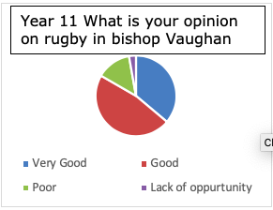

The first questions that the students answered was a general question about their opinion on rugby. The answers to “What is your opinion on rugby in Bishop Vaughan” have been structured into four responses, these being “Good”, “Very Good”, “Poor” and lastly “Lack of Opportunity”. There is a correlation between the “Good” and the “Very good” columns. This follows steadily throughout the year groups, therefore, showing potential as the general trend shows that the students enjoy the sport. This is presented by Interview 1 Question 2, “What is your opinion on rugby, this could be linked again to participation, enthusiasm on the overall perspective? In your opinion?” In which interviewee Tom proceeded to compliment the sport, saying “It's different than it makes the kids see, see sport in a different light. Um, it brings to them different values.” This expresses a teaching method which may have a great influence on old and new students within the school, which is having positive effects on almost three quarters of the pupils questioned. Furthermore, there are concerns that over the three school years there is a small minority of pupils who do not enjoy the sport and argue that there is a lack of opportunity. This again, could be linked to Question 2 in the interview in which Tom highlights the fact that “Rugby is a new sport to most of our pupils who arrive here without any knowledge of the game.” Moreover, “With experience being so limited. Um, it starts off quite slow”, these could be indicators that may not have been addressed within a small minority of pupils and as a result has shown on the graphs above.

Question 2

What effects your ability to participate in rugby lessons?

The question above welcomes the pupils’ view on factors that they may feel effect their personal abilities to participate in rugby lessons. The reason for asking this is that it may show a correlation or conflict in opinion with the teachers. By understanding pupil limitations, they can build and adapt new methods of training or input within the lessons to inspire the remaining pupils who do not participate. “Nothing” seems to be a category of favour, this could be due to the already effective teaching methods in place. Taken from the transcript within Part 6 of the appendices, question 1 “what is your opinion of sport as a whole in Bishop Vaughan this could be linked to participation, extracurricular and the standards of the department.” Tom Davies proceeds to compliment the schools participation and also the “levels of interest.” This is an ideal correlation as they are doing the best they can with the methods in place. Also, other factors effecting participation such as “Physical sides to rugby” and “lack of participation” are two answers which could reflect on both students and teachers’ performances as new coaching methods could help improve the physical and mental challenges the pupils perceive.

Question 3

Do you see a future in rugby on a personal level? If yes has Bishop Vaughan encouraged this? Explain.

The question at hand clearly shows a wide margin within the pupils’ personal preference of a “future in rugby”. Even though there is a clear indication that the majority do not see a future in the sport, from a teaching perspective Tom Davies proceeds to evaluate Graham. Donaldson, P. (2014), within Question 3 within Part 6 of the appendices transcript data. The question reads “Do you see a future for the sport in Bishop Vaughan, this could be linked to the curriculum or changes and also the Donaldson report”. A highlighted area that can change the outcome of a question like this is that “there’s a lot of branches with Donaldson that require many of the characteristics that rugby bring about”. These tied together, could broaden the reach of rugby within the school. Tom proceeds to give examples “overcoming fears, overcoming challenges and lastly other aspects of skills”.

Question 4

What can be improved within rugby lessons in Bishop Vaughan?
See Part 3 of the appendices which includes a further two studies of year 10 and 11.

This question was structured in a way to allow room for the pupils personal input for recommendations for now and also for future preferences. There seems to be a common answer throughout the years “More dedicated rugby lessons, “More dedicated Rugby Teachers” and also “Skill development”. This could be due to the lack of time the pupils may have just for rugby within schools’ hours. This heavily reflects what Tom Davies said within Question 5 (see part 6 of the appendices transcript) “What can be improved to prevent a short future for the sport? this can be in your own opinion and if you could give examples”. He proceeds to reflect the graphs data in which he states firstly “Experienced staff members be more involved with the sport”, “reinforcing basic skills, “further staff from outside the department also buy into the rugby culture and opportunities that we can offer our kids”. Both have highlighted improvements which can act as ideal methods to improve rugby lessons at Bishop Vaughan.

Question 5

Are teaching methods helpful and do they encourage you to play?
From these graphs there is a clear indication from the pupils that the teaching methods from Tom Davies and the rest of the Physical education department are effective within the whole of sport in Bishop Vaughan. This is a great standing point within the feasibility of sport as a whole in Bishop Vaughan. Question 8 (see part 6 of the appendix) from the transcript data asks, “Is participation in all areas of physical education a key aspect towards sport involvement”. Also Question 10 asks, “What are your methods for getting kids more involved in rugby within the school”, both questions compliment “Top end” and “least talented pupils” and these headings are portrayed throughout Tom Davies’s feedback examples being;
- Enthusiasm
- Encouragement
- Developing rapport
- Good working relationships
This clearly outlines that there is a dedicated mindset in all the teaching staff they target all strengths and abilities in all sports. “Yes” in this question seems to average off to around 30 in each of the recorded years nine, ten and eleven, which wins the majority vote that methods of teaching encourage large participation outcomes.

Question 6

Do you participate in PE lessons generally?
The graphs above clearly state the high levels of participations recorded within years nine, ten and eleven. The answers to this question compliment the research project as it clearly states that there are high amounts of students willing to participate and to contribute to their own personal sporting career. Relating back to Question 1 within part 6 of the appendices, Tom Davies refers to the schools participation strongly, “Pupils are very keen to pursue sport further”. Tom Davies continues, “The levels of participation is very high, extracurricular opportunities at the school are rich”, these both promote the levels of pupils wanting to get involved which can be an ideal backing to future recommendations within this project.

Question 7

Are you aware of local clubs you can join?
Promoting rugby within a school setting is the ideal approach to further individual careers within community clubs. The importance of this question to my thesis is that it provides evidence that the school and teachers are doing everything they can. Not only influencing rugby participation in schools but outside school can have positive effects on the overall future outcomes of the sport. The charts clearly outline the knowledge of community clubs and that pupils involved in this study are aware of local clubs that may benefit their involvement in the sport. Furthermore, within Question 11 in part 6 of the appendices, “Did you have any knowledge of community clubs and also do you encourage involvement? Can you give examples of success stories”, Tom Davies proceeds to compliment his “Strong knowledge of community clubs”. Additionally, he mentions the benefits from his own background of sport, as he is able to contact personal coaches of community clubs and set up direct meets, this allows the pupils quicker pathways into clubs and new teams.

Question 8
Extension…
If so where did you find this information?
Part 4 of the appendices includes a further two studies of this question.
A background on the methods of how pupils find community clubs and information is an ideal way of concluding and creating further recommendations in this research project. From the study above and the two further in the appendices, there are dominant groups these being “Bishop Vaughan/teaching staff, Friends and also online resources”. These being an ideal three as they can complement each other if combined within the school and the resources it has access to. Relating to Question 11 in part 6 of the appendices, the transcript can clearly see a link to the impression Tom Davies has influenced within the Bishop Vaughan category. An example being “when I started in the school there was four of our current year 11 Rugby squad playing rugby and now there is 18” this has been deemed as a “massive success”. Having a case study within the transcript allows the research project to set further goals for all years to strive to this example and record any further pupil participation in community clubs.

Question 9

Do you see a future in the sport on a personal level? (Elite/Amateur).
Similarly, to Question 3, the above question offers a more accurate overview of the pupil’s personal agenda within rugby on an elite or amateur basis. As you can see there is a complete opposite result compared to question 3 which only includes participation as an option (being yes or no). When asked a further two options, elite and amateur, these findings as they are pushed to a more participation within rugby, there is still a high volume of pupils saying they do not see a future but in comparison to the “yes” column is has highlighted a sense of uncertainty and can be an area to cover for future recommendations.

Question 10

Do you prefer other sports if so state which sports? Give three answers.
Part 5 of the appendices includes a further 2 studies from this question.
Including this question is a vital point to include and exclude competition within the sporting culture of the school. There is an obvious indication that “Football” and also “Basketball” are two sports dominating the graphs. Regarding part 6 of the appendices, the transcript within the primary data collection Question 6 promotes the use of “Basketball” in a strong comparison to rugby and that they are both very popular sports. Both sports are ideal for “Skill development”, whereas he sees football to be almost a threat to these sports due to the “Football culture”, “Trap of football”, and lastly “Attitudes from clubs”. Tom Davies considers football to be a heavily involved sport within the school but when it comes to PE they are offered a range of sports listed above and that they seem to enjoy them far more than the top chosen sports. This can help with future recommendations of the Research project.

Question 11

How would you rate Rugby overall on a scale of 1 to 10? (Circle your answer).
1 being bad, 10 being very good.
The final data collected is the overall rating of rugby as a whole, this being within and outside the department. The data clearly shows that there is a high correlation in positive answers, this does not reflect the full study but shows that there is potential for a future in the sport, in regard to the “personal future” Questions both 3 and 9 they both state that the majority see no future, yet they have rated the sport highly within all three years of the study. This has opened up a key insight to the conclusion within the research project explained in the next chapter.

Chapter 5 Conclusion
The purpose of this research project was to analyse and come to a conclusion of rugby within the changing curriculum. It did this by collecting information through questionnaires, interviews and lastly over 460 hours of assistant teaching at “Bishop Vaughan Catholic School”. This thesis was able to identify key areas being the curriculum, new reports, school priorities within sport, challenges, participation and lastly the procedures which influences all areas of the department.
The objectives within my two-part research aim;
- Investigate the key factors which influence participation in sport.

- Identify curriculum developments which influences rugby participation.

- Consider factors that may affect pupils taking part in rugby.

- Evaluate a future in rugby in Bishop Vaughan Catholic school.
The aim of this research project can be split into two parts in which they can both reflect positive outcomes. Firstly “Analyze the current factors that influences participation in rugby at Bishop Vaughan Comprehensive school” and secondly “determine its feasibility for continued investment in the school’s Curriculum”. Both sections have impacted the results of this study. Firstly, the factors that influence participation have been measured with the resources the project had available to it. Question 6 analyses participation by asking “Do you participate in PE (Physical Education) generally?”. This question had the majority of pupils responding positively and show high rates of participation, this could be down to the leading results exported from the transcript and questions an example being “Richness, new opportunities” stated by Tom Davies in which this has been backed up by the pupils within the questionnaire. Furthermore, labelling factors that influence participation as a whole in Bishop Vaughan are very much down to the teaching and the approaches. They outline this in Question 5 within the pupil questionnaires and they state clearly that “yes”. This response could link in with Tom Davies’ interview (see part 6 of appendices) where he outlines the dedicated approaches these being, “enthusiasm”‘ “encouragement”, “developing repours”, “good working relationships”.
Secondly, this project analysed rugby “feasibility for continued investment in the school’s curriculum”. Both Question 1 within the pupil questionnaires and the chart spanning over the three year groups show a strong “good” result proving that rugby is popular within the school. This also reflects Question 10 rugby is rated a high eight overall, this proves that there is a motivation to play rugby. Therefore, it is a sport that is taken into serious pupil consideration in Bishop Vaughan School. There is conflict within this project this is linked to the personal futures of the pupils within the sport. In regard to Question 3 the findings show “No” they do not see a future in rugby or sport. This negative approach is repeated in a very similar way in Question 9, as they have a change in opinion when asked about “amateur and elite”. This indicates that they are unsure that they would progress outside of school. There is clearly an opportunity for a further study into this topic area. There is a necessity to expose sports just like rugby for the beneficial skills taught and used in all areas of life, this can be linked to the interview with Tom Davies. In Question 3 in regard to where rugby sits with the new curriculum (Graham. Donaldson, P. (2015). In relation to health and well-being Tom proceeds to link “branches” with the report and that rugby can “bring out” characteristics. Examples being “overcoming fears and overcoming challenges”, this is a great way to tackle the stigma that rugby is a dangerous sport and can defend against reports like “Tackle and scrum should be banned from school rugby” Pollock, A. (2016).

Chapter 6 Recommendations
This thesis clearly outlined means to carry out further investigation into this topic Bishop Vaughan’s Rugby Future it has shown the forever growing curriculum and school priorities, it did this by following the objectives below;
- Investigate the key factors which influence participation in sport.

- Identify curriculum developments which influences rugby participation.

- Consider factors that may affect pupils taking part in rugby.

- Evaluate a future in rugby in Bishop Vaughan Catholic.
The findings show a clear indication that there is a future for rugby within the school and with its pupils overall. The sport is rated very highly Tom Davies head of the department has expressed the need for the continuation of this sport within the curriculum. Using Bishop Vaughan as this project’s main and only case study has allowed a very close and personal view to the day-to-day life of the school’s Physical Education department. Using the results from this project the first recommendation is linked to the case study, this recommendation would be that further information gathered across South Wales would enable a far more accurate study. This would find an overall outcome and allow for a new project name The future of rugby in the changing curriculum. It would also create useful ideas for “The Donaldson Report” in regard to health and well-being. This would not only secure rugby’s future within the curriculum but would develop a new initiative that involves using skill development and characteristics of rugby could as an active way of tackling fears and challenges in life.
Secondly, there is an obvious trend throughout the interview and also the pupil questionnaires this being in line with the lack of “teachers”, “rugby specific lessons” and lastly “skill development lessons”. With all three of these complementing each other as long as there is staff willing to teach, go the extra mile to ensure that pupils within the case study are getting the most out of rugby and its positive characteristics. A recommendation would be to advertise extracurricular opportunities throughout all the teaching staff and volunteers in this case Trinity Saint David BA Sports Management within Bishop Vaughan. Specifically targeting part-time teachers and volunteers is a further opportunity to identify new skills, teaching methods, insights to other departments and would eventually build a repour with teaching staff within the school, this being the ones who are willing to go the extra mile for the sport and pupils’ interests.
In regard to a new and developed thesis with the help of local clubs, amateur or elite and interests from the WRU (Welsh rugby union), the women’s rugby game should be taken into serious consideration. A recent study by the (Rugby Union, 2019) on the “Try and Stop Us” campaign in England has indicated an opportunity to back this theory in a sense that “more girls than boys have started playing rugby in the last two years”. Also, the numbers of women players have risen by “28% since 2017” by investing time into projects like this and getting feedback from pupils across South Wales, it would be a standing point into all round participation. Creating room for a more diverse rugby setting would advance the curriculum and developments within it. This idea would see all-round positive results as a more inclusive approach that would help to develop rugby in Welsh Schools. Also, it could be formed to suit the characteristics of health and well-being within a school setting. Lastly, from the positive feedback on the topic of community clubs, it could contribute to the study “Try and Stop us”.

Chapter 7 References
Adar Ben‐Eliyahu, Ph.D., 2104. Understanding different types of research: The difference between qualitative and quantitative approaches. http://chronicle.umbmentoring.org/on‐methods‐whats‐the‐difference‐between‐ qualitative‐and‐quantitative‐approaches/. 24 November 2014, 14:12
A. Bryman, 2006) Bryman, A. (2006). Integrating quantitative and qualitative research: how is it done? Qualitative Research, 6(1), pp.97-113.

Cale, L. (2000). Physical Activity Promotion in Secondary Schools.
European Physical Education Review, 6(1), pp.71-90.

Cherry, K. (2019). Extrinsic vs. Intrinsic Motivation: What's the Difference? [online] Very well Mind.
Available at: https://www.verywellmind.com/differences-between-extrinsic-and-intrinsic-motivation-2795384
[Accessed 11 Dec. 2019].

Cassidy, T., Jones, R. and Potrac, P. (2009). [online] Iranvolleyball.com.
Available at: http://iranvolleyball.com/wp-content/uploads/2017/11/11-
Understanding-Sports-Coaching.pdf [Accessed 11 Dec. 2019].

Cooperative Learning in Physical Education, 1952-1996, 2nd Edition, Pages (1-25).

Dept. For Education, Dept. For digital Culture,
Media and Sport and Dept. For Health and Social Care (2019).
[online] Assets.publishing.service.gov.uk. Available at:
https://assets.publishing.service.gov.uk/government/uploads/system/uploads/
attachment_data/file/848082/School_sport_and_activity_action_plan.pdf
[Accessed 9 Dec. 2019].

David Whitson. 1990, “sport in construction of masculinity”, in Messner and Sabo, sport and men and the gender order, Page.1-21, Chapter 1-13.Duthie, G., Pyne, D. and Hooper, S. (2003). Applied Physiology and Game Analysis of Rugby union. Sports Medicine, 33(13), pp.973-991

Dudovskiy, J. (2019). Positivism - Research Methodology.
[online] Research-Methodology. Available at:
https://research-methodology.net/research-philosophy/positivism/
[Accessed 12 Nov. 2019].
(DeFranzo, 2020)

DeFranzo, S. (2020). Difference between qualitative and quantitative research.
[online] Snap Surveys Blog. Available at: https://www.snapsurveys.com/blog/qualitative-vs-quantitative-research/
[Accessed 10 Feb. 2020].

Foster, D. and Roberts, N. (2019). Physical education, physical activity and sport
| Supporting health and wellbeing | Learning at home | Parent Zone. [online]
Education.gov.scot. Available at: https://education.gov.scot/parentzone/learning-at-home
/supporting-health-and-wellbeing/physical-education-physical-activity-and-sport/
[Accessed 26 Jul. 2019].

Firestone, 1986)
Firestone, W. (1986). THE RFETORIC OF QUANTITATIVE AND QUALITATIVE RESEARCH. [online] Files.eric.ed.gov. Available at: https://files.eric.ed.gov/fulltext/ED292816.pdf [Accessed 10 Feb. 2020].

Gov.wales (2013). [online] Gov.wales. Available at: https://gov.wales/sites/default/files/publications/2018-02/
physical-literacy-an-all-wales-approach-to-increasing-levels-of-physical-activity-for-children-and-young-people-
schools-and-physical-activity-ask-and-finish-group.pdf [Accessed 10 Dec. 2019].

Graham, Donaldson CB, P. (2015) [Online] Google.com. available at : https://www.google.com/url?sa=t&rct=j&q=&esrc=s&source=web&cd=3&ved=
2ahUKEwifyuHp
7K3mAhV2VRUIHZwWB1IQFjACegQIARAC&url=https%3A%2F%2F
www.nasuwt.org.uk%2Fasset
%2FA788604C-3046-4005-A1EA0EAFF023E0DD%2F&usg=AOvVaw0UxhQbju-ucdIN0wwul0zz
[Accessed 11 Dec. 2019]

Gov summary of the Donaldson report (2014). [online] Gov.wales.
Available at: https://gov.wales/sites/default/files/publications/2018-03/succesful-futures-a-summary-of-professor-
graham-donaldsons-report.pdf [Accessed 11 Dec. 2019].

Graham. Donaldson, P. (2015). [online] Blog.vocaleyes.org.
Available at: https://blog.vocaleyes.org/wp-content/uploads/2018/06/Donaldson-Review-Successful-Futures.pdf
[Accessed 11 Dec. 2019].

Haseler, C., Carmont, M. and England, M. (2010).
The epidemiology of injuries in English youth community rugby union.
British Journal of Sports Medicine, 44(15), pp.1093-1099.

John McNamee, M., Partridge, B. and C. Anderson, L. (2015). [online] Available at: https://www.researchgate.net/publication/284562946_Concussion_Ethics_and_Sports_Medicine
[Accessed 10 Dec. 2019].

J.Kremer, K.Trew, S.Ogle, (1997), Young Peoples involvement in sport, first edition,
Pages (1-25).

Jean Rhodes, 2014. On Methods: What’s the difference between qualitative and quantitative approaches? http://chronicle.umbmentoring.org/on‐methods‐whats‐the‐difference‐ between‐qualitative‐and‐quantitative‐approaches/. 24 Nopember 2014, 14:12

Kirkwood, G., Parekh, N., Ofori-Asenso, R. and Pollock, A. (2014).
Concussion in youth rugby union and rugby league: a systematic review.

(M.H.P. Sinaga, 2020)
M.H.P. Sinaga, A. (2020). Difference Between Qualitative And Quantitative
Analysis And How It Should Be Applied In Our Research. [online] Academia.
Available at: https://www.academia.edu/10722206/Difference_Between_Qualitative_And_Quantitative_
Analysis_And_How_It_Should_Be_Applied_In_Our_Research [Accessed 10 Feb. 2020].

Middleton, F., 2020. Reliability Vs Validity In Research | Differences, Types And Examples. [online] Scribbr. Available at: <https://www.scribbr.com/methodology/reliability-vs-validity/> [Accessed 29 April 2020].

National Assembly for Wales (2019). [online] Assembly.wales.
Available at: http://www.assembly.wales/laid%20documents/cr-ld12643/cr-ld12643-e.pdf [Accessed 9 Dec. 2019].

Nauright, J. and J.L Chandler, T. (1999). Making Men: Rugby and Masculine Identity, first published in 1996,
Frank Cass & CO.LTD, Reprinted 1999, pages 1-26, chapters

Pollock, A. (2016). Why I wrote to the government to ask them to remove the tackle
from school rugby and put in place injury surveillance – Allyson Pollock.
[online] Allysonpollock.com. Available at: https://www.allysonpollock.com/?p=2237
[Accessed 13 Nov. 2019]

Reading Youth Rugby (2008). [online] Files.pitchero.com.
Available at: http://files.pitchero.com/clubs/3599/RRFC%20RugbySafety.pdf [Accessed 11 Dec. 2019].

Rowley, J. (2002). [online] Psyking.net. Available at: http://psyking.net/HTMLobj-3843/using_case_study_in_research.pdf [Accessed 3 Mar. 2020].

Sport collision injury collective (2016). [online] Sportcic.com. Available at: http://www.sportcic.com/resources/Open%20Letter%20SportCIC%20March1st%202016.pdf
[Accessed 10 Dec. 2019].

Sports Wales (2014). [online] Sport. Wales.
Available at: http://sport.wales/media/1923315/education_evidence_paper_2015.pdf [Accessed 10 Dec. 2019].

sports Wales attitudes to sport (2011). [online] Sport.wales.
Available at: http://sport.wales/media/1090090/attitudes_to_school_sport_english.pdf [Accessed 10 Dec. 2019].

(Sauro, 2015)Sauro, J. (2015). [online] Measuringu.com.
Available at: https://measuringu.com/qual-methods / [Accessed 12 Nov. 2019].

Susan E. Wyse, 2011. What is the Difference between Qualitative Research and Quantitative Research? http://www.snapsurveys.com/blog/what‐is‐the‐ difference‐between‐qualitative‐research‐and‐quantitative‐research/. 24 Nopember 2014. 12:10.

School, R., 2020. Rugby School - A History Of Rugby Football. [online] Rugbyschool.co.uk. Available at: <https://www.rugbyschool.co.uk/about/history/a-history-of-rugby-football/> [Accessed 4 April 2020].

Trueman, N. (2007). Rugby Football History. [online] Rugbyfootballhistory.com.
Available at: http://www.rugbyfootballhistory.com/originsofrugby.htm [Accessed 10 Dec. 2019].

Union, R., 2019. World Rugby Launches Campaign To Increase Participation In Women's Game. [online] BBC Sport. Available at: <https://www.bbc.co.uk/sport/rugby-union/48348245> [Accessed 15 April 2020].

Welsh Assembly Government (2008). [online] Hwb.gov.wales.
Available at: https://hwb.gov.wales/storage/7b01cf26-9974-4c3d-bb1f-ee79e111b448/
physical-education-inthe-national-curriculum.pdf [Accessed 9 Dec. 2019].

WRU Rugby Pathway (2018). [online] Wrugamelocker.wales.
Available at: https://www.wrugamelocker.wales/media/1007/rugby-pathway-200117.pdf [Accessed 11 Dec. 2019].

Chapter 8 Appendices
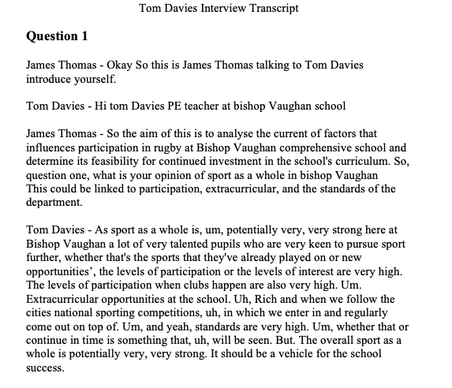
Part 1 – Methodology Interview transcript example. (Question 1).

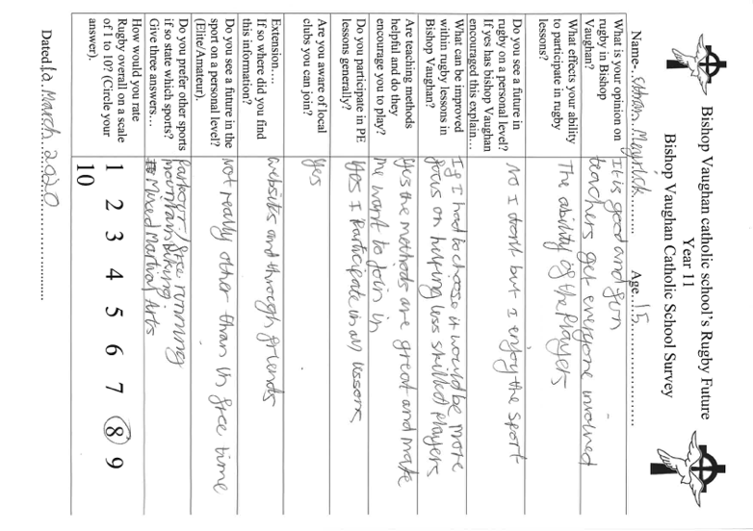
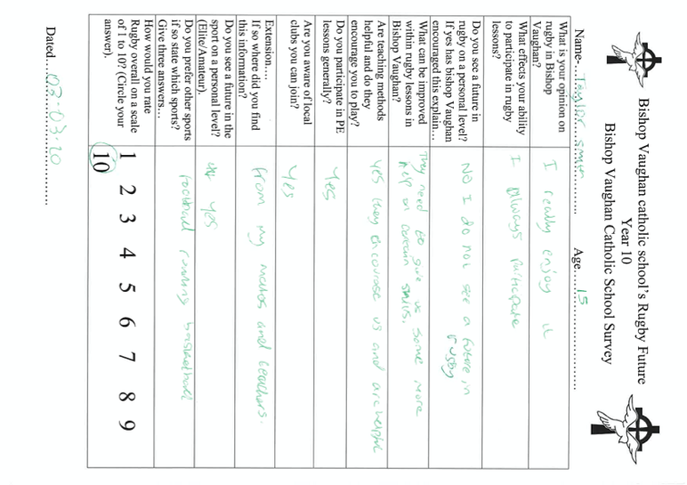
Part 2 – Methodology pupil questionnaire year 9, year 10, year 11.
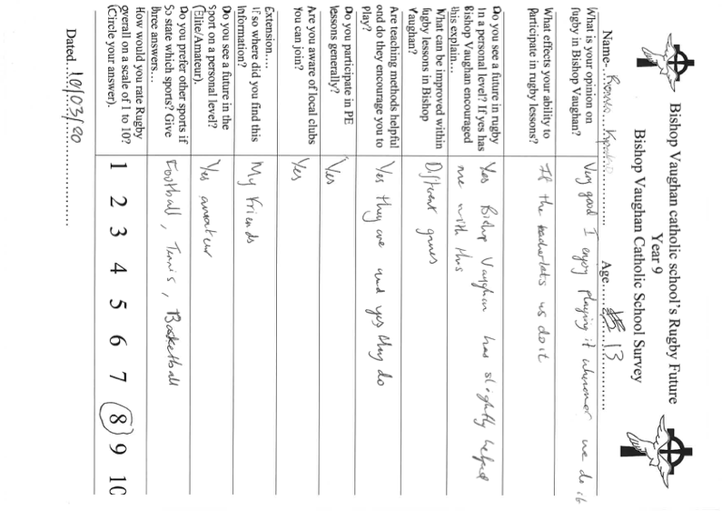

Part 3 – Question 4

Part 4 – Question 8

Part 5 – Question 10

Part 6 – Interview 1 Transcript Tom Davies.
Question 1

James Thomas - Okay So this is James Thomas talking to Tom Davies introduce yourself.

Tom Davies - Hi tom Davies PE teacher at bishop Vaughan school

James Thomas - So the aim of this is to analyse the current of factors that influences participation in rugby at Bishop Vaughan comprehensive school and determine its feasibility for continued investment in the school's curriculum. So, question one, what is your opinion of sport as a whole in bishop Vaughan
This could be linked to participation, extracurricular, and the standards of the department.

Tom Davies - As sport as a whole is, um, potentially very, very strong here at Bishop Vaughan a lot of very talented pupils who are very keen to pursue sport further, whether that's the sports that they've already played on or new opportunities’, the levels of participation or the levels of interest are very high. The levels of participation when clubs happen are also very high. Um. Extracurricular opportunities at the school. Uh, Rich and when we follow the cities national sporting competitions, uh, in which we enter in and regularly come out on top of. Um, and yeah, standards are very high. Um, whether that or continue in time is something that, uh, will be seen. But. The overall sport as a whole is potentially very, very strong. It should be a vehicle for the school success.

Question 2

James Thomas - This is a question two What is your opinion on rugby, this could be linked again to participation, enthusiasm on the overall perspective? In your opinion?

Tom Davies - Rugby is a new sport to most of our pupils who arrive here without any knowledge of the game. Um, very few of our pupils coming from East Swansea have actually played rugby before, whether it's a primary school, um, or certainly not at, at club level. Um, and as a result of that, with experience being so limited. Um, it starts off quite slow. Uh, however the pupils soon buy into it and, and very, very quickly. They get to really enjoy it. We've currently got 24 members of our year, seven, uh, cohort in our rugby squad. We play in quite fairly regular. And as yet throughout this season, I've only been beaten once in I think 12 fixtures, which shows the potential we have despite the serious lack of experience.

Tom Davies Extension - And it's really real enthusiasm for the game. Um, and your overall perspective is, is the fact that it's very strong and once again, should be. Used more so than other sports because it's, it's different than it makes the kids see, see sport in a different light. Um, it brings to them different values and what they've experienced at club football and with various other, uh, activities that they've done and those values that are fundamental in rugby, um, or enhance it in inheriting in society where what our kids need to grasp some of that and experience that.

Question 3

James Thomas - This is question three. Do you see a future for the sport in Bishop Vaughan, this could be linked to the curriculum or changes and also the Donaldson report?

Tom Davies - Yeah, I can genuinely see a massive future for the sport rugby Bishop Vaughan. I think even though that Donaldson is very much going down the route of health from well-being, which I fully agree with and I fully support at the same time. At the same time, there's, um, there's a lot of the branches with Donaldson that require many of the characteristics that rugby can bring about. So, for example, um. Overcoming fears and overcoming challenges. And these types of things can be directly linked with many of the aspects and skills that we learned through rugby.

Tom Davies Extension - Um, so instead of base in our lessons success rate on how many pupils can make a tackle in rugby, we should be based in a success rate of a lesson by how many pupils have overcome the fear. And can now learn to do the right technique of some sort. In a rugby environment, whether that's at full contact or not is totally irrelevant. You've got pupils who understand the skill, how to carry out the scale, how to teach the skill to their peers, and due to that understanding of the game, they've overcome an element of fear or overcome a challenge within their own mindset, uh, within the game of rugby or via the game of rugby, I should say. So, I definitely see a future for the sport of rugby, uh, in Bishop Vaughn. Um, and, uh, it's through the curriculum and hopefully with extracurricular as well.

Question 4

James Thomas -This is question four. What is your background in rugby? This could be personal preference on the sport as well.

Tom Davies - Um, my background is that I was brought up via rugby family and the rugby club, and I grew up. Playing a lot of sports as a youngster, played county and at a district level, um, of many different age groups before I played Swan, um, football for Swansea city and went on to get representative honours and international owners in football. Uh, however, I think the rugby. The game of rugby sort of called me back. Um, and the reason for that was the attitudes and family values that the rugby club brings. I didn't want to be part of the football culture anymore, and that was very much why I still support the game of rugby. And that's very much why I promote it so much through schools.

Tom Davies Extension - Um, and through the job to the kids that we have. Your Bishop Vaughan, who, unlike me as a child, didn't get to experience that or haven't yet experienced it. Um. I see the value in what they would get out of it. So that's my rugby background. I still play to this day for like our lougher RFC. Um, and again, it's the values that are behind the game, that are the things that I want to promote, not only for myself and for my family and for my children, but for the pupils that I teach here at bishop Vaughan here as well.

Question 5

James Thomas - This is question five. What can be improved in the Bishop Vaughan to prevent a short future for the sport? This can be in your on, opinion and if you could give examples.

Tom Davies - The thing that must be improved in Bishop Vaughn to rent a short future of the sport is experienced staff members be more involved in sport. Having more of an enthusiastic approach with pupils in lessons, making sure that we always reinforce the basic skills in lessons rather than falling into the trap of. Games, lessons be in, just have a game where many kids feel left out and isolated. Um, what needs to be improved then is, uh, further staff from outside of the department. Also buy into the rugby culture and opportunities that we can offer. Our Kids. And there's very, very little support you have for extracurricular activities. And as a result, when it's left on one person's shoulders, it can often fall short of what we should be achieving and what we should be offering our pupils.

Tom Davies extension - Um, so for Bishop Vaughn rugby to, to carry on and have a bright future, these things have to be addressed. And they were staff involvement and extracurricular provision and more provision being offered to pupils. More of a focus within lessons on basic skills, um, and overcoming challenges even on the new curriculum. Um, and if those things can happen, then I'm sure that there will be a bright future. Uh, however, if they don't happen, uh, and with members of staff who are quite reluctant to get involved, then I have no doubt that the sport of rugby and Bishop Warren will completely disappear.

Question 6

James Thomas - This is, um, question six for the people's, enjoy the sports more. If so, what ones,

Tom Davies - uh, pupils obviously come to old school being very experienced in football in particular. Um, and although they claim to enjoy football more when they realize how good the sport rugby is, how good the sport of basketball is, how good gymnastics can be in our environment. The pupils love everything that we do here. Um, and this is seen in rugby lessons, in basketball lessons where the kids are genuinely happy to learn new skills and play new games, whereas when they fall back into the trap of their football lessons carrying on their, from their attitude, from their clubs at home, and they bring that attitude towards lessons.

Tom Davies Extension - Um. And they soon realize that when they're 20 minutes or half an hour into a lesson, elements of frustration creep in, elements of blame creep creeps in with certain individuals. Arguments can happen within lessons, and this for me, shows the pupils claim to enjoy football more, but they actually love everything that we offer here, whether it's basketball, gymnastics, fitness, cricket, athletics, rugby. Um, and within six months, seven months of being here in year seven, we often get a lot of pupils who've made the switch and crossover to, to those other sports. And they do realize that they enjoy them even more than football.

Question 7

James Thomas - This is question seven. In your professional opinion, does the curriculum involve rugby enough? Is it being pushed out of it?

Tom Davies - Um, I think at the moment we're holding onto it and there's a fair amount of rugby on our curriculum. Uh, however, um, it could easily be pushed out by inexperienced staff members who are reluctant to want to teach it correctly and reluctant to want to encourage the boys to do more extracurricular.

Um, the staff may see more of. More value out of pushing other sports that they feel more comfortable in teaching. Uh, and this isn't a, a good thing for the school. Um, and that is my professional opinion. Um, I don't yet think it's being pushed out, but then there is risk of it.

Question 8

James Thomas This is question eight, is participation in all areas of physical education a key aspect towards sport involvement?

Tom Davies - Uh, absolutely. Participation is everything, obviously, that we want to strive for in all of our physical education lessons. Uh, and being it from the top end, most talented pupils, all the way to the least talent that we want them all to participate.

We want them all to learn more, to have fun. Um, however, um. Participation at the top end has had a massive impact here in Bishop Vaughan with our pupils being able to climb the performance pyramid. Um, and there are two or three examples of the fact that we currently have two boys in the ospreys under 16’s squad who hadn't played any rugby before arriving here at Bishop Vaughan.

Tom Davies - One of whom only started playing in your eight, and you only started playing club rugby and under sixteens, and he's already fast tracked into the off ospreys under sixteens. Um, and that goes to show the amount of talent that we have here at Bishop Vaughan and depending on the member of staff who might be the, the direct link for that pupil is very much based on the enthusiasm that member of staff can give an amount of encouragement that member of staff can give to that pupil to push them on.

Question 9

James Thomas - So this question nine how invested is, how invested in the school on sport compared to other topics? Do they see sports in this case as a priority state? Yes or no and expand,

Tom Davies - to be fair of our senior management team are very supportive of sport. They're very encouraging of pupils who want to take part. They're very encouraging of staff who wants to take extracurricular provision. Um, however, as just a pure, purely and simply a lack of staff who are willing to do this. Um. I don't think sport is seen as a priority. However, senior management are aware that many of our pupils want to achieve in the classroom and anywhere near the standards that they are capable of achieving on the sports field. And as a result of that, senior management are very supportive. It's a cry in shame that there are very, very few teachers in this school who are willing to see it the same way and get involved and encourage people the same way

Question 10

James Thomas - This is a question 10 what are your methods for getting kids more involved in rugby within the school?

Toma Davies - Uh, uh, methods for getting kids more involved in the same methods for getting anything, any results from pupils. First of all, to develop a repour with the pupils, develop good working relationships and to encourage them to do the best they can within lessons.

And Continually setting a high standard in lessons. Um, that way they can be more involved in rugby, whether they. They're talented or not is irrelevant. They can be part of our rugby squads. Um, and that's one thing that I've always tried to strive for is just purely encouraging any kid to be fully involved in it.

Um, my methods then for getting more kids involved is once I've got them in the door, is to offer regular training sessions. So, we've trained once a week, every week, uh, since September. With regular fixtures. So, we're backing up what we've done in lessons with further extracurricular, um, training, and then what the kids like to do most of all, which is to compete, then actually represent the school, backing it up again with further fixtures.

And as I said earlier on, we've lost only one out of the 13 fixtures so far this year with a very, an experienced your seven sites. So of course, to show what we can do here and how the methods that I use do work. Um. Furthermore, then what I'll do is I'll invite Osprey's rugby community coaches in the school and try to work within local community clubs to direct their kids there.

Um, we currently have three year, seven pupils who've just started within the last month, one for South Gower, rugby club, and two for Morrison rugby club. Um, so it shows that there is going to be a success there. Um, so I do find this though my methods do work to get more involved. Uh, and I hope that this can continue in Bishop Vaughan.

Question 11

Question 11 did you have any knowledge of community clubs and also do you encourage involvement? Can you give me examples of success stories? Yeah. I have quite a strong knowledge of the community clubs in our local area. After being part of one myself. Um, I've also gone out and made many links within the community clubs as Penn land and more Austin, a pawn of Maine, which would be our liras clubs as a school.

Um, I made links with the junior sections there, who the junior secretaries are, and then get in the contact numbers and cards of the junior coaches from each of those teams to try and encourage our pupils to go there. So when I talk to a kid about getting in touch with the club or when the train, I can actually give them a contact number with the train training days on times on that.

And the people can take that home and give it to their parents and, and what will come of that will come to that. But. That's my level of knowledge within the community. Uh, and that's what we tried to do. Um, we've had many examples of success stories via this. Um, a lot of our year 11 boys started rugby quite late.

Um, it didn't start until your rate or your nine, but many of them have gone on to play for the community clubs. When I started in the school, there was four of our current year, 11 rugby squad playing club rugby, and now there's 18. Uh, and for Bishop Vaughn to have 18 rugby club play has, is a massive success.

Uh, and as mentioned earlier on two of those and are involved in the ospreys and the 16 set that as well, which goes to show that there is a great amount of talent here that needs to be nurtured and it needs to be pushed and encouraged.

Question 12

James Thomas - So this is question 11. Do you think teachers are doing enough from the school? This could be helping out with teams pushing their own personal experience onto the pupils, if not state. Why and what can be done in your opinion to improve this?

Tom Davies - A simple answer for the question the teachers doing enough is no.
Um, there's far few. Um, far too few teachers who are willing to help out. Um, despite the fact that we've got many very experienced rugby players as teachers in the school, um, who play, we've played in the past for many. Different, many different, uh, community clubs. Um, and it's a real shame that they don't push their own personal experience towards the pupils and see the benefits of what they could offer. Um, what has to be done to overcome this is that there has to be more support, uh, and more encouragement for these teachers to get involved. Um, and if they do, they're going to have a great impact on the school overall. Um, one example of the fact that we haven't got enough teachers helping out is the fact that I currently attend cohort, have no rugby team, despite the fact that it is a lot of interest for boys who want to play.

Tom Davies Extension - Um, the impact this is going to have on those boys is that they creep into the old habits of football only culture. This affects their behaviour around the school, their rapport and their relationships with their teachers do to bring it in their football culture rather than learning to be a more rounded individual from playing different sports. It also affects their overall GCSE physical education marks by not having as much experience of play in rugby, despite the fact that that rugby is going to be one of their marked activities for GCSE, uh, overall Mark, which is vast, which greatly going to affect the amount of. A star to C that we get, because we're talking about kids drop in marks for up to drop it up to 10 marks purely on one activity for their overall grade.

Tom Davies Extension - Um, teachers should be doing far more. We're here to help pupils, we encourage Pupils to try new things, and that doesn't happen enough. Um, for it to happen, as I said earlier, there needs to be more encouragement. It needs to be more involvement. It needs to be more of a. A link to the benefits that we actually bring these kids. And if a teacher, in my experience does it once and realizes how just how positive an environment take in an extracurricular rugby team can be and how much the boys love it, I think they will continue to do it. Um, but sadly that just isn't the case and teachers are very unwilling to get involved.

Question 13

James Thomas - This is a question four, what do you think I will gain from this research project. Based on year 9, 10, 11. Is it going to be positive or negative? Give your opinion.

Tom Davies - Um, yeah. I think the overall results would be extremely positive for you as a person. Um, not just because of the topic you've tried to research, but because of your involvement and how, uh, how much you got involved with school rugby in your placement here, how much, how much willingness you had to be involved in the extracurricular side of things.

Tom Davies extension - Um, how much you realize and learned from. First-hand unexperienced, the, the richness and the added value that it can bring to many pupils. The actual research itself, I'm sure it is going to give you find many positive results because you will see. Um, a vast improvement in pupils’ attitudes, outcomes, um, and results for those pupils who fully immersed themselves in rugby culture, and you'll also see first-hand the negative connotations that it's had on. For example, our year 10 cohort who just simply haven't had the time and the provision given to them. So the fact that our rugby program in Bishop Vaughan has many negatives and many positive stories, the ultimate, the ultimate results of this investigation are no doubt going to be extremely positive for you in the future going forward as a teacher because it will give you the knowledge and awareness of those extra values and those added things that we can give to kids that they simply don't get from any other area of the curriculum.

End of interview - So ultimately, I think you'll gain a great deal from, from research in this topic.

Figure 1-A breakdown of the physical education key stages in wales.
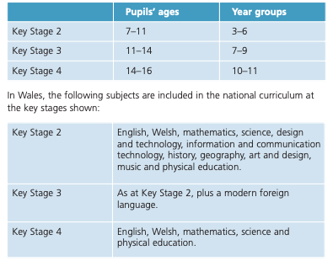

Figure 2- Allyson Pollock letter

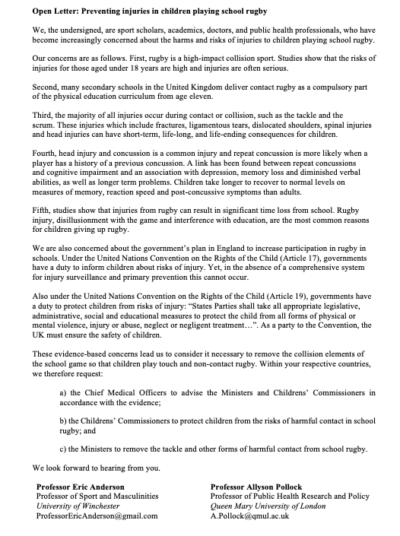

Figure 3- Average number of minutes per week for curriculum PE
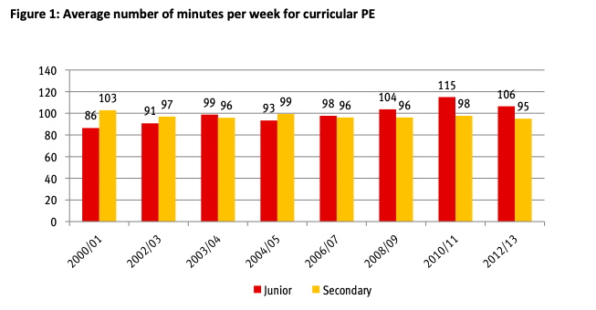
Sports wales

Figure 4- Physical education a core subject in the curriculum.
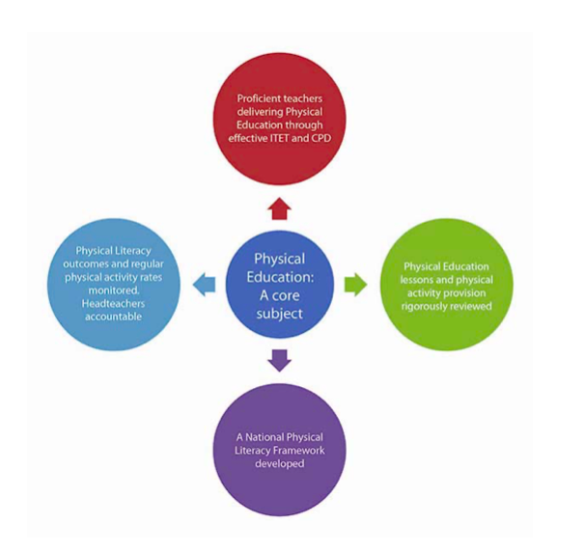

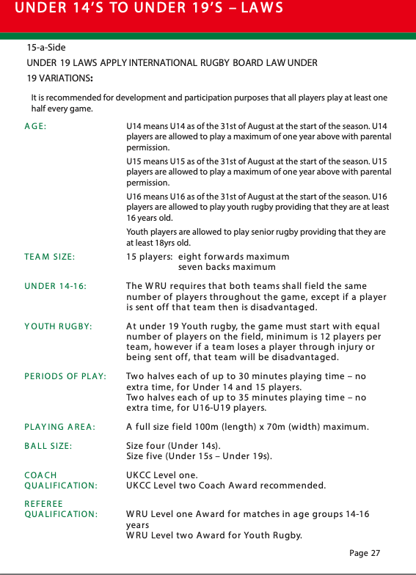
Figure 5- WRU Rugby Pathway.

Figure 6- The Donaldson report principles.
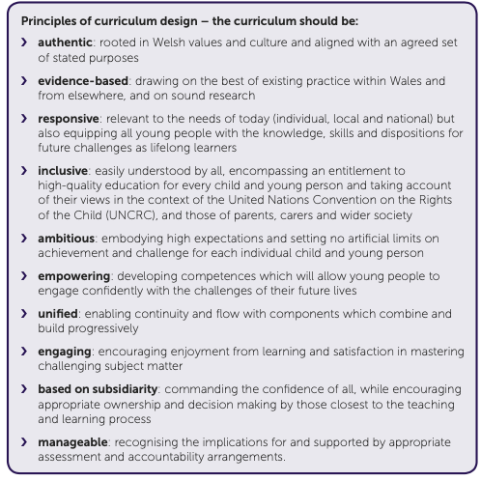

Figure 7- The purposes of the Donaldson report within the curriculum.
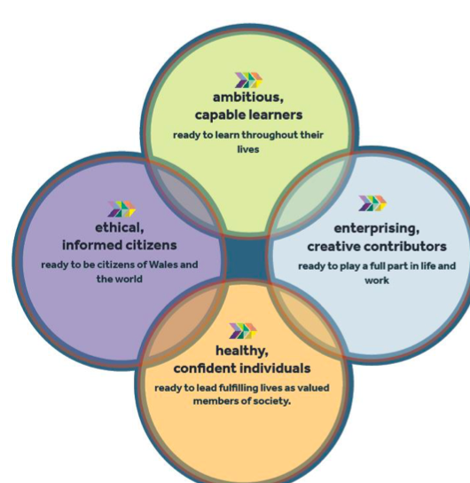

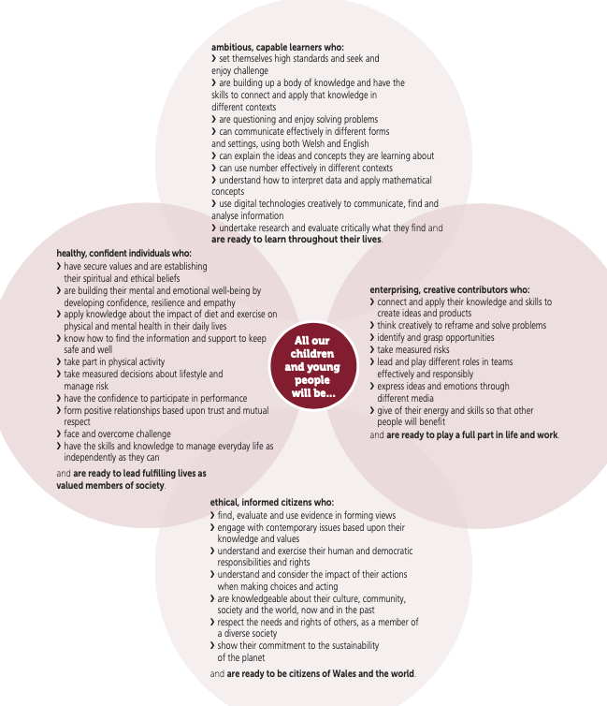

Chapter 9 Ethics Form
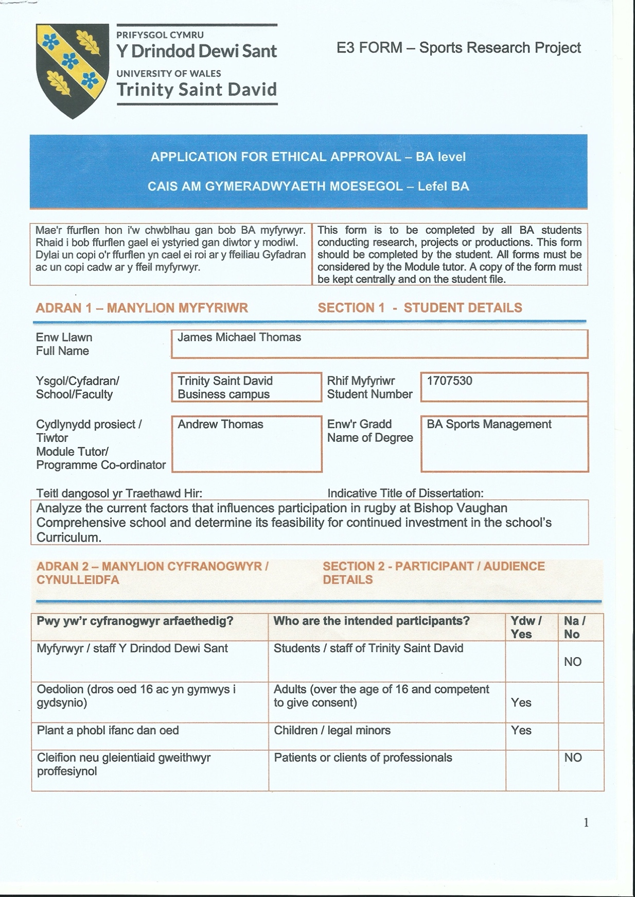

Insert Ethics Form P2 into the table below

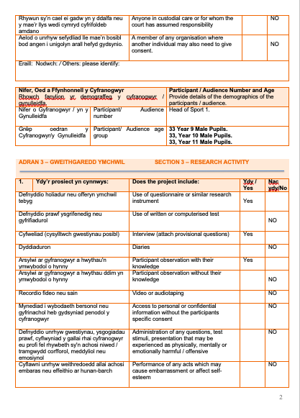

Insert Ethics Form P3 into the table below

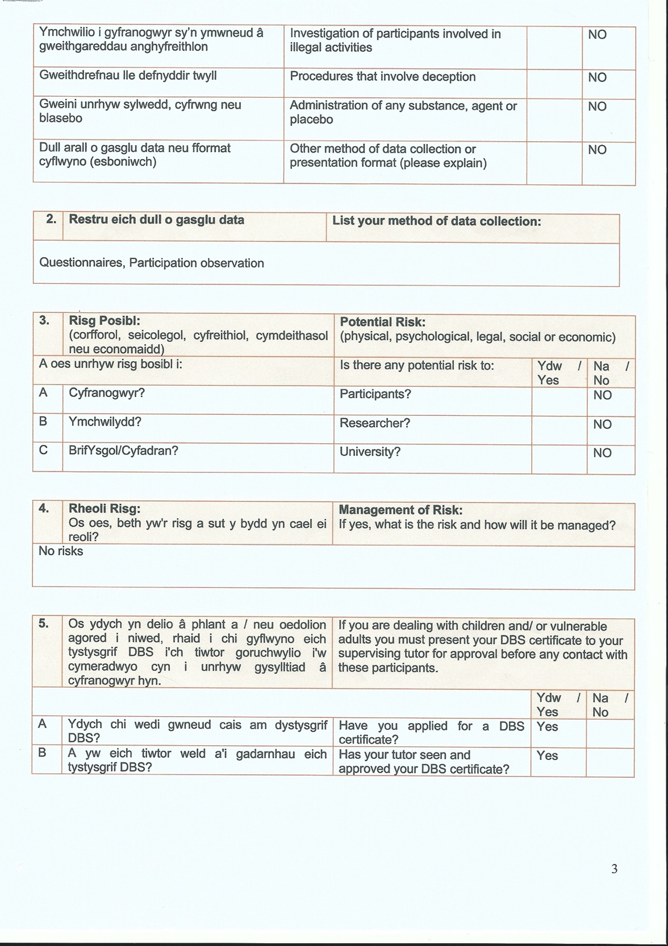

Insert Ethics Form P4 into the table below

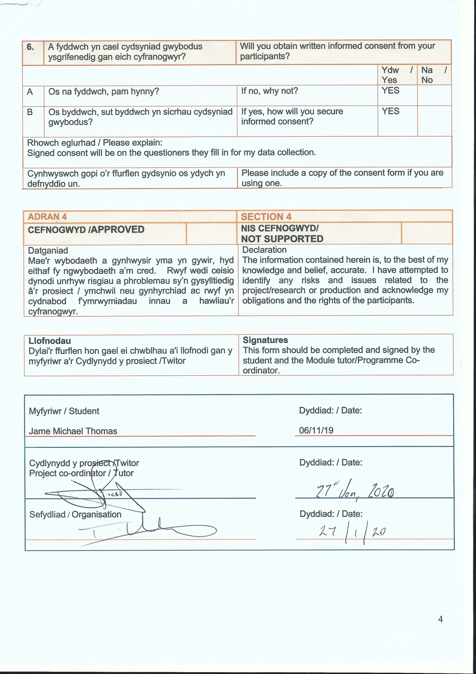

Insert Ethics Form P5 into the table below

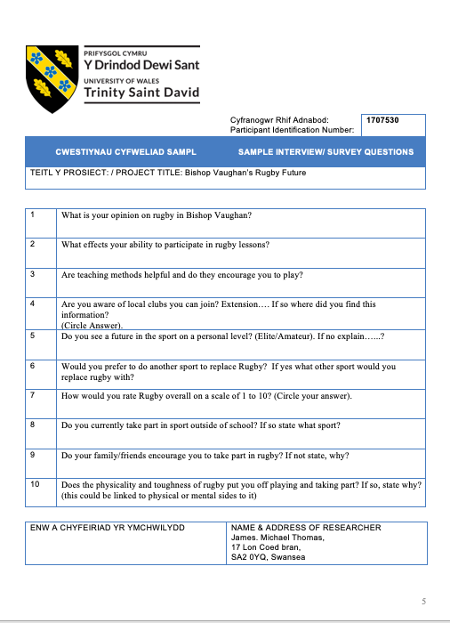

Insert Ethics Form P6 into the table below

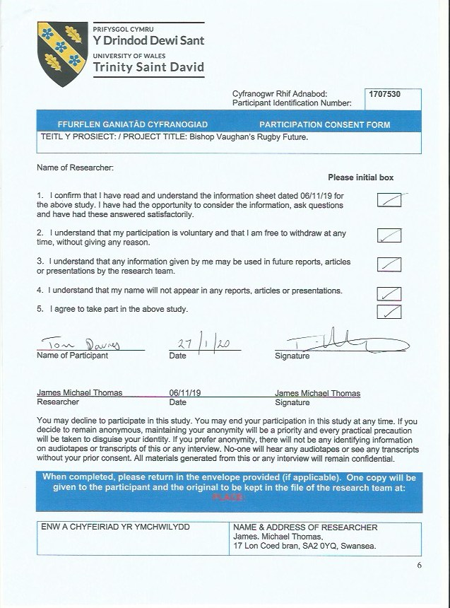

Insert Ethics Form P7 into the table below

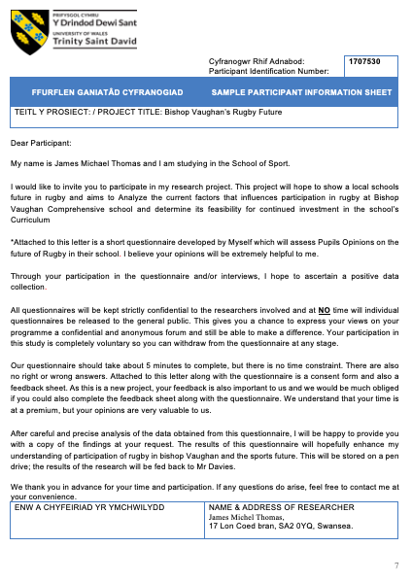

Insert Ethics Form P8 into the table below
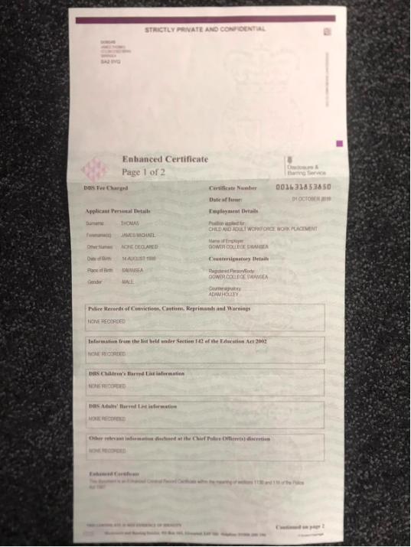

Insert Ethics Form P9 into the table below

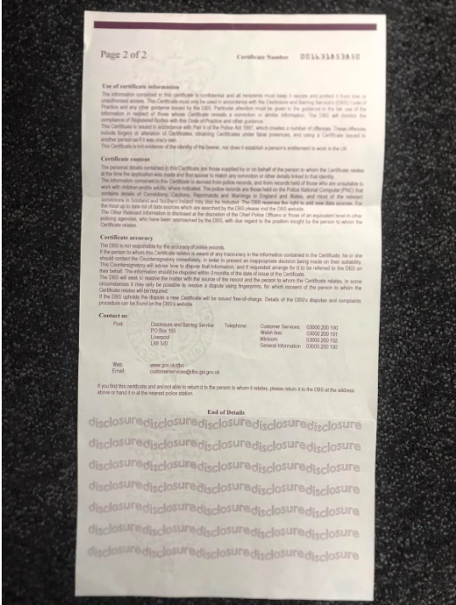

Submission Evidence

Faculty Office (1 x Paper Copy, Bind Professionally)
+
Online Turnitin Submission (prior to Deadline)



BA Sports Management Portfolio

Research Project
Report

UWTSDSport

