Ash Harris
2501186
BA illustration
Chris Harrendence
How does one's background affect they're artwork?
There are a multitude of factors that go into an artist's work and that includes their background and up bringing, the way that someone was raised can tell you a lot about them and artists are no different especially with how personal art can be to an individual, it is said to be an emotional outlet for many so from technique to the subject matter of the piece itself and the story behind it can be shaped by the artist and the life they have lived and their beliefs. On the flip side you could look at an artist work and at first glance see little to no influence from their past come into their work, there is also outside influences artist can take from. It varies from artist to artist, but I truly want to explore how an artist sees the world and how each piece of art is a gateway for the viewer and how each artist gets their views and ideals across.
Frida Kahlo was a Mexican painter that was born in 1907, died 1954. her work often explored themes of identity, the human body and death with her work clearly showing the viewer a lot about her and how she views the world and the different facets of herself. Her style is very psychedelic, with uncanny landscapes, sharp colours and even sharper faces, making for a memorable body of work that doesn't leave your mind once you're done looking at it, it could be said that her turbulent life made for good artistic inspiration.
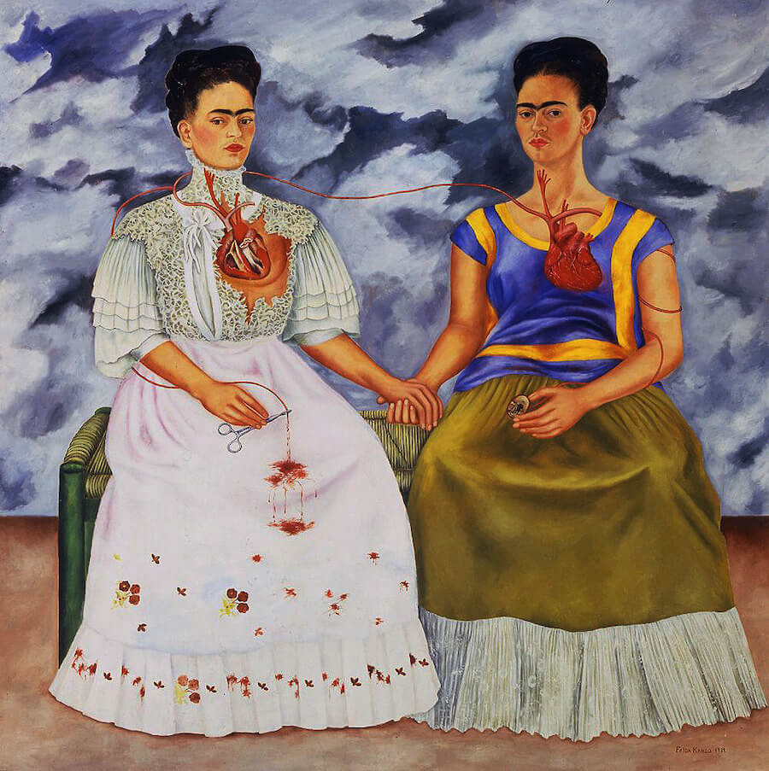 A good example of a piece that shows Fridas exploration of her identity is a piece called “The two Fridas” it is one of Frida Kahlo's more notable works and it depicts two versions of Frida, each in different clothing one with more traditional clothing and the other with more Mexican style clothing, it clearly conveys the theme of identity and Fridas own struggles with her heritage as a way to express her desperation and loneliness, with her separation from her husband, another famous Mexican painter, Diego Rivera, happening not to long before the piece was finished. Being born from a “father with Hungarian descent and a Mexican mother of Spanish and Native American descent” (Britannica, Alicia Zelazko, 2026) the piece clearly shows the viewer that she clearly favours her Mexican descent, with her more traditional, German descent bleeding out and with the dress torn to reveal the heart.
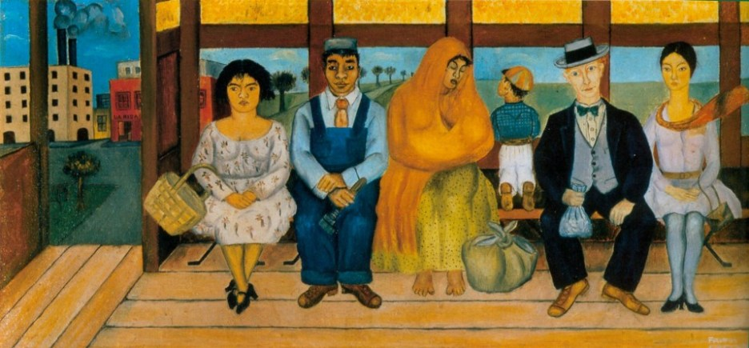
Frida also struggled with a lot of medical issues throughout her life; she suffered from polio in her early life and later in life was in a bus accident, her spine was practically shattered from where a handrail impaled her, in her words ”Handrail pierced me the way a sword pierces a bull” (Lisa's history room, Julian Levy, 2009) and her collar bone was broken along with her pelvis, along with her ribs and her leg being fractured in eleven places as well has her foot also being shattered, the doctors were not sure that she would survive but she fortunately pulled through. It was while she was hospitalised that Frida truly began to paint and started the journey of being the artist that she became. Her work was also classified as surrealism and was well like by a notable surrealist artist André Benton, but she never claimed her artwork was surrealist and actively resisted the notion” I never painted dreams, I painted my own reality” (Mexican autobiography,1953) she was very in tune with herself and was always exploring and expressing herself through her artwork, even despite what she went through.

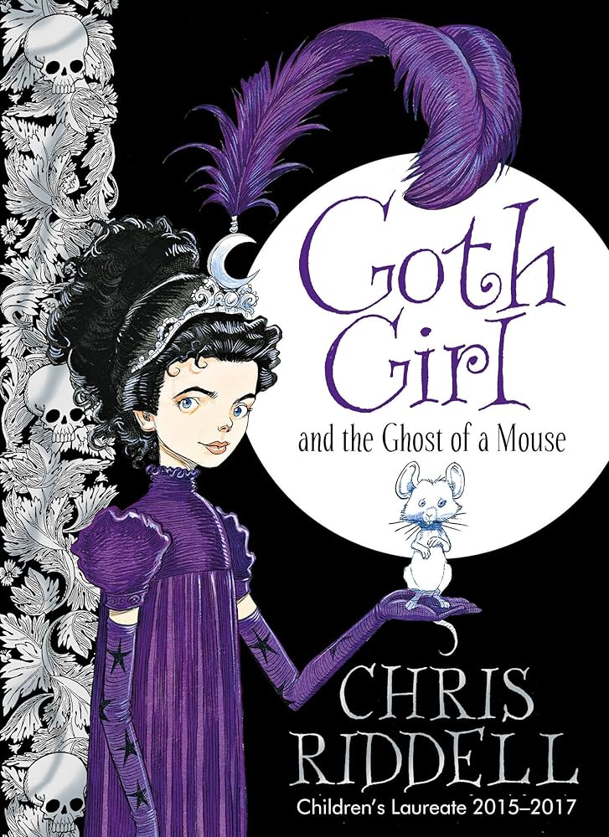
Chris Riddell is a very famous book illustrator and writer; he was born in 1962 and is still an active illustrator to this day, he was born in South Africa with him and his family moving to England when he was just a baby and being raised there. He graduated from “Brighton polytechnic art school with an honour's degree in illustration” (the guardian, cartoons by Chris Riddell, 1996) and went on to win quite a few awards for his work, like his self-authored work Goth girl and was named “Britains new children's laureate” (Reuters, Simon Falush, 2015)
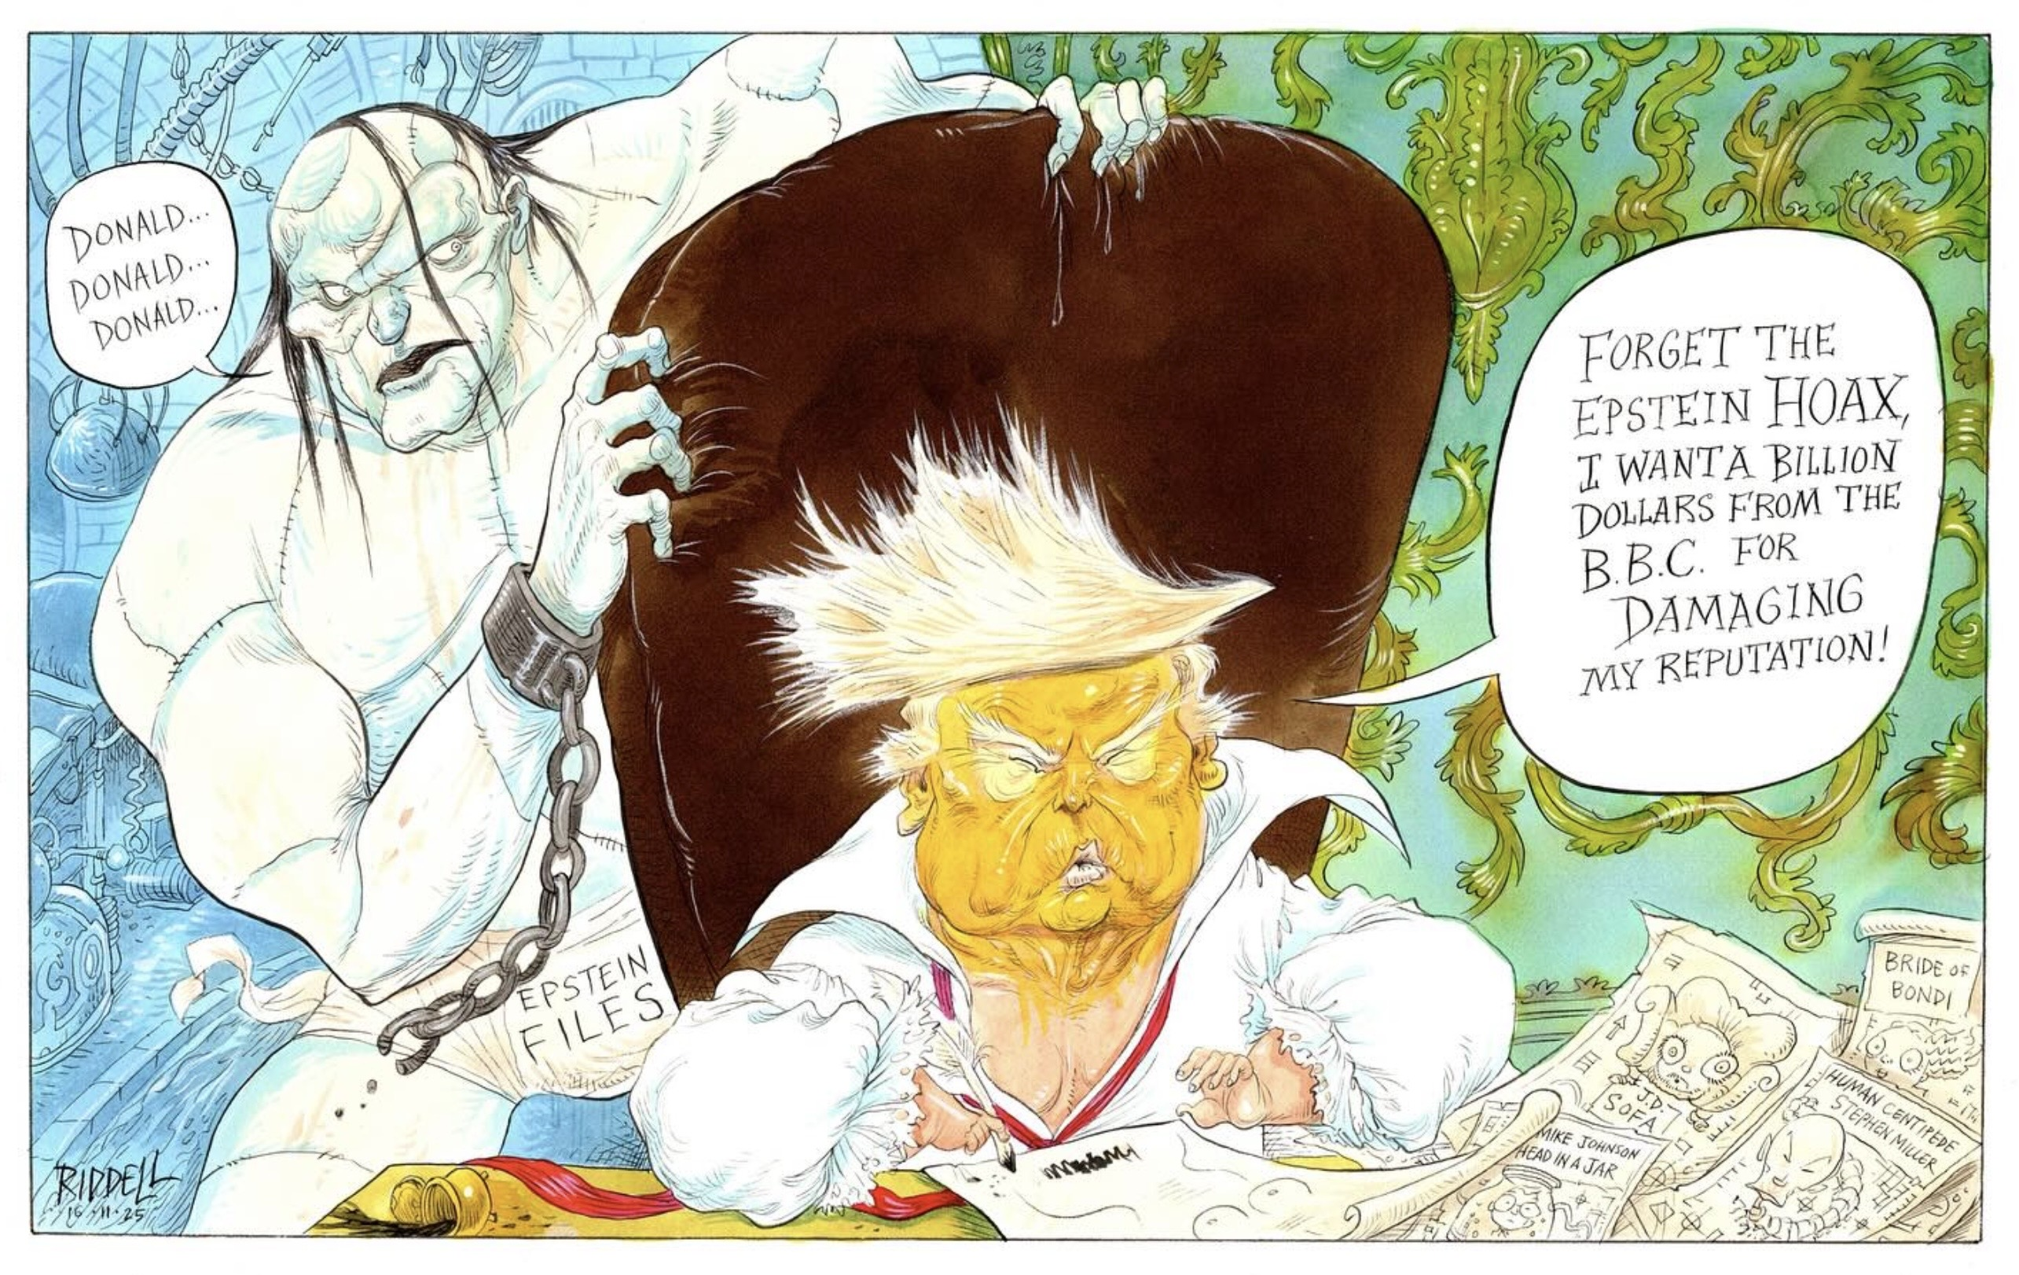
His work really has a sense of whimsy yet is quite odd with one of his inspirations being John Tenniel's original illustrations for Alice in wonderland, which has the same fairytale like tone yet it is somewhat macabre in a way, a sense of wackiness and fun. He also takes inspiration from E.H Shepards art from the Winnie the Pooh books and overall takes inspiration from 18th century illustration.
Not only does did the man write and illustrate children's books, but he also drew political cartoons, in 1990 to 1991 he worked at the observer drawing for “the personal finance page” (University of Kent, British cartoon archive) both of his parents were political activists and were fighting against racial segregation (Books for keeps, autograph no.148: Chris Riddell, 2004) and has still been drawing political illustrations even in the present day with the more recent work dated up to 2025. Making caricatures of infamous political figures and using his art to poke fun at and shed light on the state of the world through the years. He clearly cares about the world we live in, the future generations and specifically the future generation of artists and the arts as a whole.
James Jean is a Taiwanese American artist, born in 1979, he studied illustration “at the school of visual arts” (Sessions college, Taylor Slattery, 2020) and is known for a multitude of works like his large-scale sweeping paintings, comic book work and film posters. His work is very clearly inspired but traditional Chinese art and Japanese woodblock print with a flowing, organic look his attention to detail is unmatched with his use of acrylic paint and colour creating “a liminal space, straddling the line between something human and something other" (Medium, La Vela Antonio, 2024)
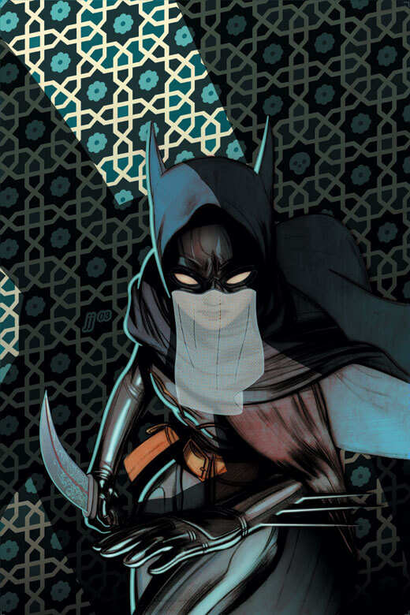 He ended up working at DC comics and “is best known for the batgirl and Fables comics” (Thunder chunky, Jon Raffe, James Jean, 2005) he also drew covers for green lantern and the justice league. Most of his work is coloured on computer with the use hand painted textures that are scanned in along the way, his comic book work obviously fits right in with the rest of DCs catalogue and it shows more than anything his adaptability and can successfully make artwork for a lot of different mediums while also staying true to his overall style.
He has also won quite a few awards for his artwork, most predominantly the “world fantasy award- for fantasy works” (Sfadb, Mark R. Kelly, 2012) in 2006. His work is very detailed, and you will always find something new that will catch your eye in each piece, he also adds lots of little recurring motifs in his work” from butterflies to frogs to the droplets of dew” (Booooooom, Jeff Hamada, 2024). He has also done film posters, with the most notable being the 2017 horror/mystery film” mother!”, it is basically about Mother Nature, the wreckage of the planet and religious history, the whole piece has an ethereal feel to it and with the plants around her looking like a 18th century painting While she tenderly holds her own heart in her hands, the juxtaposition is off putting and unsettling but it conveys the film well and tells you all of its themes and tone without any words.

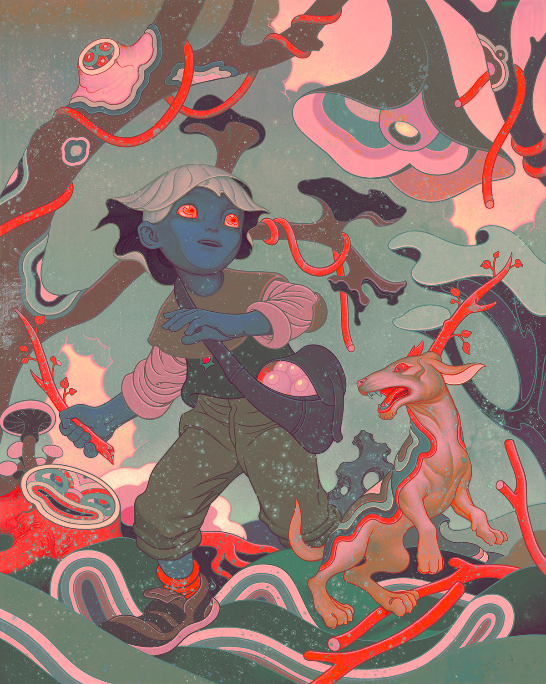
He also had an exhibition quite recently with the focus being on “the intricate dynamics between heritage, cultural identity, and personal experience” (Booooooom, Jeff Hamada, 2024) according to Jean he didn't go into the art with the theme in mind, letting the themes and messages to flow naturally. He also uses his own son as an inspiration for his work, some of the figures in his artwork being recognised as his son, as well as his wife being an inspiration for a project for Prada “trembled blossoms” which was an illustration turned animation project to advertise Prada's spring/summer collection in 2008, with the contrast between the white nymph like character contrasting the colour of the abstract flora making a vivid and memorable image.
In conclusion each artist has not only reasons for their style, medium and subject matter but also, the way they go about making their work and the process of it. The journey is half the battle when it comes to art and a person's personal experience and background can shape the outcome of an individual's artwork and it's good to find out about an artist's background to give you more insight into not only their lives but also their artwork and can even open up new avenues of inspiration if you are an artist yourself, there are lots of things in the world you can take for inspiration and finding these artists and with their own inspirations can open up one's eyes to new perspectives and methods.
Bibliography:
(Britannica, Alicia Zelazko, 2026)
(Lisa's history room, Julian Levi, 2009)
(Mexican autobiography, 1953)
(The guardian, cartoons by Chris Riddell, 1996)
(Reuters, Simon Falush, 2015)
(University of Kent, British cartoon archive)
(Books for keeps, autograph no.148: Chris Riddell, 2004)
(Sessions collage, Taylor Slattery, 2020)
(Medium, La Vela Antonio, 2024)
(Thunder chunky, Jon Raffe, James Jean, 2005)
(Sfadb, Mark R. Kelly, 2012)
(Booooooom, Jeff Hamada, 2024)

Reference list:
(Amnesty international, 2015)
(Britannia, Alicia Zelazko, 2026)
(Booooooom, Jeff Hamada, 2024)
(Books for Keep, autographed no. 148: Chris Riddell, 2004)
(Book Trust, 2015)
(Christie's, collecting Japanese woodblock prints, 2024)
(Forward, Jay Michaelson, 2017)
(Fida worldwide, 2018)
(Lisa's history room, Julian Levi, 2009)
(Motionographer, Justin Cone, 2008)
(Medium, La Vela Antonio, 2024)
(Mexican autobiography, 1953)
(Reuters, Simon Falush, 2015)
(Sfadb, Mark R. Kelly, 2012)
(The guardian, cartoons by Chris Riddell, 1996)
(Thunder chunky, Jon Raffe, James Jean, 2005)
(University of Kent, British cartoon archive)
(Vanity fair, Simon Abrams, 2017)
(V&A, Frida Kahlo: making herself up, 2024)

