

Module: Data Security, Governance and Compliance

Assignment Title：Apply the principles and practices
of Data security, Governance and
Compliance based on a given scenario

Student name： Zhiqiang Geng

Student ID number: 2200520

Abstract
This paper designs a set of solutions to the data security problem of CoffeeBlend Company. It mainly protects the company's data security and information security from two aspects. The first is personal information security protection, including employees and users. For individual users, relevant solutions have been deployed in terms of transmission process, hardware protection, service isolation and device monitoring; at the same time, for employees, employees need higher-level data Security protection, because it is related to the information security of all customers, so the device partition and high-level encryption protection are used. The second is the relevant protection of the company's intellectual property rights, mainly in three aspects: confidentiality, search and infringement litigation.

Keywords: data security; personal information security protection; intellectual property security
catalog
Abstract 1
1 Program requirements and research hypotheses 4
1.1 Problem background and program requirements 4
1.2 propose a hypothesis 4
2 Overall design 5
2.1 Firewall 5
2.2 Personal Safety Protection 5
2.3 Safety protection against company intellectual property rights 5
3 Personal Information Security Protection 7
3.1 Information Security for Customers 7
3.1.1 File server is isolated from client 7
3.1.2 Automatic Encryption and Decryption of Files 7
3.1.3 Monitor user client operations 8
3.1.4 Mobile Device Interface Protection 8
3.2 Information security for employees 9
3.2.1 Employees need to partition devices 9
3.2.2 Employee data encryption and decryption 10
3.3 payment security 11
4 Security protection for the company's intellectual property 12
4.1 Confidentiality and encryption of intellectual property 12
4.2 Monitor the product patents of other related manufacturers 13
5 Conclusion 14
References 15

1 Program requirements and research hypotheses
This part repeats the problems of CoffeeBlend, and puts forward the problems faced by the company in terms of data security, and at the same time lists the requirements put forward by the company in terms of data and information security; in addition, puts forward a number of assumptions to facilitate the solution design and implementation.

Problem background and program requirements
Because of its growing workforce and customer base, CoffeeBlend continues to have a data and information security maintenance system to protect the data security and legitimate rights and interests of its employees, customers, and companies. After analysis, you can see that the background of the problem and the problems to be solved are as follows:
- 95% of the company's network is wireless network based.
- Protect the data security of individual employees and customers.
- Protect the intellectual property rights of the company.

propose a hypothesis
- Most employees and users access CoffeeBlend's network/resources through mobile devices and wireless networks, which means that many employees need to work remotely.
- Individual employees can access and modify customer-related data to complete customer service and company tasks without informing customers.
- Customers access the company's network/resources using a company-specific client or mobile app.
- CoffeeBlend's servers are not built locally in the company, but are purchased from companies such as Oracle, which greatly increases the security of the company's servers.

Overall design

Firewall
First of all, the most important thing is to protect the data security and network security of the company's server, because if hackers and external organizations directly attack the company's server or crack the company's database, then all the company's content will be displayed in front of the hacker without reservation. If this catastrophic situation occurs, then the data security protection work for employees and users will lose its meaning. Therefore, it is very necessary to use a firewall to strictly protect the company's server.
Firewalls usually consist of software firewalls and hardware firewalls. The software firewall is a barrier to network security, and it can help us strengthen network security policies and maintain our data security to a certain extent. But CoffeeBlend's servers are purchased or leased, so at the server software firewall level, companies like Oracle will help you solve most of the firewall security issues.
But in order to further ensure the company's information security, we can also pretend to be a hardware firewall, such as using a hardware firewall produced by CISCO, and use the management center of the hardware firewall to complete the unified management of application control, intrusion prevention, URL filtering and malware defense. Of course, hardware firewalls have functions that cannot be achieved by firewalls. For example, hardware firewalls are based on the mechanism of state detection, and security vendors can develop application-layer filtering rules according to different market needs to meet the control of the intranet. Filtering at a high level achieves many things that software firewalls cannot do. Especially for the popular ARP virus, the hardware firewall has made corresponding strategies according to the principle of its intrusion, completely eliminating the harm of the ARP virus.

2.2 Personal Safety Protection
The security protection for individuals here includes: data security protection for users; information security protection for employees.

2.3 Safety protection against company intellectual property rights
On the one hand, it is to keep confidential and encrypt the company's intellectual property rights; the second is to dynamically monitor the product content of other companies and manufacturers, and to detect infringements in a timely manner; the last aspect is to upload them in a timely manner after infringements are discovered. Go to the intellectual property protection system of the company's background, and then hand it over to the legal department for appeal and rights protection.

Personal Information Security Protection
For employees, data information is protected from two aspects of local storage and network transmission; for customers, in order to protect the privacy and rights of customers, data information is only protected from the level of network transmission.
Among them, permission protection is very important. All private files and data can only be accessed and modified within the network. When accessing private files and data remotely, you need to contact the administrator to operate, so based on remote access permissions: for customers, provide short-term permissions ; Long-term permissions can be provided for employees.

Information Security for Customers

3.1.1 File server is isolated from client
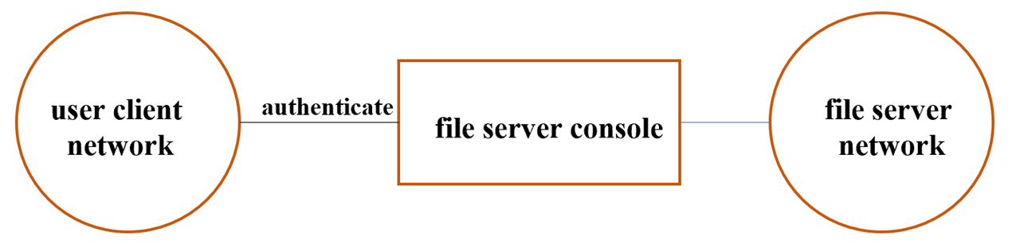
The file server that stores files should be isolated from the user network, and ordinary users cannot access the server without authentication. The schematic diagram is shown in Figure 1 below.
Figure 1 Schematic diagram of isolation between file server and client
It can be seen that after the user passes the identity authentication, he can access the file server. Users can download the files on the file server to the local, read and write and other operations. The contents of the file are encrypted during transmission from the file server to the user's client computer. In this way, users are prevented from obtaining file content through network eavesdropping and other means. When the file is downloaded and saved locally, it is automatically encrypted with a key to become ciphertext. When files are accessed locally, they are accessed through dynamic encryption and decryption under the monitoring of the intellectual property protection system.

3.1.2 Automatic Encryption and Decryption of Files
The transparent encryption and decryption technology of files is used in the operating system kernel to realize the transparent encrypted storage of enterprise secret documents. The encrypted files can be circulated normally within the local area network where the individual is located. Once the files are disconnected from the network, they cannot be opened. That is, all personnel in the LAN automatically encrypt files in the background while operating new documents or drawings created by the computer, but the operator is unaware, making it impossible to force the automatic encryption files to leave the PC environment, and the files can only be used normally on any computer inside the LAN where the individual is located. In the LAN environment that separates individuals, files can only be used normally if they are decrypted by administrators and other people. This will tightly restrict some core data in personal computer to the local area network, prevent illegal copying and external distribution between users, prevent leakage of confidential electronic information within the unit and secondary dissemination of electronic documents, effectively ensure the security of core data.

3.1.3 Monitor user client operations
The data security system can monitor the clipboard, file copy, and Internet history, and store the log in the server; the data security system can also record the file operation behavior of the client in real time. All of these are enough to act as a deterrent, and can trace the channels of information leakage; make "prevention of leakage, controllable during the event, easy to trace after the event" into practice, and prevent the occurrence of internal leaks. In addition, the data security system will disable functions such as "save file as" and system screenshots to prevent file leaks.
Of course, it is worth mentioning that the monitoring here does not design any privacy of the user, but only monitors the relevant behavior of the user's device when the user accesses the network/resources of CoffeeBlend, and checks whether the user's device is in a situation that the user does not know. related illegal operations.

3.1.4 Mobile Device Interface Protection
Most mobile device providers currently provide users with useful interfaces that they can use to connect external devices such as mobile hard disks, mice, printers, etc. These interfaces provide very convenient functions for people, and at the same time provide a very fast transmission rate. But there are advantages and disadvantages. Because mobile devices open interfaces to the outside world, that is, they open a door to many external devices, which can lead to some hackers having the opportunity to invade mobile devices such as computers and mobile phones through external devices. In addition, with the growing capacity of mobile storage devices, allowing users to store a large amount of data on mobile devices is a real security risk for enterprises, because it may lead to a large number of core data leaks leading to a business crisis. Therefore, it is necessary to control the interface by necessary and reasonable means.
In the existing situation, there are several methods to protect the interface of mobile devices, which can effectively resist illegal intrusion and data theft, so as to ensure the user's data security.
The first method is to disable the interface and set up the motherboard, but it is obvious that these methods are not convenient for individual users, especially for customers.
The second method is to control by some software, some software can identify the device. In order to use the device, it must first be registered with the server, some unregistered devices will not be used, which guarantees the use of mobile devices to a certain extent, but if important files are stored on the device, device accidental loss will still cause losses to the enterprise. Some control software, which is not safe on its own, can be easily ended by users, thus losing its protection.
Clearly, the second method is more appropriate.

Information security for employees
According to the related reports of some information security research institutions, 73.5% of data security and information security accidents were caused by improper operation of related employees in the enterprise itself. These bad practices are often "crimes of downloading spyware or malicious programs, computer viruses in employee calculations, and inappropriate end-to-end document sharing, which result in theft of confidential enterprise information, including unauthorized internal access, theft of patent information, financial deception of internal personnel, etc."
CoffeBlend requires many employees to work remotely, so the problem of information disclosure will become more serious. In summary, it is necessary to design a more rigorous information security system for CoffeBlend's internal staff.

Employees need to partition devices
Employees partition their working computers or other equipment into two areas: working area and non-working area (for example, auxiliary software or entertainment originals are placed in the non-working area).
Then set high-security confidentiality measures for the files in the work area; at the same time set management permissions, you must be in the company's internal network to read the company's resources, and you can also apply for long-term permissions in the external network; every time you access the files in the work area , all need to verify the authority.
Moreover, the files, programs and related users in the non-working area cannot access and modify the files in the working area. This also fundamentally eliminates data and information leakage caused by employees downloading programs at will.

Employee data encryption and decryption
Because I made an assumption before: In order to facilitate the normal work of the employees, the employees are qualified to read the relevant information of the users. Therefore, the operational protection of employees is very important, because once the relevant processing files of employees are stolen, it is likely to cause a large-scale leakage of customer data.
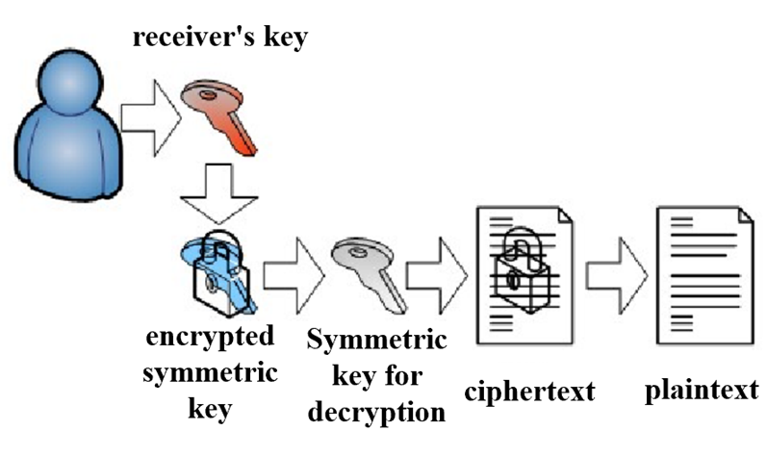
To sum up, encryption of employee data needs to be more aggressive.
Figure 2 Data encryption process for employee operation files
Mainly the following steps: (1) Employee identity login verification. (2) Automatically encrypt and decrypt files. (3) Record the operation behavior in real time and upload the record. (4) Disable system screenshot and file save as operations. (5) Implement client security policies. (6) Administrator user security policy and user rights management. (7) Administrator file decryption.

Payment security: encryption and main program protection
There is no doubt that payment security is the most important link in all security guarantees, because it involves the customer's property security to a large extent. Once any problem occurs in the payment link, it is likely to cause the customer's property loss. Of course It will also seriously affect the interests of the company.
Therefore, in order to protect the user's payment security and property security, the highest level of security protection must be used in the payment link. To sum up, the following scheme can be used.
In this scheme, users and bank servers join an identity-based cryptographic system, and they no longer need identity authentication based on digital certificates, which saves users' money and time costs at the same time. The user goes directly to the bank to open the business and initializes the app provided by the bank. When logging in, the bank uses a highly secure server to accurately verify the user's identity. When paying, the mobile banking APP uses the user's private key to generate a combination of SMS verification code and bank server verification. In this scheme, SMS verification code and digital signature will jointly provide security guarantee for users, thereby ensuring the security of mobile payment.
Second, the main program protection needs to be used to ensure the stability and security of the payment program. Mainly consider from two aspects to ensure the normal operation of the system. First, hide the program, so that it is difficult for users to discover the existence of the program, and there is no way to start. Second, apply the three-thread protection method, put the code to be executed in the main thread, and then generate two auxiliary threads. These three threads supervise and protect each other to ensure the normal operation of the system. When the main thread of the program is terminated, the auxiliary thread will restart the main thread. Also when the auxiliary thread is terminated, the main thread will restart the auxiliary main thread or regenerate a auxiliary thread.

Security protection for the company's intellectual property

Confidentiality and encryption of intellectual property
The confidentiality work here is mainly aimed at relevant insiders of CoffeeBlend. Because the company's relevant intellectual property rights are only accessible to scientific researchers and managers. Therefore, on the one hand, it is necessary to do a good job of confidentiality training for internal personnel, sign a confidentiality agreement in advance, and try to ensure that everyone who has access to intellectual property signs the relevant confidentiality agreement and abides by the confidentiality regulations. On the other hand, researchers need to register the relevant intellectual property rights of CoffeeBlend in a timely manner. For example, the secret coffee recipe that the company has developed for many years needs to be registered with the relevant state departments in a timely manner.
On the other hand, after researchers complete the research and writing of related patents or other intellectual property rights, they need to ensure that they are strictly protected before the patents are issued. At the same time, if there are some exclusive secret-level intellectual property rights, these intellectual property rights need to be strictly protected, and high-level confidentiality and high-level encryption can be performed at the same time.
A common method of data encryption in the intellectual property industry can be used here: separate security servers and security agents. Among them, the security server is mainly responsible for encryption policy configuration, key management and so on. Support master-slave mode. And security agent (TDE extension plug-in): After the deployment is completed, the database service will have the capabilities of data encryption and decryption, enhanced authority control, etc.
For the encryption method, because the file-type database system is based on the file system, encryption outside the library can be used. When using the encryption method outside the library, the data can be encrypted in the memory using DES, RSA, etc., and then The file system writes the encrypted memory data into the database file each time (note that the entire database is treated as an ordinary file, rather than written according to the data relationship), and it can be used normally by decrypting it in reverse when reading it in. . Of course, this encryption method requires us to properly manage the keys.

Monitor the product patents of other related manufacturers
Because in addition to intellectual property rights that cannot be disclosed to the public, such as CoffeeBlend’s secret coffee recipe, there are many intellectual property rights that other manufacturers can imitate and plagiarize. This requires the company to arrange relevant personnel to check whether other manufacturers’ products are timely. Infringement, if the infringement does exist, it should be submitted to the company's background in time and handed over to the legal department for processing.

Conclusion
This article establishes a complete processing plan for CoffeeBlend in terms of personal data security and the company's intellectual property security. Among them, in terms of protecting personal data security and information security, it is fully ensured that when employees and users remotely access the company's network/resources in a timely manner, personal information security and property security can also be well protected. At the same time, by protecting customers And the data security of employees indirectly protects the overall data security of CoffeeBlend. At the same time, it effectively protects the company's intellectual property security in three aspects: confidentiality, search and infringement litigation.

References
[1] Zhang Yuan. Enterprise information security maintenance based on strengthening data security system [J]. Heilongjiang Science and Technology Information, 2015(30): 180.
[2] Yuan Jinsheng, Wu Yannong. Computer Network Security Foundation [M]. People's Posts and Telecommunications Press:, 201802.361.
[3] Wei Ren, Lizhe Wang, KimKwang Raymond Choo, Fatos Xhafa. Security and Privacy for Big Data, Cloud Computing and Applications[M]. IET Digital Library: 2019-08-16.
[4] Shiekh Mohammad Idrees, Parul Agarwal, M. Afshar Alam. Blockchain for Healthcare Systems: Challenges, Privacy, and Securing of Data [M]. CRC Press: 2021-05-18.
[5] Li Muzhi. Research on Security Risks and Countermeasures of Blockchain Technology in E-government Data Sharing [D]. Guizhou University, 2022. DOI: 10.27047/d.cnki.ggudu.2022.000934.
[6] Chi Ji. Design of data management and client prototype tool for railway disaster prevention safety system [D]. Beijing Jiaotong University, 2010.
[7] Li Yanan. Data security system based on file system filter driver technology [D]. Shandong University, 2009.

