Becoming A Professional Body
Module Code – ACBA4003
Ayesha Williams

Introduction
Progression is an important process for anyone working within their career and for myself within the built environment. The definition of progression as stated by the Cambridge Dictionary is “The process of changing or developing towards an improved situation or state” (Cambridge Dictionary, N.D) and with this in mind the reasoning behind the report is to highlight the next progression steps which I would like take to better the experience I have within this current industry and company. The Progression onto the next steps will be detailed throughout this report. This report will also contain knowledge of the current professional structures of the built environment and illustrate the critical issues influencing its functions within the following;
- Professions
- Government control
- Housing market
- Climate change imperatives
This report will also contain a ‘Personal Development Plan’ which encourages goals and lifelong learning which encourages self-development and targets to aim strive towards.

Becoming A Professional Body
The construction industry and built environment has been an ever-growing industry for a very long time, and as stated by (Constructible, 2019) “building activities are as old as humans themselves” and for this vast time of the developing construction industry it has always been male dominated with stereotyping women as not equivariant to the male kind when it comes to this industry. As the modern times appear, we have now begun to see a wider range of both male and females starting off their careers with the built environment just like myself.
Structure of the built environment
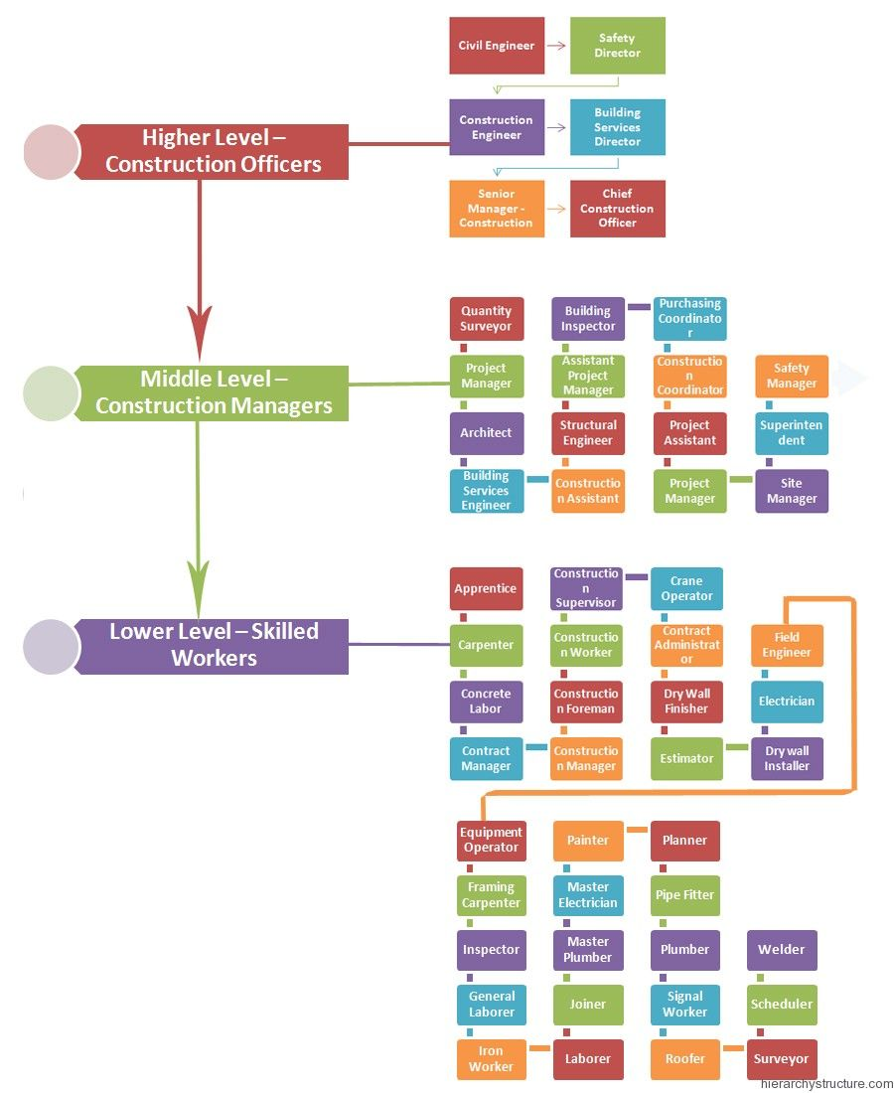
In the current industry there are vast numbers of professional structures and personnel’s which contribute to the construction and built environment as a whole. The construction industry has been spilt into three different sections as per the figure to the right taken from (Hierarchy Structure, N.D), firstly, the “Lower Level” which consists of the skilled workers such as the trades and skilled professionals, moving on up to the “Middle Level” which consists of the construction managers such as the building surveyors, Architects, Site Managers and so on, then lastly, the “Highest Level” of Construction Officers such as the Civil Engineers and the Construction Engineers. The hierarchy structure provides the levels in which the professionals lay within the construction industry, this does not limit the experience or drive that any employees from these professionals can have, Just like myself working currently as a building surveyor, I stive to achieve the most out of my career and this “hierarchy structure” does not stop myself from achieving more than what is labelled as “Middle level”.
Figure 1- This figure shows the hierarchy structure within the construction industry - https://www.hierarchystructure.com/construction-jobs-hierarchy/
Critical issues influencing the construction industry functions
There are many critical issues influencing the industry, they can be identified as the government-controlled issues, the current housing market and climate change imperatives. In relation to the government-controlled factors, they are responsible for set the pricing figures for all labour costings and materials, the government has full control on how to “facilitate the local construction industry, the government can fix the price levels, and provide subsidies for some materials, especially for the materials that are used in public sector projects” (Pheng, 2019). The Housing market during these past few years are increased a considerable amount, from the years of 2019 to this current year of 2022, bare in mind that is just over a year, the housing market has sky rocked to by an incredible “7.4% as pent-up buyer demand” (Johnson, 2021) and as website article from Yopa has stated this percentage has risen since the COVID-19 lockdowns were introduced, from the position of our current industry this has had positive and negative outcomes from the COVID-19 lockdowns, The positive aspects of the large increase within the housing market is that the over growth of the construction industry has risen to cope with the demand of the increasing market however this posed issues relation to the availability of materials to use within the construction phase and as result of more construction, this mean more materials, large labour costs to speed up the construction to cope with the demand however with increased demand on these factors such as materials and labour results in a higher cost and price due to the limited sources available and to combat this current issue in regards to housing market, having more increased skilled individuals to complete the “Middle Level” jobs such as the Building Surveyors like myself, the Site Managers and Quantity Surveyors with a good representation and knowledgeable background can ensure that the construction phases are overseen and finished to the highest standard they can be. Finally, the issues relating to climate change within the construction industry is that with more adverse weather condition and the extreme forms of which, we will soon see more concerns and with the following having the greatest impact on the industry, “These four primary concerns are;
- Worker safety
- Weather-related delays
- Construction materials design and manufacturing
- Insurance costs”
(Hegeman, 2019)
To further explain the four primary concerns, worker safety is paramount within any industry, however with the construction industry is extremely necessary to ensure worker safety with the vast amount of dangerous and hazard areas working on almost every day when it comes to climate change and a change in the weather, season becoming harsher, this real does need to have the top priority. Weather related delays this can cause many times scales in relation to finishing deadlines to increase which poses threat to the company itself in regards to reputation if all jobs are currently over run. The material design and manufacturing will be under increased stress as materials will need to be developed to withstand extreme condition that climate change can throw at the industry for example larger scales of storming weather with both heavy rain and winds causing destruction meaning that pulls companies away from current jobs to help repair any damages meaning the result of new homes being delayed and the housing market struggling again to cope with the ever-growing demands. Insurance cost will be set to increase due to all of the concerns already stated above especially the weather-related factors.

Personal Development Plan
The use of a personal development plan as seen below, details a continuous plan which will develop my own independent learning throughout my working career and how I intend to further my knowledge and skills. This personal development plan outlines my next steps that I shall take within my working career. Finally, to assist my personal development plan, I will detail a short SWOT analysis to accompany my Personal Development Plan.

Firstly, focusing on my strengths, I believe that I am a very driven individual, with a excellent work ethic and willingness to achieve goals within my development. I believe the way forward is starting from the bottom and working my way up. I would say that another strength of mine I would working within a team.

Moving onto my weaknesses, I believe that I need to improve my time management skills and confidence of speaking within a large number of individuals. Time management has always been on the back foot of mine due to the fact I believe working under pressure is the best point of call for achieving great results however as I develop further, I now need to plan my time wisely to ensure that my work is the best possible standard It can be and to achieve this, I will need to dedicate more time, speaking in front of large groups will be developed by accessing a course to help develop this weakness.

Opportunities of developing are vast within this industry as there is always more to learn. I tend to complete or achieve always with any given opportunities, Some of those opportunities will include attending workshops for improving confidence, keep up to date with new building regulations as and when they come into force, understand what they consist of and how my work will adapt to these new regulations.

Threats within this current industry may include new qualifications that need to be achieved for a new sector or employees that may come with higher levels of education and knowledge within surveying from having past experiences. Although this may be a threat, it can also be seen as a positive way to work with employees with further work experience and with new qualification It continues to provide ongoing training whilst in industry. (Mind Tools, N.D)

 | Name: Ayesha Williams
Review Of Learning Needs |  |  |  |  | Development Plan
Area of development |  | In what area do I need to improve my performance? | What do I need to learn in order to achieve this? | What will I do to achieve this? |  | What are the likely resources and support that I will need? | How will this benefit you? | When do I hope to achieve this?
The New Building Safety Regulator - Key Guidance - Webinar |  | Keep up to date with new building regulations coming into force | n/a | Pay small fee to attend webinar and talks |  | Computer and note taking, staff within university | Provide myself with update information on the building regulations | End of academic year 2022
Volunteer for a trainee surveyor position alongside current profession |  | Gain onsite knowledge and understanding. | Learn the daily tasks of a qualified surveyor | Volunteer for a part time apprenticeship/ work |  | From the trainee surveyor, independent learning | Provide visual knowledge on what a surveyor would be responsible for | 2024
Complete University degree (BSc,HND,HNC) |  | Educational writing to help achieve better grades for written assignments | Better academic writing – for better grades on assignments | Read more educational course books |  | University library, course staff within university | Achieve a degree, allowing myself to go on and qualify for a chartered surveyor | End of academic year 2024
Student Health and well being |  | General health and well-being within student life | Time management to reduce stress around assignment due dates and exam time | Join a weekly webinar with a tutor and other students |  | Access library/ compute, support from other students | Allow a better mental and healthy student well being to complete tasks to full potential | end of academic year 2024
Complete an accredited qualification by RICS |  | Further independent learning, developing knowledge and understanding | Full detailed of skills and knowledge of becoming a chartered surveyor | Achieve a degree from the university |  | University library, course staff within university | Become a chartered surveyor | 2025
Read the monthly MODUS from RICS |  | Keep up to date with the articles from RICS MODUS. | n/a | Receive a copy each month |  | Online access | Allow myself to up to date with all new details regarding chartered surveyors, reading new interesting articles helping with day-to-day tasks. | Continuously
Improve confidence of speaking within large groups |  | Speaking within large groups. | Attend a conference speaking course | Practice within smaller groups first and then move to larger groups |  | Course access online and in person during work life and university life | This will help achieve better grades within university tasks/ assessments and in everyday life | Continuously
Time management |  | Preparing work/ university assignments ahead of time. | Manage time more effectively | Use diary to plan time more efficiently |  | Purchase diary to track important deadlines and dates | This will ensure that there is time for making improvements which could help better marks or grades in future. | Continuously

Conclusion
To conclude the reasoning behind this report and why and how it is important for myself to join the professional body of RICS within my current career with yourselves, this is for a number of reasons., To highlight some of the benefits of an employee like myself joining a professional body, will help provide better knowledge within the company in which can help train and develop new employees and members, provide a better reputation for the company as a whole as if more companies have qualified ‘surveyors’ or managers, an increase in custom will be present due to having more experienced employees providing a better standard of work. The quality of work produced by a professional surveyor will provide an increase in cost as customers will be required to pay more for a higher-quality service. The whole company will see a vast improvement with a happier, safer and better and improved community for all employees and its customers and well as making a more diverse industry for both males and females, recognising that female professionals can provide the same quality of service within the construction industry as men or even better!

References
Cambridge Dictionary, N.D. Cambridge Dictionary. [Online]
Available at: https://dictionary.cambridge.org/dictionary/english/progression
[Accessed 2022 January 04].
Constructible, 2019. A (Very) Brief History of the Construction Industry. [Online]
Available at: https://constructible.trimble.com/construction-industry/a-very-brief-history-of-the-construction-industry
[Accessed 2022 January 04].
Hegeman, K., 2019. ForConstructionPros.com. [Online]
Available at: https://www.forconstructionpros.com/business/article/21049882/raken-changing-weather-is-changing-the-construction-industry
[Accessed 2021 January 07].
Hierarchy Structure, N.D. Construction Jobs Hierarchy. [Online]
Available at: https://www.hierarchystructure.com/construction-jobs-hierarchy/
[Accessed 2022 January 04].
Johnson, B., 2021. The House Price Tracker. [Online]
Available at: https://www.yopa.co.uk/homeowners-hub/brexit-house-prices/
[Accessed 2022 January 07].
Mind Tools, N.D. Mind Tools. [Online]
Available at: https://www.mindtools.com/pages/article/personal-learning-plan.htm
[Accessed 2022 January 10].
Pheng, L. S., 2019. Construction Quality and the Economy.. The Economy and the Construction Industry.

