Sustainability plan for ETTE

Kelly Darcy

MBA Sustainability Leadership

Embedding Sustainability within Organisations

Assessment Two

13 December 2020

1. Executive Summary

This report follows the initial management report on the managerial implications of sustainability for the fashion brand ETTE, the format of this report with be a recap of the introduction of the brand, the plan to embed the recommendations from the previous report using the methodology of the SVAT, SMART Goals and a GANNT chart for the project goals or the sustainability plan. Finally, a summary of the terms of reference can be found within the Appendices. ETTE is a Micro business and is a luxury vegan silk scarf brand with a focus on Enclothed Cognition, Sustainable Values and Wellbeing, there are many opportunities identified to embed sustainability and add in uncaptured value within this report in the recommendations section that ETTE can incorporate into the business.

Contents
- Executive Summary
- Introduction
- Main body of the plan
  - Clear description of the sustainability initiative taken from the prior report and the impact on other organisational functions
    - Recommendation one from the prior report: To perform a SVAT
    - Recommendation two from the prior report: Technology Development: RFID Incorporate
  - Type and size of potential benefits to the organisation and stakeholders
  - Time schedule and resources required, GANNT Chart
  - Assessment plan, SMART Goals
- References
- Appendices
1.1 fig 1 SVAT
1.2 fig 2 SVAT findings
2.1 Short glossary of terms

2. Introduction

ETTE is a London based micro fashion brand with Enclothed Cognition as its main branding strategy, the brand was launched in 2008 but ceased in 2010. The brand relaunched in early 2020 but has some issues with embedding sustainability within the business even though the brand aligns itself with sustainability as one of it’s core values.

ETTE as a concept brand; the name of the brand stands for Empowerment Through Thoughts Embodied, this is based on the values and the ‘why’ of the brand, the values of the brand a built upon the founder’s discovery of the core values of sustainable practice, wellbeing through cognition and embodiment. The focus was developed and inspired by the works of Simon Sinek who developed the process of understanding, those who start with WHY never manipulate, they inspire. And people follow them not because they have to; they follow because they want to (Sinek, 2009).

Main body of the plan

A) Clear description of the sustainability initiative taken from the prior report and the impact on other organisational functions;

1) Recommendation one from the prior report: To perform a SVAT

“An SVAT, reducing any kind of the uncaptured value in the manufacturing process by investing some time in experimenting with the Sustainable Value Analysis Tool (SVAT), the tool is designed to assist manufacturing businesses identify opportunities to create sustainable value by analysis the captured and uncaptured value, uncaptured value is prevalent in almost all companies such as waste, underutilised recourses and lack of circularity, the tool is easily accessible and was developed by the University of Cambridge Institute for Manufacturing (IFM, 2020), this would help with many areas identified within the body of the report such as the packaging and the wider supply chain” (Darcy, K., 2020)

SVAT findings and analysis, the SVAT findings showed that there is value uncaptured in all three stages of the product life. These following actions are the top line takeaways from the in-depth SVAT to be taken by the brand ETTE shown in the appendices 1.1 and 1.2.

Beginning of life phase
- Find collaborations with strategic partnerships to develop technological solutions that are less resource impactful.
  - ETTE fostering partnerships with suppliers, manufacturers and tech companies to find solutions that are less resource impactful will require time and effort, some cost implications may also be factored in but as a starting point a three month research and connections building plan consisting of two hours a week scheduled time to explore this is proposed as feasible when looking at the brands work capacity, some examples of partnerships are Fashion Revolution, Fashion Roundtable (the secretariat to the APPG for textiles within the UK Government), the Ellen McArthur foundation and Centre for Sustainability at the London College of Fashion, all of which ETTE can look to apply for some research or project funding with Knowledge Exchange as the mutual benefit.
- Design to last
  - Designing the scarves that ETTE sell
- Create a system/platform for feedback and analysis from suppliers
  - This could be a simple as an Excel spreadsheet to begin with to then be developed into either using an existing software provider or looking into funding to develop something bespoke, the time and resources required for this are approx. one hour in additional time for the brand to account for a week over three months.
- Search for local solutions to manufacturing and material sourcing, impacting carbon footprint
  - This action is to be taken over a two month period to source a local supplier and understand the cost implications and carbon footprint impacts or reductions.

Middle of life phase
- Create a system/platform for feedback and analysis of data from customers
  - The plan to embed a meaningful Customer Relationship Management system (CRM) is to co-produce with the customers and understand their perspective of the sustainability landscape and expectations. This has not been added to the GANNT Chart as the implementation can start to take place immediately, however it is proposed that it should be reviewed every three months.
- Offer a repair service to extend life of the garments
  - The plan to offer repairs as a service to extend the life of the scarves that ETTE sell, can be explored though a trial phase by understanding the types of damage that occurs to the garments. This exploration can co-inside with the durability aspect of the design to last activity.
- Become an industry innovation leader for good practices to inspire and increase impact (strong PR and marketing)
  - The plan to increase the momentum for fostering and embedding sustainable practices can be shared with other SME’s within the fashion industry. This can improve the brand image but also the basis of this activity is to utilise the brand owners values in Transformational Leadership.

End of life phase
- Incentives for receiving clothes back for recycling within company (e.g., discount on new order)
  - This activity will take some research time and will be dependent on factors such as the condition of the scarf, however due to the high price point of the luxury vegan silk scarf the potential for recycling might be low as the consumer will hold on to it, or if the RFID plan to trace ownership of the scarves there will be potential to transfer the ownership.
- Partner with University research departments /entrepreneurs to find solutions for waste management
  - Leading on from the above action within the plan, it would be advisable for ETTE to look at the end of use of all of the components of the product, this is especially important for the RFID as technological waste is an ever-growing concern. “The EU also requires manufacturers to shoulder the burden of safe disposal. Recently a new EU directive encourages "green design" of electronics, setting limits for allowable levels of lead, mercury, fire retardants, and other substances. Another directive requires manufacturers to set up infrastructure to collect e-waste and ensure responsible recycling-a strategy called takeback. In spite of these safeguards, untold tons of e-waste still slip out of European ports, on their way to the developing world”. CARROLL, C., (2008). This is a consideration ETTE needs to understand within the plan to embed technology within the product.

This in-depth process of the SVAT is visually reflected within the figures in the appendices 1.1 and 1.2, and also reflects many of the findings from the prior sustainability management report of the brand ETTE, the process uncovered many suggestions to implement along the stages of the product life that are now proposed within a GANNT chart timeline in section C of this report.

2) Recommendation two from the prior report: Technology Development: RFID Incorporate

“Technology Development: RFID (Radio Frequency Identification) for transparency Information technology, IT, provides us with new ways to track the garments, more recently the origin of the product – could be increased through the help of new technology. RFID codes or yarn including the same information (Webster 2017) could include information about the fibre content of the garment and could also inform about suitable recycling technology for the garment and its materials (EMF 2017). Another consideration is Cloud services these tools can also help the producer to make the right sustainable choices along the way, however there is a digital footprint to consider, makersite.net provides tools for brands and teams to work with sustainability issues along the production chain and to calculate the best choices through LCA (life cycle analysis) (Niinimäki, K., 2018)” (Darcy, K., 2020).

RFID viability findings

When applied to textile and clothing, radio frequency identification (RFID), which has been noted as one of the most promising technological innovations, can be used in manufacturing, inventory control, warehousing, distribution, logistics, automatic object tracking and supply chain management. Various retailers and manufacturers (of clothing as well as consumer goods) such as Tesco, Prada, Wal-mart and Procter & Gamble, are now implementing the technology and exploring the impact of the technology on their business. On the positive side, RFID technologies may improve the potential benefits of supply chain management through reduction of inventory losses, increase of the efficiency and speed of processes and improvement of information accuracy.

Radio frequency identification can also be used to avoid illegal product alteration to grey market and increasing product security and to give information about shopping behaviour of customer at retail. Having all these issues solved, textile and fashion supply chain can be made more streamlined and efficient in terms of cost and performance.

However, it is worth noting the potential threats and downsides to RFID, the use of RFID systems can increase the productivity and efficiency of tracking garments, they also expose new threats to the security and privacy of individual organisations (Phillips et al. 2005; Bogdanov et al. 2008; Ayoade 2007). Hackers can easily use duplicate tags to provide wrong information or can break the security algorithm or can modify the message (Nayak, et al., 2015). ETTE may wish to wait until further research and development resolves these issues, however it is advised ETTE action the activity as part of research with a university or institution to partner with as discussed further in the report in section C.

B) Type and size of potential benefits to the organisation and stakeholders;
Impact estimate and potential reporting are changing, non-financial metrics are growing in importance and should matter as much as financial ones according to Henriksson and Weidman Grunewald. As comprehensive sustainability targets track a company’s most important impacts across the value chain. Bold targets that stretch and challenge organisations are vital: it’s not just about looking good; it’s about making a difference. At a minimum, targets should be relevant to the business, quantifiable, and fact-based. In the area of climate, science-based targets are the gold standard. It is proposed that brands learn how to distinguish a strong key performance indicator (KPI) from a weak one and how to anchor sustainability metrics by connecting them to the core business and normal performance reporting, with clear lines of responsibility and accountability. ETTE can look at how strong metrics can help their sustainable efforts outperform their peers. (Henriksson H., Weidman Grunewald E, 2020).

C) Time schedule and resources required;
A GANNT Chart is proposed as part of the plan to based on the SVAT findings. The resources required are discussed within section A.
 | DEC | JAN | FEB | MAR | APR | MAY | JUN | JUL | AUG | SEP
SVAT Analysis and findings
Collaboration partners
Redesign to last
Supplier Platform
Repair Service launch
Thought Leadership
Buyback Scheme
Solution waste management
Review Project
Fig 1. GANNT Chart

D) Assessment plan

The assessment plan is using SMART goals that will be set to implement the plan in accordance with the GANNT chart. SMART is the acronym for specific, measurable, achievable, realistic and time, all of which the plan will need to be in order to be successful. However, it is worth noting that the SMART goals tools have been criticised in recent years that it stifles innovation as stated by Prather “The dumb thing about SMART goals for innovation is that they circumvent innovations that could become breakthroughs for your organisation” (Prather, C. W, 2005).

S – Specific, the specifics of this sustainability plan is to implement the proposed actions listed below from the SVAT findings of value uncaptured.
- Find collaborations with strategic partnerships to develop technological solutions that are less resource impactful
- Design to last
- Create a system/platform for feedback and analysis from suppliers
- Search for local solutions to manufacturing and material sourcing, impacting carbon footprint
- Create a system/platform for feedback and analysis of data from customers
- A repair service to extend life of the garments
- Become an industry innovation leader for good practices to inspire and increase impact (strong PR and marketing)
- Incentives for receiving clothes back for recycling within company (e.g., discount on new order)
- Partner with University research departments /entrepreneurs to find solutions for waste management

M – Measurable, the measure of the plan is to take the existing data from the brand where possible.

A – Achievable, the plan is based upon the premise that the specific actions provided within this plan are achievable.

R – Realistic, the realistic aspect is to determine if the action points given within this plan are suitable for ETTE, this relies on ETTE agreeing to aspects of the plan that are suitable and with the potential to leave other action points for the future.

T – Time, the proposed timing for the plan is discussed and shown within the GANNT chart.

References
Adam, H. and Galinsky, A.D., 2012. Enclothed cognition. Journal of experimental social psychology, 48(4), pp.918-925.

Ayoade, J., 2007. Roadmap to solving security and privacy concerns in RFID systems. Computer Law & Security Review, 23(6), pp.555-561.

Bogdanov, A., Leander, G., Paar, C., Poschmann, A., Robshaw, M.J. and Seurin, Y., 2008, August. Hash functions and RFID tags: Mind the gap. In International workshop on cryptographic hardware and embedded systems (pp. 283-299). Springer, Berlin, Heidelberg.

Carroll, C., 2008. HIGH-TECH TRASH. National Geographic, 213(1), pp. 65-67,69-71,74-81.

Darcy. K., 2020. A management report on the managerial implications of sustainability for the fashion brand ETTE, pp. 1-11.

Nayak, R., Singh, A., Padhye, R. and Wang, L., 2015. RFID in textile and clothing manufacturing: technology and challenges. Fashion and Textiles, 2(1), pp.1-16.

Niinimäki, K., 2018. Sustainable fashion in a circular economy. Aalto University.

Phillips, T., Karygiannis, T. and Kuhn, R., 2005. Security standards for the RFID market. IEEE Security & Privacy, 3(6), pp.85-89.

Prather, C. W. (2005) ‘The Dumb Thing about Smart Goals for Innovation’, Research Technology Management, 48(5), pp. 14–15. doi: 10.1080/08956308.2005.11657331.
Sinek, S., 2009. Start with why: How great leaders inspire everyone to take action. Penguin.
Appendix
1.1 SVAT Activity
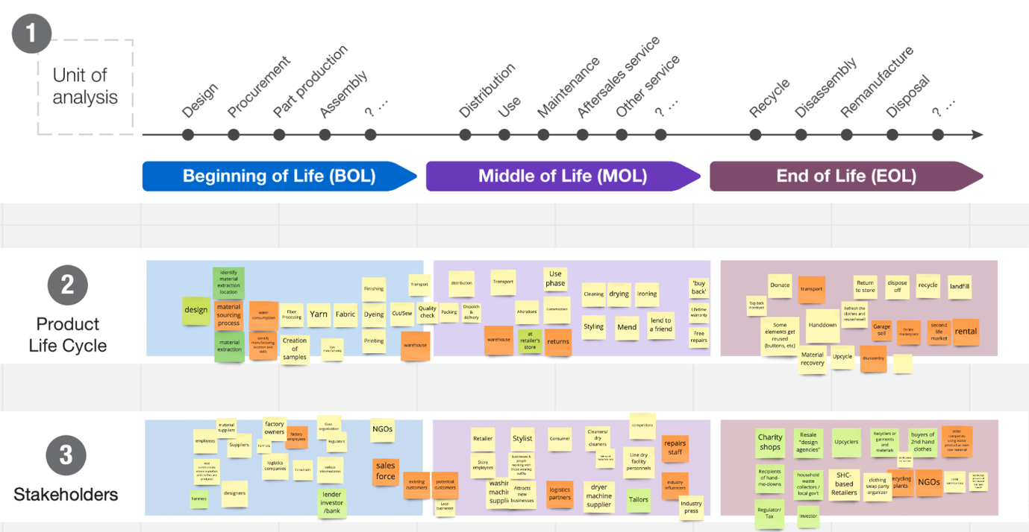
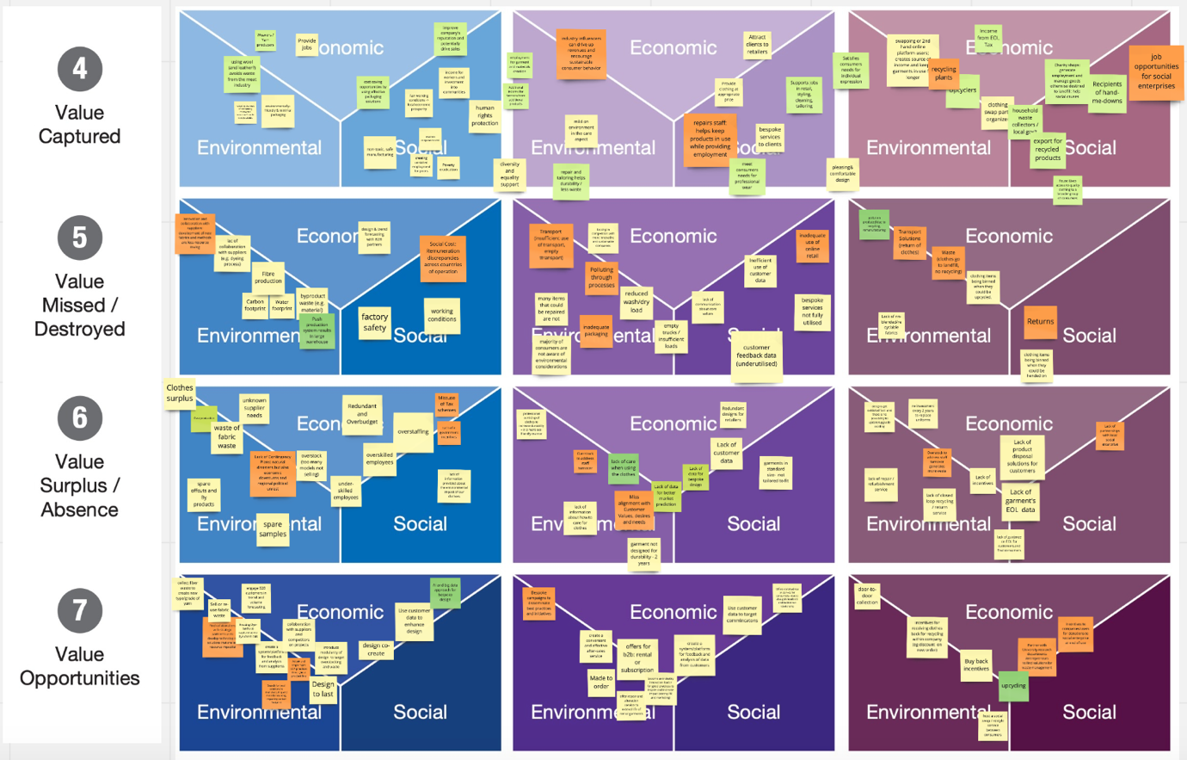
Fig 1. SVAT
1.2 SVAT Findings
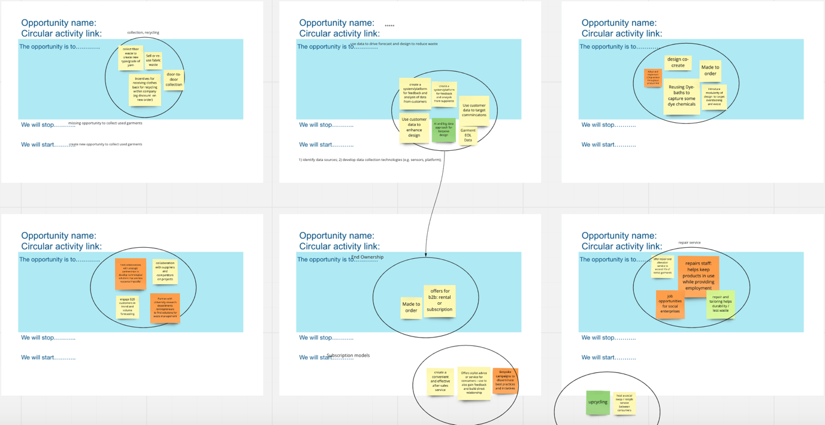
Fig 2. SVAT Findings

2.1 Short glossary of terms.
CRM – Customer Relationship Management
Enclothed Cognition - the systematic influence that clothes have on the wearer's psychological processes.
ETTE – Empowerment Through Thoughts Embodied, the brand within this report.
IFM – Institute for Manufacturing (part of the University of Cambridge)
LCA - Life Cycle Analysis
RFID - Radio Frequency Identification
SMART – Specific Measurable Achievable Realistic Time
SME – Small or Medium Business Enterprise
SVAT - Sustainable Value Analysis Tool

