Martin Dykstra - 2305923
Research in Context – ADAD5003

Using at least 3 examples, consider how image makers have utilised digital technology to explore one of the following: Conflict, Identity, the Surveillance State, the Technological World?

Question 1. The Surveillance State.
Illustrations List

Fig 1. NASA. (2022). Blue marble picture, 50th anniversary. [World Wide]: Online.
Fig 2. NASA. (2022). Blue marble picture, 50th anniversary. [World Wide]: Online.
Fig 3. Whiterose. (2017). Eprints. [World Wide]: Online.
Fig 4. The Guardian (2018). Panopticon. [World Wide]: Online.
Fig 5. Paul Souders/Corbis. [World Wide]: Online.
Fig 6. Daily Telegraph. (2022). England-police-deploy-cardboard-officers-deter-speeders. [World Wide]: Online.
Fig 7. Daily Telegraph. (2022). England-police-deploy-cardboard-officers-deter-speeders. [World Wide]: Online.
Fig 8. Amalia Ulman, (2015). Excellences & Perfection. Arcadia media. [World Wide]. Online.
Fig 9. Xiuwen. C. (2000). Ladies Room. Letterbox publishing. [World Wide]. Online.
Fig 10. Wolf. M. (2008). Transparent City. [Installation]. Kochgallery.
Fig 11. Weiwei. A. (2012). WeiweiCam. [World Wide]. Online @ Ai Weiwei.

Digital technology, in the form of the surveillance state, has been a mainstream discussion among scholars and artists since the invention of photography due to its ability to capture factual images of the here and now. These images can be taken with or without an individual’s knowledge or permission. I will discuss how artists have used digital technology and their practices to question its safety and boundaries.
One area of art influenced by surveillance technology is informatics; it combines technology with various art practices. It is usually made to highlight the negative impacts of technology, such as spying, using private data without permission, voyeurism, and in some cases, used to manipulate and disinform you.

As such, artists have been using informatics art to highlight these issues in our digital age. I will look at how surveillance technology has inspired artists to make creative art with powerful meanings (usually foreboding).

The surveillance society started in the late 19th century and was best described by historian Jean-Louis Comolli as a ‘frenzy of the visible’ (Comolli 1980). Media has changed and manipulated our view of things for many years, one instance is the first image of the world from the crew of the Apollo 17 mission. The original has Africa as its main feature, however, if you look at NASA’s image now it has the Americas as the central feature. NASA has never actually stated this was not the original.

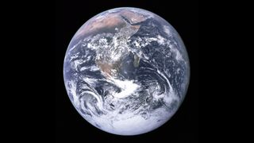
Fig 1.

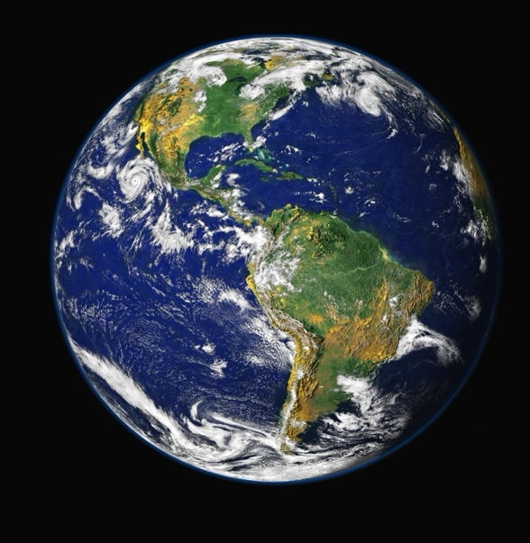
Fig 2.

This manipulation was also seen during the Moors murder trials in 1966, here the tabloids and TV news articles (with or without the governments’ knowledge) posted images of Myra Hindley, whose features had been altered to give her an eviller look.

Fig 3.

These are just some of the ways we have been fooled by the media. Another instance of information misinformation was in 2016, ahead of the US elections, when Facebook was found guilty of disseminating false information about the presidential campaign. Futurist philosopher Yuval Noah Harari stated, ‘Disinformation and propaganda were serious problems throughout history’ (Nicholas Mirzoeff. 2015). As a society, we are susceptible to believing false information; this has become mainstream for artists worldwide.

The surveillance state incorporates all aspects of life, including conflict, the environment, and one’s identity. This started with Jeremy Bentham, who, in the early nineteenth century, designed a prison called the Panopticon, which was a circular prison with a central watchtower. Although the facility was never built, it has become the iconic symbol of people’s rights being misused in a way that makes us feel we are being watched when we are not.

Due to its shape, a person in the watchtower could see all prisoners in their cells without themselves being seen. It was designed so inmates would think they were always being watched, even if they were not and, as such, would behave accordingly. In short, the inmate “is seen, but he does not see.”
(Foucault 200; Miller 3)
As the power of surveillance has increased in recent years, the late artist Vito Acconci commented that ‘surveillance is power’ is more prevalent than ever.

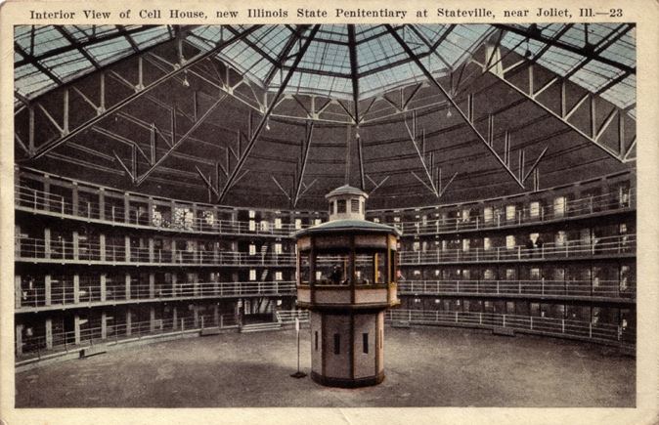
Fig 4.

The paranoia of being watched is a phenomenon called gaze detection, and neurological studies have shown certain brain cells react when a person is being watched, or believes they are being watched. In recent times this trait has been successfully used by police to prevent crime, in the form of posters and cutouts.
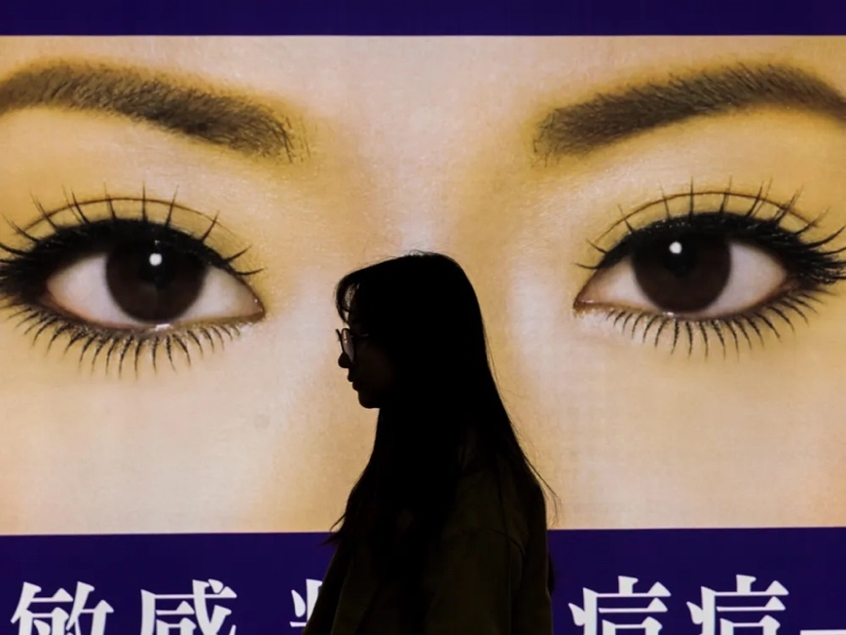
Fig 5.

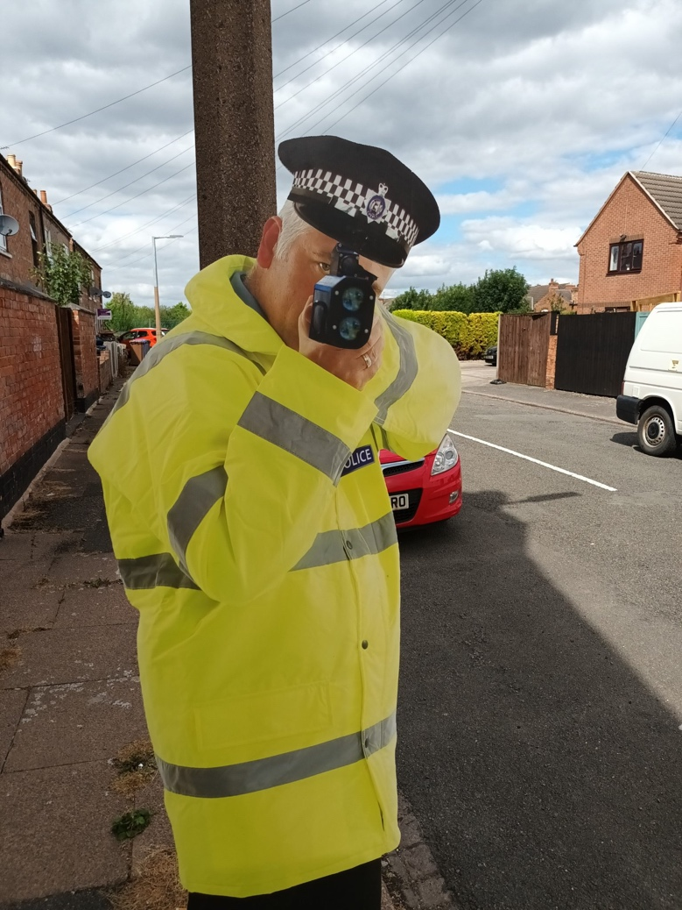
Fig 6.

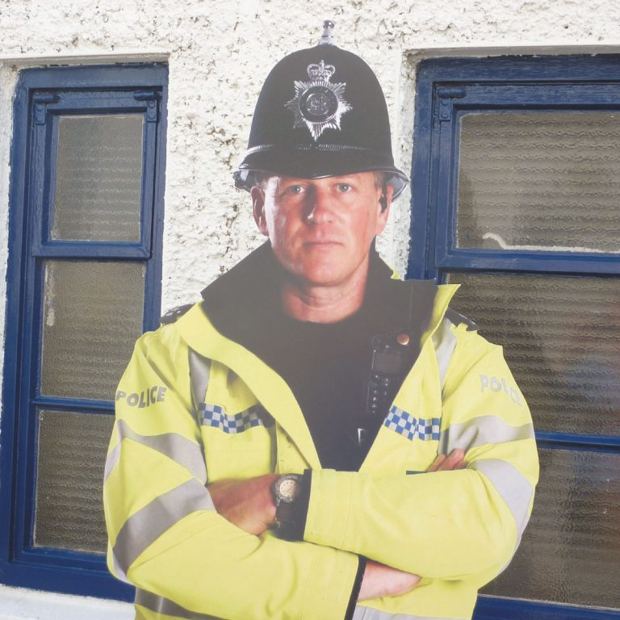
Fig 7.
In 2013, a former technical assistant for the CIA, Mr Edward Snowden. Leaked confidential government information to the press regarding the American government’s use of personal data and how these agencies were using this information to spy on its citizens.

Snowden stated to the Guardian newspaper:

“I’m willing to sacrifice all of that because I can’t in good conscience allow the US government to destroy privacy, internet freedom and basic liberties for people around the world with this massive surveillance machine they’re secretly building.” (The Guardian 2013)

It would seem that since Snowden’s leak, surveillance technology has always been in the news, unfortunately, mainly from a negative viewpoint. This had a major impact around the world, now, what people believed was happening was proved to be true. This led to public outrage and has inspired activism and art forms around the issues.
So, do we now interact with images differently?

The answer is quite simple: YES. How can we not? In an age of continuous technological advances, which gives people the opportunity to talk and share images instantly with friends and family using Apps like Facebook, Snapchat and Instagram, to name but a few. The positive social aspect is staggering, mobile phones allow a closeness to each other never know before, nearly gone are the days of letter writing, waiting several days to get a reply. However, there is a rising concern with these technologies; scam artists, solicitation, and grooming are now unfortunately commonplace. Pornography sites have become easy for underage children to view, which leads to the unfortunate sexualisation of women. Worse still, the companies owning the sites have been proven to spy on us. In 2005, Google was the first site to be found to keep our search histories indefinitely.

Surveillance art impacts society: it sparks important conversations about privacy and security. Artists have exposed how surveillance technology can be used to control and manipulate individuals; this has challenged us to reconsider our assumptions about privacy and consent.

Artist Amalia Ulman produced a work, “Excellences and Perfections”, in July 2014. She began a project
using iPhone and media apps to create a fictional young woman whose story she shared over a few months. Her idea was to make people believe the fictional young woman was changing her personality and sexualisation from a ‘cute girl’ to a ‘life goddess’. (Arcadia Media).

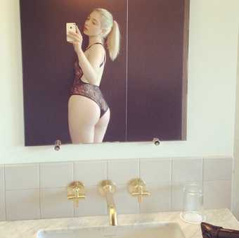
Fig 8.

Ulman began by asking viewers questions about gender and sexism. She turned the project into a performance to explore how women’s images are seen online. Following research into famous women’s sites, she took on three personas, ‘Cute Girl’, ‘Sugar Baby’ and ‘Life Goddess’, which Ulman said she chose because ‘they seemed to be the most popular trends online for women (Ulman, 2016).

At the end of the project, in September 2014, Ulman had compiled 88,906 followers. Ulman then let it be known that the site and woman were fake. Ulman explained:

“The idea was to bring fiction to a platform that has been designed for supposedly ‘authentic’ behaviour, interactions and content. The provocative work uses everyday technology to highlight the potentially manipulative nature of social media.” (Arcadia Media.)

Following this project, Ulman became widely known as the ‘Instagram artist who fooled thousands’ (Kinsey, 2016). Her work around anonymity is backed by academics, such as anthropologist Daniel Miller, who stated in a paper article:
“The Internet initially appeared to expand the field of anonymity, which meant people could explore new forms of identity, shift identity, or secure multi-identities with relative freedom. By contrast, Facebook has been associated with not just the loss of anonymity but as a threat to all aspects of privacy.” (Miller, 2013).

Ulman’s work demonstrates that people are willing to look for vulnerability and the exploitation of innocence online. This form of voyeurism has, with the aid of social media, become the norm, even if the social media sites state they are removing said videos and images. Instagram states about appropriate imagery on their site: “We don’t allow nudity on Instagram, with some exceptions, like photos of post-mastectomy scarring and women actively breastfeeding. Nudity in photos of paintings and sculptures is OK, too.” (Instagram 2018) However, a small search on Instagram will show you very quickly that this is not the case.

With that in mind, surveillance art challenges these traditional norms. It can provoke discussion and raise awareness. However, as surveillance art can violate the rights of people to control their personal imagery
and information, it highlights ethical considerations, which are a paramount concern in surveillance art.

Other artists see it as necessary in the fight against the surveillance culture. Artist Cui Xiuwen has produced notable exhibitions regarding surveillance. Her most well-known and controversial project is ‘Ladies Room, 2000’.

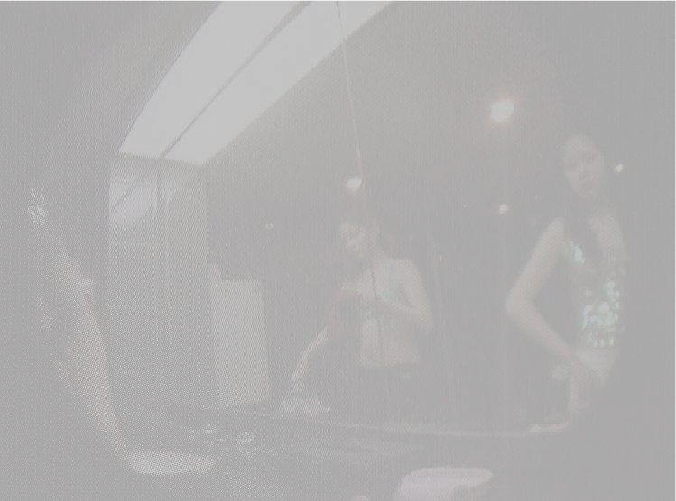
Fig 9.
Wang used secret recording equipment to capture local prostitutes in a ladies’ restroom. The video showed the girls on their phones talking to clients, as well as changing their clothes. The footage was shot in low resolution. It turns the video into a voyeuristic piece as if the viewer is a peeping tom, looking into people’s private and intimate lives. There was major criticism about this work, mainly that she made the women sexualised for predominantly the male gaze and made financial gain by exploiting those already exploited individuals.

In a justification of her work, Cui Xiuwen stated that she did not aim to make any comments or judgments on the scene, but did it to provide an alternative perspective, to reveal a facet of China which is often neglected.
As John McGrath points out in Loving Big Brothers:

“Crime scene footage also contributes to the psychological process of distinguishing the self and the other: by showing criminals or violators on screen, the audience is led to believe that “I am not seen by the camera because the camera sees only criminals and I do not look like a criminal.”
It functions in the same way as the cameras in the Ladies’ Room, which implies, “I am not shown in the video because I am not a prostitute.” Whiterose

The use of surveillance footage in art is, as we know, is controversial, particularly in installing surveillance cameras and using this surveillance for personal use without consent. Although Xiuwen was never taken to court over her artwork, it does raise legal as well as moral issues. Especially when the individuals being recorded are used to make artists money. This is, after all, exploitation; it agrees with what the state does with our images, and if not illegal, at the least, it is immoral.

In 2008, artist Michael Wolf produced a work called ‘The Transparent City’ like Xiuwen, it focussed on taking images of individuals without their permission for personal and financial gains.

Wolf took images of the Chicago cityscape, using powerful zoom lenses, he took photographs of people in their high-rise apartments, going about their personal lives in the privacy of their own home. He stated he wanted to depict human vulnerability and modern life.

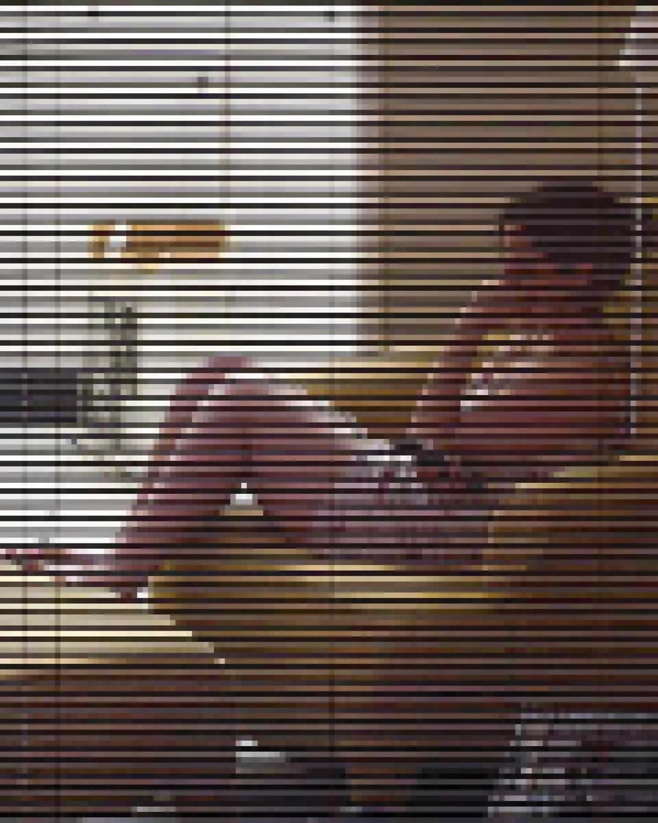
Fig 10.

However, once again this is without doubt voyeurism, and one must again about the question of legal and moral constraints.
The widespread nature of surveillance cameras, recording all aspects of individuals being viewed without permission, can be viewed as the panopticon and Foucault's notion of a prison-like society. Foucault believed that public surveillance was not only used for punishing or controlling criminals but also as a means of regulating the behaviour of ordinary people.

This brings us to government surveillance Artist Ai Weiwei also used video surveillance in his work titled WeiweiCam. The project was based on his own experience of being placed under house arrest for 80 days, where he was monitored by numerous cameras 24 hours a day. A year later, in 2012, he launched his 24 hours a day self-surveillance project using four cameras to monitor his everyday movements. The project drew a lot of attention and at its peak had over 5.2 million followers. Within 48 hours the webcam site was quickly removed by the Chinese government. This shows the government’s power to stop individuals criticising them even though no laws were broken.

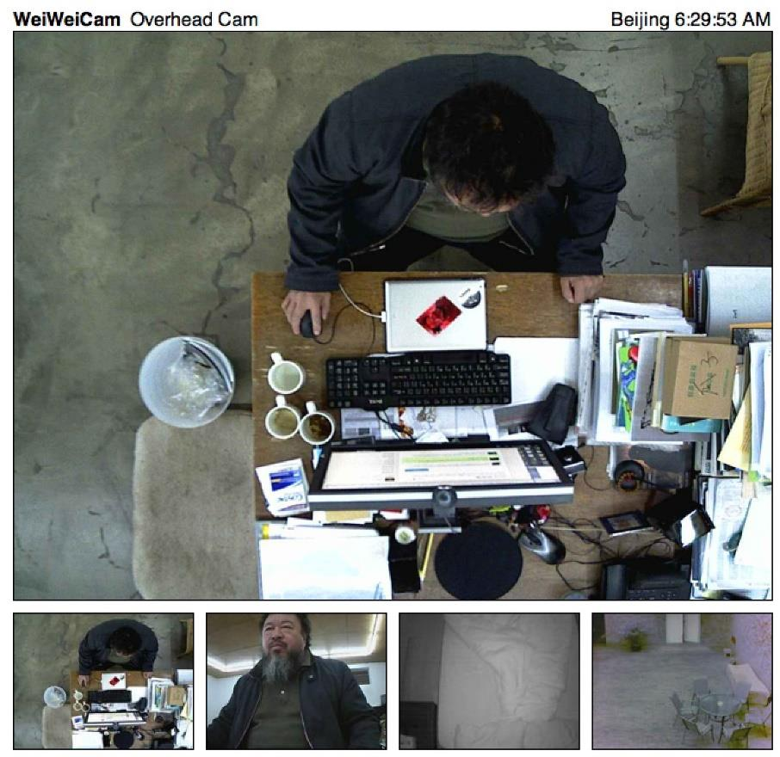
Fig 11.

From an article in the University of York:

“According to the artist, the project raises questions of transparency in two ways: firstly, it refers to the fact that prior to his house arrest, the installation of cameras around the artist’s studio was secretly carried out, and secondly, it also suggests that in the action of surveillance, the relation between the observer and the observed is non-transparent; surveillance cameras construct a one-way observation. The viewer is shielded behind a camera while those monitored are exposed to constant observation; the observer remains undetectable and invisible and, thus, occupies a uniquely powerful position.” (whiterose)

For state surveillance, we are viewed as information to be analysed. In most cases, an individual cannot see or guess who is watching them, only that they are observed; thus, the threat of the panopticon remains.

The use of spyware and cameras everywhere, along with many governments’ misuse of our data, has become so prevalent that the UN has become involved. They warned that the threats to privacy and human rights are growing. Due to these threats on the 16th of September 2022, the UN made a statement at the Geneva Summit. This paper stated:
“People’s right to privacy is coming under ever greater pressure from the use of modern networked digital technologies whose features make them formidable tools for surveillance, control and oppression. This makes it all the more essential that these technologies are reined in by effective regulation based on international human rights law and standards. Surveillance tools such as the “Pegasus” software can turn most smartphones into “24-hour surveillance devices”, allowing the “intruder” access not only to everything on our mobiles but also weaponising them to spy on our lives.”

Acting High Commissioner for Human Rights Nada Al-Nashif also stated:

“Digital technologies bring enormous benefits to societies. But pervasive surveillance comes at a high cost, undermining rights and choking the development of vibrant, pluralistic democracies.”
“In short, the right to privacy is more at risk than ever before,”
(OHCHR 2022)

Surveillance technology was originally designed and legitimately intended to combat the threat of crime and terrorism, however, as we have seen, it has been misused to misinform and alter individual views and persecute those who present them. This includes journalists, opposition political figures and human rights defenders.

Despite being a common practice by artists, using surveillance footage in art has been controversial. It has inspired activism, prompting individuals and governments to take a more critical stance regarding the power inherent in the surveillance of people, both publicly and in private. However, when artists focus their cameras on people who have not consented, concerns of exploitation and invasions of privacy are brought to the fore.

It is without question that the technological advances in today’s society bring us closer together, it helps make life easier, and, in the main, it helps make the world safer. However, factual evidence from experts, governments and industry (such as Google and Facebook), proves our anonymity is being eroded away, one could say the positives outweigh the negatives, and if you are an honest person, you have nothing to fear from being observed in your daily lives. Whilst this is true, our privacy is exactly that, private and should not be used to spy on us and our daily movements and choices sold to make money by faceless companies. As such, the widespread use of surveillance cameras ultimately brings us closer to the Foucauldian notion of a prison-like society.

Bibliography

Books

Mirzoeff, N. (2015). How to see the world. Pelican Books. United Kingdome.
Zudoff, S. (2019) The Age of Surveillance. Profile Books. United Kingdome.
Campbell, J & Wynne, R. (2011). Introduction to remote sensing. Guilford press. New York. USA.

Websites

https://letterboxd.com/film/ladies-room-2000/genres/ https://eprints.whiterose.ac.uk/192300/1/Wang%2C%20Zhixuan%20-%20Watch%20Me%20Watching.pdf
https://www.e-ir.info/2011/03/02/to-what-extent-is-the-panopticon-a-suitable-analogy-for-power/
https://www.theguardian.com/world/2013/jun/09/edward-snowden-nsa-whistleblower-surveillance
https://about.instagram.com/blog/announcements/instagram-community-guidelines-faqs/
https://www.irishmirror.ie/gallery/lazy-days-posing-snaps-beloved-7141546
https://kochgallery.com/exhibitions/michael-wolf-the-transparent-city-2008/
https://www.ohchr.org/en/press-releases/2022/09/spyware-and-surveillance-threats-privacy-and-human-rights-growing-un-report
https://www.smithsonianmag.com/smart-news/putting-eyeballs-billboards-might-help-stop-crime-180956394/
https://www.space.com/blue-marble-picture-50th-anniversary
https://www.telegraph.co.uk/news/2022/08/18/england-police-deploy-cardboard-officers-deter-speeders

Other
Weiwei, A. (2012). WeiweiCam. @ Ai Weiwei
Ulmans, A. (2015). Excellences & Perfection (Instagram Update, 8th July 2014), Courtesy Arcadia Missa and The Artist​.

