University of Wales Trinity Saint David (Birm)
BSc Health & Social Care
BMHP5014 Changemakers Creativity and Value Creation
Student Name: Ann Marie Ogilvie
Student Number: 2419544 Creativity a
Module Leader:
Tutors Details: Tomy Adattu Chacko
Portfolio – Component 2: Written assignment (Poster and Pitch)
Submission Date: Sunday 19th July 2026 (2pm)

Content Page
1 Title Page ..………………………………………………………………………………………… 1
3 Poster: Family First Hub ..………………………………………………………………………. 3
4 Campaign Pitch - Introduction and Case for Change ..………………………………… 4 Families and the Public, Local and Policy Bodies, Health and Care Professionals
5 Who This Campaign Targets ..……………………………………………………………… 5 Promotion Channels, Hub Services and Operation, Implementation and Technology
6 Promotion, Service and How the Hub Work ..………………………………………………. 6 Delivery Plan & Governance Supporting Technology
7 Conclusion ...……………………………………………………………………………………… 7
8 References …………………………………………………………………………………… 9 & 9

POSTER: FAMILY FIRST HUB - ONE-STOP EARLY HELP AI NAVIGATOR
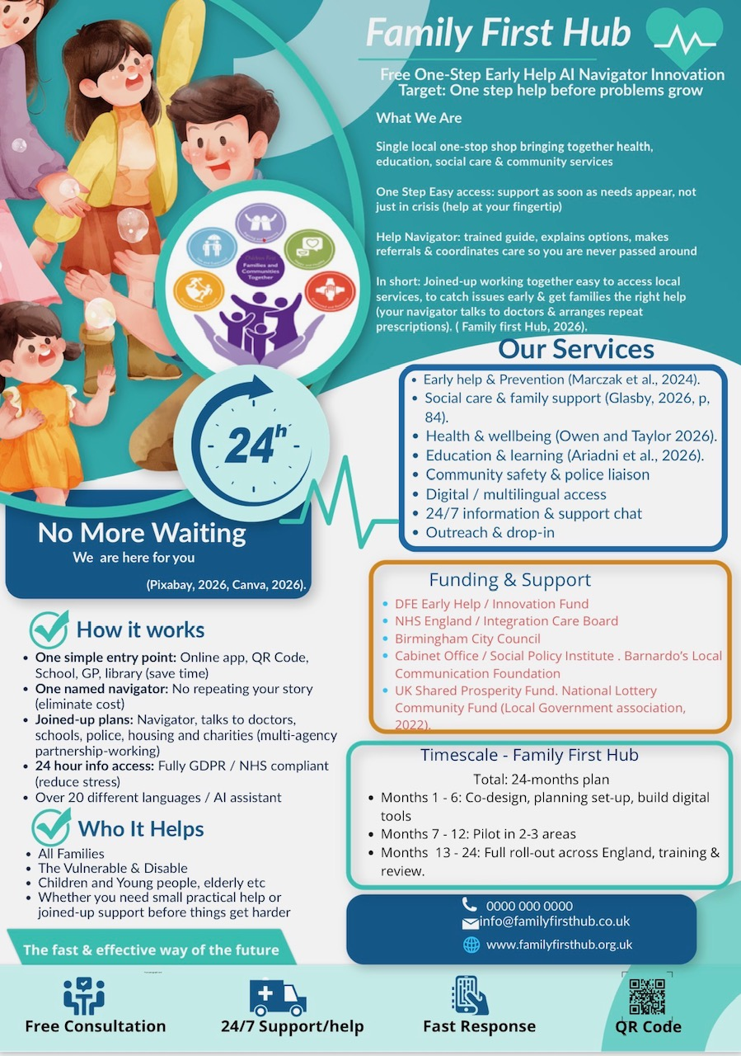
Campaign Pitch: (Family First Hub Free One-Step Early Health AI Navigator)
Introduction
For too long, families across the UK have faced a health and social care system that feels like a maze: repeating personal stories to half a dozen different teams, waiting weeks for a referral, and watching small worries grow into big crises simply because they could not get the right support in time (NHS England, 2024). The Family First Hub One-Step Early Help AI Navigator is the innovation that changes this. Funded by the DfE Early Help Innovation Fund, NHS England, Birmingham City Council, and trusted partners including (Bernardo’s, 2023) and the National Lottery Community Fund, the service is a single, accessible one-stop shop bringing together health, education, social care, and community support. This campaign sets out exactly what offers, who it is for, where it will be promoted, and how it will deliver life-changing benefits for families, professionals, and communities alike.
The Case for Change Why We Need This Innovation
The UK policy priorities prevention-first care, yet most support remains reactive and fragmented. Research shows that 60% of families reaching crisis point could have received earlier help but only 15% get targeted support when they first needed it (Social Policy Institute with Barnardo’s, 2023). Families spend an average of 12 hours repeating their stories to different services; while disabled people, those with limited English, and low-income households face extra barriers, waiting even longer (Birmingham City Council, 2021).
Delayed early help turns small concerns, children struggling at school, older people feeling isolated, or a family facing housing stress, into complex costly crises. The Early Intervention Foundation (2024) calculates that every £1 invested in early help saves £1.70 on emergency care, statutory intervention, and long-term support. The Family First Hub fixes this: it delivers simple, fast, joined-up support before problems escalate.
Who This Campaign is Targeting?
This campaign speaks clearly to three key groups, with tailored messages to show exactly what is in it for them:
The General Public & Families
This is my primary audience: All families, vulnerable groups, disabled people, children and young people, older adults, and anyone who needs practical or emotional support before things get harder. I want to reach people who feel overwhelmed by the system and do not know where to turn, or have given up asking for help because it felt too difficult.
What this means for you:
- No more waiting: Get support the moment you need it, not just in an emergency.
- No more repeating your story: One dedicated navigator handles everything for you.
- All your needs in one place: Health, school, housing, money, or family worries, we will link you to the right people.
- Always open: 24/7 access, free for everyone, with support in over 20 languages
- Peace of mind: Your information is fully protected under General Data Protection Regulation [GDPR] and NHS standards.
Local Authorities Commissioners & Policy Makers
I will pitch this initiative to Birmingham City Council, NHS Integrated Care Boards, the DfE, and national health bodies. The hub reduces demand on crisis services, meets legal duties for early intervention, and delivers better value for public money.
Health, Social Care and Education Professionals
This includes GPs, social workers, teachers, police officers, care staff, and charity workers. The hub cuts administrative work, removes duplication, and lets staff focus on caring for people, rather than navigating referrals.
Where I Will Promote the Campaign
I will advertise and raise awareness everywhere our audiences are:
Community spaces: Libraries, schools, GP surgeries, community centers, faith venues, food banks, and care homes, with QR codes linking directly to the service.
Digital platform: Local social media channels, and NHS websites, counsel web pages and multilingual community groups, short, simple videos on billboards showing how the hub works.
Local media: Radio, television, newspapers, and newsletters to reach people who do not use social media.
Professional channels: Training events, partnership meetings and NHS bulletin boards to spread the word among frontline staff.
Outreach teams: Face-to-face visits to hard-to-reach groups, including Gypsy, Rama and Traveler communities, refugee families, and isolated older people.
What the Family First Hub Delivers
Core services
The hub brings together all the support you could need:
- Early help in prevention for all families
- Social care, family support, and well-being guidance
- Help with health, education, housing, and community safety
- 24/7 multilingual support, digital access, and free drop-in sessions
How it works
- One simple entry point: Accessed via the free app, QR code, or in person at any partner location.

- Your dedicated navigator: A trained guide who listens, explains options, makes referrals, and coordinates care across all services.

- Trusted partnership working: Your navigator talks directly to doctors, schools, housing teams, and charities, so you do not have to.

- Safe, secure and inclusive: Fully compliant with GDPR and NHS rules with support for over 20 languages and AI assistance.
Implementation, Timeline & Governance
The service will be launched within community settings across Birmingham and the West Midlands, run by trained navigators working alongside local agencies. The 24-month plan is:
Months 1-6: Co-design with families, build digital tools, and formalise partnership agreements
Months 7-12: Pilot in 2 - 3 high-need areas, with feedback shaping required improvements
Months 13-24: Full rollout across the region, national training, and ongoing evaluation
All operations meet the Health and Social Care Act 2022, Uk GDPR and NHS Digital Standards to keep personal data safe.
Technology That Puts People First
Technology does not replace care; but will make care better. The AI-powered app offers instant answers, real-time translation, and easy self-referral, while secure systems let navigators share information safely with consent. This frees staff time to focus on listening and supporting rather than paperwork.

Conclusion
The Family First Hub (AI Navigator Innovation) is more than a new service, it is a promise: that no one will be left waiting for the help they deserve, no one will have to fight the system alone, and small worries will never become crises again. For families it brings relief and support; for professionals, it also removes frustration and duplication. For communities, it will build fairness, resilience, and better outcomes for all. This is a faster, kinder and more effective way to deliver free quality care, and it is ready to be launched. No more waiting, this service is here for you. Family First Hub, the fast and effective way to the future.

References
Ariadni, D.K., Nisman, W.A., Lusmilasari, L., Endriyani, S. and Fatmawati, Y., 2026. School-Based Abuse Prevention Education Programs for Preschool-Aged Children: a Scoping Review. International Journal on Child Maltreatment: Research, Policy and Practice, pp.1-37. (Accessed: 15 July 2026).
Birmingham City Council. 2021. Barriers to accessing early help in the West Midlands Birmingham: Birmingham City Council. Available at: https://www.birmingham.gov.uk/ (Accessed: 09 July 2026).
Birmingham City Council Public Health Directorate. 2023. Birmingham public health strategy. Birmingham. Birmingham City Council. Available at: https://www.birmingham.gov.uk/downl/public_health (Accessed: 09 July 2026).
Cabinet Office. 2023. Leveling up: health and social care integrated care strategy update. London: Cabinet Office. Available at: https://www.gov.uk/government/organization/cabinet-office (Accessed: 09 July 2026).
Canva (2026) Family First Hub Poster Design. Available at https://www.canva.com/design/DAHN3QZGEsY/Whqd3wrrPcm7FfnnY7qQA/edit (Accessed: 04 July 2026).
Early Intervention Foundation 2024 The cost of late intervention: UK evidence review. London: Early intervention foundation: UK Evidence review London early intervention foundation available at https://foundation.gov.uk/updates/2024/08/the-costs-of-late-intervention 2024.pdf (Accessed: 09 July 2026).
Family First Hub (2026) Free One-Step Early Help AI Navigator Innovation. Birmingham: Family First Hub. Available at: https://www.family/firsthub.org.uk (Accessed: 04 July 2026).
Glasby, J., 2026. Understanding health and social care. In Understanding Health and Social Care. Policy Press. (Accessed: 15 July 2026).
Information Commissioner's Office. 2018. UK General Data Protection Regulation (UK GDPR): guidance. London: Information Commissioner's Office. Available at: https://ico.org.uk/for-guide-to-data-protection/guide-to-the-general-data-protection-regulation-gdpr/ (Accessed: 11 July 2026).
Local Government Association (2022) Funding and delivery of early help services: guidance for councils. London: Local Government Association. Available at: https://www.local.gov.uk/publications/funding-and-delivery-early-help-services-guideline-councils (Accessed: 04 July 2026).
Marczak, J., Wistow, G. and Fernandez, J.L., 2024. Ready, willing, and able? Local perspectives on implementing prevention in social care in England. The British Journal of Social Work, 54(3), pp.12971318. (Accessed: 15 July 2026).
NHS England. 2024. Early help in integrated care: national guidance. London: NHS England. Available at: https://www.england.nhs.uk/publication/early-help-in-integrated-care-national-guidance/ (Accessed: 11 July 2026).
Owen, L. and Taylor, M., 2026. Quantifying the case for prevention: disease burden and cost-effective interventions in UK. Journal of Public Health, 48(2), pp.512-519.
Pixabay (2026) Free images: family support, hands, community help, flat design family navigator compass, care support. Available at: https://pixabay.com/images/search/family%20support/ (Accessed: 04 July 2026).
Social Policy Institute with Bernardo’s. 2023. Fragmented support: how service design excludes vulnerable families. London Social Policy Institute. Available at: https://www.spi.org.uk/reports/fragmented-support/ (Accessed 11July 2026).

