

EFFECTIVE IMPLEMENTATION OF STRATEGY BY MANAGER’S TECHNIQUES AND PRACTICES: A COMPARISON OF JOLLIBEE FOOD CORP AND MC DONALDS

NAME : ANSIF ANSARY
STUDENT ID : 2215082

Table of Contents
Introduction 3
Background 3
Aim 3
Objective 3
Research Question 4
Literature Review 4
Use of the strategic management models 4
Discussion of the Cross culture management 5
Research Methodology 6
Research methods 6
Sampling Size and Sampling Method 6
Data Collection Method 6
Data analysis technique 7
Ethical Consideration 7
Conclusion 7
Resources and Planning 8
Time Plan 8
Budget Determination 8
References 9

Introduction
In the ever-changing fast-food market the success of notable firms hinges on managers' ability to apply strategic administration really. Two significant participants in the global fast food industry, Jollibee Food Corp. and Mcdonald's are the subjects of this research, which examines and contrasts their administrative strategies and practices. This research seeks to additional understanding of strategic administration in the fast-food industry by examining their approaches to strategy. Thus one could expect to enlighten the unique methodologies used by managers to overcome obstacles and seize opportunities.

Background
Strategic management is pivotal for extended success in the fast food business since it is a dynamic and competitive market. While both Jollibee Food Corp and McDonald's are worldwide behemoths, their paths to the highest point of their respective industries are altogether different (Khan et al. 2022). Dissimilar to the American symbol Mcdonald's, the Filipino brand Jollibee prioritizes neighborhood preferences and social adaptability using standardized methods. To recognize successful strategies even with the intricacy of the worldwide market, this research examines the subtle management practices used by these industry leaders, adopting into account their various strategies. Businesses traversing shifted markets could profit from the study's insights in regards to managers' methodology customisation, which add to the strategic management writing.

Aim
The purpose of this research is to look at McDonald's and Jollibee Food Corp's management styles about the plans they set in motion. The study's general objective is to realize what these fast food giants are doing great to stay at the top through a similar assessment.

Objective
To analyze the strategic management techniques used by Jollibee Food Corp. and McDonald's in order to stay at the top in the fast food industry.
To analyze how well each company's management strategies adapt to different cultural and commercial environments.
To identify the key factors influencing the successful implementation of various strategies in the fast food sector.
To provide managers with helpful insights and suggestions that could be used in enhancing the market game of each company based on a comparison of the strategic approaches of McDonald's and Jollibee Food Corp.

Research Question
Q1. How do Jollibee Food Crop and McDonald's differ in their strategic management practices within the fast food industry?
Q2. To what extent do market-specific factors and cultural factors influence the managerial techniques that are employed by each company?
Q3. How can the insights could be gained through the comparison of the mentioned organization’s strategies and how the particular insights could be recommended for the managers in the broader business landscape?
Q4. What are the critical success factors contributing to the effective implementation of the strategies in the highly competitive fast food sectors?
Q5. In the fast food sector, how do McDonald's and Jollibee Food Corp's. respective corporate cultures influence the companies' capacity to go with long-term strategic choices?
Q6. How in all actuality do fast food chains like McDonald's and Jollibee Food Corp. figure out how to speak to customers in various social settings by offsetting worldwide standards with local preferences?
Q7. How do Jollibee Food Corp. and McDonald's empower a spirit of development among their employees and which part does development play in their strategic administration practices?

Literature Review

Use of the strategic management models
Organizations depend on strategic management models to direct their decisions, especially in fast-paced industries like this one. Various notable models are analyzed in the writing study; these models give various angles on the subject of strategic preparation and execution (Mina and Campos, 2020). The famous SWOT analysis, which looks at the upsides and downsides of a business as well as the opportunities and threats it faces from the outside, is the central matter of emphasis. By dissecting both Jollibee Food Corp and McDonald's through this methodology, this research will look further into their strengths and weaknesses as well as the outside factors affecting their markets.
To fathom the cutthroat dynamics that are forming the fast food industry, the research will also investigate Porter's Five Forces model. This model takes into account the accompanying factors: the strength of serious contention, the probability of new entrants, the strength of substitution products, and the bartering force of suppliers and buyers. By using it on Jollibee and Mcdonald's, one can get a more definite investigate the cutthroat landscape of the business and the extraordinary problems that these two giants are confronting.
Another perspective that is inspected is the Resource-Based View (RBV), which places an emphasis on the inward assets and skills that assist a business with keeping up with its strategic advantage (Gomez and Quintos, 2023). Taking a gander at it from this point helps to uncover the special skills and resources that Jollibee Food Corp and McDonald's have, which thus sheds light on the ways in which their resource portfolios influence their strategic choices and generally speaking business sector success. To have a careful grasp of the fast-food industry's strategic management landscape, the writing research fundamentally evaluates these approaches.

Discussion of the Cross culture management
Multinational firms, such as McDonald's and Jollibee, depend vigorously on cross-social management in their overall operations. The writing review reads scholastic articles that discuss how cross-social management is significant for developing successful strategies for carrying on with work on a worldwide scale. In order to understand their functional success, it is necessary to examine how these businesses manage the intricacy of cross cultures (Aporbo, 2022). Jollibee and McDonald's management techniques, advertising strategies, and general business approaches are thoroughly analyzed in this assessment to see how they take special care of neighborhood tastes and social abnormalities. Insights into the creation and execution of socially sensitive corporate strategies are presented by this investigation into the difficulties and expected benefits of cross-social relationships. These multinational fast food chains are a microcosm of the bigger worldview of social variation in worldwide business; their success in various markets depends on their mastery of the nuances of cross-social management.

Research Methodology

Research methods
The research technique for this study is investigating the practices and tactics used by fast-food sector managers through qualitative methodologies. The strategic management practices of McDonald's and Jollibee Food Corp. will be looked into by directing an extensive search for dependable sources. Researchers will utilize qualitative approaches to dig into the subject of managers' strategies for beating obstacles and benefiting from opportunities in their organizations. There will also be an assessment of the data using thematic qualitative data analysis. Finding commonalities and interpretations in the qualitative data allows us to gather significant data on the management styles of fast food chains McDonald's and Jollibee Food Corp (Do et al. 2021). This study uses subject analysis to track down commonalities and contrasts in strategic management techniques; the results should give light on the fast food industry's dynamics and the way in which managers simply decide.

Sampling Size and Sampling Method
In order to ensure a wide representation of management levels inside Jollibee Food Corp and Mcdonald's, the research would use a purposive sample approach to pick 50-60 participants. The necessity for a strong dataset, considering accessible resources, dictates the sample size. The focus of the survey will be on strategic management techniques, and it will consist of 20 numerous decision questions. By taking this tack, One should rest assured that this research work gets a full aspect of how the fast food corporations' strategies are working out on the lookout.

Data Collection Method
A structured survey with 20 multiple-choice questions will be used to gather data. Using this approach, quantitative insights on McDonald's and Jollibee Food Corp's strategic management processes coukld be efficiently gathered (Le et al. 2023). At the same time, the application of the secondary data collection method could be seen in gathering the financial reports and various repots on the organization that could be available at Market Line, .

Data analysis technique
The application of the pie chart application could be seen in order to analyze the data at the same time the application of descriptive statistics could be seen to analyze the gathered information with the help of the survey analysis (Borbon, 2020). With the help of the pie chart application, the interpretation of the categorical data could be seen. The mentioned analytic techniques enhance the clarity and precision of the findings facilitating a comprehensive interpretation of the gathered information.

Ethical Consideration
The ethical consideration is another vital aspect while doing the research work and this study needs to consider the ethical aspect as it will use the primary data collection technique. The data that are being used here and being collected only for the research purpose. At the same time, the data will not use any sensitive data of the participants. In addition to that while conducting this research the government standards that are present here also will be considered properly.

Conclusion
The research will illuminate the distinct strategies and management approaches of the mentioned organizations in the fast food industry. The application of the mixed-method approach will be seen in order to understand the pattern and the perspective of the organization. The results will give strategic decision-makers nuanced views on managing cultural diversity and market dynamics, which should end up being significant insights. This comparison research resembles a strategy map; it shows how different fast food chains all through the world might use it to plot out winning tactics.

Resources and Planning

Time Plan
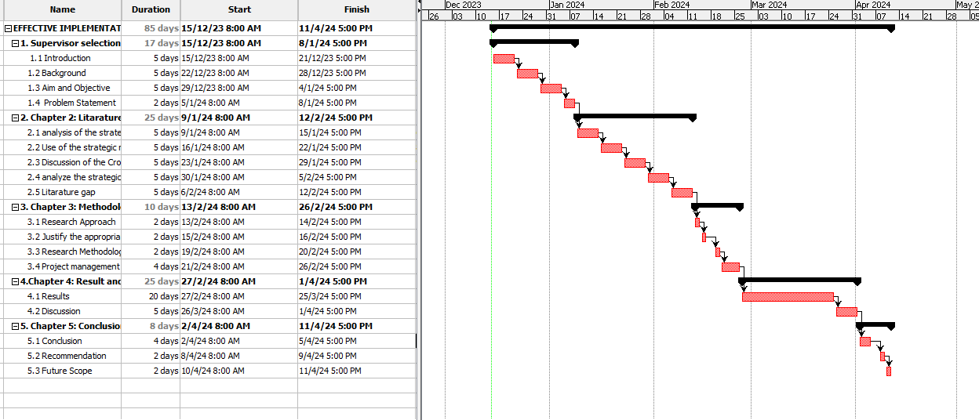
Figure 1: Visualization Of the Time Plan
(Source: Self-Created)

Budget Determination
The budget that could be used for this particular study to be conducted could range from $250-350. As here the survey analysis is being done that is why the mention of the cost has been mentioned other than there are no noticeable expenses related to the study.

References
Aporbo, R., 2022. Discourse analysis of fast food advertisements. Discourse analysis of fast food advertisements, 111(1), pp.18-18.
Borbon, N.M.D., 2020. Impact assessment on the beneficiaries of the Sanayang Kabuhayang Industriyal Program. Asia Pacific Journal of Multidisciplinary Research, 8(2), pp.77-85.
Do, T.K.C., Herat, S. and Kaparaju, P., 2021. The Current Use and Management of Single-Use Items (SUIs) in the Fast Food Industry in Ho Chi Minh City, Vietnam. Nature Environment & Pollution Technology, 20(3).
Gomez, D.M.R. and Quintos, D.G., 2023. Workplace Bullying: Impact on Productivity, Teamwork, Sales and Income among Food Service Industry. Journal of Business and Management Studies, 5(5), pp.78-96.
Khan, M.A., Sobaih, A.E.E., Lee, K. and Ha, I., 2022. Cultural differences and McDonald's: a multi-country comparative study. International Journal of Business and Globalisation, 31(4), pp.391-411.
Le, T.M.H., Nguyen, V.K.L., Le, T.T.H., Nguyen, T.T.H. and Vu, K.N., 2023. Customer satisfaction and fast-food restaurants: an empirical study on undergraduate students. Journal of Foodservice Business Research, 26(6), pp.771-792.
Mina, J.C. and Campos, R.B., 2020. Promotional Mix and Industry Practices of Leading Fast–food Industry in the Philippines: A Case of NE Pacific Mall, Cabanatuan City, Nueva Ecija. American International Journal of Business Management (AIJBM), 3(12), pp.08-18.

