DIGITAL SURVEYING &
HIGHWAY DESIGN ASSIGNMENT

Prepared for
ACBA4017
Digital Surveying & Highway Design
University of Wales Trinity St David
Swansea

Prepared by
Emma Mackay
2410357

January 5, 2025

TABLE OF CONTENTS
Table of Figures iii
Part 1 – Planning the Survey 1
1. Introduction 1
2. Purpose of the Survey 1
3. Survey Area Definition 1
3.1 Scope of the Survey 1
3.2 Required Level of Detail 2
3.3 Constraints and Assumptions 2
4. Site Assessment 2
4.1 Access Points 2
4.2 Proposed Scanner Positions 2
4.3 Environmental Conditions 2
4.4 Safety Considerations 3
5. Risk Assessment Summary 4
Risk 4
Potential Impact 4
Likelihood 4
Mitigation Measures 4
6. Methodology 5
7. Expected Deliverables 5
Part 2 – Practical 6
1. Survey Execution Summary 6
2. Adaptations Made On-Site 6
3. Problems Encountered and Responses 7
Part 3 – Measurement and Analysis 8
1. Measurement Extraction 8
2. Accuracy Discussion 9
3. Comparison with Traditional Methods 9
Conclusion 9
References 10
Appendices 11
Appendix A – On-site Manual Measurement Records 11

Table of Figures
Figure 1: Exterior View of the Dylan Thomas Centre, Swansea (Hisgett, 2022) 1
Figure 2: Floor plan of the second-floor corridor with red 'X' marking the laser scanning positions 6
Figure 3: Dimensioned floor plan of surveyed second-floor corridor (derived from point cloud data) 8

Part 1 – Planning the Survey

Introduction
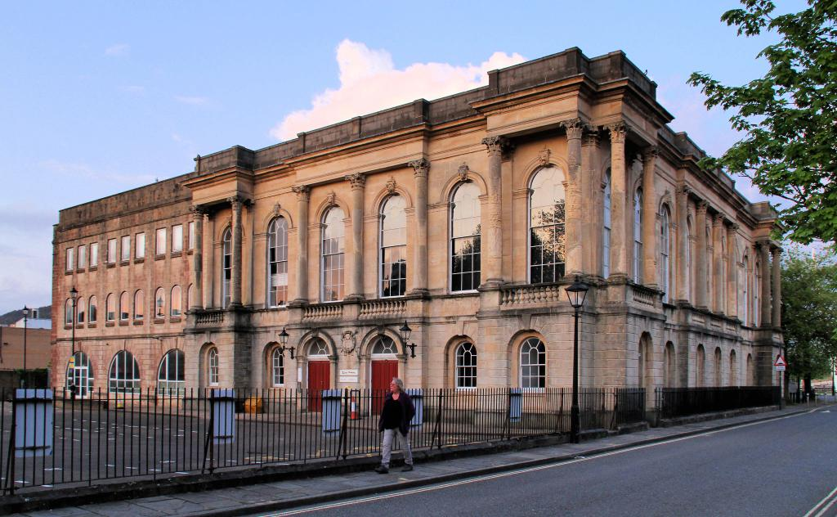
A survey will be carried out at the Dylan Thomas Centre, a Grade II listed building and museum in Swansea, Wales. This document is a professional survey plan that will capture highly accurate spatial data to create a digital record of the building’s existing condition. Laser scanning allows precise measurements of internal spaces and architectural features, producing a detailed point cloud for design and documentation. The objectives of the survey are to obtain detailed ‘as-builts’, reduce the need for visits or repeated site visits, cut down human errors made by manual measurements, and support digital technology systems such as BIM modelling and CAD drafting. This professional survey plan will detail the purpose of the survey, the scope, site conditions, logistics, safety factors, and methodological approach necessary for carrying out the professional digital building survey.
Figure 1: Exterior View of the Dylan Thomas Centre, Swansea (Hisgett, 2022)

Purpose of the Survey
A terrestrial 3D laser scanner will be used to capture the exact shape, size and position of the corridor. The output of the survey will be a point cloud file, where a floor plan and section cuts can be made. This will allow precise measurements to be taken of the internal layout, including corridor dimensions, openings, and architectural features.
This survey is needed due to refurbishment plans for the existing corridor of the second floor of the Grade II listed building. CAD drawings will be able to be produced and documented, and an existing conditions model via BIM can be made, where design proposals for the refurbishment will be able to be added to the BIM model and used for reviews.

Survey Area Definition

3.1 Scope of the Survey
The perimeter corridor on the second floor of the museum is to be surveyed. It excludes any rooms or stairways behind doors that are a part of the corridor, except for details such as their openings. The survey is to cover the whole area between the spiral stairway and lift area, passing through the theatre doors to the fire escape stairs area, multiple rooms in the core, and looping back at the spiral stairway area.

3.2 Required Level of Detail
The survey will capture precise X, Y and Z coordinates to provide corridor dimensions with an accuracy of approximately 10-15mm. Structural elements and architectural features, including irregular or non-square surfaces, will be captured within the point cloud. Included in this plan are all openings in the corridor space, including the exact height, width, and location of all doorways, windows, and other openings.

3.3 Constraints and Assumptions
Possible constraints of the survey are the doors. Multiple doors are positioned at a variety of positions, such as corners and midpoints of the corridor. Therefore, multiple scans will be needed at a variety of different positions and angles to cover the details of the whole area. Door stoppers are a requirement so that the doors can remain open during the laser scanning, and that the whole length of the corridor can be scanned and included in the final point cloud model.
Unrequired elements such as adjacent stairways, occupants, and wall-mounted objects may be captured. Through being a literary museum and a learning space for students, there may be timetable restrictions. It is advised that the building remain closed during the survey to avoid any interference with the survey and equipment.

Site Assessment

4.1 Access Points
The survey team will be able to access the corridor in multiple ways. Access is available via the fire escape stairs connecting the ground and second floors. They can be accessed by walking through the main entrance of the building or via the fire exit door at the back of the building. Another access point is the spiral staircase, which begins on the ground floor by the main entrance and leads to the second floor. However, the spiral staircase area is narrower and limited for the survey equipment compared to the fire exit stairs. The advised access point is the fire exit stairway or the lifts.

4.2 Proposed Scanner Positions
The corridor perimeter is of a rectangular shape with 4 main edges and 4 corners. To cover all areas of the corridor in the laser scan and capture it with the accuracy required in the survey, 8 scanning positions are predicted. One at each midpoint of the long corridor edges, and one at every corner. This is to cover all blind spots of the corridor area and allow for easier combination of datasets in the point cloud software. Various positions and angles will ensure complete coverage in complex areas.

4.3 Environmental Conditions
The lighting conditions of the building are well-lit and bright, with no major surface reflection. There are possible reflections of the ceiling lighting on windows, posters and pictures hanging on the walls, but this will be confirmed on site. Carpets on the floor are of a dark navy colour, so details such as condition and quality may not be captured unless additional bright lighting is used.

4.4 Safety Considerations
The laser scanning equipment set up, such as the tripod, is a trip hazard in the narrow corridors. It may also be heavy and restrict the user’s view whilst being transported to a different scanning position. Considerations will be needed if working around the public/staff, so that no persons are injured by the equipment, and no accidents happen. Severe wet conditions are forecasted in the area; therefore, the equipment will need to be in a waterproof casing, dried and assembled indoors to reduce the chance of electrical damage or accidents.

Risk Assessment Summary
Risk | Potential Impact | Likelihood | Mitigation Measures
Trip hazards (tripod, cables, uneven floors) | Injury | Medium | Mark scanning positions clearly, keep set up tidy, avoid positioning equipment in walkway blind spots
Interaction with the public or staff | Collision, disruption/obstacle to scanning | Medium | Conduct survey during unoccupied time periods, use warning signage, give awareness
Manual handling of equipment (laser scanner, tripod) | Injury | Low | Use correct lifting techniques, avoid restricting vision
Confined spaces or restricted access | Limited coverage of scan, risk to safety | Medium | Pre-inspect spaces, avoid unsafe areas, avoid positioning in blind spots
Reflective surfaces or poor lighting | Scan quality is reduced, mistakes in identifying | Low | Adjust scan positions, increase overlap of scan, check data on site
Electrical hazards | Electric shock or damage to equipment | Low | Avoid cables, inspect surroundings visually before setup
Equipment instability | Damage to equipment | Low | Ensure tripod is extended fully and levelled, avoid uneven surfaces

Methodology
A terrestrial 3D laser scanner will be used to capture accurate spatial data of the existing corridor by emitting laser pulses and recording their return, generating a dense point cloud of the surveyed environment (PointSCAN, 2025). Before attending the site, the building layout and access conditions will be examined to identify potential constraints to access or line of sight. Survey objectives and the required level of detail will be reviewed, and all equipment will be checked to ensure it is suitable for the site conditions and operational requirements.
On-site, the laser scanner will be mounted and levelled on a stable tripod and positioned at the 8 specific locations to capture 360-degree data from each setup (PointSCAN, 2025). Scan positions have been selected to ensure sufficient overlap between adjacent scans, allowing individual datasets to be aligned during post-processing (PointSCAN, 2025). The survey will be carried out in a systematic order through the building to maintain spatial continuity and reduce the risk of data gaps. Scan resolution will be selected to balance accuracy and efficiency, with a higher resolution used in areas containing complex geometry or key architectural features.
Scan data will be reviewed on site to identify any shadow areas or incomplete coverage, with additional scans undertaken where required. Following completion of fieldwork, all scan data will be securely stored and processed using point cloud software, where individual scans will be registered into a single coordinated dataset suitable for measurement extraction (PointSCAN, 2025).

Expected Deliverables
The survey will produce a registered point cloud of the existing corridor. This dataset will enable accurate measurement extraction and the generation of floor plans and section views. The final point cloud will also be able to be used for CAD drawings and BIM modelling. Supporting deliverables will include site photographs and survey notes documenting any deviations from the original survey plan.

Part 2 – Practical

Survey Execution Summary
The survey plan proposed the use of terrestrial laser scanning to capture accurate spatial data of the perimeter corridor on the second floor of the Dylan Thomas Centre. The planned scope focused on the corridor between the spiral stairway and lift area, extending through the theatre doors and returning to the spiral stairway. 8 scan positions were planned to ensure sufficient overlap and full coverage.
On-site, the survey was carried out closely to the original plan, apart from a few setbacks with the presence of staff and the public. Firstly, the surveyor arrived on site and accessed the corridor by using the lift and assembled the equipment in the theatre room positioned in the corridor. The surveyor took a scan in 7 positions and maintained complete, precise coverage of the whole scope. All data sets received were reviewed between each scan to check the resolution and detail captured. The individual scans were processed using point cloud software and registered into a single coordinated dataset suitable for measurement extraction.

Adaptations Made On-Site
The original scan positions in the plan were altered slightly on-site to get more coverage of the corridor area in fewer scans. A total of 7 scans were completed rather than 8 in the positions shown in Figure 2.
Figure 2: Floor plan of the second-floor corridor with red 'X' marking the laser scanning positions

Problems Encountered and Responses
During the survey, there were multiple interactions with the staff and members of the public as the building remained open. The equipment always remained supervised, and any individuals captured within the scan could be removed during post-processing when the datasets from different scan positions were registered within the point cloud software.
An unexpected health and safety incident also occurred during the survey, when a member of the public experienced a seizure while scanning activities were underway. Although the cause was unconfirmed, the incident highlighted a previously unidentified risk associated with visual sensitivity during scanning operations.

Part 3 – Measurement and Analysis

Measurement Extraction
A floor plan of the surveyed corridor was produced from the processed point cloud data and provided in printed A3 format. Measurements were extracted manually from the scaled drawing using a ruler. Due to the irregular perimeter layout of the corridor, dimensions were recorded as a series of chained linear measurements between changes in wall alignment. Overall extents were measured to establish scale, with local dimensions taken at corners, wall piers, and door recesses to accurately represent the geometry of the space.
The perimeter corridor has a maximum length of approximately 29.1 m and a maximum width of 16.5 m. The clear corridor width along the primary circulation route measures a maximum of 2.0 m, reducing locally to a minimum width of 1.1 m at wall piers and door recesses. Square masonry piers commonly measuring approximately 300 mm x 300 mm and 400 mm x 100 mm project from the perimeter walls at regular intervals. Floor-to-ceiling height is approximately 2.4 m.
Figure 3: Dimensioned floor plan of surveyed second-floor corridor (derived from point cloud data)
Dimensions extracted manually from a scaled A3 floor plan produced from registered point cloud data. Overall dimensions shown in metres. Worked measurement drawings and on-site manual measurement records are provided in Appendix A.

Accuracy Discussion
The floor plan was printed on an A3 sheet at a scale of 1:100, and measurements were taken manually using a ruler and rounded to the nearest 0.5 mm. While the survey plan targeted an accuracy of approximately 10-15 mm at the point of data capture, the accuracy of the extracted dimensions was reduced due to manual measurement from a scaled printed output. At this scale, minor architectural details such as door frames and some wall piers were represented at less than 1mm on the drawing, making precise measurements difficult. Where features could not be reliably measured, they were omitted from the final dimensional values to avoid introducing false prediction. This approach ensured that the reported dimensions reflected conservative or worst-case clearances within the as-built condition.
For improved accuracy and ease of measurement, it is recommended that future measurement extraction be undertaken from larger-scale drawings, such as 1:50 or 1:25, printed on A1 or A2 sheets, or directly within point cloud measurement software.

Comparison with Traditional Methods
The use of laser scanning for the survey of the Dylan Thomas Centre provided several advantages over traditional manual measurement methods.
Laser scanning was a time-effective method of capturing corridor geometry due to its speedy setup, scanning speed, and ability to reduce the need for multiple visits. The process of taking manual measurements using equipment, such as a tape measure, a ruler, or a laser distance meter (LDM), is a tedious and time-consuming method in comparison. Likely because each measurement is taken individually and sketched or noted by hand. Any measurements that are incorrect or missed would require another visit to the site. Laser scanning improved overall efficiency by allowing measurements to be rechecked or extracted later without returning to the site.
The laser scanning allowed complex and irregular features, such as wall piers, door recesses, and non-square geometry, to be captured comprehensively within the point cloud. Traditional manual methods can capture the same, however, they rely on selective measurement and interpretation, increasing the risk of missed or inaccurate recording of features. Laser scanning provides millimetre-level accuracy at the point of capture. However, accuracy in this survey was limited by manual extraction from a scaled printed plan. In comparison, the manual measurements that were taken of the corridor on a separate occasion were more specific and detailed.

Conclusion
To summarise, laser scanning has demonstrated its effectiveness for conducting a professional digital building survey of a complex, irregular corridor within a Grade II listed building. Due to careful planning, on-site data capture, and post-survey measurement extraction, accurate spatial data was collected to support refurbishment and documentation requirements. The survey highlighted the advantages of laser scanning in capturing complete and detailed as-built geometry while reducing the need for repeated visits. Although measurement extraction from a printed floor plan introduced limitations in accuracy compared to direct digital measurement, the data provided a reliable record of the space.
The manual measurements method remains suitable for simple spaces but proves to be less effective for complex or irregular buildings. Laser scanning has shown that it’s particularly better for refurbishment projects and listed buildings where accuracy, completeness, and reduced site disruption are important.

References
Hisgett, T., 2022. Flickr. [Online]
Available at: https://www.flickr.com/photos/hisgett/52061411523/
[Accessed 5 January 2025].
PointSCAN, 2025. A Guide To 3D Laser Scanning. [Online]
Available at: https://www.pointscan.co.uk/a-guide-to-3d-laser-scanning/
[Accessed 2 January 2026].

Appendices

Appendix A – On-site Manual Measurement Records

