
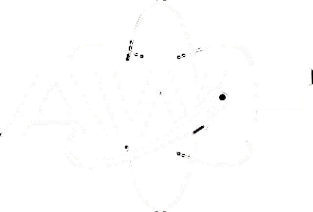
Introduction
A building within AWE’s explosives area has been condemned for several years following the discovery of cracking in its slag arched roof. With a number of projects to uplift AWE’s explosives estate on the horizon, this location has been chosen to develop a suitable procedure for either safely renovating or demolishing legacy buildings whilst considering surrounding explosives facilities. This poster details the process undertaken for this task.

Characterisation and Preparation for the Demolition of an Explosives Facility by Jordan Hayston

University

of Wales

Trinity Saint David

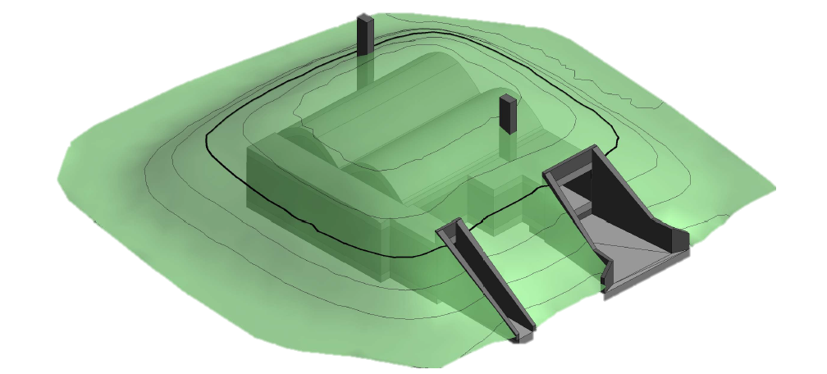
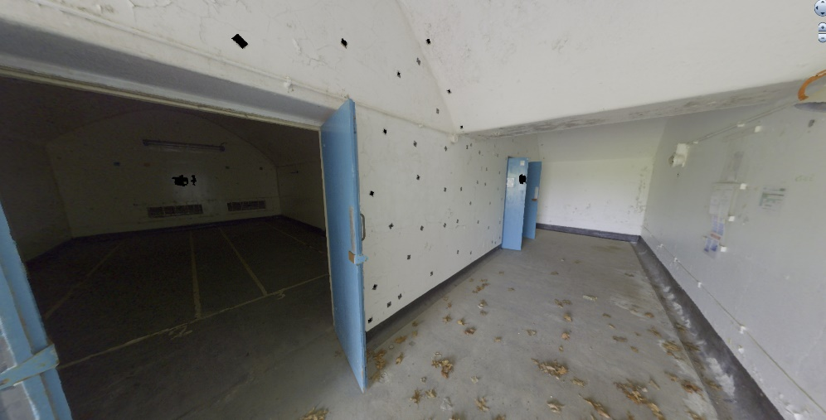
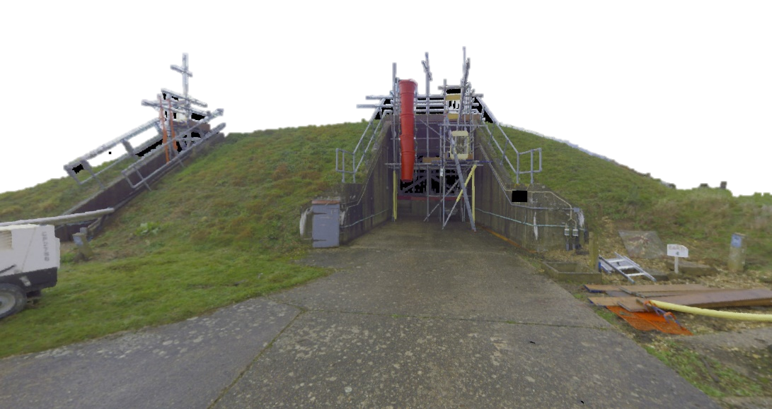
6. Deployment of Personnel within an Explosives Area
5. Hazard Identification & Hazard Operability
4. Explosives Site Licence Variation
- History File
3. Environment &
FFEH
- 3D Scan &
Topographical Survey
First, AWE’s Geographical Information System (GIS) team were tasked to carry out a 3D scan and topographical survey of the building. The intent of the interior scan was to provide an easily accessible 3D image of the location, to allow for remote analysis of the defective structure whilst the topographical survey would provide information on the soil depth of the earth mounding. This information was required to support the decision to whether demolish or renovate the facility.
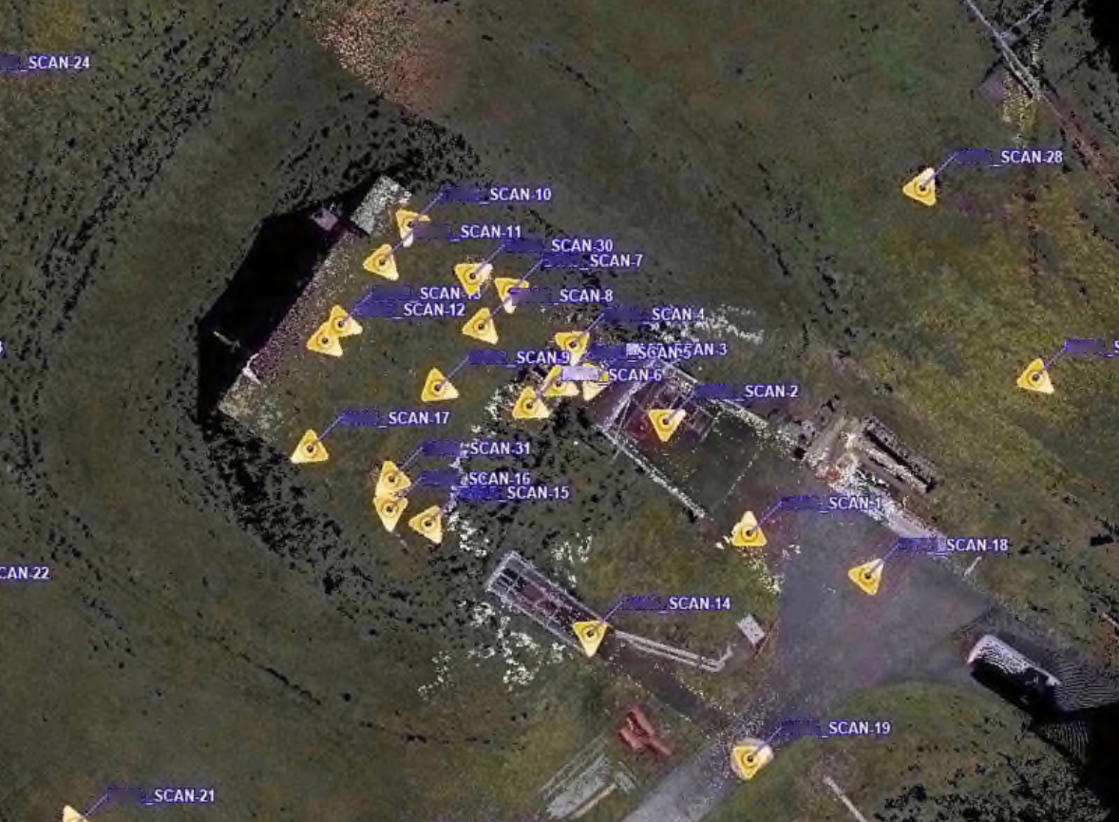
Map of 3D scan points throughout the building
Unfortunately, these tasks suffered severe delays and the results were not of good quality. Consequently, multiple building visits were carried out with blast and structure SMEs (subject matter experts) and the decision to demolish the building was finalised.

Using a wide collection of sources, a history file for the building was produced to outline key aspects of its construction and past use.

The original building drawings identified the design and materials used to erect the facility in 1953, whilst the GIS mapping system showed that live electricity and water supplies were still present. AWE’s Asset Management System (AMS) determined that although electricity still supplied the building, most of the internal devices were disconnected.

The permitted operations within the facility determined that the probability of contamination was low, but not impossible.

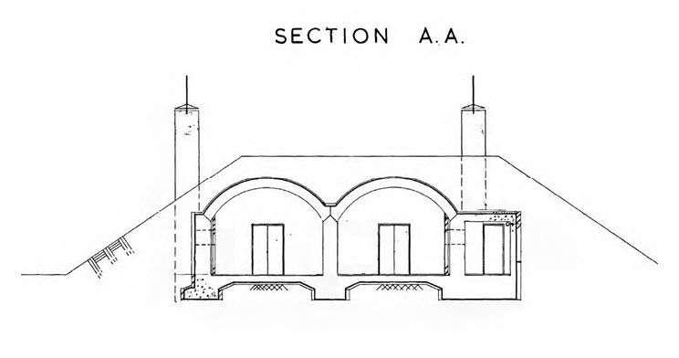
Sample of original building plan

Several environmental aspects of the project were explored, including the requirement for Free From Explosives Hazard (FFEH) certification. A FFEH certificate will be required before any building works can go ahead.

As explosives contamination cannot be fully ruled out, FFEH sampling is required. Surface swabbing is to be carried out first, where one swab can be used up to 1m² and must not return over 0.2mg of explosives. Where heavy contamination is found, intrusive core sampling must be carried out and the area is to be cleaned.

Other areas such as ground contamination and waste routes have been investigated.

A continuous groundwater monitoring programme has ruled out the possibility of contamination from radioactive material, chemicals (including explosives) and asbestos.

All controlled waste must be disposed of in accordance with AWE’s Management System Procedure for Waste Management however, it has also been identified that the building’s earth mounding can be recycled and used to repair other facilities.
To ensure AWE does not breach its explosives site licence, it is imperative that the licence is changed in the correct manner to allow for certain tasks to go ahead.

A licence variation must first be submitted to declare the location as a non-explosives building residing within an explosives area, only once the location has been certified as FFEH. Once the new licence has been confirmed, the demolition works may go ahead.

A second licence variation must be submitted once all demolition works have been concluded, to remove the location from AWE’s explosives site licence altogether.

All licence variations must be agreed with the HSE (Health & Safety Executive), who act on behalf of the ONR (Office for Nuclear Regulation), before the paperwork is formally submitted via AWE’s RICC (Regulatory Interface Co-ordination Centre) office. It is important to note, at this time a licence variation may take up to 18 months to be returned to the business and so this must be factored into the timescales of the demolition project.
A hazard identification study was first carried out to highlight prominent hazards in and around the work location, discounting any relating to the specific construction tasks (not including explosion hazards).

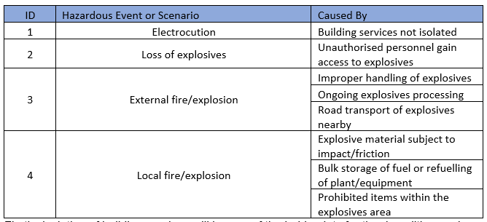
Table of hazards

A hazard operability study was then carried out to determine how the risk from these hazards could be managed. A number of management and engineering controls were applied in accordance with the Explosives Regulations 2014 Safety and Security Provisions (L150 and L151) to achieve an ALARP status.

Based on the decision to demolish the explosives facility, construction tasks were selected whilst detailing the permitted number of personnel required and the timeframe of the project. A total of 12 separate workers were required, however the maximum permitted at any one time could be limited to 6, for a duration of 1 month.

18 explosives licenced locations were found to have a Class D Separation Distance affecting the work location. A scaled distance calculation was implemented which determined that the cumulative risk from these locations was intolerable for 6 persons over 1 month.

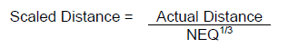
Scaled distance formula
The most hazardous buildings were reviewed to reduce their explosives limits, therefore reducing their Class D Separation Distance to a point where it no longer affects the work enclave.

The reduced explosives limits, in conjunction with a series of management controls, reduced the level of risk to a tolerable level. A Deployment Strategy was prepared, detailing the safety measures in place to allow for the safe deployment of contractors within the explosives area.

