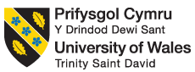

Differences in anxiety levels after a CBT short course.

Alisha Beckett
Student ID: 2104485

Contents
Introduction………………………………………………………………………………………….page 3
Method…………………………………………………………………………………………………page 4
Design…………………………………………………………………………………………………..page 5
Materials………………………………………………………………………………………………page 6
Procedure…………………………………………………………………………………………….page 7
Results………………………………………………………………………………………………….page 8
References……………………………………………………………………………………………page 9
Appendices…………………………………………………………………………………….page 10-13

Introduction

This report looks into anxiety levels within children that have been diagnosed with asperges. The aim of this report is to conclude whether a CBT short course has a positive impact on the anxiety levels within children with asperges. This report will entail into the procedures of recruitment, methods, design and materials that were used to conduct this experiment. (Soronoff K,et al, 2005).

Method

Participants
There were seventy-one children between the ages of ten and twelve with a diagnosis of asperges, that were elected to participate in this study. The selection of children was not gender specific. This study focuses on the anxiety levels within children with asperges before and after a short course of CBT. The parents of the participants had a parent-report of anxiety symptoms for their child which was disclosed in a brief interview.
During the study, the children were randomly allocated to one group to conduct the experiment. There were three groups in total, which were ; intervention for child only, intervention for child and parent and wait-list control. (CAST; Scott, Baron-Cohen, Bolton, & Brayne, 2002).

Design

The design consists of seventy-one children between the ages of 10 and twelve, completing an anxiety symptoms questionnaire (ASQ) before and after participating in a six week course of CBT. (Soronoff K,et al, 2005).

The independent variable in this study was the completion of the questionnaire, completed by the children who participated.

The dependant variable in this study was the level of intensity in the anxiety levels reported, of the children with asperges.

The Wilcoxon signed ranks test will be used to analyse the data that has been collected from this study. The completed version of the Wilcoxon signed ranks test can be found in the appendices. (Soronoff K,et al, 2005).

Materials
To collect data for the participants the anxiety symptoms questionnaire (Baker,et al 2019) was used. The questionnaire was used to record the intensity levels that the participants self-reported. The questionnaire typically records the intensity and frequency of the symptoms for anxiety but for this study specifically, we just looked at the intensity of anxiety levels within children.
Therapists within this study conducted sessions that followed suit of the trainers manual. The therapist had a check list to work through to ensure all factors of the session were covered during the experiment. Twenty-five percent of the sessions conducted by the therapist were recorded by videotape and these were reviewed by independent raters to assess and confirm content fidelity. It was found that around ninety-eight percent of the material that was used for these experiments was accurately covered within the sessions by the therapist.

Procedure
Participants were recruited to take part in this study via the local newspaper, radio and the Asperger syndrome support network newsletter. All of the children that participated in this study had a primary diagnoses of asperges from a paediatrician. A partially structured phone interview was conducted with the parents of the participants, to explain the DSM-IV criteria. A further check with the childhood Asperger syndrome test with factors based on DSM-IV criteria was also used and involved with the questionnaire that was used to carry out this study.
The primary difference between diagnosing a child with asperges and/or high functioning autism is centred around the idea of whether the child had a significant delay in there language development before the age of three. No parents of the participants reported a significant delay in their child’s language before the age of three. However five of the seventy one participants did not meet the symptom score criteria. These children still ended up participating in the study but their collected data was not included within the analyses of the experiment. Parents were also asked if the children, the participants had any other additional diagnoses but regardless of the answer, no children were excluded from this experiment on the grounds of comorbid disorders.
The therapists that conducted the experiment were post-grad students who were completing their second internship. These therapists had enrolled in the clinical psychology programme that was held at the university of Queensland. All of the therapists that conducted these studies, also participated in a one-day training workshop before proceeding with the CBT intervention.
In intervention one, (child only), eight groups were formed, each group consisted of only three children and two therapists. Parents of the participants did not receive any training prior to the experiment , however the therapists did meet with the parents at the end of each session to briefly explain the feedback of the child’s participation. They were also informed about the weekly home based projects.
In intervention two (child&parents), nine groups of three children with two therapists each was formed. The therapist trained parents to work as co-therapists for the intervention. They were instructed to encourage and use specific strategies to encourage successful completion of home based projects
Results
During the experiment two intervention groups showed greater decreases in parent-reported anxiety symptoms during the follow-up of the experiment and also a significant increase in the child’s ability to generate positive strategies and coping mechanisms in an anxiety-provoking situation. There were a lot of differences between the two interventions within the study that was conducted. This result suggests that parent involvement is beneficial to the child with asperges dealing with anxiety related symptoms. (K Soronoff et al, 2005).

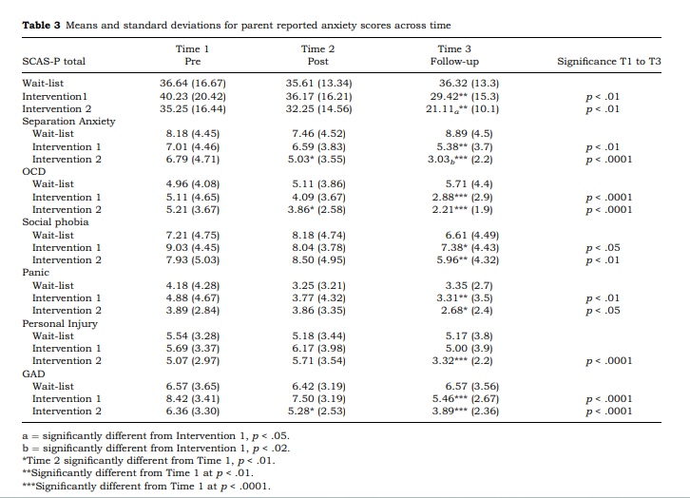

References

Baker A, et al. General Psychiatry 2019; 32:e100144. doi: 10.1136/gpsych-2019-100144
K Soronoff, T Atwood and S Hinton. 2005. ( A randomised controlled trial of a CBT intervention for anixiety in children with Asperger syndrome). Journal of child Psychology and Psychiatry 46:11. Issue Number: 10.1111/j.1469-7610.2005.00411.x. Pages 1152-1160.
Scott, F.J., Baron-Cohen, S., Bolton, P., & Brayne, C. (2002). The CAST (Childhood Asperger Syndrome Test). Preliminary development of a UK screen for mainstream primary school age children. Autism, 6, 9–31.

Appendices

Anxiety questionnaire

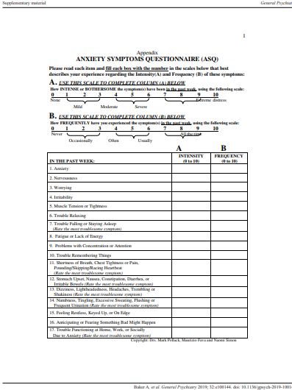

CBT Consent Form

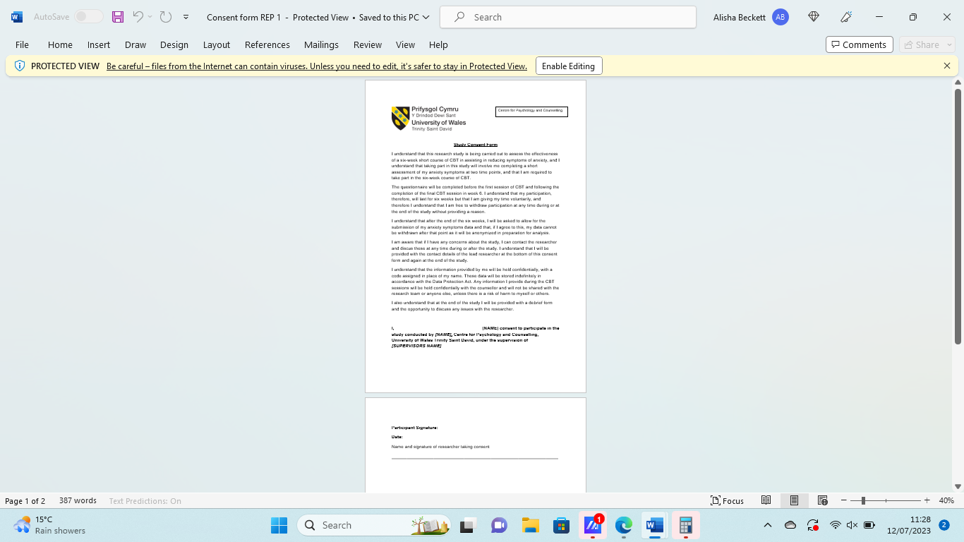

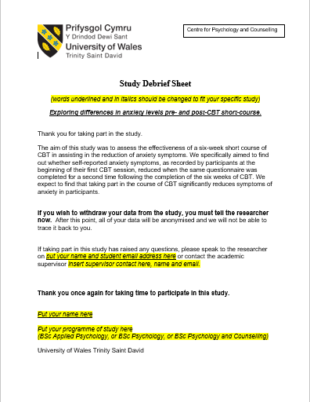
CBT Debrief Form

Report 1 Data: Wilcoxon Signed Ranks Test

P | Anxiety BEFORE CBT | Anxiety AFTER CBT | Difference | Order | Rank | Sign
1 | 100 | 80 | 20 | 1 | 3 | 3
2 | 56 | 46 | 10 | -1 | 3 | -3
3 | 111 | 110 | 1 | 1 | 3 | 3
4 | 80 | 84 | -4 | 1 | 3 | 3
5 | 54 | 50 | 4 | -1 | 3 | -3
6 | 40 | 41 | -1 | -2 | 7 | -7
7 | 21 | 23 | -2 | -2 | 7 | -7
8 | 35 | 29 | 6 | 2 | 7 | 7
9 | 34 | 30 | 4 | 3 | 9 | 9
10 | 45 | 25 | 20 | -4 | 12.5 | -12.5
11 | 81 | 74 | 7 | 4 | 12.5 | 12.5
12 | 64 | 60 | 4 | 4 | 12.5 | 12.5
13 | 27 | 31 | -4 | 4 | 12.5 | 12.5
14 | 58 | 60 | -2 | -4 | 12.5 | -12.5
15 | 51 | 50 | 1 | 4 | 12.5 | 12.5
16 | 101 | 81 | 20 | -5 | 16 | -16
17 | 49 | 48 | 1 | 6 | 17.5 | 17.5
18 | 84 | 80 | 4 | 6 | 17.5 | 17.5
19 | 29 | 39 | -10 | 7 | 19 | 19
20 | 40 | 45 | -5 | 10 | 20.5 | 20.5
21 | 68 | 65 | 3 | -10 | 20.5 | -20.5
22 | 27 | 28 | -1 | 20 | 23 | 23
23 | 12 | 10 | 2 | 20 | 23 | 23
24 | 56 | 50 | 6 | 20 | 23 | 23

W+ = 218.5
W- = 81.5

So W = 81.5
Critical value W = 91
Our calculated W=81.5 which is smaller than the critical value (91) therefore there is a significant change happening between anxiety levels before and after the CBT short course.

