A comparison of the marketing methods of two multinational hotel brands
Name: Azeb Atsebha
Student ID: 2234854
Module Title: Marketing Essentials BMIH4005
DALE CLARKE
WORD COUNT: 1650
INTRODUCTION
This essay attempts to compare the marketing methods for two multinational hotels, the Holiday Inn and Six Senses, both of which were founded in different countries. For this comparison, SWOT and PETELE tools shall be used.
The brand was founded in 1952 by Kemmons Wilson in Memphis Tennessee. The hotel after a decade spread to over 1200 locations worldwide. Presently, Holiday Inn is a member of the intercontinental hotel groups (IHG). The IHG manages 5,900 hotels distributed over 100 countries globally ​(Hotel Chamtel, 2023)​.
However, Six Senses was first established in 1995 in Soneva Fushi,Maldives ​(Six Senses, 2022)​. Its aims to take customers beyond their feelings by reawakening feelings for emotional disconnection and reconnection. Moreover, it now manages 16 hotels and resorts (1,347 rooms) in 12 countries. Apart from its fame for comprehensive treatment and locally driven therapies, it provides yogic, longevity and multi-day retreat activities ​(Six Senses, 2022)​.

Body
First explained by Learned et al, SWOT (strength, weakness, opportunities, and threats) is a tool used in business to assess and address complicated issues for improvement of decision-making ​(Helms, Nixon 2010)​. On the strengths, Holiday Inn owns comfortable modern facilities, 1,234 hotels (224,855 rooms) and accommodates over 100 million yearly. (Gowrea 2021)​. In addition, it has highly experienced employees, unique product, and visibility (​MBA Skool Team 2020)​.
Regarding weaknesses, Holiday Inn client’s recent feedback has shown dissatisfaction about poor customer service, lack of carparking pace, smelly rooms etc, (Trustpilot, 2023). Other weaknesses include hacking of customers’ visa cards and poor hygiene standards ​(Gowrea 2021). ​ Opportunity-wise, it could expand in the current market as more travellers are interested in new destinations. Primary threats for the brand include many competitors and continuous rise of operational costs. It is important to note that other budget hotels have more expansion rates than Holiday Inn and that the numbers of tourists have reduced because of natural and manmade catastrophes (Gowrea 2021; MBA Skool Team 2020)​.
However, Six Senses Hotel’s SWOT analysis shows a strength of persistent upgrading and creativity, rotational assignment of staff, customised clients experience and advancement of green tourism. However, the weaknesses are reduced shares in the USA and European markets and high operational costs. Whereas the opportunities include rising needs in America and Europe and increased consciousness of green tourism, the threats comprise increased numbers of competitors in Asia and the Middle East and high numbers of new competitors with the same business concepts (Blogmarketing9113BC_10.3 2019). More information about the SWOT is found in appendix 1

PESTLE analysis looks at political, economic, social, technological, legal, and environment facts that affect hospitality industry. Politically, there are various methods a government could take to control the hospitality industry such as legislation and enactment of policies on business, real estate, conservation of archaeological materials and revenues. The arrival of tourists and travellers to a country improves economic growth through cash injection into hospitality and other sectors. But, during economic crisis, number of people eating out gets reduced. Cultural orientations affect access to hospitality sector and thereby quality of services and products it provides. Technological advancement has helped people to do online booking for their tables in restaurants. Many people order their food via Uber Easts, Just Eat, Hungry Eat etc. Similarly, technology enables hotels to reduce their workforce as some tasks are being done by machines, thus allowing for more efficiency. Apart from the huge water, electricity and fuel, hospitality sector produces much wates in from of food, water, furniture and appliances. When it comes to legal issues, hospitality industry must adhere to lots of regulations on food hygiene standards, gas safety regulations 1998 and health and safety at work act 1974 (Howandwhat, 2023) It also has its laws and code of conduct that regulate the work of its staff as well as its engagement with other partners. environmentally, Holiday Inn is committed to respecting and managing effects for the welfare of the communities. It does this by adopting environmentally friendly designs and operations (IHG, 2023). In contrast, Six Senses hotel has a policy of zero-tolerance of plastic (Six Senses, 2023).
The ‘marketing mix’ phrase was first introduced by Neil Borden in 1953 then Mcarthy (1964) explained its 4 P’s, product, price, place, and promotion as “a combination of all the factors which managers may leverage to satisfy market needs”. Booms and Bitner in 1995 added more 3P’s namely people, process and physical evidence e’s to make marketing mix tools 7P’s. Because it is easy to use and understand, marketing mix 7P’s have largely been accepted and applied globally (Jain Majoj, 2013; Gandolfo Dominici 2009). While product refers to goods and services a hotel provides to its users, price is money clients have to pay in return for the services. Place means the undertakings and partnerships that take the product closer to consumers, just like Holiday Inn’s partnership with IHG. Promotion amplifies the quality of the product and appeal to the clients to purchase it (Kotler, Phil T., et al. 2020.pp 51-52). Holiday Inn marketing strategy has introduced a multi-million-dollar promotion that requests clients to “look again” at the brand. Independent research revealed that four elements significant to clients are: free access to fast internet; availably of comfortable in-room workspace; complete range of services, conference halls and strong rewards programme. However, according to large-scale research, hospitality clients consider Holiday Inn a family leisure place.
Holiday Inn excels in innovation in the sector, and it plans to shout it on rooftops. It has a well-managed televised promotion in Fallon Minneapolis that advertises its services. Additionally, its marketing engagement has expanded by carrying the ‘Look Again’ campaign into consumers’ lives through sponsoring of the NASCAR Series Major League Baseball. Moreover, the new brand ‘look again’ no 29 Holiday Inn Chevrolet with Jeff Burton and Richard Childress as drivers is reaching the strongholds of 75 million baseball supporters (UK Essay.com, 2015).
However, Six Senses has three brands: resorts, spas, and residences all of which are designed to keep guests wanting to return. It promotes its products via Travel & Leisure magazine, press releases from its public relation office and social media like Facebook etc. It is considered the best luxurious wellness and hospitality brand. It was voted by Travel & Leisure readers as the No (1) hotel worldwide. Six Senses on social responsibility aspects
According to Blythe (2019) market segmentation aims to divide customers into subsets based on their common wants and needs. The goal of market segmentation is to narrow a business's focus to a subset of consumers whose demands may be satisfied by a specific service. Segmentation can be done on many different dimensions, but here are some of the most common ones: geographic, demographic, psychographic and behaviour customer. Demographics can be divided into geographically distinct groups. Climate, location, and population are the three main subcategories of geography (Brassington, 2006, p. 198).
The geographic features of Holiday Inn (53.4%) and Sex Senses (46.6%) are as per the UK show tariff share of 6.01%. Demographics provides additional information on the client and the customer's household based on demographic and socioeconomic indicators such as age, gender, race, income, occupation, and family composition. Appendixes 2 & 3 contain demographic descriptions of the differences between Holiday Inn and Sex Senses Hotels. Psychographic or lifestyle segmentation is challenging to put down due to the presence of intangibles like customers' hopes, expectations, and biases (Brassington, 2006, p. 203-204).
Since Six Senses' market segmentation is conducted based on clients' lifestyles and psychological attributes like willingness to shift or nervousness, the psychographic factor plays a crucial role. Six Senses focuses on couples by offering a relaxing and romantic environment. As a result, the resort is a popular location for weddings, anniversaries, and other milestone celebrations between partners (Blogmarketing9113BC_10.3, 2019). Whereas The Holiday Inn chain is a popular choice for both business and vacation tourists (IvyPanda, 2022).
Behaviour segmentation is how a customer feels about the product. People with similar demographic and/or psychographic characteristics may nevertheless react differently to the same product, therefore this is an issue that needs to be addressed. Thus, the phrase "behavioural segmentation" is used to describe the process of dividing a market up in this way (Brassington, 2006, p. 207)
According to (Jobber, 2019) The selection of target markets is a crucial part of any successful marketing plan, and market segmentation is a means to this purpose. In order to determine which segments to focus on, businesses must first learn about them.
Bowman’s strategy clock is a tool meant for a company’s market positioning by giving a choice between a price and value of a product (Product Mindset's Newsletter 2022).
Comparing the price of a room in the two hotels in Rome, Italy, one night for one guest without breakfast in Holiday Inn is £194 (Holiday inn 2023) ,whereas in Six Senses it is £1,266.31. The room in Six Senses is more expensive by £1072.31 (Six Senses, 2023)

Looking at the Bowman’s strategy clock, Holiday is more likely to fall under hybrid position (No 3),while Six Senses falls within focused differentiation position (No 5)

Conclusion
Holiday Inn and Six Senses hotels are big multinational hotels and members of the IHG. Both have business in many countries worldwide. Whereas Holiday Inn is technologically innovative and socially centred, Six Senses is well known for plastic freedom. Holiday Inn’s clients are on increase, but Six Senses’ have decreased because of disasters.
Holiday Inn does its promotion through ‘look again’ campaign by funding NASCAR series, TV programmes. However, Six Senses promotes its brand through Travel & Leisure magazine, social media and public relations office. Holiday Inn is a budget hotel, whereas Six Senses is expensive. A comparison of a price of one room for one night in each hotel in Italy was made. Six Senses was 73% more expensive than Holiday Inn. Using Bowman’s strategic clock, Holiday Inn provides a differentiated service with a reasonable price, making it more competitive than Six Senses.

References

Blogmarketing9113BC_10.3 (2019). Internal Analysis of the Six Senses Available at: https://sixthsense513094188.wordpress.com/2019/11/17/internal-analysis-of-the-six-senses/ (Accessed 09th April 2023)

Blogmarketing9113BC_10.3 (2019). Differentiation & Positioning of Six Senses Available at: https://sixthsense513094188. Wordpress.com (Accessed 09th April 2023)
Blythe, J., (2019). Essentials of Marketing, In: S. edition, ed. E-Book. Harlow, England, New York,: Pearson Education, p. 1.

Brassington, F., (2006). Principles of marketing. In: 4. Edition, ed. New York: Prentice Hall, p. 197.
Jobber, D., 2019. Principles and practice of marketing. In: N. edition, ed. Maidenhead: McGraw-Hill Higher Education, p. 218.

Dominici, Gandolfo,(2009) ‘From Marketing Mix to E-Marketing Mix: A Literature Overview and Classification’ International Journal of Business and Management, Vol. 4, No. 9, pp. 17-24, 2009, Available at SSRN: https://ssrn.com/abstract=1961974
​​
​​GOWREA, V., (2021). SWOT analysis of Holiday Inn (Holiday Inn SWOT).

​HELMS, M.M. and NIXON, J., 2010. Exploring SWOT analysis - where are we now? A review of academic research from the last decade. Journal of Strategy and Management, 3(3), pp. 215-251.

​Helms, Marilyn M, Nixon, Judy, (2010).’ Exploring SWOT analysis – where are we now? A review of academic research from the last decade ‘Journal of Strategy and Management Vol 3 215- 251p DOI:10.1108/17554251011064837

Holiday inn (2023), holiday inn Rome.Available at:https://www.ihg.com/ holidayinn/hotels /gb/en/rome/romdm/hoteldetail? fromRedirect=true&qSrt=sBR&qRms= 1&qAdlt= 1&qChld=0&qCiD=18&qCiMy=042023&qCoD=19&qCoMy=042023&qAAR=6CBARC&qRtP=6CBARC&setPMCookies=true&qSHBrC=HI&qDest=Viale%20Castello%20Della%20Magliana%2065,%20Rome,%20IT&qpMn=0&srb_u=1&qPm=romdm (Accessed 19th April 2023)

Hotel Chamtel (2023). What Hotel Group is Holiday Inn. [Online] Available at: https://hotelchantelle.com/what-hotel-group-is-holiday-inn/ (Accesses 8th April, 2023).

How and what (2023) PESTEL analysis of the hospitality industry Available at https://www.howandwhat.net/pestel-analysis-hospitality-industry/ (Accessed 05th May 2023)

IHG (2023) Policies and positions statements Available at https://www.ihgplc.com/en/responsible-business/policies-and-position-statements (Accessed 05th May 2023)

Ivypanda (2022) Intercontinental Hotels Group: Market Segmentation, Targeting and Positioning Research Paper Available at https://ivypanda.com/essays/hotel-management-4/ (Accessed 05th May 2023)

Kotler, P.T. Armstrong, G. Harris, L.C and He H. (2020). Principles of Marketing, .8th ed, Harlow: United Kingdom Pearson Education Limited, p. 51-52
MBA SKOOL TEAM, (2020), Holiday Inn SWOT Analysis, Competitors & USP.

Product Mindset's Newsletter (2022) what is bowman’s strategy clock. Available at: https://productmindset.substack.com/p/bowmans-strategy-clock (Accessed 19th April 2023)

Six Senses (2022) What's the story of Six Senses? Available at: https://www.sixsenses.com/en/about-us/history (Accessed 19th April 2023)

Six Senses (2023) Six senses sustainability plastic freedom Available at https://www.sixsenses.com /en/sustainability/ plastic-freedom (Accessed 07th May 2023)
Six senses (2023), Six Senses Rome Select accommodation. Available at: https://www.sixsenses.com/en/hotels/rome (Accessed 19th April 2023)

Trustpilot (2023) Holiday Inn Reviews. Available at https://uk.trustpilot.com/review/ .holidayinn.com (Accessed 05th May 2023)

UK Essays.com (2015) Marketing strategies of Holiday Inn Hotel Available at: https:// www.ukessays.com/essays/marketing/marketing-strategies-of-holiday-inn-hotel-marketing-essay.php (Accessed 05th May 2023)

Appendixes
- Holiday Inn SWOT
Strengths | Weaknesses
- Cosy contemporary facilities that meet clients' expectations.  - Has 1234 hotels, 224,855 rooms worldwide,  - Benefits from the effective management of IHG  - Holiday Inn Club Vacations and others promote group’s reputation.  - Steady annual income increased from 2009  - Highly experienced employees  - Unique product and visibility because of effective promotion  - Benefiting from intercontinental (Related Party) new business opportunities. | - Weak digital security – clients’ visa cards compromised.  - Issues in hygienic standards (In Birmingham, England, one hotel found not conforming)  - Issues with health & safety authority.  - Loss of emotional appeal ( many customers in review complained about many issues)
Opportunities | Threats
- Potential to expand in the current markets as there are more travellers interested in new destinations.  - Ability to invest in more hotel bedrooms | - Many competitors in the hotel industry such as Travelodge, Premier Inn  - Continuous rise of operational costs  - Expansion of other budget hotels more than Holiday Inn  - Numbers of tourists reduced because of catastrophes.  - Legal issues on trademark (accusing another company of illegally receiving money from vanity phone)
​​(Gowrea 2021, ; MBA Skool Team 2020)​.
https://pro.similarweb.com/#/digitalsuite/websiteanalysis/audience-demographics/*/999/3m?webSource=Total&key=holidayinn.com,sixsenses.com
- Age distribution
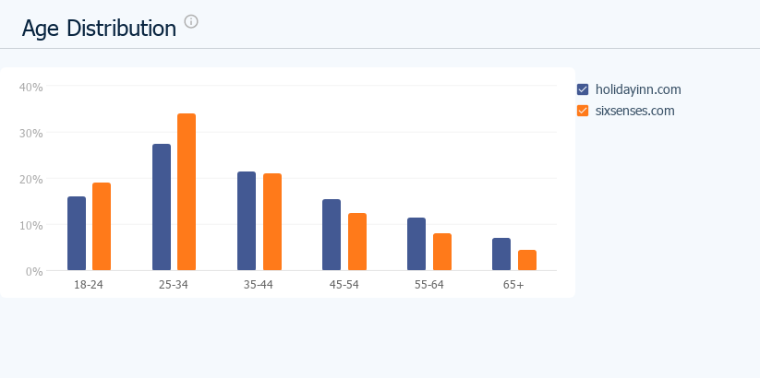

- Gender distribution
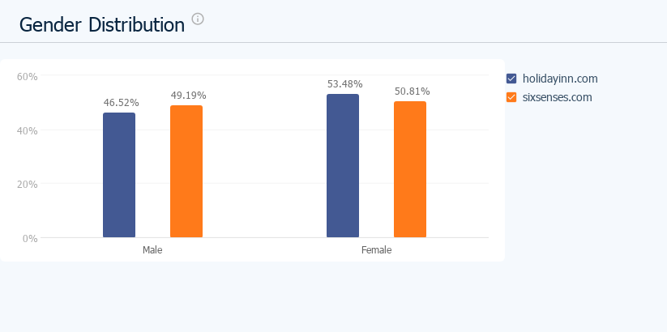

Bowman’s strategic Clock
- Diagram of Bowman’s strategic clock
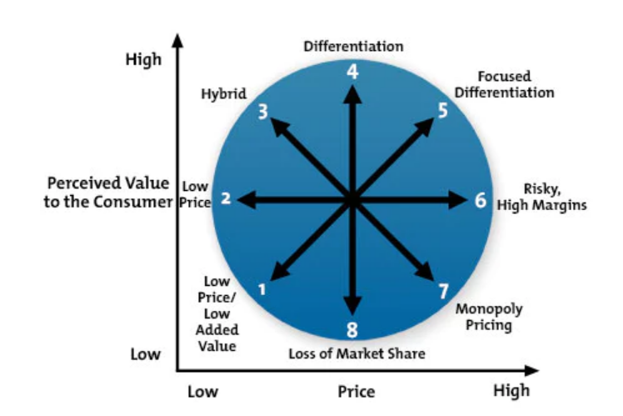
(Source: Mindtools, 2023)

