A consultancy project aiding Seaside café through Brexit


June 2020
MODULE NAME: Consultancy project
Name: Jack dean gilmore-jones
Student Number: 1706465
word count: 5944

Executive summary
The project was initiated in the hope of aiding Seaside Café a small business operating in Llanelli. With the business-facing large uncertainty due to the government letting them down by providing no advice or support in what is the largest political event in the UK's history, it will have large economic repercussions on businesses throughout the world.
The project was presented with one overall aim, which was to remove the uncertainty surrounding this event. It then had 3 objectives which would then work coherently to achieve the aim of removing uncertainty. The 3 aims were, how will it affect the customers, how will it affect the employees (present and future) and how will it affect the supply chain of the business. These objectives were analyzed using analysis "tools" the three tools used within the project were, a PESTLE analysis, PEST analysis, and a SWOT analysis, these gave the report structure and enabled the report to cover every aspect that could affect the business.
The project had to be adjusted heavily due to the Covid-19 pandemic, the primary research was changed so that the business could still get a grasp of the thoughts of the public, as well as what was going through the minds of their customers. The business was then advised on how to eliminate the problems that were prevalent with the primary research. For example, it was advised that the employees should be highly re-assured about their job position, as this was a large aspect in the confidence of their hospitality within the UK as financial insecurity was a major concern regarding Brexit. And due to lower migration due to Brexit the potential employee pool being drastically cut.
The uncertainty was measured with a rating system of 1-10. The project had a high of 5, this occurred when the business was informed of potential implications that could affect the business, and at the end of the project, there was a rating at 2 which is considered a success as their will always be uncertainty regarding Brexit it is just a matter of how well the business is prepared to deal with it.

Table of contents

1.0 Introduction 1
1.1 Report Remit 1
1.2 Background of the organization 1
2.0 Aim of the project 2
3.0 Main Body 5
3.1 How it affects customers 5
3.1.1 Swot Analysis 5
3.1.1.1 strengths 5
3.1.1.2 Weaknesses 5
3.1.1.3 Opportunities 6
3.1.1.4 threats 7
Findings 3.1.2 7
3.2 How it affects employees (present and future) 10
3.2.1 Findings 10
3.2.2 PEST 12
3.2.2.1 Political 12
3.2.2.2 Economic 12
3.2.2.3 Social 13
3.2.2.4 Technological 13
3.3 How it will affect the supply chain 14
3.3.1 Findings 14
3.3.2 PESTLE 14
3.3.2.1 Political 14
3.3.2.2 Economic 15
3.3.2.3 Social 15
3.3.2.4 Technological 16
3.3.2.5 Legal 16
3.3.2.6 Environmental 16
3.4 Limitations to the project 17
4.0 Recommendations to the business 18
5.0 conclusion 20
References 21

Figure 1:Q3 of the Public Questionnaire 8
Figure 2: Q8 of Public Questionnaire 10
Figure 3:Q6 of the Public questionnaire 11
Figure 4:Q1 of the Public questionnaire 18

Introduction

Report Remit
This report is based upon a consultancy project carried out. The project was based on Seaside Café, which operates within the Llanelli area. The company has been let down by the government regarding information on Brexit. This has caused the business great uncertainty, which in a matter of this political magnitude is disastrous. Small/medium-sized enterprises (SME’s) such as this one are the backbone of our economy and if the UK is to grow from Brexit these companies must be well and truly up to date with matters that affect them. In an interview with the owner was asked:
“Do you feel the Government has given enough information and support to businesses like yourself during this time?”
The owner responded with:
“No, there has not been any support regarding Brexit, we have kind of been left in the dark regarding the matter, the only time we would hear something is from news reports.”
This project aimed to supply the business with information from various primary and secondary sources. The information was tailored specifically for the business allowing them to benefit from the findings further.

1.2 Background of the organization
The owners opened the café in 2015 and have been running it for the last 5 years.
They predominately serve classical English breakfasts, but also venture into home-cooked classics to give variety to the customers. Furthermore, they also offer a delivery service to customers. Their prime target audience tends to be people operating within a trade and pensioners, but during the football season, they often get customers from the nearby football club.
The café usually operates from Monday to Saturday between the hours of 8 am until 2 pm. They also provide a buffet service and are in partnership with Ffos Las Racecourse, where they provide buffets for the Jockeys that participate there. They currently have 5 staff employed with 4 full time and one on a part-time basis. They are quite close-knit within the community and have very limited information online.
The word Brexit originates from the words “British exit” and refers to the process of the United Kingdom leaving the European Union. (BBC, 2020)
The vote to leave the EU was carried out on the 23rd of June 2016 and the UK officially left the EU on the 31st of January 2020. The leave vote was 51.9%, with 48.1% voting to remain. (Bloomberg, 2020)
Brexit has led to uncertain times for businesses within the UK, especially SMEs. SMEs are a crucial part of the economy and makeup about 99.3% of total businesses within the UK and 60% of people employed in the UK are employed by SME's, so make up a crucial part of the UK economy. (FSB, 2020)

2.0 Aim of the project
The overall aim has been developed since the initiation document of the report and is one of the requests of the business.
The owner said there was a lot of uncertainty around Brexit, and with Brexit being a major political event with large economic consequences it is important for them to be up to date. So, the business requested that they could have information regarding Brexit to reduce their uncertainty.
“The UK vote to leave the European Union (Brexit) in June 2016, was an unparalleled political event with potentially seismic consequences for the economy” (R.Brown et al, PG.1, (2018))
Brexit has and will have a large effect on all businesses due to the effects on the economy, and they are somewhat in the dark as they have had very little advice from the government.
With Brexit being publicized so much this can often be very daunting for a small business like this which will have so much on the line. This is supported by the Financial Times as they state. “With many small businesses being let down by the UK with its advice for post Brexit.” (Financial Times, PG.1, (2018))
The project, therefore, aimed to look to consult the business in this aspect by clearing up some of the effects Brexit has had and will continue to have as it develops further. This aim was “Smart”, it was specific in giving the company exactly what it wanted, clear advice on effects of Brexit that would have an impact on them. Additionally, it was decided it would be measured with a rating system developed in communication with the owners.
During meetings with the owner, they gave a rating at the end, to demonstrate their level of uncertainty regarding Brexit. The business agreed with this measure deeming it as fair, especially due to the circumstances surrounding the project, and that the advice given would set them up for the future when normality is resumed, it was additionally realistic as the project can provide statistics to the company from primary and secondary research which will provide the business with useful information regarding how the surrounding market has adjusted and how it will in the future.
It had been ensured to be time-bound by sticking to meetings that correspond with the owner’s desires as well as ensuring that the information was delivered within a good time.
Another one of the aims was to provide the business with an insight on how this will and has, affected their customers. This has again been developed since the initiation document. This will be key for them going into the future as for a small business like this the customers are make or break.
“As a business owner, you’re already aware that your customers are the lifeblood of your business.” (J. Rampton, 2015)
It managed to stay specific by ensuring that it was only financial implications directly caused by Brexit, as well as ensuring it was related to SME’s. This made it more applicable to the cafe.
The objective was measured on how happy the business is, implementing a rating score of 1-10, it was ensured there was substantial information to back up the points that had been put across, by providing primary data in the form of questionnaires filled in by the public, and then secondary research from studies making sure it is put across in a way which was useful for the business to apply. This was additionally developed further from the project’s initiation document ensuring it is “SMART”.
The second aim was targeted on how the employees of the business will be affected. But it also takes into consideration potential future employees. This was additionally developed after the initiation document.
As the telegraph stated that many SMEs will have to rethink their strategy with there being a 95% decrease in EU nationals joining the UK workforce in the first quarter of 2018, compared to 2016. This was a key factor within the report as there is a large migrant population in the area surrounding the café, with there being an influx of around 2000 Polish migrants in just 2013 alone. (Wales Online) With the migration to the area potentially being cut drastically, it could hamper the number of customers that the business is getting, as well as hampering the current and future workforce, with the current potentially having their hospitality within the country threatened. This has the capability of harming the business as the migrant population is such a prevalent part of this area.

3.0 Main Body

3.1 How it affects customers

3.1.1 Swot Analysis
The report evaluates this objective using SWOT analysis, SWOT stands for strength, weakness, opportunities, and threats. (Picketon Et al, (1998))

3.1.1.1 strengths
A strength of the business is they reach into more than one market. With the business operating in the traditional café market, as well as serving buffets and doing takeaway orders. This would allow the business to attract serval different types of customers, this diverse customer base would lead to stability within the business, as, if one of these markets are struggling the others can potentially still provide a solid cashflow for the business. (Frost et al, PG 119-132 (1999))
An additional strength of the business is they are part of a tight-knit community, this causes them to have highly loyal customers due to the ties with the local football club. This would allow the business to be more likely to retain customers and hold an advantage over their competitors within the market.
“loyalty in competitive repeat‐purchase markets is shaped more by the passive acceptance of brands than by strongly‐held attitudes about them” (Uncles, PG1, (2003))

3.1.1.2 Weaknesses
A weakness of the business is, there is relatively high competition in their main market. Operating in a saturated market like this could mean that customers who are not loyal to the business will have other options should they have a negative experience with the company. This competition could also instigate a price war, as the other businesses in the market could lower their prices to gain a higher market share in the area. The business should avoid these as while having a large market share is important, it will also mean that they earn less per sale should they lower their price, instead they should rely on the loyalty of customers to overcome the price war. (Kucher, (2019))

3.1.1.3 Opportunities
In terms of opportunities for the business, they can use social media to put more attention to the buffet section of the business this would lead to a whole new target market. This could additionally lead to the business securing more deals likewise to the current one at Ffos Las racecourse. With deals like this allowing the business to receive a consistent cashflow. Partnerships can lead to a business's "increased competitive advantage" among others in the market, according to the book industrial marketing management. Social media will also allow them to see the demographic (for example, key demographics for the business are age, gender, ethnicity, and location. (Hawlk, 2017)) of the people taking an interest in the business, as well as reaching out to other parts of the audience that was not previously accessible without an active social media.
Furthermore, social media can give a message to your stakeholders in a different light, as it is seen as a more informal method of communication, which is a positive as it will allow stakeholders to see the business from a different perspective, and being within a tight-knit community, As they are, this would be key as it would break down barriers between customer and business, as it would not be seen as such as just a sale to the business and more of a relationship, which would then create value. (Powell et al 2011)
Creating value in your target audience will lead to achieving superior performance within the market. So, should they be able to branch into other markets providing value to several markets within the area they should be able to compete. With them operating as a normal café and now providing buffets, they should be able to use social media platforms to reach to areas they had been unable to before.
A further opportunity for the business is the removal of some uncertainty they have surrounding Brexit; this will contribute to my overall aim in removing the uncertainty surrounding Brexit. This will be done through gaining an insight into the demographics as previously stated, as well as them gaining some insight from this task during the meetings,
The combination of these opportunities would lead to progress towards the overall aim of reducing uncertainty.

3.1.1.4 threats
One of the threats of this is if they do branch into social media it could come at a cost, dependent on whether they hire a professional to run their sites, which could be costly for the business if especially if it does not bring success, which is not guaranteed. Success isn’t always the reward for businesses who opt to use social media, in the book Business Horizons they are quoted saying “U.S. companies spent $5.1 billion on social media advertising in 2013, but a recent Gallup survey revealed that these advertisements had no influence on the majority of the U.S. consumers’ buying decisions” ( Yu-QianZhua et Houn-GeeChenb 2015)
An additional threat to the business will be regarding figure 2, should they need to increase the costs that may be incurred from the introduction of a social media plan that incurs costs, this may result in a reduction of how often current customers visit the business which would be costly to the business, as it will weaken the current customer base they already have. This would also see their rivals within the area gain market share within the local community, Robert Buzzell and Bradley Gale did a study linking companies to market share and discussing the profitability of the businesses, in total there were 57 businesses and it was said they found market share showed an upward trend of profitability. Citing market shares importance for any business

Findings 3.1.2
The bank of England gives an insight into how economic uncertainty can affect people’s spending.
"People's expectations about the economic outlook are important for spending and investment decisions. For example, people might spend less now if they think that their income is likely to be lower in the future." (Bank of England, 2019)
A questionnaire was completed as part of the primary research aimed to give an insight into how the public feel: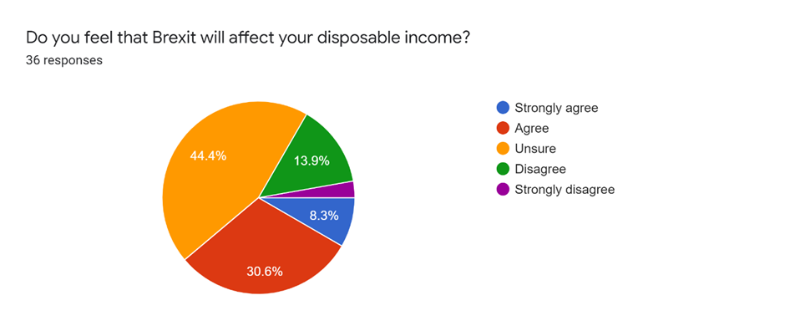

Figure 1:Q3 of Public Questionnaire
While the original plan was to get the questionnaire completed by customers from within the café, this had to be reconsidered as there was not sufficient access to enough customers to obtain a fair result due to the Covid-19 pandemic. It was decided the questionnaire would be carried out via social media instead and would obtain the answers from the public.
The chart shows most of the public are unsure of how Brexit will affect them, with much of the rest agreeing that it affects their disposable income. This has been communicated to the business within the meetings allowing them to see how the public feels in terms of their economic security. This was communicated to the business to show them how a section of the public responded to the question at hand.
To support the point given to the business that uncertainty among consumers leads to a reduction in spending, Murphy's book on Business Economics was used, especially referring to the discussion between the correlation of household debt and consumer spending. With the uncertainty around Brexit shown by the public within this questionnaire, the public within the area has the potential to follow the trend of this study, as the economic uncertainty may spark fears in the public of potential debt, which will then, in turn, reduce the amount the customers will be spending.
Giving the business an insight into how the customers fared throughout Brexit was a key factor in reducing the uncertainty that the business had, as it was a cause for concern for the owner of the business, as during an interview the owner was asked: "Do you feel that Brexit will affect your customers' ability to spend, which will, in turn, affect the amount spent at the Cafe?"
The owner then responded with
“ Yes it will, the area is full of companies who operate within a trade, regeneration projects from the EU would normally give business to these trades, and the stopping of these projects will lead to less income for these businesses, which would then lead to less spent at our business, as they are a big part of the customers we get.”

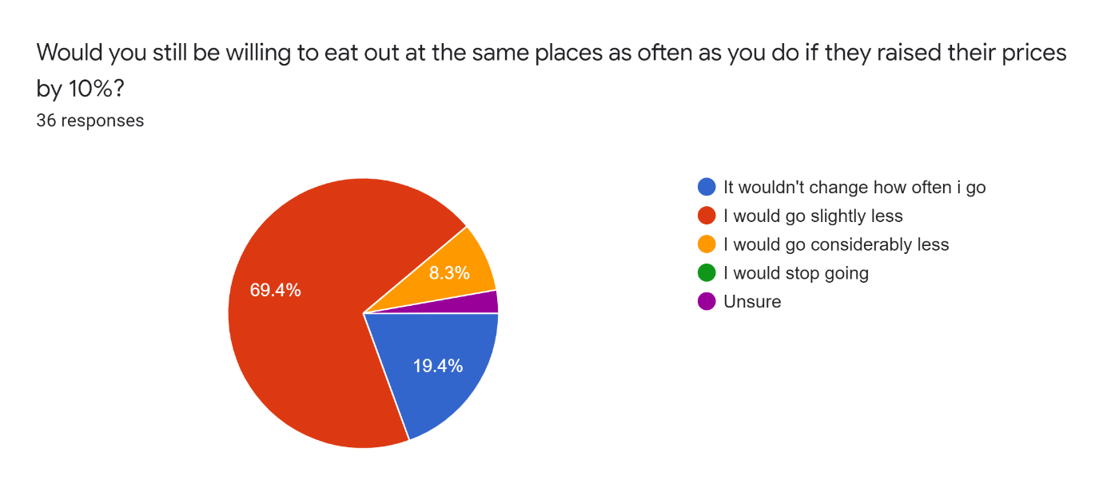

Figure 2: Q8 of Public Questionnaire
This question was additionally asked in the study and was aimed at showing the business how it will be affected, should it have to add to its costs from implications regarding Brexit. The figure of 10% was chosen during an interview with the owner as he deemed it would be an increase the business would consider should costs rise. It shows that if they were to increase their prices by 10% that almost 70% of people would go slightly less, this may be seen as worrying for the business as any additional cost could lead to a reduction in the amount that customers currently visit the café.
Additionally, the Nationwide Caterers Association said that as the price of the pound lowers that the cost will also be felt by caterers. Additionally, it is said it costs more to import the food, which would then have a knock-on effect to the café itself. (NCASS, 2020)

3.2 How it affects employees (present and future)

3.2.1 Findings
Although this was an area that the owner was not concerned with, it was an area that was addressed due to the fact it is an area that was felt that it would highly affect the business. During a one to one interview with the owner he was questioned:
“Do you feel that you will have a smaller pool of potential employees after Brexit?”
The owner responded:
“No, with the cuts from European schemes there will be more unemployment so more potential employees for the business”
While this may be a factor that would lead to an increase in the number of potential employees, many other factors need to be considered.
Uncertainty with employees can be a big problem for a business, with Glenn Llopis saying, “uncertainty makes it difficult for employees to trust the workplace culture and its leadership, which impacts their ability to perform at their highest levels.” (Llopis 2015)
When in an interview with the employees they were asked, “Do you as an employee worry about job security due to Brexit?” and “Do you feel that you and your fellow employees could be affected by Brexit?” the response to both of the questions was no so they seemed fairly confident in their job security, which would suggest that what Forbes said does not apply as much to the employers at the moment but could apply in the future.

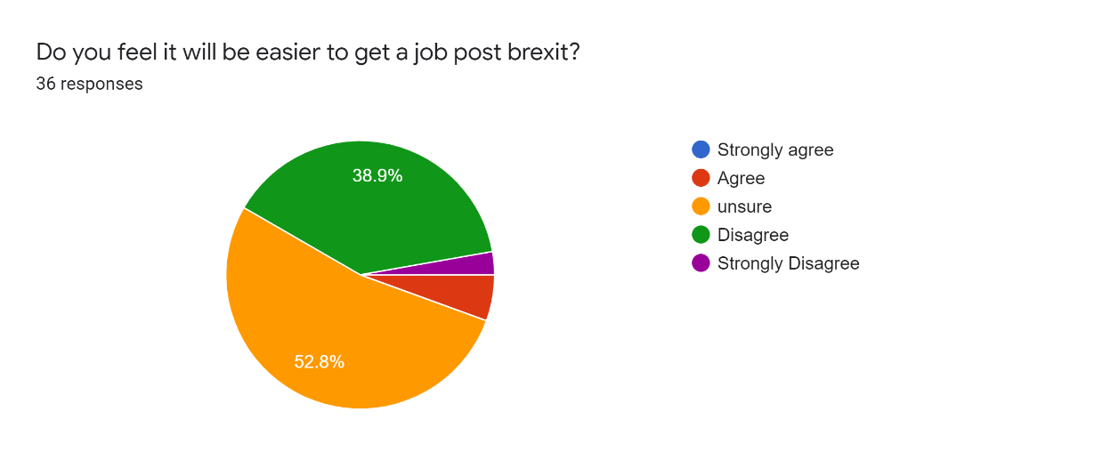
Figure 3:Q6 of the public questionnaire
In terms of the public, they agree that the number of jobs post-Brexit will be either reduced or there is again the sign of uncertainty with just over half saying they are unsure, and then just over 40% saying that it will be harder to get a job, this shows that there is the potential for a larger pool as the public see fewer jobs. But as this is a low skilled job the positions would normally be taken by migrants due to the fact its low skilled and low pay, these conditions are usually off-putting for someone who is a UK national. (Migrant Advisory Committee)

3.2.2 PEST
"The concept of PEST analysis, which stands for Political (P), Economic (E), Social (S) and Technological (T) analysis on the external business environment it is carried out by businesses to support their strategic analysis activity"( Keung Ho, Pg 6479-6480 (2014)

3.2.2.1 Political
A political issue the business has regarding this area is the potential harming of the plans to raise the minimum wage, in the future should the UK economy be harmed in the future due to leaving Brexit, this could lead the businesses employees to be demotivated, as should the price of living increase then the employees of the business may struggle. (Financial Times, 2018)
This could be looked at within the business, as to counter the staff being demoralized by the lack in change of the minimum wage movement, the café could consider whether they should raise the staffs pay themselves, but then would also have to consider figure 2, and weigh up whether it would be worth taking a reduction in profit, or a slight increase in costs for the customers. They would have to consider whether this increase in price would affect the business' profits. The company could use supply-demand curves to study how the change in price would affect them. (Anna Obizheva, 2013)

3.2.2.2 Economic
The large economic factor is the reduction in GDP growth, if the UK had stayed within the EU then the economy would be 30% larger in 2030, compared to out of the EU where growth is just 24%. (Begg et al P.G 2, 2016)
A loss of GDP could cause a recession which will have significant effects on the employees and the business, this will result in less income for the employees, as well as less income for the business due to the public having less disposable income, this will put the business in further uncertainty as the livelihood of their staff will cause demotivation and with the recession, the profits of the business could be hampered.

3.2.2.3 Social
A social factor is the reduction of migrants within the area. Migration is very prevalent in Wales, around 80,000 EU citizens currently live, work, and study in Wales. (Gov.UK) This would mean that there would be fewer future employees for the business, as well as current employees who are of EU origin would potentially move out of Wales. This is a key factor as it is said that only 63% of EU nationals in Wales have applied to remain within Wales (BBC). This would apply especially to the Seaside Café as EU nationals account for 27.5% of the consumer workforce within the UK. (McKenzie, 2017)
During the meetings with the business, it was advised that the business should assure the employees of the business, especially those of a foreign background as a secure job within the area will heavily impact their decision when choosing to remain in Wales. Additionally, it was also communicated that current employees who are of UK descent should be reassured, as job security would make them more likely to stay with the job as they know their importance to the business.
During an interview with an employee, they were asked “Would you prefer working at a small firm like this, rather than a large chain?”
Their response was: “ Yes, I would much rather it because you get more interactive with the customers, as well as closer relationships with fellow employees, and more of a sense of importance as the company is smaller and you know who you are working for, rather than working for a brand.”
This showed that the employees were satisfied with job security, as well as having a sense of importance within the company.

3.2.2.4 Technological
With Brexit potentially cutting the employment pool, the business can choose from due to migration policies with Brexit. The business can take advantage of technology and use social media as well as job recruitment websites to combat the lack of employees searching for this job. This may potentially help find an employee more suited to the job, as job recruitment businesses will find in-depth information about the employee which may not be discovered with the normal process of just a CV submission.

3.3 How it will affect the supply chain

3.3.1 Findings
“The food and drink sector is arguably one which will be most impacted by Brexit. Food and drink manufacturers that our wholesale members purchase from import a large share of their goods and 70% of their imports come from or through the EU. (FWD, 2020)
During an interview with the owner, it was discovered that the business gets most of its supplies from Castell Howell. Castell Howell is a welsh wholesaler who base their operations from South Wales and has been doing so for 31 Years. (Castell Howell)
While these do not deliver outside of Wales and South West England, the companies within Wales who do export will struggle to export their produce. The National Farms Union of Wales (NFU Cymru) posted on their website that Welsh exporters will struggle post-Brexit, if the businesses exporting can no longer do so they will sell the product within Wales increasing the competition for Castell Howell. With increased competition within the market may cause Castell Howell to struggle with Bigger suppliers due to them taking advantage of economies of scale. This could then leave the café with the uncertainty, as its supplier is struggling.

3.3.2 PESTLE
To properly analyze this a PESTLE analysis will be used:
“PESTLE is a mnemonic which in its expanded form denotes P for Political, E for Economic, S for Social, T for Technological, L for Legal and E for Environmental.” (PESTLE)

3.3.2.1 Political
The political factor that affects the cafe's supply chain would be cuts in EU funding to wholesalers within the UK. If the companies can not cut their reliance on the EU while selling their produce at current levels, they may have to increase the costs of the products to subsidize this, this can lead to a rise in cost on the side of the cafe. On the other hand, it could be a positive for the café, as an increase in market competition could cause the wholesalers to reduce their prices to gain a greater market share to subsidize the cost. (Hendry et al N.P, 2019)

3.3.2.2 Economic
An economic factor that could affect the business’s supply chain is a decrease in imports from the European Union to the UK by 25%. (H.U. Brautzsch, et al, 2019)
This decrease in imports will lead to wholesalers needing to source their produce from elsewhere or face paying the additional import tariff, this could cause them additional costs as due to the cost of EU produce increasing there will be more demand within the UK for the produce that is of UK origin due to no tariff restrictions. This will cause the price to increase for the UK produce. The wholesaler would have to then either pay for the increase on UK produce or pay for the EU produce with the additional tariff.
This will then affect the café as it will also feel the additional cost if there is one put onto the wholesaler, as the wholesaler will want to retain their levels of profit which will then cause a price increase on the produce purchased.

3.3.2.3 Social
One of the harms to the supply chain is the loss of workers who have migrated to the UK. 72,000 migrants work within the food and drink wholesaling industry, and it's reported that around 75% of EU nationals are concerned about their status within the UK. (FDF P.G 1-3, 2017) This would create uncertainty amongst these staff which could make them demotivated. Additionally, since it is such a large proportion of the staff potentially losing their hospitality, and therefore potentially their job. This could lead to shortages in staff for the wholesaler, which could lead to them not having the capabilities to cope with their current output levels, furthermore, the recruitment of new staff could be an expensive process due to a lack of an employee pool being available.

3.3.2.4 Technological
The supply chain will be affected by a reduction in Foreign Direct Investment (FDI) in the UK, as Brexit reduces the attractiveness of the UK to investors within the EU. It is estimated that in total FDI will be reduced in the UK by 22% (Dhingra et al P.G.24, (2016)
This will affect the supply chain as FDI within the areas can benefit everyone within the area as it can provide additional customers for the suppliers, as well as a lack of FDI reducing the growth in the economy which would then reduce the value of the pound which would additionally affect the suppliers. The consequence of this is a lack of investment around the area of the suppliers which would lead to a lack of potential customers as well as the economy that the supplier operated in weakening. (Bisztray P.G.1, (2016))

3.3.2.5 Legal
One of the legality problems facing the supplier of the business is the tariffs that go on the machinery that they use, in 2019 machinery was the largest imported good within the UK, totaling a value of £183.18 billion, (Statista, N.P.(2020))
With machinery being a large aspect to the functionality of wholesalers the additional cost from the tariffs or purchasing from within the UK will be greatly felt. The cost will be felt throughout the supply chain as the additional cost will be passed on by the supplier to ensure they make a profit. This could lead to additional costs for the business.

3.3.2.6 Environmental
Since leaving the EU the UK has stuck along the same lines as the EUs Environmental policies. But some notable changes will impact Suppliers. As they have made the legislation stricter on businesses' pollution levels. In particular, the environmental impact assessment has been made stricter, failure to comply with this could lead to fines for the business which could prove very costly. (Hilson, P.G. 89-113, (2018)), (Environmental protection UK, N.P. (2020))

3.4 Limitations to the project
One of the major limitations to the Project was the Covid-19 global pandemic that had infected 5,567,169 people as of 25/05/20 according to worldometers, (a website that keeps tracks of hundreds of global statistics) The café had to close on the 20th march due to the government shutting down all pubs shops and cafes on this date. (BBC)
Covid-19 hampered the project heavily, Changes needed to be made to the way the project was judged. As we could not get any financial records, due to the compulsory closure of the business, it was decided that there would be a satisfaction measure put in that gave us a perspective on how satisfied they were, 10 was rated as in extremely worried about the business’ future due to Brexit, and 1 being satisfied. During the first interview where this scheme was implemented, the owner gave a figure of 4, which may be another issue as it will not be accurate of the real aid given, this is because the first score was taken after previous interviews where aid was given.
The outbreak also caused problems as the interviews had to be carried out over text responses rather than face to face as planned, this made it difficult to gather a perspective of emotion as well as being longer spread out making communication difficult. (Linkedin)
Covid-19 also changed the process of the questionnaires. The questionnaires were planned to be given out from within the café, this would have allowed the responses to be from the customers themselves, which would have given a direct perspective of how the customer would have felt Brexit would directly affect them. Instead, it was decided that the questionnaire was posted on social media so while it had the potential to come from a wide audience, it was not successful, as every person who completed the questionnaire was from the UK. Also, there was very little age disparity as most answers were from 18-24-year olds, as shown below, this could have instigated bias in the questionnaire dependent on their political opinions.

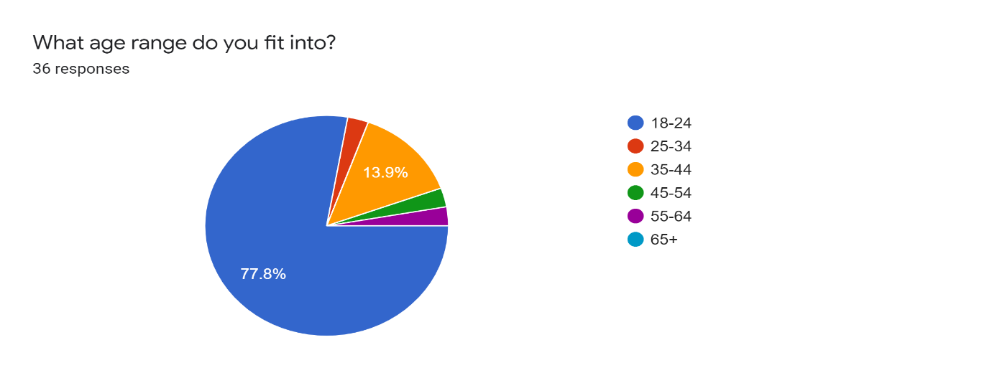
Figure 4:Q1 of the public questionnaire
Additionally, the original Gantt chart was not strictly stuck to but was used to keep the task on track, this was due to numerous reasons, with the outbreak and the changes that were caused by it the main reasons. The company was difficult to communicate with at first, this caused the project was to be off time and would, therefore, be pushed back, never the less, the project was carried out and completed with the advice being delivered to the company.
During the project, the uncertainty rating the business was giving did increase mid-way through, this was due to the business not being aware of how much Brexit could affect them. This was solved throughout the course with the delivery of primary and secondary information that would remove the uncertainty around these new avenues that could affect them.

4.0 Recommendations to the business
One of the recommendations to the business would be to continuously observe the suppliers within the area, as many factors will affect each supplier differently. If competitors within the area benefit from operating with a supplier that has to drop its prices due to Brexit, then they will have a competitive advantage over the business and will be able to lower their prices to gain a market share or making higher a higher contribution per unit and therefore becoming more profitable.
An additional recommendation is to venture into social media further, as while this may not directly affect any of the legislation caused by Brexit, it can combat the effects that the legislation has caused. For example, an active social media page can help the business gain more customers day in day out, as well as potentially helping them gain partnerships with additional businesses likewise to the one currently obtained at Ffos Las Racecourse, this would allow them to have a form of “passive income” which would not be vulnerable to fluctuations of customers as the deal would be a recurrence and would be an income source the company would then be able to rely on.
It will be key for the business to stay up to date with the ongoings of Brexit as it will continue to develop further as trade deals can be made and tariffs can be altered which will end up affecting the general market surrounding them, there are many ways that the business can do this, one is looking out for specialized organizations that are aimed to help small business venture through Brexit and provide aid free of charge, this will allow the business to gain a competitive advantage over rivals within the area who are not doing so. A good example of one of these organizations is The Federation for Small Businesses, which are more commonly known as FSB, they offer free advice although there is a membership that can be subscribed to where the business can get additional information in exchange for a monthly fee. (FSB)
Furthermore, news tabloids like the financial times and the telegraph will be reporting on events as they occur, this is another way the business can keep up with the changes occurring. But they must then be cautious to just rumours compared to confirmed changes, so the news must be reacted to cautiously as well as judging the reliability of the source.

5.0 conclusion
To conclude while the consultancy project was a success by reducing the score of a 4 in the first interview, to a 2 overall at the end, there were problems through the project as to start the business wasn't sure of how uncertain it was, as more information was brought to the owner's attention the uncertainty went up to a 5, but through presenting more primary and secondary research the business became less uncertain as they had an understanding that the entire sector would be affected including their rivals. But it is to be noted that the business must now stay up to date with how Brexit progresses after the Covid-19 pandemic as the economy will be very weak and how Brexit then progresses will be very key for the business during this time of economic instability. While the project itself was hampered by the pandemic, it was adjusted to ensure that the business could get as much as information as possible with the circumstances. It was ensured that the information was not only from secondary research as this was a unique period due to this large political change and a global disaster, so the opinions of the public were a key factor as they are the sole income for the business. The three aims covered three avenues where Brexit could cause problems for the business and worked coherently in reducing the uncertainty that had the potential to cause problems for the business. In conclusion, the business should be able to safely progress through Brexit and come out stronger afterwards, but the business must keep up to date with progressions that would affect them, otherwise, they could fall behind and lose a competitive advantage over their rivals.

References
Bank of England, (2019), In focus - Uncertainty and Brexit, accessed: (14/05/20) available from: https://www.bankofengland.co.uk/monetary-policy-report/2019/november-2019/in-focus-uncertainty-and-brexit
BBC, (2020), Alex Jenkins, Brexit: Wales' EU citizens behind in applications to stay, Accessed: (27/05/20) available from: https://www.bbc.co.uk/news/uk-wales-51285843
BBC, (2020), Brexit: All you need to know about the UK leaving the EU, Accessed: (05/05/20), Available from: https://www.bbc.co.uk/news/uk-politics-32810887
BBC, (2020), UK pubs and restaurants told to shut in virus fight, Accessed: (26/05/20) available from: https://www.bbc.co.uk/news/uk-51981653
Begg, I. and Mushövel, F, (2016), The economic impact of Brexit: jobs, growth and the public finances. Accessed: (28/05/20)
Bisztray, M., 2016. The effect of FDI on local suppliers: Evidence from Audi in Hungary (No. MT-DP-2016/22). IEHAS Discussion Papers. Accessed: (29/05/20)
Bloomberg, (2020) EU Referendum: Final Results, Accessed: (05/05/20) available from: https://www.bloomberg.com/graphics/2016-brexit-referendum/
Brautzsch, H.U. and Holtemöller, O, (2019), Potential international employment effects of a hard brexit (No. 4/2019). IWH Discussion Papers. Accessed: 27/05/20
Brown, R., Liñares-Zegarra, J.M. and Wilson, J.O, (2018) What happens if the rules change? The impact of Brexit on the future strategic intentions of UK SMEs. The Impact of Brexit on the Future Strategic Intentions of UK SMEs (March 1, 2018). Accessed: (06/05/20)
Buzzell, R.D., Gale, B.T. and Sultan, R.G, (1975) Market share-a key to profitability. Harvard business review, 53(1), pp.97-106
Castell Howell, N.D, History, accessed: 28/05/20, available from: http://www.castellhowellfoods.co.uk/history/
Dawar, N. and Frost, T, (1999) Competing with giants: Survival strategies for local companies in emerging markets. Harvard business review, 77, pp.119-132.
Dhingra, S., Ottaviano, G., Sampson, T. and Van Reenen, J., 2016. The impact of Brexit on foreign investment in the UK. BREXIT 2016, 24(2).
Environmental Protection UK, (2020), N.P, Air pollution laws, accessed: 29/05/20, available from: https://www.environmental-protection.org.uk/policy-areas/air-quality/air-pollution-law-and-policy/air-pollution-laws/
FDF, (2017), P.G1-3, Breaking the chain accessed:29/05/20 available from: https://www.fdf.org.uk/publicgeneral/Breaking-the-Chain.pdf
Financial Times, Delphine Strauss, (2018), Disruptive Brexit could force delays to rise in minimum wage, accessed: (26/05/20) available from: https://www.ft.com/content/b848bdf2-f26c-11e8-9623-d7f9881e729f
financial Times, Sarah Gordon, (2018), The UK has let down business with its lack of Brexit advice, Accessed: (06/05/20) available from: https://www.ft.com/content/7ab52d68-d11a-11e8-a9f2-7574db66bcd5
FSB, (2018), N.P, UK Small Business Statistics, Accessed: (05/05/20) available from: https://www.fsb.org.uk/uk-small-business-statistics.html
FSB, (2020), N.P, Brexit guidance for small businesses, Accessed: (29/05/20) available from: https://www.fsb.org.uk/campaign/brexit-guidance-for-small-businesses.html
Forbes, John Rampton (2015), 8 Ways To Engage Better With Your Customers. Accessed: (14/05/20) available from: https://www.forbes.com/sites/johnrampton/2015/09/14/8-ways-to-engage-better-with-your-customers/#60bd916551f3
Forbes, Glen Llopis (2015), 5 Certain Ways to Engage Employees During Uncertain Times, accessed: (23/05/20) available from: https://www.forbes.com/sites/glennllopis/2015/02/16/5-certain-ways-to-engage-employees-during-uncertain-times/#479f702927a3
FWD, (2020), defining Brexit, accessed:28/05/20 available from: https://www.fwd.co.uk/current-issues/brexit/
Gov.uk, N.D, Package of support for EU Citizens living in Wales announced, accessed:27/05/20, available from: https://gov.wales/package-of-support-for-eu-citizens-living-in-wales-announced
Hawlk, K, (2017) Need Marketing Ideas? Ask Your Target Audience. Journal of Financial Planning, 30(11), pp.28-29. Accessed: (20/05/20)
Hendry, L.C., Stevenson, M., MacBryde, J., Ball, P., Sayed, M. and Liu, L, (2019) N.P Local food supply chain resilience to constitutional change: The Brexit effect. International Journal of Operations & Production Management. Accessed: 28/05/20
Hilson, C., 2018. The impact of Brexit on the environment: exploring the dynamics of a complex relationship. Transnational Environmental Law, 7(1), pp.89-113. Accessed: (29/05/20)
Ho, J.K.K, (2014) Formulation of a systemic PEST analysis for strategic analysis. European academic research, 2(5), pp.6479-6480. Accessed (29/05/20)
Kucher. S, (2019) Stay Strong – How to Fight a Price War, Accessed: (28/05/20) available from: https://www.simon-kucher.com/en/blog/stay-strong-how-fight-price-war
Linkedin, Charlie Marshall, (2016) Face-to-Face Interviews - Advantages and Disadvantages, accessed: (26/05/20) available at: https://www.linkedin.com/pulse/face-to-face-interviews-advantages-disadvantages-charlie-marshall
Mazars, (2016), BREXIT: PREPARING FOR CHANGE, PG1, accessed: 28/05/20, available from: https://www.mazars.co.uk/Home/Insights/News/Tax-News/Brexit-The-tax-implications
McKenzie. B, (2017), The realities of trade after Brexit, accessed: (27/05/20)
Migrant Advisory Committee, (2014), The growth of EU and non-EU labour in low-skilled jobs and its impact on the UK, accessed: (23/05/20)
Murphy.R, (1998) Business Economics Vol. 33, No. 3 (July 1998, PG33-38, accessed: (19/05/20)
NCASS, (2020) Brexit: does this mean change for independent food businesses? , accessed: (26/05/20) available from: https://www.ncass.org.uk/mobile-catering-home/articles/does-brexit-mean-change-for-independent-food-businesses-
Obizhaeva, A.A. and Wang, J, (2013), Optimal trading strategy and supply/demand dynamics. Journal of Financial Markets, 16(1), pp.1-32.
PESTLE, N.D, what is PESTLE analysis, accessed: (23/05/20) available from: https://pestleanalysis.com/what-is-pestle-analysis/
Pickton, D.W. and Wright, S, (1998) What's swot in strategic analysis?. Strategic change, 7(2), pp.101-109. Accessed: (21/05/20)
Powell, G., Groves, S. and Dimos, J, (2011) ROI of social media: How to improve the return on your social marketing investment. John Wiley & Sons. Accessed: (22/05/20)
Reed, Michaled Cheary (2020), Brexit Britain: Five ways leaving the EU could affect your job search, accessed: (19/05/20) available from: https://www.reed.co.uk/career-advice/brexit-britain-five-ways-leaving-eu-could-affect-your-job-search/
Seaside Café, (2020) accessed: (14/05/20) available from: https://www.facebook.com/157694777637193/photos/a.566527976753869/3783523805054254/?type=3&theater
Slater, S.F., Hult, G.T.M. and Olson, E.M, (2007) On the importance of matching strategic behavior and target market selection to business strategy in high-tech markets. Journal of the Academy of Marketing Science, 35(1), pp.5-17.
Statista, (2020), N.P. United Kingdom: largest import commodities 2019, accessed: (29/05/20) available from: https://www.statista.com/statistics/281818/largest-import-commodities-of-the-united-kingdom-uk/
This statistic shows the main import commodities of the United Kingdom (UK) in 2018 in million GBP. This ranges from machinery and oil to food and chemicals. In this year, the largest imported commodity was machinery and transport equipment at approximately 183 billion British pounds.
Largest import commodities of the United Kingdom (UK) in 2019
Telegraph, Sally Percy, (2019), A force for good or bad? What Brexit could mean for small businesses, accessed (06/05/20) available from: https://www.telegraph.co.uk/business/challenges/brexit-for-small-businesses/
Tuten, T.L. and Urban, D.J, (2001) An expanded model of business-to-business partnership formation and success. Industrial marketing management, 30(2), pp.149-164. Accessed: (22/05/20)
Uncles, M.D., Dowling, G.R. and Hammond, K, (2003) Customer loyalty and customer loyalty programs. Journal of consumer marketing. Accessed: (28/05/20)
Wales Online, Robin Turner, (2013), Poles immigrate to Welsh town by thousands, Accessed: (06/05/20) available from: https://www.walesonline.co.uk/news/wales-news/poles-immigrate-welsh-town-thousands-2256284
Worldometers, (2020) coronavirus, Accessed: 25/05/20, Available from: https://www.worldometers.info/coronavirus/
Zhu, Y.Q. and Chen, H.G, (2015) Social media and human need satisfaction: Implications for social media marketing. Business horizons, 58(3), pp.335-345. Accessed (22/05/20)

