University of Wales Trinity Saint David
School of Engineering
Engine Performance Characteristics
Christian John Engelbrecht
2104471
BA Automotive and Transport Design
10/12/2021
Vehicle Technology ACHA4004


Table of Contents
1. Introduction 1
2. Testing Equipment and Methods 1
2.1 Equipment 1
2.1.1 Dynamometer 1
2.1.2 Control Room 2
2.1.3 Engine 2
2.2 Methodology 3
3. Data 3
3.1 Tables 3
3.2 Graphs 6
4. Questions 7
4.1 Why does torque vary in relation to engine speed? 7
4.2 Why does brake power vary in relation to engine speed? 7
5. Conclusion and Evaluation 7
5.1 Conclusion 7
5.2 Evaluation 7
6. References 8

Introduction

Engine dynamometers are utilized to assess an internal combustion engine (ICE) that has been taken out of a piece of equipment, in this example an automobile. Engine dynamometers can expose inherent flaws with an ICE, or they can be used to facilitate a better understanding of engine performance characteristics. The aim of this this report is to investigate the relationship between an increase in engine rpm (revolutions per minute) and torque, as well as it’s effects on brake power. In addition, this report will provide details regarding the methodology and equipment used to achieve the aim, there will also be data tables and graphs to support the findings of the investigation.

Testing Equipment and Methods

2.1 Equipment
The following subsection includes a brief overview of the primary pieces of equipment required to perform the investigation.

2.1.1 Dynamometer
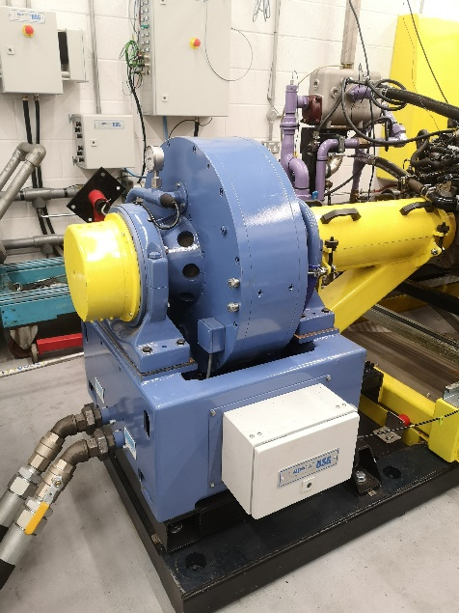
A dynamometer, most often referred to as a “dyno”, is a measuring device that can produce torque and rotational speed readings of an engine, from this information we can then determine the power produced by the engine. In this investigation we are using an engine dynamometer (figure 1), an engine dynamometer is connected directly to an engine’s crankshaft via a driveshaft. This produces a more accurate reading in comparison to a chassis dyno as there are fewer mechanical losses in power through a drivetrain.
Figure 1

2.1.2 Control Room
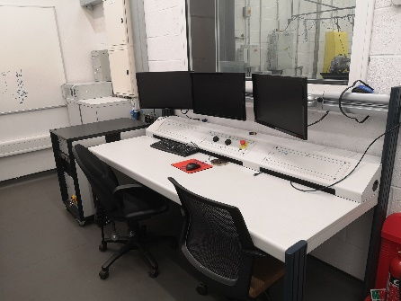
The Control room (figure 2) is simply a location from which the dynamometer and engine can be controlled and observed. In the control room you can find two dials, one to control engine throttle position and the other to control the load placed on the engine via the dynamometer.
Figure 2

2.1.3 Engine
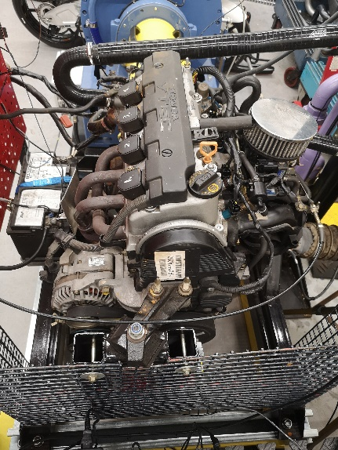
The engine used in the investigation is a naturally aspirated 4-cylinder single overhead camshaft (SOHC) produced by Honda known as the D16A (figure 3), it is equipped with variable valve timing and has a displacement of 1,595cc.
Figure 3

Methodology
Since the aim of this investigation is to determine the impacts of increasing engine rpm on both power and torque figures, it most appropriate to use a sweep test on the dynamometer. A sweep test increases engine rpm over a predetermined range and time, whilst simultaneously increasing load. A sweep test replicates the conditions an engine faces under acceleration, but most importantly it provides us with a range of force and rpm figures which can be used to further this investigation.
The next step is to gather all the collected data into a spreadsheet program such as Microsoft Excel, this simplifies the process of calculating torque, power and BMEP.

Data

3.1 Tables

Table 1
Temperature (°C) | 26 | diameter | 0.075 | m
Barometric Pressure (bar) | 1.01067 | stroke(I) | 0.09 | m
Humidity (%) | 42.8 | Area (a) | 0.004418 | m^2
Torque arm (m) | 0.815744

Table 2
Diameter (m) | 0.075
Stroke (m) | 0.09
Area (m^2) | 0.004418

Table 3
Force (N) | Engine Speed(rpm) | torque (nm) | Power(w) | corrected power (w) | BMPE(Pa)
130.037 | 1000 | 106.076903 | 11108.35 | 11250.15405 | 848811.9854
130.61 | 1050 | 106.544324 | 11715.16 | 11864.71352 | 852552.2229
131.485 | 1100 | 107.2581 | 12355.25 | 12512.97059 | 858263.7549
137.723 | 1350 | 112.346711 | 15882.64 | 16085.3965 | 898982.0825
139.186 | 1400 | 113.540144 | 16645.85 | 16858.352 | 908531.764
140.496 | 1450 | 114.608769 | 17402.61 | 17624.77129 | 917082.7433
141.522 | 1500 | 115.445722 | 18134.17 | 18365.66864 | 923779.9226
142.271 | 1550 | 116.056715 | 18837.82 | 19078.29721 | 928668.994
143.07 | 1600 | 116.708494 | 19554.7 | 19804.32696 | 933884.4386
143.631 | 1650 | 117.166126 | 20244.85 | 20503.29481 | 937546.3466
143.895 | 1700 | 117.381483 | 20896.67 | 21163.43471 | 939269.5974
143.984 | 1750 | 117.454084 | 21524.59 | 21799.36339 | 939850.5418
143.769 | 1800 | 117.278699 | 22106.51 | 22388.72103 | 938447.1368
143.411 | 1850 | 116.986663 | 22664.01 | 22953.33105 | 936110.3043
143.045 | 1900 | 116.6881 | 23217.14 | 23513.5288 | 933721.252
142.816 | 1950 | 116.501295 | 23789.97 | 24093.67259 | 932226.4625
142.873 | 2000 | 116.547793 | 24409.71 | 24721.32178 | 932598.528
143.19 | 2050 | 116.806383 | 25075.47 | 25395.57661 | 934667.7345
143.772 | 2100 | 117.281146 | 25791.47 | 26120.71958 | 938466.7192
144.551 | 2150 | 117.916611 | 26548.63 | 26887.54116 | 943551.6145
145.344 | 2200 | 118.563496 | 27315.07 | 27663.76693 | 948727.8944
146.106 | 2250 | 119.185093 | 28082.33 | 28440.81891 | 953701.8228
146.954 | 2300 | 119.876844 | 28872.99 | 29241.57601 | 959237.1133
147.835 | 2350 | 120.595514 | 29677.52 | 30056.37882 | 964987.8101
148.72 | 2400 | 121.317448 | 30490.4 | 30879.63415 | 970764.6167
149.675 | 2450 | 122.096483 | 31325.49 | 31725.38339 | 976998.3459
150.825 | 2500 | 123.034589 | 32210.38 | 32621.57088 | 984504.9309
152.138 | 2550 | 124.105661 | 33140.6 | 33563.66758 | 993075.4926
153.556 | 2600 | 125.262386 | 34105.36 | 34540.74229 | 1002331.438
155.005 | 2650 | 126.444399 | 35089.25 | 35537.19205 | 1011789.735
156.482 | 2700 | 127.649253 | 36091.98 | 36552.71837 | 1021430.801
157.786 | 2750 | 128.712983 | 37066.68 | 37539.86343 | 1029942.616
158.838 | 2800 | 129.571145 | 37992.24 | 38477.24505 | 1036809.509
159.646 | 2850 | 130.230267 | 38867.39 | 39363.56551 | 1042083.701
160.156 | 2900 | 130.646296 | 39675.62 | 40182.1101 | 1045412.708
160.53 | 2950 | 130.951384 | 40453.93 | 40970.35712 | 1047853.98
160.755 | 3000 | 131.134927 | 41197.25 | 41723.1676 | 1049322.66
160.772 | 3050 | 131.148794 | 41888.3 | 42423.03953 | 1049433.627
160.64 | 3100 | 131.041116 | 42540.04 | 43083.09725 | 1048572.001
160.269 | 3150 | 130.738475 | 43126.34 | 43676.88013 | 1046150.312
159.847 | 3200 | 130.394231 | 43695.53 | 44253.33405 | 1043395.721
159.295 | 3250 | 129.94394 | 44225.02 | 44789.58445 | 1039792.561
158.657 | 3300 | 129.423496 | 44725.55 | 45296.50625 | 1035628.038
158.007 | 3350 | 128.893262 | 45217.2 | 45794.43048 | 1031385.186
157.267 | 3400 | 128.289612 | 45677.15 | 46260.25765 | 1026554.861
156.714 | 3450 | 127.838505 | 46185.9 | 46775.49787 | 1022945.173
156.031 | 3500 | 127.281352 | 46651.05 | 47246.58947 | 1018486.914
155.394 | 3550 | 126.761723 | 47124.32 | 47725.9 | 1014328.919
154.841 | 3600 | 126.310617 | 47617.98 | 48225.86167 | 1010719.231
154.283 | 3650 | 125.855432 | 48105.36 | 48719.46016 | 1007076.905
153.895 | 3700 | 125.538923 | 48641.7 | 49262.64906 | 1004544.249
153.537 | 3750 | 125.246887 | 49184.34 | 49812.21411 | 1002207.416
153.207 | 3800 | 124.977691 | 49733.01 | 50367.88713 | 1000053.353
152.982 | 3850 | 124.794149 | 50313.39 | 50955.67884 | 998584.6732
152.81 | 3900 | 124.653841 | 50909.51 | 51559.40663 | 997461.9492
152.686 | 3950 | 124.552688 | 51520.35 | 52178.04961 | 996652.5435
152.585 | 4000 | 124.470298 | 52138 | 52803.57918 | 995993.2695
152.443 | 4050 | 124.354463 | 52740.59 | 53413.86913 | 995066.3695
152.235 | 4100 | 124.184788 | 53318.86 | 53999.5196 | 993708.6567
151.91 | 4150 | 123.919671 | 53853.88 | 54541.36319 | 991587.2305
151.399 | 4200 | 123.502826 | 54319.38 | 55012.8095 | 988251.6958
150.827 | 4250 | 123.03622 | 54758.37 | 55457.40588 | 984517.9858
150.068 | 4300 | 122.417071 | 55123.79 | 55827.48687 | 979563.6397
149.154 | 4350 | 121.671481 | 55425.12 | 56132.66861 | 973597.5366
148.116 | 4400 | 120.824738 | 55672.04 | 56382.74029 | 966822.0278
147.008 | 4450 | 119.920894 | 55883.49 | 56596.88227 | 959589.5964
145.914 | 4500 | 119.02847 | 56090.85 | 56806.88884 | 952448.5495
144.832 | 4550 | 118.145835 | 56293.52 | 57012.15438 | 945385.8322
143.855 | 4600 | 117.348853 | 56528.22 | 57249.84576 | 939008.4988
142.954 | 4650 | 116.613868 | 56784.76 | 57509.65902 | 933127.2527
141.876 | 4700 | 115.734496 | 56962.53 | 57689.70544 | 926090.6453
140.982 | 4750 | 115.005221 | 57205.76 | 57936.03966 | 920255.0914
140.028 | 4800 | 114.227001 | 57416.75 | 58149.72312 | 914027.8897
139.039 | 4850 | 113.42023 | 57605.09 | 58340.46711 | 907572.2266
137.983 | 4900 | 112.558804 | 57756.94 | 58494.25189 | 900679.2234
136.865 | 4950 | 111.646803 | 57873.55 | 58612.34923 | 893381.5174
135.733 | 5000 | 110.72338 | 57974.63 | 58714.71813 | 885992.4269
134.623 | 5050 | 109.817905 | 58075.53 | 58816.90535 | 878746.9405
133.253 | 5100 | 108.700335 | 58053.67 | 58794.77048 | 869804.3133
131.742 | 5150 | 107.467746 | 57958.08 | 58697.96017 | 859941.3134
129.994 | 5200 | 106.041826 | 57744.3 | 58481.45632 | 848531.3044
128.245 | 5250 | 104.615089 | 57515.15 | 58249.37545 | 837114.7678
126.542 | 5300 | 103.225877 | 57291.88 | 58023.25546 | 825998.4947
125.13 | 5350 | 102.074047 | 57187.06 | 57917.09287 | 816781.7139
123.554 | 5400 | 100.788434 | 56994.52 | 57722.09666 | 806494.4288
122.083 | 5450 | 99.5884748 | 56837.4 | 57562.97391 | 796892.5276
121.004 | 5500 | 98.708287 | 56851.89 | 57577.65118 | 789849.3927

Graphs

Figure 4

Figure 5

Questions

4.1 Why does torque vary in relation to engine speed?
Throughout the rpm range of an ICE engine, it will produce varying levels of torque, most of the torque is produced at lower engine spends and this is partially to do with the design. Manufacturers will design engines to make more torque lower down, this is because it makes for a more pleasant driving experience as the car feels more confident when accelerating. As a result, the usable torque range starts at 1,000-1,200 rpm and usually reaches its maximum at 2,500-4,000 rpm, the engine in this report produces peak torque at roughly 3,000 rpm as seen in figure 4. However, where the narrow band of usable torque lies is not entirely by design. At lower rpm valves are open longer, the charge mixture is given more time to mix in the combustion chamber and ultimately achieves a better burn. This changes at higher rpm as the valves are open for shorter periods of time and the engine struggles to achieve proper ignition of the charge mixture; it can’t breathe. Therefore, torque will decrease with increasing rpm beyond 3,000 rpm as seen in the Figure 4. Although, frictional losses also play a role in reducing torque at higher rpm, the forces going through bearings become higher and reduce their efficiency.

Why does brake power vary in relation to engine speed?
Brake power varies throughout rpm range like torque, but it doesn’t resemble the torque curve. This is essentially because brake power is a product of engine rpm and torque. But why does brake power not decrease after peak torque has been achieved? This is because the decrease in torque does not compensate for the increasing engine rpm until later in the rpm range as seen in figure 5, power only decreases beyond 5,000 rpm.

Conclusion and Evaluation

5.1 Conclusion
The aim of this report was to investigate the effects of increasing engine rpm on both torque and brake power, this has been achieved. The findings of the investigation show that inefficiencies at higher rpm within an engine reduce the ability to create higher torque values at higher rpm, this is further exaggerated by the desire for engines which produce torque at lower rpm ranges. It can also be determined that decreasing torque figures at higher rpm play a role in in the shape of the brake power curve, however, so does rpm.

Evaluation
In evaluation of my report there are a few things that can be said, first of all I believe I performed well given that this is not a field I am familiar with currently. To rectify this, I could to some further reading regarding the subject. As for improving the investigation as a whole, I would perform more dynamometer runs, this would improve the uniformity of the data and exclude any anomalies. Although given the circumstances this was not possible.

References

CarBikeTech. 2019. What is Engine Torque? It's Characteristics & Formula. [online] Available at: <https://carbiketech.com/engine-torque/> [Accessed 8 December 2021].
Dulcich, S., 2006. Engine Dyno Testing Process - 4Wheel & Off-Road Magazine. [online] MotorTrend. Available at: <https://www.motortrend.com/how-to/131-0610-engine-dyno/> [Accessed 8 December 2021].
Hoffman, D., n.d. Honda D16 Engine Review: Problems, Specs and Reliability. [online] Engineswork. Available at: <https://engineswork.com/engines/honda-engine/d16-engine.html> [Accessed 8 December 2021].
Largiader.com. n.d. Torque and Power. [online] Available at: <http://largiader.com/articles/torque.html> [Accessed 9 December 2021].
Power Test Dynamometer. n.d. What is a Dynamometer?. [online] Available at: <https://powertestdyno.com/what-is-a-dyno/> [Accessed 8 December 2021].

