Is the external challenge a good or a bad?
Analyse the impacts of external environment on employee recruitment and retention

Student Name: Alina Boestean
Student Number: 2207646

Module title : Personnel Resourcing & Development
Module number: (BMIH5005)
Lecturer name: Dr. Helen Lee

Table of Contents
Introduction 3
Background 3
Innovation and Luxury at The Langham 3
Importance of Elegance and Tradition 4
Cultural Significance and Social Responsibility 5
Discussion 6
Impact of Current Affairs on Employee Retention 6
Brexit and Employee Retention 6
Inflation 7
COVID-19 Pandemic 7
Uncertainties with Economic Situation 7
Potential Solutions and Industry Examples 8
Employee Well-being Prioritization 8
Strategic Workforce Planning 9
Flexible Work Arrangements 11
Evaluation and Conclusion 11
SWOT Analysis 13
Internal Factors 13
External Factors 14
PESTLE Analysis 15
References 21

Introduction
This comprehensive investigation examines The Langham hotel in London to assess the challenges associated with recruitment and retention of personnel within the hotel industry in the United Kingdom. The objective of this investigation is to examine the intricate factors and potential advantages that impact the recruitment and retention of employees within the hospitality industry in the United Kingdom as a comprehensive entity. This approach entails directing attention towards a singular environment and providing an extensive analysis of its various aspects. Through an analysis of contemporary events and external challenges, this occupation endeavors to ascertain the potential impact of these factors on workforce dynamics, while devising intelligent strategies to foster employee satisfaction and motivation. The assignment will focus on the current global challenges.

The Langham, London distinguishes itself as an innovative institution by seamlessly integrating contemporary opulence with timeless elegance. In addition to its extensive historical background, this accolade is the most recent recognition bestowed upon the hotel. However, Bowie (2018) identified that numerous modifications have been implemented inside the hotel premises to ensure the continual excellence of its amenities and services. 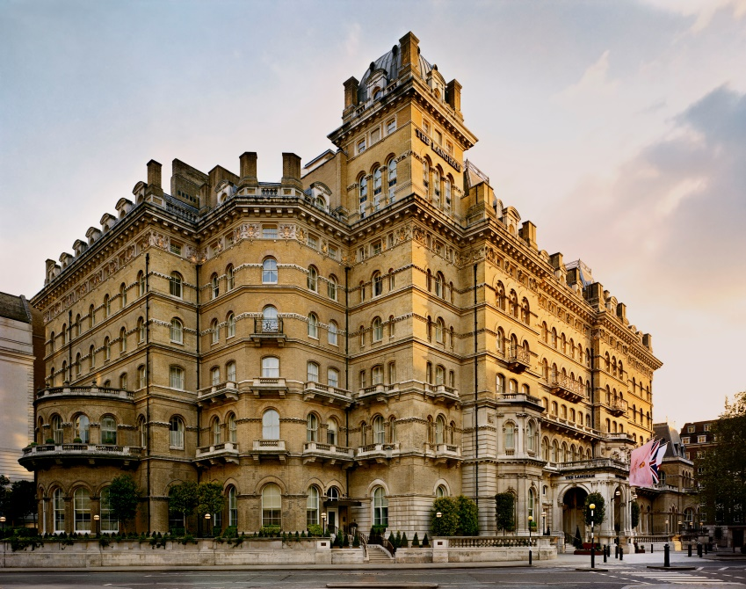
Figure 1: Langham Hotel, London

Importance of Elegance and Tradition
The Langham, London is a hotel that seamlessly integrates elegant traditional aesthetics with contemporary conveniences. The location is situated inside the central area of London. Ever since its establishment in 1865, this renowned hotel has served as a symbol of affluence (GORDON, n.d.). Visitors hailing from many backgrounds, including patrons, politicians, and aristocrats from several global regions, have converged to partake in this visitation. The Langham Hotel is widely regarded by a significant number of individuals in London as the foremost establishment for accommodation within the thriving tourism and hospitality sector of the city


Figure 2: The Langham, London – Hotel Review | Condé Nast Traveler

Cultural Significance and Social Responsibility
The Langham, London encompasses a range of amenities and offerings outside its primary function as a hotel. The institution in question is a cultural entity that has a strong historical and societal connection to the urban environment (Cherapanukorn and Focken, 2014). The hotel's implementation of sound business practices, its active engagement in the arts, and its dedication to environmental conservation all contribute to the enhancement of the city's cultural landscape and the preservation of its natural environment.


Figure 3: Hotel Corporate Social Responsibility | The Langham, London

The hotel has gained recognition as an environmentally conscious establishment, particularly at a period when the significance of responsible sustainability is being emphasized globally. In accordance with unwavering commitment, it will continuously strive to enhance the existing environmental policies and initiatives that are already implemented (Kucukusta, Perelygina and Lam, 2019).

Discussion
The retention of employees in the hotel business has been a topic of significant scholarly contributions, with several specialists making valuable contributions to the expanding body of knowledge in this field (YAU, 2020). The primary focus of a significant research conducted by McCalman et al. (2019) is to illuminate the key determinants that exert influence on the rates of employee turnover. The findings of their study underscore the significance of using intelligent strategies for the recruitment and retention of personnel, alongside the implementation of comprehensive training initiatives and the cultivation of successful leadership practices. This demonstrates the significance of employing and retaining personnel via strategic methodologies.

Impact of Current Affairs on Employee Retention

Brexit and Employee Retention
Following the referendum on membership in the European Union, the United Kingdom has experienced a shortage of labor within the hotel industry. Concerns have arisen over the availability of individuals with high intellectual capacity and various backgrounds after the cessation of unfettered mobility and the implementation of revised immigration regulations. According to Hamre and Wright (2021), considering the current circumstances, there is a need to adapt tactics for staff retention, particularly with regards to attracting and retaining international personnel. As an example, it has been observed that some hotels, such as The Langham in London, have used targeted recruitment strategies as a means to navigate the evolving employment landscape resulting from the Brexit phenomenon.

Inflation
The dynamic nature of the economy necessitates constant fluctuations, often accompanied by concurrent increases in prices. This poses a challenge for companies in formulating and executing strategies pertaining to competitive compensation. However, considering the constant occurrence of these changes, hotels are compelled to conduct comprehensive evaluations that result in modifications to their existing compensation systems in order to retain their current workforce. In order to maintain operational continuity, it is imperative for hotels to implement the following modifications. Certain prominent corporations within their respective industries, such as Marriott International, have shown their adaptability by modifying their compensation structures and employee perks in order to foster more transparency in light of the volatile economic climate.

COVID-19 Pandemic
The COVID-19 pandemic has precipitated significant changes in the occupational landscape of the hotel business. There is a growing trend among individuals to engage in activities such as remote work, altering their occupational responsibilities, and implementing more stringent regulations pertaining to workplace health and safety. Due to the global epidemic, several hotels, like as The Langham in London, were compelled to modify their staff recruitment and retention strategies (Muritala, Hernández-Lara and Sánchez-Rebull, 2022). This included giving workers the autonomy to choose their own working hours and accommodating their evolving requirements. Ensuring the safety and well-being of workers in the workplace has garnered significant attention as a means to maintain high levels of employee satisfaction and attract prospective employees.

Uncertainties with Economic Situation
Due to the inherent volatility of the economy, there exists a possibility that employees may encounter uncertainty over the stability of their employment. In order to effectively address employee issues and instill confidence in job security, it is essential for hotels to adopt a policy of transparency and candor. Organizations such as InterContinental Hotels Group (IHG) recognize the significance of maintaining elevated levels of employee satisfaction and trust (Tony, 2014).

Potential Solutions and Industry Examples

Employee Well-being Prioritization
Hilton Worldwide has received significant acclaim for consistently prioritizing the happiness and well-being of its employees. Hilton is highly regarded within the hospitality industry due to its consistent commitment to prioritizing the well-being and contentment of its employees. The organization offers many initiatives, such as employee assistance programs, fitness programs, and mental health support services. Various factors contribute to enhancing employee satisfaction and reducing turnover rates in the workplace (He, Morrison and Zhang, 2019).

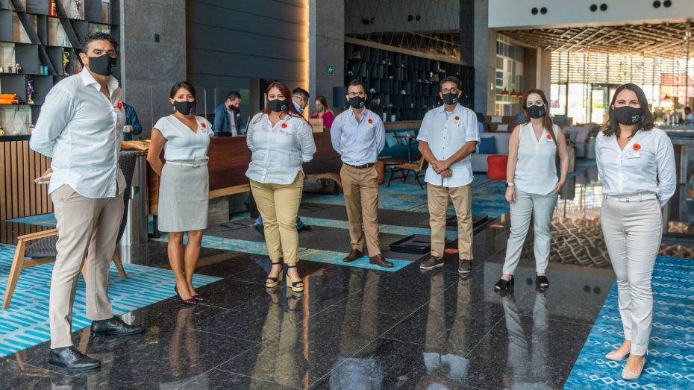
Figure 4: Hilton Retains Talent and Saves on Energy Costs

According to a recent statement by Silcock, it has been acknowledged that the manner in which Hilton treats its staff has a direct impact on the way these employees interact with the hotel's clients (Weinstein, 2012). The inclusion of our firm on Fortune Magazine's list of the top workplaces in the United States for the last two years has elicited a profound sense of excitement inside our organization.
Optimal outcomes may be achieved by adopting a managerial approach whereby workers are handled in a manner consistent with the desired treatment of consumers. Striking a balance between professional commitments and personal life, as well as maintaining transparency with colleagues and superiors, are often seen as commendable practices. Being a host encompasses more than only a designation within a professional setting (Bova, 2020). The individuals comprising our team see it as very significant in terms of their professional pursuits.
The hotel industry has the capacity to contribute positively to global welfare. Hilton, an established corporation with a history spanning over a century, is confident in the veracity of this claim and diligently endeavors to ascertain the magnitude of its impact. The organization has a dedicated department that assumes exclusive responsibility for the management and analysis of data. The responsibility of this department includes the formulation of business strategies and the enhancement of operational efficiency (Bova, 2020). The real-time visibility of discussions is made possible by the integration of EX and CX, enabling the executive team to access and monitor them.

Strategic Workforce Planning
It is well recognized that Four Seasons Hotels and Resorts possess meticulously devised strategies for personnel management. By proactively identifying the necessary skills for the future, organizations may strategically manage their workforce to ensure a consistent availability of talented personnel, therefore mitigating the influence of external variables on employee retention (Alawar, 2015).


Figure 5: Four Seasons Strategic Growth Driven by Robust Development Pipeline and Enhanced Commercial Strategy

The opening of Four Seasons shops in Taormina, Italy; Napa Valley, California; and New Orleans, Louisiana, garnered positive reviews, indicating the significance of these locations. The firm is already capitalizing on the favorable response. To expedite its worldwide growth initiatives, the organization intends to establish an additional four locations inside the United States within the year 2022. The aforementioned locations include Tamarindo, Mexico; Fort Lauderdale, Florida; Nashville, Tennessee; and Minneapolis, Minnesota. Furthermore, the Four Seasons brand has considerable strength because to the rising prices and demand for pre-existing properties under its management, as well as the rapid emergence of new properties entering the market (Bokareva and Yudina, 2020).
The Four Seasons organization is now engaged in the strategic development and construction of over fifty upcoming projects. Each location will be situated inside a prominent market in the United States, Italy, Spain, China, Japan, Colombia, or Belize. In all, there are over fifty initiatives of this kind. The corporation now has a total of 122 hotels and spas, in addition to 48 private properties that are geographically dispersed over 47 different nations. The aforementioned assets will be included into their existing collection.
According to Bart Carnahan, the President of Global Business Development and Portfolio Management at Four Seasons Hotels and Resorts, the company has a substantial portfolio of upcoming projects that are set to be established in significant international locations. These projects are being undertaken in collaboration with development partners that have a shared dedication to maintaining high standards of excellence. The Four Seasons Company is poised to achieve significant success in its strategic expansion endeavors (Bokareva and Yudina, 2020). Furthermore, the development plan of the company places great emphasis on the domestic business sector, considering it a fundamental component of its growth strategy. A comprehensive portfolio of more than 30 projects is anticipated to be executed globally throughout the next five-year period, together amounting to a sales value of around USD 7 billion

Flexible Work Arrangements
Marriott International has implemented revised business practices that include a greater emphasis on open work arrangements, which have proven to be effective. The "My24" program facilitates more autonomy for employees in managing their schedules, so promoting a favorable equilibrium between work and personal life commitments, and fostering enhanced employee retention within the organization.

Figure 6: Marriott International Hotel

Evaluation and Conclusion
The primary subject of this comprehensive investigation was The Langham in London. The objective of this study was to examine the intricate interplay between opportunities and challenges associated with recruitment and retention of personnel within the service hotel industry in the United Kingdom. This study seeks to provide comprehensive insights into various aspects of the recruitment and retention climate within the broader context of the UK's hospitality industry, with a specific focus on The Langham. The first phase of the investigation was a comprehensive overview of the hotel's extensive historical background and its steadfast commitment to ensuring safety. Subsequently, the discourse transitioned towards the present volume of scholarly undertakings and the primary determinants influencing staff retention within the hotel sector, predominantly.
A comprehensive investigation was conducted to examine the impacts of current occurrences such as Brexit and the global dissemination of COVID-19, as well as their influence on pricing, economic conditions, and global retirement patterns. The report identified many significant concerns, including the potential labor shortage resulting from Brexit, the need for adaptable work arrangements in response to the COVID-19 pandemic, and the impending global surge in retirements. “AccorHotels, IHG, The Ritz-Carlton, Marriott International, Hilton Worldwide, and Radisson Hotel Group” are prominent entities within the hospitality industry that have significantly contributed to the existing body of knowledge pertaining to employee retention strategies. These individuals of notable repute within the discipline have not only established benchmarks, but have also spearheaded innovative practices. The perspectives provided are highly valuable in assisting individuals employed within the dynamic hospitality sector to devise effective strategies for employee retention.
In conclusion, The Langham, London serves as an emblematic representation of affluence and historical significance within the hotel industry of the United Kingdom. The establishment commenced operations in the year 1865 under the name "Langham." In order to maintain a motivated and content workforce, it is essential to establish an effective framework for addressing external challenges and opportunities. Based on the recommendations, The Langham, London has the potential to enhance its standing as a premier destination for luxury hospitality by implementing the suggested measures. By doing so, the establishment can cultivate a dedicated and adaptable workforce capable of navigating the dynamic external landscape.
The Langham, London possesses the capacity to address existing challenges and establish itself as a highly desirable employer within the rapidly evolving hospitality sector in the United Kingdom. This can be achieved by fostering a professional atmosphere that prioritizes the well-being of employees, continuous learning opportunities, and transparent communication channels. The findings of this research have implications not just for individual hotels, but also provide valuable insights for the broader hospitality sector on strategies to effectively manage personnel and thrive throughout periods of fast expansion.

References
‘FOUR SEASONS STRATEGIC GROWTH DRIVEN BY ROBUST DEVELOPMENT PIPELINE AND ENHANCED COMMERCIAL STRATEGY IN 2022 AND BEYOND’ (2022) Four Seasons Press Room [Preprint]. Sarah Tuite. Available at: https://press.fourseasons.com/news-releases/2022/strategic-growth-and-expansion/ (Accessed: 12 November 2023).
Alawar, R.S., 2015. Strategic HRM effectiveness in the case of Four Seasons Hotel. Theses, Dissertations, and Projects.
Bokareva, E.V. and Yudina, E.V., 2020. Strategic management in the hospitality industry. Revista Turismo Estudos e Práticas-RTEP/UERN, (4), pp.1-8.
Bova, T., 2020. ‘How Hilton Saved $1 Billion in Energy Costs, Retains Talent, and Delights Customers’, The 360 Blog, 11 November. Available at: https://www.salesforce.com/blog/hilton-retains-talent-saves-energy-costs/ (Accessed: 12 November 2023).
Cherapanukorn, V. and Focken, K., 2014. Corporate social responsibility (CSR) and sustainability in Asian luxury hotels: Policies, practices and standards. Asian Social Science, 10(8), pp.198-209.
GORDON, W., THE LANGHAM HOTEL, PORTLAND PLACE, LONDON.
Hamre, E.F. and Wright, W., 2021. Brexit & the City: The impact so far. New Financial.
He, J., Morrison, A.M. and Zhang, H., 2019. Improving millennial employee well-being and task performance in the hospitality industry: The interactive effects of HRM and responsible leadership. Sustainability, 11(16), p.4410.
Kucukusta, D., Perelygina, M. and Lam, W.S., 2019. CSR communication strategies and stakeholder engagement of upscale hotels in social media. International journal of contemporary hospitality management, 31(5), pp.2129-2148.
McCalman, J., Campbell, S., Jongen, C., Langham, E., Pearson, K., Fagan, R., Martin-Sardesai, A. and Bainbridge, R., 2019. Working well: a systematic scoping review of the Indigenous primary healthcare workforce development literature. BMC Health Services Research, 19, pp.1-18.
Muritala, B.A., Hernández-Lara, A.B. and Sánchez-Rebull, M.V., 2022. COVID-19 staycations and the implications for leisure travel. Heliyon, 8(10).
Tony, S.M., 2014. The Making of an International Hotel Brand: A Case Study of the Langham. International CHRIE.
Weinstein, A., 2012. Superior customer value: Strategies for winning and retaining customers. CRC press.
YAU, T.K., 2020. The impact of perceived talent management practice on turnover intention of hotel employees. Signature.

