

Iqra Haseen
2407622
BMHP5014
Poster and Pitch Component 2
Creativity and Value creation in Health and Social Care

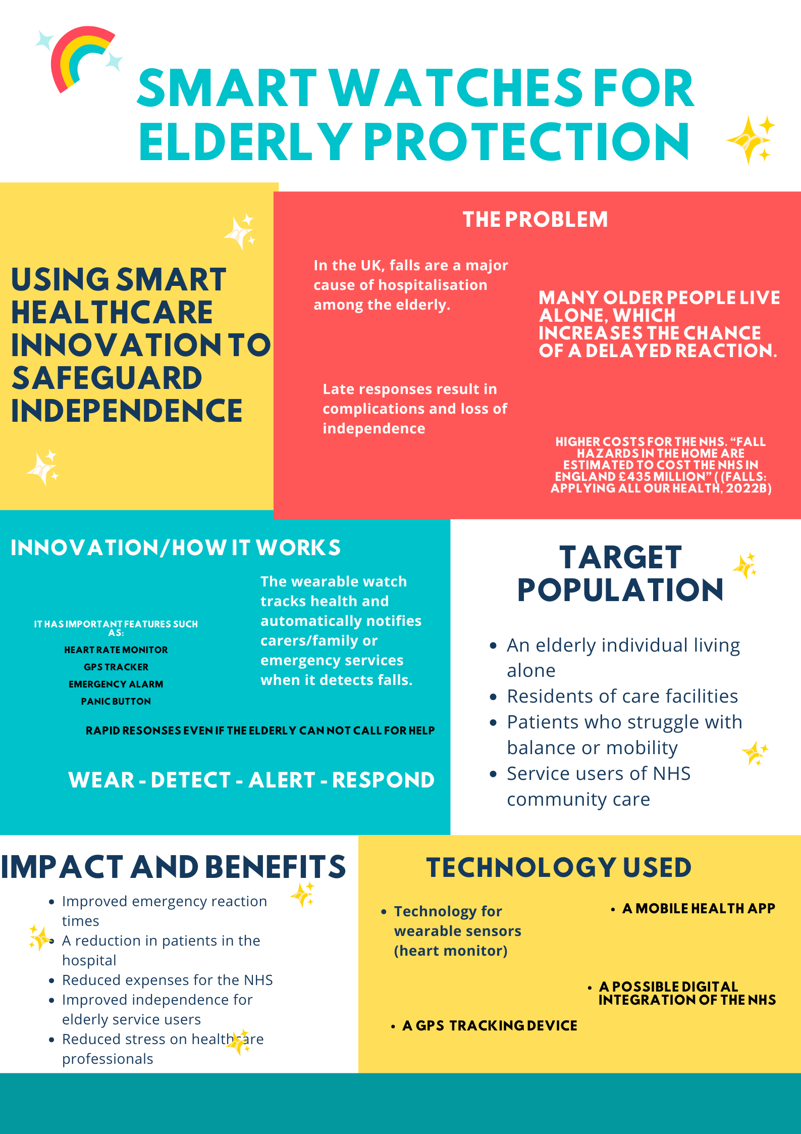

Pitch:
Safe Band: transforming elderly care through smart wearable technology
As the population ages, the United Kingdom must deal with an increasing number of healthcare challenges. “The pace of population ageing is much faster than in the past” (World Health Organization: WHO, 2025) The risks of delaying medical care are growing as the number of elderly people living alone rises. “Falling is a cause of distress, pain, injury, fear, loss of confidence and self-esteem, depression, loss of income, loss of independence and increased care needs, hospital admissions, and mortality.” (Hannah, no date) Falls among elderly people continue to be a major source of injury, “as people get older, they are more likely to fall over,” (Department of Health and Social Care, 2020) hospitalisation, and loss of independence, “can lead to long-term disability.” (Falls and fractures in older adults, no date) making it one of the most serious problems. Even with the current care systems in place, there is still a significant gap in guaranteeing quick emergency response in the case that an older person falls, especially if they are by themselves. “If you cannot reach an alarm or phone, try to get someone's attention by shouting for help or banging on a wall or the floor.” (NHS, no date) I suggest developing and introducing Safe Band, a smart wearable gadget that can identify falls, track health and instantly alert carers or emergency services, as a solution to this problem.
Safe band is an advanced healthcare solution that supports independent living and improves patient safety by combining wearable technology with real-time monitoring systems. Wearable like a watch, the gadget continuously monitors the individual’s vital signs, including heart rate and movement. Safe Band uses built-in sensors, such as a movement sensor, to identify sudden impacts or odd motion pattens that point to a fall. Through a linked mobile application, the gadget immediately notifies selected contacts, such as family members, carers or medical professionals, when it detects a fall. To ensure that assistance is given as soon as possible, the system escalates the alarm by notifying emergency service if no response is received within the time limit
This innovation’s importance comes from its ability to deal with a well- established and expanding issue in the UK healthcare system, “around a third of people aged 65 and over, and around half of people aged 80 and over, fall at least once a year.” (Falls: applying All Our Health, 2022) according to the NHS data, making falls the leading cause of emergency hospital admissions for the elderly. Long lay times after a fall, “A simple slip can turn into a life-changing event quickly when help is not readily available.” (Modern Diplomacy, no date) when a person is unable to get up or ask for assistance, can also result in serious consequences such as pressure sores, dehydration and even death. “Falls are the most common cause of death from injury in the over 65s” (England, no date). In addition to influencing the individual’s health, these incidents raise healthcare expenses and increase the requirements for the NHS services.
A proactive and preventative approach to elderly care is provided by Safe Band. This innovation allows for ongoing monitoring and immediate assistance instead of depending just on reactive healthcare services. Safe Band has the potential to significantly increase health outcomes and lower hospital admissions by shortening the time between a fall and medical attention. It also encourages the independence in older people, allowing them to live securely in their own homes without continuous supervision. This is in line with the UK’s current healthcare policies, which places a strong emphasis on community-based treatment and easing the strain on hospital services.
A scheduled method would be used to introduce Safe Band. To verify the device’s effectiveness and get users input, an experiment might first be implemented in a few NHS trust and assisted living facilities. Collaboration with healthcare professionals would guarantee professional reliability and safety, while partnership with IT companies would be important in creating a dependable and user-friendly solution. The gadget may be implemented more widely in community healthcare facilities after successful testing, and it could potentially fit into current NHS digital systems, including patient records and monitoring systems.
Involving participants is necessary to this innovation’s success. NHS organisations, carers, local government and the families of the elderly are important stakeholders. Research organisations like the Medicine and Healthcare Products Regulation Agency (MHRA) would also have to make sure the gadget satisfies quality and safety requirements; “enable innovation and research and development that is beneficial to public health.” (About us, no date). Since Safe Band would handle sensitive health data, Data protection is another important factor. “Data protection legislation controls how your personal information is used by organisations, including businesses and government departments,” (Government Digital Service, no date) maintaining users’ confidence and privacy would need a follow-through to the UK General Data Protection (GDPR).
Although Safe Band has several advantages, there are certain things that need to be considered. Cost is one of the primary issues. Large-scale wearable service development and distribution demand substantial financial investments. However, the long-term savings from fewer hospital admissions and hospital visits may cover this expense. User acceptance is another issue, especially for older people who might not be as familiar with technology. To get around this, the gadget needs to be made simple, with a layout that’s simple and little interaction from the user. It would also be important to provide users and carers with training and assistance.
Safe Band has room to grow and innovate in the future. Further development might use artificial intelligence to analyse movement patterns and health data to predict falls before they happen. Its functionally could be improved by adding features like voice assistants, prescription reminders and connection with other smart home appliances. As a result, Safe Band would become a complete elder care system rather than just a reactive emergency device.
In conclusion, Safe Band is a useful, creative and significant answer to one of the most important healthcare issues facing in the UK. It tackles the most important problem of delayed intervention after falls in the elderly by combining wearable technology with emergency response systems and real-time monitoring. By lowering the demand for healthcare services, this innovation not only improves patient safety and freedom but also contributes to the NHS’s sustainability. As part of the UK’s continuous efforts to improve health and social care for its aging population, I strongly encourage for the introduction and advancement of Safe Band.

References:
About us (no date). Available at: https://www.gov.uk/government/organisations/medicines-and-healthcare-products-regulatory-agency/about (Accessed: March 30, 2026).
Department of Health and Social Care (2020). Available at: https://www.pslhub.org/learn/organisations-linked-to-patient-safety-uk-and-beyond/government-and-alb-direction-and-guidance/dhsc/falls-applying-all-our-health-r3717/ (Accessed: March 30, 2026).
England, N. (no date) NHS England » Public health and Prevention. Available at: https://www.england.nhs.uk/ahp/greener-ahp-hub/specific-areas-for-consideration/public-health-and-prevention/ (Accessed: 30th March 2026)
Falls: applying All Our Health (2022b). Available at: https://www.gov.uk/government/publications/falls-applying-all-our-health/falls-applying-all-our-health. (Assessed: 24th March 2026)
Falls and fractures in older adults (no date). Available at: https://www.nia.nih.gov/health/falls-and-falls-prevention/falls-and-fractures-older-adults-causes-and-prevention (Accessed: March 30, 2026).
Government Digital Service (no date) Data protection. Available at: https://www.gov.uk/data-protection (Accessed: March 30, 2026).
Hannah (no date) Falls Figures - HCPA. Available at: https://www.hcpa.info/guideline/falls-figures/ (Accessed: March 30, 2026).
Modern Diplomacy (no date) Fall Alert Devices For Elderly People Explained. Available at: https://moderndiplomacy.eu/2026/03/27/fall-alert-devices-for-elderly-people-explained/ (Accessed: March 30, 2026).
NHS (no date) Falls. Available at: https://www.nhs.uk/conditions/falls/ (Accessed: March 30,2026)
World Health Organization: WHO (2025) Ageing and health. Available at: https://www.who.int/news-room/fact-sheets/detail/ageing-and-health (Accessed: March 30, 2026).

