

Changes Within Tourism Organisations – UBER
Mrs Sarah Louise Hillam – P137987
Submitted to Mike Davies and Shehla Khan

Executive Summary
The focus of this report is look at change management and how Uber have incorporated this into there organisation using change management models and data collected from various sources. The main purpose of this report is too look at how change management works and Uber can improve management within for the future success of Uber, this will be done by looking at the Uber change management process since the organisation started in 2008 through to now 2021 and what significant changes the organisation has made around the globe, which will include internal and external expansions, polices, company values and beliefs and polices and procedures for Covid-19. This report will also show the positive and negative impacts that has affected the organisation over the years and what the outcomes have been for these.
It will also consider the change management process among employees and how they have adapted to change or resisted these changes within Uber.
This report will also focus on Lewin’s 3 stage model for change management and how uber have used this to incorporate the successful and unsuccessful changes that they have made within the organisation.
Also using Porter’s Five Forces with Uber to consider Uber’s rivals and these rivals have affected the organisation over the last 13 years.

Contents
1.0 Introduction 4
1.1 Background Information 4
1.2 Definition of Change Management 5
1.3 Planned and Emerging Changes 6
1.4 Resistance to Change 6
1.5 Sharing Economy 6
1.6 Ubers Business Model 7
1.7 Uber Rivals 8
1.8 Porters Five Forces and Uber Competition Analysis 9
1.9 Background Information of 2020/2021 11
1.10 Ubers Approach to Covid-19 12
2.0 Lewin’s Three Step Change Model 13
2.1 How Has Lewins Three Step Model Been Incorporated into Uber 16
2.2 Uber Change Management 17
2.3 Change and Vision for Uber 18
3.0 Conclusion 19
4.0 Bibliography 20

1.0 Introduction
This report evaluates changes within tourism organisations that can be successfully introduced to improve Uber and the way the organisation is by considering how these changes can be introduced without causing disruption within the workplace. Using strategic management tools and change management models the role of change can be looked at and successfully implemented.
Significant changes within organisations are continuously developing and they play a crucial role in any successful organisation as organisations must be willing to change over time for the organisation to remain successful in the future this includes Uber and its Co companies.
Uber’s managers are in control of managing the day-to-day operations of the organisation such as recruiting, overseeing to the continuous training and development of employees, managing employee’s performance, providing feedback, maintaining protocols and procedures and employee retention and employee engagement and making the big decisions about changes within the company such as external expansion, internal expansion that will continue to help the organisation remain successful for the future.
1.1 Background Information
Uber’s journey started in Paris in 2008 when two friends, Travis Kalanick, and Garrett Camp were attending an annual tech conference the Economist. They had both recently sold start-up companies that they co-founded for large sums. Kalanick sold Red Swoosh to Akamai Technologies for $19 million (Uber, 2021) while Camp sold Stumble Upon to eBay for $75 million (A Heartman, 2016)
The idea for Uber was created one night during the conference when the pair was unable to get a Taxi. ﻿ Uber was therefore created on a single idea: "What if you could request a ride from your mobile phone?" Initially Kalanick and Camp had the idea for a timeshare limo service that could be ordered via an app. After the conference, unfortunately the entrepreneurs went their separate ways, but when Camp got back to San Francisco, he continued to be focused on the idea and he then bought the domain name UberCab.com (A Heartman, 2016). Uber has continued to change by expanding the organisation significantly over the past decade through international expansion around the globe and branching out into different tourism sectors.
Since expanding rapidly, uber have taken the globe by storm and setup Uber taxis, Uber eats and even uber black, and by partnering up with Deliveroo to offer food deliveries to consumers made uber one of the largest food delivery services across the globe, but here are some of the key points about uber (Cava, 2017)
Key points
• The world's largest ridesharing company, Uber Technologies, was founded in 2009 and quickly grew to become the world's most valuable start-up (Connely, 2008-2021)
• In 2017, Uber's corporate culture was outed for being highly hostile, sexist, and offensive, resulting in a company-wide investigation. CEO Travis Kalanick was forced to resign, along with more than 20 employees.
• Uber's IPO was one of the most highly anticipated of the year, and the company was valued as high as $120 billion by Wall Street investors. The company went public on May 9, 2019, but fell flat: Uber made history with the biggest first-day dollar loss in U.S. history (HA, 2014).
Since, Uber has worked on becoming profitable and has completed some high-profile acquisitions of companies including Lime, JUMP Bikes, and Postmates. It sold its highly anticipated self-driving car division in 2020 and Uber hotels by 2022 (Cava, 2017).
After researching why Uber are not present in certain countries such as Russia, it has been stated that Russia are a communist country and the taxi firms in the red area in figure 1, show that Uber are not present here due to the rules of the Government in Russia. Russia’s government have stated they done this for the sole reason so that citizens of this country can secure jobs with out having to worry about people from other nations taking over (Makagonva, 2018).
1.2 Definition of Change Management
What is change management? Change management is when an Organisation Changes the process in which its company changes its day-to-day operational methods such as, technologies, organisational structure, whole structure, or strategies, as well as what effects these changes have on the organisation and current employee and even the clients (Britannica, 2017) (Spacey, 2016).
Changes within any organisation are inevitable and can happen rapidly without warning, tourism sectors such as Uber must be adaptable to change as this can happen at any point during the organisations trading history (Britannica, 2017). The management and employees of Uber must be adaptable to these changing environments if the organisation want to survive in future (Lauer, 2021).
1.3 Planned and Emergent Changes
Planned change approaches rely more on assumptions that an organisation’s environment is known. Change can then be planned to facilitate movement from one condition to another. In contrast, emergent change emphasises the need to be responsive and adaptive: that change is constantly around us. Emergent change is a strategy of quickly developing and shipping working features and improvements. Planned change is a strategy of planning and implementing long term strategies that may involve multi-year programs and projects (Spacey, 2016).
1.4 Resistance to Change
Uber’s management have seen some resistance to change over the past decade, this happens when altered circumstances or modification of the status quo within the workplace. Some employees may resist change when they have not been briefed on the reasons for the change or the thinking behind the decision-making. Listening to employee concerns and ideas will help reduce resistance to change. By these changes within the organisation, staff and management have had to adhere to many changes since the organisation began in 2008 in Paris, this includes rapid expansions around the globe and within cities where Uber already exists, changes include, staff expansion, policy changes and new business adventures for the management of Uber. Although the changes have been positive ones mostly made up by expansion of the company throughout the globe, there has been staff feedback with negative aspects as well. During its expansion, Uber has met fierce resistance from the taxi industry and government regulators. As part of their strategy to mitigate the opposition, the company hired David Plouffe, a high-profile political and corporate strategist who worked on Obama's 2008 presidential campaign (Connely, 2008-2021).
1.5 Sharing Economy
In capitalism sharing economy is a socio-economic system that is built around the sharing of resources within an organisation, Uber have become a sharing economy as they share resources with other organisations such as Deliveroo, and Airbnb as well as many other businesses around the globe that they share resources with. It can often involve a way of purchasing goods and services that differs from the traditional businesses that hire employees to produce products to sell to consumers (Sundararajan, 2017). It can include but is not limited to the following: shared creation, production, distribution, trade and consumption of goods and services that are created by different people and organisations. These systems use a variety of different forms, often exploiting information and technology to sanction individuals, corporations, non-profits, and government with information that enables the distribution, sharing and reuse of excess capacity in goods and services (Connely, 2008-2021).
There are two main types of sharing economy initiatives:
- Non-profit, usually based on the concept of book-lending libraries, in which and goods services are provided for free (or sometimes for a modest subscription).
- Commercial, in which a company provides a service to customers for profit.
1.6 Uber’s Business Model
As already noted, Uber is a service like a taxi service, founded on the idea of the sharing economy, or collaborative consumption. Headquartered in the Unit-ed States of America, it operates in 82 countries around the world, including the USA (Figure 1 shows a world map with blue areas which represent countries where Uber is currently present (A Heartman, 2016). Uber has some fundamental differences that set it apart from classical taxi companies, although they are start-ing to offer services like Uber. the first difference is the dynamic pricing system, powered by computer al-gorithms which work with user data collected from Uber’s mobile app. In times of a surge in demand, for example on a Saturday night or a rainy day, there is an excess of demand. Consequently, there is a lack in the supply of available vehicles. Based on the number of users who open the app (but not necessarily ask for a ride), Uber’s algorithm calculates a percentage price surge which causes a lower demand and a higher supply (Uber, 2021). In that way, a certain portion of users decides not to ask for a ride because the price surge makes it too expensive, and a certain por-tion of drivers decides to make themselves available for a ride because the price surge is high enough. A price surge that doubles the fare is expressed as 2x, a 20% price surge is noted as 1.2x, and so on. Further analysis shows that, even with a certain price surge, an Uber ride is cheaper than a taxi ride (Uber, 2021).

Figure 1
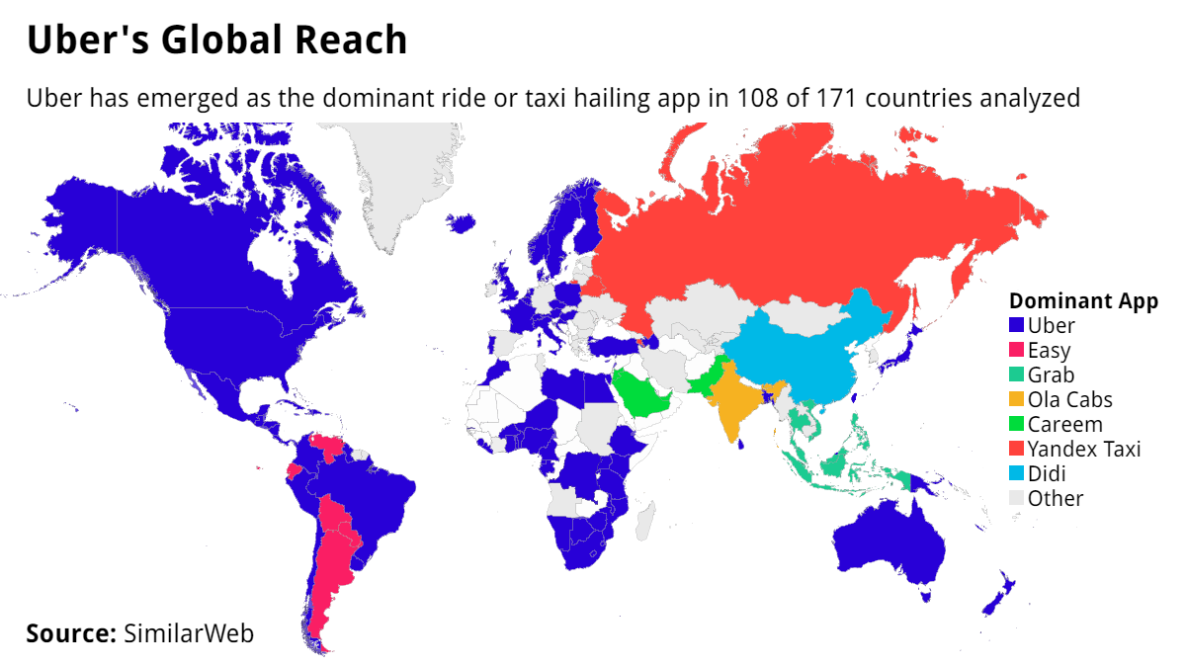 (Google, 2021)
1.7 Uber Rivals
Uber is one of the top private companies in the United States, with the utilization of Uber technology; consumers can schedule transportation with the help of a mobile App. Uber Technologies Inc. receives client requests and sends the same requests (bearing location and final destinations) to drivers who are within proximity to the said clients. As one of the tools of operation, the drivers must, therefore, have smartphones.
The same applies to clients who must utilize the Uber app in making ride requests. This company was founded in the year 2008 and has its headquarters in San Francisco. It has around 12,000 employees and revenue from sales was estimated to be around 6.5 billion dollars by the end of 2016. As one of the companies that have shaped the taxi business around the world, Uber receives both direct and indirect competition from the following companies: Lyft, Grab, Ola Cabs, Local Taxi’s, Public Transport.

1.8 Uber Porter’s Five Forces and Ubers Competition Analysis

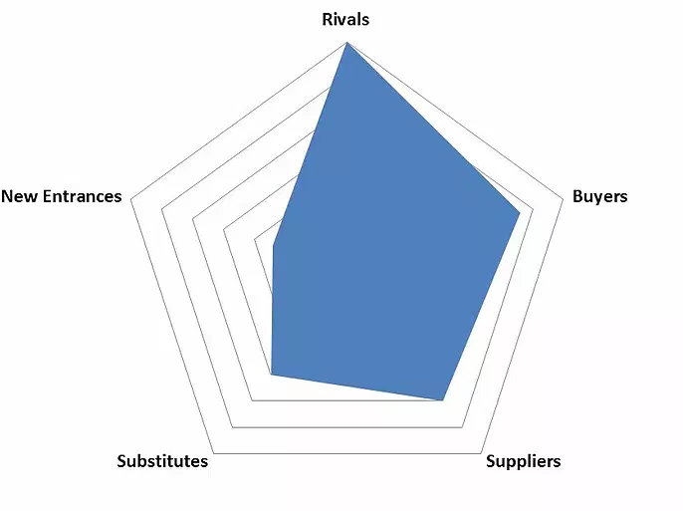
According to Michael Porter’s five forces of competition analysis, Uber’s specific five forces is shown as follows by plotting a radar chart (Jurevicius, 2013).
Potential new entrants: Low
Uber is positioning itself in a technology field that provide a channel of linking bridge between ride-demanding customers and spare car providers. This market requires a higher amount of initial capital, and this capital requirement has risen the entry level compares to other markets (Uber, 2021).
Since Uber is facing legal issues around several area and has been fined by some government authorities, the market is still under controversies the new entrants would still be very cautious on stepping into the business. Thus, at least for a short time, the threat from new entrants will stay low (A Heartman, 2016).
If the legislation problems been settled down, as an O2O technology-based company, it is not easy for Uber to stop followers’ imitation, which means that it is easy to be copied and other competitors could operate in the same way as Uber.
Threat of substitutions: Medium
Considering about the service quality that Uber applies, the potential threats coming from the traditional transportation industry (including the public transportations, taxis, and private cars, etc.) are low because of its lower-cost and efficiency, as well as user-friendly designing. The graph below shows that the average coming time of both Uber cars and traditional taxis. More than 94% of the Uber cars will be arrived less than 15 mins while that number of traditional taxis is only 27% (Uber, 2021).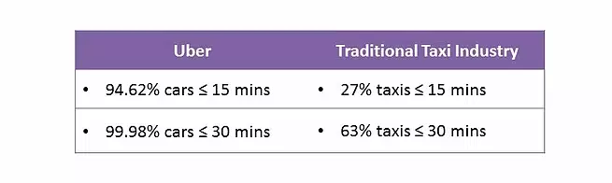 (Google, 2021)
Since there already are some companies provide similar services in this market among different regions, customers might switch to other available services just simply because of the feature of higher price sensitivity.
Threat of suppliers: Medium
One of the main suppliers of the industry including many individual drivers. The concentration of this group of suppliers is not very high, which to some extent, has restricted the bargaining power of suppliers.
Oil and gas suppliers (and may also extend to hybrid vehicles) is another main supplier. Oil price has been plunged since 2015 and the lowest level has reached less than $30 in January this year. Highly fluctuation of price brings a higher risk to the market because of uncertainty and non-predictability (Uber, 2021).
Threat of buyers: High
As the market getting bigger, the increasing number of participators bring customers more choice and the switching cost for customers is relatively low.
Although the number of private cars experiences a huge rise during the past few years, the parking problems have been more serious than ever before and the private car using in the cities is not expanding as fast as before as well (BBIN, 2019).
Degree of rivalry: High
The trend of concentration of the industry is appearing to be higher than previous years, and the existing company in the market is compete on both suppliers (car drivers) and customers.
Since the initial capital requirement to enter this industry is relatively high, the sunk cost during the early stage has raised up the exit barriers (Jurevicius, 2013)
1.9 Background Information of 2020/2021
The start of 2020 seen the global pandemic of Coronavirus/ Covid-19 hit the globe quite significantly, this brough widespread fear into people living all over the globe but had a significant impact on businesses worldwide. At first uncertainty took hold among business owners across the globe and they feared they would lose their businesses forever.
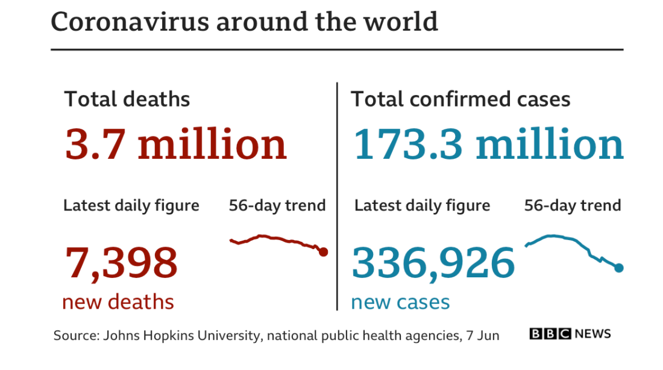
Uber was one of the businesses affected by the pandemic and found it difficult to maintain the level of clients they were used to before Covid-19 took hold on the globe, this affected millions of workers for Uber across the globe as well as many other organisations within the tourism industry such as Airbnb, Eurostar and many more. Even now in 2021 over 16 months from when the pandemic struck the Uk and the rest of the world, things are not the same. The effects of Covid-19 and the pandemic will be around for a long period of time as more recently the globe has seen the Delta Variant take hold and be more present within the UK, as over night the BBC and Wales Online news have reported that Delta Variant cases have now risen by 30,000 in a one week, with certain areas of the UK being most affected (Smith, 2021).
(BBC, 2021)
It has also been announced by Public Health Wales on the 11/06/2021 that the Delta Variant is 60% more infectious and the AstraZeneca and Pfizer vaccines are not as good for protection against the new variant (Smith, 2021). Public Health England says” the delta variant of Covid is 60% more infectious than Alpha - the Kent variant - and vaccines are less effective at beating it” More than 90% of new Covid-19 cases are now the Delta variant, which continues to show a significantly higher rate of growth compared to the Alpha (or Kent) variant according to the Public Health England Chief Medical Officer (GOV.UK, 2021) (England, 2021).
1.10 Uber’s Approach to Covid-19
Uber have created s great approach to Covid-19 throughout its branches across the globe, it has stated it is committed to supporting its employees with any assistance they need to get through the pandemic (Room, 2021). They have committed to support employees with financial help, PPE, Alternative earning opportunities, lowering fixed costs and educating riders (Uber.com, 2021). Uber’s management announced on their website that “The safety and wellbeing of everyone who uses Uber is at the heart of what we do. We're continuing to expand our response to COVID-19 with new features for our users, support for those who earn on our platform, and partnerships and initiatives that serve our cities” (Uber.com, 2021) Uber have also dedicated over 300,000 free rides and meals to NHS UK workers as a way of appreciation to staff during the pandemic, this can be done by going to www.uber.com/nhs and following the guidelines on the website (Uber.com, 2021).
Uber management have announced on their newsroom website that they are now shipping free disinfectant spray and masks to all drivers across the UK and USA, they have ordered tens of millions more masks and expect them to arrive in other cities and regions around the world in the coming weeks (Uber.com, 2021). Uber management have stated “We are sourcing these masks from outside of the traditional healthcare supply chains. For example, one of our first major orders is with a company that typically makes electronics and is now producing ear-loop face masks to help meet global demand. Uber is also donating all of the N95 masks, which are in short supply for health care workers, stored in our offices to local hospitals” (Room, 2021).

2.0 Lewins 3 Step Change Model
While these leadership changes make for good press, they are less surprising than one may think -- and they represent an opportunity for Uber to change, taking on an even more important role than ever before. First point: CEO transitions are not unusual in high-growth companies. It is not unusual for founder CEOs to step aside (A Heartman, 2016).
Step 1: Unfreeze.
Lewin’s 3 Step Model believes that human change follows a similar philosophy, to do this you must first unfreeze the status-quo before you may implement organisational change. Though not formally part of Lewin’s model, actions within this Unfreeze stage may include:
• Determining what needs to change.
• Survey your company.
• Understand why change is necessary.
• Ensuring support from management and the C-suite.
• Talk with stakeholders to obtain support.
• Frame your issue as one that positively impacts the entire company.
• Creating the need for change.
• Market a compelling message about why change is best.
• Communicate the change using your long-term vision.
• Commercial, in which a company provides a service to customers for profit.
Step 2: Change
Once you’ve “unfrozen” the status quo, you may begin to implement your change. Organizational change is notoriously complex, so executing a well-planned change process does not guarantee predictable results. Therefore, you must prepare a variety of change options, from the planned change process to trial-and-error. With each attempt at change, examine what worked, what did not, what parts were resistant, etc.
During this evaluation process, there are two important drivers of successful and long-term effectiveness of the change implementation process: information flow and leadership.
• Information flow refers to sharing information across multiple levels of the organizational hierarchy, making available a variety of skills and expertise, and coordinating problem solving across the company.
• Leadership is defined as the influence of certain individuals in the group to achieve common goals. A well-planned change process requires defining a vision and motivation.
The iterative approach is also necessary to sustain a change. According to Lewin, a change left without adequate reinforcement may be short-lived and therefore fail to meet the objectives of a change process.
During the Change phase, companies should:
• Communicate widely and clearly about the planned implementation, benefits, and who is affected. Answer questions, clarify misunderstandings, and dispel Rumors.
• Promote and empower action. Encourage employees to get involved proactively with the change, and support managers in providing daily and weekly direction to staff.
• Involve others as much as possible. These easy wins can accumulate into larger wins and working with more people can help you navigate various stakeholders.
Step 3: Refreeze.
The purpose of the final step—refreezing—is to sustain the change you have enacted. The goal is for the people involved to consider this new state as the new status-quo, so they no longer resist forces that are trying to implement the change. The group norms, activities, strategies, and processes are transformed per the new state (Britannica, 2017).
Without appropriate steps that sustain and reinforce the change, the previously dominant Behavior tends to reassert itself. You will need to consider both formal and informal mechanisms to implement and freeze these new changes. Consider one or more steps or actions that can be strong enough to counter the cumulative effect of all resistive forces to the change—these stronger steps help ensure the new change will prevail and become “the new normal” (Talib, 2018) (Britannica, 2017).
In the Refreeze phase, companies should do the following:
• Tie the new changes into the culture by identifying change supports and change barriers.
• Develop and promote ways to sustain the change long-term. Consider:
• Ensuring leadership and management support and adapting organizational structure when necessary.
• Establishing feedback processes.
• Creating a rewards system.
• Offer training, support, and communication for both the short- and long-term. Promote both formal and informal methods, and remember the various ways that employees learn.

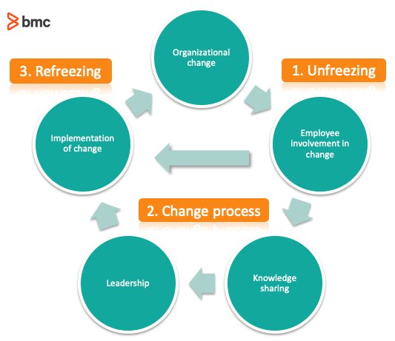 (Google, 2021) (BMC, 2021)
2.1 How has Lewin’s 3 step model been incorporated into Uber
Uber have incorporated Lewin’s 3 stage model into there business by following the steps that Lewin has set out on the model. For example when the pandemic hit the globe Uber management decided to unfreeze the status-quo within th organisation and make changes to the way the organisation is ran, this includes asking employees for their ideas and how best Uber management can support them during Covid-19, this included discussions on what needs to change within the organisation to make things run more consistent within the workplace, do staff surveys to see what staff need and want and consider how this would benefit Uber themselves. The management team also decided to have talks with stakeholders and directors to see what ideas and plans they had for the organisation during the global pandemic and gain support from them for future commitments (Uber, 2021).
After Uber management had talks with stakeholders, directors, and staff it then became the time for the change process within the organisation, Uber’s change process began in 2009 when they invested in Uber Technologies and then in 2011 when Uber cabs go live in New York and Chicago, ad amazingly when they expanded to Paris in 2011 also, Uber soon became the name of the well-known taxi firm you can order from your mobile phone app. In 2012 uber then decided to expand to Canada and london and then in 2013 they had a massive international expansion to Taiwan and Taipei and even to South Africa and India (Cava, 2017) (Uber, 2021). In 2014 Uber launches Uber Rush in New York City, a courier service using bicycle messengers to deliver packages. This marks the beginning of Uber's transition into a logistics company, and expanded to China starting in Beijing, over the following years Uber had many more expansions to the organisation such as Uber fresh, Uber bikes, Uber x, and Uber Visa credit card, partnered with Barclays Bank plus they built a fleet of 50 self-drive cars in New York and Uber robotics laboratory in Los Angles and soon to be launched is Uber hotels around the globe. These expansions were rapid changes for the organisation and its management team and current staff members. By following Lewin’s 3 step model the Uber management team have been able to successfully implement the changes into the organisation that was desperately needed to secure the future of Uber (Uber, 2021) (Zipkin, 2017).
Now that the changes within the organisation have been completed, they have now implemented Lewin’s step 3 of refreezing the organisations change management plans, they have done this by implementing the plans to meet the cultures and values and beliefs of the organisation and staff members and clients, and make sure that all management, stakeholders, and directors agree with the changes that have been implemented and create a feedback system for staff and clients to help management make sure the organisation is performing to the best of its ability.
2.2 Uber Change Management
Since starting in 2008 Uber have become one of the most successful taxi companies in the world and is classed as the most reliable and commonly used transportation services around the globe, but there has been need for change after the organisations management and staff came under scrutiny after a member of staff was accused of raping a client after he drove her home from a night out in london in 2016 (Samuels, 2016), this caused the organisation some major setbacks and a lot of bad publications from the media. In fact, over 32 Uber drivers in 2016 in london alone were accused of raping clients after collecting them from nightclubs or event venues (Samuels, 2016)
Uber has now faced a long battle to get the organisation back to a respectable level again and have clients trust drivers, they have enhanced their operations to enhance performance, effectiveness, profitability, and most of all their reputation (Uber, 2021). As it stands at present there are various internal and external forces driving the need for change within Uber despite being one of the leading start-up organisations across the globe (Samuels, 2016).
The internal forces driving the need for change within Uber include the organisational culture this has had significant impact on staff members across the globe, which impacts the productivity of its workforce (Zipkin, 2017). The other internal forces include the need to provide more HR support to staff during difficult times and support during complaints from clients. The external forces driving the need for chang are the bad reputation among employees which comes from numerous client complaints about staff which amount from everything such as rape, customer harassment and stalking, this bad news is a major setback for the management of Uber.

2.3 Change and Vision for Uber
The desired transformational change is for Uber to improve the organisations reputation among clients and employees across the globe, as well as enhance profitability in this ever-changing market in which many of Uber’s competitors make regular changes within their organisation (Zipkin, 2017) (Cava, 2017). They also need to look at changing values and beliefs which could include creating a safe working environment for staff and to promote the safety of clients who use the Uber services daily, to enhance the excellent customer service, integrity, and honesty within Uber (Connely, 2008-2021).

3.0 Conclusion
While comparing the change management process and Uber, it is evident that Uber have made significant changes to the way the organisation is run (Uber, 2021). They have made these changes using internal and external expansions around the world by expanding into other businesses such as food deliveries, private limo hire, Uber fresh, Uber Technologies, Uber rush, Uber black and even Uber visa credit card which is partnered with Barclays Bank (John E. Barbuto, 2016). These changes have been significant to the organisation and have made Uber one of the most recognisable names around the world now as they dominate 108 countries out of 177 with Uber services (Uber, 2021) (Zipkin, 2017).

Bibliography
A Heartman, N. M., 2016. The Story of Travis Kalnick and How He Built Uber. [Online]
Available at: www.businessinsider.com/ubers-history
[Accessed 24 May 2021].
BBC, T. V. a. D. T., 2021. Covid map: Coronavirus cases, deaths, vaccinations by country. [Online]
Available at: https://www.bbc.co.uk/news/world-51235105
[Accessed 11TH June 2021].
BBIN, 2019. PORTER'S 5 FORCES OF COMPETITION ANALYSIS. [Online]
Available at: https://bbinn3.wixsite.com/ubercatalyst/5-forces-analysis
[Accessed 11TH June 2021].
BMC, 2021. BMC Blogs. [Online]
Available at: https://www.bmc.com/blogs/lewin-three-stage-model-change/
[Accessed 6TH June 2021].
Britannica, T. E. o. E., 2017. Change Management. [Online]
Available at: https://www.britannica.com/biography/Kurt-Lewin
[Accessed 24 May 2021].
Cava, M. D., 2017. Can Uber Really Change?. [Online]
Available at: www.usatoday.com
[Accessed 24TH May 2021].
Connely, M., 2008-2021. Change-Management-Coach. [Online]
Available at: https://www.change-management-coach.com/what-is-change-management.html
[Accessed 24TH May 2021].
Economist, T., 2017. uber Crisis. [Online]
Available at: WWW.economist.com/news/uber
[Accessed 24 May 2021].
England, P. H., 2021. Coronavirus. [Online]
Available at: https://www.england.nhs.uk/coronavirus/
[Accessed 11TH June 2021].
Google, 2021. Google Images. [Online]
Available at: www.googleimages.com
[Accessed 11th June 2021].
GOV.UK, 2021. Data.Gov.UK. [Online]
Available at: https://coronavirus.data.gov.uk/
[Accessed 11TH June 2021].
Guest, D. E., 2013. HRM and Performance: Achievements and Challenges. 1st ed. Manhattan: John Wiley and Sons Ltd..
HA, H., 2014. Change Managment for Sustainability, New York: Business Expert Press.
John E. Barbuto, J., 2016. How is Strategy Formed in Organizations? A Multi-Disciplinary Taxonomy of StrategyMaking Approaches, Nebraska: University of Nebraska-Lincoln .
Jurevicius, O., 2013. Porter's Five Forces. [Online]
Available at: https://strategicmanagementinsight.com/tools/porters-five-forces.html
[Accessed 18th November 2020].
Knowladge, M., 2018. The Concept Of Strategy. [Online]
Available at: ttps://www.mbaknol.com/strategic-management/the-concept-of-strategy/#:~:text=According%20to%20Johnson%20%26%20Scholes%20strategy%20is%20“the,or%20clients%20so%20as%20to%20meet%20stakeholder’s%20expectations”.
[Accessed 11th November 2020].
Lauer, T., 2021. Change Management. 1 ed. Springer-Verlag GmbH Germany: Springer, Berlin, Heidelberg.
Lilc, A., 2018. 7 Reasons Your Employees are Unhappy and What to do About it. [Online]
Available at: https://awardsinternational.com/2018/11/28/7-reasons-your-employees-are-unhappy-and-what-to-do-about-it/
[Accessed 17th March 2021].
Luckman, N., 2019. Strategy and why it is important. 1st ed. Chicago: s.n.
Makagonva, V., 2018. Cabs In Russia. [Online]
Available at: https://www.tripsavvy.com/how-to-get-a-cab-in-russia-1622517
[Accessed 11TH June 2021].
Martin, L. A., 2010. Effective Data Collection. [Online]
Available at: https://www.tandfonline.com/doi/abs/10.1080/0954412006856
[Accessed 27th March 2021].
Mullins, L. J., 2007. Management and organisational behaviour, London: Pearson education.
Nickolas, F., 2012. Strategy: Definitions and Meanings. [Online]
Available at: https://nickols.us/strategy_definition.htm#:~:text=In%20short%2C%20Porter%20argues%20that%20strategy%20is%20about,of%20activities%20different%20from%20those%20used%20by%20competitors.#:~:text=In%20short%2C%20Porter%20argues%20that%20strategy%20is%20about,
[Accessed 11th november 2020].
Omer Cloutier, L. F. C. H., 2015. The Importance of Developing Strategies for Employee Retention. Business Management, pp. 1-11.
Research, T. A. f. C., 1978. Motivation-Need Theories and Conumer Behaviou.. [Online]
Available at: www.acrwebsite.org
[Accessed 13th November 2020].
Room, U. N., 2021. Uber Covid-19 Safety Update. [Online]
Available at: https://www.uber.com/newsroom/covid-19-safety-update/
[Accessed 6TH June 2021].
Samuels, G., 2016. Uber drivers accused of 32 rapes and sex attacks on London passengers over the past year. [Online]
Available at: https://www.independent.co.uk/news/uk/uber-drivers-accused-32-rapes-and-sex-attacks-london-passengers-a7037926.html
[Accessed 11TH June 2021].
Smith, M., 2021. Wales Online News. [Online]
Available at: www.walsonline.com/deltavariant
[Accessed 11th June 2021].
Spacey, J., 2016. Emergent Change VS Planned Change. [Online]
Available at: https://simplicable.com/new/emergent-change#:~:text=Emergent%20change%20is%20a%20strategy%20of%20quickly%20developing,strategies%20that%20may%20involve%20multi-year%20programs%20and%20projects.
[Accessed 24 May 2021].
Sundararajan, A., 2017. The Sharing Economy. In: The End of Employment and the Rise of Crowd-based Capitalism. s.l.:MIT PRESS, pp. 23-26.
Talib, S., 2018. Kurt Lewin's change model: A critical review of the role of leadership and employee involvement in organizational change. [Online]
Available at: https://www.sciencedirect.com/science/article/pii/S2444569X16300087
[Accessed 24 May 2021].
Uber.com, 2021. Our approach to Covid-19. [Online]
Available at: https://www.uber.com/gb/en/coronavirus/
[Accessed 6TH June 2021].
Uber, 2021. Uber.com. [Online]
Available at: www.uber.com
[Accessed 24TH May 2021].
Williams, G. S. a. A. M., 1994. Critical Issues in Tourism, London: Pearson educatonal.
Zipkin, N., 2017. Uber Needs Company Culture. [Online]
Available at: www.entrepreneur.com/article/295844
[Accessed 24th May 2021].

