

NOMNOM CHOCOLATE – Liam Burgess
Use new data management process to the growth of the activity
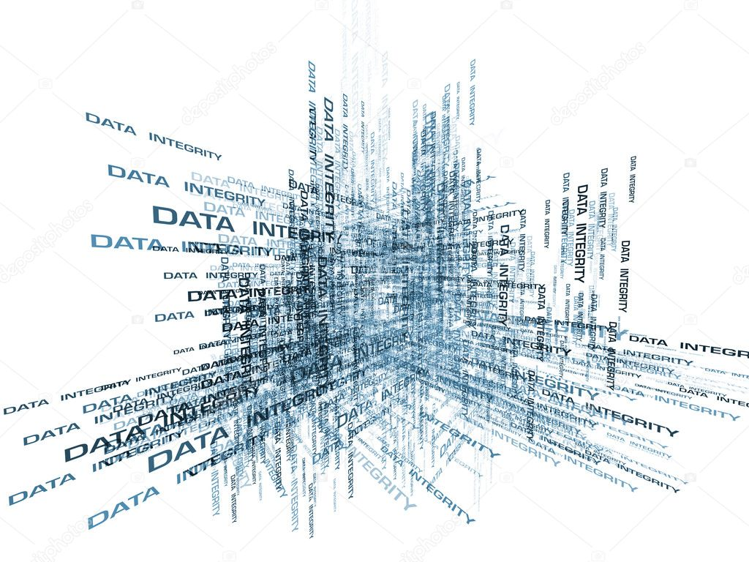

Chloé JUGAN
UWTSD Business School
2018-2019

QUESTIONS

- Begin with an introduction to managing data that includes a definition and discusses the benefits and drawbacks of such systems. (20 marks)

To introduce this assignment, this report will cover the data management process and show if the NomNom chocolate company should integrate new data management systems.

NomNom chocolate is a chocolate company based in Llanboidy which was created in 2011 by Liam Burgess. The business has received a great success thanks to the quality and variety of its products and the origin of its ingredients used to make its delicious chocolates. Liam Burgess work with local Welsh products but also international products from Venezuela or Ecuador.
Despite the great running of the business and the factory, he wants to innovate and follow a database management system which is used to create, maintain and provide a controlled access to databases (Keith Gordon, 2013, Principles of data management, page 10). Indeed, he would like to develop this system to take better decisions, understand the market and the customers, and work more effectively and efficiently, as he said, thanks to the valorisation of data.

Liam Burgess is right, in today’s industry to improve and boost his chocolate company it is about time he changes the system of his business by moving to managing data systems.
But what really is the managing data process? There are different ways to define it. Data management is the company department which helps with the collection of information services by controlling and coordinating the use of reliable and pertinent data. Molly Galetto say that “Data management is an administrative process that includes acquiring, validating, storing, protecting, and processing required data to ensure the accessibility, reliability, and timeliness of the data for its users” (Molly Galetto, 2016, page 1, available at : https://www.ngdata.com/what-is-data-management/, page 1). This management allows to collect the information from different sources to improve the performances of the company, especially enhancing the satisfaction of customers, by taking better decisions.

But such systems have drawbacks despite all its benefits.
Regarding the advantages, managing data could help firms in difficulty to analyse their problems and find out the fragilities in their management operations. It also allows to target the customers by understanding better what they want and by knowing how to meet their expectations. Hence, thanks to this system, companies can improve their activities and products. The setting up of this system has an economic impact thanks to the improvement.
However, the cost of all this enhancement is high. The company has to hire qualified staff to manage the process and perform correctly the information cycle. The staff must be qualified, it means they must have knowledge and training regarding data management. Moreover, if the information is not well interpreted and the sources are biased or inaccurate, it could result in poor managing choices. We have to know companies have to keep in mind that there is no turning back once the new process rolls out as this system needs time to be set up. Finally, due to its complexity, it needs maintenance and tight security, and data must be protected from the public.

- Identify some of the computerised data management system options available to them to collect and manage it. (30 marks)

To implement such system, a company has to create new departments to collect the information. They have to choose the most compatible data management system option with their existing one and adapt their internal organisation to it. The company has to manage and organise data by employing databases.

Firstly, marketing managers with a managing approach have to know what information they need. For examples, the customer behaviour, their characteristics, their cravings, the competitors in the market, their products sell according to people’s age, gender, or periods of the year for example, and their marketing plans. Then, there is the internal records, which is the interface between the operations of the business and the collection of data through technology (Will Flemming, 2018, lesson). The company has to collect the information. During this part of the process, it is important to find interesting sources and choose information inside variety of sources. There are external sources at a macro-environmental scale (informations about the market, politically, economically, socially, technologically, legally, and ecologically speaking), and at a micro-environmental scale (informations about marketplace, customers and suppliers). There are also basic sources within the company. Here, it is the transaction processing system, relate to sales informations (sales and customer services, accounting, product operations, digital codes and complaints).

After the collection, thanks to an effective support system, the company must store data. Data are principally customer, potential new customer, product, geodemographic, transactional and promotional informations, and are stored on databases. According to the company, data storage can be different (e.g. clouds, telephone book). Then, thanks to an executive information system, informations are shared inside the company with different stakeholders which includes employees, suppliers, and intermediaries through Groupwares like the internet, the intranet, and the extranet.

The next step is to manage and organise data. For that, there is some computerised data management options. The different functional database models allow to support analytics applications.
- The expert system investigates the databases and provides customer’s answers thanks to a software.
- The customer relationship management is the central database which turn around customer, because without customer there is no business. This system improves relations with customers by meeting their expectations and understand their claims. This system also integrates customers’ informations from all sources, analyse it in depth and apply the results.
- The knowledge management, which refers to the way organisations develop, keep, and use their intellectual knowledge, to renew opportunities and improve customer services. Companies do not only talk about data and information but also about knowledge as data is “instrumented, interconnected and intelligent” (Will Flemming, 2018, Marketing information system lesson).

Moreover, data go through the information cycle process which is an important part of the marketing information system. Data managers, thanks to the company tools, follow a specific process which goes by different steps: analysis of informations, presentation with tables and graphs, interpretation with comparisons, trend analysis, and to finish the final information is used in a feedback to see how to improve the organisation.

Finally, thanks to the decision support system which helps marketing managers to evaluate different decision paths and choose the best one marketing managers, the company can take strategic, operational and tactical decisions.

- Explain to the management team what the future of data management is beginning to look like and what Big Data might mean to them. (25 marks)
This system is an ever accelerating technological progress. Nowadays, the new form of managing data is called about Big Data. Data management is a revolution for companies because it allows them to develop and improve even more all their activities and increase the satisfaction of their customers thanks to better tools.

Big data is an upgraded version of databases. The informations collected are more consequent and they are treated more effectively. It is a new intelligent method which improves the data management organisation, thanks to faster analysis, more sources and higher information quality, variability and visibility. We talk about data warehouse, bigger software to store more informations. The rule of the six “V” (volume, variety, velocity, veracity, variability and visibility) is used in Big Data, which represents the information characteristics in this system. Many companies are now using Big Data more than ever before in order to take marketing decisions and to better understand customer behaviours, trends, opportunities, and of course extract value from data.

Data management systems are constantly modernizing themselves in order to maintain competitive edges. Indeed, the ability to store data must evolve to make room for constantly more information. However, these new data management technologies require strong and percussive data security measures. A lot of new systems will emerge like IT outsourcing, AI (Artificial Intelligence) such as machine learning, deep learning, cognitive analytics or Blockchain, smart contracts, which are news mathematics models and algorithms. Companies use internet and social media to collect information, and will do so even more in the future, and they use clouds and servers to store that information. Furthermore, new positions such as data officers are starting to appear in companies. On the whole, people say that future is made of the automatically upgrades and the autonomous technologies. That is to say the automation of administration tasks, provisioning, safeguard, security, and availability. That allows the companies to take lower risks and to work more efficiently.

However, NomNom chocolate has to know that these systems have limits, especially regarding security, confidentiality, accurate sources, and in particular costs.

- Finally, provide an outline of the General Data Protection Regulations and show clearly how they can affect the company in how it manages and controls the data it collects. (25 marks)

Today the overwhelming rising data collection and processing through Big data technology require tighter control. There is a need for higher security implemented through laws and regulations, just as any new big innovations. The protection of data is now really important in the organisational strategy, because of ethical and social responsibilities and issues. Companies must respect some rules on data marketing management to face up to the technology improvement and the cyber security risks. Indeed, the collection of personal informations can go against the privacy of customers. Companies use the information security which “is the practice of defending information from unauthorised access, use, disclosure, disruption, modification, perusal, inspection, recording or destruction” (Andy Taylor, 2013, Information security management principles, page).

Nowadays facing the rise of the cyber-attack, the data security must be reinforced and more controlled. The general Data Protection Regulation is a regulation in the European union law voted in 2016. In 2018 in UK, the new Guide to general Data Protection Regulation have been written to secure the access to information and the private life of people through personal data. Its purpose is to help companies to establish a marketing information system in a proper way, because all good informations handling allow to make good business sense. Regarding data protection, the GDPR is based on eight principles:
- About the process: it must be fairly, lawfully, transparent, and secure (respect the conditionality and control accesses), with a limited purpose, a limited storage, and in accordance with the data subject’s rights.
- About data: they must be accurate, adequate, relevant and not excessive (minimized).
Companies can be sanctioned through fines or warnings if they don’t respect the right of erasure and the right of access, penalties can be high. They must be transparent towards customers regarding data collection. Data security is also about protecting the database against unauthorised users (Keith Gordon, 2013, Principles of data management, page 20) to prevent the loss of vital company information, confidentiality, integrity, availability, loss of costumer trust and so on … The information is used for analysis, planning, implementation, and control. Hence the data protection, companies has to establish a management policy to respect the rules and the ethical issues.

There are some keys to secure data. The data recovery prevents possible failures or system crashes. The database administration responsibilities concern the management and control of the software used to access physical data. These services combine various points: the management of the security, the performance monitoring, the prevention against failure, and the management of upgrades to the database management system software. Companies can also be helped by external companies specialised in this field.

Hence, if NomNom chocolate establish a data management, the company has to be secured (with the high control), organised (with a process data register and the storage of only interesting data) and transparent (with privacy policy) in order that people give it trust thanks to protecting data.

CONCLUSION

In closing the reflection, I think that today, the use of databases in big companies has become almost essential to be competitive in the marketplace, to improve the skills and to ensure good relationships with the customers. It is the area of “business intelligence”. Data management is a great assistance to decision making in terms of general business and specific marketing activities.

To sum up, such a system has a cost, but it is necessary because collecting data aims at solving issues and improving business. It is one of the only way to properly analyse the customer behaviour and the competitors in the market. However, the system must be rigorously controlled and monitored because of the technology improvement and the cyber security risks.

REFERENCIES

Andy Taylor, David Alexander, Amanda Finch, David Sutton, (2013), Information security management principles, BCS.

Arif Mohamed, 2007, Computer weekly, Choosing the right database management system, available at : https://www.computerweekly.com/feature/Choosing-the-right-database-management-system

Arthur L, (2013) Big Data Marketing: Engage your customers more effectively and drive value. New Jersey. John Wiley and Sons Inc.

Bernt Ostergaard, 2017, Computer weekly, Data management: What does the future hold, available at: https://www.computerweekly.com/feature/Data-management-What-does-the-future-hold

Chris Kelsey, 2016, Wales Online, This 23-year-old from Wales is making the chocolate you're seeing everywhere available at: https://www.walesonline.co.uk/business/business-news/23-year-old-wales-making-13015343

ICO, 2018, Guide to the General Data Protection Regulation (GDPR), available at: https://ico.org.uk/for-organisations/guide-to-the-general-data-protection-regulation-gdpr/

Ilona Gabinsky, 2018, Oracle, The Future of Data Management is Autonomous, available at: https://blogs.oracle.com/database/the-future-of-data-management-is-autonomous

Keith Gordon, (2013), Principles of data management, facilitating information sharing, Edinburgh.

Netapp, protect and secure data, available at: https://www.netapp.com/us/solutions/data-protection/index.aspx

Irfan Ahmed, 2017, Smart data collective, The Future of Big Data: 10 predictions you should be aware of, available at: https://www.smartdatacollective.com/future-big-data-predictions/

Loïc Bremme, 2016, Le Big Data, définition : qu’est-ce que le big data, available at: https://www.lebigdata.fr/definition-big-data
Margaret Rouse, 2017, Techtarget, data management, available at: https://searchdatamanagement.techtarget.com/definition/data-management

Nick Ismail, 2018, Information aga, 5 technology trends transforming data management, available at: https://www.information-age.com/5-technology-trends-transforming-data-management-123472524/

NomNom chocolate, 2016, Sourcedmarket, available at : https://sourcedmarket.com/nom-nom-chocolate/

Oracle, 2018, Youtube, The Future of Data Management is Autonomous, available at: https://www.youtube.com/watch?v=izoH-vovw9A

Sophie Rees, 2016, Buzzmag, The Willy Wonka of west Wales: NomNom’s Liam Burgess, available at : http://www.buzzmag.co.uk/uncategorized/willy-wonka-west-wales-nomnoms-liam-burgess-food-interview/

Talend team, 2018, Talend, the future of big data, available at: https://www.talend.com/resources/future-big-data/

