2019
Annmarie Francis
1604693
12/6/2019
Human Developing Innovation and Creativity for Business Advantage BMSK6002
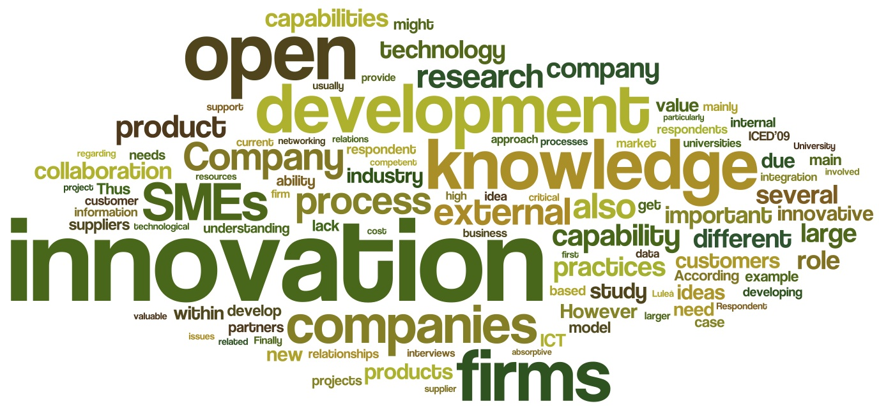

Executive Summary
This report presents the findings of Stockholm gases teeth whitening product, the research and findings are carried out by Annmarie Francis
The research is to commission a clear understanding of the importance of innovation to business development and the ability to critically review models and characteristics of the innovation process.
Regarding the case study “Developing a new product for the teeth whitening market,” there will be a written report that highlights the approach to Stockholm gases.
After taking one member of the management team of the teeth whitening product, there will be an analysis of the individual's role in the teeth whitening project as well as taking into account the individual's organizational knowledge and experience.
Next, there will be an evaluation of an open and closed model of innovation. The analysis will demonstrate how the open and closed innovations can apply to the teeth whitening project. With justification, there will be an explanation of which innovation one would recommend if the project should go ahead.
Finally, there will be a recommendation to the board on whether Stockholm gases should invest £10million into the project or not invest, with the conclusion.

Contents
Executive Summary 1
Introduction 3
Part One 6
Background to Stockholm Products 6
Stockholm Products approach 7
Part Two 12
Part Three 15
Open and closed innovation 15
Part four 18
Yes or no to the investment? 18
Conclusion 19

Introduction
With the recommendation to the case study developing innovation for the Teeth Whiting Company, there will be a report that addresses the questions in action. Part one of the Report will be a recognized account of the approach of the Stockholm products approach to innovation.
Part two of the report will demonstrate the title role of management within the Teeth Whiting project group. In this case, the product development manager is the case study, reflecting on the product development manager's organizational knowledge and experience to the project.
Part three of the report will be an account of one open and one closed model of innovation. Also, there is an evaluation of how the models will apply to the teeth whitening group, with a detailed and transparent clarification of which model one would oppose if the project goes ahead.
Part four of the report will be the proposal to the board of directors on if Stockholm products could invest the 10milion into there new product project or decide not to invest.
Innovation has an understanding of the method of translating an idea before invention in an excellent service that generates value, for which the consumers will pay. In organizations, innovation regularly results when ideas are harnessed by the business to fulfill the needs and expectations of the consumer.
The organization that sees how to generate value for mutual consumers and businesses can switch the source of competition in their industry. By forming efficient business systems targeted for producing new value in a market, organizations reclassify a value as well as lockout competitors who cannot recreate the active business model that produces it (Johnston, 2003).
The least sophisticated approach to classify innovation is in two ways, incremental innovation and radical. Incremental innovation is an enhancement in an existing product, for example, product, process, or service. Radical innovation disrupts the organization's current system or process and supplements it with something new.
For example, the teeth whitening product is incremental innovation. Stockholm products are looking into enhancing the current fundamental competencies and capabilities, adding value to the organization, also understanding Stockholm products in responding to customer needs acknowledged from the organization's current offers.
As well as innovation, there is a focus on creativity: the new awareness and beneficial idea to innovation as the development which formulates that idea into a reality within a market that values it. Organizations mostly have an understanding of how new ideas have produced and shared and accepted to generate successful innovations.
Creativity has been deﬁned as the creation of new visions by progressing toward issues or existing practices in innovative or creative manners. It has acknowledged that creativity requires rethinking assumptions and interpreting facts, ideas, and past encounters. It additionally reported that a developing interest for creativity as a source of competitive advantage has established as of late (Goodman, 2003).
According to Schumpeter, the cyclical process is exclusively the outcome of innovation in the organization, industries, and commercial. Besides innovation, he infers the changes in the approaches of production and transportation, creation of a new product, change in the industry organizational relationship, to open up a new market, and so on. Innovation does not mean invention. Instead, it alludes to the commercial applications of new technology, new material, new techniques, and new sources of energy.
Stockholm products is an Industrial gas organization established in Sweeden for over eighty years. The history of Stockholm gas company resides with the history of supplying oxygen to the health care market as well as carbon dioxide to drinks and beverages industries. Stockholm product is an international macro organization that employs over 32.000 people in over seventy countries globally. The organization's annual sales for the year 2018 grossed in at £12.1billion.
Stockholm's product expertise reflects in their valuable research and development history. Research and development have helped maintain a dominant stance in the gas market, with over £100milion annual budget appointed to research and development with a recent investment of 10% of this budget to a single project of Teeth Whitening.
The organization's research and development department has over 100 products on the run systematically, with one that was investigating products for the use of plasma as a cleaning agent. Stockholm products at present are looking into Plasma, an ionized gas with the capacity of operating electricity, and also absorbing energy from an electrical supply.
According to Langmuir (1920). Plasma is a hot ionized gas comprising of roughly equivalent quantities of positively charged particles and negatively charged electrons. There are characteristics of plasmas that are not necessarily quite the same as those of common neutral gases. Plasmas viewed as distinct. For instance, plasma formulated up of electrically charged particles which actively manipulated by the electric and magnetic areas while neutral gases are not. The temperature increase allows the ions to vibrate faster, hence the scrub of the surface.
Bear in mind the new plasma innovation of teeth whitening may seem like a disruptive innovation as there are barely any known products that may offer trouble-free use. The prediction is that most brand proprietors will respond by, argue that the safety issues of using plasma as a whitening agent or even Recommendation of a brand partnership.
Stockholm products found a copyright that was submitted by the University of Southern California. The university maintained that the plasma, which they used to sterilize teeth, had side effects, one of them being whitening of teeth. There was a light bulb moment for the scientist, and the team of researchers assembled to investigate if the idea would be a valuable business opportunity, so the team had 12 months and a budget of £1milion to decide whether they want to invest.

Part One

Background to Stockholm Products
Stockholm products employ 32.000 people in more than 70 countries globally, and with an annual review of sales which gross at £12.1billion in the 2018 financial year. Stockholm products are an industrial gas company, so this organization historically established to be cyclical.
Cyclic innovation model
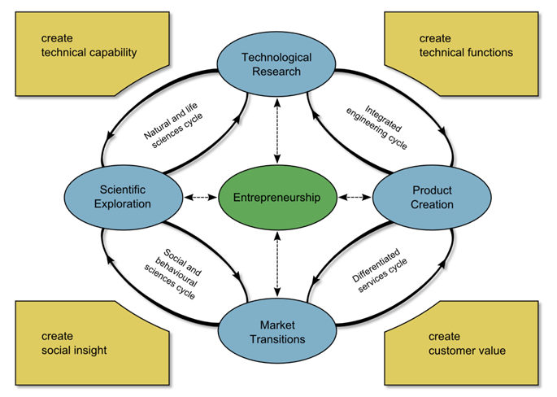
- Entrepreneurship, Stockholm gases research and development department entrepreneurship has a planned development for the teeth whiting product.
- Technological research, Stockholm gases research and development department, chemical technologically use of plasma as a cleaning agent, with plasma being the fourth matter which could be either solid or liquid, which is a gas of the fourth type.
- Project creation, over the year, Stockholm gases explored the sustainability of integrating plasma for a cleaning agent and to whiten the teeth. Artificial plasma created when energy added to the gas, maybe when using an electrical field or laser.
- Market transition, Stockholm gases uncovered a patent and its potentials, which quickly established a team of researchers to investigate if the product could be a sustainable business opportunity additionally might even convey to the market. 90% market study completed.
- Scientific exploration, Stockholm gases identified the uncovering of a patent submitted to the University of Southern California, which maintained the scientist used the plasma to sterilize pig teeth, and one of the side effects is the whitening of teeth.
The organization is a sustainable industry, which their strategy focuses on international business with pioneering products and services. Stockholm gases provide a large-scale of gases, such as liquid oxygen, which they supply to healthcare partners, and carbon dioxide, which they also supply to drinks and beverage companies. Because of this partnering, Stockholm gases are a reliable collaborator for other sustainable industries.
The healthcare and drink and beverage industries are innovation-driven organizations; for example, the healthcare industry is consistently looking for new alternatives to drugs and cures for life-threating diseases. With this, there is a constant need for research and development programs. With the very same for Stockholm products, the history through the development of the different gases, for the appointed organizations, opens the floor for research and development for the improvement of existing products as well as new innovative products.
The industry is once in a while linked with manufacturing, as in differences among industry and services. Industrial relations have, on a fundamental level, never been so limited. Nevertheless, in any case, consideration up to this point frequently centered around specific parts of the economy. These, in reality, grasped more than manufacturing to incorporate the public sector (Edwards, 2003).

Stockholm Products approach
Sweden adopts a free-market approach to the energy policy, which emphasizes competition in guaranteeing efficient energy supply inside a policy structure that plans to encourage renewable power sources. A market is free if individuals can purchase and sell anything they desire with no impedance from the government, and if the organic market sets costs.
Stockholm gases being a free-market industry cements the fact that they can continuously innovate, as well as the organization, has the freedom to create new ideas, new products, and services to sell for profits.
Stockholm products are part of the petroleum industry. The organization supply raw materials to these industries, with long-term relations between them, as well as having inter-organizational relationships with there stakeholders, which are the healthcare and the drinks and beverage industries.
According to Schumpeter’s theory of imperialism, Schumpeter saw imperialism as coming from earlier rooted forces such as nationalism, militarism, and activism he took these as somewhat retrograde and activistic, and he identified capitalism with free trade and peace.
Schumpeter was probably the first to distinguish between Economic growth and economic development. Economic growth is translated as a quantitative measure when it produces an increase in inhabitants or wealth since it creates no qualitatively new phenomena but only change processes. In contrast, economic development characterized those qualitative changes in the economic process, which, by way of taking out new combinations with already existing means of production, brings dynamics into a stationary economic process (Kishor, 1994).
Research and developments Micheal Glass, the project leader, presented his discoveries with hopeful results, after a review on the project milestone, there was some convincing evidence. Experimentation is not allowed on human teeth. Stockholm products used pigs teeth in the experimental process, indirect results to the outcome of the experiment revealed several extraordinary changes, the exposure from the plasma showed discolored yellow teeth strikingly change to a shade of white.
Petroleum gas industries have a massive responsibility to the environment according to Legislation on Biotechnology in the Nordic Countries 2018. The EU mandate puts weight on species-specific education and training in laboratory animal science and the implementations of the Three R’s. Which are;
- Replacement, animal experiments with alternative methods when possible
- Refinement, methods, and procedures so that pain and discomfort of animals avoided.
- Reduction, the number of animals used
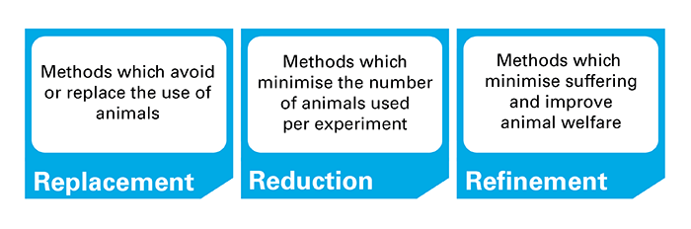
At present, the Three R’s have progressively more seen as a framework for operating high-quality science in the academic world with the focus of developing substitute approaches that avoid the issue of animal testing.
According to the three R’s animals have moral standing. However, not really ''rights'' in the philosophical sense. They recommend that the Rs are hierarchical, to such an extent that Replacement, which can utterly eliminate harm, ought to be considered prior Reduction, which diminishes the number of animals hurt, with refinement studied last. They additionally distinguish the requirement for an up to this point implicit fourth R: Reject, which enables the IACUC to deny authorization for a project which does not guarantee a satisfactory benefit to offset the torment and distress liable to be brought about by the proposed research (Howard, 2016).
Stockholm product's use of pig's teeth would have meant the research and development team would require an ethical permit/license. The process of attaining a permit means Stockholm products would come up against a committee, which will have the power to grant or turn down the organization's license.
The University of California submitted a patent; a patent is an intellectual property that gives its owner the lawful right to reject others from making, developing, selling, and importing an invention for a limited period of years.
Stockholms products Innovation management team of individuals is handling all activities needed to introduce teeth whitening products, which is something new to the organization. In practice, this can mean launching new ideas developing and focusing on implementing them alongside putting the idea into practice, for example, introducing the teeth whitening product or establishing new internal procedures fo it.
Innovation management is the process of impending and introducing new things and developing the organization, no matter which way. To truly understand the aspect of Stockholm's innovation management, there has to be a breakdown of the process.
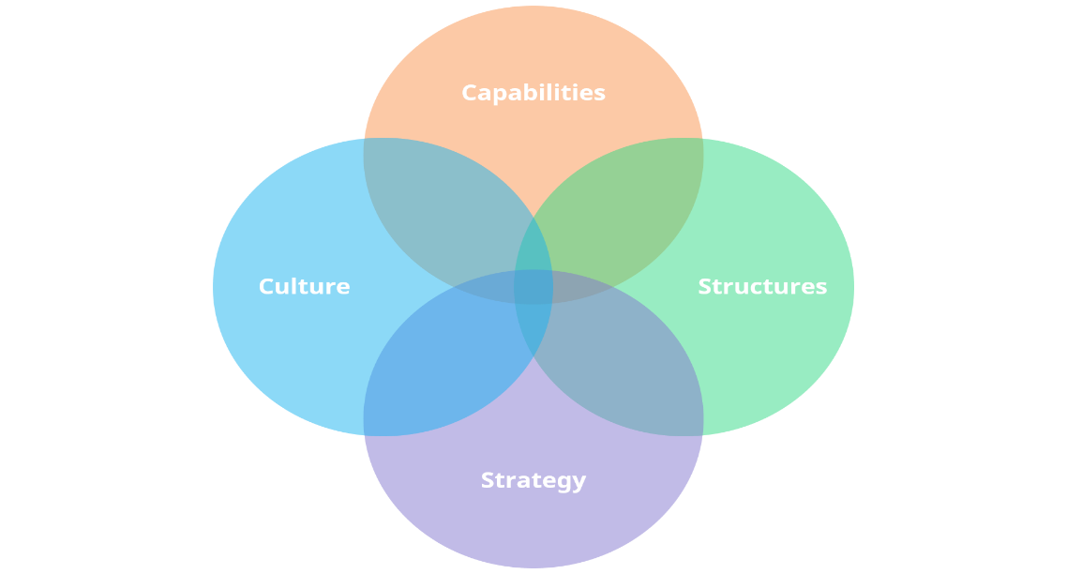
There are four elements of the process that will break it down.
- Capabilities, the capabilities aspect relies primarily on the individuals, and the innovation relies seriously on the abilities of the individual and the group mutually. Stockholm products team has a diverse array of abilities.
For example, the product development manager is responsible for the project and while the Development Manager keeps the development group on track and gives everyday specialized management and procedure direction on development activities, then, on the other hand, there is a research and development project leader who is responsible for the research and planning as well as implementing new programs and procedures and overseeing the development of new products. Both managers cover unique insights as well as the now how of practical abilities.
- Structures, the structures of Stockholm products enable the effective use of the said capabilities, so in practice, this means organizational structure infrastructure and processes of the business, the right structures are useful and can accumulate force permitting the business to develop and innovate even more effectively. For instance, Stockholm's product is a part of the free market infrastructure. A system, the market is free if individuals can purchase and sell anything they desire with no impedance from the government, and if the organic market sets costs.
Organizational structure, the organizational structure is a crucial factor; working teams on innovation need to shift fast and adapt to the environment that surrounds them. Making independent decisions of the customary way of doing things in the business so for Stockholm gases, this means the organization can extract additional knowledge flows, which can substantially improve the product development process, and this is an advantage and strategic strength of using network models.

Culture, culture is what enables the organization to obtain the capabilities related to the individuals. Stockholm products have a suitable pro-innovation culture that energizes the correct sort of conduct and disheartens an inappropriate kind. As the impacts rapidly accumulate, culture can have an excellent effect on the inventiveness of a business. Here are some of the more ordinarily acknowledged qualities for an innovative culture:

the organizational culture of the teeth whitening group gives enough opportunity and responsibilities and is driven mainly with vision and culture rather than a hierarchy of leadership approach. Also, the group will highlight the need to weigh up continuously reflecting on methods to get better.
- Strategy, Stockholm products strategy is to place the plan of the organization so that the business can attain long-term success. Innovation is a means of achieving strategic business goals. Being productive is vital at managing innovation, understanding both the bigger picture as well as the individual elements that made it up.
Innovation management enables creativity through the practical creation of several methods that assist organizations in increasing competitive advantage. Innovation management requires the implementation of a process together with a genuine understanding of strategy, critical thinking, and essential leadership. It is just through managing with the innovation process that organizations can create culture and climate that is conducive to the generation (Goodman, 2013).

Part Two
A project development manager is an individual liable for the undertaking of the project while the Development Manager keeps the development group on track and gives everyday specialized management and procedure direction on development activities.
Project development management has five phases of project management, conception, and initiation, planning, execution, performance/monitoring, project close.
Project management is the function of knowledge, abilities, tools, and techniques to a broad scope of actions in order to reach the needs of a specific project. Project management has five phases, and if the lifecycle gives a high-level perspective of the project, the stages are the guide to achieving it.
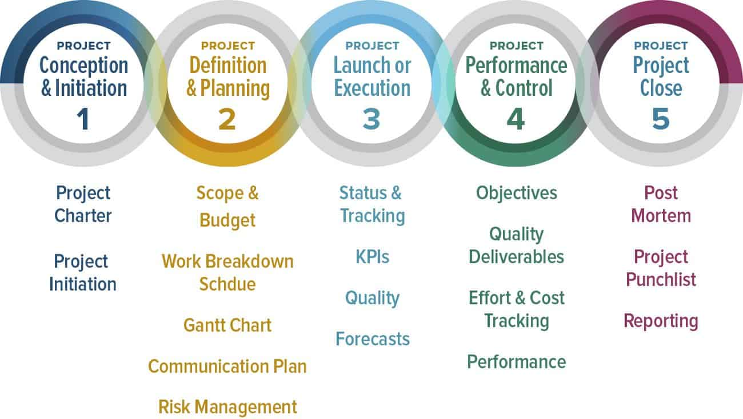

As a Project Development Manager Bernard Bing, has numerous duties, yet the primary one is to get a product out of the door. Bernard Bing's objective is to deliver results to the consumer, or even market, and do all things needed to accomplish this. To do this, Bing would have to ensure the development group able to work effectively as possible, which would mean they have clear objectives, which are both short-term and long term, and that nothing keeps them from doing their work.
When expanding from the initial project scope to send out the products to consumer's sites, each progression is Bing's duty. Bing can, and should, delegate as much as he can yet be prepared to check that things complete as they are needed and be prepared to take over in on the off chance that it is not.
This Code of Practice places the project manager as the customer's agent, even though the duties may differ from project to project. Hence, project management might characterize as 'the overall planning, coordination and control of a project from start to finish targeted at meeting a customer's requirements as to deliver a practical and financially suitable project that will be finished safely, on schedule, inside approved cost and to the vital quality and standards (Blackwell, 2014).
Bernard Bing discovered with research that the simple teeth whiting products is a lucrative and growing market, but currently, the major toothpaste companies are turning away from tooth decay, It is not adequate. Today's products are offering extra benefits such as fresher breath healthier gums and whiter teeth. Bing warned that entering this market is complicated since the competitors and the multinationals such as Colgate-Palmolive and Procter and Gamble have immense power.
Having immense power in this field also presents opportunities, particularly when it comes to licensing technology, being a dominant multinational brand management firms are always looking for competitive advantages and exclusive access to a unique technology would provide such an opportunity.
In light of Bing's findings Stefan Boch, the licensing manager at this stage of the research, is a vital participant as the licensing manager he can go forward and request and approve licensing for this teeth whitening product which would gain revenue as the product stands, but on the other hand, the organization will not lose anything if they pull out altogether at this stage.
Patents play vital strategic roles in various industries. Patent law gives a uniform set of rights to innovators operating in environments with altogether different industry structures, capital needs, or then again research and development pattern, or among those exhibiting fiercely many relationships among innovation and commercialization, components of the law that are vital to individual industries pose grave dangers to other people. However, each patent, irrespective of quality, is a possibly a legitimate government permit approving its carrier to limit, lessen, control, and challenge all items in its circle of restrictiveness (Abramson, 2014).
There are many advantages to having a tangible product like patent licensing, and this technology can keep ownership over the teeth whitening product. Keeping ownership of the teeth whitening products intellectual property will allow licensing to give suppliers, competitors, or complementary organizations certain rights over the patent while receiving royalty income and still retaining ownership of the asset.
However, there are disadvantages to a patent license. By licensing out the patent teeth whitening product, the organization is effectively creating competition for the business, and trying to limit the possibilities of the license as much as avoiding giving the competitors an additional advantage in the marketplace.
There is also the disadvantage of managing the relationships that come with the license cautiously because things can go wrong in the light of disputes and or legal costs as well as poor quality management damaging the brand or product reputation.
Patents aim at protecting specific types of invention - not fundamental research; however, applied invention, sometimes reduced to a specific practice and applied in a particular endeavor. This emphasis is reliable with economic literature that recognizes invention, defined as the idea, and innovation described as turning the idea into a feasible product (Lemley, 2016).
Bernard Bing proposed that the power of the multinational competitor's brand management firms are always looking for exclusive access with a competitive advantage to a unique technology that would provide such an opportunity.
A brand partnership strategy would be the process. Bernard Bing would use to partner up with other organizations, for example, Colgate-Palmolive and Procter and Gamble are all giant dental industry competitors, what is better than having multiple brand names on excellent service as part of a strategic alliance. Co-branding with these partners will unquestionably add value to the organization.
The majority of organizations must have the option to transform and progress if they want to be ahead within the market place. Organizations work with the beneficial information that their competitors will, undoubtedly, go to the market with a product that shifts the source of competition. The ability to change and adapt is fundamental to survival (Trott, 2017).

Part Three

Open and closed innovation

Closed Innovation Principles | Open Innovation Principles
The intelligent people on topic work for Stockholm gases | Not all intelligent people work for Stockholm gases, so be indebted and find and tap into the knowledge and expertise of bright individuals outside the company.
Stockholm gases will profit from R&D, and the organization must discover it, develop it, and ship it to Stockholm gases. | External research and development can create significant value: Stockholm gases internal Research and development is essential to claim some portion of that value.
If Stockholm gases discover it ourselves, we will get it to the market first. | Stockholm gases do not have to research to profit from it.
If Stockholm gases get the innovation to the market first, they will win. | Constructing a better business prototype is better than getting to the market first.
If Stockholm gases create the most and the best ideas in the industry, we will win. | If Stockholm gases make the best use of internal and external ideas, we will win.
Stockholm gases should regulate intellectual property (IP) so that the rivals do not profit from our ideas | Stockholm gases should benefit from the individual's use of our IP, and we should buy others’ IP whenever it expands our business model.

Open innovation influences in many industries, such as Stockholm products. In today's market place, the industries have to innovate continually. There are two types of Innovation, open innovation and closed innovation. The traditional method is to attain is inside the organization's own research and development department.
This method is called the closed innovation process, closed innovation on the established company's overall control over the entire innovation process. On the other hand, this means the business is meticulously keeping the developed IP out of external touch. Because of this, there are many drawbacks, for instance, limited market share, significant investments in support of providing the research and development department, lost of ideas.
The concept that pitted against closed innovation is open innovation, open innovation established on allowing the organic flow of the company's internal Knowledge, and gaining from innovative external solutions. The method in which open innovation works is that the model is about trading ideas and knowledge amongst stakeholders, customers, scientists, universities, and public institutions.
Open Innovation, once in a while, is conflated with open-source systems for software development. Some concepts share between the two, for instance, the larger external of evidence to create value. Despite this, open innovation combines the business model as the source of both value creation and value capture (Chesbrough, 2006).
The changes implemented through incremental innovation usually are centered around improving an existing product's effectiveness, profitability, and economic differentiation. This open innovation has various enterprises, the incremental practice innovation to help preserve or improve a product's market position. Incremental innovation has become a routine tactic in the customer's technology industry, as organizations attempt to improve individual personal devices with consumer-friendly structures.
The teeth whitening teams approach of incremental innovation lies with the various team member's roles and tools that they have to offer, for instance, Stefan Boch, the Licensing Manager of teeth whitening team would acquire a patent to be able to license the plasma technology to other industries and partners, the advantages of this would be, getting to the innovation market quicker hence the teeth whitening team If they issue a permit to a built-up business, teeth whitening team will have the opportunity to use their experience, framework, and association. They will generally be progressively ready to move there item into the commercial center all the more effectively and faster.
Radical innovation is a closed innovation. The concept focused on destroying current products, services, and business models to create new markets and supplant existing ones. Radical innovation goes further than incremental innovation, in which the improvement and streamlining of existing products and services are at the forefront. Radical innovation is a management concept with the objective of long-term purpose.
The research products launched, from the science and innovation base of the firm. They progress within the process, and a few of the projects have come to an end, while theirs selected others for additional work. A subset of these picked to go through the market. This procedure is named a 'closed' process since projects can enter in one manner, in the first place, and can exit in one way (Chesbrough, 2006).
Maria Klaus, the marketing manager of the teeth whitening team, envisage a handheld small plasma toothbrush in bathrooms all over the world her view was that ultimately it was the business model that they constructed and selected in the long run that will influence the outcome. Maria Klaus would have the teeth whitening
There are many different open innovation models, for example, outside-in is an open innovation that captivates external knowledge provided by the business and science environment to improve the business own innovation performance, Insideout open innovation looks for opportunities to share internal knowledge besides the external environment which will add value to the business.
According to Henry Chesbrough, Open innovation is the procedure of purposive inflows and outflows of knowledge to fast-track internal innovation and increase the market for internal use of innovation, commonly. This concept presumes that organizations can and should operate internal ideas, just as internal and external paths to market, as they seem to be advancing their technology.
The open and closed innovation, a recommendation for the teeth whitening project, would be incremental, incremental is an open innovation, usually centered around improving an existing product's effectiveness, profitability, and economic differentiation. This open innovation has various enterprises, the incremental practice innovation to help preserve or improve a product's market position.
In this way, radical innovations are more likely to succeed when developers obtain different sources of knowledge and feedback from their high-quality relationships with external entities to such an extent that they identified potential market opportunities and participate in outside‐the‐box thinking — conversely, Incremental innovations firm‐specific knowledge identified with cost minimization and improved fit to the market. Relationship quality with internal group members who have expert knowledge of their organization is probably going to affect incremental innovations (Michael, 2016).

Part four

Yes or no to the investment?
According to Bernard Bing, The project development manager of the teeth whitening project, the multinational competitor's brand management firms are always looking for exclusive access with a competitive advantage to a unique technology that would provide such an opportunity. Co-branding, as well as the licensing patent, both elements would not require the organization to continue with the research.
Stockholm gases should verify endorsements from one of Europe's driving toothpaste markets before thinking about going to market. Securing endorsements will expedite a positive effect on Stockholm gases. It will be simpler for the organization to sell the product through already established outlets. For example, driving leading toothpaste brands, this would prompt a win-win circumstance for all parties implicated.
The other option is the licensing, going forward, and license the technology without starting a business. Stockholm gases seeking a technological licensing agreement which could grant the license and the rights to make use of particular technologies, patent, and software, with the expertise or product design. Stefan Boch was Licensing Manager for Stockholm gases explained how the licensing would allow Stockholm gases to gain revenue from the plasma technology by licensing to other organizations. This option will permit Stockholm gases to exit the development at this stage of product development without any further cost.
The teeth whitening product is not a finished project; it would need more time and money to develop, £1million has already spent, but there are significant evidence and testimonial that backs up both notions of co-branding and licensing. So if the teeth whitening project stops now, the organization will not be lost any profits. Stockholm gases will have add value to the organization as well as gain new business partners, which will expand the organization's portfolio.

Conclusion
Part one of the report concludes that Stockholm's gases approach to innovation in research and development, as well as Stockholm gases being a free-market industry, cements the fact that they can continuously innovate, as well as the organization, has the freedom to create new ideas, new products, and services to sell for profits. Stockholm products strategy is to place the plan of the organization so that the business can attain long-term success. Innovation is a means of achieving strategic business goals.
Part two of the report concludes that the Project Development Manager Bernard Bing would have to ensure the development group able to work effectively as possible, which would mean they have clear objectives, which are both short-term and long term, and that nothing keeps them from doing their work. Bernard Bing suggests Keeping ownership of the teeth whitening products intellectual property will allow licensing to give suppliers, competitors, or complementary organizations certain rights over the patent while receiving royalty income and still retaining ownership of the asset. Bernard Bing also suggests brand partnership strategy would be the process. The organization would use to partner up with other organizations, for example, Colgate-Palmolive and Procter and Gamble are all giant dental industry competitors.
Part three of the report concludes an open and closed innovation and which one would apply to Stockholm products, in this case, it would be incremental innovation which lies with the various team member's roles and tools that they have to offer, for instance, Stefan Boch, the Licensing Manager of teeth whitening team would acquire a patent to be able to license the plasma technology this is part of the open innovation.
Part four of the report concludes that Stockholm gases should not move on with the teeth whitening project in light of the capital they have already spent for the project and the further research that would need to carry out to perfect the teeth whitening product. The two recommendations of the patent and the Co-branding would both save the organization money from further research and also add value to the organization through partnerships and licensing.

References
Abramson, B., 2014. Patent Strategy in the Modern Economy. Licensing Journal, 34(2), pp. 12-18.
Blackwell, W., 2014. Code of Practice for Project Management for Construction and Development. 5th ed. United Kingdom: The Chartered Institute of Building.
Chesbrough, H., 2006. Open Innovation. United States: Oxford University Press.
Chesbrough, H., 2006. Open Innovation. United States: Oxford University Press.
Edwards, P., 2003. Industrial Relations. 2nd ed. United Kingdom: Blackwell Publishing.
Goodman, M., 2003. Creativity and Strategic Innovation Management. London: Routledge.
Goodman, M., 2013. Creativity and Strategic Innovation Management. London: Routledge.
Howard, C., 2016. The Three Rs of Animal Research: What they Mean for the Institutional Animal Care and Use Committee and Why. Science & Engineering Ethics, 22(2), pp. 549-565.
Johnston, R., 2003. The power of strategy innovation. United States of America: American Management Association.
Kishor, T., 1994. Schumpeter's Theory Of Economic Development and Development Economics. Review of Social Economy, 52(4), pp. 353-363.
Lemley, M., 2016. Patent Licensing, Technology Transfer, and Innovation. The American Economic Review, Volume 106, pp. 188-192.
Michael, O., 2016. Whom Should We Talk to? Investigating the Varying Roles of Internal and External Relationship Quality on Radical and Incremental Innovation Performance. Journal of Product Innovation Management, Volume 33, pp. 136-147.
Trott, P., 2017. Innovation Management and New Product Development. 6th ed. United Kingdom: Pearson.

