Heather Ashen (0950155)
Martin Bush and Ryan Moule
M4X01559
Advertising and Misrepresentation.
Word Count: 1149

List of Illustrations
Figure 1 – McDonald’s Advert
Figure 2 – Caged Chicken, Timo Stammberger
Figure 3 - Uncle Sam' points an accusing finger of moral responsibility in a recruitment poster for the American forces during World War I. MPI / Getty Images
Figure 4 – C.R.W. Nevinson, Paths of Glory, 1917, oil on canvas, 46.7 x 60.9 cm (Imperial War Museum, London)
Figure 5- Snickers Advert
Figure 6- Elephants walking, Aaron Gekoski
In this essay we will look into the ethics and misrepresentation in advertising by looking at how the companies advertise their product or service, and the how the product itself is produced or how the reality of what the advisement sells. The exhibition will look at six images in sets of twos the first being McDonald’s chicken advert and caged chickens, the second being army recruitment poster and a painting depicting the reality of war and finally the snickers advert and an image showing the production of palm oil and the aftermath. Through looking at these images it will raise questions of ethics, morals and misrepresentation.
The exhibition will consist of and advertisement of a product and images of how it might be produced. As the images will be displayed in twos it would be left to the viewer to link the meaning between the two images and coming up with their own conclusions. A contemporary approach will be taken with the exhibition, hopefully this would make viewers think about the products they are using and the way the advertisements have misrepresented the behind the scenes of the image itself.
There are three approaches to identify unjust advertising they are fraud, falsity and misleadingness. Fraud is where the advertiser deliberately creates a unfounded belief about the product, falsity is where the advertiser doesn’t give the whole truth for example showing a price but this being a monthly charge rather than a one off payment. Misleadingness is focuses on the consumer perception of what they are being told. (Russo and Stephens, 1981)
The exhibition looks at misrepresentation in advertising as it is highlighted a lot in world news and often has impact on the consumer and the company itself this is proven in the horse meat scandal in Tesco of 2013 where it was concluded by Advertisement Standards Agency that the advertisement was misleading. (Sweney, 2013)
The way we would enter this exhibition would be through a red stage curtain which would represent behind the scenes of a theatre. The lighting would be very low and there would be a vanity style desk as in the dressing room at the back stage, giving a ‘behind the scenes feel’ to the exhibition which symbolises the theme of the exhibition. The images would be lit in a similar way to a vanity mirror, which would tie into the theme. The exhibition highlights the ethics of advertisers who could be considered to demonstrate unethical behaviours. (Rodgers and Thorson, 2012).
Firstly, the images we are looking at are paired. The McDonald’s advertisement (Figure 1) is because the company were accused of mistreating there chickens in relation to this McDonald’s then produced an advert to represent them in better light and chicken in the dark caged (Figure 2) is showing how the chickens are kept in the small cages. The photographer Timo Stammberger had a project called ‘Making a Connection’ in the project he went undercover with Animal Equality to investigate the farms of which the chickens were being produced as photographer Stammberger observes; ‘that these facilities are out of sight and out of mind for us; we can disassociate ourselves from what takes place, never seeing, let alone critically examining, the system of animal use that pervades our everyday lives.’ (Stammberger, 2016) So this ties in with the theme of behind the scenes and portrays the message that is trying to be conveyed. Both images contrast to each other one is displaying the idealistic way of the chicken and the other is showing the reality.
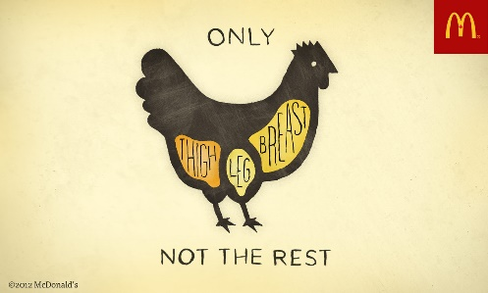
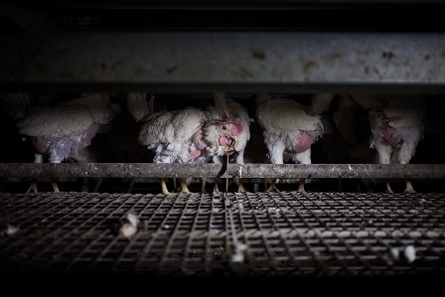

Secondly, the images we are looking at are of World War One advertising the need for people to come and fight. The advert itself is not bad, it does not misrepresent or fraudulently mislead the person reading it that because people were needed for the war. However, it does not show the full extent of what the soldiers will experience in the war zone. The painting is showing a realistic image of the war and does not glamorise what is happening and shows a solemn sad view of the reality. Bringing the two images together displays the contrast between intentions of the advertisement to get people to join the army and the reality of the war itself. In The Power of the Poster Timmers writes: ‘The emotional appeal of this poster, addressed personally to each viewer, gave an immediacy and urgency to the message and made it highly effective.’
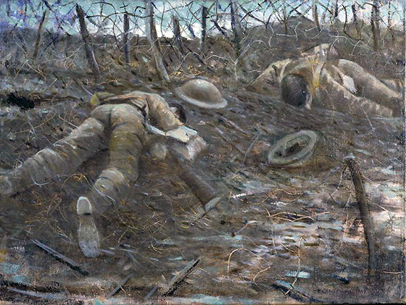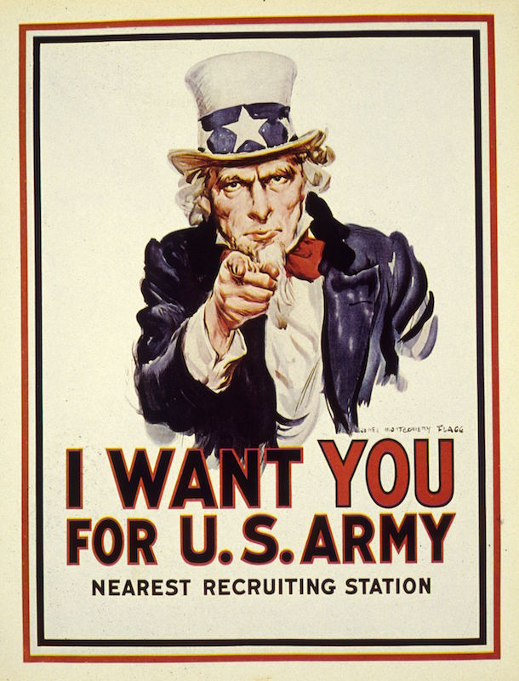

The third set of images are looking at the deforestation for the production of palm oil. Initially the obvious relation to these images is the fact that Snickers tagline is ‘You’re not you when you’re hungry and the fact that in the image of the elephants there is little food and they are not as full. However the reason that the two images are displayed together is because Mars the owners of snickers use palm oil in this product therefore are contributing the deforestation.
Looking at the exhibition from a postmodernist view the idea of the advertisement creating the illusion of things being sustainable as Odih writes; ‘of particular concern is the representation of advertising reality as a hyper-reality of fragmented images.’ (Odih 2007)

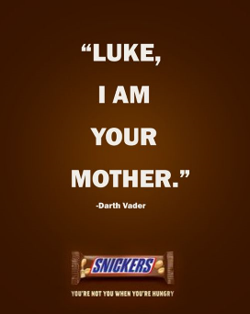

In conclusion from experiencing the exhibition people will look at the ethical issues surrounding advertising and the truth behind the brands and how the products and services are produced as well as advertised. Looking at animal cruelty, recruitment and deforestation which will make people consider looking at adverts differently not on just face value. From a postmodernist perceptive there is the theory of reason judging what is truth, this is showing in advertisement where the truth is adjusted to sell product or service more effectively. Thorson and Rodgers talking about advertising and values describe advertising as a ‘paid communication from an identified sponsor for using mass media to persuade an audience.’ (Thorson and Rodgers, 2012) this is showing the advertising is used to persuade the buyer rather than just sell the product as it is. It could be considered that advertising does not necessarily put in to cover up truths but perhaps bends the truth to give it a more light-hearted approach.
From viewing the exhibition there is an element of debate that surrounds what is the truth? And this would provoke the viewers to converse about the exhibition and the topics it relates to. The topics that are raised through the exhibition are serious and could have been displayed more graphically. The images of advertising being more humorous approach as to be memorable the images relating have been kept serious but still viewable for a younger audience. The exhibition was to provide a topic of debate rather than to cause judgement to advertising, neither trying persuading the viewer to thinking that advertisement was bad. However the adverts that were used were tools to formulate an argument and raise awareness of the issues that surround them.

References
Books
Odih, P. (2007) Advertising in Modern and Postmodern Times Sage Publications: London
Rodgers, S. and Thorson, E. (2012) Advertising Theory Routledge: New York
Timmers, M. (1998) The Power of the Poster: V&A Publications: London
Online Sources
Pippus, A and McArthur, J. (2016) Interview With Documentary Photographer Timo Stammberger. Available at:http://www.weanimals.org/blog.php?entry=239 (Accessed: 27 April 2018).
Sweney, M. (2013) Tesco criticised over 'misleading' horsemeat ad. Available at: https://www.theguardian.com/media/2013/sep/04/tesco-horsemeat-ad (Accessed: 27 April 2018).
Journals
Russo, J.E., Metcalf, B. and Stephens, D. (1981) ‘Identifying Misleading Advertising’ Journal of Consumer Research 8 (2) : 119-131.

