

ACCA4023
Introduction to Web and Database Concepts
HTML & CSS Web Development

Website Design and Development Report
Website Name: Luxe Aura Jewellery

Student Name: VIORICA-MIHAELA POSIRCA
Student ID: 2512924

Contents
1. Introduction 2
Abstract 2
2. Requirements 3
3. Implementation 3
4. Validation 7
5. Evaluation 7
Four key principles of WCAG 2.1 8
Search Engine Optimisation (SEO) 9
Evaluation of Website 9
Comparison of Two Existing Websites 10
6. Conclusion 11
References 12

1. Introduction

Abstract
This report is intended to show the design, development, implementation and evaluation of the Luxe Aura Jewellery website. The site was designed and hand-coded using HTML5 and CSS3 web standards, and has multiple interconnected pages, including Home, Shop, About and Contact pages. The website's purpose is to give its visitors a beautiful and professional web presence to view luxury jewellery products and find out more about the brand. Modern websites should meet a number of technical and user requirements such as being usable, accessible, responsive and visible to search engines. Therefore, this report discusses the design requirements of the website, the implementation process, validation procedures and an evaluation of the completed website. Moreover, the academic research on usability and accessibility issues and on search engine optimisation (SEO) is examined to illustrate the importance of these in good web design. The report is concluded with a comparison of two of the existing websites, followed by suggestions for websites in the future.

2. Requirements
The website developed for this project is called Luxe Aura Jewellery. It is a luxury jewellery site that is meant to feature top-quality jewellery items and offer details regarding the company. The main aim of the website is to develop an online identity for a jewellery business and enable visitors to view the products that are on offer. The site serves as a virtual catalogue, from which users can browse jewellery varieties and get more information about the company and its history.
The target market is adults who are interested in luxury jewellery products, gift buyers, fashion-conscious consumers and online shoppers who are looking for quality accessories. The website has been designed in an elegant style which includes gold, black and white colour combinations that are linked to luxury brands, making it attractive to this audience. Some of the functional requirements were identified at the planning phase. These included making several web pages, providing easy navigation from one web page to another, displaying products, providing company information and a contact form. The site also needed to be functional on various sizes of screens and devices. These pages are developed and released as the main pages:
- Home Page
- Shop Page
- About Page
- Contact Page
The non-functional requirements were also taken into account. The website should look professional, load quickly, be responsive, easy to use, accessible and compatible with the latest browsers. HTML5 and CSS3 were used for compliance with modern web standards, simplicity and maintainability.

3. Implementation
The website has been built with HTML5 and CSS3. The site was not built with automated website builders or code-generation software. Each page was hand-coded and connected to the others with a standard navigation system.
Home Page
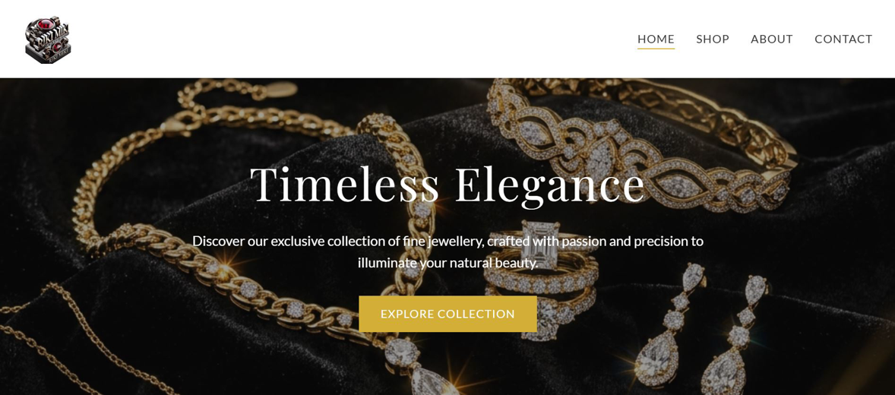
The home page is the most important page on a site, and it is the first page that users encounter when they arrive at the site. It features a big hero area, introducing the Luxe Aura brand and conveying its luxury nature. Customer reviews and promotions are interspersed with featured jewellery products. The homepage was conceived to immediately attract the attention of the users, visualising high-quality product images and elegant typography. A call-to-action button is there to prompt visitors to check out the available options.
Shop Page
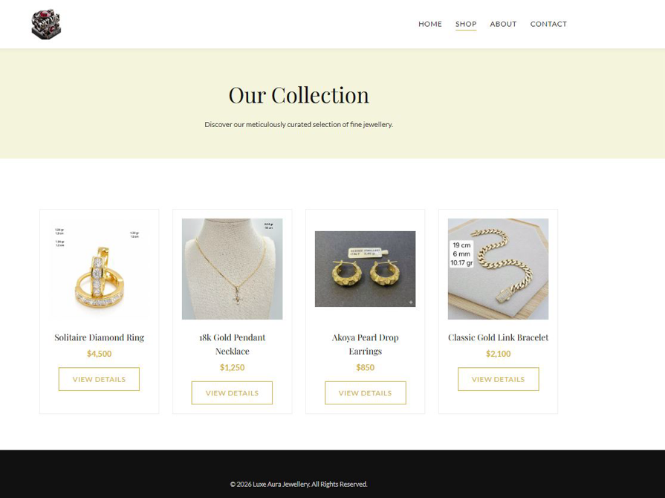
The Shop page is a vertical grid layout of jewellery products. The products are displayed with pictures, names, and prices, enabling visitors to navigate through the products efficiently. To make it easier for users to find products they're interested in, a structured layout was chosen. The uniformity of the product cards helps to create a professional look.

About Page
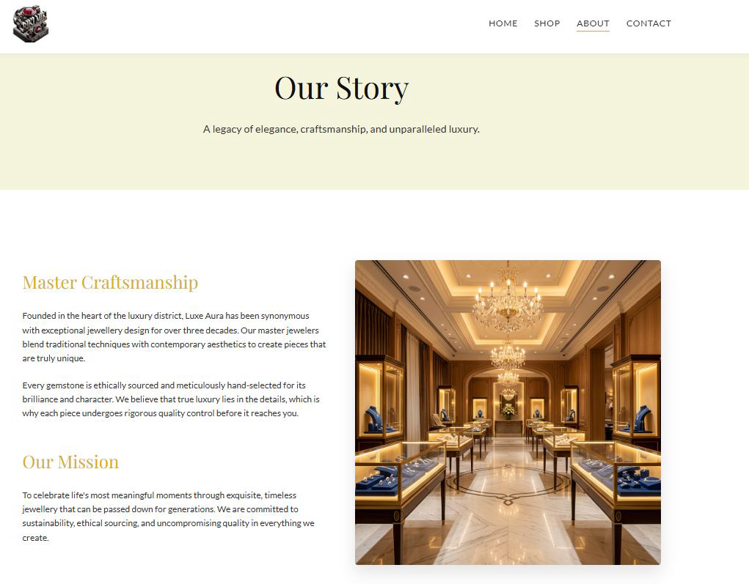
The About page tells the business story, mission and values. A description of skills and the quality of the products is offered to create visitor trust. Company information adds credibility and enables the potential customer to reach out to the brand. Luxury is used to reinforce the luxury nature of the business with the use of images.

Contact Page
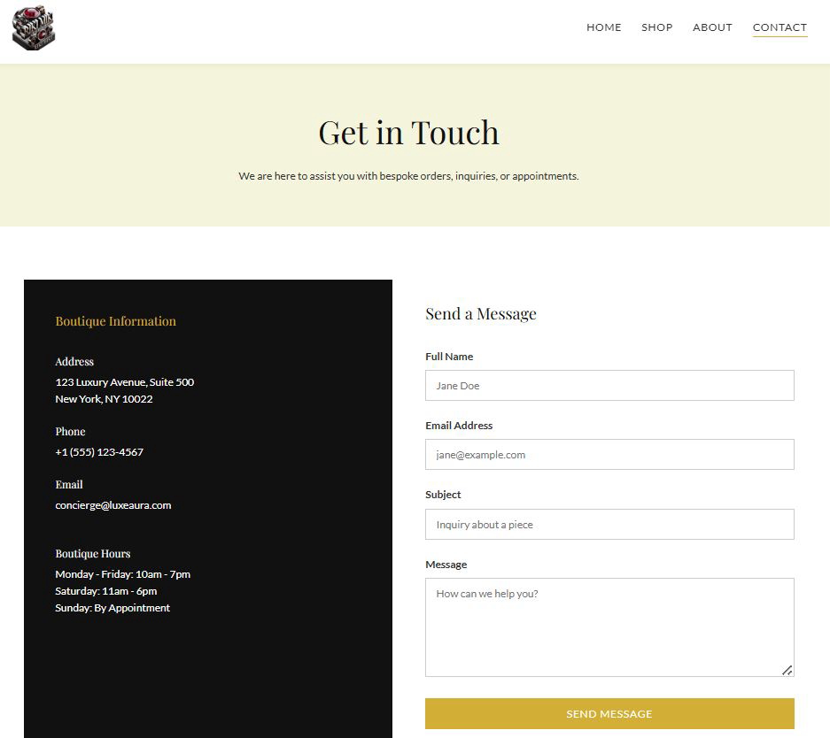
The Contact page has business contact information and a contact form. The enquiry form allows user to type their name, email address, subject and message. It is a page that will improve communication between the customer and the company and will provide a clean and professional appearance.

Design Decisions
There were some decisions to make during the design process. The colours are black, white and gold. The choice of these colours was made due to their association with the elegance, exclusivity and luxury products. The brand has used a carefully selected typography, which ensures readability and a sense of high quality. Headings are styled with an advanced font style, and body text is readable. Navigation is located on every page in the same location. It is crucial to stick to one style to help users navigate the site efficiently and to minimise cognitive load. Responsive design techniques have been used with the help of CSS media queries to make sure the website works well on desktop, tablet and mobile.

4. Validation
Validation was carried out to meet the web standards and to make it compatible with different browsers. The W3C Markup Validation Service was used for HTML validation. Validation determines if the HTML code is correct, or if there are any mistakes or problems that may cause problems in web browsers.
The most common problems found were that there was no alternative text for images and minor structural inconsistencies. The W3C CSS Validator was used to validate CSS. The stylesheet was validated to make sure it meets the CSS standard and to find any problems with the syntax. Small changes to warnings about properties peculiar to a browser were checked and amended as required. The validation process verified that the website styling was complying with accepted standards. The importance of validation in the construction of websites is that the standards-compliant code makes the website maintainable, accessible and compatible with browsers.

5. Evaluation
Website Usability
Usability is the extent to which users can use a system to achieve their goals by a satisfactory, effective and efficient method. Nielsen [1] states that usability is one of the most significant quality attributes of a website as it directly affects user satisfaction and user task completion. A user-friendly design can minimise user frustration and improve engagement. An intuitive navigation system and easy access to information can keep visitors on a website longer.
Kous et al. [2], using research conducted to assess the usability of websites across various user groups, determined that websites that adhered to the basic design principles and had consistent navigation structures performed better in terms of how well users could complete the tasks. The study showed that user experience can be enhanced significantly because of effective usability. The Luxe Aura website is designed around a number of usability principles. Navigation menus are placed in the same place on every page, making it easier for users to navigate between sections. The product information is well structured, and visitors can easily navigate the range of jewellery being offered.
Whitespace helps to improve readability and avoids visual clutter. Additionally, top-notch product photos allow users to make informed decisions, offering a clear picture of the products available. One of the strengths of the website is the fact that it has a very simple design. Users can easily find the key sections, like Home, Shop, About and Contact. This eliminates mental load and improves the user experience. It would be great for product filtering, advanced search, customer reviews, and other things to be added in the future for increased usability.
Website Accessibility
Accessibility is the process of designing web pages so that all people with different abilities and disabilities are able to access them. The Web Content Accessibility Guidelines (WCAG 2.1) are internationally recognised guidelines for accessible Web design [3].

Four key principles of WCAG 2.1
- Perceivable
Information needs must be communicated in a format that can be received by the user. That includes providing text alternatives for images and adequate colour contrast. The Luxe Aura website has image content which should always have meaningful alternative text to assist users who use a screen reader.
- Operable
All users should be able to move around the site and access all features.
The site is easy to navigate and has user-friendly interactions. The navigation stays the same all over the site, allowing visitors to more easily find information.

- Understandable
Content and its operation in the interface should be easily understood. The site's language is easy to understand, and the pages are organised the same way throughout. All forms have labelled sections to guide users as to what information is needed.
- Robust
Content should be accessible to existing and future assistive technologies. Using semantic HTML5 elements is a good thing because it helps to make the site robust and compatible with screen readers, as well as other assistive technologies.
Martins and Duarte [4] carried out a massive accessibility audit and found that the lack of alternative text, poor colour contrast and lack of proper heading structures were prevalent on contemporary websites. Their results illustrate the value of accessibility testing in the development process. The website for Luxe Aura meets the WCAG standards fairly well. ARIA labels, keyboard navigation testing and accessibility audits (available in tools like WAVE and axe) could be added, however.

Search Engine Optimisation (SEO)
SEO is the process of increasing the likelihood that a website will appear in the search engines' listings. SEO can boost website traffic, enhance its visibility, and drive business growth. Results from Setiawan et al. [5] showed that the websites which apply effective SEO methods had a significant increase in visibility and organic traffic. Their research gave proof of the significance of structured optimisation strategies.
Firstly, descriptive page titles let search engines understand the material of a web page. Secondly, heading tags give a clear hierarchy. Thirdly, internal navigation links have a positive impact on crawlability, as they help search engines find the pages. Responsive design also helps with the performance of SEO because mobile-friendly websites are more likely to get featured in search engines. This is achieved through the responsive layout adopted in the Luxe Aura website.
When images are included with descriptive ALT text, they can also be part of your SEO. This aids search engines in understanding visual content and also makes it easier for the search engine to be more accessible. Structured data markup, XML sitemaps and keyword optimisation, as well as meta descriptions, are among future improvements that can be made.

Evaluation of Website
The finished website accomplishes the desired aims. The main goal of showcasing luxury jewellery products is to be accomplished by the application of expert photographs, steady branding and structured content [6]. The website is well-structured and easy to navigate, making it easy for users to find what they are looking for. The website is user-friendly, with a clear layout and easy navigation. Users can easily navigate between pages and find information.
The overall look is very appropriate, capturing the essence of luxury. The gold colour, white and black are used to create a more elegant look that still remains readable. The information given is useful and educational. Product listings, company information and contact information all contribute to the company's business goals. Future improvements planned include:
- Shopping cart functionality
- Online payment integration
- Product search feature
- Customer reviews
- Live chat support
- Enhanced accessibility features
These additions would have been valuable to both the user and the business.

Comparison of Two Existing Websites
Both BBC News and GOV.UK are well known and easily accessible, and was chosen as an example.

Usability
The BBC News offers a rich and visual user interface, with articles, videos and multimedia. The attractiveness of the information will be offset by its volume at times, which may flood users. GOV.UK's design is minimalist with an emphasis on information retrieval. Navigation is well structured and allows users to easily find the content they are looking for.
Accessibility
The websites both score well on accessibility evaluation tools. But GOV.UK is well known and considered a standard in accessible design because it closely follows the WCAG guidelines. BBC offers captioning, alternative text and keyboard accessibility, and GOV.UK has great colour contrast and form, and semantic structure accessibility.
SEO
Both websites show good SEO techniques such as structured headings, good titles and a lot of internal links. While GOV.UK gains from a very well-structured information architecture, and the BBC gains from content which is constantly refreshed.
Mobile Friendliness
Both sites are 100% mobile friendly. But there's a cleaner mobile experience available via GOV.UK, which is designed to be simple and easy to use for content.
Overall Assessment
While both sites are super fast performers, GOV.UK has a better ability to offer a mixture of ease of use, accessibility and simplicity. The design is a good example of the user-centred approach to web design.

6. Conclusion
The Luxe Aura Jewellery website is an example website that has been successfully implemented using HTML5 and CSS3 to make the website responsive, attractive and standards-compliant. The focus on the implementation was usability, accessibility and search engine optimisation, guaranteeing a positive user experience. Review of the finished website suggests that it fulfils its intended goals and offers a professional site for browsing jewellery products. Usability, accessibility and SEO were central to the design process, and were supported by academic studies of the importance of these three factors in successful website design. Apart from the overall performance of the website, further enhancements like adding e-commerce options, improving the SEO strategy and improving accessibility features will further increase the effectiveness. The project is overall successful in its use of modern web development principles and practices.

References
[1] J. Nielsen, Usability Engineering. San Francisco: Morgan Kaufmann, 1994. Available at: https://books.google.com.vc/books?id=95As2OF67f0C&printsec=frontcover&rview=1#v=onepage&q&f=false. (Accessed Date: 20 June 2026).
[2] K. Kous, M. Pušnik, M. Heričko and G. Polančič, “Usability evaluation of a library website with different end user groups,” Journal of Librarianship and Information Science, vol. 52, no. 1, pp. 75–90, 2018. Available at: https://www.researchgate.net/publication/325418095_Usability_evaluation_of_a_library_website_with_different_end_user_groups. (Accessed Date: 20 June 2026).
[3] World Wide Web Consortium (W3C), Web Content Accessibility Guidelines (WCAG) 2.1, 2025. Available at: https://www.w3.org/TR/WCAG21/. (Accessed Date: 20 June 2026).
[4] B. Martins and C. Duarte, “A large-scale web accessibility analysis considering technology adoption,” Universal Access in the Information Society, vol. 23, pp. 1857–1872, 2024. Available at: https://link.springer.com/article/10.1007/s10209-023-01010-0. (Accessed Date: 22 June 2026).
[5] A. Setiawan, Z. Harahap, D. Syamsuar and Y. N. Kunang, “The Optimisation of Website Visibility and Traffic by Implementing Search Engine Optimization (SEO),” CommIT Journal, vol. 14, no. 1, pp. 31–44, 2020. Available at: https://www.researchgate.net/publication/343235216_The_Optimization_of_Website_Visibility_and_Traffic_by_Implementing_Search_Engine_Optimization_SEO_in_Palembang_Polytechnic_of_Tourism. (Accessed Date: 22 June 2026).
[6] S. Hamid, N. Bawany and K. Zahoor, “Assessing E-Commerce Websites: Usability and Accessibility Study,” in International Conference on Advanced Computer Science and Information Systems, 2020. Available at: https://revistas.utm.edu.ec/index.php/Riemat/article/view/7691/10241. (Accessed Date: 22 June 2026).

