Saskia Judd
HPAR4003 Introduction to fieldwork
Gender Differentiation in St. Peter’s Graveyard, Lampeter

Acknowledgments:
- Ruth Athey – For taking some of the photos
- Anne (Sue Austen – Drennan’s Mother) – For sharing her daughter’s story

Contents:
- Abstract – Page 3
- Introduction – Page 4
- Methodology – Page 5
- Presentation of results and data analysis – Page 6
- Discussion and context – Page 17
- Recommendations – Page 19
- Conclusion – Page 19
- Bibliography – Page 20
- Appendix – Page 21

Abstract:
This graveyard report focuses on gender in relation to memorial materials and typologies seen within St. Peter’s Graveyard, Lampeter, Ceredigion. St. Peter’s is an Anglican church which was built in 1884 and serves the small town of Lampeter with bilingual services offered. The survey included 373 grave markers within the site and investigated differentiation in the memorialisation of males and females between 1811 and 2019. Some differentiation was found throughout the site in the materials used and the typology of the memorials, however this could not be linked to gender and was more typically related to wealth, economy and cultural factors.

Gender Differentiation in St.Peter’s Graveyard, Lampeter
How is gender differentiated within the graveyard memorials? What can this show about changes in society in Lampeter during the period of graveyard use?
Introduction:
St. Peter’s Graveyard and church is situated in Lampeter, Ceredigion (Grid ref. SN5754448356, Co-ordinates Latitude: 52.1151 / 52°6'54"N, Longitude: -4.0819 / 4°4'54"W. Built in 1884 in response to the demands of the town following the creation of the university, it is the final resting place of a wide spectrum of people from POWs to military heroes. The foundations of the ‘old’ church are still present on the grounds and are a highly coveted location for burial.
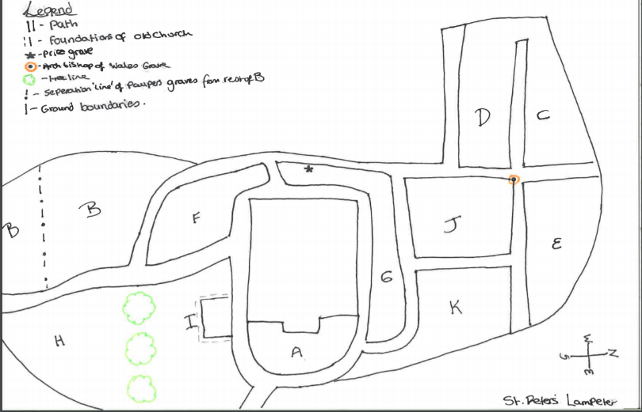
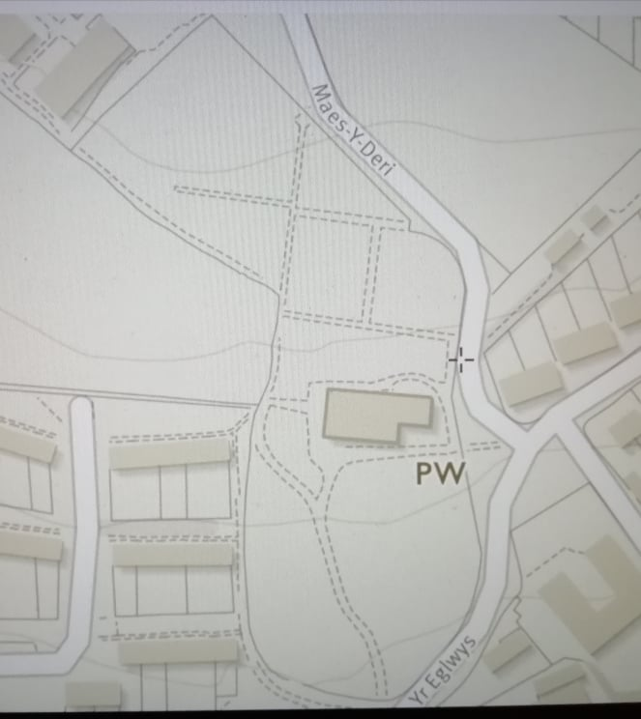
Figure 2 Site map sketch showing sections
Figure 1 OS map view of the site of St. Peter's, Lampeter

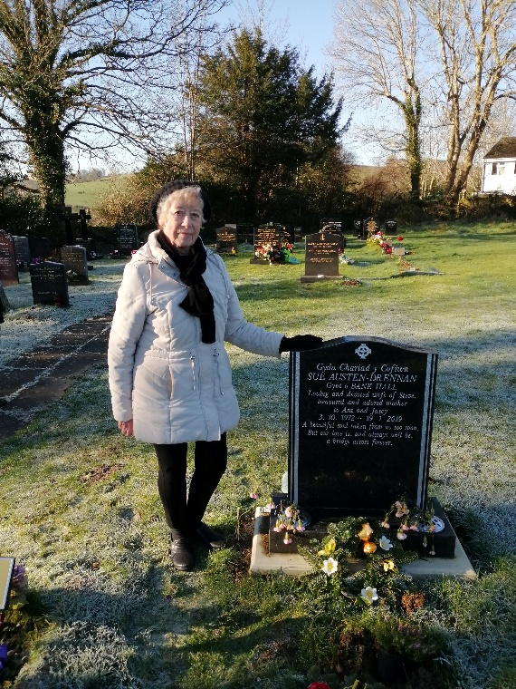
Graveyard surveying can be a very cold process. There is no context to that person’s life and it doesn’t offer a true reflection of who they were, on a grave stone, a whole life is just a line. Through talking to the public and research the stories can come to life about these people. Sir Mortimer Wheeler once stated that ‘the archaeologist is digging up, not things, but people’ (Wheeler, 1954). One in particular is that of Sue Austen-Drennan. This wonderful lady was hugely involved with the local foodbank in Lampeter. Sadly, Mrs Austen-Drennan passed away on the 19th January, leaving behind her husband, two teenage sons, her mother and other loving family. During the research period it was Mrs Austen-Drennan’s first anniversary of her death and this information was provided by her mother Anne. Anne was an equally strong lady who was willing to share her daughters wonderful but truly sad story. Sue’s gravestone is one that is easily memorable as it is one of the newest and has silver rather than gold detailing. This was her husband’s idea and gives insight to the process behind grieving and selecting a gravestone. Sue also has a tree in another St. Peter’s in Kent where she was baptised and where other members of her family are laid to rest. This again shows the importance of having symbolism close to home and the different ways that people commemorate their loved ones.

Photo 1: Sue Austen – Drennan’s grave
Methodology
The focus on gender led to the creation of the survey sheet which featured name, age, typology and material of the stone. Handwritten field notes were then translated onto a spreadsheet. The site was split into 11 sections and the pathways were used as boundaries for each locale, as they made the area easier to record and would make single plots easier to locate at a later date if needed. For the methodology in the field a systematic approach was taken within the modern graveyard especially sections C, D and E as they are more uniform and were easily countable (Sections can be seen in fig. 2 above). For these monuments every third stone was recorded. This shows a decent percentage of the modern grave site but it is still a slightly false image of St. Peters because 66% of the graves are undocumented. Using a larger sample would have made the data more reliable. For the older, less regimented, graves on the South side of the church, a random selection was made and as many were damaged and unreadable due to age related weathering some graves were excluded. Fieldwork was completed over four days (11th-15th January). The gravestones in sections J and K were a ‘bed’ style and very closely grouped together which made it difficult to survey, rendering some unsuitable for the study. A chi square test was applied to the data to improve confidence levels. The data was then manipulated to identify trends related to gender and presented in bar charts.

Presentation of Results and Data Analysis:
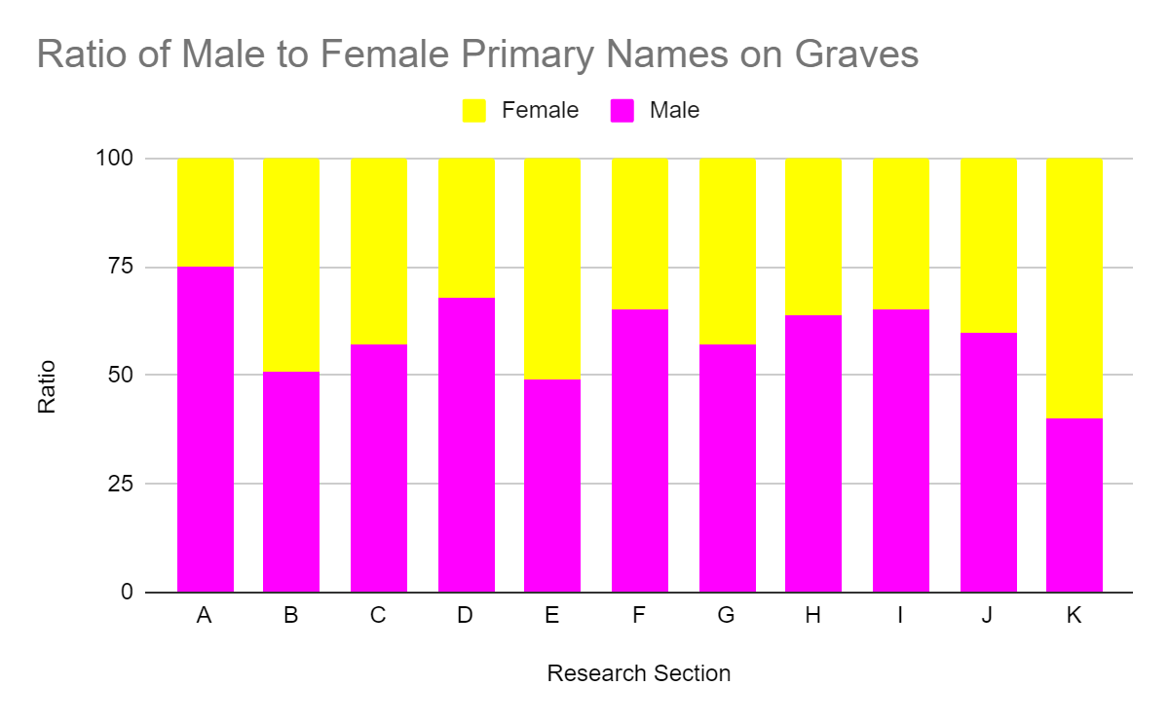
373 grave stones were included in the survey recording 740 burials, 51% of which were male. Of these 373 graves 145 were single occupancy plots. Where multiple burials occurred in the same plot the primary name on the grave stone was most often male, 60%. A male appearing as a secondary name on a gravestone was less common, occurring only 42% of the time.
Figure 3
One anomaly in the results is that section D has a significantly higher percentage of male to female primary graves, where two or more individuals are buried in the same plot. Section D is one of the most modern parts of the graveyard with graves dating up till 2018. The issue may lie with the fact that a large quantity of the graves come from the 1960s and perhaps traditional patriarchal values were more prevalent. This would explain the choice of placement of the male names over the female names, even when the female died earlier.
Another anomaly is section K. There is a 20% difference with females outnumbering the males. In the data the earliest grave is dated to 1905 and the latest is 2002, though most of the dates in the section fall within the first half of the 20th century. As seen in the other locations it would be assumed that there would be more males than females mainly because of the period and ideologies of the time. However, the absence of male burials may reflect soldiers who died in the wars but whose remains were not returned. The fact that only 27 gravestones were documented may also mean there could have been a bias to the results.
As for secondary names there are not any obvious anomalies as all the male percentages are 53% or lower. The ratio for secondary names can be seen in the bar chart below and reflects a slight bias in favour of male primary graves which is not unexpected.
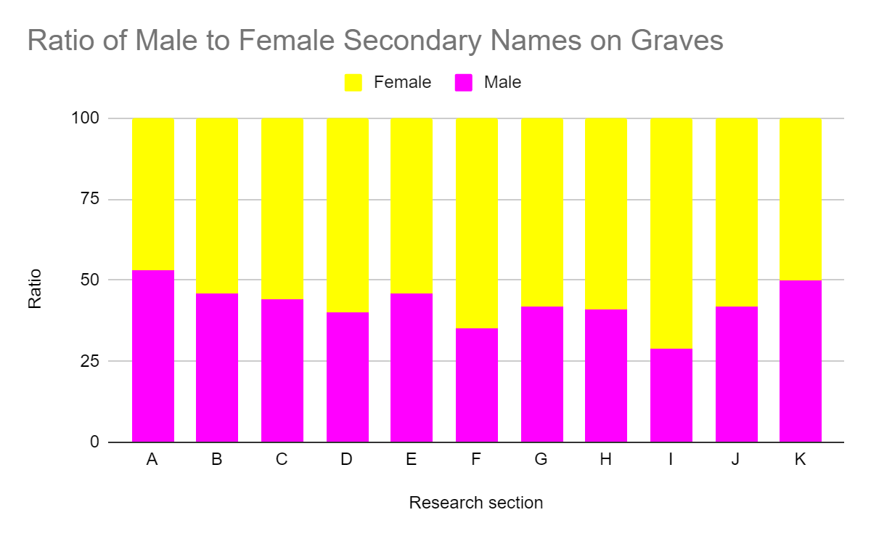Figure 4
Across the whole site, as is seen with the age ratios, the typology and material overall has no correlation to gender. To Prove this a Chi square test has been completed using the confidence levels of 0.01, 0.05 and 0.1. These all came back with a non-significant result.

 | A | B | C | D | E | Row Totals
Male | 6 (4.80) [0.03 | 34 (31.23) [0.25] | 5 (3.60) [0.54] | 155 (162.15) [0.32] | 18 (16.21) [0.20] | 218
Female | 2 (3.20) [0.45] | 18 (20.77) [0.37] | 1 (2.40) [0.81] | 115 (107.85) [0.47] | 9 (10.79) [0.30] | 145
Column Totals | 8 | 52 | 6 | 270 | 27 | 363 (Grand Total)
Chi- square statistic is 3.9969. The p-value is .40643. The result is not significant at p＜.01
Figure 5

 | A | B | C | D | E | Row Totals
Male | 6 (4.80) [0.30] | 34 (31.23) [0.25] | 5 (3.60) [0.54] | 155 (162.15) [0.32] | 18 (16.21) [0.20] | 218
Female | 2 (3.20) [0.45] | 18 (20.77) [0.37] | 1 (2.40) [0.81] | 115 (107.85) [0.47] | 9 (10.79) [0.30] | 145
Column Total | 8 | 52 | 6 | 270 | 27 | 363 (Grand Total)
Chi- square statistic is 3.9969. The p-value is .40643. The result is not significant at p＜.05
Figure 6

 | A | B | C | D | E | Row Totals
Male | 6 (4.80) [0.30] | 34 (31.23) [0.25] | 5 (3.60) [0.54] | 155 (162.15) [0.32] | 18 (16.21) [0.20] | 218
Female | 2 (3.20) [0.45] | 18 (20.77) [0.81] | 1 (2.40) [0.81] | 115 (107.85) [0.47] | 9 (10.79) [0.30] | 145
Column Totals | 8 | 52 | 6 | 270 | 27 | 363 (Grand Total)
Chi- square statistic is 3.9969. The p-value is .40643. The result is not significant at p＜.10
Figure 7

Gender differentiation, however, is apparent in some of the separate sections. The Bar charts below show the spread of different typologies throughout the 11 sections where data was collected.
Key:
A - Table
B – Plinth
C – Flat
D – Traditional (Headstone)
E – Bed
(Full typology sheet can be seen in the appendix)

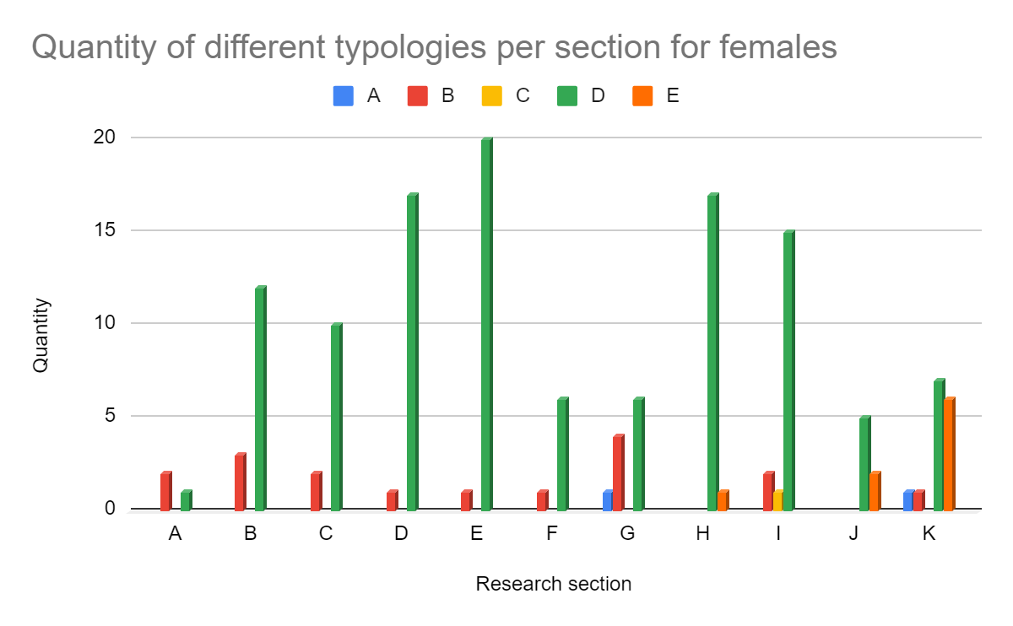
Figure 8
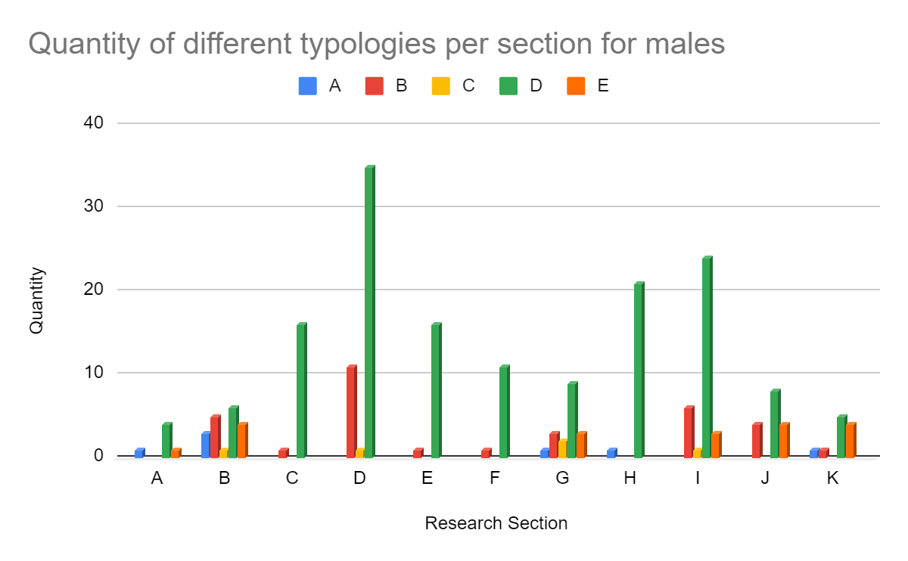
Figure 9
Male primary graves use a wider range of typologies with A and E being present from section A, but the female primary graves are strictly B and D until section G. Even when the other typologies are present in female graves, there are only three present per section except from section K. For the males, however, there is a greater spread of typologies with sections B and G even including all five different typologies. Only four sections contain just two different typologies compared to the eight for females. This fluctuation could be due to there being a larger number of male primary graves. The larger quantity of monuments allows for a greater diversity unlike the female graves where there are 20% fewer. The lack of variation in female primary graves could be a reflection of the lower standing of women in society compared to men in previous generations. The anomaly of section K may be largely different to the normal trend of female graves because there is a larger percentage of females to males in the section. This is a difficult point to argue as section K is actually one of the smallest sample sizes with only 27 graves recorded and also for the fact this section has a lot of variation throughout.

The most frequently used typology is typology ‘D’ which is a standard headstone and is common in modern times. Typology ‘D’ is the most used in every section for both males and females alike. Though for males the highest usage is in sections H,I and D whereas the highest quantity for females is in section E along with H and I. Below, typology ‘D’ has been broken down into its subsections. These results indicate that D2 is the most popular subsection of typology D and is the classic, common choice for a headstone. All six sections vary in the relationship between male and female uses of different subsections which makes it harder to see if there is a correlation but within the single sections it indicates the importance of certain subsections.
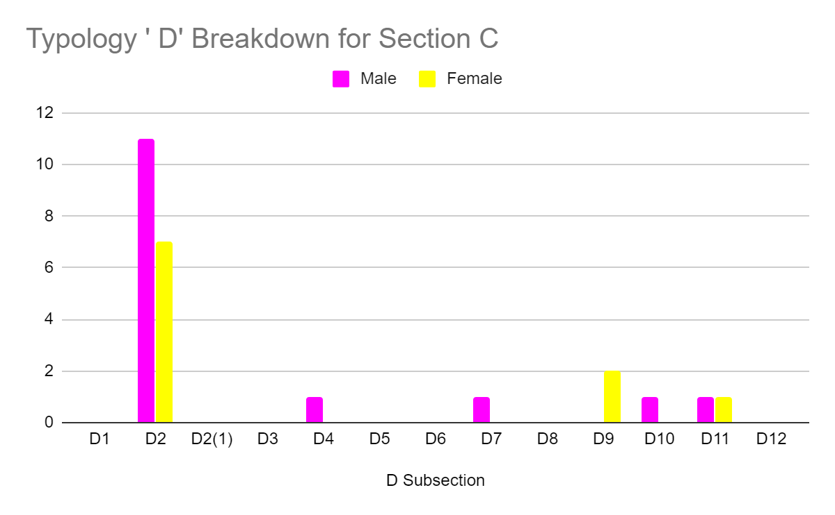
Figure 10
For section C it is clear that D2 is the most common subsection for both genders. This trend is expected since section C is the most modern part of the grave yard in which there is assumed to be the least differentiation due to modern social views.

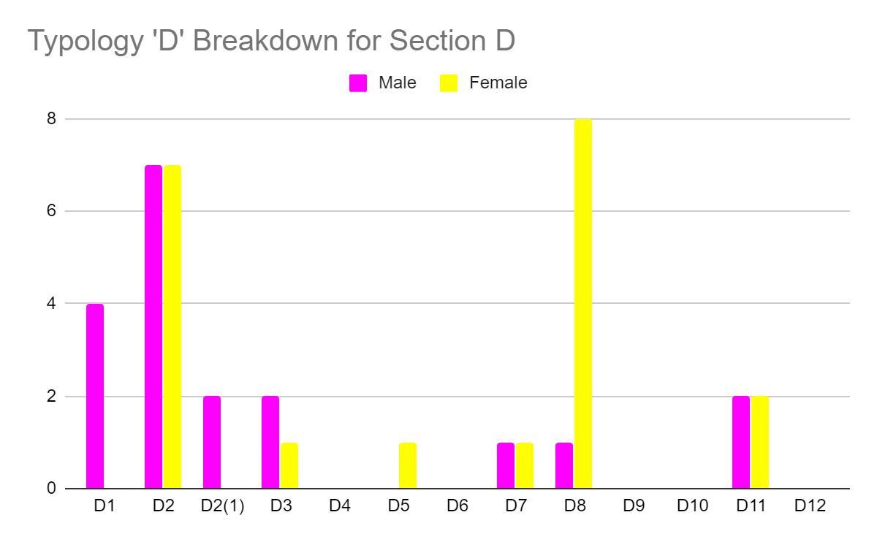
Figure 11
For section D again D2 is popular but the highest quantity for females was D8. A point of difference in section D is that the male graves use a greater variation whereas the female ones mainly focus on two and only use 5 in total (three of them only once) and the male graves use 7 and are more consistently used. This may be due to the lower quantity of female graves but it still infers that women are less individualised in memorialisation.

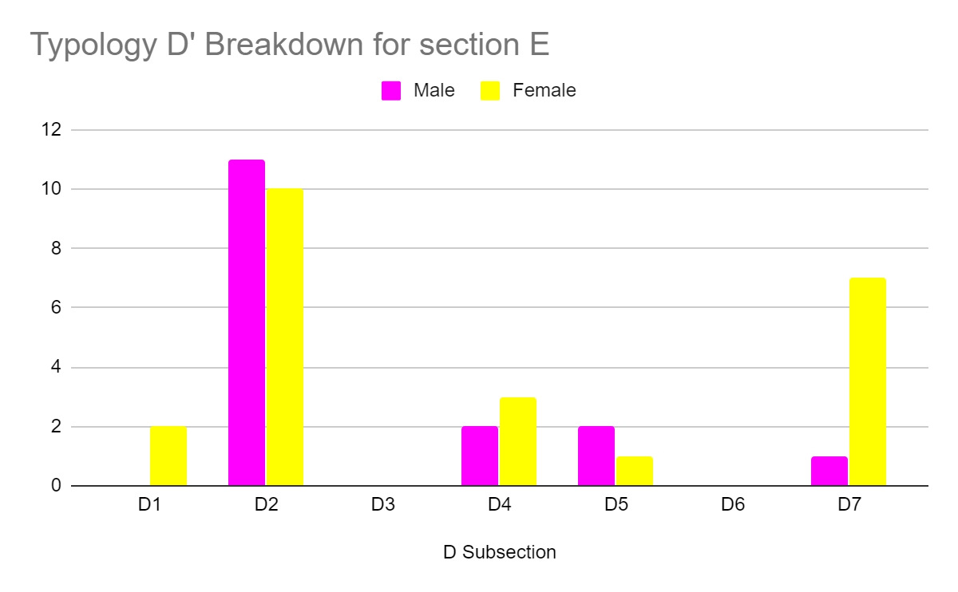
Figure 12
Again D2 is the most popular and the female bar in D7 is significantly higher than any other male bar. Also another anomaly is that the female graves actually showed a larger range within this section which contradicts many of the other sections. This could possibly be due to the fact that this section of the graveyard ranges from 1970 to 2014 and these later dates allow for more individualisation but this is only within one typology so may still reflect the lesser status of women.
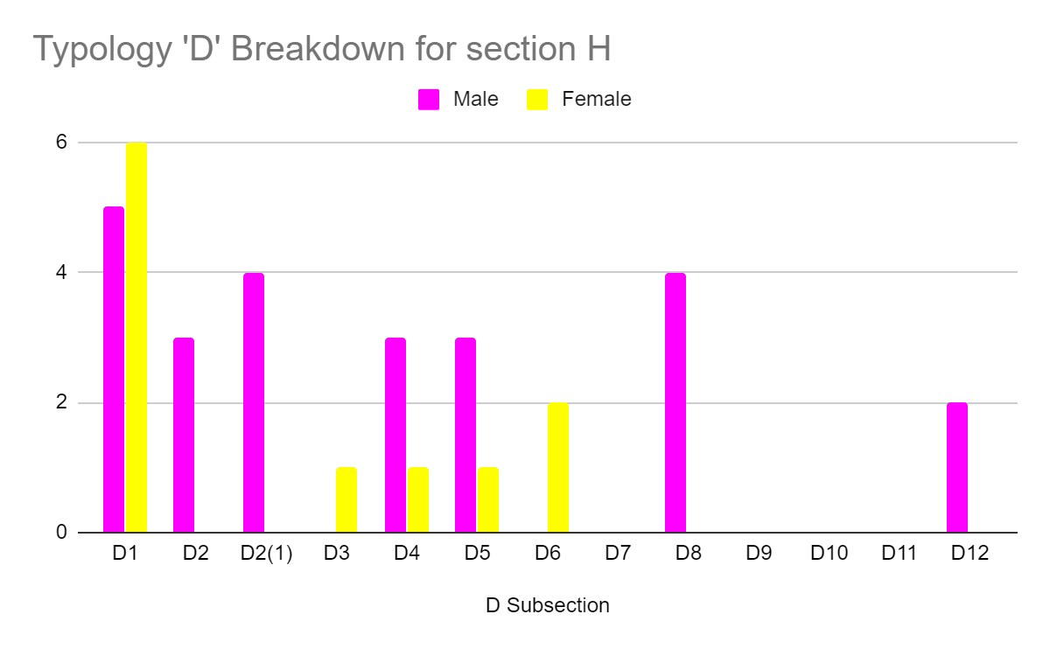
Figure 14
Males use a larger range of D subsections. A noticeable point about this section is that D2 is not the most used, is only used for male graves and is the second lowest result after D12. All the bars across the chart are significantly higher on the male side except for D3 which has a female only use in this section.

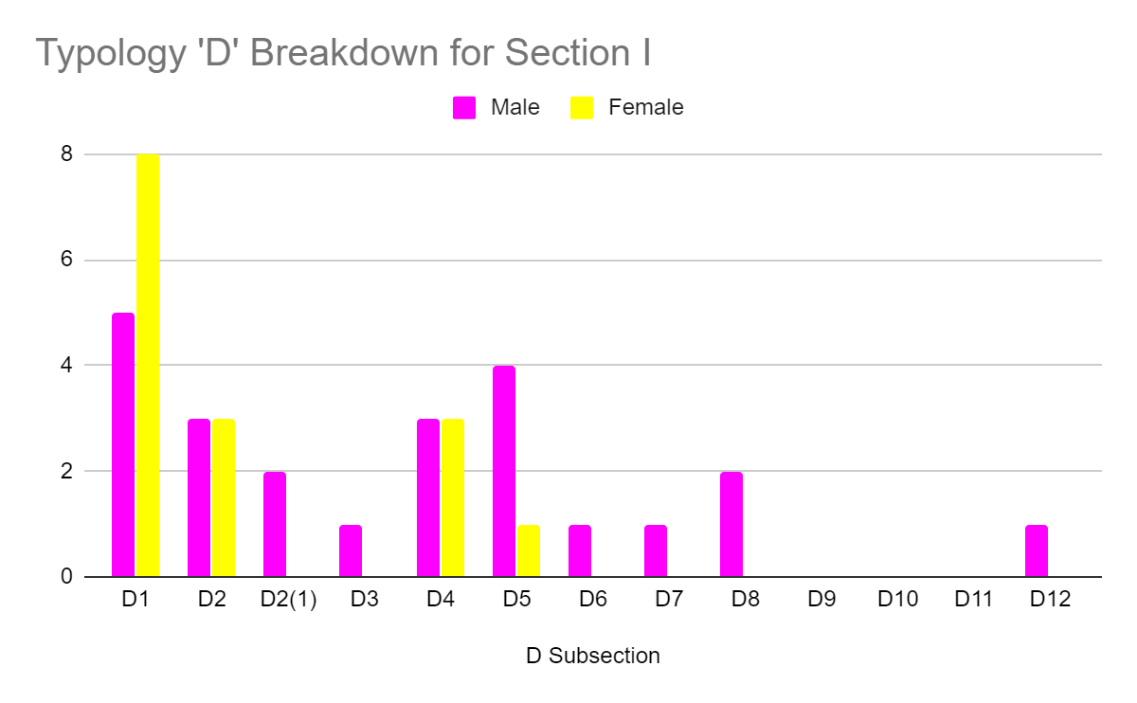
Figure 15
For section I all female bars are equal or greater than the males (besides D5). The male range is wider with there being at least one of each subsection bar three. D2 may have dropped in quantity due to the amount of other subsections used as a result of the time spanned in this section (1815-2016).

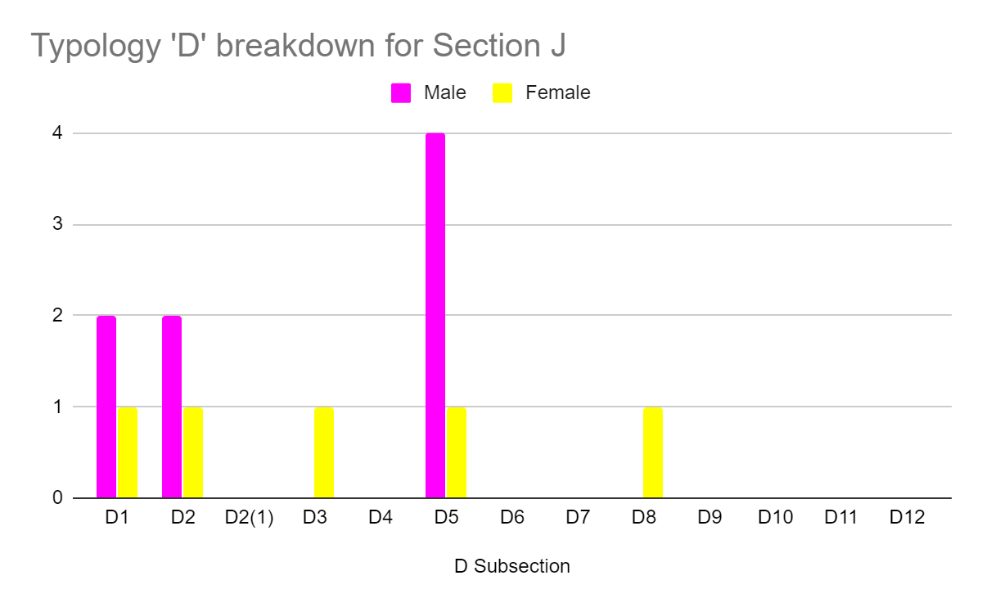
Figure 16

Section J goes against the trend as it offers a wider range from the female side rather than male. It also has a lower usage in this section not allowing for as much range.

The change in the typology could also be as a result of the time periods in which these sections were in use. All of the ‘bed’ graves are from earlier sections and do not feature in the modern grave yard sections. This is again due to social change but also down to lack of space. Land nowadays is a luxury and is a commodity that is quickly running out. With population ever rising the increased life expectancy still cannot offset the number of plots needed. Tarlow (2005) states that ‘the relationship between the living and the dead has changed radically,’ Which could explain why bed graves and other large graves have lost their popularity.

Typology can also be looked at with a different perspective: via children. People have a different view on death when it comes to children. Firstly, ‘children’ have to be defined. For the purposes of this study anyone under the age of 18 at the time of death is classed as a child. D again is the dominant typology used. 19 out of 25 of the children’s graves were of typology D. But the majority of the D typologies were not D2 but rather D1, the symbolism behind this is unclear. Another unusual observation about child graves is that a large quantity of them use typologies A (Table), B (Plinth) and C (Flat) (24%). As stated above Es (Bed) are barely seen in either gender so for two of the children’s graves to be ‘Es’ is quite an anomaly.

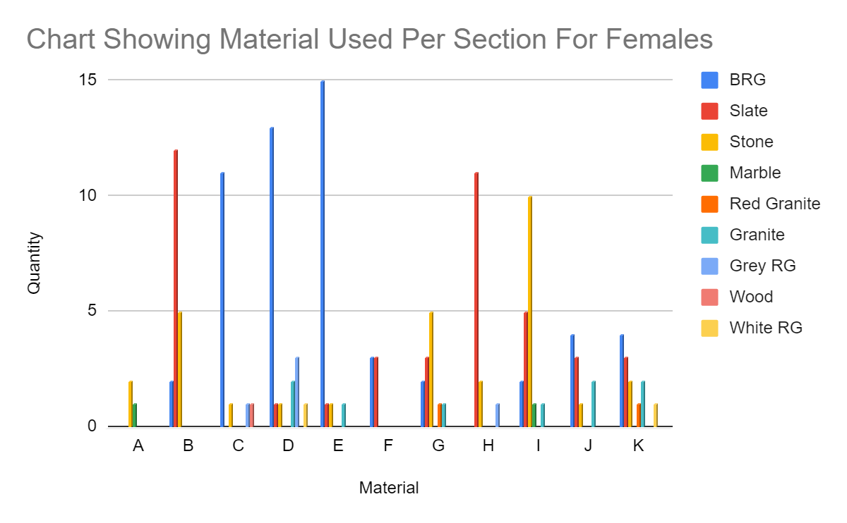
Figure 17
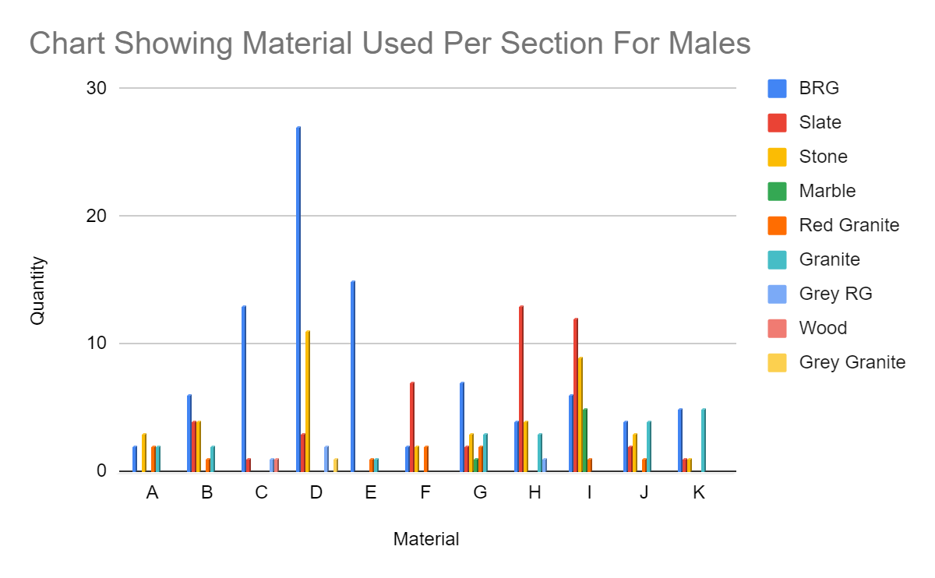
Figure 18
When it comes to materials there is a lot more variation throughout the sections. This may be due to the higher quantity of options or that there is a larger difference between genders. For females the most frequently used material is Black Reconstituted Granite (BRG) this material was expected to be the highest especially in sections such as C,D and E. BRG is the most typical material for modern graves. BRG is cheaper than other materials as it is not an actual hard rock but rather a broken down granite dust which is then moulded. BRG headstones can be brought on Ebay for as little as £60.00. (Ebay, 2020). But in five female sections other materials were the most used. The materials were slate and stone which both were also very popular. This is especially in sections where the graves are much earlier because BRG is a modern material. Slate and stone do not require the break up and moulding of BRG, it is natural stone which is carved. Section A only uses two materials but that section is very small in comparison with only three female primary graves. Again K is an anomaly and contains nearly every type of material which may relate to the shear spread of dates in that section. What does differ from the male primary graves is that Grey granite is not used at all and other materials such as marble, Red granite and wood are only used very little. This could be due to the fact that red granite is a very expensive and sought after stone and is a status symbol.

The male primary graves nearly follow the same trend as women with a few differences. The one main similarity is that BRG is the most commonly used with it being the highest in six sections and being present in every section. The fact that BRG is in every section for males and not for females shows that there is a slight gender difference. Section K for males also shows a difference between genders because only four different materials are used which is unusual as most male graves have at least five different materials per section.

As for children, all but four graves are either stone or slate. The four which do not follow the trend are produced from red granite, BRG and Marble. The importance of more of the graves being stone and slate may be because in the past these may have been the cheapest materials so were more affordable for parents and having fewer BRG could be due to it being a modern material and most children do now make it to adulthood.

Investigation into iconography offers further comparison of the genders. The bar chart below shows the eight most common forms of iconography.
Key –
IHS – Abbreviation of ‘Son of God’ in Latin
STP – T is stand in for a cross, meaning St. Peter’s
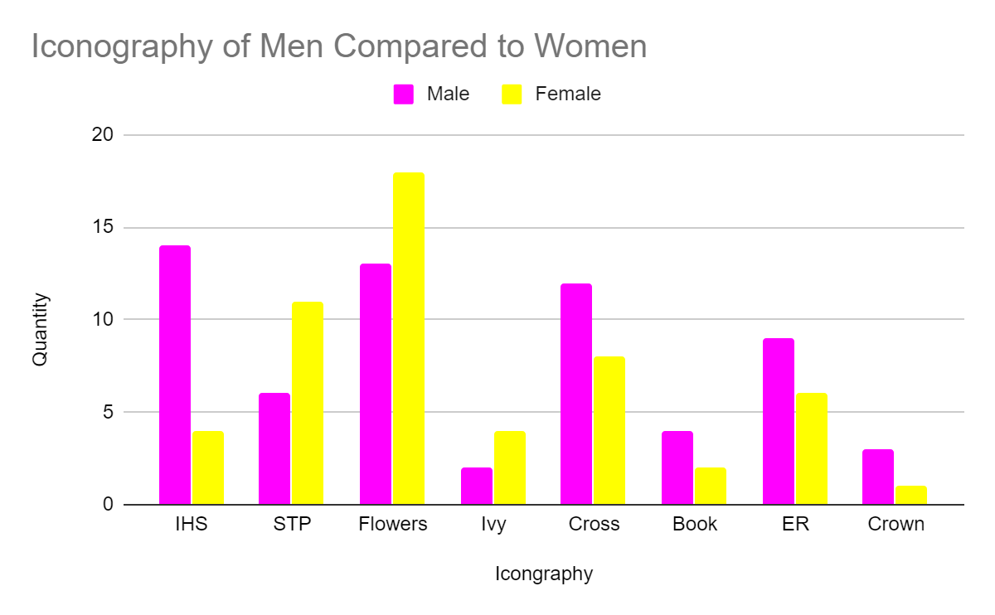
Figure 19
As seen in the bar chart flowers are the most common. This is probably due to their being many types of flowers with many meanings so occur more but each for different reasons. If this study was redone it would be beneficial to have an expert on flower meanings as it could offer another way to view differentiation. Male primary graves are higher in five of the eight categories above. This is a rather even split even though 59% of the iconography occurs on male graves (50 male, 35 female). The amount of each icon per gender does vary rather a lot which may be because of the meanings and time frames they were made in. Also since the church is a Church of Wales church it is normal, if not imperative to have religious iconography on monuments. Besides the icons listed above there were 22 different styles within the graveyard. Some of the more unusual ones were found in section C. Some of such designs were; Stirrups, shepherds and anchors. Only six of the 22 unusual icons were found on female graves. Again men were more likely to have individualised memorials than women.

When it comes to children nearly half of all the children’s graves have iconography. The chart below shows the distribution of the different iconographies.
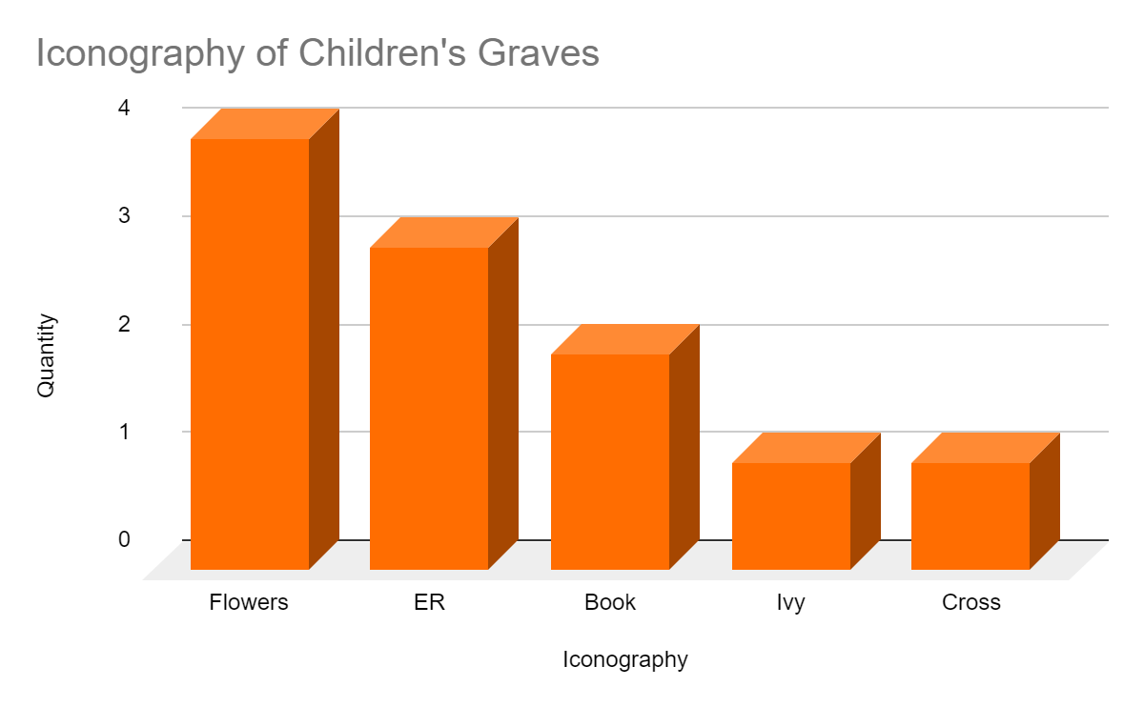
Figure 20
Compared to adults children are much more uniform in what iconography is used. This may be due to the sample size being so small but it also may be down to the meanings of the icons. The children’s graves were not from the modern era so perhaps and may reflect specific traditions of iconography considered suitable for children at the time.

Discussion and Context:
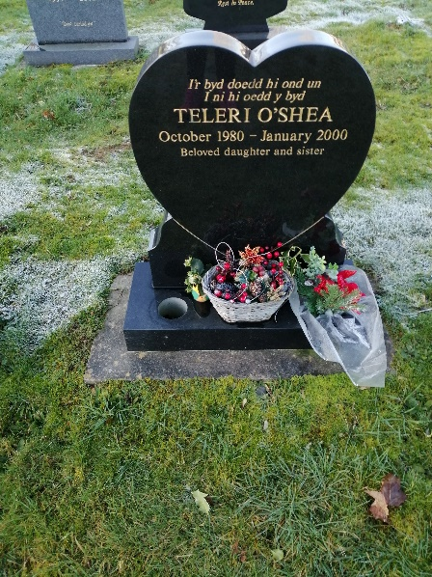
To put this study into context, if there was a difference in gravestones it is assumed that the greatest difference would be in the older graves due to there being a greater difference in the lifestyles of women and men in the 1800s and beforehand. Over the past 100 years’ gender and feminism has been a turbulent wave which has led to votes and greater equality. With this it would be understandable to have a lesser difference between men and women in the modern parts of the graveyard which in some ways is true since most graves are BRG and are all very similar in typology with only a few being inherently different from the rest, one such being Teleri O’shea’s. A trend which may have been present if the hypothesis was correct is that after 1918 women’s portrayals in the graveyard may shift focus and become more equal because of the Representation of the People Act from 1918 (UK Parliament, 2020), where women over the age of 30 got the right to vote. But especially from the 1960s/70s in which the second wave of feminism was occurring (Brunell and Burkett, 2019). As stated above it technically does follow the trend with the newer graves all being practically uniformed but it is more likely to be a consequence of social believes and standards rather than gender equality.
Photo 2: Teleri O’shea’s grave

The lack of differentiation in the modern grave can be partially explained due to nowadays over 50% of the UK population are under a bracket known as ABC1s which roughly correlates with the middle class. ABC1s refer to people who are:
A - Higher managerial, administrative and professional.
B - Intermediate managerial, administrative and professional
C1 - Supervisory, clerical and junior managerial, administrative and professional.
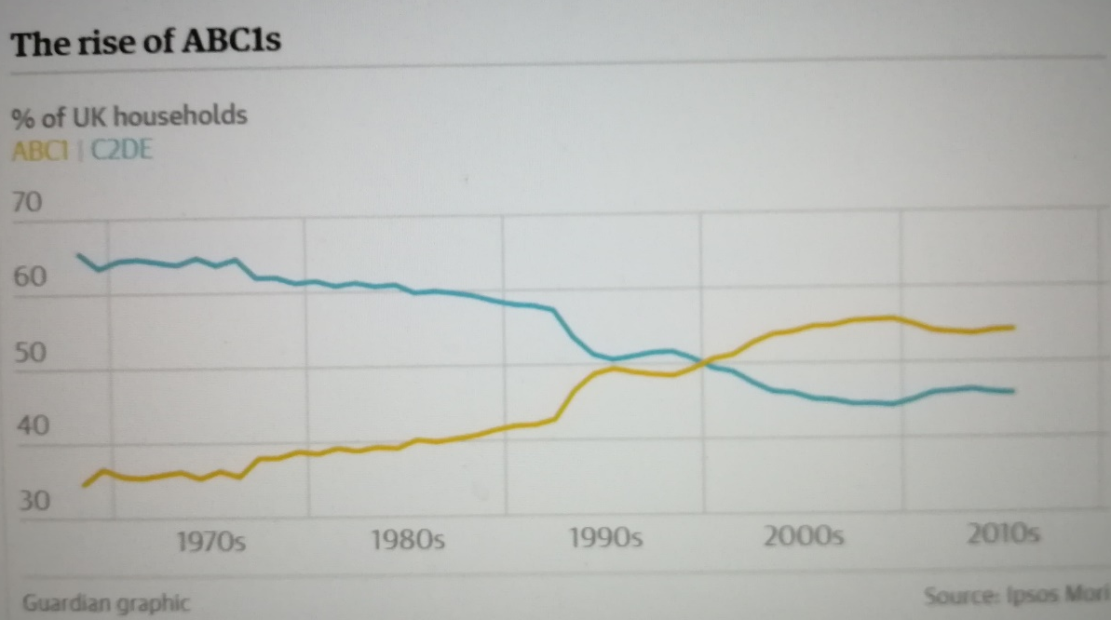
Figure 21 ABC1 percentage chart
This was shown in a line graph produced by the Guardian from an Ipsos Mori survey (Arnett, 2016). This suggests that more people are of the same economic wealth and so have a less differing quantity of disposable income to spend on their graves. An alternative theory could be that other social pressures or regulations shape a modern graveyard. Many if not all memorials look similar in today’s world and such social uniformity may influence people to represent the dead in a certain way even though the UK as a country has moved away from such highly religious views on death and burial that we had in the 1800s when the earlier part of the St. Peters was used. A further factor influencing the memorials is the supply of certain materials. The main granite reserves in Wales are in Gwynedd (Hyslop and Lott, 2007) which is 2 hours north of Lampeter (“Google maps Lampeter to Gwynedd,” 2020) which may give an idea as to why a large majority of the stones are granite or reconstituted Granite (52%).

Recommendations:
To improve this study, the option of recording every grave would make the results much more reliable but even then there are a known 1800 gravestones but many are unseen and many have been removed throughout time due to the building of the new church and the removal of the old. Also if further variables were taken into account it could show a wider differentiation. Variables such as a larger focus on iconography and text and possibly even language could offer further insight into the gendered differences in St. Peters and be a microcosm for the wider world of graveyards and funerary beliefs of the UK.

Conclusion
Overall this study set out to investigate gender differentiation in the memorials of St. Peter’s Church. The data indicates that gender is not a compelling factor for certain patterns of materials and typology. The site as a whole shows no correlation between gender and the choice of gravestones. Granted, there is a slight differentiation within separate sections but nothing that is so significant that gender differentiation can be confirmed. The main influencing factor on the material and typology of the gravestones is actually wealth, class and time period. The paupers’ graves and the more modern graves show very little differentiation with the only difference really being in the slight shape difference of the headstones in the modern graveyard. This is likely because the paupers were all the same economic class and their burials were arranged by the workhouse. The analysis of socio-economic status of the modern graves revealed a certain economic homogeneity which may be a more important factor in memorial choices. At the same time the assumption of wealth and status being shown through a gravestone is problematic. Most graves are designed by family members and not the person themselves and therefore socio-economic status may not be clear. Choices in memorialisation may have more to do with uniquely personal factors as well as social and cultural trends.
Bibliography:
- Wheeler, M., 1954. Archaeology from the earth, Oxford: Clarendon Press
- https://www.socscistatistics.com/tests/chisquare2/default2.aspx (Accessed 18th January 2020)
- Tarlow, S., (2005) ‘Death and Commemoration’, Industrial Archaeology Review, XXVII: 1, Page 166
- https://www.ebay.co.uk/itm/Memorial-Grave-Plaque-Stone-Engraved-Headstone-Large-Black-Granite 40x30cm/172306997364?epid=9027198191&hash=item281e4c2074:g:szgAAOSwzaJX~dkR (Accessed 23rd January 2020)
- https://www.parliament.uk/about/livingheritage/transformingsociety/electionsvoting/womenvote/parliamentary-collections/collections-the-vote-and-after/representation-of-the-people-act-1918/ (Accessed 23rd January 2020)
- Burket, E., Brunel L. (2019) The second wave of feminism Available at https://www.britannica.com/topic/feminism/The-second-wave-of-feminism · (Accessed 23rd January 2020)
- Arnett, G. (2016) UK Became More Middle Class Than Working Class in 2000, Data Shows Available at: https://www.theguardian.com/news/datablog/2016/feb/26/uk-more-middle-class-than-working-class-2000-data (Accessed: 18th January 2020)
- Hyslop, E., Lott, G. (2007) The Story of British Granite Available: https://www.buildingconservation.com/articles/rockofages/rockofages.htm (Accessed: 18th January 2020)
- https://www.google.co.uk/maps/dir/Lampeter/Gwynedd/@52.5297577,-4.3991473,9z/data=!3m1!4b1!4m14!4m13!1m5!1m1!1s0x486f042bbaa28371:0x206d0df279110283!2m2!1d4.078509!2d52.112903!1m5!1m1!1s0x486434b66c1c0fed:0xecce1b0314ace6fc!2m2!1d-4.1334836!2d52.9277266!3e0 (Accessed 18th January 2020)

Appendix - Typology
Table | Pitched - A1 | 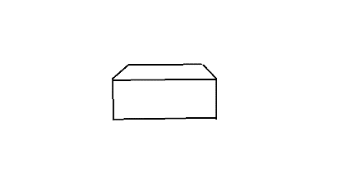 | 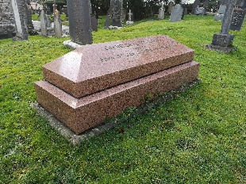
A | Cross Topped - A2 | 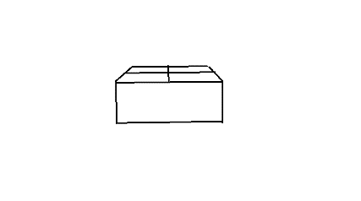 | 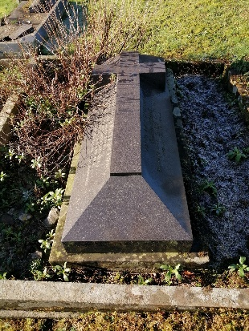

Plinth | Cross - B1 -  Celtic Cross - B1(2) | 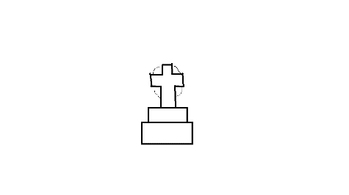 | 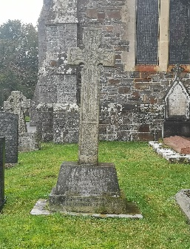  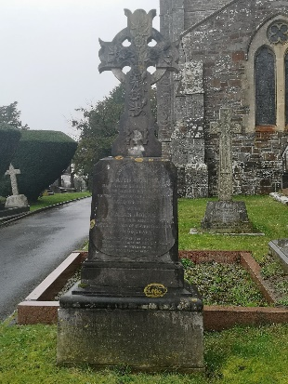
B | Urn - B2 | 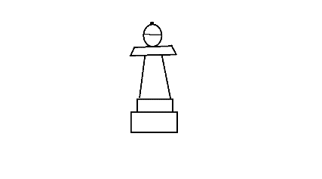 | 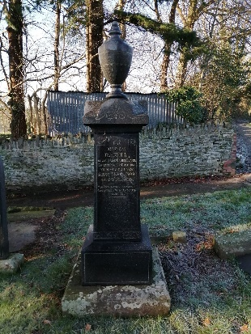
 | Covered Urn - B3 | 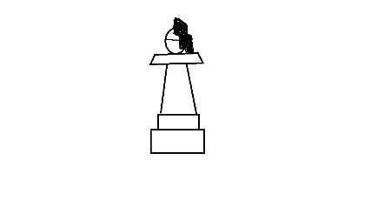 | 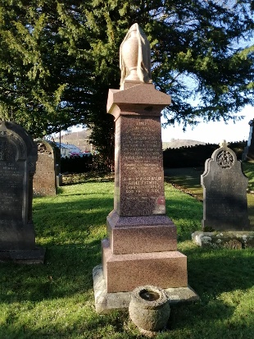
 | Pillar - B4 | 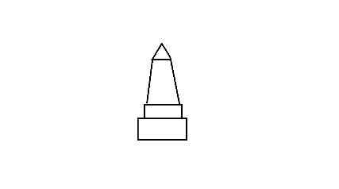 | 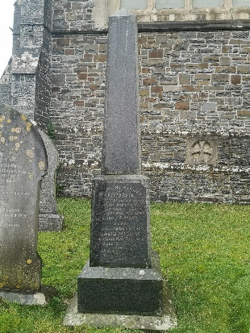

Flat | With Headstone - C1 | 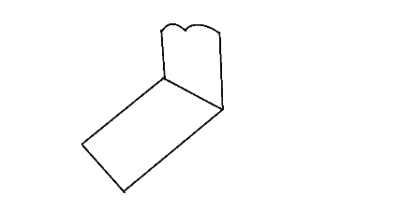 | 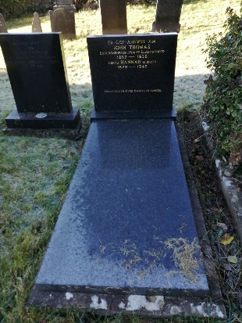
C | Book - C2 | 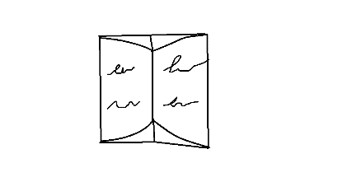 | 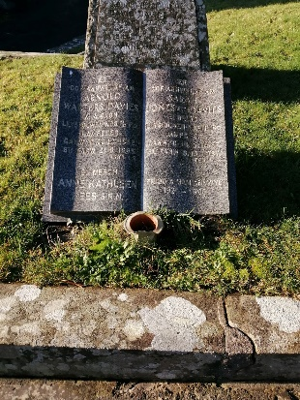

Traditional | Pointed/Gothic - D1 | 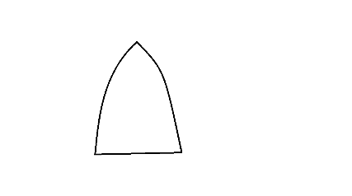 | 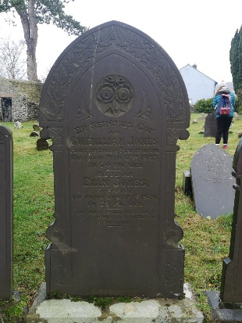
D | Waved - D2(Modern)  D2(1) Classic | 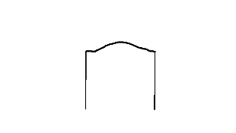  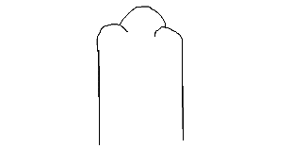 | 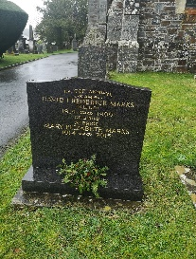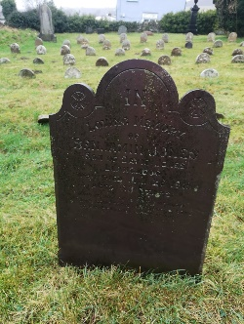
 | Scroll/ Columns - D3 | 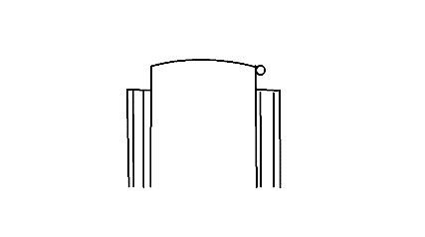 | 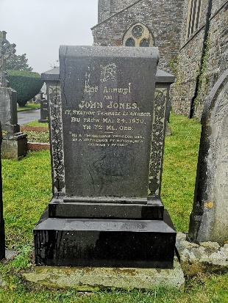
 | Trad - D4 | 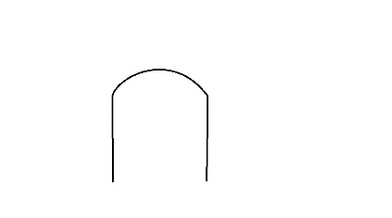 | 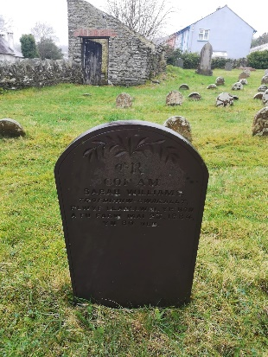
 | Square - D5 |  | 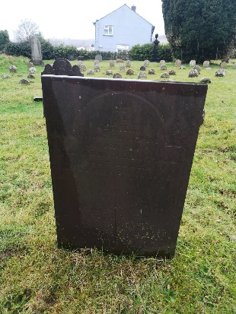
 | Central Cross/ Pattern - D6 | 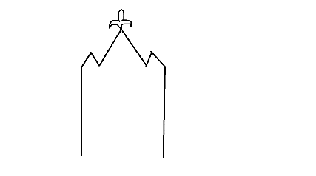 | 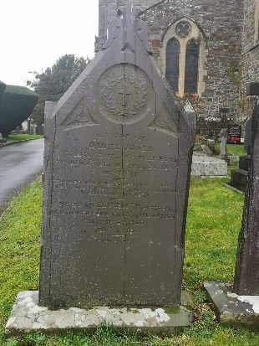
 | Rounded top with Patterned Edges - D7 | 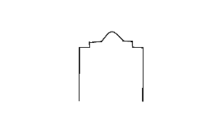 | 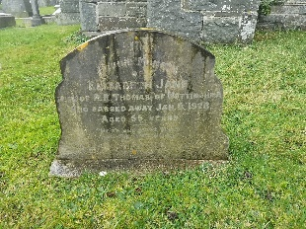
 | Straight Edge Vaulted - D8 | 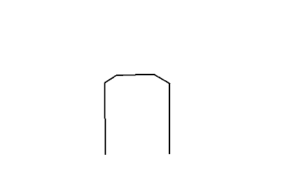 | 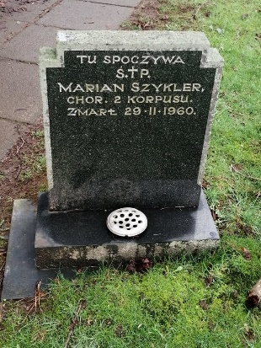
 | Heart - D9 |  | 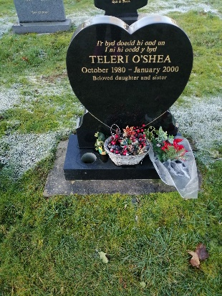
 | ‘Round’ - D10 |  | 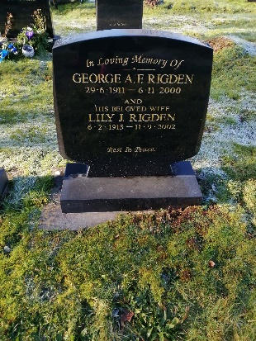
 | Asymmetric - D11 |  | 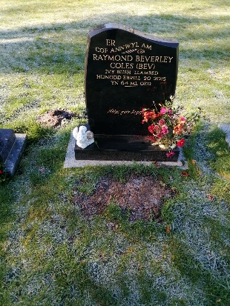
 | Oval with Checks - D12 | 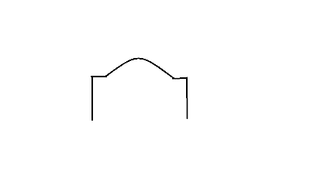 | 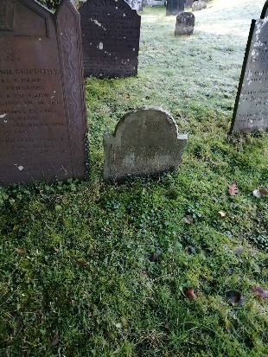

Bed | Gravel - E1 | 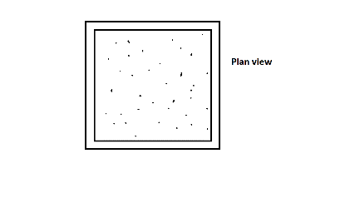Plan view | 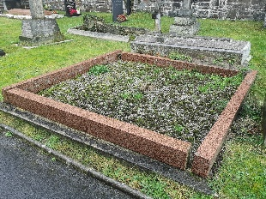
E | With Headstone - E2 | 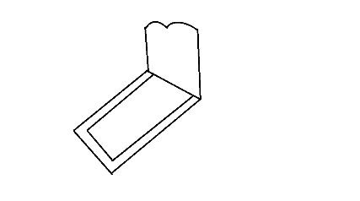 | 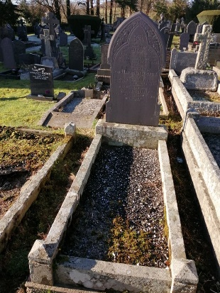
 | Birdbath - E3 | 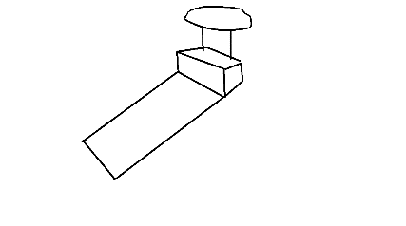 | 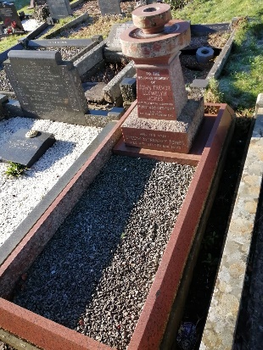
 | With Plinth - E4 | 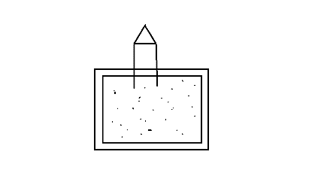 | 

