

Module name: Understanding and Engaging Stakeholders
Module code: LCLM5001
Assignment Title: Understanding the importance of Stakeholder Engagement in the successful commencement and completion of the project.
Student Name: Marian Bogdan Burzo
Student ID: 2335150
Lectures name: Mohammad Rahman

Executive Summary
This report introduces the new service StaySmart+ by Britannia Hotels. It also helped identify the external and internal stakeholders, such as the government, suppliers, shareholders, product development, and others. Other than the potential challenges related to internal resistance, skill gaps, high upfront costs, and others, they will help the hotel to achieve competitive positioning. The study also underpinned the role of effective communication and cross-functional collaboration, aligning with key theoretical frameworks for active stakeholder engagement. While stakeholders for Britannia Hotels might witness some major challenges, suitable and justified recommendations, such as customer relationship management, employee training, and others, have been proposed.

Table of Contents
Introduction to the company 4
SMART objectives 5
PESTLE and SWOT 7
Key internal and external stakeholders and their roles and responsibilities 11
Benefits and challenges to the stakeholders 13
Frameworks, models, and theories 15
Critical explanation of the process 22
Impact of stakeholders’ engagement on your business performance 25
Conclusion 27
References 28

Introduction to the company
Mahajan (2023) said that stakeholder management refers to the strategic approach by which organisations are expected to consider the interests of all their stakeholders rather than completely focusing on their shareholders. This, in turn, is known to help the business achieve long-term success as everyone feels valued. For the new service, StaySmart+ by Britannia Hotels, this report will first identify the key internal and external stakeholders and then evaluate their roles and responsibilities, as well as the potential challenges and benefits. The suitable methods for stakeholder engagement will also be discussed using various theories or models, followed by the impact of their engagement and future recommendations.
Britannia Hotels was founded by Alex Langsam in 1976, and currently operates with over 60 sites in the UK (Robinson, 2025). The hotel was initially founded in South Manchester, The Country House Hotel, after the owner had bought a hotel with 100 bedrooms (Britannia Hotels, 2026). In London, the hotel is located in Canary Wharf, which is worth £400 million (The Standard, 2025). The hotel offers a variety of restaurants, Spindles leisure club, extensive onsite parking, and a hotel bar. The property is also known to provide the best value for quality accommodation, which is perfect for business, leisure, and families, being located in seafront locations, picturesque countryside, and busy city centres (Britannia Hotels, 2026).
Project Scope
Based on the latest report, 88% of Britons are more likely to recommend a restaurant or a hotel providing tailored service, and 83% also expect personalised experiences (The Hotel Magazine, 2025). On the contrary, 71% of the consumers mentioned feeling frustrated in case such experiences are limited, and 61% also stated their willingness to pay more for the same (The Hotel Magazine, 2025). Moreover, the UK hospitality sector is also experiencing high pressure to demonstrate sustainable practices (UK Hospitality, 2024). As the demand for personalised services are on the rise, strategic decision-making, efficient services, and the effective roll-out of StaySmart+ by Britannia Hotels will help the brand to gain market competitiveness.

SMART objectives
Objective | Specific | Measurable | Achievable | Relevant | Time-Bound
To enhance guest satisfaction | Introduce AI-powered guest interaction systems in selected hotels | Improving guest satisfaction ratings by 20% | Using existing AI tools along with trained staff | Overall customer experience and long-term loyalty will be improved. | Within 4 months
To strengthen brand differentiation | - Position StaySmart+ as a high-end smart hospitality offering | - Achieving a 12% rise in premium bookings | - Through targeted marketing strategies and digital campaigns | - It will support building a stronger competitive position in the market | Within 3 months
To promote sustainability practices | - Implement eco-friendly amenities and energy-efficient solutions | - Reducing overall energy consumption by 10% | - By adopting available green technologies | - Sustainability initiatives and brand reputation will be strengthened | Within 4 months
To increase customer retention | - Provide customised travel planning services for guests | - Increasing repeat bookings by 15% | - By leveraging customer data and CRM tools | - Britannia Hotels will be capable of enhancing customer loyalty and contributing to higher revenue | Within 3 months
To expand global implementation | - Launch StaySmart+ in selected international hotel locations | - Rolling out services in at least 10–15 hotels | - Through a step-by-step implementation plan | - This will support the global expansion of StaySmart+ by Britannia Hotels. | Within 6 months
To improve operational efficiency | - Introduce automation in guest services such as check-ins and query handling | - Cutting service response time by 30% | - By integrating AI-based solutions into existing systems | - This will lower operational costs and improve service speed | Within 4 months
Table 1: SMART Objectives
(Source: Created by the learner)

PESTLE and SWOT
PESTLE
Political
In 2023, the political stability of the UK decreased to 0.51494 from 0.53318 in 2022 (Trading Economics, 2026). Hence, declining political stability may increase investment risks and operational uncertainty for StaySmart+ by Britannia Hotels.
Economic
The bank interest rates in February 2026 remained much lower at 3.75% compared to 4.5% in February 2025 (Trading Economics, 2026). For StaySmart+, it will help reduce financing costs, thus enabling investment in hotel improvements.
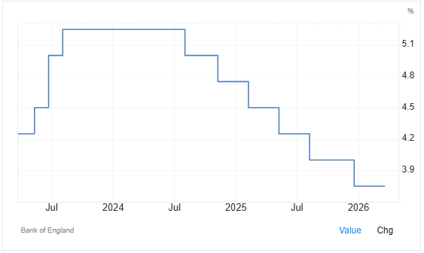
Figure 1: Interest rate
(Source: Trading Economics, 2026)
Social
Currently, in February 2026, the consumer confidence dropped further to -19 points from -16 in the previous month (Trading Economics, 2026). This, in turn, will reduce the bookings and occupancy rates, thus hindering financial viability.
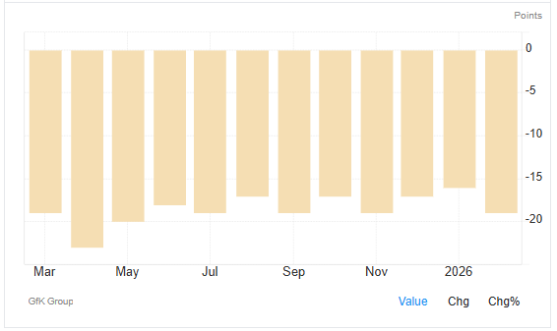
Figure 2: Consumer Confidence
(Source: Trading Economics, 2026)
Technological
Between 2026 and 2033, the artificial intelligence market size is expected to grow by 28.2% to reach $180,797.5 (Grand View Research, 2026). This will help enhance service efficiency and personalisation efforts of StaySmart+ to encourage active adoption of the same.
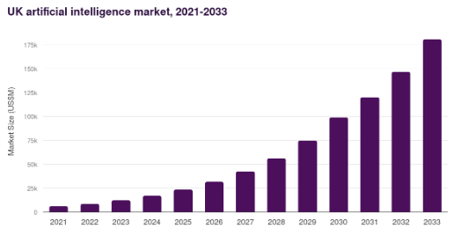
Table 2: Artificial intelligence market
(Source: Grand View Research, 2026)
Legal
The Equality Act of 2010 helps to overcome discrimination in certain situations by minimising socio-economic inequalities to harmonise and reform equality law at work (Legislation.gov.uk, 2026). In such an instance, Britannia Hotels must ensure fair employment practices to reduce legal and compliance risks.
Environmental
Based on the report from 2024, customers have mentioned that they are willing to pay 9.7% more for sustainable products and services, as approximately 85% mentioned experiencing the disruptive impact of climate change (PwC, 2024). Adhering to this and investing in greener practices will help Britannia Hotels attract more potential customers.
SWOT
Strengths
- Currently, Britannia Hotels reports a surging revenue estimated at $201.4 Million (Zoominfo, 2026).
- The pre-tax profit of the hotel increased to £39.3m, followed by an increased turnover to £154.7m in 2023 (Robinson, 2024).
- It also maintains an active presence on Facebook, X, and LinkedIn to attract a larger customer base (Zoominfo, 2026).
Weaknesses
- A main weakness is related to customer complaints regarding the cleanliness and reliability of the hotels (McNamee, 2025).
- For the 10th consecutive year, it has been recognised as the worst hotel chain for their poor experience (Lancefield, 2022).
- Based on employee reviews, outdated systems, poor management, and inappropriate compensation and benefits are the potential challenges (Glassdoor, 2026).
Opportunities
- Britannia Hotels has the opportunity to regain its lost customer loyalty and brand awareness based on the introduction of StaySmart+.
- The country also underpins a surging demand for AI-driven personalised services. For example, 75% of the guests prefer to book with the hotel brands offering tailored services (The Hotel Magazine, 2025).
Threats
- Economic uncertainties could adversely affect travel and tourism demand.
- Intense competition presented by these hotels could affect the competitive positioning of Britannia Hotels. For example, presently, the UK hospitality market is dominated by Holiday Inn, Premier Inn, Travelodge, and Marriott (YouGov, 2026).

Key internal and external stakeholders and their roles and responsibilities
For the new service named StaySmart+, the potential stakeholders of Britannia Hotels include:
Internal Stakeholders
Board of Directors
Nguyen and Huynh (2023) stated that the Board of Directors play an important role in representing shareholders so that they can participate in the management and the governance of the enterprise, aligning with the development orientation of the company. They are also responsible for improving overall business performance as they are empowered with complete authority to decide and perform the interests or obligations of the company.
Senior Management
The roles and responsibilities include strategic planning, decision-making, resource allocation, stakeholder communication, performance monitoring, and strategic implementation. For example, the management team of Britannia Hotels include Joanne Farrington, John Parker, Joanne Guest, and others (Rocket Reach, 2026).
Product Development Team
They are known to conduct in-depth market research to understand customer needs and design and develop new products or services through cross-functional collaboration to introduce the same in the market.
Marketing and Sales Department
Sales and marketing department are crucial for increasing brand revenue by performing market research, executing successful promotional campaigns, and strengthening brand awareness. For example, the hotel reports a revenue worth $201.4 Million currently (Zoominfo, 2026).
External Stakeholders
Government
Kiladze, Surmanidze and Mushkudiani (2024) mentioned that government bodies help impose regulations and laws which directly affect business operations, organisational environment, and legal obligations. They are also responsible for policy formulation, environmental protection, and welfare and social support. For example, the Data Protection Act 2018 is focused on offering legal protection for sensitive information to ensure the responsible use of sensitive information (Gov.uk, 2026).
Customers
They are perceived to be the key contributors to feedback, reviews, and revenue, which help businesses to improve their operations for operational excellence in the long run. However, Britannia Hotels reports a minimum customer satisfaction score of 56% (Lancefield, 2022).
Suppliers
As per Kiladze, Surmanidze and Mushkudiani (2024), it is crucial for companies to maintain positive connections with their suppliers as they help guarantee product quality and ensure the sustainability of the supply chain.
Shareholders or Investors
Kiladze, Surmanidze and Mushkudiani (2024) said that shareholders are known to worry about the financial performance of the business. They are also known as stockholders or investors who are responsible for generating profits from their investments by enhancing their value or being involved in corporate matters.
Travel Agencies
In 2025, the total number of transactions in travel agencies increased by 17.9% compared to the previous year (McQuarrie, 2025). They act as intermediaries between suppliers and travellers to ensure seamless travel experiences by managing travel documentation, managing bookings, and itineraries.

Benefits and challenges to the stakeholders
Internal Stakeholders
Product Development Team and Marketing and Sales Department
Britannia Hotels will be benefitted by these stakeholders through enhanced service quality, innovative approaches, and improved brand visibility. This will also help attract more prospective customers for higher brand sales. On the contrary, Gonçalves and Domingues (2025) criticised that the adoption of AI is related to a variety of threats, such as ethical issues, cybersecurity vulnerabilities, and so on.
Senior Management
They will benefit Britannia Hotels through efficient resource utilisation, performance monitoring, and the effective implementation of AI tools to execute the purpose of StaySmart+ within 6 months. However, they might face issues related to digital skill gaps, employee resistance, and the complexities of the new technology. On the contrary, Mukhuty, Upadhyay and Rothwell (2022) argued that persisting skill gaps prevents the automation and digitalisation of businesses.
Board of Directors
While the board of directors will benefit from StaySmart+ based on appropriate strategic planning, approving investments, and outlining the long-term vision of the company, they might also encounter some major challenges. On the contrary, as argued by Argyroudis et al. (2022), some of the major challenges pertaining to the adoption of advanced technologies are related to compliance with equitable principles, complex interdependencies, and individual privacy. This might prevent them from balancing the risk with innovation for operational excellence.
External Stakeholders
Customers
While customers or the end users of StaySmart+ will benefit Britannia Hotels from financial gains based on positive feedback and reviews, they might be adversely affected by cyberattacks or data breaches and high costs, thus preventing the adoption of the same. Liu et al. (2022) argued that cybercriminals are taking advantage of the vulnerabilities caused by hyper-connected systems, technology, and human-enabled errors.
Government
Government plays a crucial role for companies by outlining the policies and practices to help ensure brands are capable of complying with the same. However, Eom and Lee (2022) argued that the challenges and concerns are related to digital authoritarianism, trustworthiness, and AI.
Suppliers
While suppliers will help ensure the availability of high-quality support and resources, increased dependence on the suppliers might also result in delays or disruptions in the supply chain. The greatest risk related to the supply chain is an absence of digitalisation, distance, opaque processes, and manual reporting (Garrison, 2022).
Shareholders
While shareholders will offer financial support for StaySmart+, they might also face challenges related to high upfront costs and risks related to innovation. During the surge in digital transformation, the rate of technological innovation is known to present a major challenge (Marr, 2022).
Travel Agencies
Although travel agencies will help strengthen distribution channels and attract international customers to expand market reach, the challenges are related to inadequate knowledge of the features of StaySmart+ and inappropriate digital advertising. As criticised by Onalaja and Otokiti (2024), advertisers encounter challenges related to cyber fraud, consumer trust, and data privacy.

Frameworks, models, and theories
Stakeholder Matrix
As per the view of Chiwala, Makasa and Zulu (2025), Mendelow’s stakeholder matrix is an academic framework that is used to classify stakeholders in different groups according to their levels of power and interest. Applying the theory, the senior management and Board of Directors of the hotel relinquish the highest levels of interest and power over the development of the StaySmart+ project, as they are responsible for developing and implementing the necessary strategy. For the group of Monitoring, suppliers, product development team, and marketing department are responsible for the effective implementation of the plan, while customers and travel agencies should be kept informed. Conversely, shareholders and the government hold high power over the project as they invest their financial resources and require compliance with regulatory requirements, respectively.
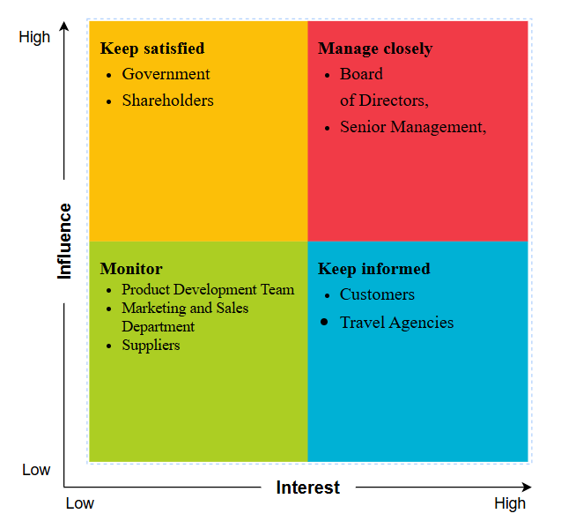
Figure 3: Stakeholder Matrix
(Source: created by the learner)
Stakeholder Group/Person | Level of Interest (H/M/L) | Level of Involvement (H/M/L) | Level of Influence (H/M/L) | Level Impacted by Project (H/M/L)
Internal to Project
Product Development Team | High | High | Medium | High
Senior Management | High | High | High | High
Marketing and Sales Department | Medium | High | High | High
Board of Directors | High | Medium | High | High
Internal to Organisation
Shareholders/Investors | High | Low | High | Medium
External to Organisation
Customers | High | Medium | Medium | High
Suppliers | Medium | Medium | Medium | Medium
Government | High | Low | High | Low
Travel Agencies | Medium | Low | Medium | Medium
Table 3: Stakeholder Assessment
(Source: Created by the learner)
Engagement Plan
Stakeholder | Unaware | Resistant | Neutral | Supportive | Leading
Board of Directors |  |  | C |  | D
Senior Management |  |  |  | C | D
Product Development Team |  |  |  |  | C
Marketing and Sales Department |  |  |  |  | C
Government |  |  | C
Customers |  |  | C | D
Suppliers |  | C |  | D
Shareholders/Investors |  |  | C | D
Travel Agencies |  |  | C |  | D
Table 4: Stakeholder Engagement Plan
(Source: Created by the learner)
C- Current
D- Desired
Koilakonda (2023) stated that stakeholder engagement is a crucial component in a project that is dependent on active listening, sharing of information and teaming up. For the StaySmart+ project, engaging with stakeholders is highly important. For the current state, the government and shareholders might be neutral. Conversely, senior management, the product development team, and others might be leading the team.
Communication Plan
Stakeholder | Weekly Meeting | Monthly Meeting | Weekly Status | Monthly Report | Newsletter | Exception Reports
Board of Directors | X F2F |  | X F2F
Senior Management | X VC | X F2F | X PIP | X VC |  | X TC
Product Development Team |  | X F2F |  | X F2F VC | X E | X PIP F2F
Marketing and Sales Department |  |  |  | X VC TC F2F | X E
Government |  |  |  |  | X E
Customers |  |  | X F2F E
Suppliers |  |  |  |  |  | X
Shareholders/Investors |  |  |  |  | X E VC
Travel Agencies |  |  |  |  | X E TC VC
Table 5: Communication Plan
(Source: created by the learner)
F2F – Face to Face
VC- Video Conference
E – Email
TC– Teleconference
PIP- Project intranet page
Communication with stakeholders is crucial for developing strategic relationships, managing risks and also for forming informed decisions (Koilakonda, 2023). As stated in the above plan, all stakeholders of Britannia Hotel will be communicated through different communication channels. The progression of the project and also the challenges will be communicated to the stakeholders through channels such as face-to-face meetings, emails, intranet pages, and so on. To keep the stakeholders updated about the progression of the project, intranet, personal communication, emails and other channels can also be used.

RACI Matrix
Tasks | Board of Directors | Senior Management | Product Development Team | Marketing and Sales Department | Government | Customers | Suppliers | Shareholders/Investors | Travel Agencies
Strategy development | R | R | C | C | I | I | I | I | I
AI system implementation | C | A | R/A | R | C | I | I | I | C
Marketing campaign | I | A | C | R/A | I | I | I | I | A
Sustainability initiatives | C | R | R/A | R/A | I | C | C | C | A
Compliance and legal | R | R | I | A | A | I | A | I | C
Customer experience | I | R | C | R/A | I | A | A | I | A
Table 6: RACI Matrix
(Source: created by the learner)

The RACI matrix is like a theoretical way to assess the roles and responsibilities of various stakeholders, which consists of four domains: Responsible, Accountable, Consulted and Informed (Ma'arif et al., 2023). From the above, it is clear that the management and BOD of Britannia Hotels will be accountable for the strategic development; on the other hand, the management will be accountable for the sustainability initiatives. In addition to this, the product development team will be accountable for the development of the product, while the marketing team will observe the marketing campaigns and sales.

Critical explanation of the process
Communication
Communication with stakeholders is a quintessential process that involves the sharing of information with stakeholders and keeping them informed. In the context of the StaySmart+ service, communicating the crucial details of the project with different stakeholders will be necessary. This can be achieved through a comprehensive communication plan. A stakeholder communication plan refers to the framework that details the channels that are used to include and inform stakeholders at every step of a project (Anderson, 2023). Muneer et al. (2022), on the other hand, criticised that poor communication is often the main reason behind the failure of projects. Hence, developing this plan beforehand will be necessary for Britannia Hotels to ensure transparent communication. Along with this, providing transparent reporting to all stakeholders is another approach that can be taken.
Collaboration
To ensure collaboration between stakeholders, the first and foremost strategy is to establish cross-functional collaboration between the product development and marketing teams. Yin et al. (2023) noted that cross-functional collaboration is important to align all project and business units. This helps ensure that all departments are on the same level. However, undefined project goals, a lack of accountability, challenges in team dynamics, and more are the common barriers in ensuring cross-functional collaboration (APAC Business Standard, 2026). Moreover, engagement with suppliers can facilitate seamless collaboration.
Consultation
To consult with different stakeholders, conducting surveys and gathering feedback from them can be a helpful approach. Mitson and Weber (2023) stated that feedback is the information returned to the sender from the receiver, which entails the perceptions and results of the communication process. Hence, through surveys, feedback from various stakeholders on the process of the project can be gathered. All the more, consulting regulatory bodies regarding the use of AI and other regulatory compliances is necessary to ensure that the StaySmart+ project is developed in accordance with regulatory compliance. This is necessary, as failure to comply with regulations leads to legal consequences, fines or lost businesses (PwC, 2025). Thereby, consultation with legal bodies is highly necessary.
Commitment
Stakeholder commitment is of utmost importance to ensure the success of the StaySmart+ project of Britannia Hotels. The main approach to attaining this is through meeting stakeholder needs. Supporting this notion, Węgrzyn and Wojewnik-Filipkowska (2022) illustrated that the stakeholder theory also highlights the importance of meeting the varying needs of different stakeholders. Aligning the needs of stakeholders with project outcomes can make them more inclined to achieve commitment from stakeholders. However, the main issue that might arise in this case is a conflict of interest. This can occur due to direct or indirect financial interest, competing loyalty between other organisations, and more (UKRI, 2026). Herein, managing this conflict becomes necessary to ensure a high level of commitment from all stakeholders of Britannia Hotels.
Managing Conflicts
Another critical aspect for the enhancement of the project is the effective management of conflicts between stakeholders. As identified above, conflict among stakeholders can occur due to varying interests, different levels of commitment, communication gaps and more (UKRI, 2026). Thereby, the management of Britannia Hotels should take effective and active measures to mitigate conflicts among various stakeholder groups. Specifically for conflicts among employees, applying the Thomas-Kilmann model can be quite effective. Sayadat (2024) insinuated that the model proposes five different types of strategies, such as collaborating, competing, avoiding, accommodating, and compromising, to overcome the conflicts within groups. Apart from this, negotiation with suppliers and other stakeholders can also be highly effective in resolving conflicts.
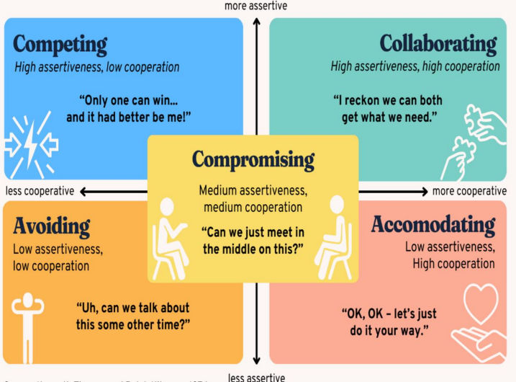
Figure 4: Thomas-Kilmann Model of Conflict Management
(Source: Sayadat, 2024)

Impact of stakeholders’ engagement on your business performance
According to Kujala et al. (2022), stakeholder engagement is described as the practices that the company undertakes to involve their potential stakeholders positively within organisational activities. It is also known to play an integral role in ensuring project success as it helps to reduce risks, build trust, and improve overall decision-making processes of the company based on varied perspectives. For Britannia Hotels, active engagement of a variety of internal and external stakeholders, such as suppliers, government, shareholders, board of directors, and others, is quite important for the development and roll-out of StaySmart+. This, in turn, will help the hotel to foster innovation by leveraging advanced technologies, such as AI and also drive sustainability, thus diversifying its services in the competitive sector. Moreover, it will also help to ensure project success for StaySmart+ upon aligning with the organisational strategy to enhance convenience and comfort for the guests. Further, adhering to regulatory compliance and strong supplier relations, as well as cross-collaboration with the marketing, product development, and sales teams, will also help Britannia Hotels to ensure long-term success. This, in turn, will positively influence the service and performance of the company, thus helping to attract and retain a larger customer base, acting as positive brand advocates to help increase sales. However, while stakeholder engagement is quite important it is also related to various issues. Conflicting interests, misjudgement, and disempowerment are some main challenges along with flawed technology (Yec, 2022).
Recommendations
For the future, it is recommended that Britannia Hotels focus on personalised feedback and communication channels to improve customer satisfaction. Personalised communication is crucial to help motivate customers towards repetitive purchases (Rusiñol, 2023). In case hotels fail to understand the needs of their potential customers, they are most likely to lose their market position based on ineffective strategic planning. Hence, personalised communication will help the hotel to attract a larger customer base in the highly competitive sector, to increase its footfall for improved reputation and profitability.
It can also be suggested that Britannia Hotels track their stakeholder interactions by leveraging advanced AI-CRM tools and systems. Within the complex business environment, customer relationship management (CRM) helps a brand attract more potential customers, crucial for its competitive positioning (Ozay et al., 2024). For the development and roll-out of StaySmart+ by Britannia Hotels in the nation, modern CRM tools will help the hotel ensure long-term sustainability based on higher customer engagement.
To overcome the potential legal issues which could lead to reputational damage and consumer trust, Britannia Hotels are expected to comply with the data protection regulations and other relevant government policies. It is of utmost importance for organisations to adhere to the policy changes (Power, 2024). Adhering to the policies will help the hotel to prevent any operational disruptions which could otherwise be detrimental to its growth.
Lastly, Britannia Hotels must also invest in appropriate staff training programs. Elsafty and Oraby (2022) advocated that training programs are crucial, which help employees to develop their knowledge and skills. This will also help Britannia Hotels to bridge the digital gap among its staff. Staff will also be capable of ensuring the effectiveness of StaySmart+ in the nation to attract a larger customer base through personalised and convenient service for long-term profits.

Conclusion
On a concluding note, stakeholder engagement for the new service StaySmart+ at Britannia Hotels is of great importance. The main aim of the service is to enhance customer satisfaction and retention, promote sustainable practices, and so on. The external environmental analysis reflected a contradictory environment with political instability and declining consumer confidence affecting the company, while the growing AI market and other factors are positive in this regard. In relation to stakeholder management, senior management, board of directors, shareholders, customers, government, and more are some important stakeholders to be managed efficiently by the company.
Based on Mendelow’s matrix, the board of directors and senior management need to be managed closely while keeping shareholders and the government informed are necessary for Britannia Hotels. To communicate with the stakeholders, direct communication channels like face-to-face meetings, video conferences, emails, and more are identified as suitable means. The RACI matrix presented detailed information about the roles of each stakeholder in this plan. Following this, engaging stakeholders through open and transparent communication, cross-functional collaboration, consulting stakeholders and meeting their needs are important. Although challenges like conflict of interest and such can occur, the company is recommended to ensure negotiation, AI-based customer relationship management, staff training and so on to gain better results.

References
Anderson, L. (2023) How To Create An Effective Stakeholder Communication Plan. Available at: https://www.forbes.com/councils/forbesagencycouncil/2023/10/27/how-to-create-an-effective-stakeholder-communication-plan/ (Accessed: 20 March 2026).
APAC Business Standard (2026) Challenges of Cross-Functional Collaboration and Solutions to Fix Them. Available at: https://apacbusinessstandard.com/challenges-of-cross-functional-collaboration-and-solutions-to-fix-them/#:~:text=Commonly%20emerging%20cross%20functional%20collaboration,organization%20and%20tackle%20problems%20efficiently. (Accessed: 20 March 2026).
Argyroudis, S.A., Mitoulis, S.A., Chatzi, E., Baker, J.W., Brilakis, I., Gkoumas, K., Vousdoukas, M., Hynes, W., Carluccio, S., Keou, O. and Frangopol, D.M. (2022) ‘Digital technologies can enhance climate resilience of critical infrastructure’, Climate Risk Management, 35, p. 100387.
Britannia Hotels (2026) A History of Britannia Hotels. Available at: https://www.britanniahotels.com/about-us (Accessed: 20 March 2026).
Chiwala, B., Makasa, M. and Zulu, J.M. (2025) ‘Power and interest levels in safely managed sanitation services in Zambia: A stakeholder mapping’, Plos one, 20(11), p. e0335130.
Elsafty, A. and Oraby, M. (2022) ‘The impact of training on employee retention: An empirical research on the private sector in Egypt’, International Journal of Business and Management, 17(5), pp. 58-74.
Eom, S.J. and Lee, J. (2022) ‘Digital government transformation in turbulent times: Responses, challenges, and future direction’, Government Information Quarterly, 39(2), p. 101690.
Garrison, R. (2022) Exposing Supplier Vulnerabilities In The Supply Chain. Available at: https://www.forbes.com/councils/forbesbusinesscouncil/2022/06/08/exposing-supplier-vulnerabilities-in-the-supply-chain/ (Accessed: 20 March 2026).
Glassdoor (2026) Britannia Hotels Reviews. Available at: https://www.glassdoor.co.uk/Reviews/Britannia-Hotels-Reviews-E704062.htm (Accessed: 20 March 2026).
Gonçalves, R. and Domingues, L. (2025) ‘Artificial intelligence driving intelligent logistics: Benefits, challenges, and drawbacks’, Procedia Computer Science, 256, pp. 665-672.
Gov.uk (2026) The UK's data protection legislation. Available at: https://www.gov.uk/data-protection (Accessed: 20 March 2026).
Grand View Research (2026) UK Artificial Intelligence Market Size & Outlook, 2026-2033. Available at: https://www.grandviewresearch.com/horizon/outlook/artificial-intelligence-market/uk (Accessed: 20 March 2026).
Kiladze, L., Surmanidze, N. and Mushkudiani, Z. (2024) ‘Social entrepreneurship & corporate social responsibility driving sustainable solutions: comparative analysis’, Access J, 5(1), pp. 85-101.
Koilakonda, R.R. (2023) ‘Effective communication strategies for stakeholder engagement’, International Journal of Core Engineering & Management, 7(8), pp. 2348-9510.
Kujala, J., Sachs, S., Leinonen, H., Heikkinen, A. and Laude, D. (2022) ‘Stakeholder engagement: Past, present, and future’, Business & Society, 61(5), pp. 1136-1196.
Lancefield, N. (2022) Britannia ranked UK’s worst hotel chain for 10th consecutive year. Available at: https://uk.finance.yahoo.com/news/britannia-ranked-uk-worst-hotel-000100706.html (Accessed: 20 March 2026).
Legislation.gov.uk (2026) Equality Act 2010. Available at: https://www.legislation.gov.uk/ukpga/2010/15/introduction (Accessed: 20 March 2026).
Liu, X., Ahmad, S.F., Anser, M.K., Ke, J., Irshad, M., Ul-Haq, J. and Abbas, S. (2022) ‘Cyber security threats: A never-ending challenge for e-commerce’, Frontiers in psychology, 13, p. 927398.
Ma'arif, S., Putrianti, F.G., Indraswari, N.M., Nhu, D.Q., Pujianingsih, E.D., Marsinta, A.K. and Ardianti, P. (2023) ‘Stakeholder Management in Developing a Sustainable Tourism Village Based on Renewable Energy Using RACI Matrix’, Journal of Industrial System Engineering and Management, 2(2).
Mahajan, R., Lim, W.M., Sareen, M., Kumar, S. and Panwar, R. (2023) ‘Stakeholder theory’, Journal of Business Research, 166, p. 114104.
Marr, B. (2022) The Top 5 Technology Challenges In 2023. Available at: https://www.forbes.com/sites/bernardmarr/2022/11/10/the-top-5-technology-challenges-in-2023/ (Accessed: 20 March 2026).
McNamee, A. (2025) The ‘completely horrendous’ company that has been named the worst hotel chain in Britain. Available at: https://www.timeout.com/uk/news/the-completely-horrendous-company-that-has-been-named-the-worst-hotel-chain-in-britain-110625 (Accessed: 20 March 2026).
McQuarrie, A. (2025) Travel agents achieve highest transactions growth for August across UK economy. Available at: https://travelweekly.co.uk/news/travel-agents-achieve-highest-transactions-growth-for-august-across-uk-economy (Accessed: 20 March 2026).
Mitson, R. and Weber, M.S. (2023) ‘Understanding Stakeholder Feedback in Digital Contexts’, International Journal of Communication, 17, pp. 21-21.
Mukhuty, S., Upadhyay, A. and Rothwell, H. (2022) ‘Strategic sustainable development of Industry 4.0 through the lens of social responsibility: The role of human resource practices’, Business Strategy and the Environment, 31(5), pp. 2068-2081.
Muneer, M., Khan, N., Awais Hussain, M., Shuai, Z., Khan, A.A., Farooq, R., Moawwez, M.A. and Tariq, M.A.U.R. (2022) ‘A quantitative study of the impact of organizational culture, communication management, and clarity in project scope on constructions’ project success with moderating role of project manager’s competencies to enhance constructions management practices’, Buildings, 12(11), p. 1856.
Nguyen, V.C. and Huynh, T.N.T. (2023) ‘Characteristics of the board of directors and corporate financial performance—empirical evidence’, Economies, 11(2), p. 53.
Onalaja, A.E. and Otokiti, B.O. (2024) ‘The Evolution of Digital Advertising in Africa: Emerging Trends, Key Challenges, and Business Opportunities’, DOI: https://doi. org/10.54660/. IJMRGE, pp. 1-1595.
Ozay, D., Jahanbakht, M., Shoomal, A. and Wang, S. (2024) ‘Artificial Intelligence (AI)-based Customer Relationship Management (CRM): a comprehensive bibliometric and systematic literature review with outlook on future research’, Enterprise Information Systems, 18(7), p. 2351869
Power, R. (2024) Navigating Policy Shifts: What Business Leaders Need To Know. Available at: https://www.forbes.com/sites/rhettpower/2024/08/25/navigating-policy-shifts-what-business-leaders-need-to-know/ (Accessed: 20 March 2026).
PwC (2024) Consumers willing to pay 9.7% sustainability premium, even as cost-of-living and inflationary concerns weigh: PwC 2024 Voice of the Consumer Survey. Available at: https://www.pwc.com/gx/en/news-room/press-releases/2024/pwc-2024-voice-of-consumer-survey.html (Accessed: 20 March 2026).
PwC (2025) How transformation leaders can manage regulatory and compliance risks: 3 essential questions. Available at: https://www.pwc.com/us/en/services/audit-assurance/digital-assurance-transparency/regulatory-compliance-risk-in-transformation.html (Accessed: 20 March 2026).
Robinson, J. (2024) Britannia Hotels: UK’s worst chain continues to rake in profits. Available at: https://www.cityam.com/britannia-hotels-uks-worst-chain-continues-to-rake-in-profits/ (Accessed: 20 March 2026).
Robinson, J. (2025) Britannia: Millionaire ‘Asylum King’ hotel tycoon rakes in the cash. Available at: https://www.cityam.com/britannia-millionaire-asylum-king-hotel-tycoon-rakes-in-the-cash/ (Accessed: 20 March 2026).
Rocket Reach (2026) Britannia Hotels Ltd Management. Available at: https://rocketreach.co/britannia-hotels-ltd-management_b5cdd0eef42e0b4a (Accessed: 20 March 2026).
Rusiñol, G. (2023) The Importance Of Personalization: A Guide For Leaders. Available at: https://www.forbes.com/councils/forbestechcouncil/2023/09/18/the-importance-of-personalization-a-guide-for-leaders/ (Accessed: 20 March 2026).
Sayadat, N. (2024) Review the Thomas Kilmann conflict resolution model: What lesson for organizational conflict management can be drawn from this model? 1–8 [online]
The Hotel Magazine (2025) The Evolution of Personalisation in Hotels: Enhancing Guest Experiences Through Technology. Available at: https://thehotelmagazine.co.uk/the-evolution-of-personalisation-in-hotels-enhancing-guest-experiences-through-technology/ (Accessed: 20 March 2026).
The Standard (2025) The £400 million asylum king who owns the Britannia Hotel and 17 other migrant hotels. Available at: https://www.standard.co.uk/news/politics/asylum-king-alex-langsam-owns-canary-wharf-britannia-migrant-hotel-b1243810.html (Accessed: 20 March 2026).
Trading Economics (2026) United Kingdom - Political Stability And Absence Of Violence/Terrorism: Estimate. Available at: https://tradingeconomics.com/united-kingdom/political-stability-and-absence-of-violence-terrorism-estimate-wb-data.html (Accessed: 20 March 2026).
Trading Economics (2026) United Kingdom Consumer Confidence. Available at: https://tradingeconomics.com/united-kingdom/consumer-confidence (Accessed: 20 March 2026).
Trading Economics (2026) United Kingdom Interest Rate. Available at: https://tradingeconomics.com/united-kingdom/interest-rate (Accessed: 20 March 2026).
UK Hospitality (2024) Upcoming sustainability reporting standards: what UK hospitality businesses need to know. Available at: https://www.ukhospitality.org.uk/upcoming-sustainability-reporting-standards-what-uk-hospitality-businesses-need-to-know/ (Accessed: 20 March 2026).
UKRI (2026) Conflicts of interests. Available at: https://www.ukri.org/who-we-are/how-we-are-governed/conflicts-of-interests/ (Accessed: 20 March 2026).
Węgrzyn, J. and Wojewnik-Filipkowska, A. (2022) ‘Stakeholder analysis and their attitude towards PPP success’, Sustainability, 14(3), p. 1570.
Yec (2022) 'Stakeholder Engagement' Needs A Rethink. Here’s What Will Replace It. Available at: https://www.forbes.com/councils/theyec/2022/08/24/stakeholder-engagement-needs-a-rethink-heres-what-will-replace-it/ (Accessed: 20 March 2026).
Yin, Z., Caldas, C., de Oliveira, D., Kermanshachi, S. and Pamidimukkala, A. (2023) ‘Cross-functional collaboration in the early phases of capital projects: Barriers and contributing factors’, Project Leadership and Society, 4, p. 100092.
YouGov (2026) The most popular hotel brands (Q4 2025). Available at: https://yougov.com/en-gb/ratings/hotel-brands (Accessed: 20 March 2026).
Zoominfo (2026) Britannia Hotels. Available at: https://www.zoominfo.com/c/britannia-hotels-ltd/8980727 (Accessed: 20 March 2026).

