

LEVEL 7 ASSESSMENT SPECIFICATION
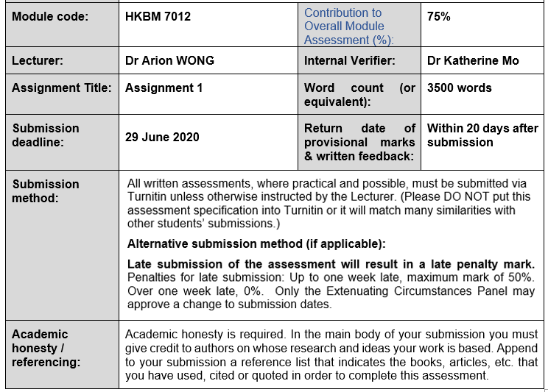
Student name: | Tsui Ao Cheung | Student ID number: | 1921900
Programme: | MBA
Module: | Marketing Management

Ed Tsui
Ed.tsui@hotmail.com
MVCI Asia Pacific (HK) Pte Ltd
Marketing Plan

Executive Summary

MVCI Asia Pacific (HK) Pte Ltd launched its new points-based timeshare product to the Hong Kong market in 2018. Currently, it has 3400+ members based in Hong Kong.

With the population rising, and the product is newly introduced to the company’s targeted segment, there are opportunities for the product to progress further in the market:

Digital capabilities – 5G technology brought up to Hong Kong, the company may tag along with more innovative ideas in the upcoming marketing campaigns.

Travel demands of travelers – More than 90 million people in Hong Kong traveled to other countries in 2018; there is a constant growing travel demand.

However, the company’s expansion is impacted by obstacles such as COVID-19 pandemic, and other threats that bring tensions to the business. Being a post-pandemic travel product in the market, the company shall enforce more innovation for a breakthrough.

This marketing plan will outline the company’s current positioning in the Hong Kong market and its distribution strategies. A comprehensive and feasible marketing strategy will be inducted with practical advice, helping the company to accomplish its objective in a 3-year period, to resume thriving in market share.

Table of Contents
Executive Summary i
Table of Contents ii

Chapter 1: Introduction
1.1 Timeshare Industry 1
1.2 Market Overview 1
1.3 Company Overview 1
1.4 Objective 2
Chapter 2: Situation Analysis
2.1 PEST analysis 3
2.1.1 Political Environment 3
2.1.2 Economic Environment 4
2.1.3 Social Environment 4
2.1.4 Technological Environment 5
2.2 SWOT Analysis
2.2.1 Strengths 5
2.2.2 Weaknesses 6
2.1.3 Opportunities 7
2.2.4 Threats 8
Chapter 3: Segmentation, Targeting and Positioning (STP) Model
3.1 Segmentation 9
3.2 Targeting 9
3.3 Positioning 9
Chapter 4: Marketing Mix Strategy - The 4P’s framework
4.1 Product 10
4.2 Promotion 10
4.3 Price 11
4.4 Place 11
Chapter 5: Recommendation
5.1 Recommended Product Strategy 12
5.2 Recommended Promotions Strategy 12
Chapter 6: Conclusion 14

Appendix A: Academic References 15
Appendix B: Bibliography 16

Chapter 1: Introduction

1.1 Timeshare Industry

Timeshare membership was first introduced in Europe in 1963, it is a fast-growing hotel leisure product since then. The concept was evolved in Asia as a non-deeded membership interest, members will be assigned a certain number of vacations points each year as currency for redemption at a hotel property, or other travel-related products (Asia Pacific Resort Development Organisation, 2020).

1.2 Market Overview

International hotel brands operate their own timeshare in Asia, including Hong Kong as one of their targeted markets, such as Marriott, Hilton, Wyndham, Anantara, and Disney.

1.3 Company Overview

Marriott Vacation Worldwide (MVW) was a subsidiary company of Marriott International (MI) between 1984 and 2011, it spun off in November 2011 and subsequently listed as a publicly traded company in New York Stock Exchange. MVW owns over 70+ resorts in the world, featuring bigger villas. It inherited the culture from MI, its members may use the membership for an accommodation at 7000+ Marriott’s properties all over the world, and more than 10,000 travel-related option. In 2019, MVW’s adjusted EBITA was USD758 million, increased USD339 million compared to 2018 (Marriott Vacation Worldwide, 2019).

MVCI Asia Pacific (HK) Pte. Ltd. (MVCI) is a diversified business unit under MVW, headquartered in Orlando; Asia’s regional office and business entity is registered in Singapore, as Marriott Vacation Club Asia-Pacific. MVCI has about 20,000 members in Asia, around 3,400 members resided in Hong Kong (Table 1-1).

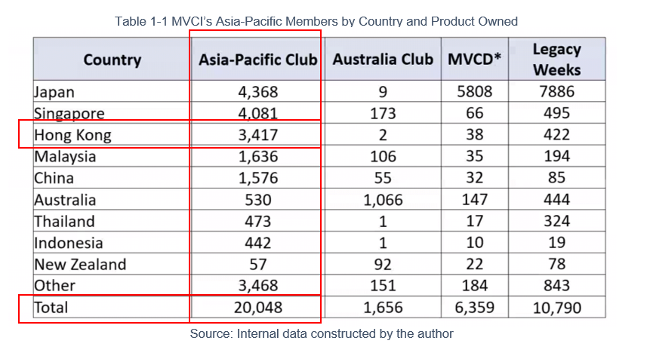

1.4 Objective

While Hong Kong has 7,500,000+ population (Census and Statistics Department, 2020), and 55,913,000 inbound travelers in 2019 (Census and Statistics Department, 2020b), the membership has the prospering potential to both local and inbound tourism market.

The objective of this marketing plan is to identify the motivation of buyers, to expand its membership base by 30% from 2 channels, inbound tourism and local, in a 3-year timeframe.

Chapter 2: Situation Analysis

This chapter examines MVCI’s strengths and weaknesses through two approaches: PEST and SWOT analysis. These analyses help the company to lean into what it does well, to refine what it does not, and to defend against its challenges in the next chapters.

2.1 PEST analysis

To identity what are the external factors that might be beneficial or detrimental, in view of politic, economic, social, and technology.
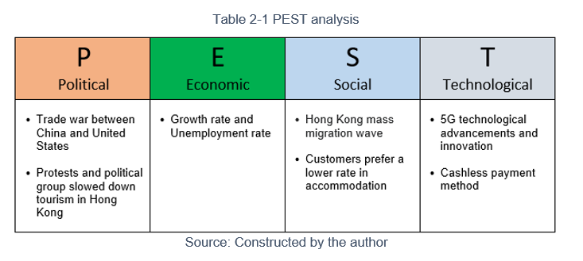

2.1.1 Political Environment

Trade war between China and the United States: It brings uncertainties and affected to currency exchange rate; the Chinese Yuan was weakening against Hong Kong dollars; it discourages the China tourists from crossing the border to Hong Kong. Since Chinese tourists might not wish to have any big spending in Hong Kong with the weaken currency, some preferred not to visit Hong Kong for now (Leung, 2018). 14.23% dropped of arrivals from China in 2019 compared with 2018 (Figure 2-2).

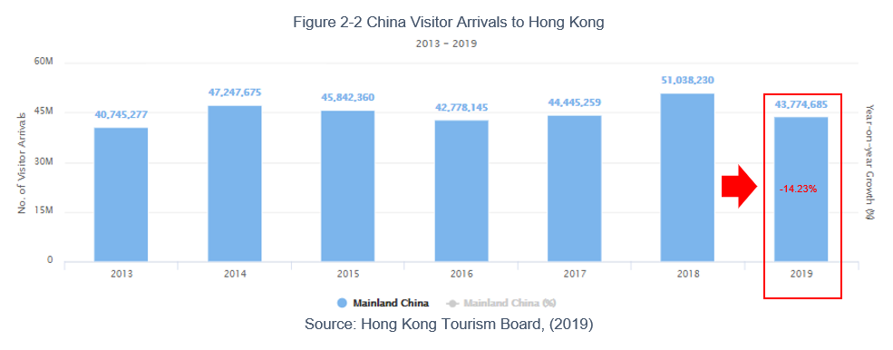

Protests and political group slowed down tourism in Hong Kong: On 26th July 2019, the Hong Kong Airport became one of the protest sites where protestors were trying to draw awareness from tourists regarding their political concern; over 200 flights were canceled due to a strike on 5 August 2019. Tourists found it is no longer safe to visit Hong Kong, a data from Google Trends indicated a raised number of searching keyword “Hong Kong safe” since end of July in 2019 (BBC News, 2019). The growth of inbound arrivals to Hong Kong in 2019 was -14.2% (Figure 2-3).

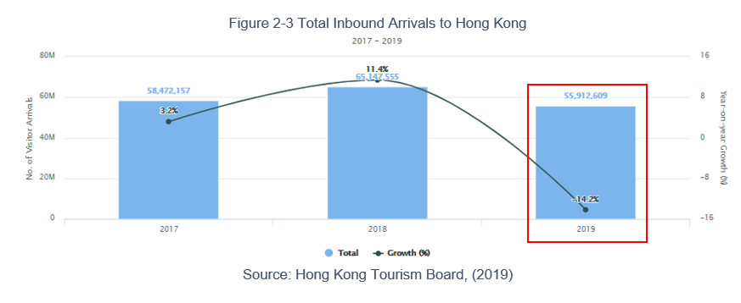

2.1.2 Economic Environment

Growth Rate and Unemployment rate: In 2020 first quarter, Hong Kong recorded -8.9% in growth rate and 5.9% in unemployment rate (Census and Statistics Department, 2020c). It reflects a weak economy status, with less labour production and inferior purchasing power, which restricted to the GDP growth.

2.1.3 Social Environment

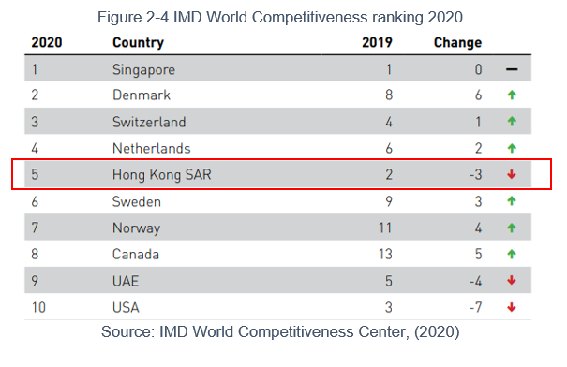
Mass emigration wave: Hong Kong rated the 5th place in the IMD World Competitiveness ranking in 2020, fell from 2nd place compared to 2019 (Figure 2-4). There were 7,600 Hongkongers emigrated to other countries in 2018; the number is rising year by year. With anti-government activities and dropping competitiveness, these are push factors for another emigration wave (Sun, 2019).

2.1.4 Technological Environment

5G technological advancements and innovation in marketing: 74% of the people plan for vacations via the Internet. With the 5G technological, there are many innovative ways to promote marketing and sales in the travel sector, such as using augmented reality (AR) or virtual reality (VR) to showcase the travel products (Vidal, 2019).

Cashless payment method: More cashless payment method has been inaugurated to Hong Kong. Carrying out cashless payment method will strengthen in sales volume (Greenacre and Akbar, 2019, pp. 87-93).

2.2 SWOT Analysis

A crucial tool to help a company to stay productive. A successful business knows where it stands in terms of strength, weakness, opportunities, and threats (Osita, Onyebuchi R. and Justina, 2014, pp. 23-32).

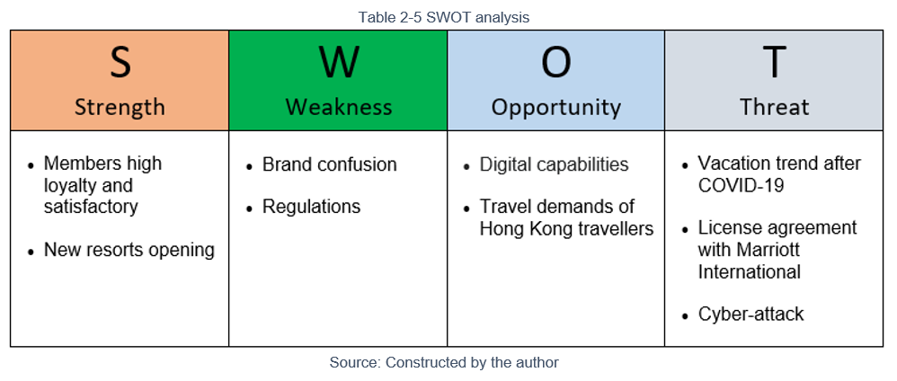

2.2.1 Strengths

Members loyalty and satisfactory: Members gave positive acknowledgment to MVW, and the company recorded about 88% of occupancy in 2019, above the average in the timeshare industry (Marriott Vacation Worldwide, 2019b).

New resorts opening: Two new resorts, in Bali and Hawaii, will be completed by the end of 2020. This brings more travel options to its members (Marriott Vacation Worldwide, 2019).

2.2.2 Weaknesses

Brand confusion: MI focuses on global expansion and has the most networks in the world across different brand names. Figure 2-7 illustrates the brands work under MI, and Figure 2-8 exhibits the brands from MVW. Customers might find it confusing when staying at different brand names, which may not be able to build up brand loyalty.

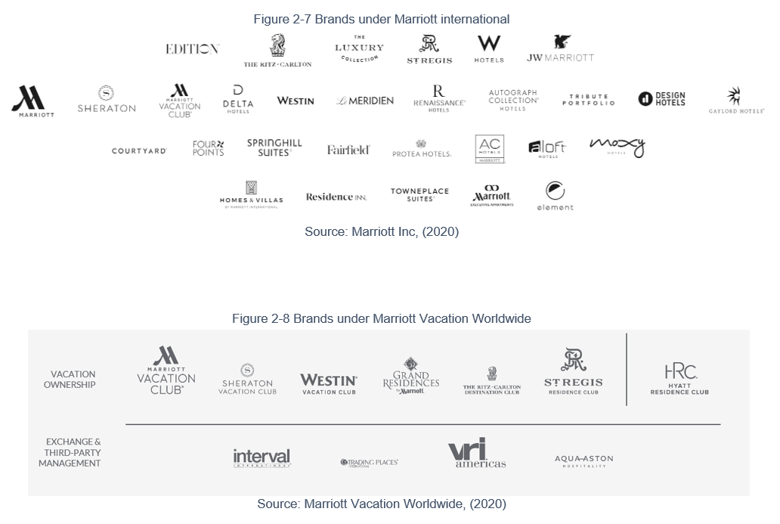

Regulations: Hong Kong received 82 complaints regarding to timeshare industry in 2017, which implicated an average of $49,000 per complaint case. It alarmed the consumer council where there are a set of stricter regulations that timeshare companies must attend to safeguard the consumers (Consumer Council, 2018).

2.1.3 Opportunities

Digital capabilities: With the 5G technology, MVW planned to expand its digital experience for the customers. These initiatives will increase marketing efficiency and lower marketing cost (Marriott Vacation Worldwide, 2019b)

Travel demands of Hong Kong travelers: Hong Kong had a total of 92.2 million people outbound travelers in 2018, was ranked the 4th highest region for outbound tourism departure (Figure 2-6).

While there is a massive travel demand, benefited to members of MVCI who can access to all hotels and resort properties from MI - the biggest hotel chain in the world. As of 31st March 2020, MI has a connection to 7,420 properties, which delivered 1,391,700 room inventories (Bethesda, 2020).

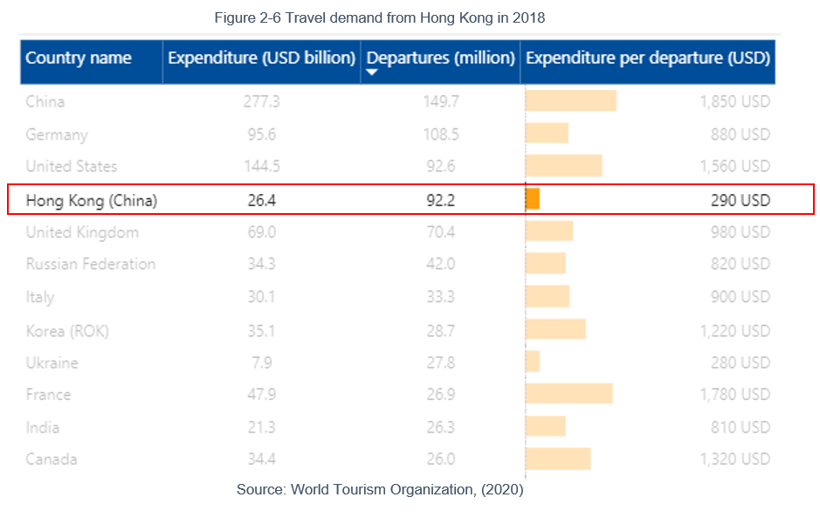

2.2.4 Threats

Vacation trend after COVID-19: Tourists may only travel again by thoughtfully choosing their accommodation; they concern about social distancing, so they may not consider staying in regular hotels with sharing facilities. The travel trend after COVID-19 will be more on private vacation unit such as Airbnb (Parker, 2020).

License agreement with Marriott International: MVW operates under the license with MI, if such agreement ends then the company is no longer able to use the Marriott’s brand for operation (Marriott Vacation Worldwide, 2019b).

Cyber-attack: MI suffered a cyber-attack in 2018; customers’ data were stolen. In the same year, MVW encountered another cyber-attack in the company’s email system. These attacks indeed will harm the brand’s reputation, and customers may lose trust with the brand (Marriott Vacation Worldwide, 2019b).

Chapter 3: Segmentation, Targeting and Positioning (STP) Model

We will review MVCI’s current marketing segmentation, its targeted customers, as well the company’s positioning among other competitors. From there, we may identify the niches, and to deliver the marketing mix in a practical approach.

3.1 Segmentation

MVCI groups the segment in terms of demographics by age and life cycle stage.

3.2 Targeting

According to a statistic constructed by American Resort Development Association, in 9.6 million of people who owned a timeshare membership, their average age is 44 (American Resort Development Association, 2020). Hence, in Hong Kong, the starting target of MVCI consists of those potential customers (inbound travelers and locals) who are between 30 to 60 years old.

The next targeted group is married couples with kids in the life cycle stage. The villas and apartments owned by MVW are more prominent compared to a regular hotel room, offering from a studio unit, 2-bedroom, to 5-bedroom apartment or above; moreover, kids club is in the resorts which implies that the program is better pleased for travelers with their family members and kids.

3.3 Positioning

MVCI offers a wide range of quality vacation options, and each creates a memorable experience for members, no matter it is to stay at one of the company’s resorts, or to enjoy a service from its travel partners. Unlike other competitors, MVCI focuses on the quality with the Marriott branding, as well as the number of lodgings and options providing to members as a market leader.

Quality – MVCI members have access to the top tier brands in the hotel industry, e.g., Ritz Carlton, St. Regis, and W Hotel.

Vacation Options Coverage – MVCI members have access to over 10,000 vacation options.

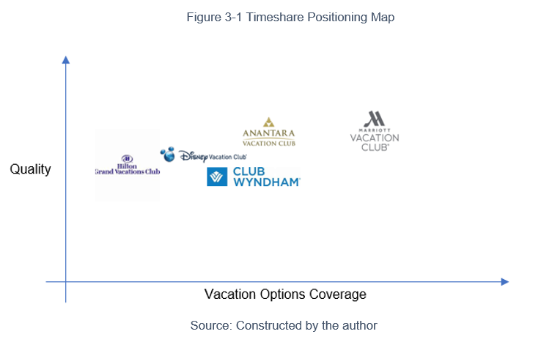

Chapter 4: Marketing Mix Strategy - The 4P’s framework

This chapter defines the current 4P’s framework of MVCI Hong Kong. The 4Ps are referring to Product, Promotion, Price, and Place.

4.1 Product

Company’s vision: Create unforgettable experiences that make vacation dreams come true (Marriott Vacation Worldwide, 2019).

The product from MVCI matches with the company’s vision. Through a points-based vacation ownership product, members of the club have access to its 70+ resorts. Moreover, members may utilize their points as a currency to exchange for other vacation options, e.g., A hotel stay at MI’s properties, a cruise trip, joining a guided tour at the holiday destination, enrolling to travel insurance, exchanging for air-tickets, etc. Members are required to pay for a membership fee up-front, and then to pay for annual maintenance fee in place of participating in the club. The points-based product offers usage in a term of specified years under a contractual condition, or perpetuity usage as a real estate deed (Marriott Vacation Worldwide, 2019).

The number of vacation choices, and the quality standard, as mentioned in the previous chapter, help MVCI differentiate from other competitors. In the US region, MVCI is currently at the maturity stage of the product life cycle; however, it is still at the introduction stage in the Hong Kong market. There are not many competitors in Hong Kong, and there are rooms for MVCI to strengthen its competitive position, and to increase the market growth rate.

4.2 Promotion

Currently, MVCI concentrates on the integrated marketing communication plan as below in the promotion mix:

Personal Selling: Timeshare membership classifies as unsought goods and services; it is not likely to have a customer waking up in the morning and thinking to buy a timeshare membership. Therefore, MVCI relies on personal selling, by tailor-made customers expectation and travel experience, to identify customers’ needs by one-to-one selling approach as a push factor, then to show each customer about the features, advantages, and benefits of the product.

Sales Promotion The product offers usage in a term of specified years under a contractual condition, in which some customers may not be able to make a purchase decision right away due to lacking commitment to a long-term membership. From there, MVCI introduced some sales promotion techniques that ease the concern:

Sampling – MVCI offers a trial package to customers, allowing them to go for one vacation by using the product at a promotional price. After customers completed the trip and if they found the club is suitable to their lifestyle, they may proceed to purchase the actual membership, the trial price that they paid for will then offset to the membership purchasing price.

Sweepstakes – Similar to sampling, customers always wish to experience and feel the benefits before they may commit to purchase the actual membership. From there, MVCI hosted sweepstakes, allowing the winners to first trying the service and accommodation, the guests were invited to a personal selling section thereafter.

Advertising: MVCI implemented a series of advertisements in different social media channels, such as YouTube videos, direct mails, and website, by broadcasting its services and travel options as a pull strategy, to drive the awareness from guests so MVCI may invite them to a personal selling section.

4.3 Price

Value-based pricing strategy: MVCI’s membership price follows a value-based pricing strategy; it varies according to the change in the global demands and the individual customer’s travel demands. A customer might own more points if the travel demand is high, vice versa. The membership price is determinate by the number of points a customer wishes to own per year. MVCI focuses on creating values for customers by expanding the vacation option network, personalized service, and quality hotels.

Customer-oriented method: MI has its loyal customers, and all customers have a perceived high value for the Marriott brand because of its quality and standard. MVCI applied the customer-oriented method by using the Marriott’s lodging price as a reference, the timeshare point-based membership then has its added value to the customers by providing extra features in terms of travel options, the club also illustrates a cost-saving structure, which MVCI may then set the final price according to customers’ perceived value.

MVCI is currently under an introductory stage of the product life cycle; the company’s objective is to maximize the sales growth and increase penetration rate. Therefore, the company concentrated on its promotion mix by aiming to win more new customers and to capture more market share.

4.4 Place

Presently, MVCI did not involve a multi marketing channel. MVCI representing as one of the brands of Marriott, the company focused on active personal selling support as a direct sales strategy.

Chapter 5: Recommendation

This chapter provides recommendations to MVCI, to enrich its product strategy, as well as promotions strategy.

5.1 Recommended Product Strategy

Offer user trainings when new features introduced or new resorts’ opening: According to the SWOT analysis in chapter 2, one of MVCI’s strengths is the new resorts’ opening. MVCI may make use of these new resorts to correspond to the needs of increasing travel demands in the market. Existing customers are the asset of a company, and the customers may refer more business to the company via referral. By increasing the customer lifetime value, it will expand the company’s profit in terms of customer referral value (Kumar, Petersen and Leone, 2010, pp. 1-17). To increase the customers’ lifetime value, MVCI is recommended to host user trainings or webinars by introducing its newest features and benefits, customers’ satisfaction will increase along with continued purchases, and referring friends after customer referral value is increased. Furthermore, the product is aiming at the customer’s family life cycle, on-going trainings may help to educate the next heir in using the product, which increases the referral value as well.

Branding strategies: A strong emotion bonding must be in place by engaging with the customers by its global branding, to maintain rapport with loyal customers for a financial gain (Hollis, 2008, pp. 67-69). MVCI representing as one of the global brands of Marriott, must be continuing with one of the company’s strengths in customer satisfaction, so to continue developing and enhancing the product for the market. The product is currently under an introductory stage of the product life cycle. As a US origin product being introduced to the Hong Kong market, the product may always have the flexibility to be fine-tuned to match the needs of potential customers. MVCI may study the customers’ comments after they have attended a personal selling section to implement any ideas for further product development that will meet customers’ needs.

5.2 Recommended Promotions Strategy

Start with why: According to Simon Sinek shared in a TED talk, customers’ buying decision is not referring to “what” is the product about, but they focus more on “why” and “how” the product is a benefit to them. Therefore, a successful business always starts the selling process by directing to the product’s why, why the customers should purchase the product and how it benefits the customers; the last part of the selling process may go back to actual product’s feature itself, the most crucial part is to have its potential customers to appreciate why the company do exist (McNeely, 2017, pp. 43-45). In the next 3-year, tourism may not resume the performance as before the COVID-19 pandemic; travelers may also have hesitations for planning a vacation. Therefore, the promotion strategy must move to its next level; MVCI has a clear vision “Create unforgettable experiences that make vacation dreams come true.” (Marriott Vacation Worldwide, 2020), which is precisely the company’s “why”, MVCI is recommended to focus on its company’s why to let potential customers know why the product will benefit them from fulfilling their travel dreams, especially for a travel product that to be used after COVID-19 pandemic.

Increase customers’ purchase intention through digital marketing: Purchasing intention from a potential customer depends on how a marketing campaign can successfully boost the purchasers’ motivators from location-based advertising (Wibisurya, 2018, pp. 153-161). MVCI may initiate more digital marketing campaigns to boost customers’ purchasing intentions. Due to the current promotion mix is relying on personal selling, under the company’s current price strategy, this is difficult to reaching out to its targeted customers massively for a higher penetration. By using digital marketing framework, the company may then reach out to the targeted segment through data processing in a cloud server, and to allow its promotion piece matching to the customers’ preference (Mogoș, 2015, pp. 240-248). MVCI may use a digital marketing platform to filter the advertisements to its targeted customers in a practical approach and to achieve the company’s objective by expanding the member base lin Hong Kong, as well as to have the advertisement reaching out to the inbound travelers effectively upon their arrival. Even with the mass emigration rate, digital marketing may reach to more potential customers through remarketing tools and search engine marketing.

Implement cashless payment and augmented reality (AR), visualizing the resorts digitally to offer memorable experiences: According to a research in 2019, AR technology benefits to tourism in terms of improving the experience, reaching out to more potential buyers, and increasing referral through the word-of-mouth; because potential customers increased their confidence in the travel-related product by visualizing it (Maaiah et al. 2019, pp. 43-54). 5G technology is introduced, this is recommended that MVCI may make use of 5G for AR application, which it also comes to a best match to the company’s vision “Create unforgettable experiences that make vacation dreams come true.” Under the current promotion mix, MVCI promoted the sampling methodology where it allows the potential customers to feel and test the product; however, customers’ purchase intention will be gradually reduced along the way after sampling. If MVCI implements the AR application, then customers may feel and visualize its resorts instantly, to increase customers’ impulsive purchase desire. Furthermore, MVCI is targeting the product to families with kids, enforcing new technology will also create excitement for kids, leading to an increase in customers’ engagement and the purchase intention when kids are appreciating.

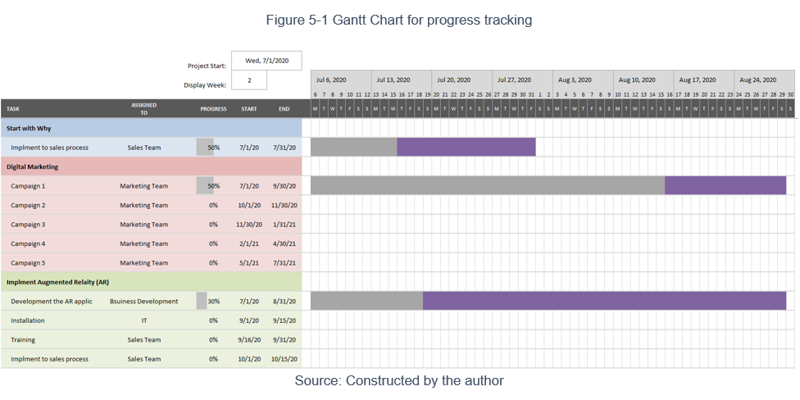

Chapter 6: Conclusion

In conclusion, it is analyzed that MVCI is required for implementing effective strategies for further growth and development.

The situational analysis is analyzed, which includes the study of strengths and weaknesses for the internal environment, and opportunities and threats related to the external environment, and forecasting in the next 3-year period. Marketing mix strategy is included in the report as well to illustrates the company’s segmentation, targeting, and positioning strategies, which are currently being adopted by MVCI. The marketing plan ends with a wide range of possible suggestions about how companies can take advantage of new opportunities and improve in challenging areas.

Firstly, it is recommended that MVCI to focus on its product and promotion strategy. In terms of product strategy, the product is under the introductory stage of the product life cycle, but unfortunately, the external threats are impacting tourism. Thus, MVCI may first enhance its selling methodology by starting with why, increasing purchase intention for the potential customers, and to implement cashless payment and augmented reality for an overall enhanced experience.

Lastly, MVCI may also be implementing a new product strategy by reviewing customers’ comments for further development.

With this marketing plan, MVCI may identify the purchase intention and motivations from buyers, to boost its membership base by 30% align with inbound tourism and local market, in a 3-year timeframe.

Appendix A: Academic References

Greenacre, L. and Akbar, S. (2019) 'The impact of payment method on shopping behaviour among low income consumers', Journal of Retailing and Consumer Services, 47(1), pp. 87-93. DOI: 10.1016/j.jretconser.2018.11.004.

Kumar, V., Petersen, J. A. and Leone, R. P. (2010) 'Driving Profitability by Encouraging Customer Referrals: Who, When, and How', Journal of Marketing, 74(5), pp. 1-17. DOI: 10.1509/jmkg.74.5.1.

Maaiah, B. et al. (2019) 'The Dynamic Role of Augmented Reality in Tourism', Tourism Culture & Communication, 19(1), pp.43-54. DOI: 10.3727/109830419X15489421397255.

McNeely, J. (2017) 'Know Your Why' Advisor Today, 112(1), pp. 43-45. Available at: https://search.proquest.com/docview/1879953291 (Accessed: 27 June 2020).

Mogoș, R. I. (2015) 'Digital Marketing for Identifying Customers' Preferences -- A Solution for SMEs in Obtaining Competitive Advantages', International Journal of Economic Practices and Theories, 5(3), pp. 240-248. Available at: https://search.ebscohost.com/login.aspx?direct=true&db=bth&AN=113828794&site=ehost-live (Accessed: 27 June 2020).

Osita, C., Onyebuchi R., I. and Justina, N. (2014) 'Organization's stability and productivity: the role of SWOT analysis an acronym for strength, weakness, opportunities and threat', International Journal of Innovative and Applied Research, 2(9), pp. 23–32. Available at: http://journalijiar.com/uploads/2014-10-02_231409_710.pdf (Accessed: 31 May 2020).

Wibisurya, I. (2018) 'The Effect of Digital Marketing Implementation through Location Based Advertising on Customer’s Purchase Intention'. Binus Business Review, 9(2), pp. 153-161. Available at: https://doaj.org/article/1a16943395c247b48a3afc02cf61df8d (Accessed: 27 June 2020).

Appendix B: Bibliography

American Resort Development Association (2020) U.S. Timeshare Industry: By the Numbers. Available at: https://www.arda.org/news-communications/timeshare-industry-basics/us-timeshare-industry-numbers (Accessed: 19 June 2020).

Asia Pacific Resort Development Organisation (2020) Product Definitions. Available at: https://31782831-6517-4546-8aa0-e7ef458bd409.filesusr.com/ugd/d81d90_30c708e74059445fa31d6f94abfb018f.pdf (Accessed: 19 June 2020).

BBC News (2019) 'Hong Kong protests: How badly has tourism been affected?' BBC NEWS, 12th August. Available at: https://www.bbc.com/news/world-asia-china-49276259 (Accessed: 19 June 2020).

Census and Statistics Department (2020) Population. Available at: https://www.censtatd.gov.hk/hkstat/sub/so20.jsp (Accessed: 19 June 2020).

Census and Statistics Department (2020b) Transport, Communications and Tourism. Available at https://www.censtatd.gov.hk/hkstat/sub/so130.jsp (Accessed: 19 June 2020).

Census and Statistics Department (2020c) National Income. Available at https://www.censtatd.gov.hk/hkstat/sub/so250.jsp (Accessed: 19 June 2020).

Consumer Council (2018) A Report to Advocate Mandatory Cooling-Off Period in Hong Kong. Available at: https://www.consumer.org.hk/sites/consumer/files/Legal/Cooling-off%20Report%20_%20ALL.pdf (Accessed: 19 June 2020).

Hollis, N. (2008) The Global Brand: How to create and develop lasting brand value in the world market. 1st edn. New York: Palgrave Macmillan.

Hong Kong Tourism Board (2019) Total Visitor Arrivals. Available at: https://securepartnernet.hktb.com/en/research_statistics/tourism_statistics_database/index.html (Accessed: 19 June 2020).

IMD World Competitiveness Center (2020) IMD World Competitiveness Ranking 2020. Available at: https://www.imd.org/globalassets/wcc/docs/2020/wcc-site/one-year-change-vertical.pdf (Accessed: 19 June 2020).

Leung, K. (2018) 'US-China trade war hits Hong Kong tourism as weaker yuan slows number of visitors from across the border', South China Morning Post. 31st August. Available at: https://www.scmp.com/news/hong-kong/hong-kong-economy/article/2162293/us-china-trade-war-hits-hong-kong-tourism-weaker (Accessed: 19 June 2020).

Marriott Inc. (2020) Marriott. Available at: htttp://www.marriott.com (Accessed: 19 June 2020).

Marriott Vacation Worldwide (2019) 2019 Annual Report. Available at: https://ir.marriottvacationsworldwide.com/static-files/e4a1c5da-295d-4951-8b6c-aecf598052d6 (Accessed: 30 May 2020).

Marriott Vacation Worldwide (2019b) Annual Report Pursuat to Section 13 or 15(d) of the Securities Exchange Act of 1934. Available at: https://ir.marriottvacationsworldwide.com/node/14171/html (Accessed: 19 June 2020).

Marriott Vacation Worldwide (2020) Marriott Vacation Worldwide. Available at: https://www.marriottvacationsworldwide.com/ (Accessed: 19 June 2020).

Bethesda, Md. (2020) Marriott International Reports First Quarter 2020 Results. Available at: https://marriott.gcs-web.com/news-releases/news-release-details/marriott-international-reports-first-quarter-2020-results (Accessed: 2 June 2020).

Parker, J. L. (2020) 'Travel Biz Predictions For A Post COVID-19 World', Forbes, 31st March. Available at: https://www.forbes.com/sites/jenniferleighparker/2020/03/31/travel-tech-predictions-for-a-post-covid-19-world/#5ff1a4e015fa (Accessed: 19 June 2020).

Sun, F. (2019) 'Emigrating Hongkongers seek stability elsewhere, heading to Australia, Canada, Singapore', South China Morning Post, 17th August. Available at: https://www.scmp.com/news/hong-kong/politics/article/3023166/port-storm-emigrating-hongkongers-seek-stability-elsewhere (Accessed: 19 June 2020).

Vidal, B. (2019) 'The New Technology and Travel Revolution', Business Intelligence & Analytics [blog]. 5 Dec. Available at: https://www.wearemarketing.com/blog/tourism-and-technology-how-tech-is-revolutionizing-travel.html (Accessed: 19 June 2020).
World Tourism Organization (2020) Country Profile - Outbound Tourism [Microsoft Power BI], p7. Available at: https://www.unwto.org/country-profile-outbound-tourism (Accessed: 2 June 2020).

