Contextual Practices
Research in Context
(ADAD5003)
Chloe Lloyd
(1906286)

“In societies where modern conditions of production prevail, life is presented as an immense accumulation of spectacles. Everything that was directly lived has receded into a representation”

Guy Debord, The Society of The Spectacle

In this assignment I was assigned to choose one question out of five, as shown above I decided to chose Guy Debord’s The society of the Spectacle. I researched Debord, his books, his quotations and primarily his book “The society of the spectacle”. I explored Debord’s work within the Situationist International, the organisation of political theorists, Avant-garde artists and intellectuals.
Guy Ernest Debord was born December 1931 in Paris. Debord’s father died when Debord was young. Debord’s mother Paulette Rossi, sent Guy to live with his grandmother in Italy. During World War two the Rossi’s left the villa and travelled from town to town. Debord attended a school in Cannes, where he began his interest in film. The family moved again to another region of France, Pau, Pyrenees- Atlantiques and he attended Lycée Louis Barthou. Debord actively opposed the French war in Algeria and joined demonstrations in Paris. Debord studied Law at the University of Paris, but did not complete his course, instead he began a career as a writer. Guy Debord was one of the founding members of Situationist International (SI). SI was an in international organisation which was made up of Avant-grade artists, political theorists and intellectuals. (Situationist International) SI was well known in Europe from its formation in 1957 to its dissolution in 1972. The foundations of SI were based on Marxism and Avant-grade art movements of the early 20th century, The situationists maintained, Karl Marx’s analysis of the capitalist mode of production, even though they expanded upon concepts and interpretations as they believed them to be fundamentally correct. The SI expanded on Marx’s concepts, including “theory of alienation” the SI believed social alienation was no longer limited to capitalist society, instead believing it had spread to all aspects of life and culture. During May 1968 in France, there was a period of civil unrest, demonstrations, general strikes and even occupation of factories and universities. Political leaders feared the unrest could lead to civil war the French president Charles de Gaulle fled to Germany, the French Government briefly stopped, and the economy came to a halt. The protests included songs, posters, graffiti and slogans. Many of protesters had penned slogans and quotes influenced by Debord.
Guy Debord’s ‘La Société du Spectacle (The Society of the spectacle) is a critical attack of our image saturated consumer culture. The book examines the “spectacle” which is Debord’s term for everyday characteristics of capitalist driven television, film, advertising and celebrity. Debord adapted society of the spectacle into his first feature length film, Debord used footage from movies, news and adverts in his film. Debord believed Europeans had become consumer obsessed after the war he suggested we do not “want” we “need”. We have been encouraged to become obsessed with needing better, needing more, needing newer. (Purje, 2022) At the time after world war two with peace seemingly here to stay and worldwide markets opening up, most people of all social classes had access to an array of goods , including home appliances, cars and electronics which they began filling their homes with, Debord did not believe this to be a good thing, Debord “believed that a society organised around such consumption induced boredom while shaping peoples desires in ways that could be fulfilled only through the purchase of consumer goods” We may have a car but need a newer one, a better one, society have become preoccupied by image and appearance, above anything else. Debord wrote society of the spectacle more than 50 years ago, but it represents how society and culture are nowadays, it has become even more apparent, the society of the spectacle was not written as a twitter thread or an Instagram story, it was against the backdrop of revolutionary anti-established emotion of 1960’s Paris, following the end of the second world war. In today’s society we are obsessed with social media, we portray our lives as happy and fulfilled. We advertise ourselves as successful, in some cases it couldn’t be further from the truth. Each day we are bombarded with advertising, we cannot get away from, television, radio, billboards and even buses, when people don’t even know why they are purchasing a particular product, it acts as proof people have difficulty distinguishing goods from commodities, therefore acting as though programmed by consumerism. (2019) A critique of Guy Debord’s society of the spectacle is Jean-Pierre Voyer. Voyer is a post situationist French philosopher. (Jean-Pierre Voyer (author of an inquiry into the causes and nature of the misery of people)) Voyer claims to be inspired by Hegel and Marx, although hi is critical of Marx. Voyer’s main thesis is the nonexistence of economy. Voyer is an original thinker, who developed a profound critique to the failures and inadequacies of Marx and the situationist, this led to his estrangement from Debord. Voyer’s provocative assertions have made him a lot of enemies. Voyer believes he makes enemies because they would rather maintain the status quo when asked important questions, preferring not to enter a critical debate. Jean-Pierre Voyer is a self-taught author, philosopher, critical thinker, he never attended a university. Voyers writings are filled with provocative wicked sense of humour and critical analysis. Voyer is an author of six books and numerous articles. Voyer’s site contains all his writings, including thousands of pages of research, correspondence, theoretical and polemical work. Voyer writes about commodity, movement and communication within society. Voyer stated that he had become fully aware his only goal in life, after reading Capitol in 1962, was to disqualify the reduction of Marx. One of Voyer’s books “An Inquiry into the nature and misery of people” takes on economists and attacks Marxist ideas. Within the book Voyer systematically shows the economy does not exist, except as a false idea and practice on the part of our enemies. In our world of communication, the most human of human acts is what commodities do, not what people do. There is no such thing as value vs value, there is only value which is the language of abstraction that commodities speak to each other without the slaves who transport the commodities. Voyer believes there is no Society of the Spectacle, instead Voyer believes there to be a Spectacle of society. Voyer believes our society is unified by commerce, not by any so-called spectacle.
Voyer states,
“Our society is a spectacle for each and every slave that inhabits it, because he or she is a slave, because he or she is isolated and separated from the other slaves and from society as a whole, slaves do not govern, slaves do not communicate, therefore slaves do not act. Their miserable lives are summed up in their miserable jobs, miserable homes, miserable nuclear families, miserable vacations and miserable purchases. In such conditions how could society be anything but a spectacle for them?” (Voyer, 2015)

Voyer further adds,
“A football game is not a spectacle for those who are acting, the ones participating in the game, the players, but only for those who are not, the same goes for society as a whole, it’s slaves are not players and so society is a spectacle for them”. The society of the spectacle is a side effect of the condition of being a slave, the spectacle of society is a consequence of the slave’s isolation, not the cause.
Voyer then goes on and states,
“Debord didn’t like talking about these things, we met frequently over several years. The one and only time I tried discussing these issues with him, after ten minutes he interrupted me brusquely saying”. “Do you think I’m an imbecile” Voyer then carried on to state “I should have thought so. despite all of his pretensions, because of them in fact, he was incapable of a meaning of the term spectacle that was not trivial”. (Voyer, 2015)

Jim Avignon is a German Post-war and contemporary painter. Avignon’s themes are failure of the individual in the digital age of mass media. One of Avignon’s solo exhibitions quotes Guy Debord in the title “the society of the spectacle”. Debord described a society that wants to find fulfilment in consumption, celebrities the superficial, considers everything measurable and buyable, admirers and looks at itself in the media, even though Debord knew nothing of social networks and the internet. Avignon has now, updated “society of the Spectacle” and illustrates how reality in the digital age is increasingly disappearing behind a world of propaganda, advertising, self-representation on society. Avignon uses bright colours interactive installations, painted windowpanes and images ranging in size, some as small as a laptop, some as big as garage doors. Avignon has provoked the art world with his street art and live paintings, humour and biting wit. (Jim avignon)

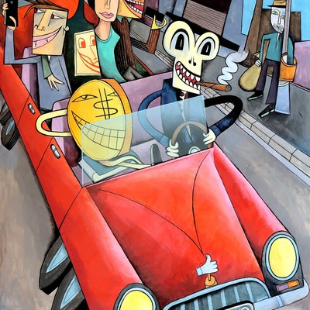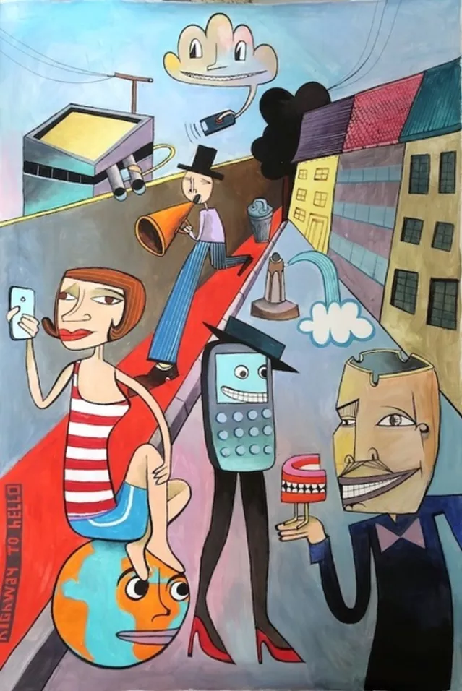

Sophia Papadopoulou is a Greek artist. Papadopoulou uses different techniques to make her images but prefers collage. Papadopoulou cuts up photographs that touch her emotionally, she uses magazines, newspapers and photo images and rearranges them to create her own artwork. Papadopoulou created a digital collage “the society of the spectacle” under the influence of Guy Debord’s book with the same title. In her series “fairytale” and “without” Papadopoulou touches on human feelings, emotions and actions using psychological aspect. Her works are personal but mythological, allowing her visions to erupt from her abstract notions. Papadopoulou has stated,
“Dadaism, its ideas, methods of expression that had a great influence on my art. Dada was very interesting art movement, it was international, anarchistic, provocative, politically active and at the same time apolitical. It rooted in Avant-garde. I like dadaism concepts of the grotesque, the absurd, and the macabre. Dada and its influence on contemporary art is, without doubt very significant, it manifests itself in all too apparent in today’s collages, performances, installations and ready-mades. Dadaists found their ideal means of expression in the collage and explored all possibilities”. (Sophia Papadopoulou Archives)

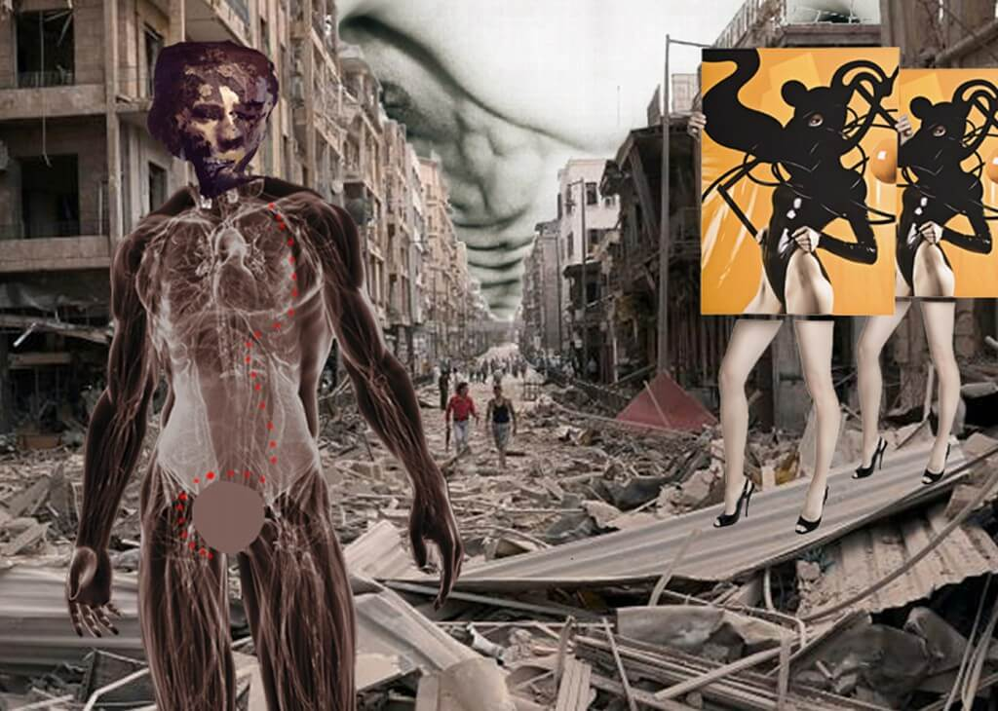

The first English translation of Debord’s text was published by black and red books in 1970. (Purje, An illustrated guide to guy debord's 'the society of the spectacle' 2022) The book cover features JR Eyermans iconic photograph of the premiere Bwana devil (1952) The first 3D colour film. It was originally reproduced in life magazine, the image captures the films audience gazing passively at the screen with their 3D glasses. Eyerman’s image reduces the audience members to uniformed rows of spectacled spectators. The image sums up Debord’s contempt of consumer culture but also implies his work to be media phobic.
Although it is tempting to believe the concept of “The spectacle” is a description of how the media works, Debord was determined it was not the case, Debord stated,
“The spectacle cannot be understood as a mere visual deception produced by mass media technologies. It is a world view that has actually been materialised”. (Debord, 1977)

Debord believed rather than the spectacle being imposed upon us, spectacle is throughout our society and we are all guilty of upholding it. Debord argued,

“Real life is materially invaded by the contemplation of the spectacle and ends up absorbing it and aligning itself with it” (Debord, 1977)

“Rather than talk about the spectacle people often prefer to use the word media” he writes “and by this they mean to describe a mere instrument, a kind of public service” (Purje, 2022) Debord describes the spectacle as capitalism’s instrument for distracting and pacifying the masses.

I agree with Debord’s concepts and theories, especially where it comes to image, consumerism, advertising, and the way in which we like to portray ourselves. People have said it’s as if Debord predicted how culture and society are nowadays. I do believe our society is more image obsessed nowadays, people use their social media accounts to portray themselves as beautiful, I always see photos of people looking their best on their Facebook profile pictures sometimes I do not recognize them in the street. We have filters on Snapchat, Instagram, our phone cameras to make our appearance flawless. Debord believed we as a society were being encouraged within needing more, needing better and needing newer, I also agree with Debord. I think of a well-known saying “keeping up with the Jones”, where someone you know will purchase an item and you feel the need to keep up appearances and purchase the same, even when it is not needed, Debord says people’s desires were being fulfilled only through the purchase of consumer goods, trying to prove that we are just as successful as them, as happy as them, as fulfilled as them, as well as financially abundant as them. I believe the media does affect the way we think, and how we see and feel about ourselves, our lives, homes and others around us. We are bombarded every day in the media by image, celebrities who have probably been airbrushed to look perfect and flawless, we aspire to look like them, be as beautiful, as rich, even as popular as them. I think the way in which we strive to look, act and be as popular as celebrities, is unhealthy. The way women are portrayed, always wrinkle free, no cellulite, no fat, is damaging to the younger generation. Young girl’s teenagers aspiring to be something they aren’t, and something they cannot become, s we cannot. airbrush away our imperfections in real life. I think the only way to not be affected, is to sometimes have a break, move away from our televisions put our phones down and enjoy our lives away from other people’s observations and opinions.

Bibliography
Books,
Debord, G., Perlman, F. and Knabb, K. (2021) The Society of the Spectacle. United States: Critical Editions.
Debord, G. (1977) Society of the spectacle. Detroit: Black and Red.
Voyer, J.-P. (2015) There is no society of the spectacle. United States.
(Voyer, 2015)
Voyer, J.-P. (2015) It's crazy how many things don't exist. Berkeley, CA: Cruel Hospice.
(Voyer, It's crazy how many things don't exist 2015)

Websites,
Jim avignon (no date) Society of the Spectacle / Exhibitions / Program. Available at: https://www.urbanspree.com/program/exhibitions/jim-avignon-society-of-the-spectacle.html (Accessed: December 21, 2022).
Jean-Pierre Voyer (author of an inquiry into the causes and nature of the misery of people) (no date) Goodreads. Goodreads. Available at: https://www.goodreads.com/author/show/1011160.Jean_Pierre_Voyer (Accessed: December 21, 2022).
Purje, T.M.& L. (2022) An illustrated guide to guy debord's 'the society of the spectacle', Hyperallergic. Available at: https://hyperallergic.com/313435/an-illustrated-guide-to-guy-debords-the-society-of-the-spectacle/ (Accessed: December 21, 2022).

Situationist International (no date) Encyclopædia Britannica. Encyclopædia Britannica, inc. Available at: https://www.britannica.com/topic/Situationist-International (Accessed: December 21, 2022).
Sophia Papadopoulou Archives (no date) Malou Art Consulting and Art Gallery. Available at: https://malouartconsulting.com/product-category/artists/sophia-papadopoulou/ (Accessed: December 21, 2022).
(2019) YouTube. YouTube. Available at: https://www.youtube.com/watch?v=RGJr08N-auM&t=781s (Accessed: December 21, 2022).

