
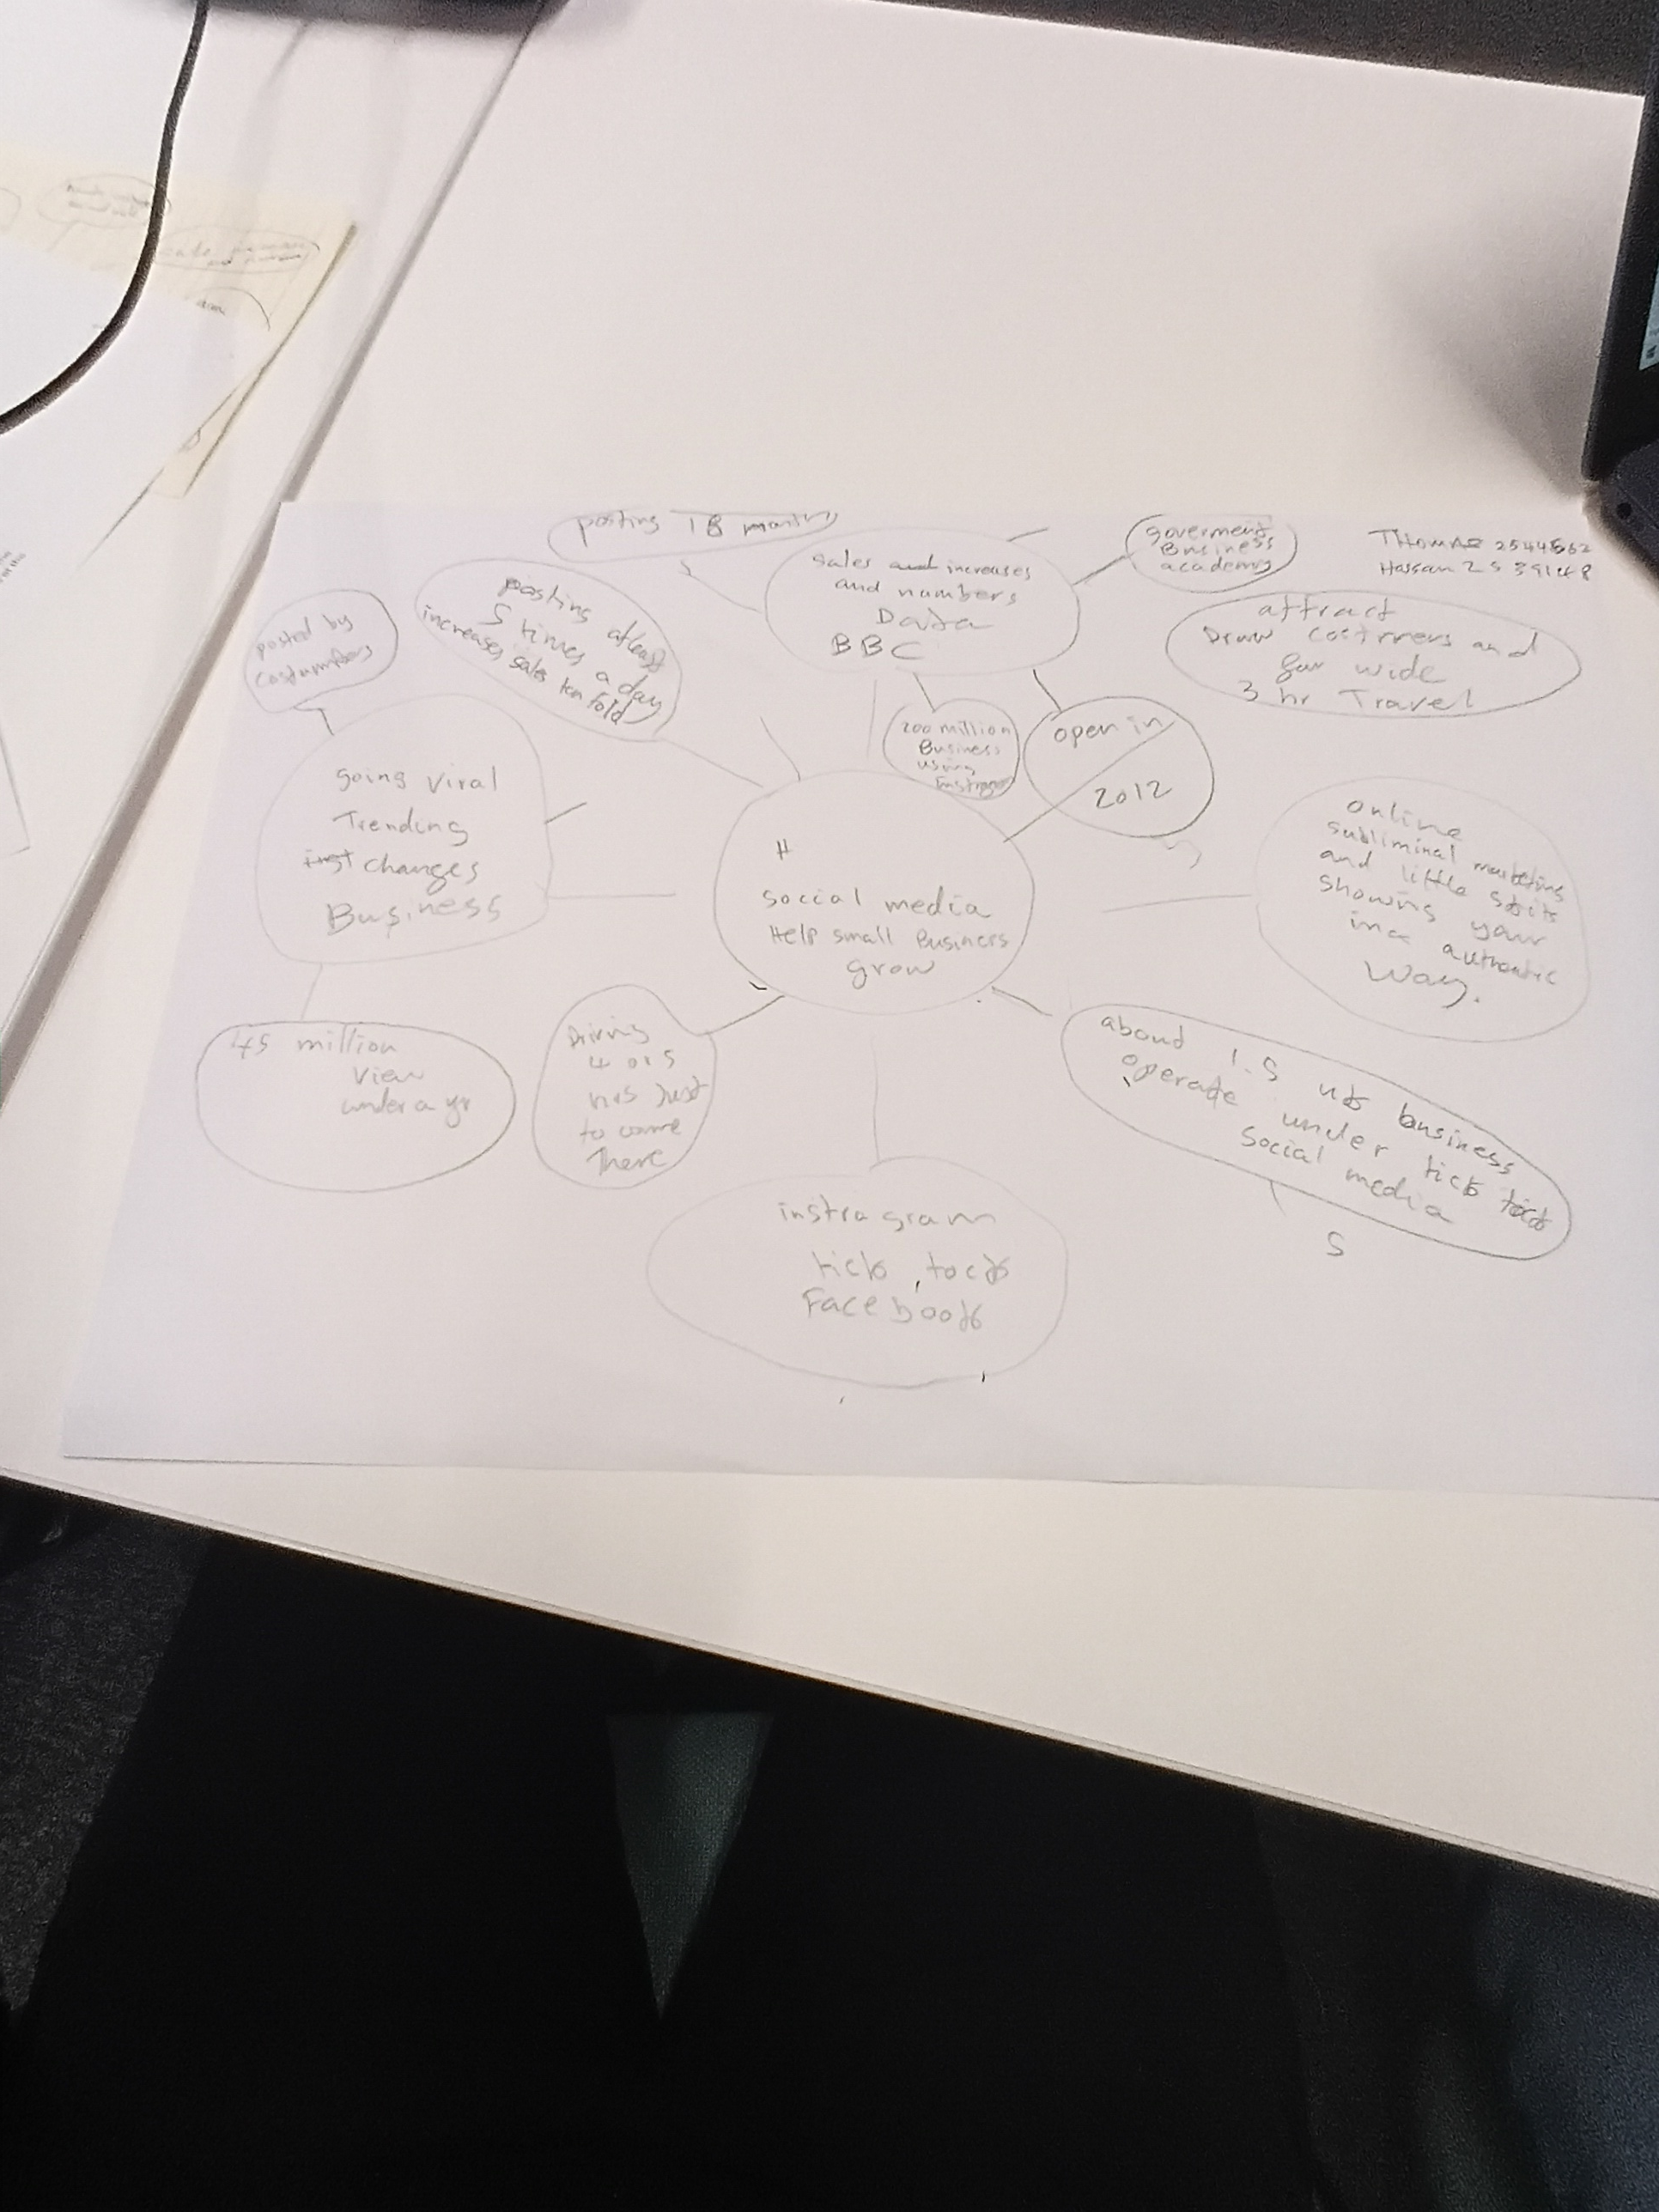
Task 1 – Reading Task Template
Upload your photo of your A3 in-class notes here:


1. Answer these questions using the sentence starters below
a. What is the main idea of the text?
The main idea is that To show how small business grow threw internet and social media.
b. What are two key points?
One key point is it helps attract costumers far and wide
Another key point is helps you get more sales .
c. What part of the text did you find most important? Why?
The most important part is that social media a lot people use social media in the uk about 1.5 million people so very ideal to use it .
d. Was anything unclear or difficult to understand?
I was not sure about how on to edit Templates before using my phone.
e. How did your group help you understand the text better?
My group helped me by sharing there ideas and explaining things to each other slowly that was good .
3. One sentence reflection
Question: What did you find challenging about this task?
The hardest part was the templates and editing the templates to finish my work.

