Emily Lewis – P150612
How Can Health Care Professionals Help to Improve Child Protection in A Hospital Setting Within The UK?
BSc (Hons) Health and Social Care
UWTSD Swansea
2018

Research Project submitted as part of the requirements for the award BSc (Hons) Health and Social Care.

Acknowledgments
I would like to express my sincere gratitude towards my partner, your constant support, encouragement and reassurance has allowed me to complete this project and has allowed me to develop better as an individual and for that I am very grateful.
I would like to give thanks to Jessica Hain-Griffiths and Jessica Lewis for the ongoing revalidation and encouragement.
I would also like to thank my supervisor for your words of encouragement.

Abstract
This paper provides a detailed insight into how health care professionals such as paediatrics can help to improve child protection in a hospital setting within the UK. The main methodology used throughout this paper is a literature review which has been carried out systematically. The main method being used throughout this paper is the critical appraisal skills programme which is particularly useful for determining whether the literature used was of a valid source or not.
There is no general consensus as to what child protection means however it is suggested that child protection is a way of preserving children from any type of harm and is not to be confused with safeguarding.
Many healthcare professionals such as paediatrics and doctors appear to lack the general knowledge and sufficient training when it comes to child protection in a hospital. Furthermore, there is an inadequacy of training between services with higher tier occupations appearing to have more training than lower tier occupations.
Children who have are suspected to be abused are more likely to develop injuries such as bruising and there is demographic bruising pattern between children who have been abused and those who have not been abused. However, it is not to say that every injury is as a result of child abuse and it is consequently up to healthcare professionals to distinguish between accidental and non-accidental injury.
Lack of knowledge, lack of training and suspected child abuse patterns are all leading reasons as to why child protection within a hospital in the UK is not adequate. If these three concepts were to be ameliorated, then it would help to improve child protection in the UK.

Table of contents Page
Title page 1
Acknowledgements 2
Abstract 3
Table of contents 4
1 Chapter 1 6
1.2 Background information 6
1.3 Justification of study 7
1.4 Aims and objectives 7
2.Chapter 2 8
2.1 Methodology and justification 8
2.2 Methods and justification 9
2.3 Search strategy sheet 10
2.4 Ethical considerations 10
2.5 Creation of themes 11
3 Chapter 3 12
3.1 Findings and gaps in literature 12
3.2. Methodological weaknesses identified 12
3.3 Knowledge 13
3.4 Training 14
3.5 Suspected child abuse patterns 15
4. Chapter 4 17
4.1 Overall conclusions 17
4.2 Recommendations 18
GANNT chart 19
Reference list 20
Bibliography 25
Appendix 26
Appendix 1: Evidence of themes 26
Appendix 2: CASP checklist 30
Appendix 3: Search strategy sheet 41

Chapter 1
Background Information
Although there is not a direct definition of what child protection is, Beckett (2007) implies that child protection is a way of making sure that children in any situation are to be preserved from any form of physical and emotional harm. He also suggests that children need this sort of protection because they are considered a vulnerable group. Children may be considered ‘vulnerable’ because of certain circumstances which can make them more susceptible to harm. For example, children with disabilities may be vulnerable.
AWCPP (2008) suggests that most policies surrounding child protection and safeguarding have been developed from cases such as the baby P case where both health and social care professionals have failed to protect children from harm and has resulted in serious consequences.
The term safeguarding is like child protection; however, it covers more areas. Safeguarding is based on shielding children and adults from harm or abuse and teaching those to recognise the symptoms of abuse. Additionally, safeguarding is a requirement for every organisation; ensuring that what they do is to protect children from harm. (Home Office, 2017).
Bishop (2009) suggests that a health care professional is an individual who delivers effective health to people using a service. Health care professionals include people such as doctors and nurses.
When it comes to child protection, there are two main pieces of legislation which stand out. The first piece of legislation is the Children Act 1989. Allen (2005) suggests that ever since the Children Act first came into force, the main priority of the act was to ensure that a child’s health and safety is of supreme importance in any given circumstance.
The second piece of legislation which is also of importance is the Social Services and Wellbeing Act 2014. Established under this act is the regulation of the National Independent Safeguarding Board, which has the responsibility to safeguard children who are either experiencing or are at risk of abuse, neglect or any other type of harm and to prevent this type of abuse and harm from happening. (Home Office, 2014).
Similarly, there are many policies which are set up to improve child protection in hospitals. Kemp et al (2008) suggest that healthcare professionals should always suspect a child may be abused if they have come to hospital with a bone fracture and without a confirmed cause. Furthermore, Macleod (2003) found that junior doctors tended to fail to remember indicators of abuse because they had no training in recognising child abuse and neglect.
A policy relating to the safeguarding of children within hospital is the Welsh Government’s action plan to protect children and adolescents from child exploitation and to prevent it from happening in future. Drakeford (2016) implies that the Welsh Government published a paper based on the prevention and identification of children and adolescents who are suspected to be sexually exploited; the government has made sure that health care professionals can successfully apply this framework through educating them to help identify children at risks and what needs to be done to safeguard them. Despite this framework being in place, McCartney (2014) found that 1400 cases of child sexual abuse went unnoticed from 1997-2014.
Justification of study
Fry & Lannen (2017) suggest that the research on child protection is a sensitive topic and can therefore be controversial. From research there appears to be much literature based on the different types of safeguarding procedures that are required for practitioners to engage in however, there appears to be a gap in research on the different ways on how health care professionals can help to improve child protection within a hospital. It is therefore vital to explore the reasons why there is such a gap in research. The main organisation being investigated here is the NHS which is the national institution providing free health services for individuals in the UK. (Taylor, 2013).
Aims and objectives
The main aim of this research proposal is to gain an understanding of how healthcare professionals such as doctors and nurses within a hospital setting can help to improve how children are protected within the UK. To complete this research project, there are four main outcomes which need to be achieved. These are…
- To provide a detailed description on how healthcare professionals such as doctors and nurses help to safeguard children from harm within a hospital setting
- To examine the current policies and legislation put in place which are set up to safeguard children by examining scientific research
- To evaluate how effective current policies and legislation are in terms of improving child protection within hospitals
- To give future recommendations for improvement which have arisen from the research used throughout the assignment.
Chapter one has provided a clear insight into the background information of child protection and also why there is a need to explore this topic in more detail. It also set clear aims and objectives. The following chapter describes the main methodology and methods used.
Chapter 2
Chapter two will describe in detail the correct methodology used throughout this research, the main methods used and will provide a comprehensive reason as to why researchers should be ethically considerate when undertaking research.
Methodology and justification
The methodology in a systematic literature review refers to the ways in which the research is going to be undertaken. (Bhattacharyya, 2006). The chosen methodology here is a systematic literature review. According to Petticrew & Roberts (2008) a systematic literature review is a type of literature review which is a way of understanding large frameworks of information. It has an aim to a question and should rule out areas where there is little, or no research done on a topic. It should also include both inclusive and exclusive research.
There are many advantages and disadvantages when undertaking a systematic literature review. Boland et al (2017) suggests that one of the main advantages when conducting a systematic literature review is that the title can be chosen around a topic of personal interest. Furthermore, they suggest that since a systematic literature review is based on secondary research only, there is not a need to observe participants nor carry out any ethical considerations. Supporting this, Torgerson (2003) suggests that systematic reviews are particularly useful as they are a scientifically detailed method for summarizing research and looking for inconsistencies in research.
Following on from this, Mulrow & Cook (1998) imply that systematic literature reviews typically identify gaps in research which thereby may help individuals to address these gaps. It also allows an insight into the strengths and weaknesses of currently published research. (Boland et al, 2017). An additional advantage of undertaking a systematic literature review is that the different results of research used can be compared and contrasted and this can allow for a conclusion to be drawn on whether or not the results can be generalised or if there is a consistent pattern. (Greenhalgh, 2010).
The disadvantages to a systematic literature review come when looking for research as there may not be enough literature. (Jesson, 2011). Similarly, in relation to research, there is the limitation of the researcher only publishing biased research because they may believe that their research will not be published if it is not interesting or positive enough. This then relates to the issue that the literature may not be representative of all the research which has been published around a similar topic. (Hoffman et al, 2009)
Additionally, when it comes to any type of literature review there may be a struggle when trying to find literature, much research may not be useful because it is not focussed on an area. Subsequently, Glaziou et al (2001) suggests that it can be particularly difficult to find relevant enough studies which are related to just one question because there are various types of different search methods to choose from.
Methods and Justification (See appendix 1)
The main critical appraisal tool used to help conduct the systematic literature review will be the critical appraisal skills programme (CASP). Aveyard and Sharp (2013) suggest that CASP is a checklist which is designed to review relevant clinical papers and determine whether their results are reliable or not. When reading through research for the literature review, the main method to utilise the research used will be through a CASP checklist consisting of 10 questions. This checklist will be filled out and evidenced in the appendix.
Critical appraisal tools such as CASP are particularly important for when it comes to research in health and social care as it can allow the researcher to assess the research found and decide to exclude information which they may deem as irrelevant. However, it does not evaluate whether the research found is completely valid or reliable. (Gosall & Gosall 2012).
Following on from this, Hewitt-Taylor (2017) suggests that while appraisal tools are useful when it comes to reviewing clinical papers, it remains very important to choose the right critical appraisal tool depending on the methodology of each study. In relation to this, Aveyard (2014) implies that CASP is the main critiquing tool used for systematic literature reviews because it allows the researcher to enhance their understanding of each journal article, reconsider the relevance of each piece of literature chosen for the review and to consider the strengths and limitations portrayed from the CASP checklist.
However, it is not to say that the checklist isn’t always effective. Aveyard and Sharp (2013) Argue that since critical appraisal tools ask questions regarding the chosen literature, it can result in the appraiser only reporting the literature wanted rather than decide on whether or not the information is relevant.
The use of search terms relevant to the chosen question is particularly important for gaining relevant research. (Efron & Ravid, 2018). The sole focus is on the different ways in which health care professionals can improve child protection in the UK so in order to achieve the desired literature, works which were carried out within the UK will be only considered therefore ruling out any works which were carried out in America and elsewhere.
One of the main search terms used throughout this assignment is healthcare professionals and not social care professionals. The main reason being for this is because social care professionals as Cree (2009) puts is because social care professionals’ work often takes place within the community through individuals’ homes. Since the main setting is a hospital setting and not a community setting, only literature including the works of healthcare professionals in hospitals such as doctors and nurses are to be examined.
In order for the research to be applicable it is important to only use literature which has been released within the past 15 years. Thus, allows for a narrower search when it comes to literature.
In order to look for applicable research, it must be searched through relevant search engines. A search engine is a large database which allows an individual to search key words in order for certain information to be retrieved which may make it particularly useful when searching for information for a literature review. (Ridley, 2012).
The main search engines used in is this assignment will be Google Books, Google scholar, PubMed, Cochrane library, UWTSD online library and BMJ.
Search strategy sheet (See appendix 2)
The search strategy sheet will include all the different search terms used to find relevant literature to carry out this assignment and will include the number of results found. It is listed in the appendix.
Ethical considerations
Alderson & Morrow (2011) suggest that ethics in research are respected and agreed standards between the researcher and the participant. These agreed standards cover the right to consent, confidentiality and privacy.
The systematic review guidelines prohibit the use of empirical research therefore only secondary research is to be used throughout the review. Thus, means that ethical consideration does not need to be considered. Gregory (2003) stresses the importance for ethical considerations in research. He suggests that people cannot make decisions for other people when it comes to being involved in research. Put simply, participants have the right to engage or disengage in research.
Ethical standards in research set the guidelines for the ways in which researchers behave and if ethical standards are not met, it can cause a large amount of physical, mental and financial harm to the participant. (Midgley et al, 2013)
If researchers meet ethical standards, then they can be assured that the research they are taking out is morally correct and that they are putting the welfare of the participant first.
The use of ethics in research is particularly important when it comes down to the rapport of the researcher and the participant involved as there may be a disagreement between beliefs which could lead to biased or false research. (Shamoo & Resnik, 2013).
Creation of themes (See appendix 3)
Oliver (2012) suggests that themes in literature reviews are topics of the research relating to the research question. The emergence of themes can allow for a better summary of the main findings when completing the end of the systematic literature review. (Coughlan & Cronin, 2016)
The assignment guidelines suggest that the best way to find relevant themes is to highlight any key words or phrases that appear in the chosen research. The themes used throughout this assignment will be chosen as a result of key words and phrases in the main journal articles. These themes will then be evidenced in the appendix.
Chapter two has described the correct methodology and methods used in order to utilise research. The following chapter will comprehensively explain the main themes submerged from research and the main gaps and methodological weaknesses identified in research.

Chapter 3
This chapter will begin firstly by introducing the main gaps which have arisen from the chosen journal articles. It will then describe in detail, the themes which submerged from the chosen literature. The chapter will then end by a detailed conclusion of the main themes.
The main themes identified include knowledge, education and suspected child abuse patterns.
Findings and Gaps in Literature
When gathering evidence, the main gap found was that there is a lack of both quantitative and qualitative data surrounding child protection in the UK which was published within the past 5 years. Therefore, making it harder to come to a conclusive and relevant answer.
In terms of qualitative data, there appeared to be a shortage of questionnaires and surveys which set-out to understand healthcare professional’s knowledge and understanding of child protection within a hospital. Similarly, another issue was that there were many quantitative studies relating to elderly abuse however not to child abuse.
In terms of further research, there is a need for research to be carried out regarding paediatrics knowledge of legislation and legal issues when it comes to child protection, especially in the UK as this was one of the main issues found when looking for research. Furthermore, much research was focussed upon dental-care professionals’ knowledge and attitudes regarding suspicious child abuse but not that of healthcare professionals.
Methodological Weaknesses Identified
The studies used within this research project had various methodological weaknesses. Some of the studies had relatively low response rates which consequently meant that there was often a low sample size. Additionally, results were taken in one area which meant that the results obtained from the study may not be generalisable to the rest of the UK.
Secondly, questionnaires were not pre-validated which gives the issue of valid results. Thirdly, one of the studies used had the issue where participants involved were interviewed before other participants which could have meant that they could have shared results with other individuals involved in the study which therefore makes the results questionable. Furthermore, despite child protection being a sensitive topic, almost no ethical consideration was undertaken which therefore does not respect individual’s dignity.
Following on, many studies were ruled out because they were published over 20 years ago despite being published in the UK, this information would have made an irrelevant answer to the leading title. Similarly, studies were also ruled out due to an insufficient sample size of participants involved. This therefore provides a gap in research.
Lastly, the last challenge faced when searching for literature was that journal articles which were needed had to be paid for in order to be used. This meant that the information needed could not be used and is a contributing factor as to why the articles used are relatively dated.
Knowledge
The National Institute for Health Research (2016) highlighted that healthcare professionals such as nurses lack the knowledge and confidence to identify children who are at risk of harm. In addition, they argue that current training is insufficient and does not supply nurses with the knowledge they require to report these issues. Thus, therefore remains an important reason as to why literature regarding healthcare professional’s knowledge needs to be explored.
A study carried out by Rae et al (2010) examined 55 healthcare professional’s knowledge and understanding of child legislation and child disciplinary procedures. A questionnaire was sent to 55 health professionals and was divided into two main groups: group one being higher tier services such as paediatricians and group two being lower tier services such as support nurses. The questions were based on legislation and policy where the respondents were asked to answer to ‘true’, ‘false’ or ‘unsure’ statements. The main outcome was that group one had a higher understanding of child legislation in comparison to group two. However, there was no difference between both groups’ knowledge of child disciplinary techniques.
Supporting this, Ashketar et al (2007) set out to analyse junior doctors’ paediatric knowledge surrounding legal circumstances on child protection. The main method of this study was structured interviews based on child protection situations and legislation. Telephone interviews were conducted with 56 specialist registrars (SpRs) and 124 senior house officers (SHO). It should be noted that SpR’s had an average of 5 years paediatric training whereas SHOs had an average of 1-year paediatric training.
The results concluded that almost all the participants knew that an un-married mum could give consent in support of her child to have the MMR vaccination. However, 92% of SHOs and 96% of SpRs were unaware that the father could give consent subject to him having a parental responsibility order. Additionally, 66% of SHOs and 50% of SpRs were unknowledgeable that the police and social services have legal capability to safeguard children during a child protection case. Most shockingly, just under 20% of SHO’s and 33% of SpRs had recognition of the Children’s Act.
From these two studies it can be concluded that there is lack of knowledge surrounding child legislation and that there may be a link between educational training between healthcare professionals surrounding legislation - the higher the profession the more training an individual is likely to have, and this training can impact on how child protection is implemented.
The next theme analysed is training.
Training
The second theme that will be examined is training. Literature has highlighted the need for more effective training for when it comes down to child protection and this is demonstrated through the following two studies.
A study consisting of 861 midwives who worked within the community and hospitals were asked to complete a questionnaire based on training and child-abuse indications. 57% of the midwives who worked within the community disclosed that they had more training relating to child abuse and were more knowledgeable of the different systems for reporting child maltreatment. Contrary to this, only 40% of hospital midwives said that they received training on child abuse indications. This suggests an inadequacy of training between different services. (Lazenbatte et al, 2009).
Following on, a study conducted by Leung et al (2009) aimed to address current practice and views of the satisfactoriness of training and guidance given for reporting skeletal x-rays in child abuse suspicion by radiologists. A sample size of 100/222 hospitals were contacted via telephone and were given questionnaires consisting of 18 questions regarding their current radiology department and their thoughts on their radiology training and support. The main outcome was that 61% of hospital departments had a dedicated radiologist to report skeletal x-rays, 16% were assigned to a random radiologist, 23% were sent elsewhere and 52% of departments only had a radiologist specific to paediatrics. Contrarily, 15% of departments did not have an option for a paediatric radiologist to review skeletal x-rays. Thus, giving the issue of child protection.
In addition, 61% mentioned that the training surrounding radiologists was unsatisfactory. From this study, it appears that there is a lack of sufficient training and that there is a gap in the number of dedicated paediatric radiologists. Consequently, there is a need for a dedication of radiologists with a paediatric background to help improve child protection in the UK.
From both of these studies it appears that there is an insufficiency of training between health professionals and that both hospital midwives and radiologists are unsatisfied with the lack of training they receive. It is this type of training which can help to improve child protection in the UK, and it is therefore a requirement to improve these services.
The next theme examined is suspected child abuse patterns.
Suspected child abuse patterns.
The final theme identified is the issue where healthcare professionals do not suspect child abuse and injuries as a result of child abuse. NSPCC (2019) suggests that child abuse is physical, sexual or emotional harm caused by an individual.
Literature by Maguire et al (2005) suggests that injuries such as bruising are very common in children who have been abused and that child abuse should be determined by healthcare professionals based on the pattern and explanation of the injury and by the social history of the child. There therefore remains a vital need for healthcare professionals to recognise these patterns in order to improve child protection. Similarly, Leaman et al (2016) argues that fractures are the second most common type injury surrounding child abuse after soft tissue bruising.
Davies et al (2015) set out to understand characteristics between accidental injury (AI) and non-accidental injury (NAI) in children. They used the national trauma registry of England and Wales database from 2004-2013, which is a databased used by healthcare professionals where they report patients to this database who have suffered injury as a result of trauma. They classified submissions of child trauma into three categories: AI, suspected child abuse (SCA) or alleged assault (AA).
In their large study of 14,845 children, 13,708 were classified as AI, 368 as AA and 769 as SCA. They found that demographically, 751/769 0-5-year olds who were classified as SCA were severely injured. In comparison with AI, they found that participants who were suspected of abuse had larger overall injury severity scores and had a higher proportion of injury to the head and other areas such as the genitalia.
This study suggests that there is a link between the demographic pattern of injuries and SCA. It therefore remains important for healthcare professionals to recognise this pattern and act upon it, which may help the recognition of child abuse.
Similarly, Kemp et al (2014) undertook a cross sectional study with a sample size of 519 children who were under 6 years old where they were referred to two paediatric safeguarding teams. They set-out to examine the characteristics between children who were suspected to be physically abused and how they differentiate between children who were confirmed as abused and where those were excluded. They found that physical abuse was confirmed in 69% of the participants, 89% of children with suspected physical abuse had bruises in comparison to the 69% of participants who were excluded from suspected child abuse. Consequently, children who were known to social services were more likely to be physically abused.
Contrary to this, Kemp et al (2008) argue that no type of fracture can give the indication whether a child is being abused. However, it is not to say that health professionals should not assume that a child isn’t being abused and should follow a child protection case when needed.
These observations both provide a demographical link between patterns of bruising and physically abused children. That is, children who are susceptible and if healthcare professionals were to be wary of these patterns, it may improve child protection, as they would have the knowledge to report suspected child abuse.
In conclusion, it appears that healthcare professionals lack knowledge surrounding child protection legislation and there is a link between the higher the occupation the more training on child protection an individual may have. This can therefore relate to an inadequacy of training between health-care services. Lastly, children who have been abused are more likely to have injuries such as bruising than those who do not. However, it is not to say that every bruise is as a result of child abuse and it is important for health professionals to distinguish between accidental and non-accidental injury.
Chapter 3 has provided a comprehensive description into the themes which submerged from research. Furthermore, it has provided an insight into the methodological weaknesses and gaps in research identified. The following chapter will consist of an overall conclusion and recommendations for future improvement.

Chapter 4
Chapter 4 will include an overall summary of the main findings. In addition, it will include detail of how the aim and its objectives were met. Finally, it will provide realistic recommendations for future improvement.
Overall conclusions
One of the objectives in this project was to examine scientific research. This objective was achieved through analysing the statistics of bruising in children who were assessed for suspected child abuse.
In terms of suspected child abuse, children who were physically abused had some form of bruising and there is a correlation between children who were abused and them having more bruising to areas such as the cheeks, neck, head and the genitalia. The recognition of this pattern is therefore crucial to how healthcare professionals can help to improve child protection within a hospital setting. Consequently, it was also found that there were insufficient numbers of paediatric radiologist to examine x-rays of children who were suspected to be abused which remains a contributing reason as to how child protection in hospitals can be improved.
The second objective of this project was to evaluate how effective current policies and legislation are in terms of improving child protection within hospital. It appears that this objective has been achieved through of the main findings within this assignment being that specialist registrars portrayed better knowledge of the Children’s Act in comparison to senior house officers. However, both scores were relatively low. Moreover, it appears that higher tier services such as paediatricians possess a greater knowledge of legislation surrounding child protection than low tier services such as support nurses and health visitors. Contrarily, in terms of knowledge there was the main finding that healthcare professionals had no difference in knowledge surrounding child disciplinary procedures.
In terms of training, the results show that there is a link between training and higher tier services. That is, the higher the occupation the more training an individual is likely to have, and this can have can an impact on how child protection is carried out. Similarly, there appears to be an inadequacy of training between services. This is because it was found that community midwives had more training in relation to child abuse whereas hospital midwives noted that they received no training on child abuse indications and were not aware of the methods available for reporting child maltreatment.
Consequently, whilst training is inadequate it is also insufficient primarily due to radiologists stating that they were unsatisfied with the training and support received. The insufficiency of training and the lack of knowledge both answer to how healthcare professionals can help to improve child protection in hospitals.
In conclusion, the overall aim of this project was to gain an understanding and to provide a detailed description of how healthcare professionals such as paediatricians can help to improve child protection in a hospital setting within the UK. This has been achieved successfully, with the themes building a picture which answers how healthcare professionals can help to improve child protection in the UK. This can be accomplished through more efficient training where healthcare professionals can be more knowledgeable of the methods available for reporting child abuse. Furthermore, since there is a link between patterns of bruising and children who have been physically abused, educating healthcare professionals on these patterns may help to improve their knowledge which would then relate to them reporting suspected child abuse.
Recommendations
The final objective for this project is to give future recommendations for improvement which are based on the literature used in this project. To achieve better practice and research, there are four recommendations.
The first recommendation is to raise the number of dedicated radiologists with a speciality in paediatrics in each hospital department to review x-rays. This can be done through ensuring that current radiologists and trainee radiologists have sufficient access, training and support in paediatrics. This can be done through the General Medical Council. If the increase of radiologists is not possible then there is the next option of providing doctors with training which makes them knowledgeable of child abuse indications.
The second recommendation is to improve knowledge surrounding indications of suspected child abuse. In order for healthcare professionals to improve child protection, they should be trained to distinguish between accidental and non-accidental injury. Training for this can be provided through local organisation or there is information available online. Furthermore, this can be done through multidisciplinary teams, where agencies can work together and share their knowledge on child abuse indications. Similarly, there is the National Institute for Health and Care Excellence where there is a free guide published for health and social care professionals to educate them on the methods available for identifying and reporting suspected child maltreatment and neglect. (NICE, 2017).
The third recommendation, in order to improve child protection in a hospital setting within the UK, is to improve paediatrics knowledge of legislation and standard legal situations in relation to children. This can be done through the Royal College of Paediatrics and Child Health, where they provide both online and in-person courses which all relate to improving child protection and practice. Although there is a cost to this per-individual, there is the option to become a member where the costs of courses are discounted. Similarly, courses can be given as a concession. (RCPCH, 2019). In addition, these courses may be paid for by the organisation of whom the healthcare professionals are working for.
In order to improve research, the final recommendation would be for researchers to carry out more longitudinal studies based on child protection. Additionally, there is a need for studies to include an increased sample size and for them to take place not just in one area of the UK but surrounding areas too. With more longitudinal studies, it can allow researchers to analyse if the results have changed over time or not and therefore come to a more conclusive answer. Additionally, with larger sample sizes and studies being carried out in all areas of the UK, it can make the results representative of the UK and does not raise issues of validity and generalisability.
GANNT Chart
This chart will demonstrate how each task will be met and when. A GANNT chart is useful for showing how each activity can be met through a suitable timescale (GANNT 2018).
Task: | Complete by: | Completed: | Date completed:
Choose research question | 8th October 2018 | Yes | 1st September 2018
Decide on 1 aim and 4 objectives | 8th October 2018 | Yes | 1st September 2018
Start looking for literature | 27th November 2018 | Yes | 22nd February 2019 – kept changing themes
Find 6 - 10 journal articles | 27th October 2018 | Yes | 22nd of February 2019 – kept changing themes
Write background information proposal | 9th October 2018 | Yes | 9th November 2018
Write justification | 9th October 2018 | Yes | 9th November 2018
Decide on methodology | 9th October 2018 | Yes | 9th November 2018
Look at ethics in research | 9th October 2018 | Yes | 7th November 2018
Start search strategy sheet | 1st April 2019 | Yes | 29th March 2019.
Explore literature regarding child protection policies | 1st December 2018 | Yes | Found very few studies on child protection studies. Completed 27th March 2019
Evaluate current child protection procedures and legislation e.g. children’s act, guides on how to detect child abuse | 1st March 2019 | Yes | Completed 27th March 2019
Give future recommendations and improvements on child protection | 18th March 2019 | Yes | Completed 29th March 2019
Thesis deadline date | 5th April 2019 | Yes | Completed 2nd April 2019

Reference list
- Alderson, P and Morrow, V. (2011) The Ethics of Research with Children and Young People: A Practical Handbook. 2nd Ed. London: SAGE Publications Ltd.
- All Wales Child Protection Procedures (AWCPP) (2008) All Wales Child Protection Procedures. (online) Available at: http://www.childreninwales.org.uk/our-work/safeguarding/wales-child-protection-procedures-review-group/ (Accessed on: 18th October 2018)
- Allen, N. (2005) Making Sense of the Children Act 1989. 4th Ed. West Sussex: John Wiley & Sons
- Appleton, J. (2012). ‘Delivering safeguarding children services in primary care: responding to national child protection policy.’ Primary Health Care Research & Development. 13(1), pp. 60-71. DOI: 10.1017/S1463423611000375
- Ashketar, S., Hande, A., Stallard, E.,and Tuthill, D. (2007) ‘How much do junior staff know about common legal situations in paediatrics?’ Care, Health & Development. 33(5), pp.631-634. (Accessed: 28th March 2019) DOI: 10.1111/j.1365-2214.2007.00775.x
- Aveyard, H and Sharp, P. (2013) A Beginner’s Guide to Evidence-Based Practice in Health and Social Care. 2nd Ed. Maidenhead: McGraw-Hill Education
- Bannon, J. and Carter, H. (2003) ‘Paediatricians and child protection’, The need for effective education and training. 88(7), p. 560. DOI: 10.1136/adc.88.7.560
- Beckett, C. (2007) Child Protection: An introduction. 2nd Ed. London: SAGE Publications.
- Bhattacharyya, D. (2006) Research Methodology. 2nd Ed. New Delhi: Excel Books.
- Bishop, V. (2009) Leadership for Nursing and Allied Health Professionals. 1st Ed. Maidenhead: Open University Head.
- Boland, A., Cherry, G., & Dickson, R. (2017) Doing A Systematic Review: A Students Guide. 2nd Ed. London: Sage Publications Ltd.
- Cheminais, R. (2009) Effective Multi-Agency Partnerships: Putting Every Child Matters into Practice. 1st Ed. London: SAGE Publications.
- Coughlan, M. and Cronin, P. (2016) Doing a Literature Review in Nursing, Health and Social Care. 2nd Ed. Croydon: SAGE.
- Cree, V. (2009) Becoming a Social Worker. 1st Ed. London: Routledge.
- Davies, F., Coats, T., Fisher, R., Lawrence, T., and Lecky, F. (2015) ‘A profile of suspected child abuse as a subgroup of major trauma patients.’ Emergency Medicine Journal. 32(3) pp. 921-925. (Accessed: 28th March 2019) Available: https://emj.bmj.com/content/32/12/921.citation-tools
- Drakeford, M. (2016) Written Statement: Tackling Child Sexual Exploitation. (online) Available at: https://gov.wales/about/cabinet/cabinetstatements/previous-administration/2016/exploitation/?lang=en (Accessed: 19th October 2018)
- Efron, S. and Ravid, R. (2018) Writing the Literature Review. 1st Ed. New York: Guilford Publications.
- Fry, D. & Lannen, P. (2017) Child Protection and Disability: Methodological and practical challenges for research. 1st Ed. Edinburgh: Dunedin Academic Press.
- GANNT (2018) What is a GANNT Chart? (online) Available from: https://www.gantt.com/ (Accessed on: 07th November 2018)
- Glasziou, P., Irwig, L., Bain, C and Colditz, G. (2001) Systematic Reviews in Health Care: A Practical Guide. 1st Ed. Cambridge: Cambridge University Press.
- Gosall, N and Gosall, G. (2012) The Doctors Guide to Critical Appraisal. 3rd Ed. Knutsford: PasTest Ltd.
- Greenhalgh, T. (2010) How to Read a Paper. 4th Ed. Chichester: John Wiley & Sons.
- Gregory, I. (2003) Ethics in Research. 1st Ed. Cornwall: A&C Black.
- Hall, D. (2003) ‘Protecting children, supporting professionals.’ Archives of Disease in Childhood. 88(7), p. 557. DOI: 10.1136/adc.88.7.557
- Hewitt-Taylor, J. (2017) The Essential Guide to Doing a Health and Social Care Literature Review. 1st Ed. Taylor & Francis: Abingdon.
- Hoffman, T., Bennett, S. and Del Mar, C. (2009) Evidence Based Practice Across the Health Professions. 1st Ed. Chatswood: Elsevier Australia
- Home Office (2014) Social Services and Well-being (Wales) Act 2014. (online) Available at: http://www.legislation.gov.uk/anaw/2014/4/contents/enacted (Accessed: 18th October 2018)
- Home Office (2017) Safeguarding. (online) Available at: https://gov.wales/topics/health/socialcare/safeguarding/?lang=en (Accessed: 18th October 2018)
- Jesson, J. (2011) Doing Your Literature Review: Traditional and Systematic Techniques. London: SAGE Publications.
- Kemp, A., Dunstan, F., Harrison, S., Morris, S., Mann, M., Rolfe, K., Datta, S., Thomas, P., Sibert, J., and Maguire, S. (2008) ‘Patterns of skeletal fractures in child abuse: systematic review.’ BMJ. (35)1, pp. 337. (Accessed: 11th March 2019) DOI: https://doi.org/10.1136/bmj.a1518
- Kemp, A., Maguire, S., Nuttall, D., Collins, P., and Dunstan, F. (2013) ‘Bruising in children who are assessed for suspected physical abuse.’ Archives of Disease in Childhood. 99(2), pp.108-113. (Accessed: 28th March 2019) DOI: 10.1136/archdischild-2013-304339
- Lazenbatte, A., Taylor, J. and Cree, L. (2009) ‘A healthy settings framework: an evaluation and comparison of midwives’ responses to addressing domestic violence.’ Midwifery. 25(6), pp. 622-636. DOI: https://doi.org/10.1016/j.midw.2007.11.001
- Leaman, L., Henrikus, W., and Besnahan, J. (2016) Identifying non accidental fractures in children aged <2 years. Journal of Children’s Orthopaedics. 10(4) pp. 335-341. (Accessed: 28th March 2019) DOI: 10.1007/s11832-016-0755-3
- Leung, R., Nwachuckwu, C., Pervaiz, A., Wallace, C., Landes, C., and Offiah, A. (2009) ‘Are UK radiologists satisﬁed with the training and support received in suspected child abuse?’ Clinical Radiology. 64(7), pp. 690-698. (Accessed: 11th March 2019) DOI: 0.1016/j.crad.2009.02.012
- Leventhal, J. (1999) ‘The Challenges of Recognizing Child Abuse: Seeing Is Believing’. JAMA. 281(7), pp. 657-659. (Accessed: 28th February 2019) DOI: 10.1001/jama.281.7.657
- Macleod, C. (2003) Reports of new ideas in medical education teaching junior doctors to recognise child abuse and neglect. Medical Education 37 (11) Available: https://whel-primo.hosted.exlibrisgroup.com/primo-explore/fulldisplay?docid=TN_eue_11169493&context=U&vid=44WHELF_UWTSD_VU1&lang=en_US (Accessed on: 5th November 2018)
- Maguire, S., Mann, M., Sibert, J., and Kemp, A. (2005) ‘Are there patterns of bruising in childhood which are diagnostic or suggestive of abuse? A systematic review.’ Archives of Disease in Childhood. 90(2) pp. 182-186. (Accessed: 28th March 2019) DOI: 10.1136/adc.2003.044065
- McCartney, M (2014) After Rotherham—pattern spotting and child abuse. Available at: file:///C:/Users/Emily/AppData/Local/Packages/Microsoft.MicrosoftEdge_8wekyb3d8bbwe/TempState/Downloads/Margaret_McCartney_After_Rotherham--pattern_spotti%20(1).pdf (Accessed: 19th March 2019)
- Midgley, W., Danaher, P and Baguley, M (2013) The Role of Participants in Education Research: Ethics Epistemologies and Methods. 1st Ed. New York: Routledge.
- Murlow, C. and Cook, D. (1998) Systematic Reviews. 1st Ed. Maryland: ACP Press.
- National Institute for Health Research. (2016) Nurses lack confidence in escalating or identifying children at risk of abuse and neglect. Available: Nurses lack confidence in escalating or identifying children at risk of abuse and neglect. (Accessed: 19th March 2019)
- National Institute for Health Care Excellence. (2017) Child abuse and neglect. Available: https://www.nice.org.uk/guidance/ng76 (Accessed: 29th March 2019)
- NSPCC (2019) Child abuse and neglect. Available at: https://www.nspcc.org.uk/preventing-abuse/child-abuse-and-neglect/ (Accessed: 11th March 2019).
- Oliver, P. (2012) Succeeding with Your Literature Review: A Handbook for Students. 1st Ed. Maidenhead: McGraw-Hill Education.
- Petticrew, M. & Roberts, H. (2008) Systematic Reviews in the Social Sciences: A Practical Guide. 1st Ed. Oxford: Blackwell Publishing.
- Rae, H., McKenzie, K., and Murray, C. (2010) 'Health care workers’ knowledge of current child protection legislation and child discipline practices' Child Abuse Review. 19(4), pp. 259-272. (Accessed: 11th March 2019) DOI: 10.1002/car.112
- Ridley, D. (2012) The Literature Review. 2nd Ed. London: SAGE.
- Royal College of Paediatrics and Child Health. (2019) Leading the way in children’s health. Available: https://www.rcpch.ac.uk/ (Accessed: 29th March 2019)
- Shamoo, A and Resnik, D (2014) Responsible Conduct of Research. 3rd Ed. Oxford: Oxford University Press.
- Taylor, R. (2013) God Bless the NHS. 1st Ed. London: Faber & Faber.
- Torgerson, C, (2003) Systematic Reviews. 1st Ed. London: A&C Black.

Bibliography
- Aveyard, H., Sharp, P. and Wooliams, M. (2011) A Beginners Guide to Critical Thinking and Writing in Health and Social Care. 1st Ed. Maidenhead: McGraw-Hill Education
- Dyer, O. (2004) Doctors reluctant to work on child protection committees, survey shows. BMJ, 7435(328), p.307. Available: https://www.bmj.com/content/bmj/328/7435/307.2.abridgement.pdf (Accessed: 20th March 2019)
- Ferguson, H. and Norton, J. (2011) Child Protection Practice. 1st Ed. Hampshire: Palgrave Macmillan.
- Galvan, J. (2016) Writing Literature Reviews. 6th Ed. New York: Routledge.
- Merriam, S (1998) Case Study Research in Education. 1st Ed. San Francisco: Jossey-Bass
- Salter, R. and Maconochie, K. (2005). Implementation of recommendations for the care of children in UK emergency departments: national postal questionnaire survey. BMJ, 7482(330), pp.73-74. DOI: 10.1136/bmj.38313.580324.F7
- Scruggs, T. and Mastropieri, M. (2006) Applications of Research Methodology. Vol 19 1st Ed. Oxford: Emerald Group Publishing.
- Vincent, S., Daniel, B., and Jackson, S. (2010) ‘Where now for ‘child protection’ in Scotland?’ Child Abuse Review. 19(6), pp 383-459. DOI: 10.1002/car.1140

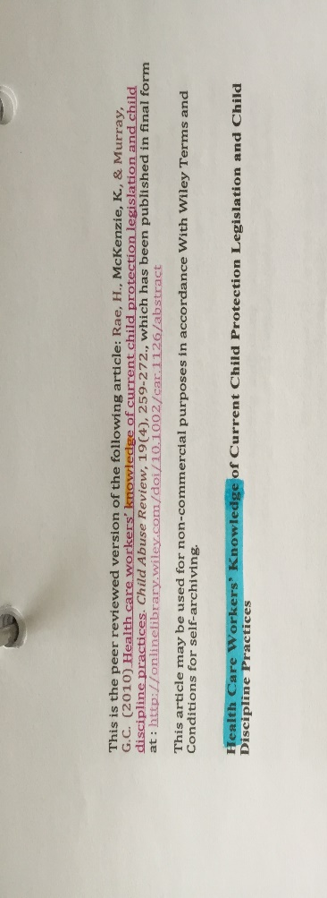
Appendix
Appendix 1). Here lies photographic evidence of where the themes submerged from research came from.

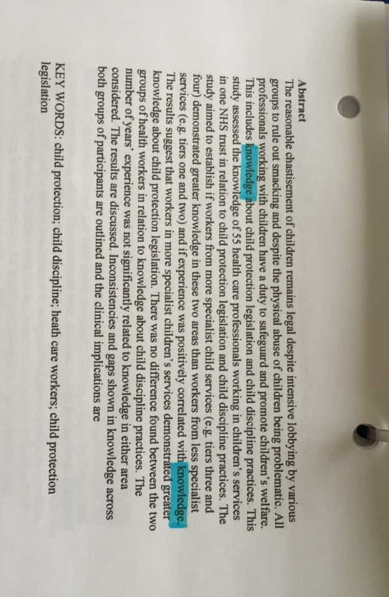

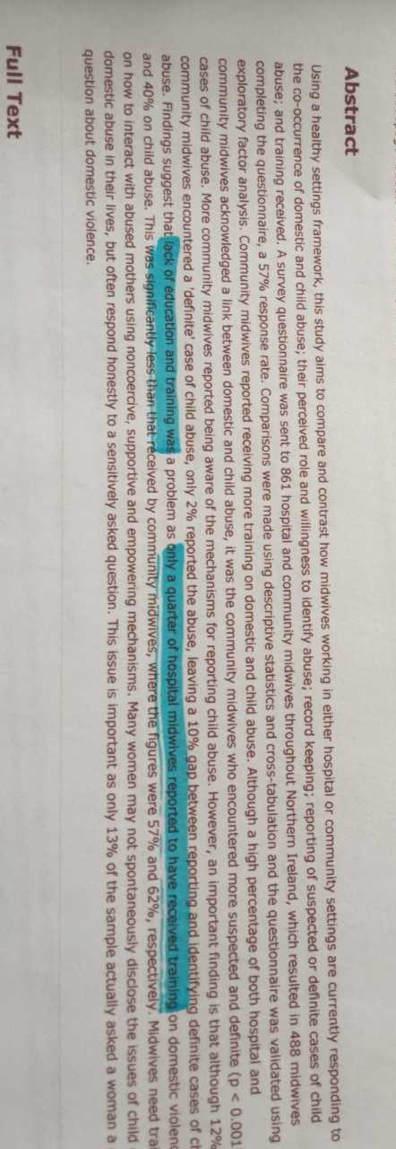
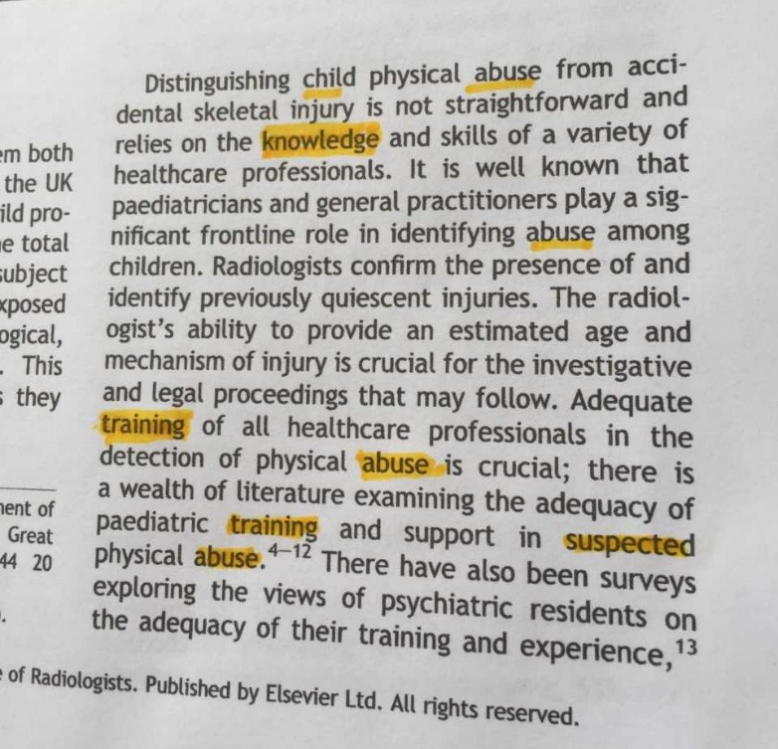
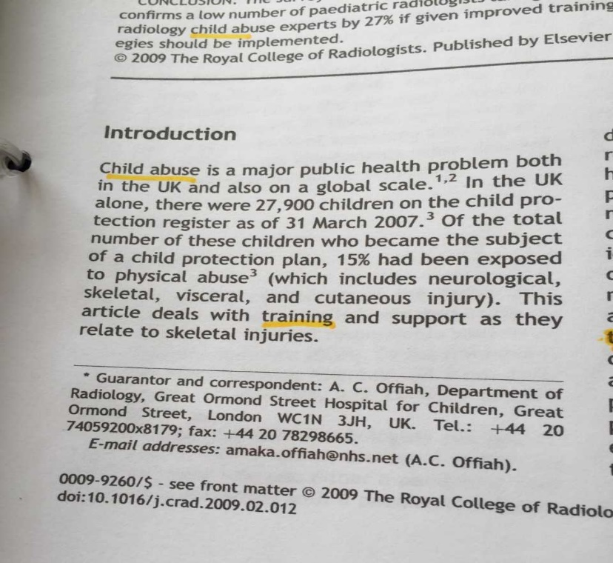
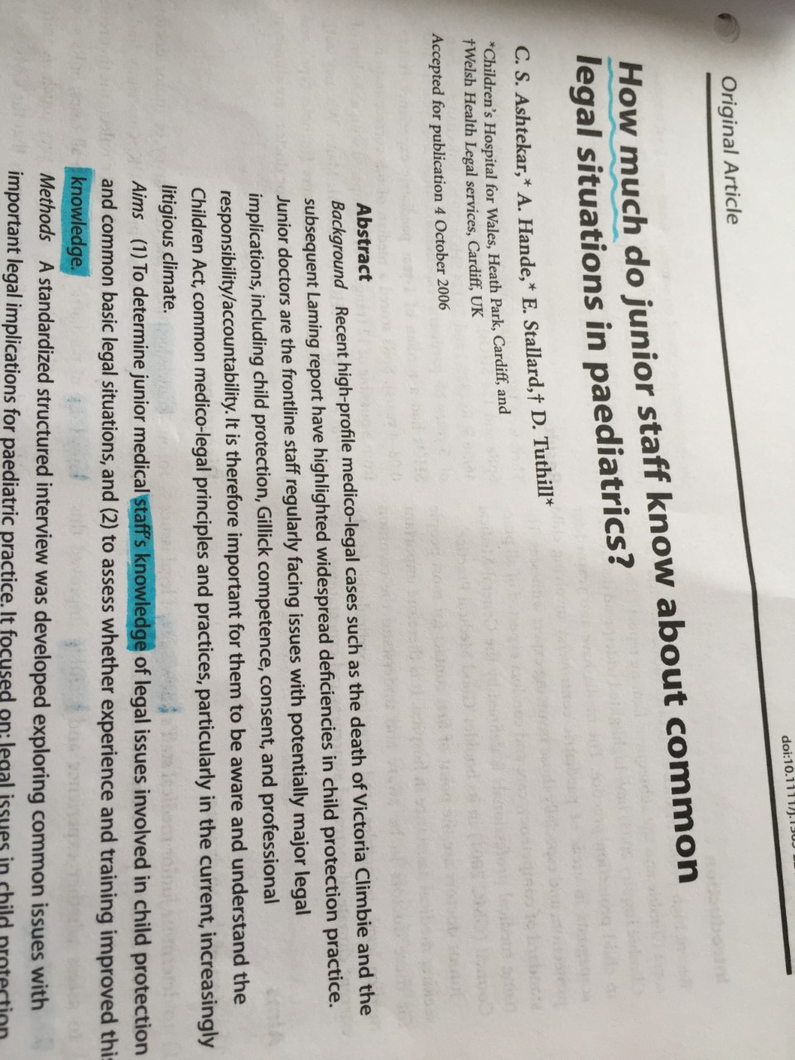
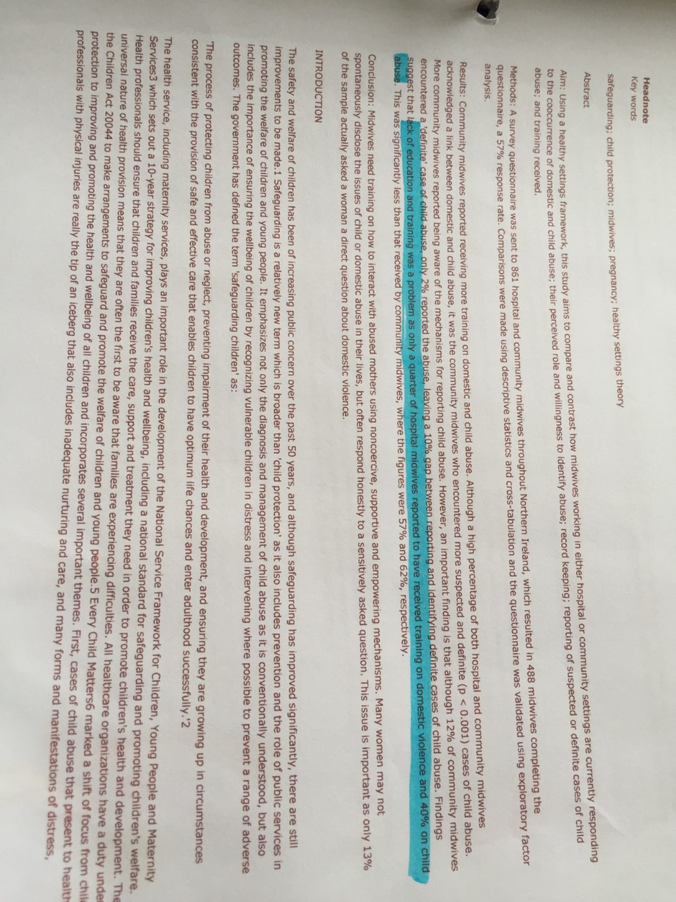

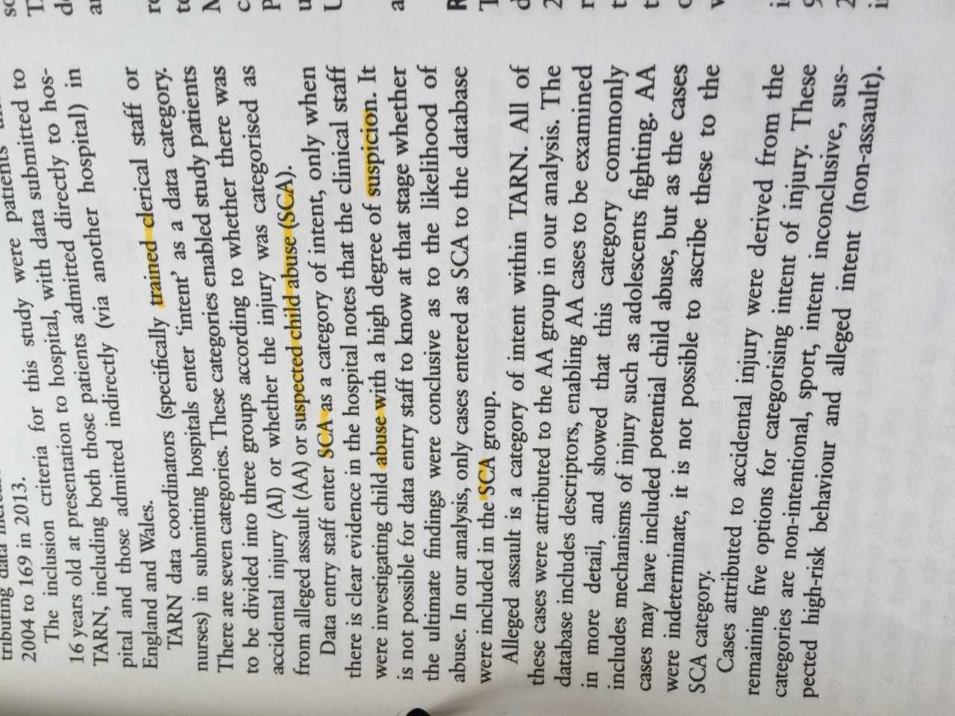
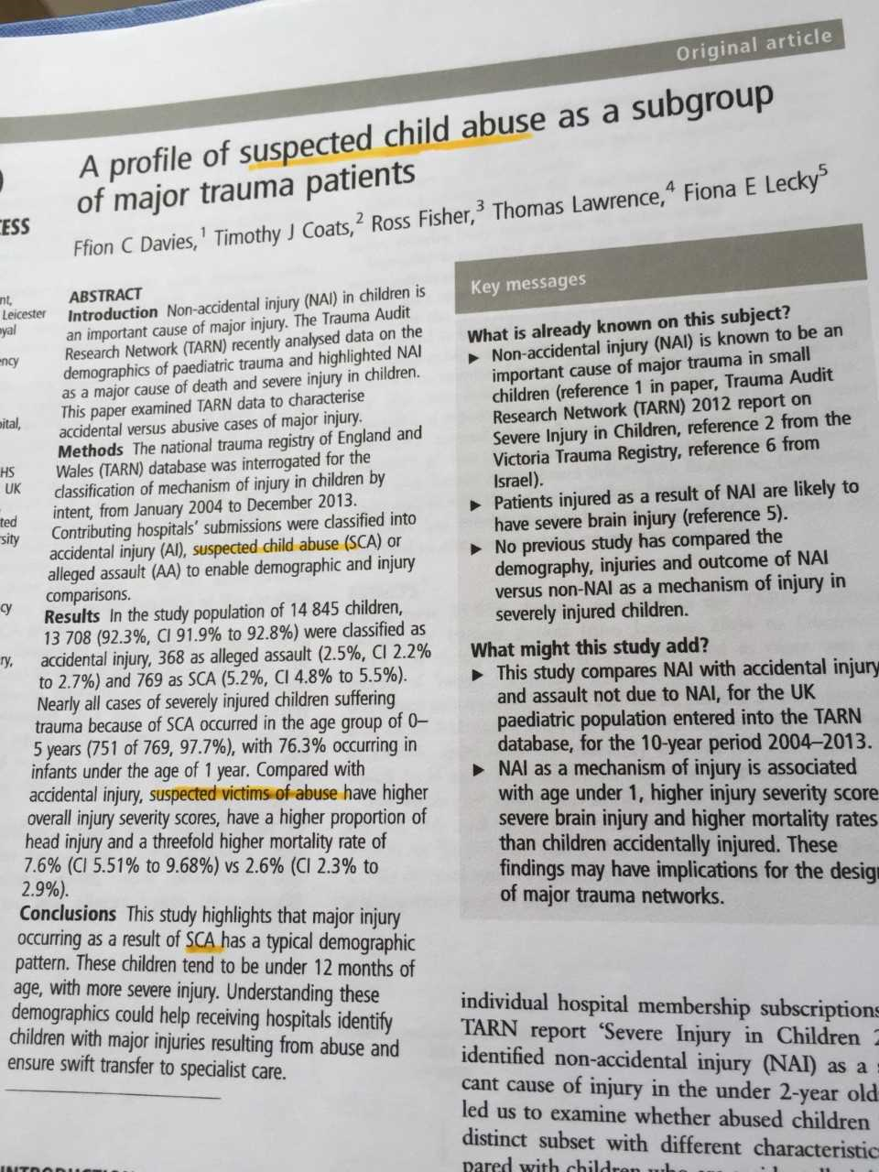

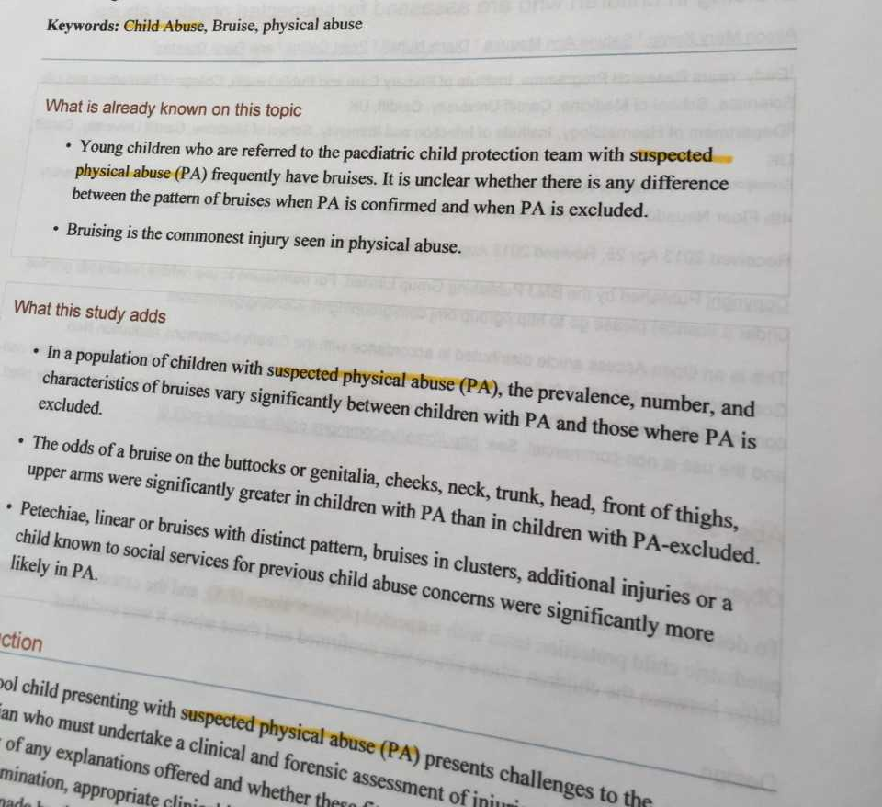
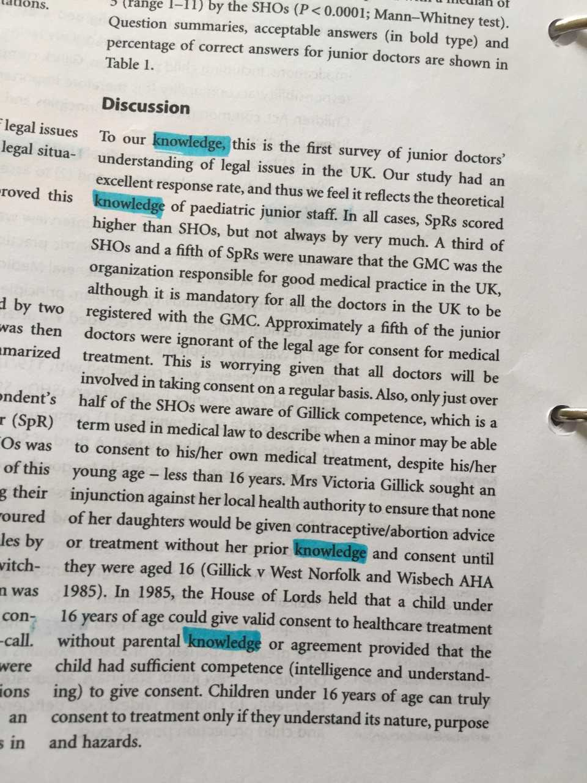

CASP Checklist
Appendix 2) The 10 questions asked will help to determine whether the literature used was reliable or not.
Journal Article 1: Health care workers’ knowledge of current child protection legislation and child disciple practices
Question: | Yes | No | Unsure
- Was there a clear statement of the aims of the research? | Yes, to understand health care professionals understanding of child protection law and disciplinary procedures.
- Is a qualitative methodology appropriate? | Yes, because it seeks to understand health care professionals understanding of child protection.
- Was the research design appropriate to address the aims of the research? | Yes, but they didn’t say why they chosen that specific method.
- Was the recruitment strategy appropriate to aims of the research? | Yes, because participants were chosen based on the fact that they were healthcare professionals and were selected on the grounds that they were working mainly with children at the time in hospitals and in children and adult’s mental health services.
- Was the data collected in a way that addressed the research issue? |  |  | Unsure because the questionnaire was non standardised.
- Has the relationship between researcher and participants been considered? |  | No
- Have ethical considerations been taken into consideration? | Yes, consent was assumed on whether or not the participants returned and filled in the questionnaire.
- Was the data analysis sufficiently rigorous? |  |  | Unsure however the researchers did examine potential factors which could have affected the data analysed.
- Is there a clear statement of findings? | Yes, there are clear findings of results.
- How valuable is the research? |  |  | Unsure because the sample size was relatively low, so their result may not be generalised to wider population.

Journal article 2: How much do junior staff know about common legal situations in paediatrics?
Question: | Yes | No | Unsure
- Was there a clear statement of the aims of the research? | Yes, to measure junior staff’ knowledge around legal situations in paediatrics
- Is a qualitative methodology appropriate? | Yes, as the questionnaires are based on experiences and understanding.
- Was the research design appropriate to address the aims of the research? | Yes
- Was the recruitment strategy appropriate to the aims of the research? |  |  | Unsure, staff were contacted via telephone.
- Was the data collected in a way that addressed the research issue? | Yes
- Has the relationship between researcher and participants been adequately considered? |  |  | Unsure
- Have ethical issues been taken into consideration? |  | No, no ethical consideration was undertaken.
- Was the data analysis sufficiently rigorous? | Yes
- Is there a clear statement of findings? | Yes, it is clear of the findings, which were that many junior paediatric staff lack legal knowledge surrounding child protection.
- How valuable is the research? | The research seems very valuable as the questionnaire was pre validated and the results took across the whole of Wales.

Journal article 3: Safeguarding children and public health: Midwives’ responsibilities
Question: | Yes | No | Unsure
- Was there a clear statement of the aims of the research? | Yes, to compare community midwives and hospitals midwives understanding of child abuse and their training received.
- Is a qualitative methodology appropriate? | Yes
- Was the research design appropriate to address the aims of the research? | Yes, they justified why they were going to use survey questionnaires which was to understand the midwives’ current knowledge and training.
- Was the recruitment strategy appropriate to the aims of the research? | Yes
- Was the data collected in a way that addressed the research issue? |  |  | Unsure
- Has the relationship between researcher and participants been adequately considered? |  |  | Unsure
- Have ethical issues been taken into consideration? | Yes, a consent form was given to the midwives before filling out the survey
- Was the data analysis sufficiently rigorous? | Yes
- Is there a clear statement of findings? | Yes, the main finding being that community midwives were more trained in child abuse in comparison to hospital midwives.
- How valuable is the research? | It seems very valuable, as it had a relatively large sample size.

Journal article 4: Are UK radiologists satisfied with the training and support received in suspected child abuse?
Question: | Yes | No | Unsure
- Was there a clear statement of the aims of the research? | Yes, the main aim was to measure radiologists’ current practice and views on the training they had received for reviewing x-rays
- Is a qualitative methodology appropriate? |  |  | Unsure
- Was the research design appropriate to address the aims of the research? | Yes, the researchers justified why they were going to undertake a survey
- Was the recruitment strategy appropriate to the aims of the research? | Yes, the researchers chose to contact radiologists through hospital numbers. The radiologists were confirmed through the Royal College of Radiologists.
- Was the data collected in a way that addressed the research issue? |  |  | Unsure, however the researchers did justify how the results were going to be collected.
- Has the relationship between researcher and participants been adequately considered? |  | No
- Have ethical issues been taken into consideration? |  | No, no ethical consideration was undertaken
- Was the data analysis sufficiently rigorous? | Yes, because the data supports the findings
- Is there a clear statement of findings? | Yes, and there is clear strengths and limitations listed from the study.
- How valuable is the research? | Results appear valid because of a decent sample size and clear strengths and limitations listed in the study.

Journal article 5: A profile of suspected child abuse as a subgroup of major trauma patients.
Question: | Yes | No | Unsure
- Was there a clear statement of aims of the research? | Yes, the researchers made it somewhat clear that they wanted to distinguish non accidental injury between accidental injury in children. The researchers also made it clear of the need to carry out this study.
- Is a qualitative methodology appropriate? |  |  | Unsure
- Was the research design appropriate to address the aims of the research? | Yes, the researcher made it clear that they used the TARN database.
- Was the recruitment strategy appropriate to the aims of the research? |  |  | Unsure, it doesn’t say how the participants were selected.
- Was the data collected in a way that addressed the research issue? | Yes
- Has the relationship between researcher and participants been adequately considered? |  | No because no ethical consideration was undertaken
- Have ethical issues been taken into consideration? |  | No, ethical consideration was not undertaken.
- Was the data analysis sufficiently rigorous? | Yes, it appears that the data portrayed does support the findings. Additionally, the researchers highlighted potential areas of weaknesses in the study.
- Is there a clear statement of findings? | Yes
- How valuable is the research? | Very valuable as the sample size was very high and was carried out throughout England and Wales.

Journal article 6: Bruising in children who are assessed for suspected physical abuse
Question: | Yes | No | Unsure
- Was there a clear statement of the aims of the research? | Yes, to determine the patterns of bruising and child abuse suspicion.
- Is a qualitative methodology appropriate? | Yes
- Was the research design appropriate to address the aims of the research? | Yes, it describes how the participants were selected.
- Was the recruitment strategy appropriate to the aims of the research? | Yes, as they were selected based on referral to paediatricians.
- Was the data collected in a way that addressed the research issue? | Yes
- Has the relationship between researcher and participants been adequately considered? |  |  | Unsure, it hasn’t been stated.
- Have ethical considerations been taken into consideration? |  | No, no ethical consideration was considered.
- Was the data analysis sufficiently rigorous? | Yes, because the data shown supports the findings and the method was pre-standardised.
- Is there a clear statement of findings? | Yes, including graphs of findings.
- How valuable is the research? | Valuable, the results seem reliable and valid as there was a high sample size and strengths and limitations within the study were highlighted.

Thesis Search Strategy Sheet
Appendix 3) Below is a list of all the searches made throughout the research project.
My research question / aim / objectives: | Question: How can health care professionals help to improve child protection in a hospital setting within the UK?  Aim: to gain an understanding of how healthcare professionals such as doctors and nurses within a hospital setting can help to improve how children and protected within the UK  Objectives:  - To provide a detailed description on how healthcare professionals such as doctors and nurses help to safeguard children from harm within a hospital setting  - To examine the current policies and legislation put in place which are set up to safeguard children by examining scientific research  - To evaluate how effective current policies and legislation are in terms of improving child protection within hospitals  - To give future recommendations for improvement which have arisen from the research used throughout the assignment
Places to search for information: | BMJ, UWTSD online library, google books, google scholar, Cochrane library, MEDline, PubMed.

Date | Database Name | Search Terms | No of Results: | Comments:
17/10/2018 | UWTSD online library | Child protection in hospitals | 117,546 | Too vague of a search term so there was too much irrelevant information.
17/10/2018 | UWTSD online library | Child protection in hospitals (UK) | 15,208 | Was not helpful as it showed irrelevant information
18/10/2018 | UWTSD online library | Safeguarding children in hospitals | 7,616 | Some research was helpful, however most if it wasn’t because the research was based in the US whereas the main focus is only literature which was published in the UK.
18/10/2018 | UWTSD online library | Child protection guide (UK) | 23,801 | Found useful information based on how professionals work in partnership to protect children from abuse.
18/10/2018 | UWTSD online library | Recognise child abuse (hospital) (UK) | 6,286 | Not helpful, too much research was based on research outside of the UK despite the search term.
20/10/2018 | Google books | What is child protection? | 11,000,000 | Too large of a search, but some information was helpful as it gave me an understanding of what child protection is
20/10/2018 | Google books | The children act | 193,000 | Gave me helpful information based on this piece of legislation and what the act covers
21/10/2018 | Google books | Safeguarding children | 786,000 | Too vague of a search however useful information was found based on what safeguarding is and how it differs to child protection
22/10/2018 | Google books | Policies on safeguarding children in hospital | 23,500 | Found some useful information based on government policies
22/10/2018 | Google books | Healthcare professionals | 2,820,000 | Too vague of a search but found a definition of what a healthcare professional is
22/10/2018 | Google books | Child protection and research | 2,380,000 | Not very helpful, no information was relevant for this assignment.
23/10/2018 | Google books | The NHS | 5,140,000 | Found some information based on the history of the NHS which was used as a reference.
01/11/2018 | Google books | Methodology in systematic literature review | 78,800 | Found some useful information based on what methodology is in a systematic literature review. However, it took me a while to get what information I needed.
01/11/2018 | Google books | Systematic review in health and social care | 10,200,000 | Useful information found based on what a systematic review was and the different advantages and disadvantages of undertaking one
01/11/2018 | Google books | Advantages of systematic literature review health and social care | 14,800 | Found more advantages based on undertaking a systematic literature review.
01/11/2018 | Google books | Disadvantages of systematic literature review | 8,670 | Useful information based on the issues of systematic literature review which was used in this assignment.
01/11/2018 | Google books | Critical appraisal tools | 71,000 | Useful information based on why CASP is used and how
 |  | Critical appraisal tools advantages | 3,780 | Not very helpful but did find some advantages for critical appraisal tools.
06/11/2018 | Google books | Critical appraisal tools disadvantages | 4,100 | Took me a while to search for what information I needed however I did find some disadvantages for CASP.
06/11/2018 | Google books | What is a social care worker | 3,270,000 | Too brief of a search term so had too many results.
06/02/2019 | Google books | Social care professional | 5,180,000 | Had too many results but eventually found a reference where a definition was useful
06/02/2019 | Google books | Search terms in literature review | 263,000 | Found some useful information based on
06/02/2019 | Google books | Ethics in research | 26,900,000 | Found relevant information based on what ethics are and what topics they cover such as consent etc. also found why it is important for ethics in health and social care research
06/02/2019 | Google books | Ethical considerations in research | 694,000 | Found some relevant information on what researchers need to do ensure that participants involved don’t get harmed
08/02/2019 | BMJ | Child abuse suspected in hospitals | 10 | found one article useful based on doctors getting a child protection guide to suspect abuse which I used in chapter 1
08/02/2019 | UWTSD online library | Protection guide + doctors | 31,434 | Found information based on junior doctors failing to recognise symptoms of child abuse in A&E departments
08/02/2019 | Bmj | Child sexual abuse symptoms | 5,506 | Found some helpful statistics to which I used as a reference
20/02/2019 | PubMed | Child + protection + UK + hospital | 726 | Useful information. Found 2 journal articles which were used for finding my themes
21/02/2019 | Google books | How to write a literature review | 3,310,000 | Useful description of what a database is when searching for literature.
22/02/2019 | Google books | Advantages of a systematic literature review | 27,100 | Too vague of a search term so therefore got too many results, however found a book which was useful for one advantage of a systematic literature review
22/02/2019 | Google books | Why undertake a systematic literature review | 71,400 | Too many results which were irrelevant
22/02/2019 | Google books | Disadvantages of a systematic literature review | 9,040 | Not useful
22/02/2019 | Google books | Evidence based practice | 9,040 | Found a useful book regarding the advantages and disadvantages of a systematic literature review
23/02/2019 | Google books | Research methodology | 13,700,000 | Wanted a direct definition of what methodology in research was, the results were not relevant.
23/02/2019 | Google books | Research methodology and methods | 4,580,000 | Found useful information on what methodology in research was.
23/02/2019 | Google books | Critical appraisal tools benefits | 6,060 | Found some useful advantages and disadvantages on CASP
25/02/2019 | Google books | Themes in literature review | 913,000 | Too many results however, found a reference based on what themes are and why they are important.
25/02/2019 | UWTSD online library | lack of training + hospitals + child abuse | 228,469 | Found useful literature to use for one of my themes –training.
28/02/2019 | UWTSD online library | Doctor + child + abuse + hospital (UK) | 5,096 | No useful information, most results were based on literature in India despite the search term being UK.
28/02/2019 | Sage journals | Doctor + confidence + child + abuse + UK | 20 | Irrelevant information as they were only based on social work rather than health.
28/02/2019 | Google books | Lack of knowledge in nursing | 283,000 | Didn’t use any of these results as they didn’t provide a direct definition of what I wanted
28/02/2019 | BMJ | Health care professional’s knowledge child abuse | 6,889 | Unrelated research. Research was based outside of the UK so was therefore irrelevant to my question
01/03/2019 | Wiley online library | Health worker knowledge child abuse | 64,974 | Find one main journal article for the theme - knowledge.
01/03/2019 | BMJ | Health care professional knowledge (UK) (study) | 42,270 | No relevant information. Despite the UK search term, studies from outside the UK were still being shown.
19/03/2019 | Wiley online library | Paediatrics knowledge on law (UK) | 6,604 | Found one main journal article for the theme - knowledge.
19/03/2019 | UWTSD online library | Safeguarding children + midwives | 773 | Found a main journal article and used it for my theme training.
19/03/2019 | Google scholar | Training UK child abuse hospital | 196,000 | Useful search as it helped me to choose another main journal article for my theme training.
19/03/2019 | Google scholar | Suspected child abuse in hospital (UK) | 66,800 | Found a journal article which was used in the theme suspected child abuse patterns
19/03/2019 | Google scholar | Suspected child abuse in hospital (UK) | 66,800 | Found a main journal article for my third theme – suspected child abuse patterns
19/03/2019 | Google scholar | paediatrics + suspected child abuse | 21,400 | Useful search. Found two journal articles which were relevant my third theme – suspected child abuse patterns

