

Electrical Fault Simulator

by
Ellis Ashton

Supervisor: Jenifer Prince Deveraj

Project submitted as part of the requirements for the award of
BEng (Hons) Electrical and Electronics Engineering

April 2026

Contents
ABSTRACT 6
CHAPTER 1 – INTRODUCTION 8
1.1 Background 8
1.2 Problem Statement 9
1.3 Aim 10
1.4 Objectives 10
1.5 Project Scope 10
1.6 Structure of the Report 11
CHAPTER 2 – RESEARCH AND REVIEW OF LITERATURE 12
2.1 Introduction 12
2.2 Electrical Fault Diagnosis 13
2.3 Educational Training Systems for Engineering 14
2.4 Microcontrollers in Embedded Systems 15
2.5 Circuit Simulation in Engineering Design 17
2.6 Summary 18
CHAPTER 3 – RESEARCH AND DEVELOPMENT METHODOLOGY 19
3.1 Introduction 19
3.2 Research Approach 20
3.3 System Development Process 21
3.4 Hardware Components 25
3.4.1 Microcontroller 25
3.4.2 LED Indicator 26
3.4.3 Push Button 26
3.4.4 Seven-Segment Display 26
3.4.5 Test Points 27
3.5 Software Tools 27
3.5.1 MPLAB X Integrated Development Environment 27
3.5.2 CCS Compiler 27
3.5.3 Proteus Design Suite 28
3.6 Experimental Design 28
3.7 Validity and Reliability 29
3.8 Summary 30
CHAPTER 4 – DESIGN AND IMPLEMENTATION 31
4.1 Introduction 31
4.2 System Architecture 32
4.3 Hardware Design 34
4.3.1 Microcontroller Selection 34
4.3.2 Clock Generation Circuit 36
4.3.3 Reset Circuit 37
4.4 Test Point Design 37
4.5 LED Load Indicator 38
4.6 User Input Interface 39
4.7 Seven Segment Display System 40
4.8 Firmware Design 42
4.9 Fault Control Algorithm 42
4.10 System Operation 43
4.11 Proteus Simulation Implementation 44
4.11.1 Physical Prototype Implementation 45
4.12 Summary 47
CHAPTER 5 – RESULTS AND DISCUSSION 49
5.1 Introduction 49
5.2 Test Environment 50
5.3 System Behaviour During Normal Operation 53
5.4 Power Supply Failure Simulation 54
5.5 Open Circuit Fault Simulation 56
5.6 Load Failure Simulation 57
5.7 Summary of Experimental Results 57
5.8 Diagnostic Reasoning Using Test Points 58
5.9 Evaluation of System Performance 59
5.10 Educational Effectiveness 60
5.11 Limitations of the simulator 61
5.12 Chapter Summary 62
CHAPTER 6 – EVALUATION 64
6.1 Introduction 64
6.2 Evaluation Against Project Objectives 64
6.2.1 Objective 1: Design a simple electrical circuit suitable for fault-finding training 65
6.2.2 Objective 2: Implement a system capable of simulating multiple electrical faults 66
6.2.3 Objective 3: Provide measurable test points for diagnostic analysis 66
6.2.4 Objective 4: Provide a user interface for selecting fault conditions 67
6.2.5 Objective 5: Implement and test the system using simulation software 67
6.3 Strengths of the System 68
6.4 Limitations of the Current Design 69
6.5 Potential Improvements 70
6.7 Chapter Summary 71
CHAPTER 7 – CONCLUSIONS AND RECOMMENDATIONS 72
7.1 Introduction 72
7.2 Summary of Project Work 72
7.3 Key Findings 73
7.4 Achievement of Project Aim 74
7.5 Benefits of the System 75
7.6 Recommendations for Future Work 75
7.7 Final Conclusion 77
References 79
Appendix 82
Appendix A - Proteus design 82
Appendix B – Source Code Figure: Screenshot of microcontroller firmware. 83

Figures
Figure 1 Project Development process 24
Figure 2 Extract of project Gantt chart 25
Figure 3 Proteus circuit design 32
Figure 4 Fault Simulator system architecture 34
Figure 5 PIC16F877A pin map [1] 35
Figure 6 Fault simulator (user perspective) 40
Figure 7 seven-segment coding error 41
Figure 8 Firmware operation flow chart 44
Figure 9 Fault condition 0 (no fault) 51
Figure 10 Fault condition 1 52
Figure 11 Fault condition 2 52
Figure 12 Fault condition 3 53
Figure 13 Appendix 1 - Proteus system design 82

ABSTRACT
This project presents the design and development of an electrical fault simulation system intended for educational training environments. The primary aim of the project was to create a safe and controlled platform that allows students to practise electrical fault-finding techniques without exposure to hazardous voltages or complex industrial equipment. Electrical fault diagnosis is a fundamental skill for engineers and technicians, yet traditional teaching approaches often rely on theoretical explanations rather than hands-on investigation.
The system developed in this project simulates a simple electrical circuit consisting of a power supply, switch and LED load. A PIC16F877A microcontroller was used to emulate a range of electrical faults within this circuit while providing test points that allow students to measure voltages and analyse system behaviour. The simulator enables multiple predefined fault conditions to be selected through a push button interface, while a seven-segment display indicates the active fault scenario. The circuit and control logic were designed and tested using Proteus simulation software before final evaluation.
Experimental testing confirmed that the simulator can successfully reproduce common electrical faults such as supply failure, open circuit conditions and component failure. The behaviour of each fault state was verified using simulated voltage measurements at defined test points, replicating the diagnostic process used in real electrical systems.
The results demonstrate that the developed system provides a practical and effective training tool that can assist students in developing troubleshooting and diagnostic skills. The project concludes that microcontroller-based fault simulators offer a safe, flexible and cost-effective approach to electrical engineering education, with potential for further expansion to support more complex circuits and fault conditions.

CHAPTER 1 – INTRODUCTION

1.1 Background
Electrical fault finding is a fundamental skill required by electrical and electronic engineers working in fields such as maintenance engineering, industrial automation and power systems. Engineers must be able to diagnose faults efficiently by analysing circuit behaviour, measuring voltages and identifying components that are not functioning correctly. In professional environments this process typically involves systematic testing using multimeters, oscilloscopes and other diagnostic tools.
Despite the importance of these skills, teaching electrical fault diagnosis can present several challenges. Traditional teaching approaches frequently rely on theoretical explanations or laboratory demonstrations, which may not fully replicate the real-world troubleshooting process. Students may understand electrical theory but struggle to apply that knowledge when diagnosing faults in practical circuits. This means creating real electrical faults in laboratory environments can introduce safety risks or damage equipment if not carefully controlled.
For these reasons, training systems that allow students to practise troubleshooting techniques in a controlled environment are highly valuable. Fault simulation systems allow instructors to introduce predefined faults into a circuit without physically damaging components or exposing students to hazardous conditions. These systems provide students with opportunities to apply diagnostic techniques, measure voltages at different points within the circuit and identify the source of faults through logical reasoning.
The development of microcontroller technology has made it possible to design flexible electronic training systems that can simulate complex behaviours with relatively simple hardware. Microcontrollers provide programmable control of input and output signals, enabling designers to replicate electrical faults and system responses through software logic rather than physical component failure. As a result, microcontroller-based training systems can offer reliable and repeatable fault scenarios that are ideal for educational use.
This project focuses on the design and development of an electrical fault simulation system that allows students to practise diagnosing faults within a simple electrical circuit. The system replicates a basic power supply, switch and load configuration while providing test points that allow voltage measurements to be taken at key locations. By controlling the circuit behaviour through a microcontroller, the system can simulate multiple fault conditions while maintaining a safe low-voltage operating environment.

1.2 Problem Statement
Electrical engineering students must develop the ability to diagnose faults in electrical circuits as part of their professional training. However, providing realistic fault-finding experiences in educational laboratories can be difficult for several reasons. Firstly, deliberately creating faults in physical circuits can damage components or laboratory equipment if not carefully managed. Secondly, real electrical systems may involve hazardous voltages that present safety risks to inexperienced users. Finally, instructors may find it challenging to produce consistent fault conditions for multiple students or laboratory sessions.
As a result, many students graduate with a strong theoretical understanding of electrical systems but limited practical experience in troubleshooting real faults. This gap between theoretical knowledge and practical diagnostic ability can reduce confidence and performance when students enter professional engineering environments.
A controlled electrical fault simulation system could address this problem by allowing students to practice diagnosing faults within a safe and repeatable environment. By providing measurable test points and simulated fault conditions, students can apply standard diagnostic techniques such as voltage tracing to determine the source of circuit failures.

1.3 Aim
The aim of this project is to design and develop a microcontroller-based electrical fault simulation system that allows students to practise electrical fault-finding techniques in a safe and controlled environment.

1.4 Objectives
To achieve the project aim, the following objectives were defined:
- Design a simple electrical circuit model suitable for teaching fault-finding techniques.
- Develop a system capable of simulating multiple electrical faults within the circuit.
- Implement a microcontroller-based control system to manage fault simulation.
- Provide accessible test points that allow voltage measurements during fault diagnosis.
- Display the active fault condition using a digital output interface.
- Simulate and evaluate the system using Proteus circuit simulation software.
- Assess the effectiveness of the system as a training tool for electrical engineering students.

1.5 Project Scope
The scope of the project focuses on the design and simulation of a basic electrical fault simulator using a microcontroller platform. The system simulates faults within a simple power supply, switch and LED load circuit. A PIC16F877A microcontroller is used to control the behaviour of the circuit and generate predefined fault conditions.
The simulator operates at low voltage and is designed primarily for educational purposes. The project does not aim to replicate complex industrial systems but instead focuses on demonstrating the fundamental principles of electrical troubleshooting. The system was designed and tested within a simulation environment to verify its functionality before potential physical implementation.
Due to the application of this system, a trade-off decision was made to reduce the fidelity of using higher DC or AC voltage to using 5V DC to provide safety. Although this fidelity loss is present, this simulation device still provides a method of instilling the principles of diagnosis as these principles remain relevant on most electrical systems.

1.6 Structure of the Report
This report is organised into several chapters that describe the development of the electrical fault simulation system. Chapter 2 presents a review of relevant literature, including previous research related to electrical fault finding, educational training systems and microcontroller technologies. Chapter 3 describes the methodology used during the project, including the research approach and development process. Chapter 4 details the design and implementation of the simulator, including circuit design and software development. Chapter 5 presents the results of testing and discusses the performance of the system. Chapter 6 summarises the conclusions of the project and suggests potential areas for further development. Finally, Chapter 7 provides a reflective discussion of the skills and knowledge gained during the project.

CHAPTER 2 – RESEARCH AND REVIEW OF LITERATURE

2.1 Introduction
The purpose of this chapter explores existing research and technologies relevant to electrical fault diagnosis, educational training systems and the use of microcontrollers in engineering education. Electrical fault finding is recognised as a core competency for electrical engineers and technicians, particularly within industrial maintenance, power systems and electronics troubleshooting, as discussed by Isermann [6] and further supported by Bird [11]. Understanding how faults occur, how they can be diagnosed and how training systems can support the development of diagnostic skills is essential to the design of an effective educational tool.
This chapter first discusses the principles of electrical fault diagnosis and the types of faults that commonly occur in electrical circuits, drawing on established circuit theory presented by Sedra and Smith [10] as well as Alexander and Sadiku [19]. It then reviews the use of training systems and simulation tools in engineering education, where Biggs and Tang [14] highlight the importance of active learning approaches, supported by practical laboratory-based systems described by Saha [15]. Following this, the role of microcontrollers in embedded systems and educational devices is examined, with Mazidi et al. [2] demonstrating their practical application in control systems and Vahid and Givargis [4] outlining their role within modern embedded system design.
Finally, the chapter reviews circuit simulation tools and their importance in engineering design and testing, with the Proteus Design Suite providing an example of integrated hardware and software simulation [12], while measurement and validation principles are supported by Morris and Langari [21]. The chapter concludes with a summary of the key findings from the literature and how they inform the design of the proposed electrical fault simulator.

2.2 Electrical Fault Diagnosis
Electrical fault diagnosis involves identifying abnormal conditions within electrical systems that prevent the system from functioning as intended. In practical engineering environments, faults may occur due to component failure, wiring damage, incorrect installation or environmental factors, as outlined in fault diagnosis frameworks presented by Isermann [6]. Engineers must be able to analyse circuit behaviour and determine the cause of faults quickly and accurately, a skill also emphasised in applied electrical practice by Bird [11].
Fault diagnosis typically follows a systematic approach. The engineer begins by observing the symptoms of the problem and then performs measurements at various points within the circuit. By analysing voltage levels, current flow and component behaviour, it is possible to isolate the location of the fault. This structured approach to troubleshooting is supported by classical circuit analysis techniques described by Sedra and Smith [10]. The process is often referred to as voltage tracing or signal tracing, where measurements are taken at different stages of a circuit to determine where normal operation stops.
Several types of faults are commonly encountered in electrical circuits. One of the most regular faults is an open circuit, where a break in the electrical path prevents current from flowing. This may occur due to a broken wire, a failed component or a disconnected connector. In such cases, voltage may be present before the fault location but will not appear beyond it, as explained in fundamental circuit theory by Alexander and Sadiku [19]. Another common fault is a short circuit, where an unintended low resistance path allows current to bypass components in the circuit. Short circuits can lead to excessive current flow and may cause damage to components or protective devices such as fuses, a behaviour widely documented in electrical engineering literature [29].
Component failure is another significant cause of electrical faults. Electronic components such as resistors, capacitors and semiconductor devices may fail due to overheating, manufacturing defects or long-term wear. In practical troubleshooting scenarios, engineers must determine whether a component has failed by analysing the voltage and current conditions around that component, an approach supported by measurement and instrumentation principles described by Morris and Langari [21].
Because electrical faults can occur in many forms, students must develop strong analytical skills and practical experience in interpreting circuit behaviour. However, gaining this experience through real equipment can be difficult in educational settings due to safety, cost and equipment limitations. As highlighted by Biggs and Tang [14], effective learning in engineering often requires active engagement and practical application. Fault simulation systems can provide valuable learning opportunities by allowing students to practise diagnostic techniques without damaging physical equipment, a concept further supported by laboratory-based training approaches discussed by Saha [15].

2.3 Educational Training Systems for Engineering
Training systems have long been used in engineering education to provide practical learning experiences that complement theoretical learning. In many engineering disciplines, students must develop practical skills that cannot be fully acquired through lectures or textbooks. As highlighted by Biggs and Tang [14], effective learning occurs when students actively engage with the material, rather than passively receiving information. Hands-on experimentation allows students to observe system behaviour, test hypotheses and develop problem-solving abilities, an approach also supported by laboratory-based learning frameworks discussed by Saha [15].
Electrical training systems often include modular circuit boards or laboratory kits that allow students to assemble circuits and measure electrical parameters. These systems typically include power supplies, measurement instruments and various electronic components that can be connected to form experimental circuits. While such systems are useful for demonstrating circuit behaviour, they may not always provide realistic fault conditions for troubleshooting exercises. This limitation is recognised in engineering education, where traditional laboratory setups are often focused on ideal operating conditions rather than fault scenarios.
To address this limitation, specialised fault simulation systems have been developed for training purposes. These systems intentionally introduce faults into a circuit so that students can practise identifying them using standard diagnostic techniques, as described in fault diagnosis methodologies by Isermann [6]. In some cases, faults are created by physically disconnecting components or inserting defective parts. However, this approach can lead to component damage and may require significant instructor supervision, reducing the practicality of repeated training exercises. This also requires a manual intervention by the supervisor to inject the fault into the circuit.
Modern training systems increasingly incorporate digital control techniques to simulate faults electronically rather than physically. By using programmable devices such as microcontrollers or programmable logic controllers (PLCs), it is possible to emulate fault conditions without modifying the physical circuit. Mazidi et al. [2] demonstrating how microcontrollers can be used to control system behaviour flexibly, while Vahid and Givargis [4] highlight their role in embedded system applications. This approach improves reliability and allows the instructor to create multiple fault scenarios using the same hardware platform.
Another advantage of digital fault simulation systems is that they allow faults to be selected or randomised through software. This ensures that students cannot simply memorise the fault location and instead must rely on diagnostic reasoning. As a result, programmable training systems provide a more flexible and effective learning environment, aligning with modern educational practices that emphasise active learning and problem-solving skills [14].

2.4 Microcontrollers in Embedded Systems
Microcontrollers are widely used in embedded systems because they combine processing capability, memory and input/output interfaces within a single integrated circuit [24]. Unlike general-purpose computers, microcontrollers are designed to perform specific control tasks within electronic devices, typically operating within constrained environments where efficiency and reliability are critical [5]. These tasks may include monitoring sensors, controlling actuators and processing digital signals, forming the basis of many modern embedded applications [16].
One of the key advantages of microcontrollers is their ability to control hardware through programmable software logic. By writing software that defines how the microcontroller responds to inputs and controls outputs, engineers can create flexible systems that perform complex functions using relatively simple hardware [23]. This approach enables rapid prototyping and system modification, making microcontrollers particularly useful for educational and experimental applications where adaptability is important.
Microcontrollers are commonly used in a wide range of embedded systems including automotive electronics, industrial control systems, consumer electronics and robotics [25]. In educational contexts, microcontrollers provide students with an accessible platform for learning about digital electronics, programming and system design, supporting hands-on learning approaches that are known to improve understanding [15]. Many engineering programmes include microcontroller programming as part of their curriculum because it combines both hardware and software development skills.
The PIC microcontroller family, developed by Microchip Technology, is widely used in both industry and education. PIC microcontrollers are known for their simplicity, reliability and extensive documentation, which supports their use in teaching environments [2]. The PIC16F877A is a popular device within this family and is frequently used in teaching laboratories due to its large number of input/output pins and built-in peripherals. These features make it suitable for projects that require interaction with external components such as sensors, displays and switches.
By using a microcontroller to simulate electrical faults, it is possible to create a training system that can reproduce multiple circuit conditions without physically modifying the hardware. The microcontroller can control output signals that represent voltages at different points in the circuit, allowing students to perform measurements and analyse system behaviour. This approach aligns with established principles of fault diagnosis, where system behaviour is inferred through measured signals and comparison with expected conditions [8].

2.5 Circuit Simulation in Engineering Design
Circuit simulation plays a critical role in modern engineering design by allowing electronic systems to be analysed and verified before physical implementation. Simulation tools enable engineers to model circuit behaviour under a range of operating conditions, reducing the need for iterative hardware prototyping and minimising the risk of component damage during development [12]. This is particularly important in embedded system design, where both hardware and software must interact correctly for the system to function as intended.
Simulation environments such as Proteus Design Suite provide the capability to integrate circuit schematics with microcontroller firmware, resulting in complete system-level testing within a virtual environment [12]. This enables designers to observe signal behaviour, verify logic operation and identify potential faults at an early stage. By simulating both normal operation and fault conditions, engineers can ensure that the system behaves as expected before committing to physical construction.
One of the key advantages of circuit simulation is the ability to analyse system behaviour under controlled and repeatable conditions. Engineers can modify parameters such as voltage levels, component values and signal timing to investigate how these factors influence overall performance [11]. This supports a deeper understanding of circuit operation and allows design decisions to be validated against theoretical expectations.
In addition to supporting design verification, simulation also plays an important role in fault analysis. By introducing simulated faults into a circuit model, engineers can study how faults affect system behaviour and develop appropriate diagnostic strategies. This approach aligns with established fault diagnosis techniques, where system outputs are compared against expected behaviour to identify abnormal conditions [6]. Simulation therefore provides a safe and effective platform for developing and testing fault detection methods without the risks associated with physical experimentation.
Despite its advantages, circuit simulation has certain limitations. Simulated models are typically based on idealised component behaviour and may not fully account for real-world factors such as noise, component tolerances and environmental conditions. As a result, discrepancies can arise between simulated and physical system performance [21]. For this reason, simulation is often used in conjunction with physical testing to ensure that the final design operates reliably in practice.
Overall, circuit simulation is an essential tool in engineering design, providing a means to develop, test and refine electronic systems efficiently. In the context of this project, simulation enabled the electrical fault simulator to be validated prior to hardware implementation, ensuring that the fault conditions and corresponding voltage patterns behaved as intended.

2.6 Summary
This chapter has reviewed key concepts and technologies relevant to the development of an electrical fault simulation system. Electrical fault diagnosis is an essential skill for engineers, requiring the ability to analyse circuit behaviour and identify abnormal conditions, as emphasised in fault diagnosis methodologies by Isermann [6]. However, providing practical fault-finding training in educational environments can be challenging due to safety concerns and equipment limitations, an issue commonly identified in engineering education research [14].
Training systems that simulate electrical faults offer an effective solution by allowing students to practise diagnostic techniques in a controlled environment. Such approaches align with laboratory-based learning strategies described by Saha [15], where practical engagement enhances understanding. Microcontrollers provide a flexible platform for implementing these systems because they allow electrical behaviour to be controlled through software, a capability demonstrated in embedded system design by Mazidi et al. [2]. The PIC16F877A microcontroller is widely used in educational applications due to its simplicity and versatility, as supported by manufacturer documentation [3].
Simulation tools such as Proteus further support the development process by allowing circuits and embedded software to be tested before physical implementation. This approach reflects standard engineering practice in system modelling and validation, as discussed in simulation and measurement literature [21]. The literature supports the use of microcontroller-based simulation systems as effective tools for engineering education.
The findings from this review informed the design decisions made in this project, particularly the selection of a microcontroller-based architecture and the use of circuit simulation software for development and testing. These decisions ensure that the proposed system aligns with both established engineering practices and modern educational methodologies.

CHAPTER 3 – RESEARCH AND DEVELOPMENT METHODOLOGY

3.1 Introduction
This chapter seeks to describe the research and development methodology used in the design and implementation of the electrical fault simulation system. The purpose of this section is to explain the processes, tools and techniques used to develop the system and to justify why these approaches were selected. In engineering projects, a structured methodology is essential to ensure that the final system is reliable, repeatable and aligned with its intended objectives, as highlighted in embedded system design frameworks by Vahid and Givargis [4].
The project is primarily a development-based engineering project, supported by experimental testing. The development component focuses on the design and implementation of the electrical fault simulation system, while the experimental component involves testing the behaviour of the system under different simulated fault conditions. This combination of development and validation reflects standard engineering practice, where system functionality must be verified through controlled testing, as discussed in measurement and instrumentation principles by Morris and Langari [21].
The methodology combines elements of engineering design with experimental verification. Microcontroller-based system development, as described by Mazidi et al. [2], typically involves iterative stages of design, implementation and testing to ensure correct operation. Similarly, embedded system methodologies emphasise the integration of hardware and software throughout the development process [5].
The development process followed a structured sequence consisting of requirement identification, system design, simulation development, software implementation and experimental evaluation. Each stage contributed to ensuring that the final system satisfied the objectives defined in Chapter 1, while maintaining consistency with established engineering design practices.

3.2 Research Approach
Engineering projects often follow either investigative, experimental or development-based methodologies depending on the nature of the problem being addressed. In this project, the objective was to design and build a system that can simulate electrical faults for training purposes. Because the project required the creation of a functional system rather than purely theoretical analysis, a development-based methodology was considered the most appropriate. This approach aligns with established embedded system design practices, where practical implementation is central to the development process, as described by Vahid and Givargis [4].
The development-based methodology focuses on designing and constructing a system that meets a defined set of requirements. This process typically involves several iterative stages including design, prototyping, testing and evaluation. Such iterative development is widely used in embedded system design, where both hardware and software must be refined together to ensure correct system operation, as highlighted by Heath [5]. Each stage lets the designer improve system performance and address potential issues before progressing further.
In addition to the development process, the project also includes an experimental component. Experimental methods are commonly used in engineering to verify that a system behaves as expected under specific conditions. This approach is supported by measurement and validation principles discussed by Morris and Langari [21], where controlled testing ensures system accuracy and reliability. In this project, experiments were conducted within the simulation environment to confirm that the system correctly reproduced the intended fault conditions and that the diagnostic measurements available to the user were consistent with expected electrical behaviour.
By combining development and experimental methodologies, the project ensured that the system was both properly designed and carefully tested. This integrated approach reflects standard engineering practice, where system functionality is validated through both design implementation and experimental verification [2].

3.3 System Development Process
The development of the electrical fault simulator followed a structured design process, as illustrated in Figure 1. Each stage contributed to the development, validation and implementation of the system, reflecting standard engineering design workflows described in embedded system methodologies by Vahid and Givargis [4].
The process began with project definition, where the overall aim and objectives of the system were established. This stage identified the need for a safe and practical training tool that lets students to develop electrical fault-finding skills through structured measurement and analysis, an approach consistent with modern engineering education principles outlined by Biggs and Tang [14].
Following this, a literature review and market research was conducted to investigate existing approaches to electrical fault diagnosis and training systems and competitive products on the market. This provided a theoretical foundation for the project and helped to justify the use of a simplified circuit combined with microcontroller-based fault simulation, as supported by fault diagnosis frameworks discussed by Isermann [6].
The next stage involved defining the system requirements specification. These requirements outlined the key functionality of the simulator, including the ability to generate multiple fault conditions, provide accessible test points for voltage measurement and allow user interaction through a simple interface. Defining clear system requirements is a key aspect of embedded system development, ensuring that both hardware and software operate effectively [5].
Based on these requirements, the system design stage began. A simplified electrical circuit consisting of a power supply, switch and LED load was selected to demonstrate fault-finding principles, drawing on established circuit analysis techniques described by Sedra and Smith [10]. Test points were incorporated into the design to enable voltage testing, and a microcontroller-based control system was chosen to simulate different fault conditions, consistent with programmable system design approaches presented by Mazidi et al. [2].
The design was then produced within the simulation stage using Proteus, where the circuit schematic and microcontroller firmware were integrated. This stage allowed the behaviour of the system to be verified before the hardware construction, reflecting common simulation and validation practices in engineering design [12].
This required firmware to be developed using the C programming language, the software was designed to generate predefined fault conditions using lookup tables and to control the outputs corresponding to each test point and indicator, an approach widely used in embedded systems to ensure predictable and repeatable behaviour [23].
Following successful simulation, the system progressed to prototype construction. A physical implementation was developed using a breadboard-based circuit housed in an enclosure, with user interface components mounted on the front panel. The transition from simulation to physical implementation is an important step in embedded system development, allowing real-world validation of system performance, reliability and repeatability [24].
The next stage involved hardware testing, where the prototype was evaluated using a multimeter to confirm that the voltage levels and system behaviour matched the expected results observed in simulation. This process aligns with standard engineering testing methodologies used to ensure system reliability and accuracy [21].
The results obtained were then analysed in the results analysis stage to verify system performance and ensure that each fault condition produced the correct output behaviour.
Finally, the system was assessed during the evaluation stage, where its effectiveness as a training tool was considered in terms of functionality, reliability and educational value. This final stage ensures that the system not only meets technical requirements but also aligns with its intended purpose as an educational resource [15].
Figure 1 Project Development process
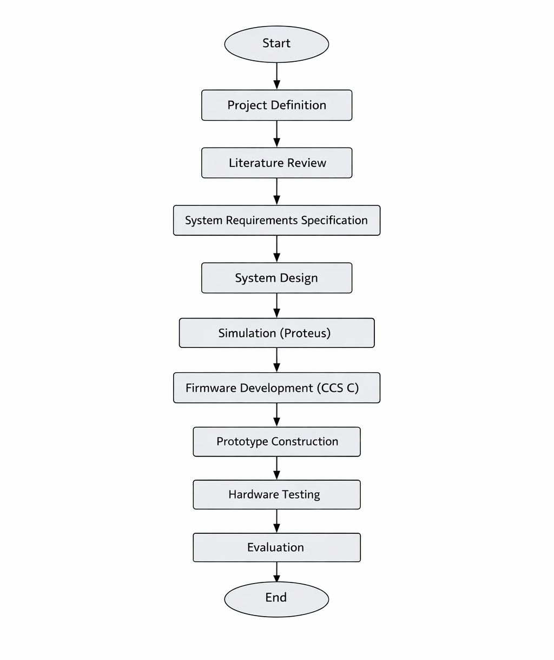
As shown in Figure 2, The planning of the project had a good level of accuracy and assumption. The scheduling of the project aligned well with the project being carried out, although this does not reflect that some delays were not encountered. The key dates of the project were met as the plan considered that there would be delays in certain aspects of the project such as the program development where there were more iterations than initially planned, particularly when implementing the fault indication logic where these refinements influenced the final system architecture. Other delays within the prototype build aspect where the lead-time on several parts was excessive. Fortunately, in the planning phase there were delays forecasted so therefore these delays still meant the project could be delivered within the deadlines.
Figure 2 Extract of project Gantt chart
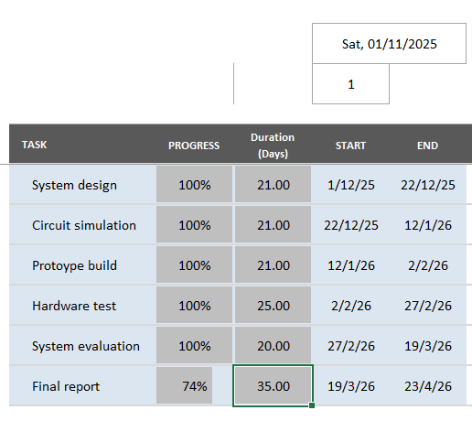

3.4 Hardware Components
Although the project was implemented within a simulation environment, it was designed with real hardware implementation in mind. The following hardware components were selected as part of the system design. The decision between using a PLC system and a microcontroller based system was made due to the size, weight a flexibility advantages of the microcontroller system.

3.4.1 Microcontroller
The central component of the system is the PIC16F877A microcontroller. This device was selected because it gives many digital input and output pins, making it suitable for controlling multiple signals within the simulator. The PIC16F877A is also widely used in educational environments and is supported by extensive documentation and development tools, as detailed by Microchip Technology in the device data sheet [3].
The microcontroller is responsible for controlling the simulated voltages at each test point and managing the fault selection logic. This type of programmable control is a key advantage of microcontroller-based systems, allowing system behaviour to be defined through software rather than hardware modifications, as described by Mazidi et al. [2]. It also controls the output display that indicates the currently active fault scenario, demonstrating the integration of input processing and output control typical of embedded system applications [4].
The PIC16F877A was selected due to it’s number of I/O pins and ease of integration within both simulation and hardware environments. While more advanced microcontrollers could provide additional features and processing capability, the chosen device offers a balance between simplicity and functionality, making it well suited to an educational application. Although, the disadvantage of this component is the lack of integrated clock system, this means that a crystal clock circuit is required as part of the circuit.

3.4.2 LED Indicator
An LED was included in the circuit to represent the electrical load. In normal operating conditions the LED illuminates, indicating that current is flowing through the circuit. When certain fault conditions are simulated, the LED will turn off or behave differently, allowing students to observe the effect of the fault.

3.4.3 Push Button
A push button input was used to allow the user to change the active fault condition. Each press of the button advances the system to the next fault scenario. This allows multiple faults to be simulated using the same hardware configuration.

3.4.4 Seven-Segment Display
A seven-segment display was used to provide visual feedback indicating the currently active fault condition. This allows the instructor or student to identify which fault scenario is being simulated at any given time.

3.4.5 Test Points
Test points were incorporated into the circuit to allow voltage measurements to be taken at key locations. These test points represent points within the simulated electrical circuit where a technician would normally measure voltage during fault diagnosis. By analysing the voltages present at these points, students can determine the location of the simulated fault.

3.5 Software Tools
Several software tools were used during the development of the project. They were chosen due to the compatibility benefits along with being readily available and intuitive.

3.5.1 MPLAB X Integrated Development Environment
MPLAB X is an integrated development environment produced by Microchip Technology for developing software for PIC microcontrollers. It presents tools for writing, compiling and debugging embedded software, supporting the full development lifecycle of microcontroller-based systems. Such integrated development environments are essential in embedded system design, as they enable efficient code development, testing and debugging, as described by Barr and Massa [23].

3.5.2 CCS Compiler
The CCS compiler was used to convert the C language program written for the PIC microcontroller into machine code that can be executed by the device. The compiler generates a HEX file that contains the binary instructions required by the microcontroller. This process is fundamental to embedded system development, where high-level code must be translated into executable instructions for the target hardware, as described by Barr and Massa [23].

3.5.3 Proteus Design Suite
Proteus Design Suite was used to simulate the electrical circuit and microcontroller behaviour. The software allows the microcontroller program to be executed within the simulation while interacting with other electronic components in the circuit. This capability enables integrated hardware and software validation, which is a key aspect of modern embedded system development, as described in simulation-based design practices [12]. This feature makes Proteus particularly suitable for testing embedded systems that combine hardware and software elements, supporting efficient verification prior to physical implementation [21].

3.6 Experimental Design
The experimental component of the project was designed to verify that the electrical fault simulator behaves as expected under different operating conditions. The experiments were conducted within the Proteus simulation environment, allowing both the circuit and embedded software to be evaluated simultaneously. This approach reflects standard engineering practice, where simulation is used to validate system behaviour prior to physical implementation [12].
Each experiment involved activating a specific fault scenario and measuring the voltages present at the test points within the circuit. The measured values were then compared with the expected behaviour of the circuit based on established electrical theory, as described by Sedra and Smith [10]. This comparison ensured that the simulator accurately represents realistic circuit conditions.
The experiments were designed to confirm that the simulator correctly represents the following conditions:
• Normal circuit operation
• Power supply failure
• Open circuit conditions
• Component failure

By analysing the voltages present at different points within the circuit, it was possible to determine whether the simulated behaviour matched the expected characteristics of each fault condition. This method of verification aligns with measurement and validation techniques used in engineering testing to ensure system accuracy and reliability [21].

3.7 Validity and Reliability
In research methodology, it is important to consider whether the experimental results accurately represent the behaviour being studied. In this project, validity refers to whether the simulated fault conditions correctly represent real electrical faults. The use of well-understood circuit models and realistic voltage conditions helps ensure that the simulated behaviour corresponds to real electrical systems, as supported by established circuit analysis principles described by Sedra and Smith [10]. Ensuring validity in this way is essential in engineering design, where models must accurately reflect real-world behaviour.
Reliability refers to whether the experiment produces consistent results when repeated. Because the system is implemented using software-controlled logic within a simulation environment, each fault scenario behaves consistently each time it is activated. This repeatability is a key advantage of simulation-based testing, allowing controlled and reproducible experiments, as discussed in engineering measurement and validation practices by Morris and Langari [21]. Such consistency is particularly beneficial for educational purposes because it allows students to analyse the same fault conditions multiple times and develop a structured understanding of diagnostic techniques.

3.8 Summary
This chapter has described the methodology used to design, develop and evaluate the electrical fault simulation system. The project followed a development-based approach supported by experimental testing to verify system behaviour, reflecting standard embedded system design practices where implementation is combined with validation [4]. A structured development process was used to identify system requirements, design the circuit and control logic, implement the system within a simulation environment and evaluate its performance. This approach ensures that both the functionality and reliability of the system are addressed through systematic testing and refinement, as supported by engineering validation principles [21].
The next chapter describes the design and implementation of the system in detail, including the circuit design, microcontroller control logic and software implementation used to simulate electrical faults.

CHAPTER 4 – DESIGN AND IMPLEMENTATION

4.1 Introduction
This chapter explores the design and implementation of the electrical fault simulation system developed during this project. The purpose of the simulator is to provide an educational training tool that allows students to practise electrical troubleshooting techniques in a safe and controlled environment. In real electrical engineering environments, technicians frequently diagnose faults by measuring voltages at different points within a circuit, a process supported by fundamental circuit analysis principles described by Sedra and Smith [10]. By comparing measured values with expected values, engineers can identify the location and nature of a fault.
The system developed in this project reproduces this diagnostic process using a microcontroller-based circuit that can simulate a few predefined fault conditions. The design presents several measurement points within the circuit, allowing students to use voltage measurements to determine which fault is present. This approach reflects standard fault diagnosis techniques discussed by Isermann [6] and replicates real-world fault-finding procedures used in electrical maintenance and repair.
The simulator is built around a PIC16F877A microcontroller, which controls the electrical behaviour of the simulated circuit. The microcontroller generates different combinations of voltage levels at specific test points within the circuit to represent different operating conditions. This type of programmable control is characteristic of embedded systems, where system behaviour is defined through software rather than hardware modification, as outlined by Mazidi et al. [2]. A push button allows the user to cycle through several predefined faults, while a seven-segment display offers a visual indication of which fault scenario is currently active.
The entire system was implemented using the Proteus Design Suite simulation environment, which allows both electronic circuits and microcontroller software to be simulated simultaneously. This integrated approach to design and testing reflects modern engineering practice, where simulation is used to validate system behaviour prior to hardware implementation [12]. The following sections describe the system architecture, hardware design, microcontroller configuration and software implementation used to achieve the required functionality.
Figure 3 Proteus circuit design
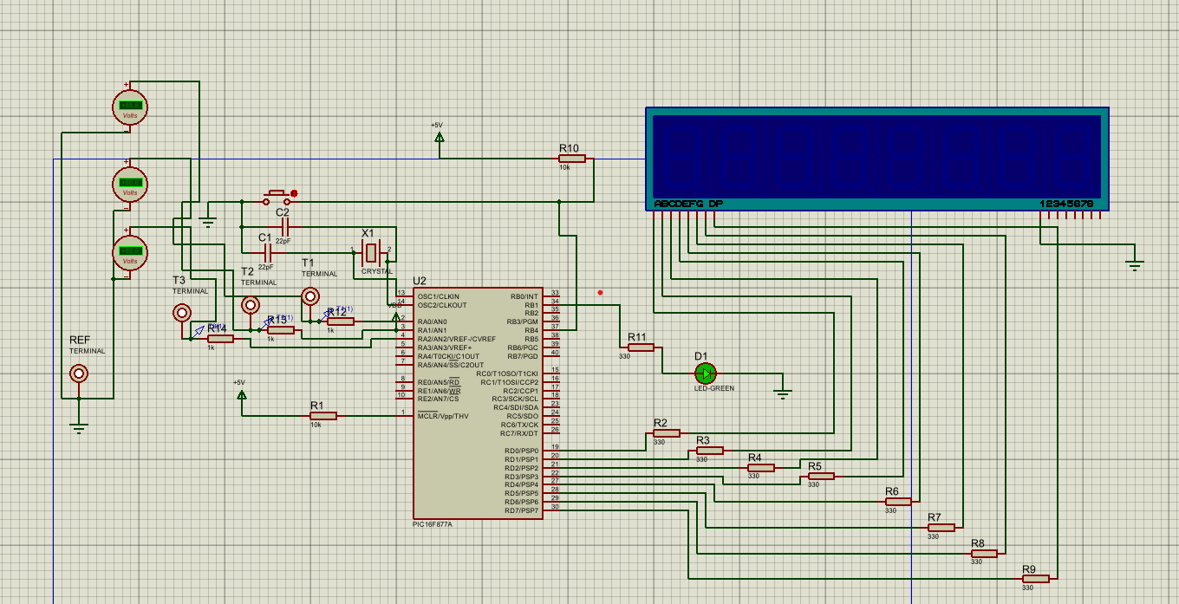

4.2 System Architecture
The electrical fault simulator is designed as a microcontroller-controlled embedded system. The PIC16F877A acts as the central controller that manages the operation of all system components. This type of architecture is typical of embedded systems, where a single microcontroller coordinates input processing and output control, as described by Vahid and Givargis [4].
The architecture of the system is made up of several functional subsystems:
• Microcontroller control unit
• Clock generation circuit
• Reset circuitry
• Test point output interface
• LED load indicator
• User input interface
• Seven segment display system
Each subsystem performs a specific role within the overall design. The microcontroller processes user inputs and generates output signals that represent different circuit conditions. The clock generation circuit ensures that the microcontroller operates at a stable frequency, while the reset circuit ensures that the device starts correctly when power is applied. These supporting subsystems are fundamental to reliable microcontroller operation, as outlined in embedded system design literature [5].
The test point outputs represent the voltage levels at different positions within the simulated electrical circuit. These test points allow the user to measure voltages using simulated measurement instruments in Proteus. By analysing these voltage values, the user can determine the location of the simulated fault, following standard voltage tracing techniques used in electrical fault diagnosis [6].
The LED indicator represents the electrical load within the system. In normal operating conditions the LED is illuminated, indicating that current is flowing through the circuit. When certain faults occur, the LED remains off to simulate a failed load or an interrupted power supply. This behaviour reflects basic circuit operation principles described in electrical engineering theory [11].
The seven-segment display gives feedback to the instructor or system operator by showing the currently active fault number. This allows controlled troubleshooting exercises to be performed where students must identify the fault without being directly told which fault is active. Such approaches support active learning and diagnostic reasoning in engineering education, as discussed by Biggs and Tang [14].
Figure 4 Fault Simulator system architecture
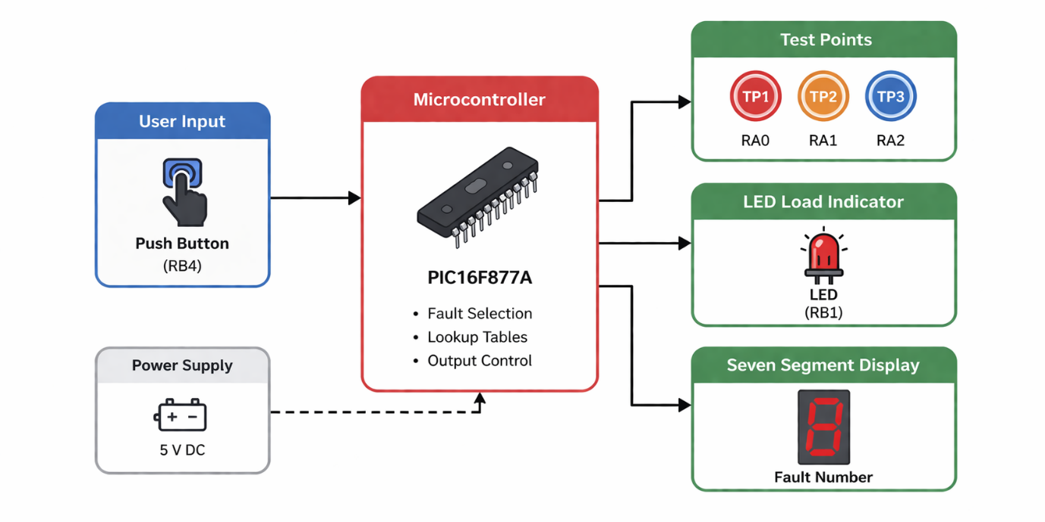

4.3 Hardware Design

4.3.1 Microcontroller Selection
The PIC16F877A microcontroller was selected as the main processing unit for the electrical fault simulator. This microcontroller is part of Microchip Technology’s widely used PIC16 family and specifies several features that make it suitable for embedded control applications, as outlined in the device data sheet [3].
One of the primary reasons for selecting this device is the availability of many input/output pins. The PIC16F877A presents five I/O ports (PORTA to PORTE), allowing multiple components to be connected simultaneously. In this project, the microcontroller must control test point outputs, an LED indicator and a seven-segment display while also reading user inputs. The number of available I/O pins makes the device suitable for this application, supporting flexible hardware interfacing as described by Mazidi et al. [2].
Another advantage of the PIC16F877A is its compatibility with the MPLAB X development environment and the CCS C compiler. These tools provide a convenient platform for writing, compiling and debugging embedded software. Additionally, the PIC16F877A is widely supported within the Proteus simulation environment, making it possible to integrate hardware simulation with software development. This integration reflects common embedded system development practices, where hardware and software are designed and tested together [4].
The microcontroller operates using a Harvard architecture with separate program and data memory. This architecture allows instructions to be executed efficiently while maintaining reliable program operation, a principle widely used in embedded system design [5]. The device also includes features such as timers, interrupt capabilities and analogue-to-digital converters, although not all these features are required for the current project.
Figure 5 PIC16F877A pin map [1]
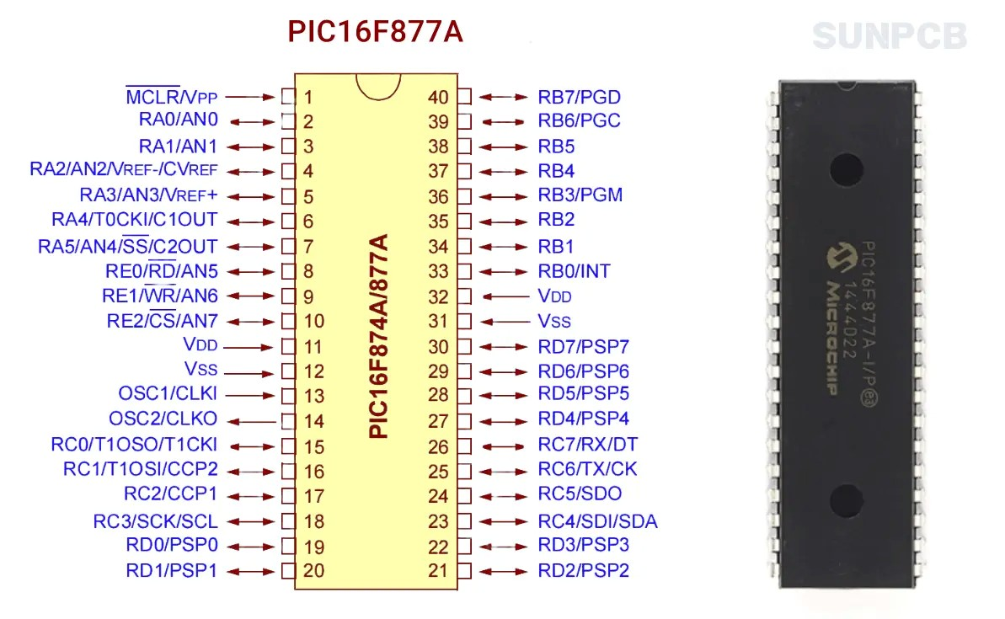

A microcontroller was chosen over a PLC for several reasons, firstly was due to the size and weight requirements of the final project. As this product is intended for use within a classroom or remotely for the students, it needed to be handheld where a PLC system would need to be larger and heavier so would not meet this specification. Also, a microcontroller is a more flexible system as it requires less maintenance and can be easily re-programmed, a PLC system shares this quality but is not as easy and would require more hardware. Although a PLC would add a level of robustness to the system, this would increase the complexity of the system, this transition could be a future consideration for the system to improve the performance and durability.
Using a PIC over a PLC system also allows for a larger selection of Inputs and Outputs making the system easier to expand over time, as the list of faults increases where further hardware is needed, these changes can be incorporated more easily where I/O ports are readily available.
The selection of the PIC16F877A reflects a design decision prioritising simplicity, availability and educational suitability over computational performance. While more advanced microcontrollers offer greater processing capability and integrated features, the PIC16F877A presents sufficient functionality for the required control tasks while maintaining a straightforward architecture. This makes it particularly suitable for teaching environments, where ease of understanding and reliability are more important than system complexity.

4.3.2 Clock Generation Circuit
For the microcontroller to execute instructions correctly, it must be provided with a stable clock signal. The clock determines the speed at which the microcontroller executes instructions and affects the timing behaviour of the entire system, as described in embedded system design principles by Vahid and Givargis [4].
The clock signal in this design is generated using an external crystal oscillator connected to the OSC1 and OSC2 pins of the PIC16F877A. The crystal oscillator offers a precise and stable clock frequency compared to internal oscillator options. Two capacitors are connected between the crystal terminals and ground to stabilise the oscillation and ensure reliable operation, a configuration commonly recommended in microcontroller hardware design [3].
The microcontroller configuration specifies the use of the HS oscillator mode, which is designed for high-speed crystal oscillators. The clock frequency used in this design is 4 MHz, which keeps sufficient processing speed for the required functionality while keeping the system design simple and stable, in line with typical embedded system timing requirements [5].
The clock configuration is defined within the firmware using the following directive:
#use delay(clock=4000000)
This directive informs the compiler of the clock frequency so that accurate timing delays can be generated within the software, supporting precise control of system behaviour [23].

4.3.3 Reset Circuit
The reset circuit ensures that the microcontroller starts in a known state when power is applied. This is achieved using the MCLR (Master Clear) pin on the PIC16F877A, as described in the device configuration documentation provided by Microchip Technology [3].
The MCLR pin is connected to the power supply through a pull-up resistor. This resistor ensures that the reset pin remains at a logic high level during normal operation. When the reset pin is pulled low, the microcontroller resets and restarts the program execution from the beginning. This type of reset configuration is commonly used in embedded systems to ensure reliable startup behaviour [5].
The configuration fuses defined within the program also enable additional features such as the power-up timer and brown-out protection. These features help ensure that the microcontroller does not start executing instructions until the power supply voltage has stabilised, improving system reliability and preventing unintended behaviour during startup conditions [4].

4.4 Test Point Design
A key concept of the electrical fault simulator is the use of test points that allow voltage measurements to be taken during troubleshooting. In real electrical systems, engineers commonly measure voltages at specific locations within a circuit to determine whether components are functioning correctly, following standard diagnostic techniques described by Isermann [6] and supported by circuit analysis principles [10].
In this design, three test points are fulfilled using output pins on the microcontroller. The test point mapping is defined as follows:
• RA0 → Test Point 1
• RA1 → Test Point 2
• RA2 → Test Point 3
Each test point corresponds to a location within the simulated electrical circuit. These outputs generate voltage levels that represent the behaviour of the circuit under different operating conditions. By observing these voltage values, users can apply voltage tracing methods to identify the location of faults within the system [11].
The values applied to these test points are controlled by the microcontroller software using predefined lookup tables. Each fault scenario corresponds to a specific combination of logic levels applied to these outputs. This software-controlled approach to signal generation is a common feature of embedded systems, where system behaviour can be modified without altering the hardware configuration [2].
This design approach allows multiple fault conditions to be simulated without requiring changes to the hardware, providing a flexible and efficient platform for training applications.

4.5 LED Load Indicator
The LED component in the circuit represents the electrical load within the simulated system. In many real-world electrical systems, loads such as lamps or motors provide a visual indication of whether the circuit is functioning correctly, as described in fundamental electrical engineering principles [11].
The LED is connected to pin RB1 of the microcontroller. A current-limiting resistor is connected in series with the LED to prevent excessive current from flowing through the device. This is a standard practice in electronic circuit design to protect components from damage and ensure safe operation [10].
The LED state is controlled by the microcontroller software. When the circuit is operating normally, the LED output is set to logic high and the LED illuminates. When certain fault conditions occur, the LED remains off to simulate a failed load or a broken circuit. This behaviour reflects the relationship between circuit continuity and load operation in practical systems [19].
The behaviour of the LED is defined using a lookup table within the software. This table specifies whether the LED should be on or off for each fault condition. Using software-defined control for output behaviour is a common approach in embedded systems, allowing flexible system operation without requiring changes to the hardware [2].

4.6 User Input Interface
The system includes a push button connected to pin RB4 which allows the user to change the active fault condition. As shown in Figure 1, the push button is mounted on the front panel of the enclosure (bottom right), providing a simple and accessible user interface for cycling through the simulated faults.
The push button is configured as an active-low input, meaning that the input pin normally reads a logic high value due to a pull-up resistor. When the button is pressed, the input is pulled to ground and the microcontroller detects a logic low signal. This configuration is commonly used in embedded systems to ensure stable and reliable input detection, as described in microcontroller interfacing techniques [2].
The program continuously monitors this input within the main program loop. When a button press is detected, the system increments the fault number and updates the outputs accordingly. This polling-based input handling approach is typical in simple embedded control systems where real-time response requirements are minimal [4].
To prevent false triggering caused by switch bounce, a short delay is introduced after detecting a button press. This technique, known as software debouncing, is widely used to ensure that only a single input event is registered for each physical button press, improving system reliability and user interaction [23].
Figure 6 Fault simulator (user perspective)
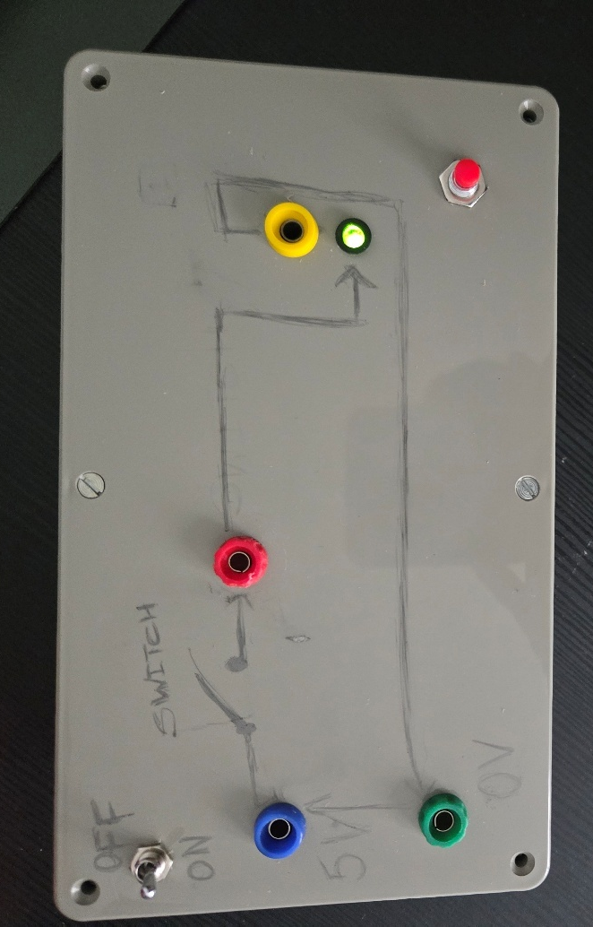

4.7 Seven Segment Display System
The seven-segment display gives a visual indication of the currently active fault condition. This display consists of multiple LED segments arranged to form numerical characters, a common output method in embedded systems for simple numeric feedback [2]. The segments of the display are connected to PORTD of the microcontroller through current limiting resistors. Each segment is controlled individually by the microcontroller, allowing specific patterns to be generated to represent different numbers.
A lookup table within the software defines the segment patterns required to display the numbers 0 to 3. These values are written to PORTD whenever the fault condition changes. This approach simplifies the control logic and ensures consistent output behaviour, as lookup tables are widely used in embedded systems to map input states to predefined outputs [23].
Using a seven-segment display delivers a simple and effective method of communicating the active fault number, particularly in educational systems where clear and immediate feedback is required for user interaction.
However, lines within the program must be correct for the seven-segment display to function, the current state of the prototype is that the seven-segment display is not on the user interface. This is due to the code display the number on the seven-segment inverted, where the unlit LED’s represent the number being displayed – This is demonstrated in the image below where the display is showing ‘2’ in the un-lit LED’s.
Figure 7 seven-segment coding error
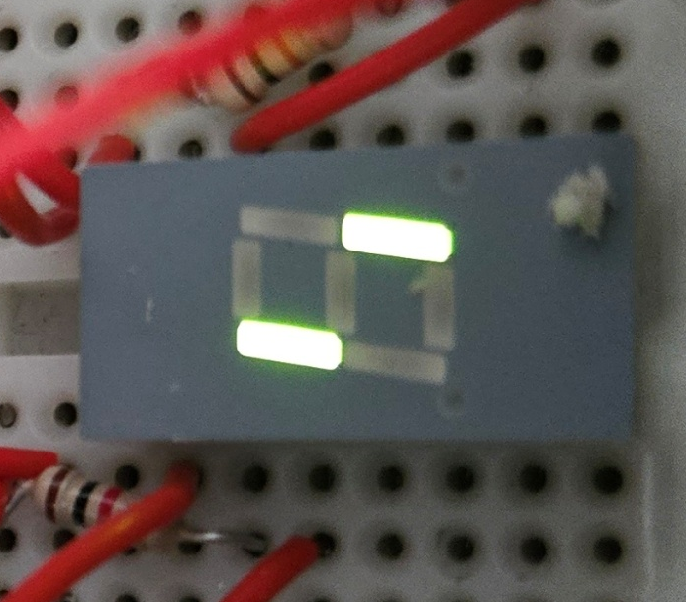
This requires a change in the code and was highlighted during the physical test phase of the system, the decision was made to remove this from the students interface to avoid confusion and present this back to the interface once the error has been corrected.

4.8 Firmware Design
The microcontroller firmware was written in the C programming language using the CCS compiler. The program begins by defining configuration fuses that control the behaviour of the microcontroller hardware. These configuration settings disable unnecessary features such as the watchdog timer and enable the correct oscillator mode for the external crystal, as specified in the device configuration guidelines provided by Microchip Technology [3].
The program defines a variable called fault which stores the currently active fault scenario. This variable cycles through the values 0 to 3. Three lookup tables are used to define the behaviour of the system. The first table defines the seven segment display patterns required to display the numbers 0 to 3. The second table defines the logic levels applied to the test point outputs. The third table defines the state of the LED indicator for each fault condition.
Using lookup tables simplifies the program structure and allows fault behaviour to be modified easily. This approach is commonly used in embedded systems to map system states to predefined outputs, improving code efficiency and readability, as described by Barr and Massa [23].

4.9 Fault Control Algorithm
A dedicated function called applyFault() is used to update the system outputs. This function reads values from the lookup tables and writes them to the appropriate microcontroller pins. The test point outputs are updated using the output_bit() function, allowing individual pins to be controlled independently. This type of direct hardware control is a common feature of embedded C programming, where specific I/O pins are manipulated to achieve the required system behaviour [23].
The LED output is updated using the same function based on the values stored in the LED lookup table. Finally, the seven segment display is updated using the output_d() function, which writes the appropriate segment pattern to PORTD. This structured approach to output control ensures that all system components are updated consistently, supporting reliable and predictable system operation, as expected in embedded system design [4].

4.10 System Operation
After the microcontroller ports are configured, the program enters an infinite loop. Within this loop the system continuously performs three main tasks:
- Apply the current fault condition
- Monitor the push button input
- Update the outputs if the fault condition changes
This type of continuous loop structure is typical in embedded systems, where the microcontroller repeatedly executes a defined sequence of operations to maintain system functionality, as described by Vahid and Givargis [4].
When the button is pressed, the fault number is incremented. If the maximum fault number is reached, the value loops back to zero. This cyclic control structure allows the system to iterate through predefined states efficiently, a common approach in embedded control applications where system behaviour is governed by discrete operating modes [23]. This process allows the system to cycle through all available fault conditions.
Figure 8 Firmware operation flow chart
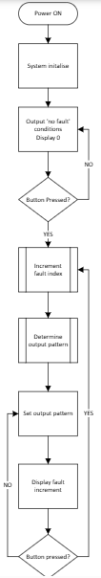

4.11 Proteus Simulation Implementation
The complete system was made using the Proteus Design simulation environment. Proteus allows electronic circuits and microcontroller programs to be simulated together within a single environment, enabling integrated hardware and software test and development as part of the design process [12].
The microcontroller program was compiled using the CCS compiler to generate a HEX file. This file was then loaded into the PIC16F877A component within the Proteus schematic. When the simulation is started, the microcontroller executes the program exactly as it would on physical hardware, reflecting standard embedded system development workflows where compiled code is deployed directly onto the target device [23].
The push button can be pressed during simulation to change the active fault condition, allowing dynamic interaction with the system. Virtual measurement instruments within Proteus were used to observe voltages at the test points. These measurements confirm that the circuit produces the expected behaviour for each fault scenario, supporting system validation through simulation-based testing [21].
This phase of the project is important to understand and rectify any errors within the system. At this phase it is much easier to rectify an error within the program or the system design as changes can be made quickly and tested, this is a more efficient development method than making the changes within the protype physical system.
During simulation, adjustments were required to ensure correct segment mapping and output behaviour. This highlighted the importance of verifying pin configurations before transitioning to hardware.

4.11.1 Physical Prototype Implementation
Following successful simulation within the Proteus environment, a physical prototype of the electrical fault simulator was constructed to validate real-world operation. The circuit was initially assembled on a breadboard, allowing flexibility during development and enabling modifications to be made easily. This approach is commonly used in embedded system prototyping to support rapid iteration and testing before final implementation [4].
The PIC16F877A microcontroller was programmed using a PICkit 3, which allowed the compiled HEX file to be uploaded directly to the device. This ensured that the firmware tested in simulation could be transferred to the physical system without modification, reflecting standard embedded development workflows [23].
To create a user-friendly training device, the main interface components were mounted on the front panel of an enclosure. These components included the test point terminals, seven-segment display, push button switch and LED indicator. This layout allows users to interact with the system in a structured manner, similar to practical laboratory equipment, supporting effective hands-on learning [14].
The breadboard containing the main circuit and a battery power supply were housed within the enclosure. This internal arrangement protects the circuitry while maintaining accessibility for maintenance and modification if required.
Permanent connections for external components such as the test points, display and battery holder were achieved through soldering. This improves mechanical stability and ensures reliable electrical connections during operation, which is essential for consistent system performance in practical applications [21]. The combination of breadboard prototyping and selective soldering grants a balance between flexibility and robustness.
The completed prototype shows how the simulated design can be translated into a functional physical training system, suitable for use in educational environments. This transition from simulation to hardware implementation is a key aspect of embedded system design, ensuring that theoretical behaviour is validated under real operating conditions [5].

4.12 Summary
This chapter explored the design and implementation of the electrical fault simulation system developed during this project. The design includes test points that allow voltage measurements to be taken during troubleshooting exercises, an LED load indicator that represents circuit operation and a seven segment display that indicates the active fault number. These features replicate standard diagnostic techniques used in electrical fault analysis, where system behaviour is interpreted through measurement and observation [6].
The firmware controlling the system uses lookup tables and a simple fault selection algorithm to update the system outputs. The complete design was applied and tested using the Proteus simulation environment, before being successfully translated into a physical prototype constructed using a breadboard-based circuit and enclosure-mounted interface components. This progression from simulation to physical implementation reflects established engineering development practices [4].
These conditions were validated during testing with the prototype, there were ongoing efforts of validation during the development to ensure that any errors were identified as early in the process as possible. Challenges encountered included identifying the pinout of the seven-segment display had to be individually determined using a multimeter as there was ambiguity in the pinout models available.
The next chapter presents the experimental results obtained from testing the system and evaluates how effectively the simulator reproduces real electrical fault conditions.

CHAPTER 5 – RESULTS AND DISCUSSION

5.1 Introduction
This chapter reveals the results obtained from testing the electrical fault simulator developed in this project and discusses how effectively the system reproduces different electrical fault conditions. The aim of the testing process was to verify that the simulator behaves according to the design specifications and that the voltage measurements available at the test points allow faults to be diagnosed in a realistic manner, following standard fault diagnosis principles [6].
The system was evaluated using the Proteus Design Suite simulation environment and further validated using a physical prototype constructed during the implementation stage. Proteus allows both the electronic circuit and the microcontroller firmware to operate simultaneously, enabling the entire system to be tested without the need for physical hardware [12]. The firmware compiled from the CCS C program was loaded into the PIC16F877A component within the simulation. Once the simulation was started, the microcontroller executed the program exactly as it would in a real hardware system, reflecting standard embedded system deployment and testing procedures [23].
Testing involved cycling through each available fault condition using the push button input connected to pin RB4 of the microcontroller. For each fault scenario the behaviour of the system was observed and recorded. Particular attention was given to the following characteristics:
• Voltage levels at each test point
• Behaviour of the LED load indicator
• Output displayed on the seven segment display
• Overall circuit behaviour
These results were compared with the expected behaviour defined by the firmware lookup tables to confirm that the system operates correctly. This comparison between measured and expected values is a fundamental aspect of engineering validation and system testing [21].
While initial validation was carried out within the Proteus simulation environment, key measurements were also verified using the physical prototype to confirm consistency between simulated and real-world behaviour.

5.2 Test Environment
The simulator was tested entirely within the Proteus simulation environment. The circuit designed in Proteus includes the PIC16F877A microcontroller, an external crystal oscillator, reset circuitry, LED load indicator, seven segment display and push button input. The microcontroller firmware was compiled using the CCS compiler to generate a HEX file, which was then loaded into the microcontroller component within the Proteus schematic. When the simulation was executed, the microcontroller began running the firmware and controlling the outputs according to the programmed logic. This integrated simulation approach reflects standard embedded system development practices, where both hardware and software are validated together prior to physical implementation [12].
Virtual voltmeters were placed at each of the test points to measure the voltage values generated by the microcontroller outputs. These voltmeters provide readings that correspond to the logic levels applied to the output pins, supporting system verification through simulated measurement techniques [21].
The test points correspond to the following microcontroller pins:
RA0 – Test Point 1
RA1 – Test Point 2
RA2 – Test Point 3
Each test point represents a location within the simulated electrical circuit where a technician might normally take voltage measurements during troubleshooting. By measuring the voltage levels at these points, it is possible to determine the state of the circuit and identify the presence of faults, following standard voltage tracing methods used in electrical fault diagnosis [6].
In addition to simulation-based testing, the physical prototype was also tested to verify real-world operation. The prototype consisted of a breadboard-based circuit housed within an enclosure, with the test points, seven segment display, LED indicator and push button mounted on the front panel. The PIC16F877A microcontroller was programmed using a PICkit 3.
Voltage measurements were taken at the test points using a digital multimeter. These measurements were compared with the simulation results to confirm consistency between simulated and physical system behaviour. This comparison between simulated and real-world results is an important aspect of engineering validation, ensuring that the system performs reliably under practical operating conditions [21].
Figure 9 Fault condition 0 (no fault)
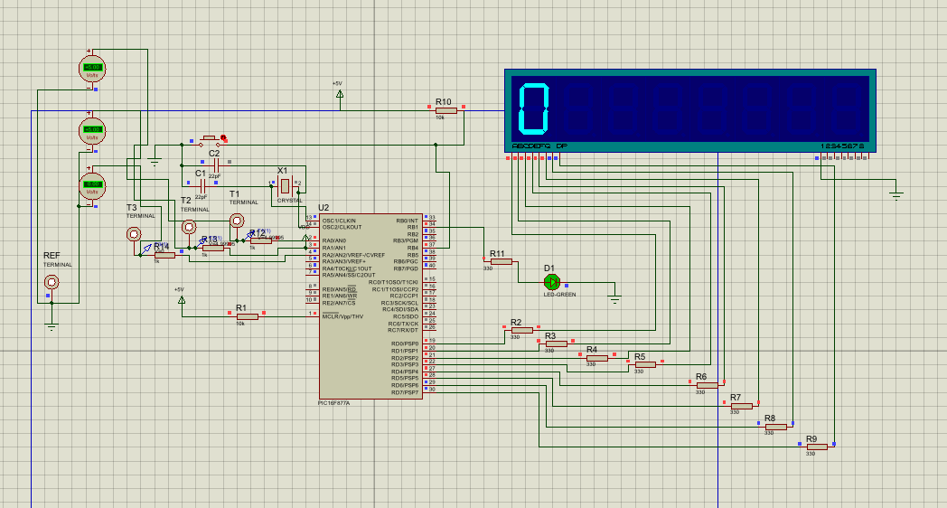
Minor variations were observed during physical testing due to measurement tolerance and component behaviour, although these did not significantly affect system operation. These voltage variations seen were in the order of 0.1V and were determined too small to effect the system or the user experience so were accepted as a system characteristic.
Figure 10 Fault condition 1
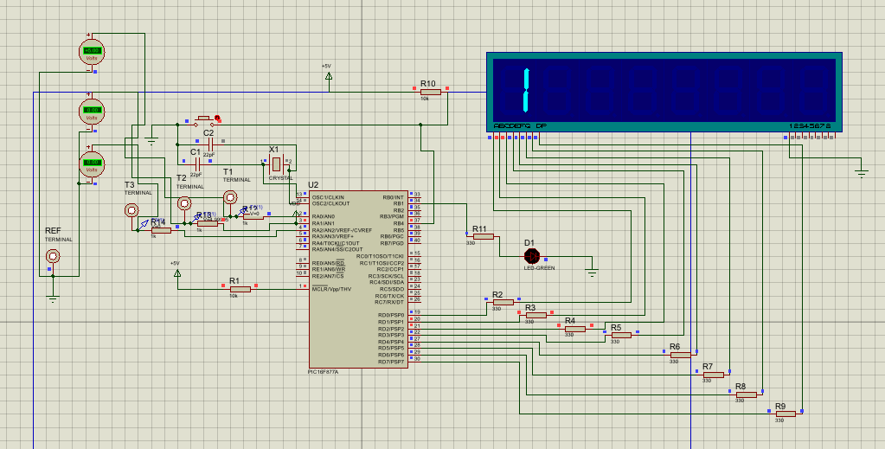
Figure 11 Fault condition 2
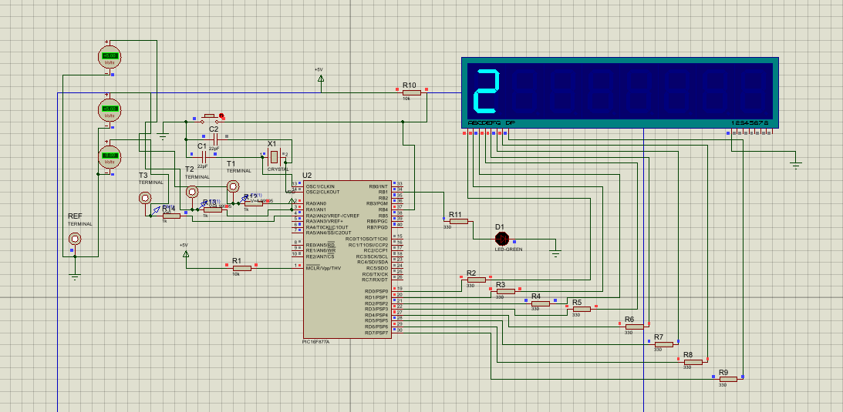
Figure 12 Fault condition 3
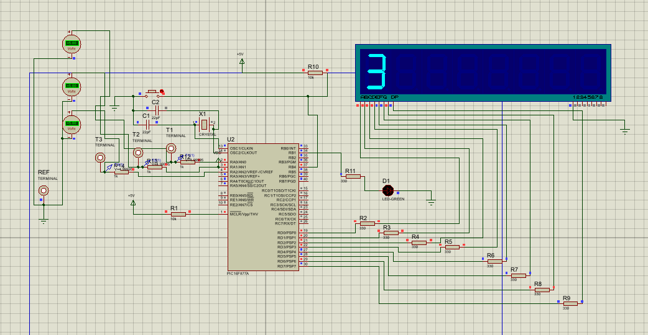
The behaviour observed in the physical prototype closely matched the simulation results, confirming that the design translates effectively from a virtual environment to real hardware. This consistency strengthens the validity of the simulation model used during development

5.3 System Behaviour During Normal Operation
The first test scenario represents normal circuit operation. In this condition the system behaves as though the electrical circuit is functioning correctly and all components are operating as expected. This scenario provides a baseline for comparison with fault conditions, reflecting standard testing practices in electrical system evaluation [21].
According to the firmware design, the following logic levels are applied to the test points in this condition:
Test Point 1 – High
Test Point 2 – High
Test Point 3 – Low
This configuration represents a situation where the power supply is functioning correctly and voltage is reaching the switching stage of the circuit, consistent with normal circuit behaviour described in electrical theory [10].
The LED load indicator is enabled in this condition. The LED connected to pin RB1 illuminates, indicating that the load is receiving power and operating normally. The seven-segment display shows the digit 0, indicating that the system is currently in the normal operating state.
During simulation, the voltmeters connected to the test points confirmed that the measured voltages corresponded with the expected logic levels. Test Point 1 and Test Point 2 measured approximately 5 V, while Test Point 3 measured approximately 0 V. These measurements confirm that the microcontroller correctly generates the output pattern defined for normal operation.
From a diagnostic perspective, a technician observing these measurements would determine that the circuit is operating correctly. Voltage is present at the appropriate locations, and the load indicator is illuminated, demonstrating standard voltage tracing principles used in fault diagnosis [6]. Measurements obtained from the physical prototype matched the simulation results, confirming correct system behaviour under normal operating conditions.

5.4 Power Supply Failure Simulation
The second test scenario simulates a failure of the power supply. Power supply faults are among the most common issues encountered in electrical systems and may occur due to blown fuses, disconnected batteries or faulty power converters, as described in electrical fault diagnosis literature [6].
In this scenario the firmware generates the following output values:
Test Point 1 – Low
Test Point 2 – Low
Test Point 3 – Low
The LED load indicator is also turned off in this state. The seven segment display shows the digit 1, indicating that fault condition one is currently active.
During simulation the voltmeters confirmed that all three test points measured approximately 0 V. This behaviour accurately represents a circuit in which the power supply is not providing any voltage, consistent with expected circuit behaviour under supply failure conditions [10].
From a troubleshooting perspective this fault condition is relatively straightforward to identify. When a technician measures zero volts at the first test point it immediately suggests that the power supply is not functioning. The absence of voltage at all test points confirms that the problem lies at the very beginning of the circuit. This diagnostic process reflects standard voltage tracing techniques used in electrical fault identification [11].
This result confirms that the simulator successfully replicates the electrical behaviour associated with a power supply failure. Testing of the physical prototype produced identical results, with all test points measuring approximately 0 V, validating the simulated behaviour and confirming consistency between simulation and real-world operation [21].
This represents a common fault within the real-world where power supplies have failed or circuit protective components have activated, identifying these situations early can save a lot of time in the fault diagnosis where the fault does not lead to the testing of several components before identifying that the circuit power has been removed.
Although, as the multimeter measures potential difference between the probes, this shows as ~0V. This would show the same result if there were the same voltage on each of the test point e.g 5V on the earth reference, this makes it difficult for an inexperienced electrician to diagnose the fault due to the potential of it having no voltage or high voltage on ground from the first measurement. This was not considered when concepting the simulated faults and should have been considered, this puts a limitation on the system

5.5 Open Circuit Fault Simulation
The third test scenario represents an open circuit fault occurring somewhere between the power supply and the load. Open circuit faults are commonly encountered in electrical systems and typically result from breaks in the conductive path, as described in fault diagnosis literature [6].
The firmware generates the following voltage pattern for this condition:
Test Point 1 – High
Test Point 2 – Low
Test Point 3 – Low
The LED load indicator remains off in this scenario. The seven segment display shows the digit 2, indicating that fault condition two is active. During testing the voltmeters confirmed that Test Point 1 measured approximately 5 V, while Test Point 2 and Test Point 3 measured approximately 0 V.
This voltage pattern indicates that the power supply is functioning correctly but that the circuit path has been interrupted before reaching the later stages of the system. In real electrical systems this type of fault could be caused by broken wires, faulty switches or damaged connectors, consistent with standard circuit fault behaviour [10]. A technician analysing these measurements would determine that the fault must be located between Test Point 1 and Test Point 2.
This scenario clearly shows that the value of voltage tracing techniques in electrical troubleshooting. By measuring voltages sequentially along the circuit path, the technician can narrow down the location of the fault, following established diagnostic procedures [11]. The same voltage pattern was observed during physical testing, confirming accurate reproduction of an open circuit condition and validating the simulator’s behaviour [21]. As damaged components and loose connections are very common is installations, particularly industrial, this is an important fault condition to become familiar with.

5.6 Load Failure Simulation
The final fault scenario simulates a failure of the load component. Load failures are a common source of faults in electrical systems and often occur due to component degradation or internal damage, as described in electrical fault analysis literature [6].
In this condition the firmware generates the following output pattern:
Test Point 1 – High
Test Point 2 – High
Test Point 3 – High
Despite the presence of voltage at all test points, the LED load indicator remains off. The seven segment display shows the digit 3, indicating that fault condition three is active. During simulation the voltmeters confirmed that all test points measured approximately 5 V.
From a troubleshooting perspective this result indicates that voltage is present throughout the circuit but the load is not operating. In real electrical systems this situation may occur if a lamp filament has broken, a motor winding has failed, or an electronic device has become defective, consistent with standard circuit behaviour under load failure conditions [10]. A technician observing these measurements would conclude that the load component itself is faulty.
This scenario highlights an important principle in electrical troubleshooting: the presence of voltage does not necessarily guarantee that a component is functioning correctly. Effective diagnosis requires both voltage measurement and an understanding of component behaviour, as discussed in electrical engineering practice [11]. Physical testing confirmed this behaviour, with voltage present at all test points while the load indicator remained off, demonstrating consistency between simulated and real-world operation [21].

5.7 Summary of Experimental Results
The results obtained from testing the simulator are summarised in Table 5.1.
The results confirm that each fault condition produces a unique combination of voltage values. These patterns allow the fault location to be identified using systematic measurement techniques.
Table 1 Expected behaviour
Fault Condition | TP1 | TP2 | TP3 | LED | Interpretation
Normal | 5 V | 5 V | 0 V | ON | Circuit operating normally
Power Failure | 0 V | 0 V | 0 V | OFF | Power supply fault
Open Circuit | 5 V | 0 V | 0 V | OFF | Break between TP1 and TP2
Load Failure | 5 V | 5 V | 5 V | OFF | Load component faulty

The measured voltage values closely aligned with the expected output patterns defined in the firmware, confirming that the system behaves as intended. This agreement between expected and observed results provides confidence in both the design and implementation of the simulator

5.8 Diagnostic Reasoning Using Test Points
The design of the simulator allows students to practise the diagnostic reasoning process used by electrical engineers. When troubleshooting a circuit, technicians typically follow a logical sequence of measurements, beginning with verification of the power supply, as described in standard fault diagnosis methodologies [6].
If voltage is present at the first measurement point, the technician proceeds to the next point in the circuit. If voltage disappears between two points, the fault must lie somewhere between them. This step-by-step approach to fault identification is commonly referred to as voltage tracing and is a fundamental technique in electrical troubleshooting [11]. The process continues until the faulty component or connection is identified.
The simulator replicates this procedure by providing three test points that correspond to different stages of the circuit. Students can then practise interpreting measurement results and drawing logical conclusions about the location of faults. This type of structured, hands-on learning is widely recognised as effective in engineering education, where practical experience reinforces theoretical understanding [14].

5.9 Evaluation of System Performance
The testing results indicate that the product performs reliably within both the simulation environment and the physical prototype. Each fault scenario produces the expected output pattern and the system responds consistently to push button inputs. This level of deterministic behaviour is characteristic of microcontroller-based embedded systems, where predefined logic ensures repeatable and predictable outputs [2].
The seven-segment display correctly indicates the currently active fault condition and updates immediately when the fault state changes. The LED load indicator also behaves consistently with the simulated circuit conditions. The use of lookup tables within the firmware ensures that the output patterns remain stable across repeated tests, allowing identical fault conditions to be reproduced. This repeatability is particularly important in training applications, where consistent system behaviour supports structured learning and skill development [14].
The consistency observed between the Proteus simulation and the physical prototype further validates the reliability of the design. Voltage measurements obtained using a digital multimeter matched those observed in simulation, confirming that the system design translates effectively from a virtual environment to real hardware. This agreement between simulated and measured results is a key indicator of successful engineering validation [21].
However, while the system design performs reliably under the conditions tested, it highlights that the simulation environment does not account for real-world factors such as electrical noise, component tolerances or environmental variation. As a result, although the product is suitable for educational use, additional testing would be required to fully assess its performance in more demanding or industrial environments.
The system performed consistently across repeated tests, with measured voltage levels closely matching expected values. However, this reliability is dependent on controlled conditions and does not account for external factors such as electrical noise or component variation, which would influence behaviour in real-world systems.

5.10 Educational Effectiveness
One of the primary objectives of the project was to develop a training tool that enables students to practise electrical fault-finding techniques. The results obtained from testing demonstrate that the simulator gives clear and distinguishable fault conditions that can be diagnosed using voltage measurements, supporting established diagnostic methodologies [6].
The inclusion of multiple test points encourages students to follow a structured troubleshooting process rather than relying on guesswork. By measuring voltages sequentially and interpreting the results, users are required to apply logical reasoning to identify fault locations. This reflects standard voltage tracing techniques used in professional electrical engineering practice [11].
The push button interface allows fault conditions to be cycled quickly, enabling instructors to present multiple scenarios within a short period of time. This enhances the usability of the system in laboratory environments and supports interactive teaching methods. Practical, hands-on learning of this type has been shown to significantly improve student understanding and retention of engineering concepts [14].
Additionally, the use of a microcontroller-based design allows the simulator to be easily modified or expanded. Fault conditions can be added or adjusted through software without requiring changes to the physical circuit, demonstrating the flexibility of embedded systems in educational applications [2].
The results highlight that the simulator effectively supports the development of diagnostic reasoning skills. By requiring users to interpret voltage measurements rather than directly identifying faults, the simulator encourages a structured analytical approach. This aligns with industry practice, where technicians must rely on measurement data rather than predefined fault indicators.
The clear distinction between fault conditions ensures that users can confidently associate measurement patterns with specific types of faults. However, this clarity also reduces ambiguity, which is often present in real systems. As a result, while the simulator is highly effective for foundational training, further complexity would be required to fully replicate real-world diagnostic challenges or this training would need to be followed by real-world application.

5.11 Limitations of the simulator
Although the simulator performs effectively for the scenarios selected, it does have certain limitations. A limitation is that the system represents voltages using digital logic levels rather than true analogue behaviour. In real circuits, voltage levels may vary continuously and faults may produce partial voltage drops rather than complete loss of power, as described in detailed circuit analysis by Sedra and Smith [10]. This simplification means that some real-world fault characteristics are not fully represented within the current design.
Another limitation is the relatively small number of fault conditions selected in the current system. Only three scenarios are included, which may limit the complexity of troubleshooting exercises. However, these limitations are largely due to the simplified design of the simulator and reflect a trade-off between system complexity and usability, a common consideration in engineering design [4]. These constraints could be addressed in future improvements by expanding the range of simulated faults and incorporating more advanced circuit behaviour.
The final limitation identified, is that the current system sequentially cycles through fault 0-3, this should randomised in further iterations to ensure that the teaching of fault diagnosis is done correctly and that the student cannot complete the exercise by remembering or being given the answers from other students.
The seven-segment display provides a simple and effective method of indicating the active fault condition. While this approach is sufficient for controlled training scenarios, it offers limited information and does not reflect the type of diagnostic feedback typically available in real systems, where more detailed interfaces may be used.
Although the system successfully demonstrates fundamental fault conditions, its simplified digital implementation limits its ability to represent more complex electrical behaviour. In particular, the absence of analogue variation reduces realism and restricts the system’s applicability to introductory training scenarios.
Power supply failure fault shows 0V across the probes which could be representative of no power at the pins or there being voltage on both pins. This should have been considered as this system is intended for inexperienced students to practice, this ambiguity makes this fault difficult to diagnose for the students. Although this is an important fault to understand, it could have been proposed as a future improvement with a more binary fault included in the initial build.

5.12 Chapter Summary
This chapter has presented the results obtained from testing the electrical fault simulator within both the Proteus simulation environment and the physical prototype. The system successfully reproduces four different operating conditions, including normal operation and three common electrical faults. The voltage patterns observed at the test points match the expected behaviour defined in the firmware in both simulated and real-world testing conditions, confirming correct system operation and validation [21].
The results demonstrate that the simulator presents a practical and effective platform for practising electrical troubleshooting techniques, supporting established diagnostic methods used in electrical engineering [6]. It describes that the results are consistent, accurate and reproducible but also outlines some of the limitations of the system. One being that the system is not representative of normal electrical systems due to the voltage level, and that due to the power supply, the output voltage is slightly lower in prototype testing (~4.8V) compared with the simulated voltage (5V), although this disparity does not effect the operation of the system.

CHAPTER 6 – EVALUATION

6.1 Introduction
This chapter evaluates the electrical fault simulation system developed in this project and assesses how effectively it meets the objectives defined in Chapter 1. The purpose of this evaluation is to analyse the performance of the simulator, discuss its strengths and limitations, and consider how the design could be improved or extended in the future. This type of evaluation is an essential part of the engineering design process, where system performance is assessed against defined requirements and objectives.
The evaluation considers several aspects of the product, including its technical performance, reliability, educational value and scalability. The results obtained during testing are compared with the project objectives to determine whether the system successfully fulfils its intended purpose. This comparison between expected and observed performance is a fundamental aspect of engineering validation and system assessment.
In addition to assessing the technical functionality of the simulator, this chapter also seeks to describe the design choices made during the project and discusses how those decisions influenced the overall outcome. This reflective evaluation aligns with best practices in engineering design, where both the process and the final product are critically analysed to identify areas for improvement.

6.2 Evaluation Against Project Objectives
The simulator was evaluated by comparing its performance against the objectives defined in Chapter 1. The primary aim of the project was to design and develop a system that allows students to practise electrical fault-finding techniques using a simulated circuit environment.
This objective has been successfully achieved. The simulator runs multiple fault conditions that can be analysed using voltage measurements at defined test points. The behaviour of the system is consistent and predictable, allowing users to apply structured troubleshooting techniques to identify faults.
The product meets its intended objectives as an educational training tool, while also highlighting the limitations of simplified communication architectures in comparison to industry-standard solutions.
The system clearly demonstrates a high level of functional reliability within both the simulation environment and the physical prototype. The use of deterministic lookup tables ensures that each fault condition produces a consistent and repeatable output pattern. This is particularly beneficial for educational applications, as it allows students to repeatedly analyse the same fault scenarios and develop structured diagnostic techniques.
However, this deterministic behaviour also introduces a limitation in terms of realism. In practical electrical systems, faults are not always consistent and may exhibit intermittent behaviour or partial failure modes. The current implementation does not replicate these variations, which may reduce the system’s effectiveness for more advanced training scenarios. Despite this, the simplified behaviour is appropriate for introductory learning, where clarity and repeatability are more important than complexity.

6.2.1 Objective 1: Design a simple electrical circuit suitable for fault-finding training
The first objective was to design a circuit that represents a simplified electrical system while still allowing meaningful troubleshooting exercises to be performed. This objective was successfully achieved by implementing a circuit consisting of a simulated power supply, switching stage and load indicator. The circuit also includes three test points that allow voltage measurements to be taken during troubleshooting, with a fourth reference being an earth reference point.
The simplicity of this design makes it suitable for educational purposes because students can clearly understand the structure of the circuit. At the same time, the test points provide sufficient diagnostic information to allow faults to be identified using systematic measurement techniques. So, this objective can be considered successfully achieved.

6.2.2 Objective 2: Implement a system capable of simulating multiple electrical faults
The second objective was to create a system that can simulate different fault conditions within the circuit.
The simulator currently implements four operating states:
- Normal operation
- Power supply failure
- Open circuit fault
- Load failure
Each fault condition produces a unique combination of voltage measurements at the test points. These patterns allow the user to determine the fault location through voltage tracing.
Testing confirmed that the microcontroller firmware correctly generates the output patterns required for each scenario. The push button input allows the user to cycle through the available fault conditions, making it easy to demonstrate different troubleshooting situations.
As a result, this objective was also successfully achieved.

6.2.3 Objective 3: Provide measurable test points for diagnostic analysis
A critical requirement of the system was the inclusion of test points that allow voltage measurements to be taken during troubleshooting exercises. The simulator has three test points connected to pins RA0, RA1 and RA2 of the microcontroller. These outputs simulate voltage levels at different positions within the circuit. The fourth test point is connected to the negative rail of the breadboard, providing a 0V reference point.
During testing the voltages measured at these points matched the expected behaviour defined in the firmware lookup tables. Each fault condition produces a unique voltage pattern which can be interpreted to determine the fault location. This highlights that the system successfully replicates the measurement process used in real electrical troubleshooting.
Hence, this objective has also been met.

6.2.4 Objective 4: Provide a user interface for selecting fault conditions
Another objective of the project was to provide a simple user interface that allows fault scenarios to be changed during operation. This functionality was realised using a push button connected to pin RB4 of the microcontroller. Each time the button is pressed the fault variable increments and the system switches to the next fault condition.
The seven-segment display connected to PORTD gives feedback indicating which fault scenario is currently active. Testing confirmed that this interface works reliably. Each button press correctly advances the system to the next fault condition and the display updates accordingly.
This objective has been successfully achieved. However, this does include the current limitation of the seven-segment display until this has been corrected.

6.2.5 Objective 5: Implement and test the system using simulation software
The final objective was to design and evaluate the system within a simulation environment. The Proteus Design Suite was used to simulate both the electrical circuit and the microcontroller firmware. This allowed the behaviour of the system to be tested without constructing physical hardware.
The simulation environment provided virtual measurement instruments which allowed the voltage levels at the test points to be observed and analysed. Testing within Proteus confirmed that the system behaves exactly as expected for each fault scenario. This exhibits that the design is functional and has the correct characteristics to then be implemented in a hardware-based prototype.
Hence, this objective has also been achieved.

6.3 Strengths of the System
The electrical fault simulator developed in this project has several strengths that make it suitable for educational use. One of the most important strengths of the system is its simplicity. The circuit structure is intentionally straightforward, which makes it easy for students to understand how the system operates. This simplicity also allows students to focus on developing troubleshooting skills rather than becoming overwhelmed by complex circuit behaviour. Another strength of the system is the use of a microcontroller to generate fault conditions, by implementing the fault logic in software, multiple fault scenarios can be simulated without modifying the hardware. This approach significantly increases the flexibility of the system whilst maintaining the effectiveness of the system.
The use of lookup tables in the firmware also simplifies the implementation of fault conditions where each fault scenario corresponds to a specific pattern of output values, making it easy to add additional scenarios if the system is expanded in the future. The simulator also offers a realistic troubleshooting experience by requiring users to interpret voltage measurements, this approach encourages logical reasoning and mirrors the diagnostic techniques used by engineers and electricians in real-world situations.
Finally, the use of simulation software allows the system to be tested safely without requiring physical hardware. This reduces development time and allows design errors to be identified early in the development process.

6.4 Limitations of the Current Design
Although the system performs effectively for the scenarios selected, it does have certain limitations. One limitation is that the simulator represents voltages using digital logic levels rather than true analogue behaviour. In real electrical circuits, voltage levels may vary continuously, and faults may result in partial voltage drops rather than complete loss of power, as described in circuit analysis literature [10].
Another limitation is the number of fault conditions available. The system currently supports three fault scenarios, which is sufficient for demonstrating basic troubleshooting principles but may not provide enough complexity for advanced training exercises. Expanding the range of fault conditions would improve the realism and educational value of the system.
The user interface is also relatively simple, as the seven-segment display provides a clear indication of the active fault number, it is reliant on the tutor to confirm that the fault diagnosis of the student is correct. More advanced display systems could enhance user interaction and improve the clarity of feedback provided with a method for the student to input the diagnosed fault and receive feedback on the assumptions made.
Although a functional prototype was constructed, the system is not a fully integrated hardware product. The use of a breadboard-based circuit limits durability and long-term reliability. A more robust design using a printed circuit board (PCB) would be required for deployment in learning environments.
A key limitation of the system is the abstraction of electrical behaviour into discrete digital logic levels. While this approach simplifies implementation and ensures clear fault conditions, it does not fully represent the analogue nature of real electrical systems. In practical scenarios, voltage levels may degrade gradually due to resistance, poor connections or component ageing. These intermediate states are not represented in the current design, which limits the realism of the simulation.

6.5 Potential Improvements
Although the system developed in this project meets its intended objectives, several improvements could be made to enhance its functionality and educational value. Additional fault conditions could be introduced using the existing hardware by modifying the firmware. These could include intermittent faults, where signals change over time, incorrect switching behaviour or conditional faults based on system state. This proves the flexibility of microcontroller-based systems, where functionality can be extended through software alone [2].
More advanced fault simulation could be achieved through the introduction of additional hardware. For example, analogue behaviour could be introduced using digital-to-analogue converters or variable resistance networks to simulate voltage drops rather than simple high or low states. Additional circuitry such as relays or switching networks could also be used to simulate faults such as short circuits or component degradation, improving the realism of the system [10].
The user interface could also be enhanced by replacing the seven-segment display with a more advanced display such as an LCD module. The seven-segment display was originally selected due to its simplicity and ease of integration [2]. However, during prototype development it was decided not to permanently surface mount the display. This allowed flexibility during testing and supported the implementation of inverse fault display behaviour, where display logic required adjustment. This reflects a practical prototyping approach, where design decisions are kept adaptable until system behaviour is fully validated [5].
Further improvements could include the development of a fully integrated PCB-based design, improve durability and make the system more suitable for long-term use in educational environments. Additionally, expanding the system to include multiple interconnected circuits would allow more advanced troubleshooting scenarios to be developed for higher-level students, increasing the scalability of the system [14].
Further faults could be provided using the existing hardware by expanding the firmware logic. For example, additional fault scenarios such as partial voltage presence, incorrect sequencing of test point values or simulated intermittent faults could be introduced through timed variations in output signals. This would increase the complexity of the diagnostic process without requiring any hardware modification.
To extend the system beyond its current capabilities, additional hardware could be incorporated. The inclusion of digital-to-analogue converters would allow the generation of variable voltage levels, enabling more realistic simulation of voltage drops and degraded signals. Similarly, integrating multiple interconnected circuit stages or additional sensors would allow the creation of more advanced troubleshooting scenarios involving system-level faults rather than single-path failures.

6.7 Chapter Summary
This chapter has evaluated the electrical fault simulation system developed in this project. The evaluation reveals that the system successfully meets the objectives defined at the beginning of the project and provides a functional platform for practising electrical troubleshooting techniques. The simulator exhibits several strengths, including its simplicity, flexibility and educational value. However, certain limitations were also identified, including the limited number of fault scenarios and the use of digital voltage simulation.
Despite these limitations, the system provides a solid foundation for future development and demonstrates the potential of microcontroller-based systems as educational training tools.

CHAPTER 7 – CONCLUSIONS AND RECOMMENDATIONS

7.1 Introduction
This chapter attempts to summarise the work carried out during the project and presents the main conclusions drawn from the design, implementation and testing of the electrical fault simulation system. The chapter also discusses potential improvements and future developments that could enhance the functionality and educational value of the system.
The purpose of the project was to design and develop a microcontroller-based electrical fault simulator capable of demonstrating common electrical faults in a controlled and safe environment. The system was intended to provide students with a practical platform for learning electrical fault-finding techniques through the analysis of voltage measurements and circuit behaviour.
The project successfully achieved this objective by developing a functional system based on the PIC16F877A microcontroller, initially validated within the Proteus simulation environment and subsequently produced as a physical prototype.

7.2 Summary of Project Work
The project began with an investigation into the importance of electrical fault diagnosis in engineering practice. Electrical engineers and technicians frequently encounter faults within electrical systems, and the ability to identify and diagnose these faults is an essential professional skill.
Traditional teaching methods often focus on theoretical explanations of circuit behaviour, but they may not provide sufficient opportunities for students to practise practical troubleshooting techniques. This project aimed to create a training system that allows students to practise diagnosing electrical faults in a structured and controlled environment.
The system developed in this project simulates a simplified electrical circuit consisting of a power supply, a switching stage and a load indicator. The behaviour of the circuit is controlled by a PIC16F877A microcontroller which generates different voltage patterns at specific test points within the circuit. Three test points were provided in the design to allow voltage measurements to be taken during troubleshooting exercises. These measurement points correspond to different locations within the simulated circuit and provide diagnostic information that can be used to identify faults.
The system includes a push button input which allows the user to cycle through several predefined fault conditions. A seven-segment display indicates which fault scenario is currently active. The microcontroller firmware was developed using the C programming language and compiled using the CCS compiler. Lookup tables were used within the firmware to define the output behaviour for each fault condition.
The complete system was first produced and tested using the Proteus simulation environment to verify functionality. Following successful simulation, a physical prototype was constructed using a breadboard-based circuit housed in an enclosure, with the test points, LED indicator, push button and seven segment display mounted on the front panel. The microcontroller was programmed using a PICkit 3.
Testing confirmed that both the simulated system and the physical prototype correctly generate the expected voltage patterns for each fault condition and respond appropriately to user inputs.

7.3 Key Findings
The results obtained during testing demonstrate that the electrical fault simulator functions as intended. The microcontroller successfully generates the voltage patterns required to simulate different fault conditions, and these patterns can be analysed using voltage measurements at the test points. Each fault scenario produces a distinct combination of voltage levels, allowing the fault location to be identified using systematic troubleshooting techniques. The consistency between simulation and physical prototype testing further confirms the reliability of the system design.
The system also proves the effectiveness of microcontroller-based control in generating simulated circuit behaviour. By using lookup tables within the firmware, multiple fault conditions can be implemented without requiring changes to the hardware circuit.
Another important finding is the educational value of the simulator. The system encourages students to follow a logical diagnostic process rather than simply guessing the location of faults. By measuring voltages and interpreting the results, students can develop practical troubleshooting skills that are directly applicable to real engineering environments. The use of the Proteus simulation environment also proved to be highly effective for initial validation, while the physical prototype demonstrated that the design can be successfully used as a real-world training device.

7.4 Achievement of Project Aim
The primary aim of the project was to design and develop a system that allows students to practise electrical fault-finding techniques using a simulated circuit environment. Based on the results obtained during testing, this aim has been successfully achieved.
The system developed during the project provides a realistic representation of electrical faults within a simplified circuit. The inclusion of test points allows voltage measurements to be taken in the same way that an engineer would analyse a real circuit. The push button interface allows multiple fault conditions to be demonstrated, while the seven-segment display provides a clear indication of the current fault scenario. The successful construction and testing of the physical prototype further confirms that the system can be deployed as a practical training tool rather than being limited to simulation.
Overall, the simulator provides a functional and effective platform for teaching basic electrical troubleshooting techniques.

7.5 Benefits of the System
The electrical fault simulator developed in this project offers several benefits for engineering education. One of the most important benefits is safety. Because the system operates at low voltage and within a controlled design, students can practise fault diagnosis without being exposed to hazardous electrical conditions.
Another benefit is repeatability. Each fault condition can be reproduced consistently, allowing students to repeat diagnostic exercises multiple times until they fully understand the troubleshooting process. The system is also flexible. Additional fault scenarios can easily be achieved by modifying the firmware lookup tables. This allows the training system to be expanded as required.
Finally, the system is cost effective. The hardware required for the simulator is relatively simple and inexpensive, meaning that multiple units could potentially be deployed in teaching laboratories.

7.6 Recommendations for Future Work
Although the system developed in this project meets its intended objectives, several improvements could be made to enhance its functionality and educational value. Identifying opportunities for improvement is an important part of the engineering design process, where systems are refined to better meet performance requirements and user needs [4].
One possible improvement would be the expansion of fault scenarios using the existing hardware. The current system supports four fault conditions, which is sufficient for demonstrating basic troubleshooting principles. However, additional faults could be achieved through software by modifying the lookup tables. Examples include intermittent faults, where outputs change state over time, incorrect switching behaviour, or partial signal loss simulated through timed or conditional logic. These types of faults would increase the complexity of diagnostic tasks while maintaining the same physical system, demonstrating the flexibility of microcontroller-based designs [2].
Further improvements could be achieved by introducing additional hardware to support more advanced fault simulation. For example, analogue fault conditions could be done using digital-to-analogue converters or variable resistor networks to simulate voltage drops rather than purely digital high or low states. Other enhancements could include the introduction of multiple circuit paths, sensor inputs or relay-controlled fault injection, allowing the system to represent more realistic electrical faults such as short circuits, overload conditions or component degradation. These additions would allow the simulator to more closely reflect real-world electrical system behaviour, as described in circuit analysis literature [10].
The user interface could also be improved by replacing the current seven-segment display with a more advanced display such as an LCD module, allowing more detailed feedback to be provided. The seven-segment display was initially selected due to its simplicity, low cost and ease of integration within embedded systems [2]. However, during the development of the physical prototype, it was decided not to permanently surface mount the seven-segment display. This decision was made to retain flexibility during testing and to accommodate the inverse fault behaviour implemented in the system, where display logic may require modification or reconfiguration. This reflects a practical prototyping approach, where components are not permanently fixed until the system design has been fully validated [5].
Additional improvements could include refining the enclosure design and implementing a fully integrated printed circuit board (PCB) rather than a breadboard-based circuit. This would improve durability, reduce wiring complexity and make the system more suitable for long-term use in laboratory environments, consistent with standard engineering development practices [21].
Finally, the system could be expanded to include multiple interconnected circuits or subsystems, allowing more advanced troubleshooting exercises to be developed for higher level students. This would increase the scalability of the system and enhance its effectiveness as an educational training tool, supporting more complex diagnostic reasoning skills [14].

7.7 Final Conclusion
This project has successfully demonstrated the design, implementation and validation of a microcontroller-based electrical fault simulator intended for use as an educational training tool. The system uses a PIC16F877A microcontroller to generate simulated circuit behaviour representing several common electrical fault conditions. Test points within the circuit allow voltage measurements to be taken, enabling users to diagnose faults using structured troubleshooting techniques.
The results obtained during both simulation and physical prototype testing confirm that the system operates reliably and produces the expected behaviour for each fault scenario. The successful construction of the prototype, including a breadboard-based circuit and enclosure-mounted interface components, shows that the design is practical and suitable for real-world educational use.
The project highlights the effectiveness of using microcontroller-based systems to simulate electrical behaviour. By implementing fault conditions through software, multiple scenarios can be generated without modifying the hardware. This provides a flexible and scalable platform for training applications.
Although the current design is relatively simple, it provides a strong foundation for further development. Additional fault conditions and enhanced hardware implementation could significantly improve system realism and functionality. Overall, the project displays the potential of embedded systems to enhance engineering education by providing safe, flexible and practical learning tools.
The project successfully achieved its objective of developing a functional electrical fault simulator, demonstrating both reliable system behaviour and practical applicability as an educational tool.
However, there are several limitations of the final prototype. One of which is the inversion of the Seven-segment display, it does display the current fault using the un-lit segments rather than the lit segments leading to the decision to keep the seven-segment from being on the interface currently to avoid user confusion.
Another shortfall of the prototype design is that the breadboard is not a suitable long-term solution, this would need to be redesigned as a PCB to avoid any variation if this product were to be produced in larger quantities. However, as a prototype of the final solution, this is suitable to prove the functionality and principles of the system.
The system prototype demonstrates compliance to the objectives identified in chapter 1, although there are limitations of the project. The success of the project provides a learning tool for the developer whilst developing the system and to the students who will utilise the system. The full source code is provided in Appendix B. The limitations and potential future improvements outlined in this report are reasonable and possible to develop due to the system being scalable and easily reprogrammale.

References
[1] SunPCB, “PIC16F877A Pinout Diagram,” SunPCB, 2025. [Online]. Available: https://www.sunpcb.com/uploads/20250423/99aa9b32f7d37d411f5f7979664a6c9c.webp. [Accessed: 4 Apr. 2026].
[2] M. Mazidi, R. McKinlay and D. Causey, PIC Microcontroller and Embedded Systems: Using Assembly and C for PIC18, Upper Saddle River, NJ, USA: Pearson, 2008.
[3] Microchip Technology, “PIC16F877A Data Sheet,” 2023.
[4] F. Vahid and T. Givargis, Embedded System Design: A Unified Hardware/Software Introduction, New York, NY, USA: Wiley, 2002.
[5] S. Heath, Embedded Systems Design, 2nd ed. Oxford, U.K.: Newnes, 2003.
[6] R. Isermann, Fault-Diagnosis Systems: An Introduction from Fault Detection to Fault Tolerance, Berlin, Germany: Springer, 2006.
[7] P. M. Frank, “Fault diagnosis in dynamic systems using analytical and knowledge-based redundancy,” Automatica, vol. 26, no. 3, pp. 459–474, 1990.
[8] J. Chen and R. J. Patton, Robust Model-Based Fault Diagnosis for Dynamic Systems, Boston, MA, USA: Springer, 1999.
[9] S. Simani, C. Fantuzzi and R. J. Patton, Model-Based Fault Diagnosis in Dynamic Systems Using Identification Techniques, London, U.K.: Springer, 2003.
[10] A. S. Sedra and K. C. Smith, Microelectronic Circuits, 7th ed. Oxford, U.K.: Oxford University Press, 2015.
[11] J. Bird, Electrical Circuit Theory and Technology, 6th ed. Oxford, U.K.: Routledge, 2017.
[12] Labcenter Electronics, “Proteus Design Suite User Guide,” 2023.
[13] F. P. Incropera et al., Fundamentals of Engineering, 6th ed. Hoboken, NJ, USA: Wiley, 2011.
[14] J. Biggs and C. Tang, Teaching for Quality Learning at University, 4th ed. Maidenhead, U.K.: Open University Press, 2011.
[15] S. K. Saha, “Design of laboratory-based learning systems for engineering education,” IEEE Trans. Educ., vol. 53, no. 4, pp. 610–615, 2010.
[16] D. G. Alciatore and M. B. Histand, Introduction to Mechatronics and Measurement Systems, 4th ed. New York, NY, USA: McGraw-Hill, 2012.
[17] K. Ogata, Modern Control Engineering, 5th ed. Upper Saddle River, NJ, USA: Pearson, 2010.
[18] J. W. Nilsson and S. A. Riedel, Electric Circuits, 10th ed. Boston, MA, USA: Pearson, 2015.
[19] C. K. Alexander and M. N. O. Sadiku, Fundamentals of Electric Circuits, 6th ed. New York, NY, USA: McGraw-Hill, 2017.
[20] P. Horowitz and W. Hill, The Art of Electronics, 3rd ed. Cambridge, U.K.: Cambridge University Press, 2015.
[21] A. S. Morris and R. Langari, Measurement and Instrumentation: Theory and Application, 2nd ed. Oxford, U.K.: Academic Press, 2012.
[22] R. Pallás-Areny and J. G. Webster, Sensors and Signal Conditioning, 2nd ed. New York, NY, USA: Wiley, 2001.
[23] M. Barr and A. Massa, Programming Embedded Systems: With C and GNU Development Tools, 2nd ed. Sebastopol, CA, USA: O’Reilly, 2006.
[24] E. A. Lee and S. A. Seshia, Introduction to Embedded Systems: A Cyber-Physical Systems Approach, 2nd ed. Cambridge, MA, USA: MIT Press, 2017.
[25] H. Kopetz, Real-Time Systems: Design Principles for Distributed Embedded Applications, 2nd ed. Boston, MA, USA: Springer, 2011.
[26] M. J. Pont, Patterns for Time-Triggered Embedded Systems, Harlow, U.K.: Addison-Wesley, 2001.
[27] D. J. Smith, Reliability, Maintainability and Risk: Practical Methods for Engineers, 9th ed. Oxford, U.K.: Butterworth-Heinemann, 2017.
[28] A. Hughes and B. Drury, Electric Motors and Drives: Fundamentals, Types and Applications, 5th ed. Oxford, U.K.: Elsevier, 2019.
[29] R. C. Dorf and J. A. Svoboda, Introduction to Electric Circuits, 9th ed. Hoboken, NJ, USA: Wiley, 2014.
[30] B. Razavi, Fundamentals of Microelectronics, 2nd ed. Hoboken, NJ, USA: Wiley, 2014.

Appendix

Appendix A - Proteus design
Figure 13 Appendix 1 - Proteus system design
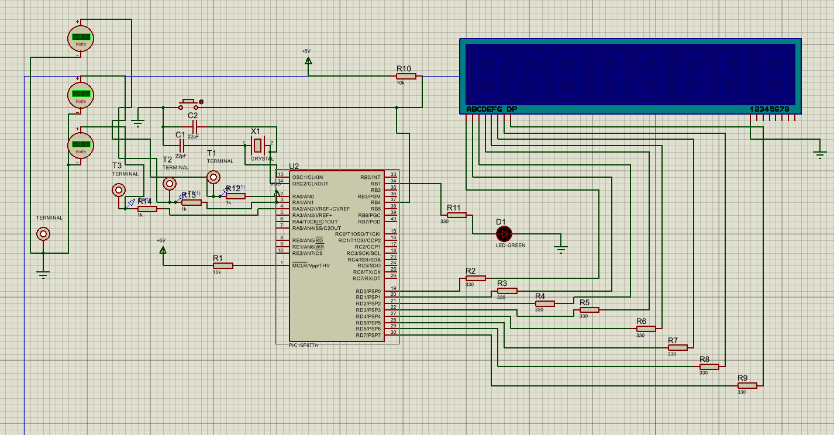

Appendix B – Source Code
Figure: Screenshot of microcontroller firmware.
#include <16F877A.h>

// Crystal oscillator hardware build
#fuses HS,NOWDT,PUT,BROWNOUT,NOLVP,NOCPD,NOWRT,NOPROTECT
#use delay(clock=2000000)

// Test point mapping: RA0 = TP1, RA1 = TP2, RA2 = TP3
// Button input on RB4 (active low)
// 7SEG-MPX8-CC: segments on PORTD

#define LED_PIN PIN_B1

int8 fault = 0; // 0 to 3

// 7 seg common cathode digit table for 0 to 3
const int8 segTable[4] = {
0x3F, // 0
0x06, // 1
0x5B, // 2
0x4F // 3
};

// Test point patterns for 4 faults (RA0 to RA2)
const int8 tpTable[4] = {
0b0000011, // fault 0: TP1=1 TP2=1 TP3=0
0b0000000, // fault 1: all 0
0b0000001, // fault 2: TP1=1 only
0b0000111 // fault 3: all 1
};

// LED table
const int8 ledTable[4] = { 1, 0, 0, 0 };

void applyFault(void)
{
// RA0..RA2 test points
output_bit(PIN_A0, bit_test(tpTable[fault], 0));
output_bit(PIN_A1, bit_test(tpTable[fault], 1));
output_bit(PIN_A2, bit_test(tpTable[fault], 2));

// LED
output_bit(LED_PIN, ledTable[fault]);

// 7-seg segments on PORTD (common cathode)
output_d(segTable[fault]);
}

void main(void)
{
// PORTA: A0-A2 outputs, others inputs
set_tris_a(0b11111000);

// PORTB: RB4 input for button
// RB0-RB3 outputs, RB4 input, RB5-RB7 inputs
set_tris_b(0b11110000);

// PORTD all outputs for segments
set_tris_d(0x00);

// Make sure analog is disabled so PORTA behaves as digital
setup_adc(ADC_OFF);
setup_adc_ports(NO_ANALOGS);

port_b_pullups(TRUE);

output_a(0);
output_b(0);
output_d(0);

int1 lastButton = 1;

while(TRUE)
{
applyFault();

// Button on RB4 (active low)
int1 readNow = input(PIN_B4);

// Falling edge detect
if(lastButton && !readNow)
{
fault++;
if(fault >= 4) fault = 0;
delay_ms(150);
}

lastButton = readNow;
}
}

