Module name: International Business Communications

Assignment 1

Module Code: LCBB6001

Name: Valentina Pituscanu
Student ID: 2124861

Table of Contents
About Aviva 3
ECONOMIC STABILITY 4
TECHNOLOGICAL INFRASTRUCTURE 4
Cultural Differences Between Spain and the Netherlands 5
Hofstede cultural dimensions: Spain vs Netherlands 7
Recommendation 10
• Cross-Cultural Training 11
• Language Support 11
• Adapt Communication Style 11
• Build Relationships 11
• Cultural Sensitivity 11
• Utilize Technology 12
• Seek Local Expertise 12
Conclusion 12
Bibliography 13

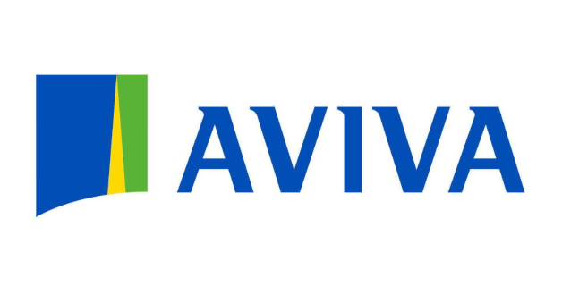

About Aviva

In 1696, in London, an insurance society called the Hand-in-Hand Fire & Life Insurance Society came into existence and later it grew into one of the biggest insurance companies in the world – Aviva plc. Aviva services teams in Europe, Asia, and North America. Here the company offers different types of insurance and financial services for companies and people. The organization attaches importance to maintaining of sustainability, innovations, and corporate governance that it is imbued with environmental, social, and governance elements. Featuring responsible corporate governance, Aviva can be fully relied upon by its clients worldwide being an important assistant for them to protect their interests and providing them with more suitable financial products.
Aviva comes second in the UK market with a market share of 10.6%. Overall, the UK insurance industry is comprised of various types of insurance offered by a diverse range of companies with different market shares. This strongly speaks of the giant role which Aviva plays specifically in the insurance sector within the United Kingdom.
The total revenue of Aviva amounted to approximately 18.5 billion British pounds in 2023 - a slight increase from the previous year.
A Proposal of EU Country that Aviva Should Consider for Expansion
Expansion of business operations into new territories represents a landmark decision by any organization that wants growth and sheer survival amid today’s globalizations. This applies also to the multinational insurance company Aviva. As an insurer at the forefront, Aviva is always after opening up new markets for it. Consequently, this essay will discuss what factors the company should consider while making recommendations on where next to expand in Europe from within the European Union.
ECONOMIC STABILITY
The first thing that Aviva must focus on when recommending a potential EU-based country for expansion is economic stability without any doubt. For instance, it provides predictability that helps reduce risks associated with market volatility. Related to the strong GDP advancement, low inflation and political stability in the country is a good environment for business expansion. This is apparent with the likes of Germany, France and the Netherlands which have great economies and stable business climates within the European Union(EU).
Regulatory Environment
Aviva needs to look at insurance industry regulatory frameworks in prospective EU-based countries. The appropriate regulations ensure competition as well as consumer protection and financial stability. Besides, sticking to EU laws and standards facilitates understanding of more general market practices thus leading to easier integration into the European marketplace.
MARKET POTENTIAL
The targeted country should be probed about its market potential by doing comprehensive market research on insurance products or services demand (Aviva). For this reason, indicators such as population demography, income levels and existing insurance penetration rates do play a significant role in estimating market potentials. It has been found that those countries experiencing demographic shifts such as an ageing population or growing middle-class segment offer attractive opportunities for insurance companies. Additionally, studying the competitive scenario along with identifying untapped niche segments may provide Aviva with a competitive advantage in the chosen country

TECHNOLOGICAL INFRASTRUCTURE
In today's digital era, technology infrastructure is essential for any business venture. Aviva should consider the technological capability of prospective EU-based countries including their internet penetration rates, literacy in digital skills and the availability of advanced IT infrastructures. Technological advancement facilitates the delivery of innovative insurance products, enhances customer engagement through digital channels and streamlines operational efficiency.
CULTURAL AND LINGUISTIC CONSIDERATIONS
Cultural nuance and language preference are major determinants of success for business operations in a foreign market. Aviva must look into cultural diversity and linguistic choice as propelling factors to ascertain whether it will be possible to communicate effectively with consumers in that region or not. Trust is built through effective communication reflecting local sensibilities and languages which make the customers feel understood. Furthermore, by understanding cultural norms, Aviva can tailor its product offerings and promotional strategies to appeal to its target audience.
Cultural Differences Between Spain and the Netherlands
To evaluate Spain and the Netherlands based on the criteria provided, let’s now look at each consideration:

Aspects | Spain | Netherlands
Country Facts | Situated in southwestern Europe, Spain has rich historical background, multiculturalism and a Mediterranean climate. It has over 47 million people as residents who speak Spanish as their official language. In high-context cultures like that of Spain, non-verbal cues and contextual factors play very significant role in communication. | Located in northwestern Europe, it is known for being flat with windmills and tulip fields. It has more than 17 million inhabitants who speak Dutch as their official language. Generally direct communication is common among the Dutch culture which embraces low-context approach.
Social Environment and Profiles | Family and personal relations are very important in Spain. The Spanish also value work-life balance hence have long lunch breaks and are not strict on time keeping. They may have hierarchical structures at workplaces which make decision making process slow as they always try to build consensus. | In the Netherlands, equality and individualism are highly upheld. Work-life balance is also significant thus employees work for fewer hours compared to other countries. Decision making in Dutch companies is a collective responsibility because communication channels are open so anyone can give their opinion.
Language | Spanish is the official language spoken by majority of Spaniards which makes it a must learn if you want to communicate well either socially or professionally. | Dutch is their national language but English proficiency levels among Dutch citizens especially those engaged in business transactions are quite remarkable thus attracting more global investors who do not have linguistic barriers with this country.
Possible Risks | High rates of unemployment among young people challenge Spain’s economy greatly while political unrest like that witnessed in Catalonia poses risks for firms operating within its territories; besides these factors bureaucracy coupled with red tapes could also slow down business activities there. | Stable economy and business-friendly environment are among the features of the Netherlands. In some sectors, however, there may be problems with rising housing prices and lack of skilled workers. Businesses connected with UK can also be affected by the uncertainties related to Brexit.
Labour Outlooks and Diversity | Spain has a diverse workforce, with people from different cultural backgrounds. Nevertheless, gender equality has not yet been achieved because many women face barriers to career progression. There is an ongoing effort to create workplaces that are more inclusive and diverse. | A large number of expatriates work in the Netherlands which therefore boasts highly diversified labour market. The country values diversity at work places while promoting inclusivity too. Women participate actively in employment thereby making gender equality relatively high as compared to most nations.
Spain and the Netherlands present different opportunities as well as challenges for businesses looking forward towards expansion abroad. Spain boasts a rich cultural heritage alongside a laid-back lifestyle but suffers from economic instability coupled with political uncertainties. On another hand, the Netherlands offers a favourable business environment characterized by stability supported by a highly skilled labour force though may face housing cost inflation in other sectors due to limited supply chain capacities caused by a labour shortage. Businesses therefore need to be aware of these facts before establishing themselves abroad in unfamiliar territories.

Hofstede cultural dimensions: Spain vs Netherlands

Most people associate culture with values, behaviours, customs, and traditions. Trying to determine what makes cultures unique, Hofstede (1980) sorted them into six dimensions. These main factors are inequality acceptance, risk aversion sensitivity, people-orientation dramatization, long-term versus short-term goals perception, and relaxation versus discipline orientation. The performances of countries can be compared using a standardized score. The game starts with a score of zero and runs up to a hundred. Taking into consideration the findings of Hofstede’s research (n.d.) we can observe the range of distinctive features between the Dutch and the Spanish cultures.

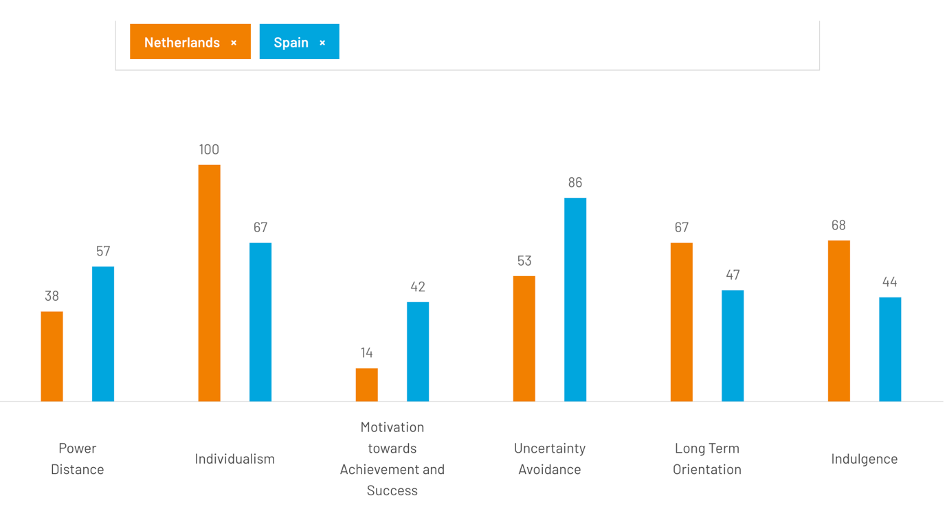

 | Spain | Netherlands
Power Distance | Spain would generally feature a high-power distance orientation, which is a measure of a social structure that holds unequal distribution of authority where the subordinates equally accept and expect this. Hierarchy is being presented in different spheres of life e.g. in the family, education and at the workplace. | While the Netherlands show a relatively small distance between power holders and the general population with the power distance score, the society of this country is characterized by egalitarianism and equality. A society of the Dutch strives for equality, equity, and dialogue; and reveres the leaders less than it prioritizes the hierarchic structures.
Individualism vs. Collectivism | Incidentally, Spain comes from the end of the individualism scale which reflects collective orientation towards the harmony of groups and family connection as opposed to individual advantages. As community-building as well as meeting the needs of individuals is equally important, choices taken into account are always the group's interest. | Netherlands does better on individualism, meaning that people may prefer autonomy, self-expression and individual achievements above all. The Netherlands tends to place a high value on personal initiative, one's responsibility as an individual, and self-sufficiency at the expense of conformism towards collective values.
Masculinity vs. Femininity | During the situation, ** Spain usually tends towards men the key features that are competition, ambition and assertiveness. In a patriarchal society, traditional roles of women in a family or society are defined more broadly. Men are generally perceived as assertive and dominant, while women adopt a nurturing and supportive role. | It looks like The Netherlands is more feminine because it stresses qualities such as harmony, modesty, and health than masculine which considers independence, risk-taking and self-confidence. Dutch ideals entail a harmony of work and family time, and gender neutrality is also more pronounced with less emphasis on power struggle by being assertive and competitive.
Uncertainty Avoidance | Shrinking towards the centre of the diagram, the Spain rate is higher in uncertainty avoidance, as a result of a liking for structure, rules and stability. Spaniards can show a lack of adaptability to uncertainty and ambiguity. They tend to establish clear lines and rules when solving problems to take the risk of failure away in this way and avoid failure. | With the lower index of uncertainty avoidance in the Netherlands, there is a (gulliver's travel) liberal attitude towards risk and change. The social fabric of the Netherlands is dynamic, adaptable, creative and open to novelty compared to stiffly organized societies with no overt rules and rigid structures.
Long-Term Orientation | More than not Spaniards are impulsive thinkers who have a concern more for the here and now rather than the future. In such a way, they not only have a great respect for the culture and tradition of the past but they also consider them the height of all achievements. The Spaniards sometimes might need to keep the totality of the existing social customs and traditions rather than changing or having long-term aims. | The Netherlands's strategy usually is long-term or even longer time orientation, which means that the country specializes in planning for long-term, innovation, and sustainability. Dutch people are attaching significant importance to frugality, endurance, and investment in education and construction of the private and public infrastructure for more affluent future years.
Things differ only in this respect: Both Spain and Netherlands belong to the European Union community of nations with varied cultural worlds, but they can be distinguished by their cultural dimensions, which are deduced according to Hofstede’s model. Recognizing the significance of space issues in intercultural communication, cooperation, and business efficiency is a necessary component for success in your nation.

Recommendation
Based on this assessment, it appears that the Netherlands provides a better environment for British firms due to a stable business setting, highly qualified workforce coupled with good command of English language among Dutch nationals. Moreover, directness in Dutch culture is more in line with typical British business interactions.
- Cross-Cultural Training
Offer extensive cross-cultural training programs for British staff who will be stationed or require frequent contact with people from Holland to enable them to appreciate various cultural communication styles including etiquette norms common within Dutch society while at the same time gaining the necessary knowledge needed when dealing with such counterparts effectively.

Language Support
Even though the Netherlands has a good command of English, it can be useful to provide language support such as translation services or language courses because this will help in easy communication, especially where difficult terms or phrases are involved which require explanation.

Adapt Communication Style
When doing business with Dutch people, British companies should adjust their communication style so that it becomes more direct and explicit as preferred by them. One should strive to make their messages concise, transparent and clear for better understanding among the parties concerned.

- Build Relationships
Relationship building is important in any given society but more so in Spain than anywhere else (so) although there is less hierarchy observed between ranks within an organization structure here compared to other parts of Europe like Britain; therefore it would not hurt if Brits took time to know each other better. They need to spend some hours together networking among themselves as well as engaging locals who can serve as valuable contacts during their stay there while at work.
- Cultural Sensitivity
People involved in any kind of business are urged to be culturally sensitive towards others they deal with and this applies even when venturing into foreign territories like Holland where customs might differ greatly from one's own country. It calls for open-mindedness on both sides lest either party may view certain actions negatively due lack of knowledge or understanding about each other ’s traditions thus causing unnecessary conflicts or misunderstandings.
- Utilize Technology
It is appropriate that technological advancements are made use of so that no matter how far apart different teams responsible for the same project may be situated geographically speaking. This means( thus ) making good use of video conferencing software like Zoom; project management tools such as Trello could also come in handy here since they allow sharing files among team members who may not be physically present at the same location.
- Seek Local Expertise
For successful communication between two parties involved in international trade, either side should seek help from professionals who have deep knowledge about their counterpart’s customs, business practices and legal framework. Thus if British businesses would like to know more about these aspects related to the Dutch market, then they should consider hiring local staff or consultants with relevant experience. By so doing, much time will be saved which could have been spent trying to figure out things by oneself thus giving room to other important duties during stay there while at work.

Conclusion
All these methods can be applied by UK companies to solve communication problems experienced when operating abroad such as in Spain and the Netherlands. Good communication skills, understanding of different cultures (cultural sensitivity) as well as networking among staff members are very vital elements that can contribute towards successful business relationship creation with partners within foreign markets like the Dutch one.

Economic stability, regulatory environment, cultural nuances and communication dynamics are among the factors that need to be considered by British businesses when making decisions about their expansion strategy. For instance, this can involve selecting Spain which has a rich cultural heritage and values personal relationships or the Netherlands characterized by a stable business environment and direct communication style; however, in either case, they need to adapt their approach based on local context.
To add on, there is a need for proactive steps like cross-cultural training, language support system establishment, adapting communication styles and fostering strong relationships with locals if they are to overcome communication barriers. Appreciating diversity; respecting cultural differences as well as incorporating technology into communication processes are also key components of creating an inclusive environment where all people can thrive.
In conclusion, what determines whether or not a British company succeeds in entering EU markets lies with how well it handles communication challenges while being sensitive towards them but at the same time flexible enough to learn from various points of view. In addition, by embracing inclusivity coupled with promoting a collaborative culture among employees; British firms could maximize their growth potential during European Union expansions thus ensuring sustainable development for all parties concerned.

Bibliography
- https://www.hofstede-insights.com/country-comparison-tool?countries=netherlands%2Cspain
- https://www.aviva.co.uk/services/about-our-business/about-us/
- https://www.sciencedirect.com/science/article/abs/pii/S107542532100096X?via%3Dihub
- Takino, M. (2020) “Power in International Business Communication and Linguistic Competence: Analyzing the Experiences of Nonnative Business People Who Use English as a Business Lingua Franca (BELF),” International journal of business communication (Thousand Oaks, Calif.), 57(4), pp. 517–544. Available at: https://doi.org/10.1177/2329488417714222.
- Dignen, B., McMaster, I. (2013). Collins Effective International Business Communication. London: Collins
- Deresky, H. (2017). International management. Harlow, Essex: Pearson.
- https://www.statista.com/statistics/1271699/total-revenue-aviva/#:~:text=The%20total%20revenue%20of%20Aviva,increase%20from%20the%20previous%20year.

