Programme: BA International Hotel Management
Module: Management & Organisational Behavior
Module code: BMIH5004
Lecturer: Ernest Wavei
Student Name: Sezen Mustanova
Student ID: 2210266
Executive Summary
This report has discussed Hilton Hotel Groups divisional structure, their inclusive culture and goals backed by Environmental, Social and Sound governance goals. Further discussion has been made on the recent change initiatives like implementation of technology and adaptation of sustainable measures that had positively as well as negatively impacted Hilton. The report has thus shown how the management dealt with the negative aspects. Lastly, a competitor analysis has be presented along with Hilton’s competitive positioning.
Table of Contents
1.Introduction 4
2.Organisation Structure, Culture, and Goals 5
A critical analysis of Hilton Group’s Hierarchical structure 5
A critical analysis of Hilton Group’s Hierarchical culture 6
An evaluation of Hilton Hotel Group’s goals 7
3.Recent change initiatives and their management 8
3.1 Identifying change initiatives by Hilton Hotels 8
3.2 Impact Analysis 9
3.3 Management Assessment 10
4.Strategic Direction 11
4.1 Mission, Vision and Objectives 11
4.2 Competitive Positioning 12
4.3 Strategy effectiveness 12
5.Conclusion 14
References 15

1.Introduction
Hilton Hotel group is an American based multinational company that deals with management of hotels, resorts, restaurants and catering. It was originally founded by Conrad Hilton and currently is being managed by Christopher J. Nassetta. Hilton Group is regarded as the world’s largest hospitality company as it is responsible for managing travel and tourism worldwide with a focus on positive environmental and social impact. It also focuses on carrying out sound governance across every function and communities with the help of Environmental, Social and Cultural strategy (ESG). Therefore, this also makes Hilton Hotel group significant in the hospitality industry as it takes into consideration ESG strategy which acknowledges environmental, social and cultural aspects (Mullins et al., 2013). This report will, therefore, discuss Hilton Hotel Group’s Organisational hierarchical structure, culture and people and how these variables perfectly align with the organisation's goal. Another discussion will be conducted on their recent initiatives and how these initiatives affected various stakeholders, employees as well as customers. The management of these changed initiatives considering factors like communication, employee engagement and resistance to change will also be critically analyzed in this report (Mullins,2020).

2.Organisation Structure, Culture, and Goals

A critical analysis of Hilton Group’s Hierarchical structure
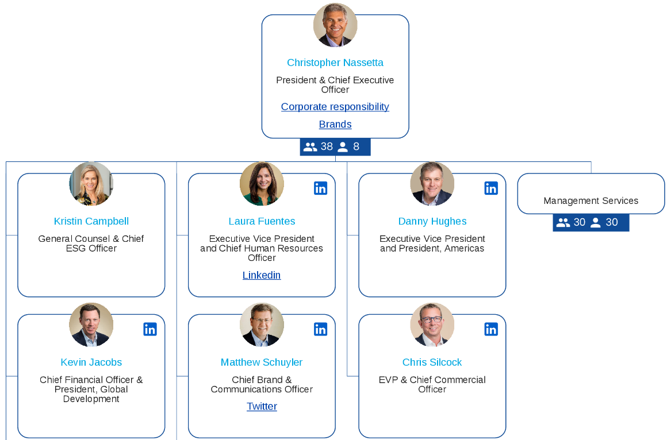
Figure: Organisational structure
Source: (Mullins,2016)
Hilton Group’s organisational structure can be defined as divisional as the business is divided into several other areas like ownership, management and franchise, timeshare. Ownership includes properties that are owned by Hilton, management and franchise includes properties managed by Hilton and timeshare includes grand vacations. CEO of Hilton, Christopher Nasseta is further assisted by a team of executives handling finance, human resource and few others (Mullins,2016). This type of structure helps to uphold a high degree of transparency and helps companies like Hilton Group to create company culture and loyalty. Contrarily, this type of structure can create competition among different divisions and high operating costs. Some of the brands are divided into different departments like luxury, Lifestyle, full service, while other brands are divided among focused Service, vacation ownership as well as loyalty.
Luxury - Luxury departments like Conrad Hotels and Resorts, Signia by Hilton focus on catering to those who seek an element of exclusivity, luxury and outstanding service.
Lifestyle - Lifestyle departments like Curio Collection, Tapestry combine several factors like personalization services, implementing competitive pricing strategies as well as other factors like gym, swimming pool, jogging park and play areas.
Loyalty - Loyalty department like Hilton Honors focuses on offering guest discounts, freebies like free nights as well as experiential rewards.

A critical analysis of Hilton Group’s Hierarchical culture
Culture - Hilton Hotels encourage diversity and inclusivity in their work culture therefore ensuring in creating an exceptionally pleasant and vibrant environment for not only customers but the employees of differences too. The culture of an organisation is vital as it transforms a brand or a company into a team who hold onto a common purpose. Therefore, Hilton has successfully committed themselves to creating the world’s best work environment for employees (Boddy,2014).
Benefits - Hilton Hotel group encourages people belonging to different ethnicities, age, gender and education, therefore, bringing in different perspectives on the table which yields to different viewpoints and better results. This diversification and inclusion had also encouraged new and creative innovation with better formation of solutions to problems along with boosting morale of the employees. They also empower employees for lifelong learning therefore helping them to build their life with a career that is right for them.
Challenges - Diversification and inclusivity can have several communication issues like language barrier, people with hearing loss, different communication styles and generational differences. Another major challenge is it can slow down the decision making process as a result of different perspectives.

An evaluation of Hilton Hotel Group’s goals
Hilton Hotel Group aims to promote travel and tourism globally with an integration of ESG strategy which focuses on environment, social and governance. Implementation of the ESG strategy acts as an important benchmark for how responsible brands like Hilton operate therefore allowing brands and businesses to implement more sustainable and ethical practices (Rollinson et al., 2008).
Environmental Goals - The chain of hotels under Hilton focus on environmental goals by reducing the company's impact on the environment like zero carbon emission and reducing wastage. They make it possible by implementing energy efficient technologies, promoting diversity and inclusion and successfully developing practice of ethical sourcing.
Social goals - Social goals of hotels under Hilton include encouraging a strong relationship between employees, communities and customers. This helped them in building a positive reputation and brand image along with employees actively engaging and securing the trust of stakeholders. Prioritizing social goals has also helped Hilton Hotels to secure long term sustainability and financial growth.
Corporate Governance- Hilton’s corporate governance structure ensures operation characterized by accountability, integrity and transparency. They have also upgraded their measurement systems to efficiently track their progress. Partnering with global, non-profit organisation, local groups and community NGOs have also helped them build a strong cross industry partnership.

3.Recent change initiatives and their management

3.1 Identifying change initiatives by Hilton Hotels
The changes introduced by Hilton group made processes faster, therefore making lives easier for business employees as well as improving the overall experiences for hospitality customers. Some of the major initiatives undertaken by Hilton Hotels include using the latest technology and improvement of sustainability in materials (Gursoy et al., 2024).
Technological change - Hilton had built a Hilton Innovation Gallery also regarded as an incubator wherein the gallery features several effective functions like lobby enhancement to meeting space ideas and guest room improvements. These implementations were part of their effort to build their future. It also included the automation of several processes therefore reducing workload, costs and few others.
Improvement of sustainability in materials - Carbon intensity, a metric for calculating carbon emissions, was projected to be halved by the end of 2030 according to Hilton’s firm commitment to sustainability. Hilton eliminated the usage of plastic straws and encouraged reducing plastic wastes like plastic bottles. They have also considered solar as well as water cycling options.

3.2 Impact Analysis
The impact of introduction of technology and improvement of sustainability had brought in both positive as well as negative impacts.
Impact of leading technological changes - The impact of technological changes has had positive impacts like competitive changes and efficient waste management. The competitive changes helped Hilton group to keep up with their competitors therefore preventing them from being outpaced by rivals with advanced technology. Efficient waste management was achieved by implementation of automation in waste management strategies, therefore, reducing food wastage and saving money spent on supplies. Contrarily, the hospitality industry largely depends on human interactions and implementation of technology can create a significant cultural shift for the employees of the industry. Another negative aspect includes customers feeling disconnected from services as a result of AI taking the place of humans.
Impact of adopting sustainability - The impact of adopting sustainability by Hilton Group can be divided into two parts: positive and negative. Hospitality industry in general contributes to greenhouse gas emissions due to energy consumption and waste generation. Therefore, adoption of renewable energy sources and energy efficient technologies can help in reduction in the emission of carbon. Another positive aspect includes reduction of food wastage through careful planning, portion control and donation initiatives. The negative aspects of adopting sustainability are some of the followings: Cost barriers and lack of awareness. Implementing sustainable practices require in advance capital, therefore making brands deter due to concerns about profitability. Another negative aspect includes the resistance to change and unawareness among the stakeholders, therefore making it important and requiring extra effort to educate stakeholders.

3.3 Management Assessment
Communication - Communication is essential for any team to work together efficiently, especially in the hospitality industry as employees must deal with customers of different personalities. Several communication issues can arise as a result of integration of advanced technology in place of human interaction. Therefore, Hilton Group can ensure communicating its brand values to every employee to make them feel unified and prioritize the use of a shared communications platform to encourage communication, engagement and interaction (Gomes et al.,2024).
Employee engagement - Employee engagement is crucial as it improves the work culture and helps in the reduction of average employee turnover. Therefore, prioritizing employee engagement during organisational culture is essential. Brands like Hilton can, thus, adopt transparent and continuous communication by necessitating active employee involvement during and after organisational change. Providing necessary training and support can also help employees to help them actively and efficiently engage with each other during changes.
Resistance to changes - Employees generally become adamant on continuing their work the same way therefore resisting any change to an organisation. Resistance can therefore include psychological resistance and sociological resistance. Hilton Group, in order to overcome this, can provide necessary training and support to employees to help them upskill. Managers can also involve the employees in the planning process of coming changes to encourage them to actively engage during changes.

4.Strategic Direction

4.1 Mission, Vision and Objectives
Mission - ‘Travel with Purpose’ is a strategy adopted by Hilton to promote responsible travel and tourism with the help of integration of ESG strategy. Using this strategy, Hilton aims to create purposeful and better experiences for its customers as well as their employees. Through environmental, social and corporate governance strategies, Hilton successfully aims to build customer loyalty and make company operations sustainable. It also helps them to focus on improving financial performance by going paperless and making energy efficient upgrades (Nam et al., 2024)
Vision - Hilton Hotel Group envisions acquiring its organisation goals by promoting sustainability among its operations. They encourage diversity, fairness, justice and inclusivity in their work force to welcome different perspectives which can yield to different viewpoints and better results. Therefore, ensuring presentation of innovative solutions by individuals of different mindset.
Objective
To improve the customer service by 2% of Hilton hotel within the next 5 years.
To increase the number of customers promoting sustainability within the business operations of Hilton hotel.
To enhance profitability of Hilton hotel by 1% within the next 6 years.

4.2 Competitive Positioning
Hospitality market analysis - The hospitality market size has drastically grown in recent years as more and more people are starting their traveling journey and seeking out hotels with good amenities and with competitive pricing. It is projected to raise more than 3978 billion GBP by the end of 2024 at a compound annual growth rate of 6.8% (Patel, 2023).
Competitors analysis - Hilton, being one of the largest hotel chains and fast-growing brands in the world, faces fierce competition. The competition in the hospitality industry has become brutal as Hilton Hotel Group are competing with other big hospitality brands like Marriott, Hyatt, Airbnb, Shangri-La Hotels and a few others. Marriott has more than 5000 properties in the majority of the countries all across the world therefore creating a fierce rivalry with Hilton Groups. Marriott’s partnership approach has gained them several resorts worldwide with different benefits and incentives and having acquired Starwood Hotels, they became the largest hotel chain. These hotels offer similar services with competitive pricing, thus making it difficult for other organisations to stand out (CLARK, 2023).

4.3 Strategy effectiveness
Hilton Group’s ESG strategy has had several positive as well as negative impacts on their business. Some of the positive impacts include:
Positive impact - Hilton Group successfully improved their relation with customers as the adoption of ESG strategy helps in putting brands in a positive light. Environmental concern, social goals and incorporating corporate governance acts as an important benchmark for how responsible brands like Hilton operate. It also helped them reduce cost as switching to more sustainable production methods tends to be more efficient and helps cutting company’s carbon footprint.
Negative Impact - Some of the negative impact that was caused by the adoption of ESG strategy by Hilton includes: Upfront cost, learning curve of training and support. Contrary to the positive effects of changes in an organisation, implementation of ESG strategy can cost an upfront amount which includes the cost of software licenses, maintenance costs as well as implementation charges. The learning curve for employees during changes in organisation can be time-consuming and could possibly require surplus of resources to ensure all users are properly trained and ready to get used to new changes.

5.Conclusion
This report therefore concludes that Hilton presents a strong and diverse portfolio of well recognized hotel brands considering various market segments from luxury to cheaper alternatives. Hilton also proves to effectively focus and implement innovative ideas and technologies by encouraging diversity, training and involving employees during the planning of changes. Some of the weaknesses that Hilton possesses include competition from various other businesses like Airbnb, Marriott and a few others. Other weaknesses include high employee turnover rates due to the changes that are brought in due to the implementation of new technologies. Hilton Hotel Groups can therefore capitalize their growth in emerging markets such as Asia-Pacific, Africa and Latin America.

References
Boddy, D. (2014) Management: An Introduction (6th Ed), Harlow, Pearson
CLARK, C., (2023). Hotel Competitive Advantage Strategy: A 2023 Guide. [Online] Available at: https://cultivateadvisors.com/blog/hotel-competitive-advantage-strategy/ [Accessed 7 May 2024].
Gomes, S., Lopes, J.M. and Ferreira, L., (2024). Looking at the tourism industry through the lenses of industry 4.0: a bibliometric review of concerns and challenges. Journal of Hospitality and Tourism Insights, 7(1), pp.436-457.
Gursoy, D. and Cai, R., (2024). Artificial intelligence: an overview of research trends and future directions. International Journal of Contemporary Hospitality Management.
Mullins, L & Dosser, P. (2013) Hospitality Management and Organisational Behavior (5th Ed) Harlow, Pearson.
Mullins, L (2020) Organisational Behavior in the Workplace (12th edition) Harlow: Pearson
Mullins, L. (2016) Management and Organisational Behavior (11th edition) Harlow: Pearson
Nam, H.J., Bilgin, M.H. and Ryu, D., (2024). Firm value, ownership structure, and strategic approaches to ESG activities. Eurasian Business Review, pp.1-40.
Patel, P., (2023). What does healthy competition look like in the hospitality industry?. [Online] Available at: https://hotelbusiness.com/what-does-healthy-competition-look-like-in-the-hospitality-industry/ [Accessed 9 May 2024]
Rollinson, D. et al (2008) Organisational Behavior and Analysis (4th edition) Harlow: Addison-Wesley Longman

